A qualitative investigation into the role of those leading singing at the intersection of singing and health.

Work based learning project BMPF7326D

Cerys Purser
Student number: 232081
Table of contents
- Proposal 5
Research question 5
The Context 5
The Justification 5
The intended impact 6
The outlined intention 6
Figure 1. Project timeline 7
The ethics and insider research 8
Personal learning outcomes 8
2. Report 9
Introduction 9
literature review 9
Singing and health as a growing field 10
Design and evaluation 11
Training and facilitation 11
3. Methodology 12
Methodological approach 12
Methods and justification 13
Figure 2. Research onion (Saunders et al., 2019) 13
Figure 3. Range health related practice represented 14
Figure 4. Braun and Clarke’s (2006) six phase model 15
Ethical considerations and reflexivity 15
Figure 5. Research timeline and process 16
Participants 16
Figure 6. Table of participants 1 to 5 17
Figure 7. Table of participants 6 to 13 18
4. Findings 19
Figure 8. Initial set of themes 19
Figure 9. Interpretative themes mapped to first set 20
Figure 10. Latent theme relationship 21
Figure 11. Latent theme relationship 21
Figure 12. Latent theme relationship 22
5. Theme 1: Navigating a hybrid professional identity 22
Practitioner identity and voice – a picture of evolving
and complex professional identities 22
Figure 13. Primary profile of practitioners 23
Professional alignment and collaboration - a picture of
Professional ambiguity 24
Figure 14. Table of organisations and health
related groups for practitioners represented 26

Training and Competence – Professional

competencies in a hybrid domain 27

6. Theme 2: Relational practice in
complex contexts 28
The practice - A bridge between worlds –
salutogenic practice, and process 28
Practitioner led processes
or process led practitioners? 28
Figure 15. Emergent approached in practice 30
Applications of singing and vocal pedagogy 31

7. Theme 3: Negotiating legitimacy, and sustainability 32
Evaluation and Evidence 32
Structural and Systemic Conditions –
contextual challenges 33
8. limitations 34
9. Conclusion 34

10. Reflective summary 35
11. References 36
12. Appendices (supporting document)
Research Instruments 2
Questionnaire responses 5
Interview transcript 38
Participant information and consent forms 79
Ethical approval 131
- Proposal

Research question
How do voice facilitators perceive their role at the intersection of singing and health with a focus on how practitioners define and develop their practice?

The Context
Singing for health is an emergent field of study and intervention (Batt-Rawden and Anderson, 2019) and there is a growing body of research exploring benefits and potential applications (Hopper et al., 2016). Just as the definition of health is broad and varied (WHO, 2025) so too are the existing activities supporting health through singing. From community music leaders who promote the wellbeing benefits of group singing (Camlin, 2020) to singing for lung health leaders, who target specific health conditions, potentially working alongside clinicians (Lewis et al., 2016). This study aims to explore how singing for health practitioners have developed their practice and how they perceive their work in the context of health.
The Justification
I currently run a town wide singing for health programme and am interested in singing and health training design and practice frameworks. My practice has evolved from a portfolio career in performance, voice teaching, music education, and latterly, continuing professional development in singing and health related research and applications. Much of the existing research on the subject focuses on the outcomes of singing for health activities (Batt-Rawden and Stedje, 2020; Hopper et al., 2016; Hendry et al., 2022) but less is known about the role of the facilitator, the heterogeneous delivery and professional experience. A singing for health claim can be attributed widely but is not always professionally differentiated, which can perhaps lead to overstating claims or undervaluing it as intervention due to a lack of specificity (Clift, 2024).

The intended impact
The intention for this study is to have a more differentiated picture of how singing for health practice has developed in a wide range of individuals. It aims at a clearer understanding of the specialist skills and tools that they employ in their work and if applicable, the professional or evidence base that informs them. A clearer picture of singing for health delivery could be formative in generating shared practice, developing future training and professional advocacy for the work. Having a more collective understanding of practice generally, would benefit my own practice especially with regard to future training design and relevant frameworks.
The outlined intention
The study is interested in the constructed realities and subjective views of participants and aims at a deeper understanding of their experiences in the context. It is also focused on a community who identify as singing for health practitioners. I will therefore undertake a fully qualitative, ethnographic approach from a social constructionist perspective (Cohen et al., 2018). Open ended questionnaires will provide subjective data, aimed at providing a clear picture of overall practice, skills and perceived impact within the context. A small number of participants will take part in semi structured interviews to gain deeper insights and clarification and for the researcher to observe and respond. The data from questionnaires and interviews will be analysed using reflexive thematic analysis, which is most appropriate to uncover the ‘story’ (Braun and Clarke, 2019) received from participants, and ensure close study of individual realities whilst triangulated (Flick, 2018) by a narrative literature review.

Figure 1. Project timeline

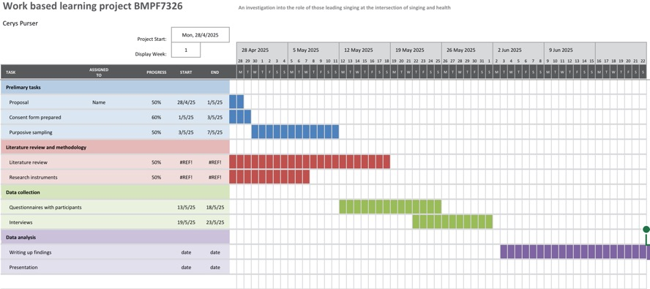

The ethics and insider research
As an insider researcher with a practice in singing for health, I am able to reflect on data received with my own experiences (Dwyer, 2009) and the ethnographic approach enables me to openly and reflexively include my observations as part of the process (Bartlett and Brodie-Leigh, 2008). The ethical considerations involve ensuring confidentiality and anonymity and also being mindful to any concerns that participants may have around efficacy and professionalism, mitigated by the option to withdraw from the study at any time. Participants are given the choice not to answer questions that may cause concern or distress (BERA, 2023). The research proposal has also undergone ethical review by the committee at University of Wales Trinity Saint David.
Personal learning outcomes
- To undertake my first research study aligned with a clear methodological process, within the timeline given.
- To critically evaluate data with literature to provide rigour
- To elicit themes that will inform future research into pedagogical practice and training the context of singing for health
- To establish clearer differentiation in working practice

- Report

Introduction
Singing for health activities are now widely available (Daykin et al. 2018) and occur in many contexts. This wide spectrum of activity encompasses community, clinical and social settings accessed by a broad range of participants (SFHN, 2025) The participant profile varies hugely and the potential scope for the facilitator is extremely broad. Given the heterogenous delivery and shifting participant focus it could follow that the profile and competencies of those leading singing and health related activities are equally varied.
Broadly, singing and health activities can sit with multiple domains such as participatory art, health, musical performance and vocal education (Forbes and Bartlett, 2020). The implications for practitioners therefore, is that singing and health related practice is professionally complex (Fortier, 2023).
The literature refers to heterogenous delivery (Daykin et al., 2018) in singing and health practice but less is known about the practitioner specific competencies and pedagogy and this is the research gap I hope to explore in this and subsequent research.
literature review
The review used a pearl growing research strategy using Dingle et al., (2019), ‘An Agenda for Best Practice Research on Group Singing, Health, and Well-Being’, as a key text, and forwards and backwards chaining. The study was focused on UK practice and practitioners. Although there are contextual similarities it excludes music therapists, who are registered as health professionals in clinical therapeutic practice (Forbes et al., 2025)
Less is written on the experiences and practices of practitioners, (Fortier, 2023) justifying the use of grey literature to build a picture of elements related to training and delivery and professional practice.

Singing and health as a growing field
The benefits of singing and health has a long history of anecdotal evidence (Stacy et al., 2002) and there is now a growing evidence base, (Batt-Rawden and Anderson, 2020, Fahey et al., 2022),which includes reviews and critiques, all with implications for practice (Dingle et al., 2019, Clift et al., 2024, Daykin et al., 2018, Lewis et al., 2016). However, the research base does not include large-scale studies and evidence of clinical efficacy (Daykin et al., 2018) which could support the integration of an interdisciplinary practice in the wider health care system (Fahey et al., 2022). In short, there is little or no standardisation in delivery and training (Fancourt and Finn, 2019). Despite growing research on the benefits of singing to health, the heterogeneous design and facilitation of singing for health activities operates outside any regulatory framework or formal accreditation. However, the growing numbers of practitioners leading singing for health interventions is gaining a more professional focus as seen by the development of the Singing for Health Network (SFHN) which has a global membership and recognises a community of practitioners, researchers and other bodies working in the field. In the UK there are now several voice education or member organisations and charities involved specifically in training, advocacy and promotion of the benefits of singing and health through continuing education such Voice Study Centre, The Musical Breath, Sing to Beat Parkinsons, Singing and the brain and Vocal Health Education. Increasingly, these recognise the need for shared systems of delivery and frameworks to undertake work in potentially vulnerable settings (Kim et al., 2023). This presents a gap in the literature, where recognition of the heterogeneous and varied delivery is discussed but not considered further (Fortier, 2023). Even though it is gaining momentum singing for health is not recognised institutionally as a health profession, perhaps in part by the limited evidence available regarding quality and variance in delivery, (Irons et al., 2020). More widely available however is a foundation of research from systematic reviews, studies and trials across a wide span of health-related concerns. Notable research includes, Lewis et al., (2016) who present a systematic review of singing for respiratory health, or Singing for Lung Health (SFLH), Williams et al., (2016) who investigate the literature regarding the efficacy of singing on measured mental health and wellbeing outcomes. Also, Irons et al., (2020) who completed a review on the effects of group singing with people experiencing pain due to effect of long-term health conditions. Some studies however, have been criticised for bias and variable delivery parameters (Williams et al., 2016) and Clift et al.,(2024) call for a more robust critique in arts and health research, rather than the desire to showcase “positive evidence” (p.1).
Design and evaluation
Whilst singing and health practice does not have a single professional affiliation, with regard to healthcare, singing for health can be situated within creative health practice (Hendry et al., 2022). The Creative Health Review published by The National Centre of creative Health (NCCH) and the All – Party Parliamentary Group on Arts, Health and Wellbeing (APPG) is driven by existing governmental policies and makes numerous references to singing for health including aspects of dementia, COPD, long covid and lung heath, heart health, mental health and postnatal depression.
A standardised model for best practice and systemised interventions are not currently developed or written about, however, although not specific to singing The Culture Health and Wellbeing Alliance has presented a Creative Health Quality Framework (CHWA, 2025) which proposes adopting quality principles for good practice, which are; person centred, equitable, creative, collaborative, realistic, sustainable and reflective. Whilst these are useful, they are extremely broad, and there is a current gap in the literature to address a potential framework specifically for singing, especially related to vocal parameters and leadership in the context of health (Cave, 2017). Dingle et al., (2019) reinforce the need for overarching theoretical frameworks highlighting outcomes reported “without any theoretical basis” (p.5) and “leaning on more descriptive values” (p.5). likewise, Batt-Rawden and Andersen (2020) in their study of choirs for wellbeing refer to poor quality of evidence citing heterogenous delivery as a factor in replicability and rigour.
Singing is described as a biopsychosocial activity (Dingle et al., 2019) which in a health context aligns with the work of Engel (1977) who introduced the term to counter the predominantly biomedical model of disease. Engel (1977) stated that any framework for health and disease should also considered with social, psychological and behavioural dimensions, implications therefore, for multi-disciplinary singing and health evaluation and training are potentially complex. A clear understanding of the social and musical interdependence and the “reflexive negotiation” (Camlin et al., 2020 p.1) between neurobiological, musical and social mechanisms that facilitation in singing for health involves is under explored.

Training and facilitation
Training is mostly shorter professional development courses rather than formal institutional pathways. These courses are accessible to practitioners from a range of disciplines such as music, education, healthcare or community interest and most do not require any prior training in music or singing (The Musical Breath, 2025). This implies a wide range of professional skill and competence, and potentially a degree of ambiguity for those seeking to commission work within this field (Kim et al., 2023). It also points to a gap in the professional support for those seeking to work in this domain and raises ethical issues, relating to support or supervision for undertaking work with those who are vulnerable (Fortier, 2023).
- Methodology
Given that this research is concerned with a role that is professionally fluid, the research paradigm must allow for multiple perspectives and offer a flexible understanding of practice. To that end, the study is conducted within a social constructivist paradigm, which is underpinned by the belief that reality is subjective, multiple and constructed through experiences, language and social interaction (Creswell, 2014). This perspective aligns with the study aim, which is to explore how practitioners may negotiate their roles and identities with an evolving and multidisciplinary field.
Methodological approach
The study is fully qualitative, focused on meaning-making, process and subjectivity rather than a search for objective truth or causality typically seen in quantitative paradigms (Creswell, 2014) Dingle et al., (2019, P.10) cites the need for a “voice on the ground in developing singing and health practice and this study is an attempt at a deeper understanding of the field from those who are embedded within it. Employing a “qualitative sensibility” (Braun and Clarke, 2013, p. 20) supports a deep engagement with the potentially complex and nuanced experiences of working practice. The study also adopts an ethnographic approach, (Hammersley and Atkinson, 2019), which is values based and enables a wider community focus. Whilst ethnographic studies are typically lengthy, this study is adopting the approach as a lens, in attempting to provide an exploration not just of what practitioners do but how they understand, define and locate their role(s) in relation to others within the practice (Fahey et al., 2022 and Harwati, 2019).

Figure 2. Research onion (Saunders et al., 2023)
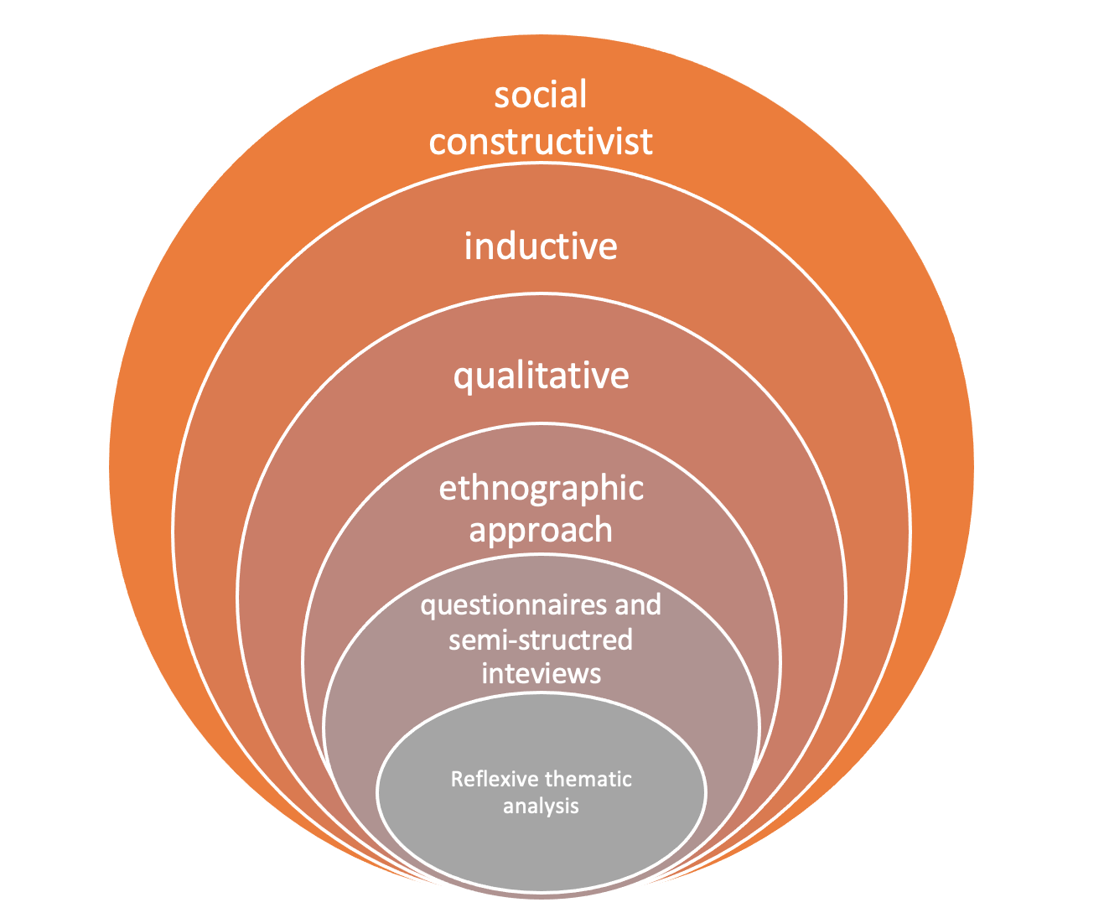

Methods and justification
Three methods of data collection were used: open-ended questionnaires, (Tombs and Strange, 2024) semi structured interviews and a reflective journal. Data was triangulated with a literature review to strengthen rigour in analysis. The open-ended questionnaires were aimed at gathering data from a cross section of practitioners engaged in the work, in a range of contexts (Tombs and Strange, 2024). And the semi structured interviews were chosen to provide a deeper layer of meaning and to replicate a number of studies in similar contexts. (Hopper et al., 2016; Batt-Rawden and Andersen, 2020) See figure 3. for the range health related practice represented.
Figure. 3

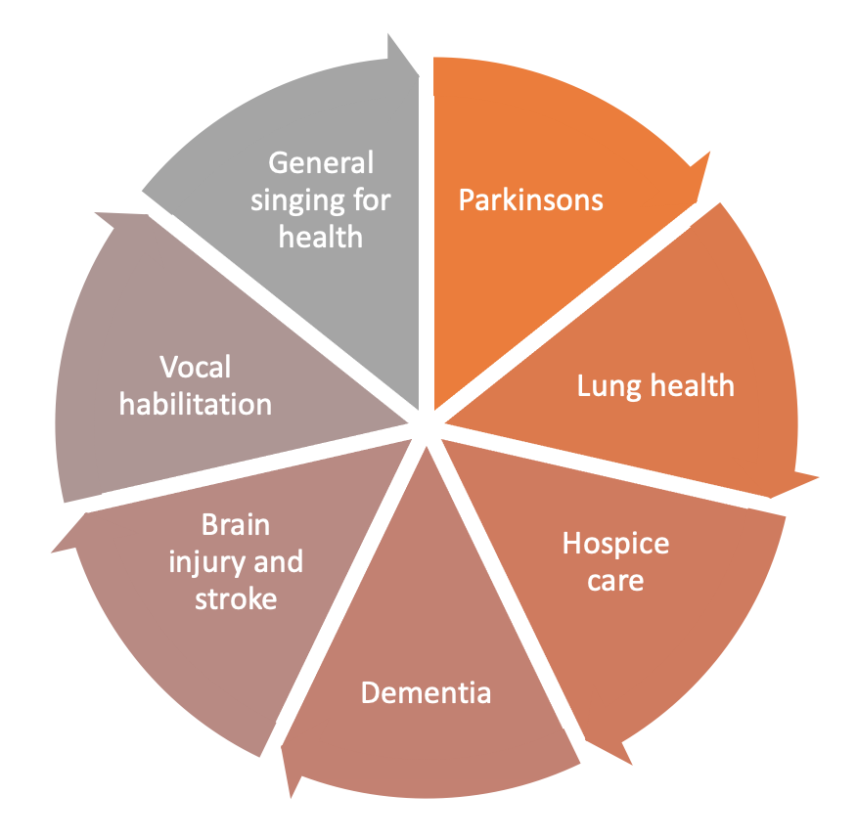
The reflective journal provided a tool for observation, capturing interpretative process and researcher positionality (Sudirman et al., 2021). Whilst other methods for data collection, such as participant observation or focus groups may have been used to provide insights, they were not practically feasible to access participants drawn nationally, therefore questionnaires and interviews were chosen for their suitability and for their potential to provide a balance of breadth and depth. The data was analysed using Braun and Clarke’s six phase model (2006; 2019; 2020) of reflexive thematic analysis (RTA). After receiving questionnaire responses, four semi structured interviews were conducted with existing participants. A first and then second set of codes were arrived at after analysing and then triangulating with questionnaire, interview and reflective journal data using the approach of Braun and Clarke’s (2006; 2019) RTA.
Figure 4. Braun and Clarke’s (2006) six phase model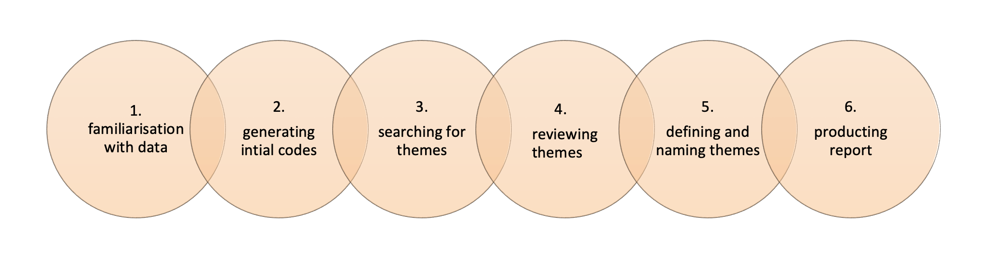

RTA is embedded in qualitative values and acknowledges the researcher’s active role in constructing meaning (Braun and Clarke, 2006). It follows an iterative process which enables reflexive theme development (Tombs et al., 2024)
Ethical considerations and reflexivity
Ethical approval was granted by the University of Wales Trinity Saint David ethics committee and all participants gave informed consent after receiving detailed information. The interviews were carried out via a password protected professional Zoom account and both questionnaire and interview data were stored securely on a protected one drive in line with data protection requirements.
Given the personal and subjective nature of research care was taken to remain participant-led and to reinforce participant choice and consent in providing answers to any questions. Singing for health practice can operate in contexts with vulnerable populations, and potentially complex health and emotional needs. The research instruments were focused on the practitioners and designed to avoid any intrusive health enquiry. The position of insider researcher impacted the process dually by being able to draw on a shared perspective of the practice whilst maintaining critical reflexivity (Mercer, 2007) The reflective journal was key to this, as it provided an additional process through which to reflect on and interpret the research openly and offer more transparency in researcher positionality and bias.

Figure 5. Research timeline and process
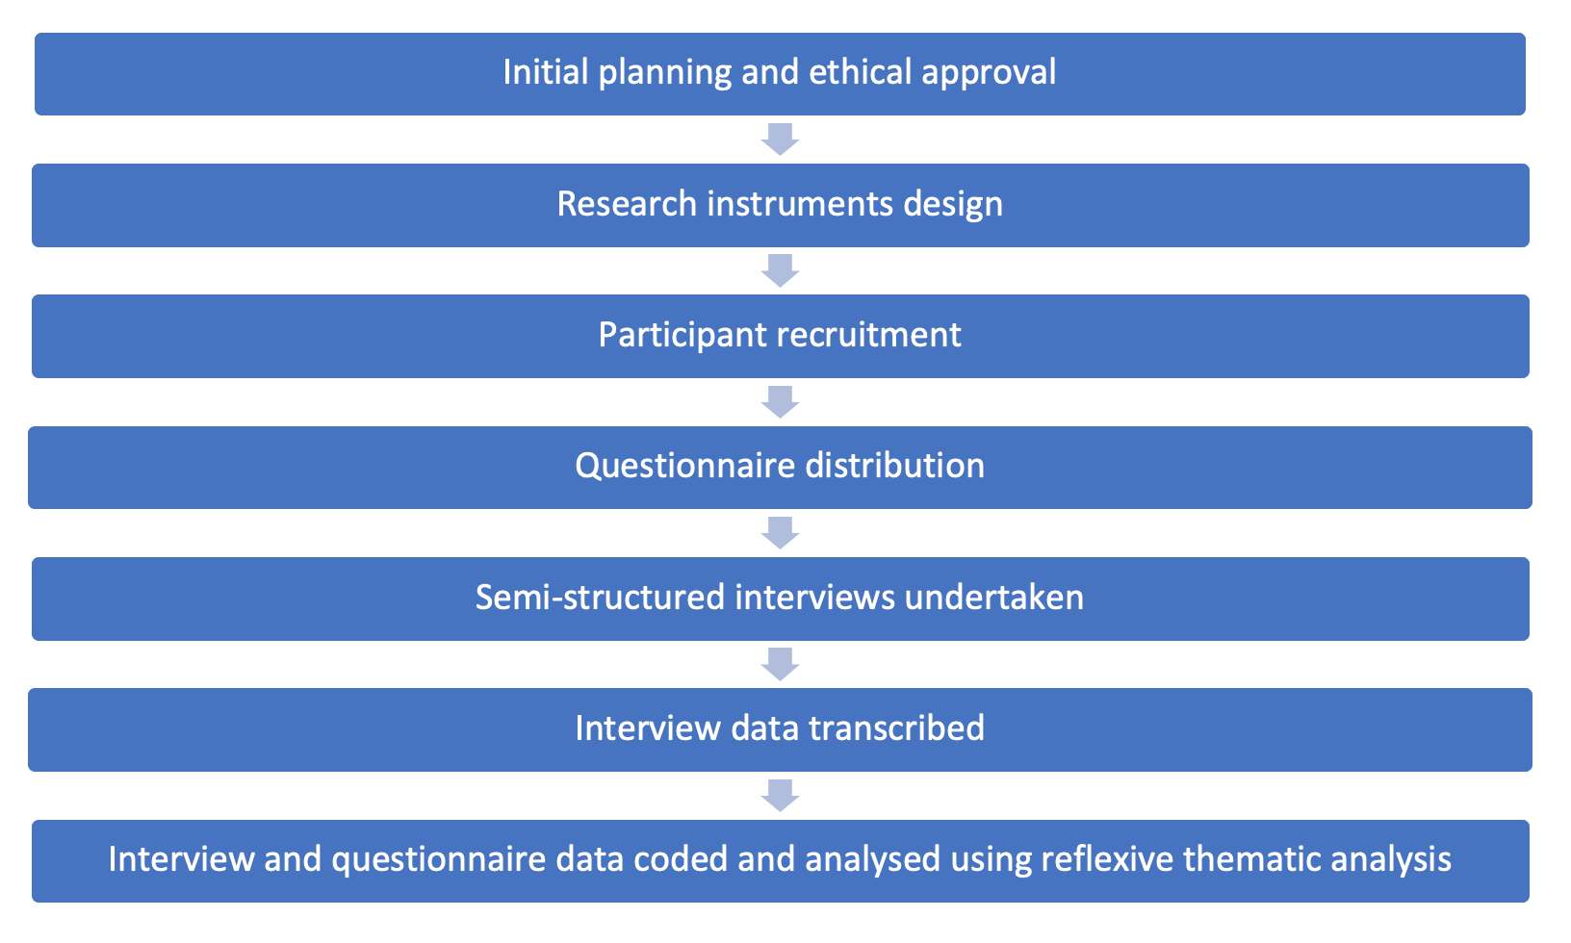

Participants
Participant recruitment was purposive (Cohen et al., 2018) and via social media networks, such as the Singing for Health Network, the Singing for Lung Health leaders and the Sing to Beat Parkinson’s leaders face book forums, the Vocal Process teacher community and the London Arts and Health Forum. Of questionnaire respondents (n = 13) four participants were chosen to undertake semi structured interviews. The selection criteria for the interviews aimed at a broad range of practitioners as would allow from the responses to elicit deeper subjective information about their practice.
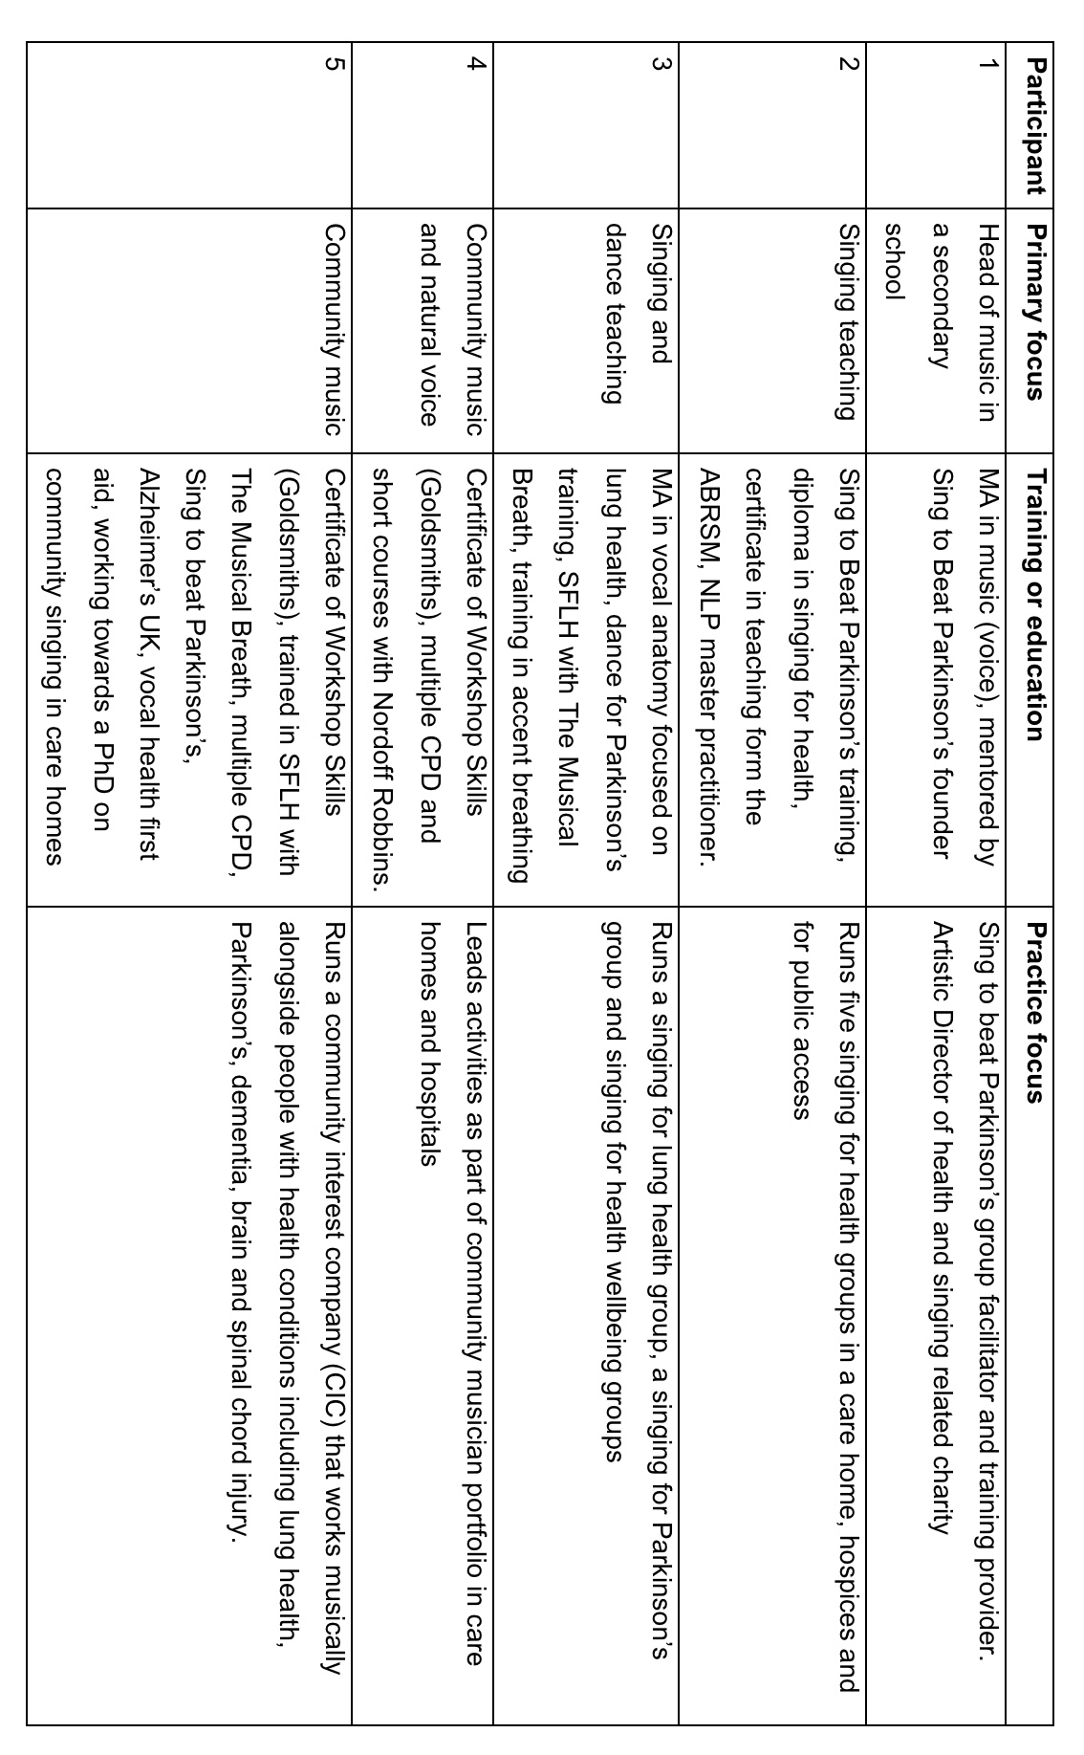
Figure 6. Table of participants 1 to 5
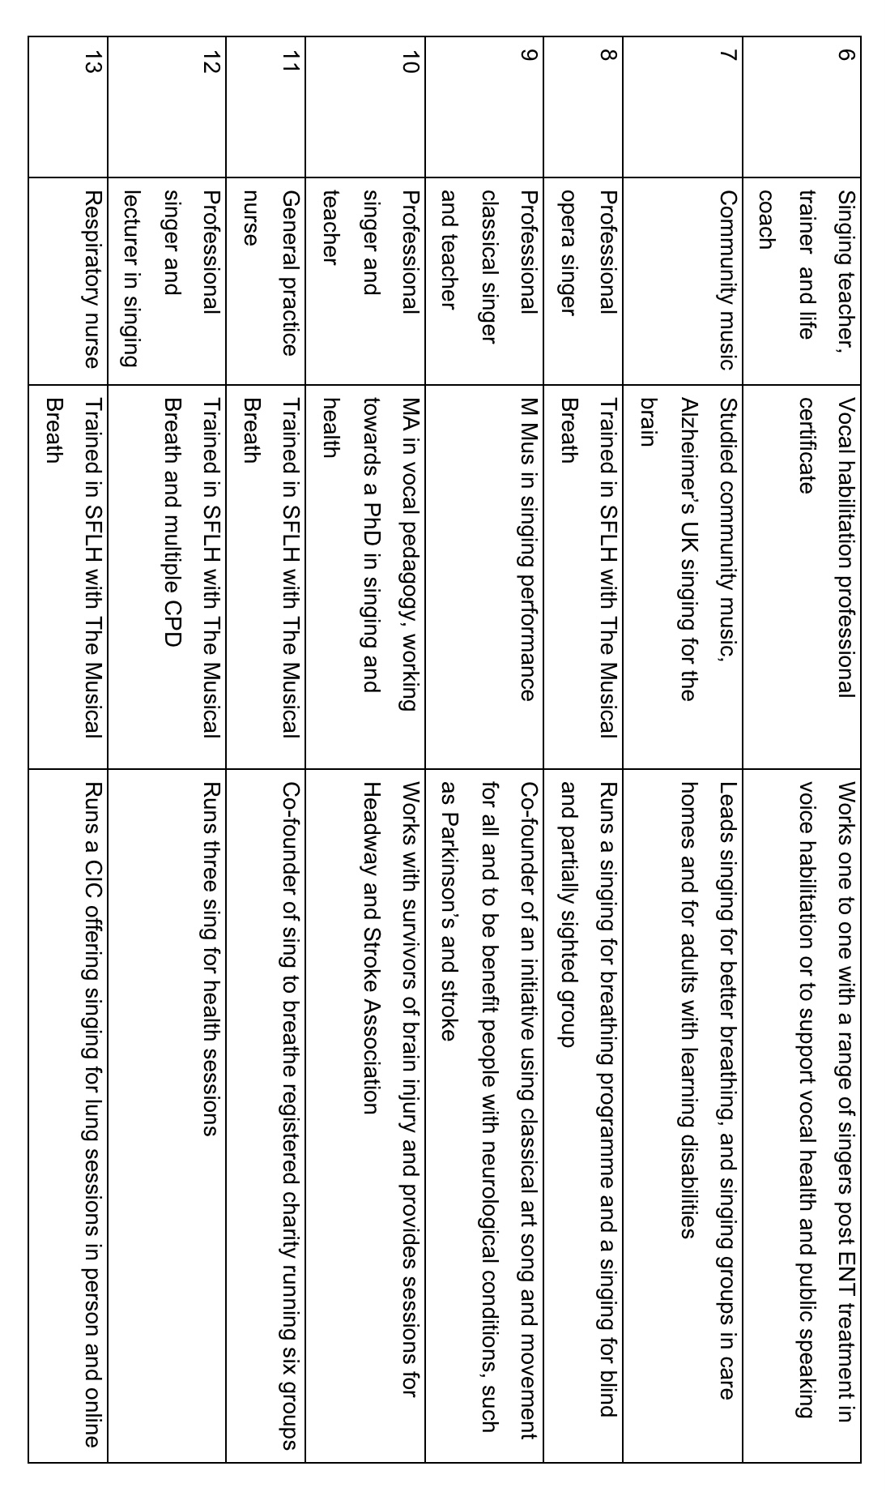
Figure 7. Table of participants 6 to 13

- Findings
A first set of themes was searched for to create a thematic map, which was analysed further to reveal three latent interpretative themes. See figure 8. for initial set of themes and Figure 9. for the interpretative themes mapped to the first themes. Figures 10., 11. and 12. show the latent theme relationships separately. Follows, a discussion each theme.

Figure 8.

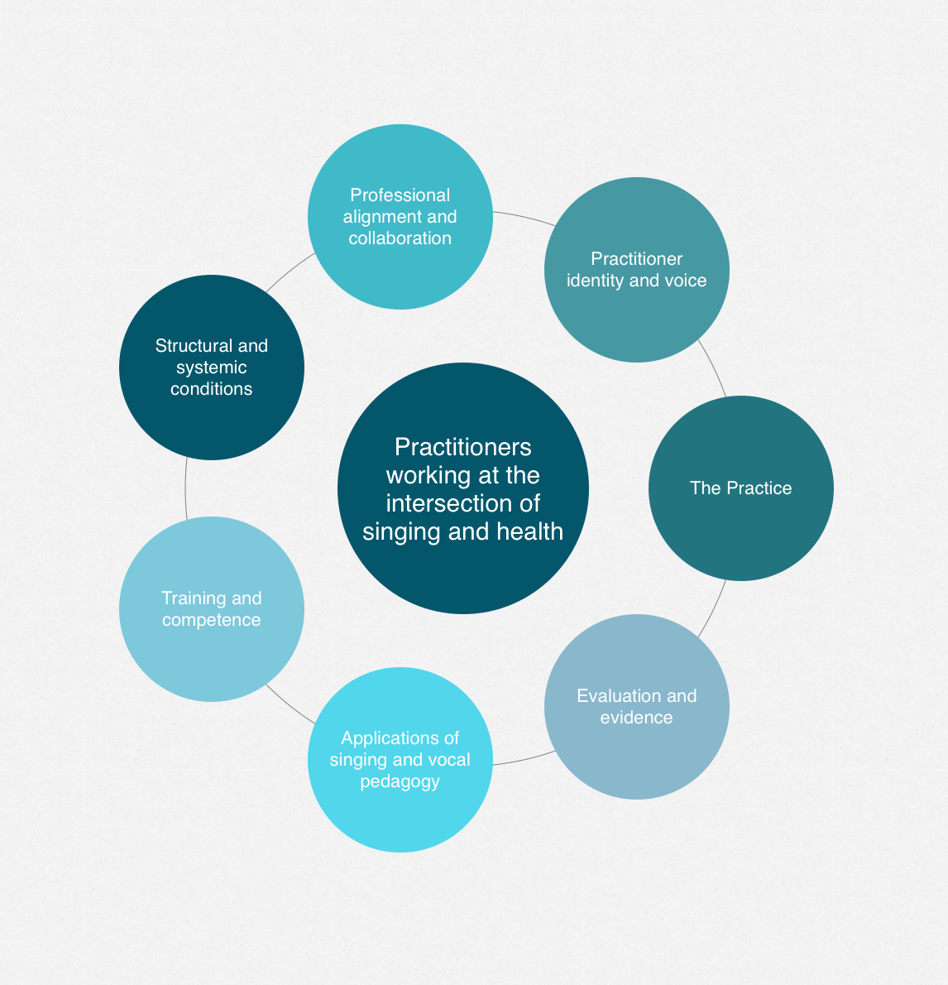

Figure 9.

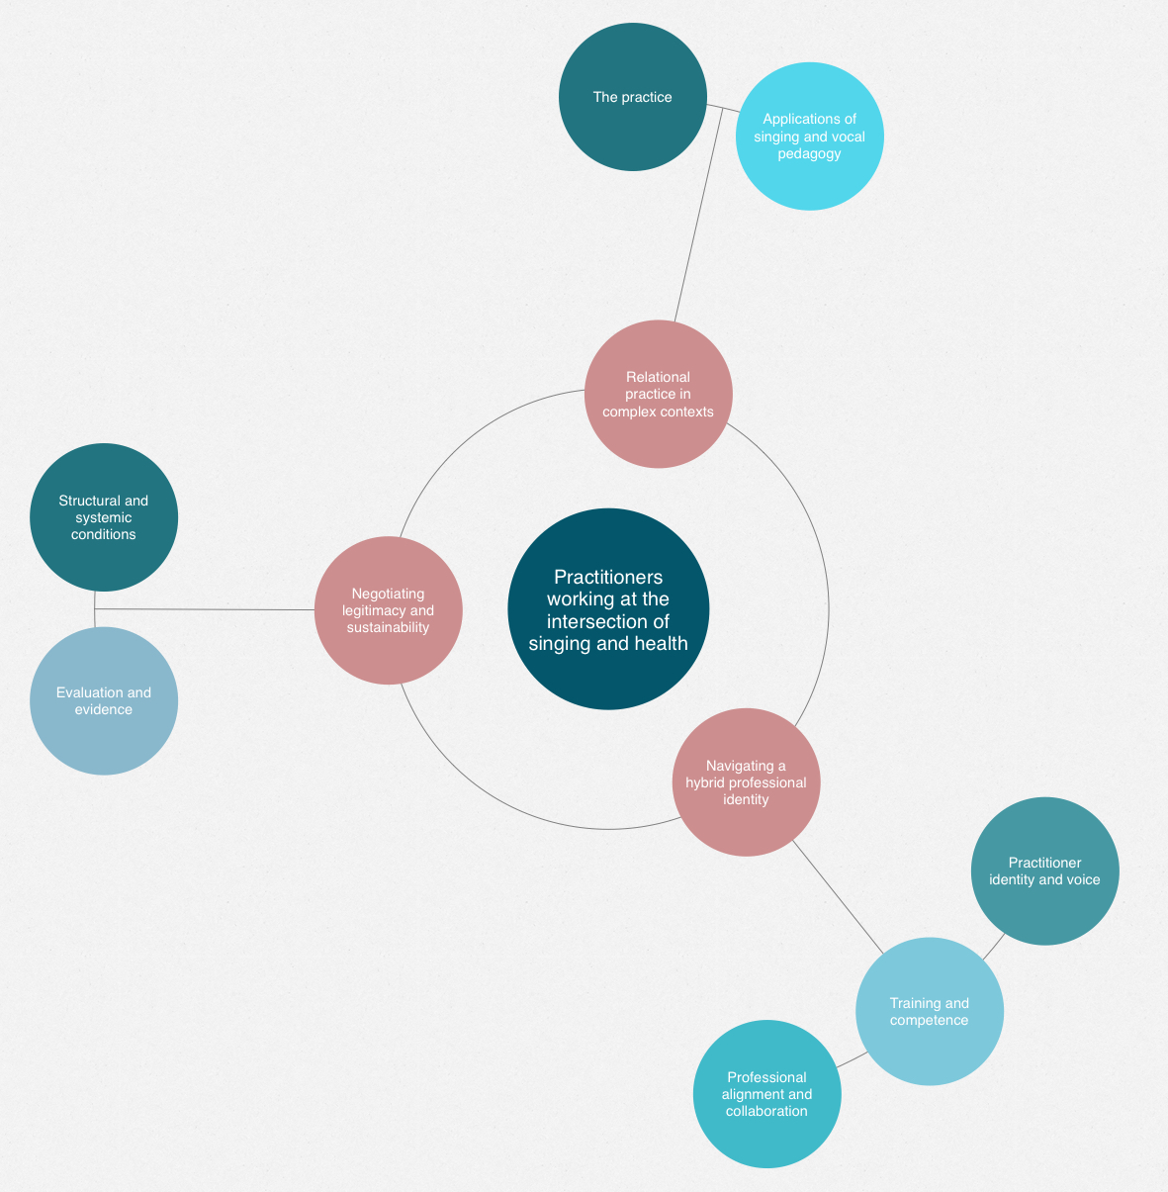

Figure 10.

Figure 11.

Figure 12.

- Theme 1: Navigating a hybrid professional identity

Practitioner identity and voice – a picture of evolving and complex professional identities

A common theme amongst practitioners working with singing and health is that they occupy a complex and ever evolving professional space. The professional profile of each participant follows an entirely unique set of professional skills, influences, and training. Commonly, the pathway into working with singing and health is one that has evolved often through deeply personal or lived experience. Forbes and Bartlett (2020) describe this relationship as a congruence between personal skills and context.

“I had asthma as a child, so have been breathless all my life. I came across a child with severe asthma and her grandmother told me that her asthma improved through singing” (participant 13)”

The work is mostly a personally motivated and negotiated practice, strongly aligned with personal values and a desire to create change and impact for participants.

“I just had a real affinity towards health and the impact that music can make. I could kind of see the joy it could bring people, and I wanted to find out more” (participant 5)

From the participants studied here, all have developed work out of their existing professional competencies and experiences. Forbes et al., (2025) refer to this as professional fluidity. Most have and continue to be highly active in pursuing continuing professional development, and there is a sense that the new information and applications build very much on their existing portfolio of expertise with a constant moulding and shaping of the work. This theme aligns with Forbes and Bartlett (2020) who discuss the nature of portfolio working and the concept of pivoting with existing competencies into creative health activities.

“I use various tools I have acquired over the years as I take a holistic approach to my work” (participant 2)

“I began teaching twenty years ago and gradually fell off into the clinical sector providing sessions first in Acquired Brain Injury units with brain injury survivors as part of their rehab” (participant 10)

Practitioners are navigating singing in a multidisciplinary domain, at times leading to an ambiguous or extremely broad field of working, this is supported by Fortier (2023) who describes an “inherently boundary crossing activity” (p.3). However, this poses challenges to defining the work, and as Dingle et al., (2019) suggest the potential lack in explanations of associated elements and an overarching framework.

The primary profile of practitioners in this study falls into three general categories;

Figure 13.
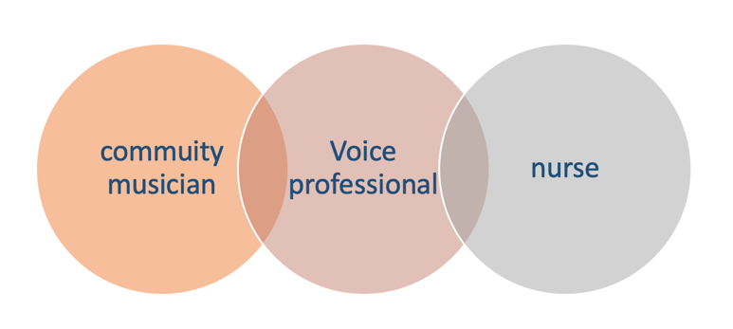
Although, singing is central to this study the relationship to voice for each practitioner is entirely unique. The aesthetic or artistic qualities are less discussed, except for participant 9, who has evolved a unique form of performance engagement to promote health benefits, for people with Parkinson’s. This would align with Forbes (2024) view of the work as “embodied aesthetic practice” (p.1). participants report improvements with aphasia even though the interaction is through gentle gestures rather than vocalisation.

“I am entirely guided by the expert collaborators who understand the conditions we are trying to ease, and for my part, I understand deeply the art form we are using to facilitate this. So with both of the factors fully realized, i.e. not with recorded accompaniment or unaccompanied singing, we try to make the art form as pure as possible, we don’t’ teach singing as such, we provide an impetus and greater engagement with the music, and give and insider’s view on posture, breathing and projection.” (participant 9)

Although singing is the main medium of delivery for all participants, it is also informed by social and community aspects and highly contextual. Kim et al., (2023) suggest a lack of specificity in terms around intervention but as Forbes and Bartlett (2020) point to, most of the research in the field has been on health outcomes, there is often little discussion around facilitation.

The relationship to health is another consideration in the practitioner’s profile. The literature signals the need for robust methodology to mitigate this, however the relationship between clinician and musician remains a negotiated space with no formal framework.

“They (healthcare providers) are usually surprised I have such detailed knowledge and the class therefore has a planned therapeutic aim” (participant 3.)

The implications for the practitioner identity is perhaps of being adrift in the health context with myriad (or no) frameworks to work within (Dingle et al. 2019) and without the ethical protection of registered health professionals (Forbes et al. 2025). As confirmed by Fortier (2023) the practitioner is navigating hybrid complex work, which can be challenging to define.

Professional alignment and collaboration - a picture of Professional ambiguity
A recurring theme across the sample set was that of professional ambiguity and the need to advocate for the work or legitimise it.
“It’s so difficult to be really concise with it because it’s so broad ranging” (participant 12)
The relationship with health care professionals is well established with some but for others they feel somewhat peripheral or misunderstood. Practitioners can also be cautious in their relationship to health, aware of the limits of their expertise.
“we are extremely cautious about moving too far into the medical as musicians, without specific medical training” (participant 12)
Despite many being proactive in undertaking health and singing specific CPD, the space for practice is often one that is negotiated by the practitioner, rather than externally practice led.
This view is supported by Fortier (2023) who describes the ad hoc nature of formal training. There is currently no institutional recognition or accreditation of singing for health, which perhaps undermines the credibility of the work and also the existing professional qualifications or competencies held by practitioners. This in part may because literature is focused mostly on participant outcomes, with less is written about practice and facilitation (Fortier, 2023). Even though practitioners seek out and belong to practice-based arts and health memberships and forums, they can remain professionally invisible.
“It’s collaborative but we also need ways to explain things that work for us, and we’re not trying to fit into other boxes” (practitioner 5)

Table of organisations and health related groups for practitioners represented
Figure 14.
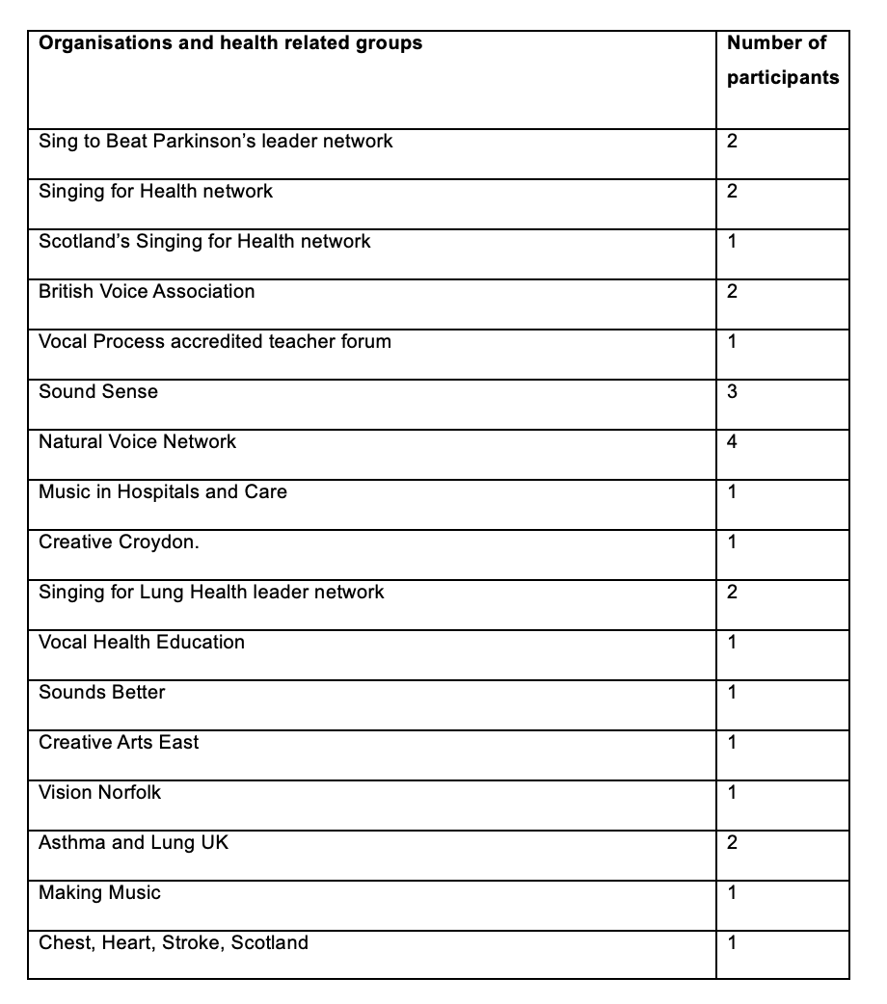

Overall, there is a sense that practitioners are having to self- navigate the ethics, credibility and risks. Work does seem to be more consistent and scalable when undertaken in partnership, and where roles are clearly defined such as, clinician, musician. Artist (singer), neuroscientist etc.
A key area for future research to address therefore is what and how to critically evolve interdisciplinary frameworks that also consider the artistic ethos at the heart of the work and maintain space for the relational and experienced based identities.

Training and Competence – Professional competencies in a hybrid domain

A common theme among practitioners engaged in singing and health is the absence of a standardised training pathway. Given that approaches are so broadly and uniquely focused, finding a common approach may be unrealistic or perhaps limit creative agency. This raises the question of whether there should be different pathways. Cave (2017) takes this discussion further and suggests that a “fully rounded training” (p.1) could be created for practitioners working across all disciplines, centred on vocal leadership and voice, with modular elements that would support practice interests. Informally, this is to certain extent what practitioners here describe with their patchwork of experiences in training and development. Most of the training related to singing and health is self-directed and funded however, in addition to primary education and training, so there are issues of accessibility for larger self- funded pathways.
As confirmed by Fortier (2023) practitioners place a high value on continuing professional development and each practitioner followed a unique pathway often addressing perceived gaps or needs in their evolving practice.
Whilst there is peer support, such as The Singing for Health Network, and various social media forums and access to health professionals, especially in the case of singing for lung health leaders. There is not any structured interdisciplinary support and each practitioner navigates this aspect uniquely. Even though the literature suggests the need for supervision and mentoring (Forbes et al., 2025), currently most of the financial load is born by the practitioner themselves.
Of the existing training available most of the practitioners in this study followed the Singing for lung health training (SFLH), alongside other shorter courses, none named carry any formal accreditation. The SFLH training, stands out as the most clearly defined process-based approach, which Fahey et al., (2022) suggest leads to greater replicability. This is echoed in these findings by practitioner 11, who has successfully created a nationwide SFLH programme.
Despite this somewhat fragmented picture, practitioners describe their portfolio training experience as key to being able to work flexibly and responsively.
“I design my work around the whole person, and this evolves as I get to know them better” (participant 6)
In terms of practice models and frameworks, there is no consensus between participants, but they are most clearly aligned with a primary or core discipline, aligned to their professional background. For a nurse practitioner the focus is on the clinical process.
“I am guided but by the thinking, breathing, functioning model (Spathis et al., 2017) (Practitioner 13)
For others however it is a merging of approaches or no formal frameworks.
As discussed by Daykin et al., (2019) There is seemingly a gap in the professional development of singing for health for models that support the ethical, practical and interpersonal facilitation practice.

- Theme 2: Relational practice in complex contexts

The practice - A bridge between worlds – salutogenic practice, and process

For most of the practitioners in this study, the format of delivery is shared group singing, some are working with a specific health focus others are working more generally with health as a broader and more holistic concept.

This aligns with the Singing for Health Model produced by Emily Foulkes for the Singing for Health Network which describes singing along a continuum from community singing, targeted singing for health groups to intensive clinical intervention (SFHN, 2025).

Practitioner led processes or process led practitioners?
There is some variation in practice style and intervention, some situate the work within a related partnership, for example a health-related charity. Others work in collaboration with Community Interest Companies (CICs) and community-based initiatives. Commonly, none of the interventions are stand alone activities as it were, all are linked to exchanges with these wider partners and collaborators.

The picture is of shifting focus and variables and the practitioners themselves are moving between them.

“like shapeshifters, boundary walkers” (participant 5)

Most practitioners highlighted the interpersonal and relational aspect as central to the work, this is also reflected in the literature and Hopper et al., (2016) highlights interpersonal “processes” (p.128) as central to group singing outcomes. This is supported too by Camlin et al., (2020) who describes it as a “complex adaptive system” (p.1)

“my work evolves to help any condition specific to participants” (participant 12)

The priority is mostly finding a person centered what works best approach informed by their experience and the patchwork of knowledge that they have constructed regarding, specific health conditions and the ability to purpose vocal and musical activities.

“I read, talk to other practitioners, go on courses, attend seminars when possible/available, talk to staff members (e.g. nursing/care staff) see what works” (participant 2)

In terms of the intervention and objectives, the work in SFLH has a much more clearly defined approach and more related to a clinical or medical model.

This study includes a number of practitioners working within SFLH whose primary domain is nursing where singing is an adjunct and with the clinician musician parameters more clearly defined.
“There’s only a certain amount that musicians need, because they’re musicians. I think it helps to have that partnership of clinician and musician” (participant 13)

It is somewhat reductive, but I could surmise that there are potentially two main approaches that have emerged from this study in relation to design and intervention. A practitioner whose professional and personal experience is grounded in singing and music (education or performance) – a more formed artist profile - who then channels their work into a health-related sphere and the clinician or health care worker who co-opts a singing intervention into their existing domain. Underlying both of these however is the shared context of supporting community, related more closely to the values of community music, where the community asset is what is most exploited for its health potential.

Figure 15.
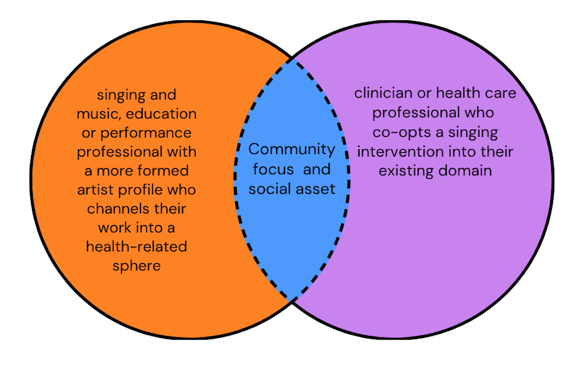

The benefits of a more differentiated view could help to define clearer practice and ethical frameworks leading to more replicability, as echoed by Fahey et al., (2022). For clinicians, the potential to promote the “art of caring” as described by Batt-Rawden and Stedje (2020, p.404) with a more rigorous structure could possibly advance integration with medicalised care. However, for the facilitator, who is primarily a musician perhaps, goals, frameworks and training need to be differently articulated and developed. Whilst literature supports the need to work flexibly and in collaboration with clinical professionals (Moss 2021) we do perhaps need to distinguish facilitation for artists further, as echoed by Forbes et al., (2025) who also consider the work as a uniquely relational form of performance.

Applications of singing and vocal pedagogy
The voice, when singing, is described as the site for connection, care and health management, this aligns nicely with Camlin et al., (2020) who describe “reflexive negotiation” which is “manifest in the collective power of the human voice” (p.1). And practitioners described diverse ways in which vocal activities were purposed and adapted. For some, an intuitive approach was adopted.
“my choices are usually based on my own experiences of what works” (participant 4)
for some a focus on vocal pedagogy was seen perhaps as a clearly defined component in a wider approach.
“singing is a mixture of speech and language therapy, physiotherapy and vocal technique” (participant 13)
For some the interpretation is that vocal pedagogy can be a difficult inclusion:
“some of mine (participants) are very poorly, you know, waiting for lung transplants and things so that can be quite difficult in terms of vocal pedagogy. I don’t go too far into it because I find that my class doesn’t enjoy it and if they don’t’ enjoy it they don’t’ come. I’m doing puffy cheeks, and I can see that only about half of the class are engaged, and the other half think it’s absolutely stupid” (participant 13)
For others, it has more specific interpretation:
“it’s not as important to us as the breathing element – if you can talk, you can sing. We are primarily a therapeutic service and see ourselves as a part of the rehabilitation. However, such things as smooth onset of a phrase can help with breathlessness” (participant 11)
Others felt that vocal pedagogy was central to successful interventions:
“for me, vocal pedagogy is intertwined with the specific approach for the health condition” (participant 5)
The level of voice and music education varied between practitioners, some were professionally trained voice educators and others were avocational singers, or described themselves as non-musical, citing challenges.
“it’s quite hard for a person with no musical background to grasp” (participant 13)
As one participant stated “there are a million strands” (participant 12) and the data captured a picture of holistic voice use, drawing on musical and somatic and psychological dimensions. This is echoed in the literature by Camlin (2020) who describes a process of “complex interdependence” (p.3) between musical and biological psychosocial mechanisms, which employs sensitivity and creativity.
Vocal function and pedagogical literacy is beyond the scope of this study however, but it is clear that like the practice itself there is a degree of variation among practitioners and externally, the level of singing expertise is often not considered, implications are for ambiguous and inconsistent practice which could undervalue the work. Vocal knowledge and vocal leadership are perhaps worth more focused consideration, as suggested by Cave (2017) and supported by Dingle et al., (2019) who report that little is known about the “characteristic of effective group singing leaders” (p.2).
Practitioners report that the participant – voice relationship is often re framed, and they are able to engage in singing which is also social but through an inclusive and salutogenic health lens.

“people keep coming back because they feel good for doing it” (participant 12)

From this it could be surmised that there is need for a broader realisation of vocal pedagogy in relation to health applications.

- Theme 3: Negotiating legitimacy, and sustainability

Evaluation and Evidence
All practitioners engage in evaluation, and for most it is in the form of verbal or written feedback from participants, and used to inform reflective practice.
For the nurse practitioners, both working with SFLH, evaluation is more in line with clinical objectives and can be share with other care partners and both practices have seen scalability. However, negotiation is a theme even for those who are operating within a clinical framework:
“a singing nurse is a novelty! I think other nurses and doctors view it as interesting and possibly helpful but not as important as clinical work” (participant 13)
Common to all is the recurring theme of a practice being understood and advocated for. There is perhaps a case for a language and tools specific to the practice, that can then evaluate benefits more clearly and capture the holistic and nuanced systemic shifts. There is something of an evidence gap that points to need for more practice focused research, perhaps the robust evaluation that the literature calls for (Daykin et al., 2018).

The areas of evaluation vary, which is not surprising given the interdisciplinary nature of the work and as previously discussed a practice which bridges social, physiological and artistic competencies. It is perhaps a case of trying to fit into existing boxes, the perceived ideal perhaps, is the clinical model which may be seen to provide legitimacy and credence, but except for practitioner 9, who uses a fully realised artistic medium, there is no evaluation of the artistic quality of the work. Whilst it is not the primary focus for all it could be argued, such as by Forbes and Barlett (2020) that even the work is situated between different disciplines and is a mode of music performance.
Practitioners reported that feedback from participants is rich and compelling but does not necessarily relate to quantifiable outcomes and there is some frustration that there is not more recognition of the work, especially from health care providers. This is perhaps compounded by unreliability of research such written about by Dingle et al., 2019 cite reported outcomes without any “theoretical basis” (p.5.).

Structural and Systemic Conditions - contextual challenges

Practitioners report that the systemic conditions of singing and health practice are often challenging. Most of the work is reliant on short term grant funding, with a high level of insecurity. Fortier (2025) makes a strong argument for the more appropriate conditions and compensations to reflect the complexity and skills required by facilitation.

“even with prior information expectations aren’t always aligned with what the groups look like. Sometimes this can be problematic as they don’t fully understand why we do what we do. Or other organisations completely underestimating the amount of work involved and offering a fee that does not align with it’ (participant 5)
“Some people don’t understand that we have a very specific approach to this work and are surprised it’s not a singalong” (participant 5)

Practitioners report wearing many hats, and often solely managing facilitation, administration without any organisational or institutional support. There is a high degree of invisible labour with work sometimes unseen and yet, passion and belief in the work motivates ongoing motivation to continue in the work. This raises issues of accessibility for those desiring to work in the field.

There is potentially a high burden placed on practitioners to sustain delivery, whilst they may also be navigating the emotional and psychological implications of practice in working with vulnerable people, often without clear ethical frameworks. With regard to frameworks, some practitioners reported co-opting from arts based (voluntary) schemes such as the ‘Creative Health Framework’ and ‘Creative alliance’ – not addressing singing specifically however and potentially not fully recognised in a health or care setting.

The national policy as seen in the Creative Health Review (2023) addresses these concerns, but practitioners do to a certain extent self – manage. Despite its demonstrable value, practice is somewhat precarious and exposed without any systemic support, integration or recognition.

- limitations

The relatively small numbers of this study, offer little scope for generalisability, and findings are suggestive rather than conclusive (Bassey, 1999), Also, demographical details were not elicited from participants so there is not a clear idea of ethnic, age or social representation.

- Conclusion

Considering the themes discussed a picture emerges of the practitioner working at the intersection of singing and health as a hybrid professional. The practitioner balances multiple roles, artist, innovator, health promoter and employs a broad and highly personal skills set which translates to a unique practice. Despite a somewhat fragmentary working context, all work with responsiveness and reflexivity and adapt to evolving advances in research and practice across multiple disciplines. All share the desire for a more clearly defined lane or pathway not just for professional recognition but for ongoing and scalable provision. There is a sense that practitioners see themselves as way makers, carving out a path for which there is high need, regardless of how seen it is within related disciplines.
A tension within the data is a lack of collective identity, one which would encompass the rich and varied work discussed here and advocate to the shared disciplines into which it bridges – a profession as yet “without a lane of its own” (practitioner 5)
Despite the challenges of working in this hybrid and somewhat ambiguous space, practitioners are highly engaged and motivated to provide meaningful interventions for participants and would benefit from more robust and also flexible frameworks that could support the myriad applications, as well as critically evaluate and recognise professional development and training. Crucially, the practitioner voice and the rich and varied contextual knowledge and experience should be central to any future systemic developments. Suggestions for future research would be for a focus of research on practice, and a clearer investigation of the core role or voice and vocal leadership in interventions.

- Reflective summary

Undertaking a research study with a clear methodological process has been challenging to simultaneously assimilate and put into practice. Whilst my understanding grew throughout the process, I realised that there was the potential to be overwhelmed but the volume of rich and dense data, and needed a clear and deliberate strategy to manage it. However, my understanding of the issues around the practice is now more nuanced and critical and I feel I have some clearly defined themes through which to pursue ongoing research.

References
Bassey, M. (1999). Case study research in educational settings. Open University Press.
ISBN: 9780335199846

Bartleet, Brydie-Leigh. (2008). “You're a woman and our orchestra just won't have you”: the politics of otherness in the conducting profession. Available at: https://www.researchgate.net/publication/37812474

Batt-Rawden, K. and Andersen, S. (2020) ‘Singing has empowered, enchanted and enthralled me’-choirs for wellbeing?, Health Promotion International, Volume 35, Issue 1, February 2020, Pages 140–150, https://doi.org/10.1093/heapro/day122

Batt-Rawden, K. and Andersen, S. (2020) ‘Singing has empowered, enchanted and enthralled me’-choirs for wellbeing?, Health Promotion International, Volume 35, Issue 1, February 2020, Pages 140–150, https://doi.org/10.1093/heapro/day122

Braun, V., & Clarke, V. (2006). Using thematic analysis in psychology. Qualitative Research in Psychology, 3(2), 77–101. https://doi.org/10.1191/1478088706qp063oa

Clarke, V. & Braun, V. (2013) Successful qualitative research: A practical guide for beginners. London: Sage

Braun, V., & Clarke, V. (2019). Reflecting on reflexive thematic analysis. Qualitative Research in Sport, Exercise and Health, 11(4), 589–597. https://doi.org/10.1080/2159676X.2019.1628806

British Educational Research Association. BERA (2023). Ethical guidelines for educational research (5th ed.). British Educational Research Association. https://www.bera.ac.uk/publication/ethical-guidelines-for-educational-research-2023

Camlin, D.A., et al. (2020) Group singing as a resource for the development of a healthy public: a study of adult group singing. Humanit Soc Sci Commun 7, 60 (2020). https://doi.org/10.1057/s41599-020-00549-0

Cave, P. (2017) Singing with one voice. Available at: https://lahf.wordpress.com/2017/03/22/singing-with-one-voice/ (Accessed, May 2025)

Clift, S. et al., (2024). The need for robust critique of arts and health research: the treatment of the Gene Cohen et al. (2006) paper on singing, wellbeing and health in subsequent evidence reviews. Arts & Health, 1–19. https://doi.org/10.1080/17533015.2023.2290075

Cohen, L., Manion, L., & Morrison, K. (2018). Research methods in education (8th ed.). Routledge. https://doi.org/10.4324/9781315456539

Creswell, J. W. (2014). Research Design: Qualitative, Quantitative and Mixed Methods Approaches (4th ed.). Thousand Oaks, CA: Sage.

Culture Health and Wellbeing Alliance, CHWA, (2025) Creative Health Framework. Available at: https://www.culturehealthandwellbeing.org.uk/resources/creative-health-quality-framework (Accessed, May 2025)

Daykin N, Mansfield L, Meads C, et al., (2018) What works for wellbeing? A systematic review of wellbeing outcomes for music and singing in adults. Perspect Public Health. 2018;138(1):39-46. doi:10.1177/1757913917740391

Dingle, G. A. et al., (2019). An Agenda for Best Practice Research on Group Singing, Health, and Well-Being. Music & Science, 2. https://doi.org/10.1177/2059204319861719 (Original work published 2019)

Dwyer, S. C., & Buckle, J. L. (2009). The Space Between: On Being an Insider-Outsider in Qualitative Research. International Journal of Qualitative Methods, 8(1), 54-63. https://doi.org/10.1177/160940690900800105 (Original work published 2009)

Engel GL. The need for a new medical model: a challenge for biomedicine. Science. 1977 Apr 8;196(4286):129-36. doi: 10.1126/science.847460. PMID: 847460.
Flick, U. (2018). An introduction to qualitative research (6th ed.). SAGE Publications.

Fancourt D., Finn S.(2019) What is the evidence on the role of the arts in improving health and well-being? A scoping review [Internet]. Copenhagen: WHO Regional Office for Europe; 2019. (Health Evidence Network synthesis report, No. 67.)Available from: https://www.ncbi.nlm.nih.gov/books/NBK553773/

Fahey, H. et al.,(2022) A chorus of voices: social singing and health promotion. Health Promot Int. 2022 Jun 2;37(37 Suppl 1):i1-i3. doi: 10.1093/heapro/daac033. PMID: 35416962; PMCID: PMC9162181

Forbes, M., & Bartlett, I. (2020). ‘This circle of joy’: meaningful musicians’ work and the benefits of facilitating singing groups. Music Education Research, 22(5), 555–568. https://doi.org/10.1080/14613808.2020.1841131

Forbes, Melissa. (2024). Addressing the Global Crisis of Social Connection: Singers As Positively Energizing Leaders Who Create Belonging in Our Communities. Voice and Speech Review. 19. 10.1080/23268263.2024.2368961.

Forbes, M., Dingle, G. A., Aitcheson, N., & Powell, C. (2025). From Music Performance to Prescription: A Guide for Musicians and Health Professionals. Music & Science, 8. https://doi.org/10.1177/20592043251338013 (Original work published 2025)

Fortier, J. (2023). Navigating Ambiguity and Boundaries: The experiences of arts, health and wellbeing facilitators working with individuals with challenging conditions or situations. 10.17037/PUBS.04671753.

Hammersley, M., & Atkinson, P. (2019). Ethnography: Principles in practice (4th ed.). Routledge.

Hendry N, Lynam DS, Lafarge C. Singing for Wellbeing: Formulating a Model for Community Group Singing Interventions. Qual Health Res. (2022) Jul;32(8-9):1399-1414. doi: 10.1177/10497323221104718. Epub 2022 May 27. PMID: 35622710; PMCID: PMC9350452

Hopper, M. et al., (2016) A qualitative study exploring the effects of attending a community pain service choir on wellbeing in people who experience chronic pain. Br J Pain. 2016 Aug;10(3):124-34. doi: 10.1177/2049463716638368. Epub 2016 Mar 22. PMID: 27583139; PMCID: PMC4994773.

Irons, J.Y. et al. (2020) ‘A systematic review on the effects of group singing on persistent pain in people with long‐term health conditions’, European journal of pain, 24(1), pp. 71–90. Available at: https://doi.org/10.1002/ejp.1485

Kim, S.J.; Yeo, M.S.; Kim, S.Y. (2023) Singing Interventions in Pulmonary Rehabilitation: A Scoping Review. Int. J. Environ. Res. Public Health2023,20,1383. https:// doi.org/10.3390/ijerph20021383

Lewis, A., Cave, P., Stern, M. et al., (2016) Singing for Lung Health—a systematic review of the literature and consensus statement. npj Prim Care Resp Med 26, 16080 (2016). https://doi.org/10.1038/npjpcrm.2016.80
Moss, H. (2021). Music and Creativity in Healthcare Settings: Does Music Matter? (1st ed.). Routledge. https://doi.org/10.4324/9780429326875

Price, Sonia & Phillips, Jes & Tallent, Jacqueline & Clift, Stephen. (2021). Singing group leaders' experiences of online singing sessions during the COVID-19 pandemic: a rapid survey.

Saunders, Mark & Lewis, P. & Thornhill, A. (2023). Research Methods for Business Students. Edition: 9th Publisher: Research Methods for Business Students ISBN: 978-1-292-40272-7

Singing for Health Network (SFHN), Singing for Health Model, Emily Foulkes. Available at: https://www.singingforhealthnetwork.co.uk/network-model (Accessed June 2020)

Spathis, A. et al. (2017) “The Breathing, Thinking, Functioning clinical model: a proposal to facilitate evidence-based breathlessness management in chronic respiratory disease.” NPJ primary care respiratory medicine vol. 27,1 27. 21 Apr. 2017, doi:10.1038/s41533-017-0024-z

Stacy, R. et al., (2002), "Singing for health: an exploration of the issues", Health Education, Vol. 102 No. 4, pp. 156-162. https://doi.org/10.1108/09654280210434228

Sudirman, A. et al., (2021). Harnessing the Power of Reflective Journal Writing in Global Contexts: A Systematic Literature Review. International Journal of Learning, Teaching and Educational Research. 20. 174-194. 10.26803/ijlter.20.12.11.

Williams, E. et al., (2018) A systematic review of mental health and wellbeing outcomes of group singing for adults with a mental health condition. The European Journal of Public Health. ISSN 1101-1262.

World Health Organisation, WHO (2025) Constitution. Available at: https://www.who.int/about/governance/constitution (Accessed, April 25)

