The Digital Revolution
The digital revolution has led to an increase of connectivity, this has improved communications, ways of working, access to shopping, and virtual social lives.
We have now moved into a digital age, and this #trend has also had a significant impact on education. Education is no longer the same as it was ten years ago. Teaching and learning habits have changed, and children today need to develop ever evolving levels of digital competence (Berguerand, 2023).

What does it mean to be digital competent?
It is the knowledge relating to technology, skills to use digital tools and attitudes contributing towards confidence, creativity, critical understanding, and independence to achieve goals in work, education, and leisure (Al Khateeb, 2017).

(Additio App, 2020)
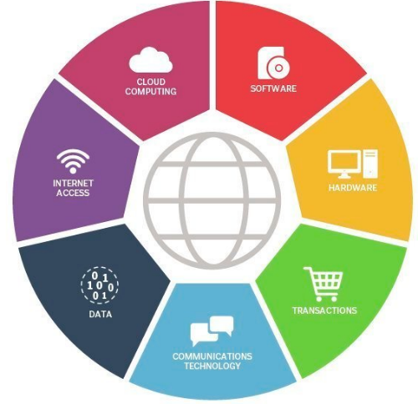

Not to be confused with Information and Communications Technology (ICT) which refers to all devices, applications, and networking components (Awati and Pratt, 2023).

(Adeagbo, 2020)

A school’s responsibility!
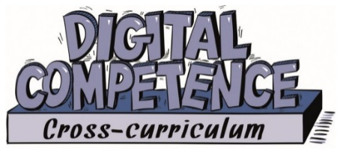
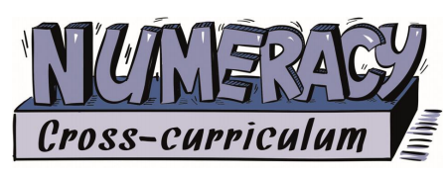
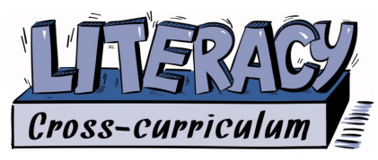
It is essential that schools keep up to date with the digital revolution. Schools must provide children with an education that sees them succeed in a digital age, #futureemployment. To achieve this in 2014 the Welsh Government asked Professor Donaldson to review the curriculum. What he found was “Children and young people thought the curriculum was out-of-date especially in technology, software and digital skills” (Welsh Government, 2015a, p.3). This led to the first element in the new curriculum, the Digital Competency Framework
(Welsh Government, 2015b)
(DCF). This is a clear and structured framework to support children throughout their schooling, that is accessible in all subject areas as one of the #threecrosscurriculumresponsibilities.
Barnes (2015) suggests cross-curricular learning is about learning through many viewpoints. We all experience life in many ways, and therefore, teaching should be no different. This helps build on prior knowledge, gaining transferable skills, and a better understanding. Where we are today, was made possible with the Plowden (1967) Report and the Education Reform Act (1988). This allowed Wales the freedom for their own curriculum that is in place today.
Donaldson (2015) suggests that in the curriculum digital competence should have as much importance placed on it as literacy and numeracy, with capability such as:
- Pedagogy
- Skills
- Transferability
- Understanding
- Application
(Welsh Government, 2015a)

How does the curriculum deliver?
The DCF has four strands, each strand has elements which are to be added into classroom teaching. These are: Citizenship, Interacting and Collaborating, Producing, and Data and Computational Thinking (Welsh Government, 2020).
Digital literacy in early years
What is important to note, children today are born into an ever-increasing digital age, and it is an integral part of life. Children will use it for play, communication, and entertainment. Although not all children will have the same access, issues with parental opinion or social economic status, and concerns for online safety and health effects are paramount (Daniels et al. 2020). Yet, in education it is important that we meet the needs of the learners.
As an early year's practitioner, it is often noticed that young children are remarkably familiar with using digital devices and are quite proficient navigating them such as, swiping left and right. However, some children have not yet been exposed to books, #doyouthinkthatisright?
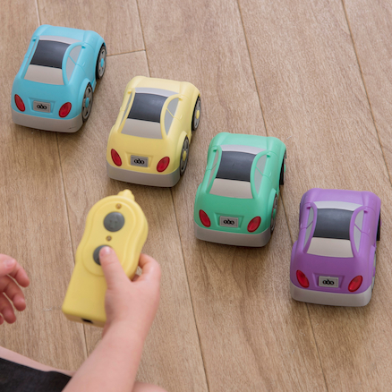
Although, just by being online does not mean children have the skills or knowledge to be safe and effective internet users. This is where education comes in.
The sole purpose of early years is learning through play, with an important focus on health and well-being, and digital competency is no different. Play-based learning can aid children’s learning while also making it fun and memorable, this links to Piaget’s (1971) preoperational stage of Cognitive Development theory in which children use objects for the purpose of role playing to learn. He also believed technology should focus on specific stages of development (Kilag et al. 2022).
(TTS, 2023)
One excellent example of engaging young children with digital literacy, is by using remote-control cars. This encourages children to experiment and explore technology, by using a handset to move the cars in different directions. This links to the following DCF strand:
Data and Conceptional Thinking; Problem-Solving and Modelling Progression step one:
- Children are beginning to recognise and follow instructions
- Making connections between the remote control, and making the car move, and using different buttons to steer in different directions
- Select and use simple language to give instructions to others
- Controlling the device, and moving the car purposefully
- Using terms to name errors
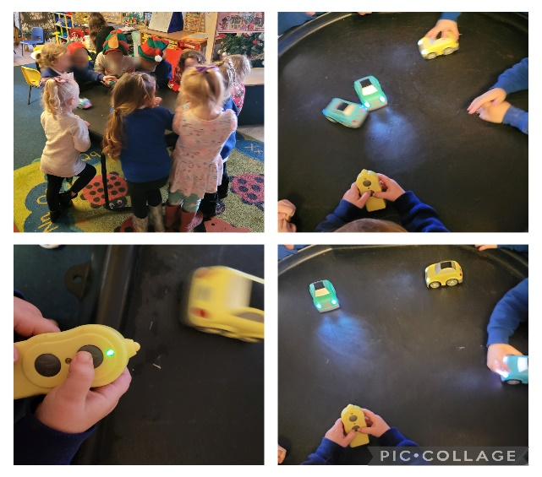
(Welsh Government, 2020)
Cross-curricular links
Numeracy
Counting “1, 2, 3, Go,” Colours “Yellow, Blue, Green and Purple.”
Language
Everyday words and describing positions. “Ready, Steady, Go.” “Forwards, Backwards, Stop, Go, Slower and Faster.”
(Authors Own, 2023)
Health and Well-being
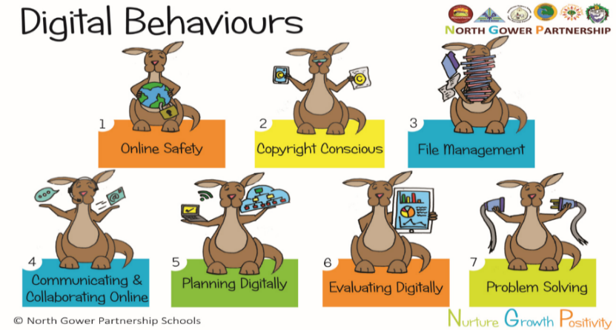
Children can work as part of a group, taking turns and sharing fairly, to be confident to try out a new activity, explore and experiment.
(School A, 2020)

School’s A ICT policy (2021) also agrees that the use of ICT should be holistic and integral to all Areas of Learning, reflecting everyday life and including opportunities to use in role play areas and the outdoor environment, with the equipment appropriate for their stage of development. Children gain enjoyment and skills such as developing their capability, applying key skills across the curriculum, at home, and become autonomous users.

This is all well and good, but are children losing skills?
Digital technology has many growth opportunities for children, but, at the same time, are they losing out on skills? Some researchers would have you believe so, as suggested some use of digital technology would constitute as “passive.” A passive learner will not learn; a child needs curiosity to be an active learner. Recent reports have shown that excessive screen time or early use of digital technology can be associated with delays in some cognitive, linguistic, and social skills (Beurkens, 2020).
The World Health Organization (2019) recommends children between 2 and 4 should get no more than 1 hour a day of screen time, #doyouagree?
One of the most important skills a young child can learn at school are social skills. Some believe this is at stake, with skills such as empathy, as we know this comes from social encounters and engagement with others. So, what happens to children that are so engrossed with the digital world that they do not engage in real life? They can struggle to understand non-verbal language, facial expression, eye contact and body positioning (Baker, 2020). Although, research into this matter is not 100% conclusive, it does leave pause for thought!
Final thoughts
The digital revolution is here to stay, and education has really moved with the times. Only one of the DCF strands was discussed in this blog, as a glimpse into what schools and practitioners implement, to provide children with the digital literacy skills they need to thrive and achieve the best outcomes in life. Still, too much of any one thing is never good. There should always be balance in life and education. Therefore, at times try and put those digital devices down and have a good old fashioned face-to-face interaction. This way you can get the best of both worlds, which is crucial for a happy and healthy life (Loubier, 2020).

References

Additio App (2020) What is digital competency in teaching? [Image]. Available at: https://additioapp.com/en/what-is-teacher-digital-skills/ (Accessed: 10th December 2023).

Adeagbo, J. (2020) Information and Communication Technology [Image]. Available at: https://echtkagoro.edu.ng/information-and-communication-technology-lecture-1/ (Accessed: 27th December 2023).

Al Khateeb, A.A. (2017) ‘Measuring Digital Competence and ICT Literacy: An Exploratory Study of In-Service English Language Teachers in the Context of Saudi Arabia’, International Education Studies, 10(12), pp. 38. DOI: 10.5539/ies.v10n12p38 (Accessed: 31st December 2023).

Awati, A. and Pratt, M.K. (2023) ICT (information and communications technology or technologies). Available at: https://www.techtarget.com/searchcio/definition/ICT-information-and-communications-technology-or-technologies (Accessed: 27th December 2023).

Baker, L. (2020) The Impact of Technology on Social Skills. Available at: https://juniorlearning.com/blogs/news/the-impact-of-technology-on-social-skills (Accessed: 30th December 2023).

Barnes, J. (2015) An Introduction to Cross-Curricular Learning. UK: Sage.

Berguerand, J.B. (2023) Top 8 digital transformation trends in education. Available at: https://hospitalityinsights.ehl.edu/digital-transformation-trends (Accessed: 10th December 2023).

Beurkens, N. (2020) How does technology affect children’s social development? Available at: https://www.qustodio.com/en/blog/technology-child-social-development/ (Accessed: 30th December 2023).

Daniels, K. et al. (2020) ‘Early years teachers and digital literacies: Navigating a kaleidoscope of discourses’, Educ Inf Technol, 25, pp. 2415–2426. DOI: org/10.1007/s10639-019-10047-9 (Accessed:31st December 2023).
Donaldson, G. (2015) Successful Futures. Available at: https://www.gov.wales/sites/default/files/publications/2018-03/successful-futures.pdf (Accessed: 31st December 2023).

Kilag., O.T. (2022) ‘ICT Integration in Primary Classrooms in the Light of Jean Piaget's Cognitive Development Theory’, International Journal of Emerging Issues in Early Childhood Education, 4, pp. 42- 54. DOI: 10.31098/ijeiece.v4i2.1170 (Accessed: 31st December 2023).

Loubier, A. (2020) How to Balance Tech and Everything Else in Life. Available at: https://www.forbes.com/sites/andrealoubier/2020/10/06/how-to-balance-tech-and-everything-else-in-life/?sh=3d05d87c6183 (Accessed: 5th January 2024).

Piaget, J. (1971) The Theory of Stages in Cognitive Development. In D. Green, M. P. Ford, & G. B. Flamer edn. Measurement and Piaget, pp. 1-11. New York: McGraw-Hill.

[School A] (2021) [School A] ITC Policy. Swansea: [School A]. Unpublished.

The World Health Organisation (2019) To grow up healthy, children need to sit less and play more. Available at:https://www.who.int/news-room/detail/24-04-2019-to-grow-up-healthy-children-need-to-sit-less-and-play-more (Accessed: 31st December 2023).

TTS (2023) Easi-Cars V2 [Image]. Available at: https://www.tts-group.co.uk/easi-cars-v2/1017615.html?cgid=Early_Years-ICT-Remote_Control (Accessed: 27th December 2023).

Welsh Government (2015a) Successful Futures. Available at: https://www.gov.wales/sites/default/files/publications/2018-03/succesful-futures-a-summary-of-professor-graham-donaldsons-report.pdf (Accessed: 30th December 2023).

Welsh Government (2015b) Wider Skills [Image]. Available at: https://www.gov.wales/sites/default/files/publications/2018-03/succesful-futures-a-summary-of-professor-graham-donaldsons-report.pdf (Accessed: 30th December 2023).
Welsh Government (2020) Digital Competence Framework. Available at: https://hwb.gov.wales/curriculum-for-wales/cross-curricular-skills-frameworks/digital-competence-framework (Accessed: 27th November 2023).

Pros and Cons of the Digital World
Digital technology is ever expanding and is an essential part in our everyday lives. The 21st century has seen a shift in how people work, learn, and communicate. As a Gen X myself, not owning my first mobile phone until eighteen years old, and then it was the size of a brick! Since then, times have moved on. Children today have been exposed to digital technologies for their entire lives and have the entire world at their fingertips. They use digital connectivity in diverse ways, at home, on the go, and in school (OCED, 2019).
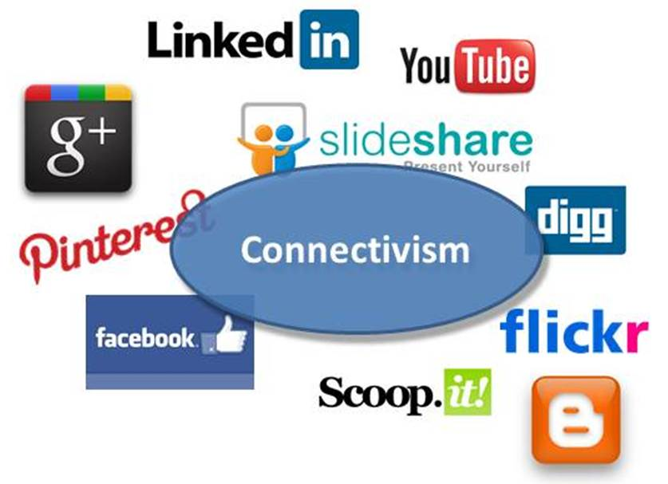

(Cesare, 2015)
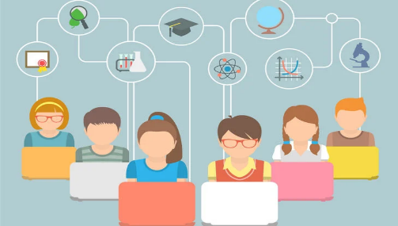
With this in mind, today's education needs to embrace the digital world and move with the times. This is where George Siemens and Stephen Downes (2005) came together and created a modern-day learning theory, to help bridge the gaps of the now digital world. To address the changes in what, how, and where we learn. We are a long way from the times of encyclopaedias. We can now gather information fast and effectively with the use of our smartphone or Google.
Siemens and Downes (2005) theory relies heavily on the use of technology. This technology promotes connectedness and choice of learning styles (University of Southampton, n.d)

- Collaboration
- Discussion
- Different viewpoints and perspectives
With this new era comes new challenges: Risk or Reward?
According to Ineqe (2023) the biggest threats to children and young people (CYP) online in 2022, continues to be shockingly peer-on-peer abuse. Cyberbullying is a form of discrimination, and children can be targets because of many reasons, their appearance, religion, or sexuality etc. There is no escape!!! Following them on all their online activities, they may be excluded, trolled, or have embarrassing/malicious images shared on social networks, to name just a few. This can be very harmful and upsetting for a CYP, being a target of cyberbullying can lead to depression, social isolation, or self-harm (NSPCC, 2022). According to Helsper et al. (2015) children that are vulnerable offline are equally vulnerable in online spaces and are at a risk of a high number of these negative outcomes.
- Misinformation
Negatives
- Scams
- Influencers
- Sexting
- Inappropriate content
- Radicalization
- Online predators
(Welsh Government, 2023)
Unfortunately, the over reliance on technology for schooling, socialising, and shopping has left most children spending all their time on their tablets, mobile phones, watching television or asking Google for homework help. This reliance has a significant risk to mental health and well-being issues, and an increasing fear, known as #nomophobic being detached from their mobile phone (Bhattacharya, 2019). However, it is not all doom and gloom, there are many positives that come with the digital time.
- Connectivity
- Access to information
Positives
- Sharing of data
- Language skills
- Problem solving
- Hand-eye coordination
(UK Safer Internet Centre, 2023)
Did you Know!
What does this look like in terms of our education?
A snapshot of 3 – 4 years old digital use:

17% have been given their own mobile phones
89% use a platform for video sharing
50% use messaging apps
81% watch TV or films on mobile devices
(Ofcom, 2022)
Connectivism
Gamification can be effective in early years; it links characteristics of game elements to learning. The best way to teach children is through play, and gamification is the online version, this engages children through their motivation #connectivism.
However, in early years access to the internet is restricted for safeguarding reasons, yet there are many apps which children can choose from. These activities may include language development such as phonics, or numeracy skills such as numbers, shapes, or colours. These are available on the iPads or the interactive white board. Games are of a suitable level of challenge, to achieve high motivation, with rewards for levelling up, and instant feedback given with correct or incorrect signs, making an active learner that can learn from their mistakes (Lamrani et al. 2018).
How do we stay connected?
Schools' social media sites, X and Facebook. Posting pictures and videos of activities the children have been involved in throughout the day; this is an ideal way of sharing information for younger children that are sometimes still working on speech and communication skills, and it continues the discussion and learning at home. The social media sites are also used to communicate information, and ask for help, for instance items for new roleplays as the #Tweet below shows.

(Authors Own, 2023)
Safety First!!
In a day and age when children need to be digitally literate, with so much of their lives spent online, it is essential that children have the skills to keep them safe. It is extremely important of schools to implement policies and regulations to educate children, parents, and professionals in what is safe. School A’s latest Religious Sexual Education policy (2023) has an element of Empowerment, Safety and Respect.
Keeping Safe Online
Phase 1- from age 3 | Phase 2- from age 7
An awareness on how to keep safe online | How and when digital media can be shared safely
Sharing with a trusted adult when feeling uncomfortable or scared | Benefits and dangers of internet and social media
 | Forming friendships/online exploiting
 | Motives behind fabricated/altered media
 | Share with trusted adult

This is advocated through online safety and anti-bullying week. In class there are activities such as discussions, songs, story books and the use of various vocabulary such as friendship, kind, and caring. School A has policies and safeguarding officers in place, and an online website My Concern, to document any incidents or a disclosure (School A, 2023). For parents:
Who to contact for help!
- CEOP- 0808 800 5000
- Hwb - https://hwb.gov.wales/keeping-safe-online/advice-for-children-and-young-people-online-issues-and-worries
- Stop It Now- 0808 1000 900
- NSPCC Online Safety Helpline- 08088005002
- Childline- 08001111
- Meic- 08088023456
- C.A.L- 0800132737
Overall
In the pursuit of knowledge, for children today it is connected to how they learn. Discovering facts, critically analysing this information, and coming to a new understanding, sometimes replacing prior knowledge (Utecht and Keller, 2019). With these changes in how children learn, practitioners and parents need to be aware of new ways of safeguarding and protecting their health and well-being. This can be achieved by keeping up to date with ever changing technology, social media sites, apps, chat rooms. Keeping those lines of communication open and ultimately, knowing the correct procedure if a child makes a disclosure.

References

Bhattacharya, S., Bashar, M.A., Srivastava, A., and Singh, A. (2019) ‘NOMOPHOBIA: MObile PHone PhoBIA’, J Family Med Prim Care, 8(4), pp. 1297-1300. Doi: 10.4103/jfmpc.jfmpc_71_19 (Accessed: 28th December 2023).

Cesare, L. (2015) What is the implication of this theory for teaching with technology in the classroom? [Image]. Available at: https://leannecesare.weebly.com/reflections/connectivism (Accessed: 27th December 2023).

Helsper, E.J., et al. (2015) Tangible Outcomes of Internet Use from Digital Skills to Tangible Outcomes project report. Available at: https://core.ac.uk/download/pdf/30671581.pdf (Accessed: 24th December 2023).

Ineqe (2023) Online Safety Trends, Risks, and Threats for 2022. Available at: https://ineqe.com/2022/01/28/online-safety-2022-trends-risks-threats/ (Accessed: 28th December 2023).

Lamrani, R, et al. (2018) ‘Game-based learning and Gamification to improve skills in early years education’, Computer Science and Information Systems, 17(1), pp. 339–356. Available at: doi.org/10.2298/CSIS190511043L (Accessed 28th December 2023).

NSPCC (2019) Protecting children from bullying and cyberbullying. Available at: https://learning.nspcc.org.uk/child-abuse-and-neglect/bullying/#article-top (Accessed: 23rd December 2023).

OCED (2019) Educating 21st Century Children: Emotional Well-being in the Digital Age. Available at: https://www.oecdilibrary.org/sites/71b7058aen/index.html?itemId=/content/component/71b7058a-en (Accessed: 19th December 2023).

Ofcom (2022) Children and parents: media use and attitudes report 2022. Available at:https://www.ofcom.org.uk/__data/assets/pdf_file/0024/234609/childrens-media-use-and-attitudes-report-2022.pdf (Accessed:19th December 2023).
[School A] (2023) [School A] Religious Sexual Education policy. Swansea: [School A]. Unpublished.

Siemens, G. (2005) Connectivism: A Learning Theory for the Digital Age. Available at: https://jotamac.typepad.com/jotamacs_weblog/files/connectivism.pdf (Accessed: 24th December 2023).

UK Safe Internet Centre (2023) Parenting in a digital age: What are the benefits for my child of using technology? Available at: https://saferinternet.org.uk/guide-and-resource/parenting-in-a-digital-age-what-are-the-benefits-for-my-child-of-using-technology (Accessed: 28th December 2023).

University of Southampton (n.d) Connectivism. [Image]. Available at:https://www.futurelearn.com/info/courses/learning-network-age/0/steps/24641 (Accessed: 24th December 2023).

Utecht, J., and Keller, D. (2019) ‘Becoming Relevant Again: Applying Connectivism Learning Theory to Today’s Classrooms’, Critical Questions in Education, 10(2), pp. 107-119. Available at: https://files.eric.ed.gov/fulltext/EJ1219672.pdf (Accessed: 28th December 2023).

Welsh Government (2023) The Wales Safeguarding Procedures for children and adults at risk of abuse and neglect. Available at: https://www.safeguarding.wales/en/int-i/int-i-i1/i1-p1/ (Accessed: 28th December 2023).

Digital Learning

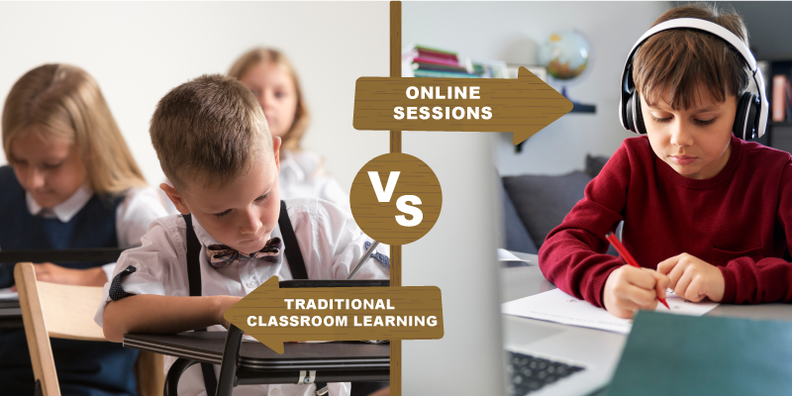
“Teaching in the Internet age means we must teach tomorrow’s skills today” (Fleming, quoted in Saini and Singh, 2023, p. 44)
(Knowledge Hub, 2021)
What are the benefits of digital learning?
According to Haleem et al. (2022b) being online can provide knowledge, be a mentor, and an assessor with instant feedback, other benefits include:

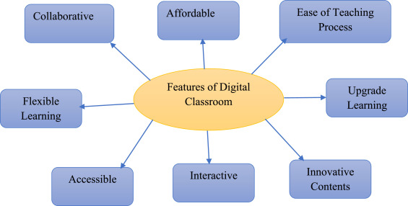
- Interactive education
- Improve presentation
- Knowledge sharing
- Increased storage for information
- Increased enthusiasm for learning
- Flexibility

(Haleem et al. 2022a)

An extremely popular benefit to digital learning is sustainability. As there is no need for paper it is a fantastic way to cut costs and save resources, #betterfortheplanet

What is the impact on learners?
How can you adapt to multiple learning styles?
Assistive technology is wonderful for children with additional learning needs. Being dyslexic does not have to hold you back academically, with support from technologies such as speech recognition and reading aloud. Additionally, visually impaired can receive help from innovative technology such as, text to speech, and for hearing impaired, sound amplifiers, and sign language applications can be used (Haleem et al. 2022b).

Working online is not only eco-friendly. The choice not to use pen and paper, and only work with online software to do your homework and projects, is easier and more convenient on a lightweight iPad, compared to a weighty book from the library. These new techniques are ever increasing children’s interests in further research (Gopika and Rekha, 2023).
(Cloke, 2022)
Did you know? That pre covid-19 digital learning usage was calculated hours per week, now it is hours per day (Haleem et al. 2022b).
Let’s not forget the impact on practitioners, the use of digital technology can help improve productivity, aid their planning, assess quicker, better resources, and gain new skills, all helping to reduce workload (Haleem et al. 2022b).
Barriers to digital inclusion
There has always been digital exclusion. Yet when the pandemic hit, it drew attention to the exact extent of the problem, the lack of internet access, and devices needed in 2020, was finally recognised as problematic for many children (Holmes and Burgess, 2022).

One of the main reasons for digital exclusion can start with poverty, as low-income families are less likely to have access to devices and the internet. This can present problems for children keeping up to date with their peers' skills and can inevitably widen the gap in academic attainment. Poverty can lead to poor housing, which can present another barrier, such as some buildings can result in poor connection, or cannot access any broadband (Holmes and Burgess, 2022). This draws on Bourdieu (1984) cultural capital and social reproduction theory, in which he believes that learners from disadvantaged background suffer oppression and social injustice that affects on their learning potential, and that schools need to be made accountable for children who fall into that category.
(Admin, 2013)
Fortunately, there were many initiatives set up by the Welsh Government (2020) during the pandemic they supported digitally excluded learners, with access to broadband, data, access to devices, development of digital skills, and protection from online harms. Furthermore, the work has not stopped there, with an investment of over £135 million in the Hwb programme, to deliver superfast connectivity to all schools in Wales, and to date have purchased over 216,000 devices, #goodjob
A bit about me!
As a higher-level teaching assistant in the nursery, I currently deliver two and a half days of face-to-face teaching. I follow the teacher’s planning, yet I am responsible for delivering the lessons, and organising staff effectively. We follow the digital competency framework with various technologies, that is implemented throughout all the Areas of Learning. We have a wide range of digital devices from iPads, an interactive whiteboard, microphones, and talk tins etc. We use apps such as Seesaw, to upload evidence of children’s practical work and use social media sites to effectively communicate with parents.
The COVID-19 pandemic saw significant disruption to education, which affected 1.6 billion learners in over 200 countries, more than 94% of the student population. This saw everyone having to improve their digital learning capabilities and fast (Gopika and Rekha, 2023). Myself being no different, welcome to the time of Microsoft Teams. The digital app where all your needs are met, well if you have a device and an internet connection. Nevertheless, Teams is where our traditional classroom move too. Whatever your views are about online learning, nobody can argue it is because of apps such as Teams, we were able to keep teaching, stay connected to our children, look after the health and well-being, and safeguarding issues of both our children and their parents.
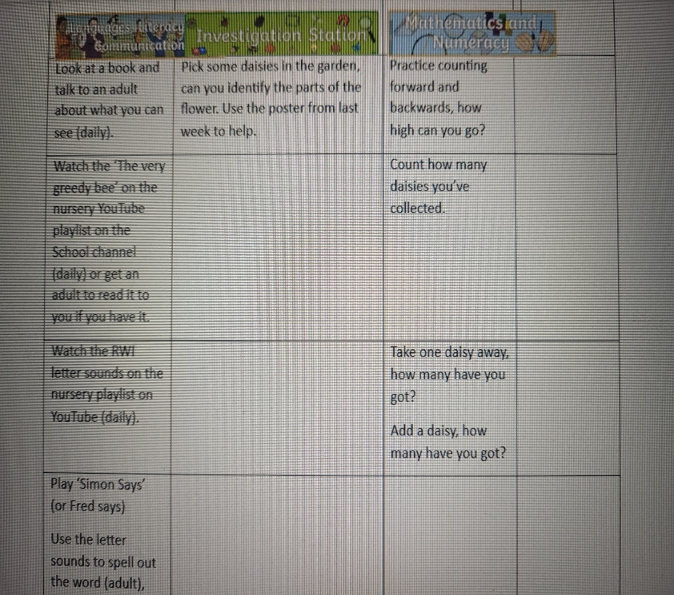
Online Lesson Plan
The online teaching experience, I found strange and quite challenging. We all know trying to keep the attention for three- to four-year-olds for a period of time is difficult. This is why our lessons, like in school were kept short and sweet. Consisting of a well-being chat or show and tell, a discussion of the weeks activities and finished with an online story.
(Authors Own, 2020)

Most of the tasks given were practical, the same as our normal routine of work set up in the classroom. Although, we felt some parents wanted more academic learning, for example to sit at a table with pen and paper. This may be due to their own work commitments and time restraints, or lack of digital skills to access the work online (Rousoulioti et al. 2022).
(Neves, 2020)

(Neves, 2020)
Personally, I did not enjoy the experience, it was teacher led, so I felt more like a spare part than anything else. I realised that I was there as a face that the children knew, and for safeguarding reasons. I was not a presenter for the group, and there was one awkward moment when the teacher's internet froze. Marvellous, I thought and carried on reading only to realise I have no control and cannot move on to the next page. Before panic sets in she’s back, and that was a lesson learnt on how to use teams. Moving forward, like most people I believe my own digital skills have improved, and in my role, it is essential that I keep up skilled for the benefit of the learners.
For the best!
If we compare digital learning to traditional learning, it should not really be viewed as old vs new, more than it is another element to be added to the curriculum that can help children achieve better outcomes (Arctic Meta, n.d). There is so much that digital technology that can improve everyone’s lives, and for the children born into this era it is essential they have the skills, and access so they are not left behind.

References
Admin, T. (2013) How to Get Around the 160′ Barrier to Collaboration [Image]. Available at:https://www.tibco.com/blog/2013/01/15/how-to-get-around-the-160-barrier-to-collaboration/ (Accessed: 3rd January 2024).

Arctic Meta (n.d) What is the Future of Digital Learning? Jonathan [Blog]. Available at: https://mussila.com/what-is-the-future-of-digital-learning/ (Accessed: 3rd January 2024).

Bourdieu, P. (1984) Distinction: A Social Critique of the Judgment of Taste. Routledge & Kegan Paul, London.

Cloke, H. (2022) CAN ELEARNING SHAPE A MORE SUSTAINABLE FUTURE? [Image]. Available at:https://www.growthengineering.co.uk/is-online-learning-more-sustainable/ (Accessed: 3rd January 2024).

Gopika, J.S. and Rekha, R.V. (2023) ‘Awareness and Use of Digital Learning Before and During COVID-19’, International Journal of Educational Reform, 8. Doi: 10.1177/10567879231173389. (Accessed 2nd January 2024).

Haleem, A. et al. (2022a) Features of Digital Classroom [Image]. Available at https://doi.org/10.1016/j.susoc.2022.05.004 (Accessed: 2nd January 2024).

Haleem, A. et al. (2022b) Understanding the role of digital technologies in education: A review, Sustainable Operations and Computers, 3, pp. 275-285. Available at https://doi.org/10.1016/j.susoc.2022.05.004 (Accessed: 2nd January 2024).

Holmes, H. and Burgess, G. (2022) ‘Digital exclusion and poverty in the UK: How structural inequality shapes experiences of getting online’, Digital Geography and Society, 3. Available at: https://www.sciencedirect.com/science/article/pii/S2666378322000162 (Accessed: 2nd January 2024).

Knowledge Hub (2021) Traditional Classroom Learning Vs. Online Sessions: Which One Is Better? [Image]. Available at: https://knowledge-hub.com/2021/11/14/traditional-classroom-learning-vs-online-sessions-which-one-is-better/ (Accessed: 2nd January 2024).

Neves, M. (2020) 10 Quarantine Activities for Kids. [Image]. Available at: https://www.himama.com/blog/10-quarantine-activities-for-kids-with-free-printables/ (Accessed: 3rd January 2024).

Rousoulioti, T et al. (2022) ‘Parents’ New Role and Needs During the COVID-19 Educational Emergency’, Interchange, 53, pp. 429–455. Available at: https://doi.org/10.1007/s10780-022-09464-6 (Accessed: 3rd January 2024).

Saini, A. and Singh, T. (2023) ‘Digital Citizenship - A Pathway for Digital Skilling through 21st Century’, International Journal of Digital Technologies, 2(1), pp. 44- 48. Available at: https://journal.nielit.edu.in/index.php/01/article/view/48 (Accessed: 3rd January 2024).

Welsh Government (2020) Device and connectivity update for digitally excluded learners during coronavirus (COVID-19). Available at: https://www.gov.wales/device-and-connectivity-update-digitally-excluded-learners-during-coronavirus-covid-19-html (Accessed: 2nd January 2024).

Technology That Helps

Topmarks is a Nottingham, UK based company, that was founded in 1998. It is an educational website designed for children, teaching professionals and parents. It offers a comprehensive range of subjects from literacy, numeracy, and humanities for the ages of between 3 and 14 years old.
(National Schools Partnership, 2021)
An online resource, that is designed to be safe, trustworthy, and reliable and offers features such as personalised learning experiences, with added coaching, and mentoring. Every child is unique and learns at a different pace. Topmarks allows for varying difficulties, making it a flexible tool that can meet the needs of the learner. Offering quality learning opportunities that are fun and engaging, it is free to use with no hidden subscription fees (Topmarks, 1998b).
Interactive maths games, for early years Counting; Ordering and Sequencing; Calculations; Money; Shape, Position, Movement and Measures.
Teaching maths concepts can be difficult for children to understand. This is why gaining a firm foundation in maths from an early age is so important. As an online tool, Topmarks can be displayed on the interactive white board, this can help to engage all children in the learning process. The games available are easy to understand and play, they are based on real life situations, this can help all children develop their problem-solving, and basic mathematical skills (Main, 2022).

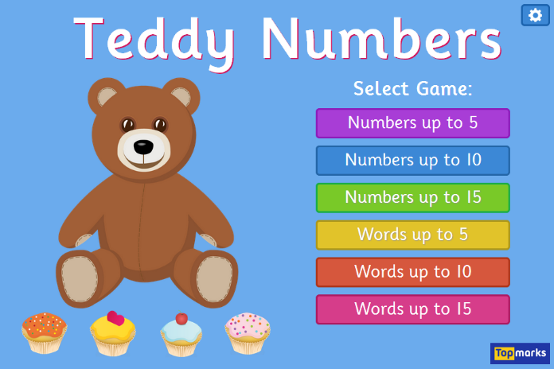

Favourites!
(Main, 2021) (Top Marks, 1998a)
Games are generally designed and take place within Vygotsky’s (1978) zone of proximal development (ZPD), where games can be adapted to a child’s skill or ability level. Vygotsky believed that there is value in the use of technology and the range of activities carried out can be in the ZPD, in a collaborative context. Children starting nursery will have different capabilities in information and communication technology, some can already perform confidently while others cannot begin to engage with technology because of their unfamiliarity (Hakkarainen and Bredikyte, 2008).
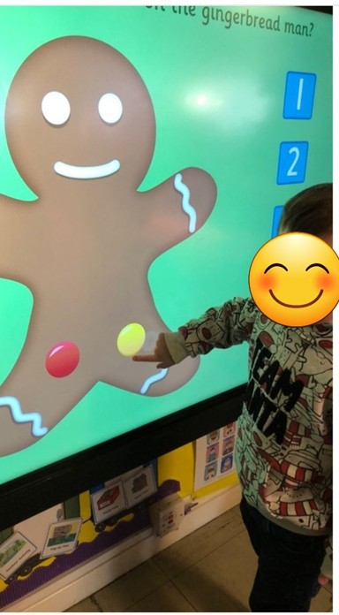
Little Teddy
Little Teddy is 4 years old and attends a nursery setting for three full days. Teddy is beginning the pathway for autistic spectrum disorder (ASD) and attention deficit hyperactive disorder. He loves nursery and has good vocabulary, although Teddy does find it hard to follow the nursery routines, preferring his own agenda. The Equality Act (2010) came into place to prevent anti-discrimination laws and allow for reasonable adjustments to be made to remove barriers of participation. He is in a mainstream setting, where the day is very routine based, in a very social environment, children with (Authors own, 2023)
ASD can struggle with relationships, and at times the classroom can become a stressful environment (Graham, 2021). Teddy has difficulties in keeping still for a period of time, finding carpet difficult, he needs to be able to physically move. He often refuses to work with staff on a focused task, and lacks understanding, he will often not answer a direct question. He prefers to play alone, loves outdoor play with water and mud. He does enjoy engaging with digital technology such as an iPad, in which he is very proficient in navigating the different apps available. His needs and learning styles are supported in the setting with provision set out in the Additional Learning Needs an Educational Tribunal (Wales) Act 2018. This has helped us to tailor learning for his needs and to focus on him as an individual.
ALNET (2018)
- The act covers 0- to 25-year-olds
- Has individual plan
- Increase participation
- Person-centred
- Practise high aspiration and improved outcomes
- Increase the collaboration
- Disagreement resolving
- Clear and concise right of appeals
- Bilingual system
(Welsh Government, 2021)

Maths and Autism
According to Apanasinook et al. (2021) children with ASD may have certain cognitive strengths in mathematics. Children with ASD prefer learning through technology as if replacing that social interaction that children can find difficult.
Therefore, for learners with ASD game-based learning such as Topmarks provides can help support their analytical reasoning, self-directed learning, cooperative skills which are essential for ASD learners (Tlili et al. 2022).

Benefits
- With a range of resources, you can identify your child’s interests
- Capitalise on their visual-spatial learning style
- Teach math concepts through visual examples and pair them with verbal instructions
- Making it fun and engaging
- Online curriculum
- Help with fine motor skills
- It provides praise and feedback keeping children motivated
- Use multiple-choice format rather than yes or no questions (Apanasionok et al. 2021)

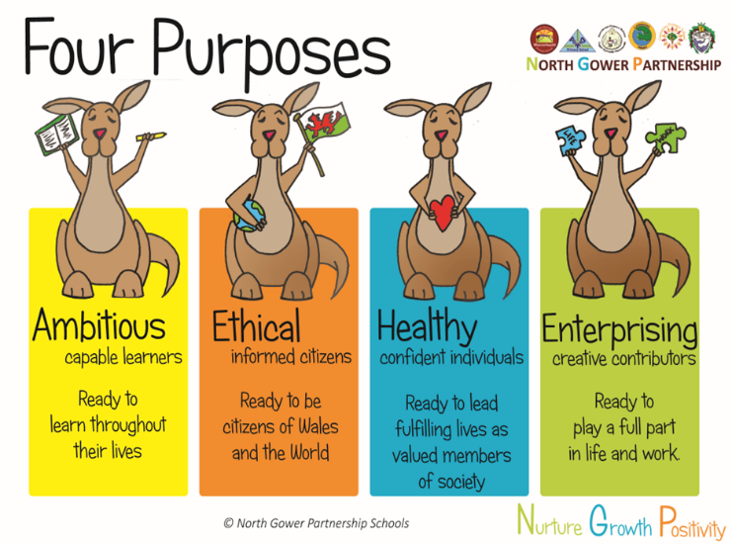
This links to one of the Four Purposes:
Ambitious, Capable Learners
- “Seek and enjoy challenges”
- “Questioning and enjoy solving problems”
- “Explain the ideas and concepts they are learning about”
- “Use number effectively in different contexts”
- “Understand how to interpret data and apply mathematical concepts” (School A, 2020)
(Welsh Government, 2020, Online)
Disadvantages
Although, the research points heavily towards the benefits of children with ASD learning through technology, there are a couple of negatives that need consideration. Firstly, the social skills of children with ASD, as previously stated, they can find it more comfortable interacting with a computer-based programme than with another person, however, what we do not want is to take all person-on-person interactions away. This will only hinder the development of these skills. Secondly, learning apps can have a repetitive nature to them, and this may reinforce these types of behaviours, as children with ASD can sometimes fixate on things (Dunckley, 2016).
Appreciation
Thanks to the digital era, we now have amazing interactive technology that can be implemented in education through the digital competence framework, supporting all learners. An inclusive education that Little Teddy is happy to connect with classroom-based activities. Enjoying the experience, that engages all his sensory needs, and benefiting from the learning process.
“We need technology in every classroom and in every student and teacher's hand, because it is the pen and paper of our time, and it is the lens through which we experience much of our world” (Warlick, n.d).

References

Apanasionok, M.M et al. (2021) ‘Teaching early numeracy to students with autism using a school staff delivery model’, BJSE, 48(1), pp. 90-111. Available at: https://nasenjournals.onlinelibrary.wiley.com/doi/full/10.1111/1467-8578.12346 (Accessed: 5th January 2024).

Dunckley, V.L. (2016) Autism and Screen Time: Special Brains, Special Risks. Available at:https://www.psychologytoday.com/gb/blog/mental-wealth/201612/autism-and-screen-time-special-brains-special-risks (Accessed: 6th January 2024).

Graham, L.J. (2021) ‘Inclusive Education Challenges for Students with Autism Spectrum Disorder’, BU Journal of Graduate Studies in Education, 13(3), pp. 21-25. Available at: https://files.eric.ed.gov/fulltext/EJ1306821.pdf (Accessed: 3rd January 2024).

Hakkarainen, P. and Bredikyte, M. (2008) The zone of proximal development in play and learning. Available at: https://lchc.ucsd.edu/mca/Mail/xmcamail.2010_12.dir/pdf6DAHjotjsS.pdf (Accessed: 6th January 2024).

Main, P. (2022) ‘Topmarks: A Teacher's Guide’, Paul Main [Blog]. 12 April. Available at: https://www.structural-learning.com/post/top-marks-a-teachers-guide (Accessed: 4th January 2024).

Main, P. (2022) Topmarks interactive maths games [Image]. Available at: https://www.structural-learning.com/post/top-marks-a-teachers-guide (Accessed: 4th January 2024).

National Schools Partnership (2021) Partners [Image]. Available at: https://nationalschoolspartnership.com/partners/ (Accessed: 5th January 2024).

[School A] (2023) [School A] Four purpose [Image]. Swansea: [School A]. Unpublished.

The Equality Act 2010, c.15. Available at: https://www.legislation.gov.uk/ukpga/2010/15/contents (Accessed: 5th January 2024).

Tlili. A. et al. (2022) ‘Game-Based Learning for Learners with Disabilities-What Is Next? A Systematic Literature Review from the Activity Theory Perspective’, Front Psychol. Available at: https://www.ncbi.nlm.nih.gov/pmc/articles/PMC8861503/ (Accessed: 5th January 2024).

Top Marks (1998a) Teddy counting number games from Topmarks [Image]. Available at: https://www.topmarks.co.uk/AboutUs (Accessed: 4th January 2024).

Top Marks (1998b) Welcome to Topmarks. Available at: https://www.topmarks.co.uk/AboutUs (Accessed: 4th January 2024).

Vygotsky, L. S. (1978) Mind in society: The development of higher psychological processes. Massachusetts: Harvard University Press.

Warlick, D. (n.d) AZ Quotes. Available at: https://www.azquotes.com/quotes/topics/technology-and-education.html (Accessed: 6th January 2024).

Welsh Government (2021) Additional Learning Needs and Education Tribunal (Wales) Act 2018. Available at:https://www.gov.wales/additional-learning-needs-and-education-tribunal-wales-act (Accessed: 5th January 2024).

Welsh Government (2022) Developing a vision for curriculum design. Available at:https://hwb.gov.wales/curriculum-for-wales/designing-your-curriculum/developing-a-vision-for-curriculum-design (Accessed: 5th January 2024).

