Html and css web development
Sam Wattis ( 1804612)

School Of Applied Computing
Computing (Computer Networks and Cyber Security)

Contents
Abstract 2
Requirements 2
Implementation 3
Validation 5
Accessibility Evaluation 8

Abstract
The following report contains information on Applying Cascading Style Sheets (CSS) and Hyper Text Mark-up language (HTML) to create a 5 page website using web standards.

Requirements
The Requirements for the website were to design a website aimed at new users or novices to give information on Debian based derivatives of Gnu/Linux the operating system and promote the benefits of using a Linux operating system with no cost to the user, this may be more relevant in poorer countries where software costs are a huge burden or someone looking for a change or to learn pen testing. This provides a large scope of content that can be used. The website needs to provide a suitable layout, with links to other resources. The site needs a Banner/Logo to be used. Use of suitable media such as pictures animations and videos to make the website interesting to users and catch their attention. A Uniform style needs to be employed across all pages. A navigation bar needs to be used to make it easy to navigate around the website.

Implementation

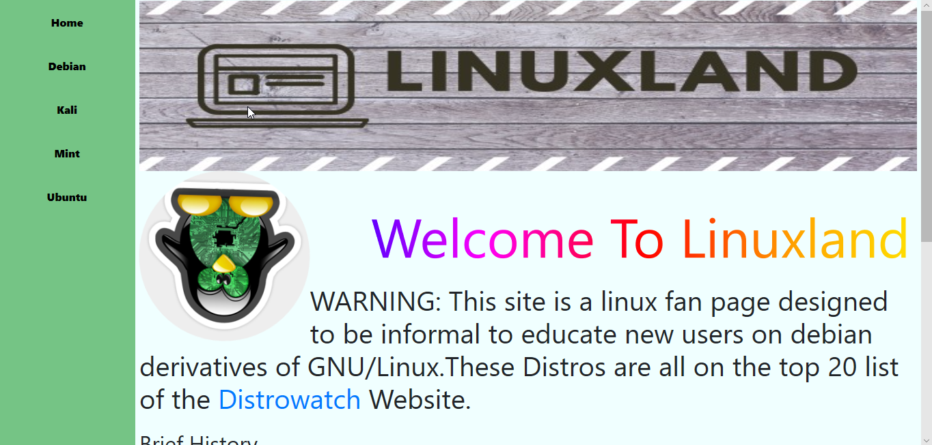
Home page index.html

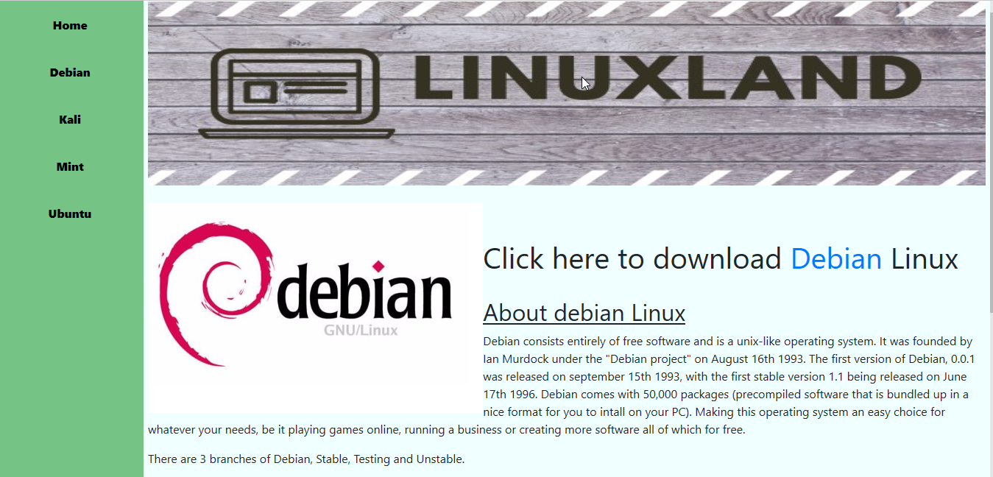
Debian information page Debian.html

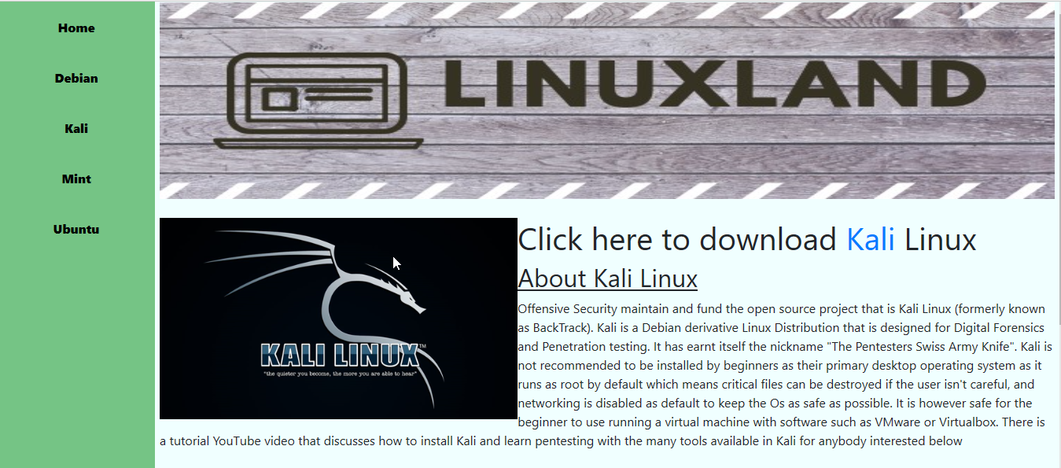
Kali information page Kali.html

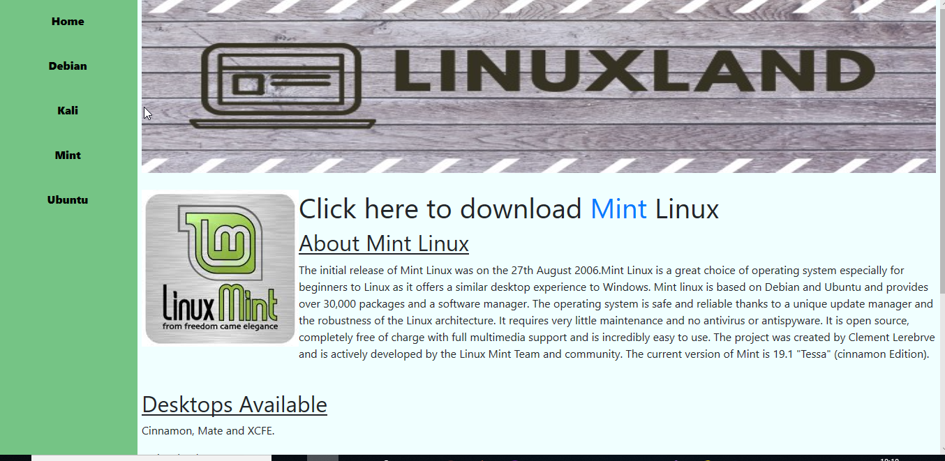
Mint information page Mint.html

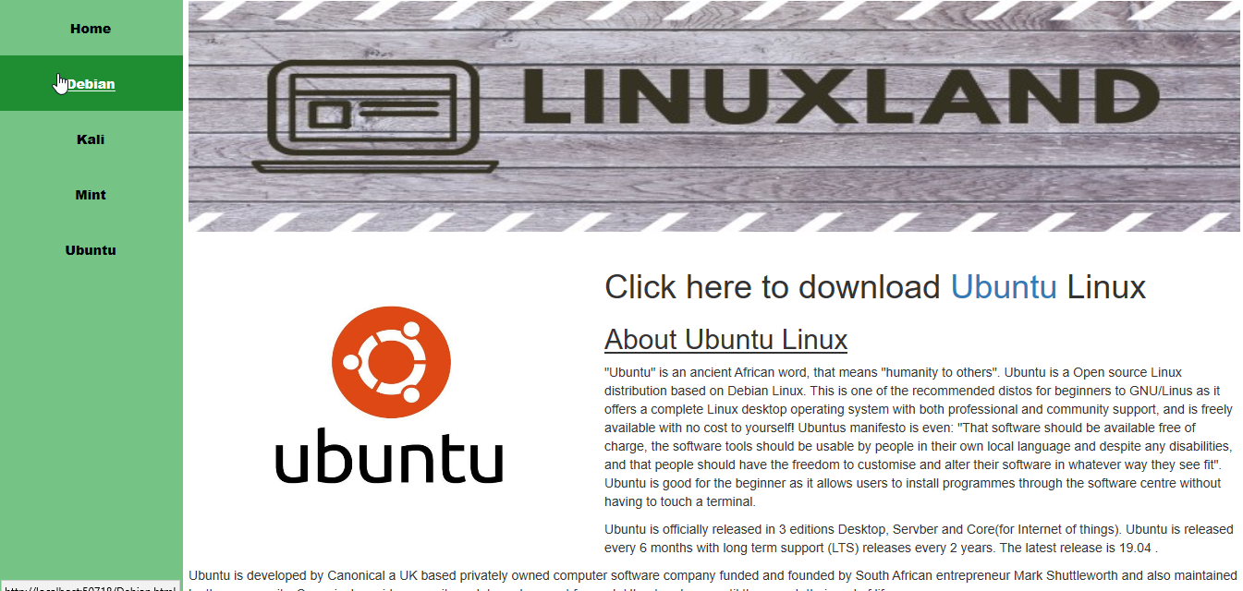
Ubuntu information page Ubuntu.html

Validation
Using W3 Schools Html Validator.[1]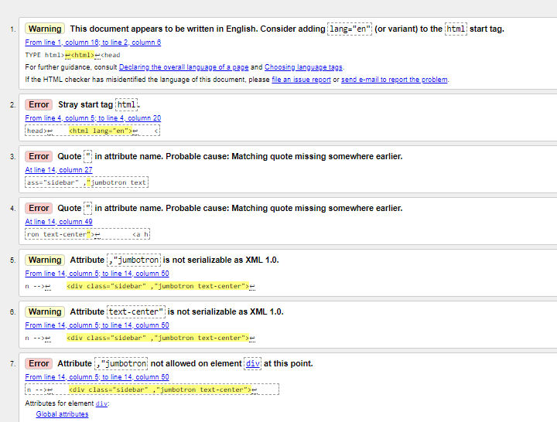
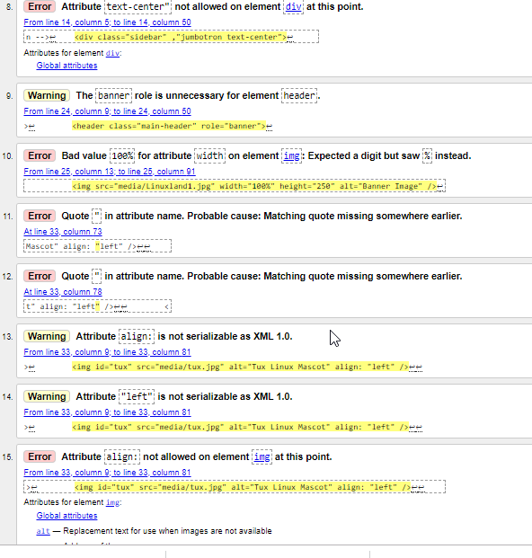

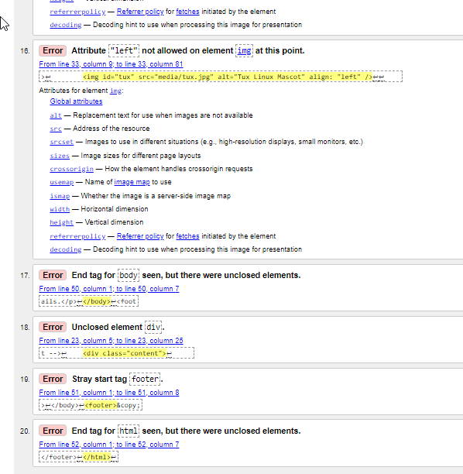

After completing the validation checks the English language tabs were appended to the document and the stray html tag removed. Footer was in fact correct and there were no stray elements. Align left attributed were removed from the html.

Using W3Schools CSS Validator.[2]
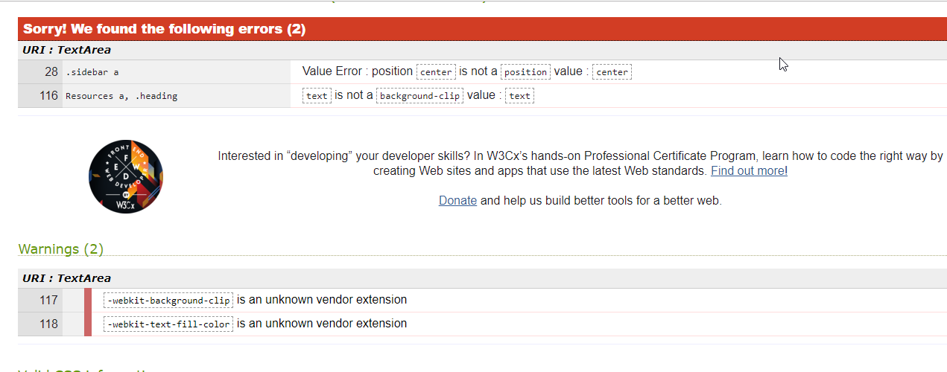

Center was an accepted position value in Visual Studio so was left unchanged. Background-clip was working as intended and when removed provided unwanted effects. Warnings were ignored as they were not essential errors in code.

Accessibility Evaluation
Below is a screenshot of a Contrast Checker.[3]
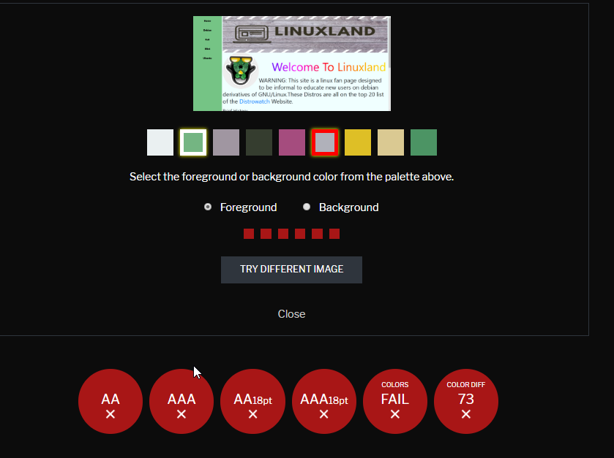
The result is a fail as the two foreground and background clash, they are not in contrast with each other, some of the text is also to small and should be fixed in any revisions of the site.
The overall websites look was kind of amateurish but was fine as a fan page. The banner was consistent and added to the site to make the logo rememberable. The audio may have been annoying to certain users and is activated in the background each time the homepage is opened so would have to be muted by the browser, animated spinning tux and Rainbow coloured text could be removed and a more professional font type, and a fixed static tux logo, but this was intended to make the site fun and demonstrate that more than one colour of text could be used at the same time. Bootstrap was used to create a carousel of images of the logos of flavours of ubuntu and could have been sized better for easier viewability and the bootstrap font Jumbotron was also used in the side navigation bar. A YouTube video tutorial was used as a great education resource to assist users in learning pen testing and installing Kali Linux as a virtual machine. The website could be made to feel more professional by better positioning of elements and adequate padding. Navigating around the Website was good as the sidebar had all the links contained in a uniform style throughout and other links were listed after the text “click here” which gives the user directions. To improve the websites content, more information on distro’s and their desktop environments could be added including more information not just the description of the ubuntu flavours that are available. There was also some padding between the banner and the navigation bar that could have been removed. The use of Javascript to make a more interactive sidebar and to add more functionality icons/widgets for linking to external pages for GitHub or twitter as an example to include social share and follow buttons. Login and register functionality could be provided with a backend and a search bar to navigate information that may be required by the user. The use of white space could have been improved to divide elements and not give the feel of elements overlapping. A flex box or grid system may have been a better way of organisation. Another improvement would be to host the iso’s of downloads without linking to external sites. The website could also be made mobile friendly. There could also be changes made to tidy up the code as there were a lot of unneeded div elements. The site could also be improved by providing a comments section to give a voice and gather opinions of registered users only to avoid trolling. A weekly newsletter could also be offered to registered users who opt in.
To improve Search engine Optimisation (SEO) there has been optimised images implemented on each page, fixed broken links, H1 and H2 tags have been utilised with relevant titles, increased relevance between site content and search engine keywords[4], YouTube videos and cross-linking has been implemented throughout the site to the same website. There is also added meta tags with an author and description of the page. Having a presence on social media would also improve SEO results.

References
[1] “Markup checker.” [Online]. Available: https://validator.w3.org/. [Accessed: 12-Jul-2019].
[2] “No Title.” [Online]. Available: http://jigsaw.w3.org/css-validator/validator. [Accessed: 12-Jul-2019].
[3] “Contrast checker.” [Online]. Available: https://contrastchecker.com/. [Accessed: 12-Jul-2019].
[4] S. Lee, W. Jang, E. Lee, and S. G. Oh, “Search engine optimization: A case study using the bibliographies of LG Science Land in Korea,” Libr. Hi Tech, 2016.

marking criteria and Student FEEDBACK

This section details the extent to which the assessment criteria are demonstrated by you, which in turn determines your mark. The marks available for each category of skill are shown. Lecturers will use the space provided to comment on the achievement of the task(s), including those areas in which you have performed well and areas that would benefit from development/improvement.

Common Assessment Criteria Applied (Assignment 1) | Marks available | Marks  awarded
1. Engagement with Literature Skills

References are satisfactory. Expand the scope of reference sources consulted to further improve your work. (Grade mark: 40.00%) | 5 | 2
2. Knowledge and Understanding Skills

Generally, demonstrates a good understanding of the standards used to design and implement a website. There is, however, room for improvement. For example, please note that if you are creating a multi-page website, it is better to have a single, external style sheet page that you add all your CSS to and then link this single style sheet to all your pages. That way, you define your styles once, which makes it easier to ensure that your pages are consistent and if you need to make changes, you only need to do it one place. You also need to be careful to properly close and nest your HTML elements. See your report for additional comments. (Grade mark: 55.00%) | 20 | 11
3. Cognitive and Intellectual Skills

A good evaluation of the website has been provided and you have particularly identified some of the accessibility issues mentioned below. A fair attempt at discussing the SEO optimisation techniques applied. (Grade mark: 66.67%) | 30 | 20
4. Practical Application Skills

A good attempt featuring a simple website with some well-thought-out content. There is, however, some room for improvement and especially for improving the accessibility of the website. As you have noted in your evaluation, some users may find the animation and flashing colours annoying. To meet WCAG guidelines you should avoid such elements and give the user the ability to control media content instead of playing these automatically. Also, aim to improve your understanding of CSS grid layouts to improve the layout of your pages and the correct way to specify a width of 100% for images is to use CSS styles preferably in the style sheet and not using the width attribute. See your report for additional comments. (Grade mark: 62.50%) | 40 | 25
5. Transferable Skills for Life and Professional Practice

The report is of a good standard. (Grade mark: 60.00%) | 5 | 3

Assignment Mark (Assessment marks are subject to ratification at the Exam Board. These comments and marks are to give feedback on module work and are for guidance only until they are confirmed. ) | Late Submission Penalties (tick if appropriate) |  | 61%
 | Up to 1 week late (40% Max) |  | 61%
 | Over 1 week late (0%) |  | 61%

