
LEVEL 5 ASSESSMENT SPECIFICATION

Student name: | Diana Adriana Les | Student  ID number: | 2222995
Programme: | BA International Hotel Management
Module: | Sustainable Hospitality & Tourism Management
Module code: | BMIH5006
Lecturer: | Lisa-Marie Bassler

I confirm that I have not used any AI tools in the research and creation of this assignment. I confirm that I have not presented any AI generated materials as my own work. I confirm I have copies of my drafts, notes, and other resources I used, which I may be asked to provide in evidence.

Executive summary
Business organisations including hotels are more concerned about sustainability initiatives nowadays. The world is heading towards green practices and empowerment-friendly initiatives to reduce the negative impact on the environment. They are ensuring green practices in the operation and manufacturing of the businesses. The energy efficiency initiatives are implemented in business organisations. This increases their cost savings, reduces the impact of pollution on the environment, increases brand reputation, increases customer satisfaction, etc. The Scarlet Hotel is well known for its eco-friendly activities and it also takes the initiative of renewable energy. This will discuss the initiatives to enhance the energy efficiency in the organisation focusing on the establishment of a wide range of solar panels. This will also evaluate the benefits of renewable energy adoption and the related challenges that the organization needs to navigate. Besides this, there will be an examination of the feasibility of this project implementation and recommendations to make careful planning of this project and ensure the instalment of cost-effective and environment-friendly activities.

Table of Contents
Executive summary 2
Introduction 4
Greener Practice Initiative in the Scarlet Hotel 5
Benefits of “Renewable Energy Adoption” in the Scarlet Hotel 7
Challenges in the Implementation of “Renewable Energy Adoption” Initiative 8
The Feasibility of “Renewable Energy Adoption” in Scarlet Hotel 10
Conclusion 11
References 12

Table of Figures
Figure 1: Renewable Energy Market in UK 5
Figure 2: CO₂ Emission in solar panels 6
Figure 3: Advantages of Renewable Energy Adoption 8
Figure 4: Challenges of Renewable Energy Adoption 9

Introduction
The sustainable actions taken by business organisations to increase the balance on nature and to minimize environmental impact is known as greener practices. Business organisations are not beyond this and are practising a wide range of activities to reduce the negative impact (Olorunsola, 2020). Reducing energy consumption, minimising wastage, recycling plastics, use of renewable sources in production, effective energy management, water management, etc. initiatives are taken by business organisations including hotels to improve their sustainability and eco-friendly activities. The hotels are promoting sustainability through achieving net zero carbon emissions to ensure a healthier planet. The Scarlet Hotel is one of the most prominent eco-friendly hotels and has taken several initiatives to improve sustainability and ensure long-term impact (Chiangphan et al, 2024). They have taken a wide range of carbon reduction initiatives and practised greener businesses through the use of solar thermal panels, natural ventilation, water-saving technology, using biodegradable materials in their services, etc. The hotel is operating Its business in Mawgan Porth, Cornwall UK with 194 rooms and a wide range of services well known for its environmentally friendly practices.

Greener Practice Initiative in the Scarlet Hotel
The Scarlet Hotel is well known for its environment-friendly activities in operations guide services and manufacturing processes. It is already practising the use of solar panels, water management technology, natural resources, use of ethical sourcing, etc. in its business operations. The hotel has more room to work to ensure sustainability so it can focus on “Renewable Energy Adoption" initiatives. The main aim is to ensure net zero carbon emissions and increase the dependency on natural resources rather than power or energy (Engle and Guevara, 2022). To implement this initiative the organisation needs to focus on renewable energy sources like solar, air, and natural lighting. The organisation can expand its capacity and take over the total energy in it through solar power and so more solar panels need to be integrated and implemented. This will increase its energy capacity and cover a large portion of the area including all the rooms, corridors, different devices and technologies, etc. It will help to reduce the dependency on nonrenewable energy and increase sustainability. The hotel will also take the initiative for turbine installation. Besides that, a smart energy management system is also necessary to cope up with the real world. For this, they can install an advanced smart system that is energy efficient like an HVAC energy management system (Dhirasasna and Sahin, 2021). This will help to identify the energy wastage areas and ensure automatic adjustment with the environment and surroundings. This technology includes a motor and sensor which can detect guests, common areas, unauthorised access, etc.
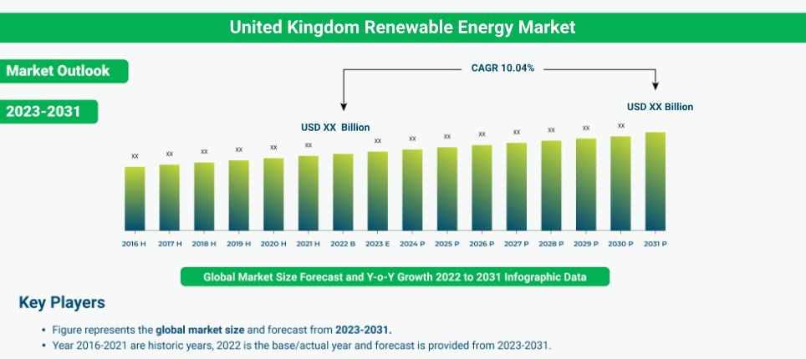
Figure 1: Renewable Energy Market in UK
Source: (Lima et al, 2020)
This can help to reduce the energy wastage. For example, if any guest exits from the room, the lights, fans AC, and other electronic devices will be stopped automatically. This is how the smart energy system will help to reduce energy waste through using this technology and increase satisfaction in guest and staff engagement (Navratil et al, 2019). The organisation can also offer renewable or reusable towels and other products to ensure sustainability. Through the adoption of these initiatives, the organisation will be able to reduce carbon emissions. Moreover, due to energy savings, they will experience cost savings and enhance guest satisfaction. All these initiatives will turn the organisation into a leader in the sustainable hospitality industry which will improve its brand reputation and positioning.
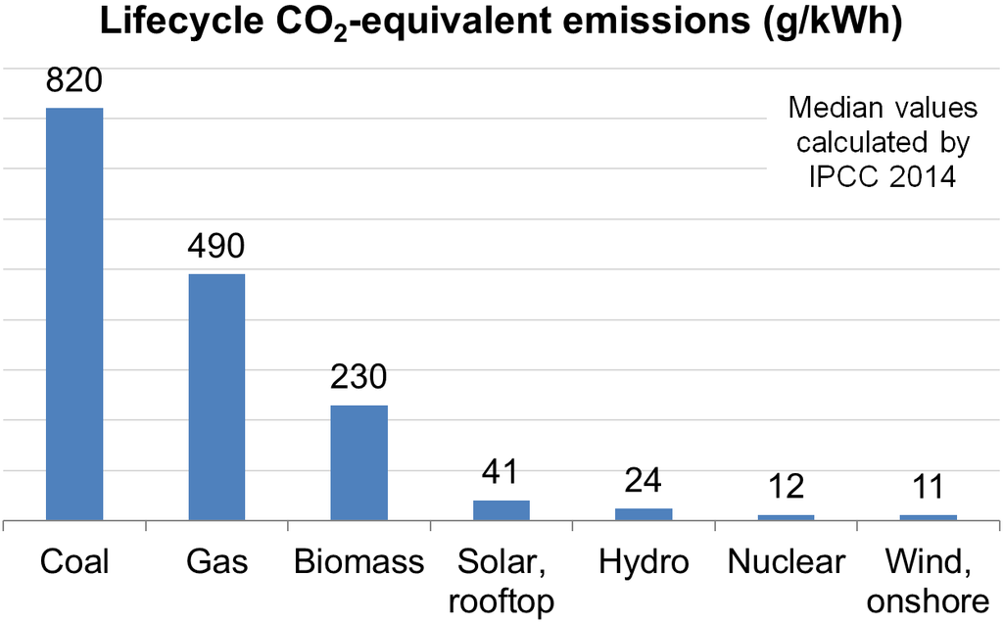
Figure 2: CO₂ Emission in solar panels
Source: (Floričić, 2020)
These energy efficiency initiatives are also implemented in other business organisations. This increases their cost savings, reduces the impact of pollution on the environment, increases brand reputation, increases customer satisfaction, etc. The Savoy Hotel established in London has taken the initiative of a combined heat and power system to ensure renewable biofuels which reduce the carbon emissions by 500 tons annually and increase its sustainability. The Bardessono Hotel in the USA is using solar power as their renewable sources which generate more than 200,000 kWh of electricity annually and reduces the greenhouse gas emission in that area including the organization (Salem et al, 2020). The Carbis Bay Hotel has installed a ground-source heat pump which is reducing energy consumption by up to 15 to 20% and increasing its commitment towards the environment. Google has invested in renewable energy and ensured 100% renewable energy in its operation. The use of solar energy is increasing day by day and it will increase up to 20% by 2020 and the hotel industry is also collaborating with this. This industry is adopting renewable energy and reducing energy consumption by up to 30% ensuring significant environmental and economic benefits (Balaji et al, 2019).

Benefits of “Renewable Energy Adoption” in the Scarlet Hotel
The Scarlet Hotel has benefited highly through the adoption of renewable energy in its business operations. This will increase its operational efficiency and brand image including the upgradation of environmentally friendly activities and impact. The use of solar and wind power will reduce the carbon gas emission and the organisation can head towards 100% renewable energy adoption through the expansion of solar power in its business area (Jacksohn et al, 2019). The solar power system will generate electricity so the organisation can save its electricity and utility bill up to 10 to 15%. According to the Solar Energy Industry Association, the Scarlet Hotel will be able to reduce 20% of its electricity bill after the usage of renewable energy in its first year of operation (Abdou et al, 2020). Nowadays the guests are also focusing on eco-friendly hotels and industries. They prefer staying on a sustainable property for which the Scarlet Hotel will be able to enhance its guest experiences through its eco-friendly activities and provide sustainable luxury hospitality to the guests.
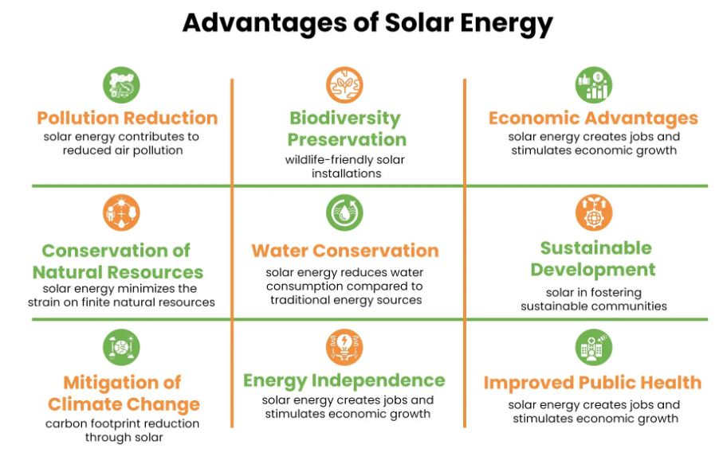
Figure 3: Advantages of Renewable Energy Adoption
Source: (Chiangphan et al, 2024)
The hotels that align with the green initiatives get 15% more bookings than the traditional ones. The government has taken different regulations to ensure net zero carbon emission by 2050 and the eruption of renewable energy can help the Scarlet Hotel to comply with the standards and regulation. Nowadays CSR initiatives act as marketing and promotion strategies for organisations (Floričić, 2020). The promotion of renewable energy will act as a corporate social responsibility that will gain positive recognition from consumers and stakeholders. Global consumers are willing to pay more for eco-friendly initiatives so the Scarlet Hotel will be benefited in its revenue and market share in its implementation. Besides that, operational efficiency, increase in performance, employee engagement, and motivation will add extra improvement to the sustainability initiative for the organization (Lima et al, 2020).

Challenges in the Implementation of “Renewable Energy Adoption” Initiative
Renewable energy adoption adds higher benefits for the Scarlet Hotel including its improvement of operational efficiency, increase of revenue, brand reputation competitive advantages, etc. But the organisation will also face different challenges in the implementation of this initiative. The organisation will face internal and external barriers in the implementation of this (Liang et al, 2019). At first, they will face financial constraints due to its high installation cost. A solar panel installation can cost up to £12,000 to £20,000 based on its size and location. This will add a high initial cost and a barrier for the organisation in the implementation of this. Moreover, in the adoption of 100% renewable resources the hotel Staffs can resist due to their negative attitude or fear of receiving more training (Prasad et al, 2021).
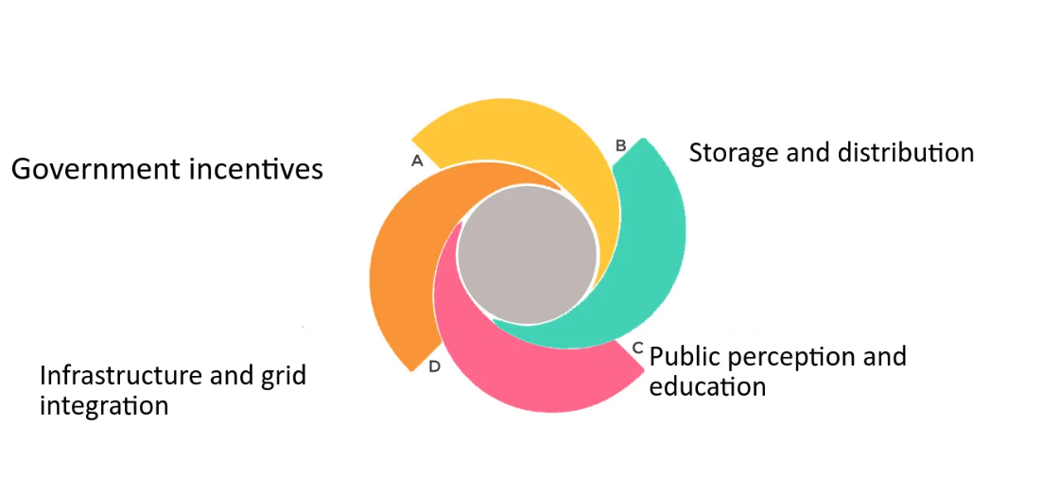
Figure 4: Challenges of Renewable Energy Adoption
Source: (Lee et al, 2022)
Lack of proper education and awareness can also add extra barriers to the implementation of this sustainable practice. Externally the organisation will face challenges in the areas of seasonality, decision-making, regulatory acts, and suppliers. Renewable energy like solar panels is highly dependent on weather so the adoption of solar energy and installation of solar power requires sunny weather. Moreover, the winter season and rain can add an extra challenge for the Scarlet Hotel (Al-Shetwi, 2022). The organisation may rely on backup energy sources during this. The stakeholders or the board members can impose challenges due to the conflict of interest and compliance with the government regulation can also act as a burden in the implementation of the renewable energy resources (Irfan et al, 2021). The organisation may also experience disruptions in its operation that can affect the guests. Maintenance of renewable energy will add extra cost and operational downtime which can impose some difficulties on the Scarlet Hotel.

The Feasibility of “Renewable Energy Adoption” in Scarlet Hotel
In the implementation of renewable energy adoption, the first concern is cost-effectiveness. Although this project requires a higher initial investment, the organisation can enjoy long-term savings and cost-effectiveness from solar adoption. The Scarlet Hotel can enjoy up to 7 to 10 years with reduced energy bills, increased efficiency, and operational optimization (Darda et al, 2019). Moreover, the government also offers incentives to business organisations in the expansion of solar panels. The Smart Export Guarantee (SEG) scheme may help the Scarlet Hotel to implement the project at a cheaper rate. Financially, the organization will get back the investment amount within 5-8 years and can realize the significant savings and cost-effectiveness.
Implementation of solar panels at a wider range is realistic as it has technological feasibility, regulatory permissions, and organisational capability. The Scarlet Hotel is capable of adopting renewable energy resources in its business operations. Moreover, solar technology is widely used and it is available in the market for which the Scarlet Hotel can easily install it to ensure renewable energy usage (Koytsoumpa et al, 2021). The hotel is situated in Cornwall where they can enjoy high wind speed and moderate sunlight levels. This will add extra benefit to the implementation of solar panels and the eruption of renewable energy sources.
Renewable energy sources will help to reduce greenhouse gas emissions and reduce the dependency on renewable energy sources like fossil fuel, coal, oil, etc. 0.45 kg of CO2 is reduced per kWh of solar energy leading the Scarlet Hotel to prevent 45000 kg of CO2 annually in the adoption of 100000 kWh renewable energy (D’Agostino et al, 2020). This will also reduce air pollutants like Sulphur Dioxide or Nitrogen Oxide ensure the preservation of natural resources, clear water and promote sustainable tourism.

Conclusion
Implementing renewable energy initiatives in the Scarlet Hotel can enhance its sustainability practices, operational efficiency, cost savings, branding, etc. Nowadays most organisations are embracing the initiatives of eco-friendly activities to ensure net zero carbon emissions and reduce the greenhouse gas effect on the environment. Consumers are also attracted to eco-friendly hotels and resorts and they are even willing to pay more for these organisations (Kapıcıoğlu and Esen, 2022). The Scarlet Hotel can take the initiative of renewable energy adoption through the expansion of a wide range of solar energy. It can reduce operational costs in the long term. Besides this, the organisation may face some challenges including its higher initial cost, a restaurant from the employees, dependency on the season, etc. The organisation can get incentives from the government and make partnerships with some other organisations that will increase the cost-effectiveness and instalment of this initiative at a cheaper rate (Lee et al, 2022). The organisation can also embrace wind turbines to increase their efficiency.

References
Abdou, A. H., Hassan, T. H., and El Dief, M. M. (2020). A description of green hotel practices and their role in achieving sustainable development. Sustainability, 12(22), 9624.
Al-Shetwi, A. Q. (2022). Sustainable development of renewable energy integrated power sector: Trends, environmental impacts, and recent challenges. Science of The Total Environment, 822, 153645.
Balaji, M. S., Jiang, Y., and Jha, S. (2019). Green hotel adoption: a personal choice or social pressure?. International Journal of Contemporary Hospitality Management, 31(8), 3287-3305.
Chiangphan, N., and Vongsaroj, R. Exploring Green Factors and Green Practices: Best Green Small Hotels in Thailand’s Active Beach Cluster. Journal of Multidisciplinary in Social Sciences (January-April 2024), 20(1), 16-28.
D’Agostino, D., Mele, L., Minichiello, F., and Renno, C. (2020). The use of ground source heat pump to achieve a net zero energy building. Energies, 13(13), 3450.
Darda, S., Papalas, T., and Zabaniotou, A. (2019). Biofuels journey in Europe: Currently the way to low carbon economy sustainability is still a challenge. Journal of Cleaner Production, 208, 575-588.
Dhirasasna, N., and Sahin, O. (2021). A system dynamics model for renewable energy technology adoption of the hotel sector. Renewable Energy, 163, 1994-2007.
Engle, C., and Guevara, J. M. S. (2022). A proposal towards better sustainable consumer information to address eco-certification skepticism and sustainability initiatives of adventure tourism companies in Norway (Master's thesis, Norwegian University of Life Sciences, Ås).
Floričić, T. (2020). Sustainable solutions in the hospitality industry and competitiveness context of “green hotels”. Civil Engineering Journal, 6(6), 1104-1113.
Irfan, M., Zhao, Z. Y., Rehman, A., Ozturk, I., and Li, H. (2021). Consumers’ intention-based influence factors of renewable energy adoption in Pakistan: a structural equation modeling approach. Environmental Science and Pollution Research, 28, 432-445.
Jacksohn, A., Grösche, P., Rehdanz, K., and Schröder, C. (2019). Drivers of renewable technology adoption in the household sector. Energy Economics, 81, 216-226.
Kapıcıoğlu, A., and Esen, H. (2022). Economic and environmental assessment of ground source heat pump system: The case of Turkey. Sustainable Energy Technologies and Assessments, 53, 102562.
Koytsoumpa, E. I., Magiri–Skouloudi, D., Karellas, S., and Kakaras, E. (2021). Bioenergy with carbon capture and utilization: A review on the potential deployment towards a European circular bioeconomy. Renewable and Sustainable Energy Reviews, 152, 111641.
Lee, M., Kim, J., Shin, H. H., Cho, W., and Kim, Y. (2022). CO2 emissions and energy performance analysis of ground-source and solar-assisted ground-source heat pumps using low-GWP refrigerants. Energy, 261, 125198.
Liang, Y., Yu, B., and Wang, L. (2019). Costs and benefits of renewable energy development in China's power industry. Renewable energy, 131, 700-712.
Lima, M. A., Mendes, L. F. R., Mothé, G. A., Linhares, F. G., De Castro, M. P. P., Da Silva, M. G., and Sthel, M. S. (2020). Renewable energy in reducing greenhouse gas emissions: Reaching the goals of the Paris agreement in Brazil. Environmental Development, 33, 100504.
Navratil, J., Picha, K., Buchecker, M., Martinat, S., Svec, R., Brezinova, M., and Knotek, J. (2019). Visitors’ preferences of renewable energy options in “green” hotels. Renewable energy, 138, 1065-1077.
Olorunsola, V. O. (2020). Green Practices: The Experiences of Guests in EcoCentric Hotels in the UK (Master's thesis, Eastern Mediterranean University (EMU)-Doğu Akdeniz Üniversitesi (DAÜ)).
Prasad, S., Venkatramanan, V., and Singh, A. (2021). Renewable energy for a low-carbon future: policy perspectives. Sustainable Bioeconomy: Pathways to Sustainable Development Goals, 267-284.
Salem, R., Bahadori-Jahromi, A., Mylona, A., Godfrey, P., and Cook, D. (2020). Energy performance and cost analysis for the nZEB retrofit of a typical UK hotel. Journal of Building Engineering, 31, 101403.

