

RESULT

ASSIGNMENT DETAILS AND FEEDBACK
SOUTH WEST WALES CENTRE FOR TEACHER EDUCATION
Sections marked with * should be completed by module lead
Student name: | Rosa Thomas | Student P number: | 1703349
Programme: * | Secondary Post Graduate Certificate in Education
Module: * | Curriculum Development and Enhancement | Module Level (6 or 7): | Level 7
Module code: * | ECSP7002 | Contribution to Overall  Module Assessment (%): * | 100
Module Lead:* | Jan Barnes
Assignment Title:* | Reflections on Teaching and Learning | Assignment No (x of x): | 1
Start date:* |  | Submission deadline:* | 14th May 2018 –full submission
Return date of provisional marks & written feedback:* | 11th June 2018

Referencing: | In the main body of your submission you must give credit to authors on whose research your work is based. Append to your submission a reference list that indicates the books, articles, etc. that you have read or quoted in order to complete this assignment (e.g. for books: surname of author and initials, year of publication, title of book, edition, publisher: place of publication).
Submission: | All assignments must be submitted to Turnitin unless otherwise instructed by the Lecturer.  Note: the Turnitin version is the primary submission and acts as a receipt for the student. Late submission of the electronic version of the assignment will result in a late penalty. Penalties for late submission: Up to one week late, maximum grade D. Over one week late, Refer. Only the Extenuating Circumstances Panel may grant an extension. | Date: | 12/5/18
Module lead to tick to indicate if a hard copy version of the assignment must be submitted.* | YES
 | NO | √

Module 3- Curriculum Development and Enhancement

Do specific Assessment for Learning strategies, such as Peer Assessment have any impact or improve the writing skills of Key Stage 3 Pupils?

Assessment for Learning (AfL) strategies are a vital and important factor in maintaining and monitoring learning throughout all the lessons in the secondary classroom. AfL should be an integral part of everyday teaching, meaning teachers should incorporate it into all lessons, adjusting teaching strategies at any time in order to enhance learning. In doing so, learners are encouraged to adjust their learning strategies, promoting motivation and emphasising progress and achievement rather than failure within the class. Thereby, learners can build confidence within lessons; taking ownership and responsibility for their learning. School X is an 11-18 amalgamated school and is one that has a positive ethos determined to develop learning and cater for all students throughout their time in school and develop in to reflective and confident adults (School X, 2018).
School X credits the importance of high quality teaching and the support of all students, regarding them as individuals, and therefore the highlight the significance of learning being active where students contribute fully. Students must reflect on their work regularly in lessons and not just set, but act on any targets set which are constructive and realistic to the individual.
The class selected and focussed on consisted of 32 Key Stage 3 pupils, 27 of whom were identified as more able and talented (MAT). Participants were a part of a set 1, year 8 class and were chosen for this research project as they are independent and conscientious learners, and continuously want to improve and succeed in all areas of their learning. The school as a whole promotes the use of peer and self-assessment within lessons and therefore learners are familiar and willing to participate within the research. During the time teaching this class, a range of AfL strategies have been introduced in order to promote all aspects of learning by stretching and challenging all pupils; including introducing different questioning techniques and written feedback via book marking. This research project focusses specially on the use of a peer and self-assessment task based on identified success criteria and whether targets generated from this helped improve their descriptive writing performance. In doing so, it helps focus learners on the task and helps promote higher order thinking skills as they are providing constructive feedback independently without the help and support of the class teacher.

Literature Review
Assessment for Learning is now used continuously within the class to check for understanding and where the priority in its design is to promote students’ learning and therefore differs from assessment in which the main purpose is to rank or certify competence on a specific topic (Black, Harrison, Lee, & Marshall, 2004). Assessment for Learning is the only means which can be used to find out whether a specific set of activities has ‘resulted in the intended learning outcomes’ (Wiliam, 2011, p. 3). Integrating AfL into the secondary classroom requires teachers to reorganise their classroom procedures. The nature of a secondary classroom means that all learners are likely to be at different stages of understanding of a topic when the instructions are initially given, and therefore within a short amount of time all learners will have reached very different levels of understanding. Consequently, AfL techniques are crucial and are the ‘central process’ in effective instruction (Wiliam, 2011, p. 3). Assessment for Learning techniques are central in the classroom, especially in the UK, where there are a diverse range of learners from different backgrounds, hence different levels of education and possibly very low levels of higher education (Brown, 2005). This varied population of students necessitates a greater focus on achievable learning outcomes rather than a focus on teacher led methods (Rust, 2002). Assessment for Learning needs to allow for gauging what students have learned and to what extent they can demonstrate it (Brown & Smith, 1997). Integrating these AfL methods into the learning process is essential, rather than subsequently adding them on. This will allow teachers to concentrate and give focus on giving constructive feedback throughout the lesson and make effective decisions about the performance of the class (Brown, 2005). The success of using various methods of AfL techniques to assess the understanding learners have of various topics within the class has meant a shift in focus towards this in recent years. Teaching and learning must therefore be interactive, which allows teachers to gain valuable knowledge of their pupils’ progress, highlight any difficulties with their learning and therefore they can accurately adapt their work to meet pupils’ needs (Black & Wiliam, 1998). Various methods can be used by teachers to find out what their pupils’ progress is, including ‘observation and discussion in the classroom and the reading of pupil’s written work’ along with features of peer and self-assessment (Black & Wiliam, 1998, p. 2). This assessment is known as ‘formative assessment’ and is when the evidence gathered is used effectively to change teaching and meet students’ needs (Black & Wiliam, 1998, p. 2). Introducing new activities based on the feedback received by the teacher during lessons means new tasks can be introduced to promote and enhance student learning (Kahl, 2005).
High quality feedback is essential from teachers in order for AfL strategies to encourage and develop learning within a class. ESTYN (2015) confirms the significance of ‘high-quality’ feedback, and the ‘involvement of pupils in assessing their own work an and that of their peers’ (p. 37). There are various forms of feedback that can take place, including peer and self-assessment and can be in the form of verbal or written, that can take place during any one lesson. These forms of feedback need to be developed in order to support and underpin learning, rather than to weaken pupil’s confidence which could be detrimental to their attainment and progress (Torrance, 2007). Constructive feedback from the different forms of formative assessment have ‘the capacity to turn each item of assessed work into an instrument for the further development of each student’s learning’ (Hyland, 2000, p. 234). Biggs (1999) found that providing feedback ensures deeper learning of a skill, meaning learners are more likely to be able to use this skill in later life or across other subjects, developing learning. Learners are central in the learning process, known as ‘active makers and mediators of meaning within particular learning contexts’ and are not just ‘simply receptacles for transmitted information’ (Higgins, Skelton, & Hartley, 2002, p. 53). Consequently, teachers are to move away from teacher led lessons where learners are provided with information and are to include pupils more in the learning process. Learners can be used at ‘active learners’ when providing focused peer assessment feedback and targets to others, hence are a vital element to the improvement of other learners in the class.
However, in order for any form of formative assessment of AfL strategies to work successfully in the classroom, the feedback must be constructive and provide learners with critical information about how they are currently performing and what they must do to improve and achieve their targeted performance. Peer and Self- Assessment provides scaffolding to learners as the success criteria provided to do so will guide learners into including what they need to achieve. Alongside this, students can receive valuable feedback, which is of great importance in influencing learning (Hattie & Timperley, 2007). When any form of feedback is paired with ‘effective instruction in classrooms, it can be very powerful in enhancing learning’ (Hattie & Timperley, 2007, p. 104).
The main purpose of feedback is to allow learners to see what they have done well and to gather information on how they can improve their work. As a teacher, gauging learners level of understanding during a lesson, before moving onto another topic, is of great importance. Effective feedback then, allows teachers to be reflective practitioners, and therefore steer learners in the direction of improvement and advancing onto the next stage in their learning. Peer assessment encourages collaborative learning within the class and consists of learners requiring to provide accurate advice on what was done well and what could be done to improve. In providing such information, it is only ‘effective when it consists of information about progress, and/or about how to proceed’ (Hattie & Timperley, 2007, p. 89).
Self-assessment is also of particular importance in the process of providing feedback. Providing opportunities for learners to read and improve their own work can be highly influential for strengthening writing skills as ‘it is what students bring to the table that predicts achievement more than any other variable (Hattie, 2003, p. 1). Allowing such ‘further engagement’ into the task provided, makes it an influential tool of feedback (Hattie & Timperley, 2007, p. 102).
It is the responsibility of the teacher within the class to ensure all pupils receive positive and beneficial feedback so that they can apply it to any future work undertaken, hence reach higher target levels. Prior to prioritising Assessment for Learning throughout lessons to check for understanding, schools main focus was almost entirely on Assessment of Learning. Schools focusing almost entirely on Assessment of Learning was disadvantaging pupils as it meant the priority was reaching minimum requirements of awarding bodies and not doing what was needed for the specific class being taught. Assessment of Learning prevents pupils being active learners and having an element of responsibility for their own learning. This subsequently makes learners less independent and less able to identify any areas needing improvement and setting their own focused targets. Putting learners at ‘the heart of the assessment process’ refocuses the lesson objectives so that learners become the ‘primary benefactor’ in their own learning (Jones, 2005, p. 1). This means that the learners are the main priority in the class, unlike when schools focused heavily on Assessment of Learning strategies, and therefore improve learner’s confidence in making their own decisions and judgements in how to improve and enhance their development. Numerous Ofsted reports emphasise the importance of AfL strategies being used continuously throughout any one lesson in the classroom. Ofsted states that several schools use AfL strategies ineffectively, indicating that they are crucial and of great importance to enhance learning and subsequently the performance of the school in question (Jones, 2005). As a result, Ofsted have called for ‘strategies to further engage and actively stretch all learners to reach their full potential’, through the form of AfL, which is a ‘proven strategy that can and does help teachers meet these important challenges’ (Jones, 2005, p. 2). The focus in many schools still being on Assessment of Learning strategies and therefore pressure for exam results, puts great stress onto learners and teachers. Assessment for learning is far more beneficial to both learners and teachers as it reduces the burden from external assessments, however learners are still be challenged at all times, including stretching and promoting higher order thinking skills in more able and talented learners (MAT) in the class (DfES, 2005). In doing so and allowing teachers to shift focus to using AfL, it readily allows more pupils needs to be met. More time will consequently be free in order to ‘get back to basics’ and allow for ‘internal assessment for the benefit of the learners’ and not purely just focus on meeting targets and ‘requirements of external assessment regimes’ (Jones, 2005, p. 2). Putting learners needs within a specific class at the forefront benefits them greatly, improving attainment and maximising learning in every learning term. Feedback provided from AfL techniques is individualistic, meaning it not only has potential to act as a support to lower achieving pupils, it can encourage higher achieving pupils to strive for better results if they can see the requirements they need to attain in order to do so.
Aiding lower attaining pupils is another important purpose that comes from successful use of peer and self-assessment as an AfL strategy within the classroom. Wiliam and Black (1998) found that aspects of formative assessment can help all pupils, however it yields especially improved results with low achievers as when feedback is focused and detailed it gives them a ‘clear understanding of what is wrong and how to put it right’ (Black & Wiliam, 1998, p. 6). Using peer assessment strategies can also help teachers build confidence in learners which can come from experiencing success from constructive peer feedback. Wiliam and Black (1998) found that pupils can accept work with messages from peers about what is wrong what needs to be improved, which can build confidence, however it should not be comparative others; making it detrimental to learning. In summary, the advice given should be about the qualities of the work produced intertwined with advice on how to improve. Repeating these AfL strategies continuously throughout programmes of learning allows learners to more readily access the feedback they receive and reflect on any improvements they have made over a period of time. This in turn allows learners to ‘gain a sense of control over their own learning’, building confidence in these students (Stiggins & Chappuis, 2005, p. 3). This also allows learners to know what the end goal is and are therefore more able to actively participate in their own learning.
The higher achieving pupils are often identified by schools as being ‘more able and talented’ learners, however, often face different challenges to other learners in the classroom. According to ESTYN (2011), MAT learners benefit greatly from having a more individualistic and personalised approach to learning. The importance of embedding AfL strategies into teaching helps MAT learners know how well they are currently performing and gives them areas to focus on in order to improve. Using peer and self-assessment strategies throughout lessons allows MAT learners to be involved in their progression as they can set ‘challenging targets which are relevant to their specific needs’ in which they can monitor and review. This can allow and build confidence in MAT learners, if they can see a clear path for progression, as MAT learners require control over their thinking and problem-solving skills (ESTYN, 2011). Embedding peer and self-assessment within lessons is a highly beneficial strategy of AfL, alongside questioning and discussions. MAT learners benefit from contributing to the curriculum from an early age, and often gain a lot within class discussions about what they already know and ‘what they would like to know’ about a topic (ESTYN, 2011, p. 15). In order for these AfL strategies to be effective in the class, there needs to be a whole-school approach in the implementation of AfL strategies which can include in-depth discussions, effective questioning and opportunities for peer and self-assessment, all of which stretch MAT learners and develops higher order thinking skills, hence promoting attainment. Incorporating self and peer-assessment within a classroom helps ‘create a sense of community’ and allows to students to metacognitive be engaged in their own learning (Garrison & Ehringhaus, 2007). Allowing students to create success criteria and goal setting, using peer and self-evaluation is a ‘logical step in the learning process’ (Garrison & Ehringhaus, 2007, p. 3). MAT learners can particular benefit as they have check for quality of work against formerly established criteria, therefore creating a deeper knowledge and understanding of the skill. Learners working together, provides opportunities for discussion of ideas and learning collaboratively, another factor which can help learners achieve their targets and aims. This is highly beneficial as ‘focused talk in lessons allows learners to evaluate their own understanding and add to that of peers’ (Welsh Government, 2010). Allowing students to peer and self- assess work develops their ‘error detection skills’ which leads them creating their own effective self-feedback aimed at reaching a goal (Hattie & Timperley, 2007, p. 86). Error detection is highly powerful in furthering attainment in learners as it provides them with an insight into the knowledge needed to improve. The role of the teacher during opportunities of self and peer assessment is to provide a task of suitable challenge for learners, alongside criteria that they must meet in order to succeed. The criteria and feedback provided must be specific which will focus learner’s attention rather than more generalised comments and aims which can be ineffective (Hattie & Timperley, 2007).
Using peers to assess work means you are activating them as ‘learning resources for one another’ meaning that learners are ‘clarifying, sharing and understanding learning intentions’ (Wiliam, 2013, p. 16). Wiliam (2013) states that peers can be highly effective assessors of each-others work providing hat the focus is on improving what has been produced and is not the provide grading. Learners can provide constructive and critical feedback of peer’s work, often more critical than that feedback from teachers, and therefore it can be very effective in improving skills of learners, especially in writing (Wiliam, 2013). This was found in a study done on improving writing skills within a secondary classroom. The learners and teacher collaboratively created success criteria for students to include within their writing. Once they had completed the task, the word was swapped, and learners became ‘editors’ in which they had to peer assess the ‘authors’ work using a variety of different coloured pens. The teacher reported that the students took the task very seriously and hence provided well-constructed feedback for improvement. Because of this critically displayed by learners, it suggests that with ‘well-structured peer-assessment, one can achieve better outcomes than would be possible with one adult for every student’ (Wiliam, 2013, p. 19).
Although peer assessment does provide many collaborative learning opportunities for learners and has been emphasized in its effectiveness in promoting effective teaching, there are aspects which may be problematic within a large Key Stage 3 classroom. Nuthall (2000) suggests that although learners may look engaged and playing an active role in learning, they may not be focused at all. Therefore it is of importance to provide clear and precise success criteria and instructions to help focus learners when providing peer feedback and minimising opportunities for them to look ‘interested and involved while finding ways to minimise effort and disengage their minds’ (Nuthall, 2000, p. 46). Using certain AfL techniques such as peer and self-assessment can be also be problematic as they have been found to be limiting in their effect of improving literacy standards. Often, problems can arise because pupils don’t engage in providing meaningful and constructive feedback and often do not know how to comment ‘meaningfully on understanding and interpretation of texts’ (Estyn, 2015, p. 13). If the success criteria provided isn’t specific or focused enough, often learners just focus on correcting basic spelling and punctuation mistakes rather than how to improve the content or style of their writing, which is not beneficial for improving attainment. A minority of pupils gain better understanding from using peer and self- assessment techniques because the understanding of a majority of students of the task and the success criteria provided ‘is not strong enough to be able to apply them successfully’ (Estyn, 2015, p. 13). Learners often do not fully understand the task they must undertake and how or why it fits into their scheme of learning and the curriculum, leading to less inclination to complete it. Despite this limitation in peer assessment, learners are generally more engaged in feedback and comments for peers than from teachers (Nortcliffe, 2012).
In order to strengthen understanding, communication between the whole class needs to be clear and done collaboratively. Learning is unable to be done individually but has to be done as a class to produce clear, precise criteria which is in line with levelling criteria and the curriculum. Communicating this to learners and discussing it as a class means it encourages and ‘unlocks learners’ full potential to learn and ultimately achieve’ (Jones, 2005, p. 7). Learners can visualise and observe others applying assessment criteria to the task, allowing them to gain a deeper understanding of how to use them and what they must strive towards in order to achieve higher levels which adds an element of encouragement to learners in the class (Jones, 2005). Further problems could arise during peer assessment if it is used to compare learner’s achievements, leading to confidence problems, especially in lower achieving pupils. There is always the risk when pupils are compared to others based on peer and self-feedback that it will lead to teaching lower attaining pupils they ‘lack ability, causing them to come to believe that they are not able to learn’ and become demotivated, rather than promoting and aiding ‘personal improvement’ (Black & Wiliam, 1998, p. 4).
The National Foundation for Educational Research (2007) highlight that as well as providing success criteria for a task, modelling examples of work that do and do not meet the agreed success criteria is beneficial as it can ‘help pupils understand more fully what is required and to reflect on the things they need to do in order to improve’ (NFER, 2007, p. 2). NFER (2007) also point out that in order for self and peer assessment to be valued learning opportunities, a positive classroom ethos needs to be maintained where ‘errors are valued’, and learners understand that they are acceptable and can aid learning. Pupils must critique each other’s work and therefore teachers must ensure there is a balance of positive and negative feedback in order for learners to maintain motivation. Therefore, teachers must set the classroom culture to ensure pupils feel comfortable in making mistakes and be encouraged to accept any weaknesses, something which can take time to build and develop (NFER, 2007).
Aspects of AfL being used in the classroom, including examples of peer and self-assessment, can be usefully shared in staff meetings allowing teachers and other educators an insight into its positive values. It can also be observed being practised successfully in other schools which can lead to its development and therefor expanding the use of these strategies into schools where they are not currently being utilised to their full potential. Schools in which are not currently embedding AfL strategies into lessons frequently and focus solely on Assessment of Learning strategies, would benefit from these observations. Spiller (2012) indicates that learning is enhanced and is most effective when grading is not involved as there is less pressure placed on learners and they are not in direct competitions with each other. Self and peer assessment also helps develop crucial life-long thinking skills, preparing learners with the tools they may need outside of school and into their future careers.

School Policy and Practice
The School Improvement Plan developed for the 2017-2018 academic year identifies the need to ‘develop strategies to improve student attitudes via Growth Mind-set’ (School X, 2017, p. 11). The importance of developing a growth mindset within the class is highly important and can be reinforced into learners if praised and given positive feedback within the class. School X aims to develop teaching and learning in order to secure and build positive mind-sets into learners, which can be done through AfL strategies, including positive praise after question of after peer and self-assessment. Dweck (2008) states that this would encourage learners to develop and further their abilities by putting in more effort and through practice. School X is also focusing that new schemes of work are being developed for across all subjects, including English, ensuring they are in line with new specifications. By doing so, clear focus will be on aims, outcomes and AfL strategies including questioning and different forms of assessment. In line with Dweck (2006), the department is focusing on improving these AfL strategies as teachers need to be adaptable as one’s ‘initial talents and aptitudes, interests or temperaments’ can change at any time through ‘application and experience’ (p.7). School X, therefore is not focused on developing this with the aim of stretching and challenging those students, not just already high achieving or identified as MAT, but for those slightly lower performing too. Building a growth mind set into pupils, means that their ‘qualities can be developed’ which promotes learning and attainment (Dweck, 2006, p. 7).
School X is also focused on developing the quality of teaching and have a clear aim to develop the use of feedback to make advances in pupils learning. School X is aiming to improve the use of pupil feedback to impact and improve standards, in line with Wiliam (2013) in which he points out that learners are able to provide constructive and critical feedback of peer’s work. Focusing on improving written feedback from teachers and ensuring it is of high quality is another intention of School X and needs to be evidenced in books so that learners can build on it and develop skills over time. Providing learners with constructive and accurate feedback is valuable and important in the influence over learning (Hattie & Timperley, 2007). Feedback is also being made consistent within and across all tall departments with the development of a marking policy. Estyn (2015) highlight the importance of ‘having a whole-school approach to marking pupil’s work’ as it introduces consistency to pupils in practice (p.4). School X have done this via the involvement of a marking grid and marking codes which are used consistently in pupil’s exercise books and means that pupils can also use it during peer and self-assessment. Pupils can easily understand the marking codes used and therefore can correct and improve any work that has been marked using it.
Within the schemes of work produced across Key Stages 3 and 4, there are ample opportunities created for learners to develop success criteria and for teachers to provide examples of good and lower level models. Developing and making clear within lessons learner outcomes and aims is a key priority (School X, 2017). These outcomes and success criteria being made obvious to learners before completion of the task is essential, according to Estyn (2015), in which they state that if learners understanding of success-criteria is not strong or developed enough, they can-not apply them successfully to their work.

Methodology and Ethics
Before conducting this investigation, ethical issues had to be accurately addressed. This included the production of an ethics form and the use of a consent form that learners had to sign to show their willingness to participate in the study. The consent form (Appendix A) was designed to outline to participants the research that was going to be conducted and that all data collected, including personal information, would remain confidential. All names will be anonymised in the assignment and the data, as well as being removed from any raw data used in the assignment itself. Any data collected will be stored on an encrypted USB memory stick and any identifying information will also be removed about the school. A majority of research ‘necessitates obtaining the consent and cooperation of subjects’ (Cohen, Manion, & Morrison, 2007, p. 52). This refers to fact that this specific research required learners in the class to be cooperative and complete the tasks given to the best of their ability in order to obtain accurate results. Cohen et al (2007) state that informed consent was defined by Diener and Crandall (1978) as ‘The procedures in which individuals choose whether to participate in an investigation after being informed of facts that would be likely to influence their decisions’ (p.52). This refers to the idea that students being involved in the investigation needed to be informed of the procedures and facts beforehand that would be more likely to alter their decision of whether to participate or not. The pupils in the class chosen to participate in the study were made aware that their work and their levelled results would be used as a part of the investigation and they were to make an informed decision on whether they consented. This gave students an option and their participation was voluntary. The AfL strategy that was introduced, in this case peer and self-assessment, was done as a part of their normal English lessons. Learners were already familiar with this aspect of Assessment for Learning, and therefore it took no extra time from the learners participating.
The study was conducted during the classes normal timetabled English lessons and was built into their scheme of work on poverty, therefore required no additional work from any participants involved. The research was undertaken within the normal classroom environment and involved looking at if pupils work could be improved from an AfL intervention strategy. The question of ‘Do specific Assessment for Learning strategies, such as Peer Assessment have any impact or improve the writing skills of Key Stage 3 Pupils?’ meant that a form of action research was undertaken to see whether pupil’s attainment in writing was higher. The main reason for engaging in action research is to aid ‘the “actor” in improving and/or refining his or her actions’ (Sagor, 2000). Not only does it allow learners to improve on their own work, it gives teachers a chance to reflect on their own teaching. They can then make informed decisions on if there are any areas of improvement that could be done for future teaching and therefore improve learning (Ferrance, 2000). Action research within the class should be ongoing and begin a ‘cycle of posing questions, gathering data, reflection, and deciding on a course of action’ (Ferrance, 2000, p. 2).
The study entailed gathering the current levels of a class if top set year 8 pupils for descriptive writing, allowing for comparison between pre and post intervention data. This will ensure that any improvement made by the Key Stage 3 pupils can be assessed and monitored for their fictional writing skills. The class was given time to plan their task (Appendix B) in the lesson previous to this and were therefore aware of the success criteria (Appendix C) required for a well written and high attaining piece of descriptive writing. The descriptive writing was incorporated into their scheme of work, which this term was focused on the topic ‘poverty’. Pupils were allocated sheets to provide scaffolding (Appendix D), which gave them prompts to assist with writing and allowed space for learners to collaboratively create an adjective word bank in which they could incorporate into their writing if needed. The descriptive writing was based on character and setting development and involved skills of empathy from the writers, all of which had been amalgamated into previous lessons in the scheme of work, in order to achieve higher levels in the task. Once completed, the descriptive writing was marked according to the fictional writing criteria of School X before any intervention had taken place and meant that the pre- intervention data was collected. The writing was then returned to pupils and it was then peer assessed in purple pen, in line with the peer and self-assessment marking policy of School X. The success criteria was provided to learners in the form of a grid in order to keep targets and marking focused and on task, in line with Garrison & Ehringhaus (2007) where they state providing success criteria is a consistent way to develop the learning process. The grid used meant that learners could easily see what they had done successfully, building their confidence and allowing them to see areas that needed improvement. Incorporated into the success criteria was ‘accurate spelling and punctuation’. Consequently, this meant any spelling or grammatical errors were also corrected, in accordance to the new GCSE specification. Following marking peers work, learners were asked to provide a constructive target for learners to improve their work based on the success criteria of the task. Exemplar targets were provided on the board to model to learners the different between a helpful and meaningful target and those less so. The writing and marking grid was then returned to the correct pupil and they were allocated time to read through their feedback and targets, and then were required to set their own targets based on the feedback already given by their peer. This meant they were actively building on feedback given by using it to create their own focused target on someone they felt needed the most improvement. Based on these targets set by themselves and their peers, learners were required to improve a section of their writing during ‘directed improvement and reflection time’ (DIRT). This was done through a ‘yellow-box activity’ task where learners had to identify an area of 15 lines within their writing which needed the most improvement and surround it with a yellow box. Another yellow box was then drawn underneath their original descriptive writing, 20 lines in length, and this was then re-drafted with the targets and corrections kept in mind. Pupils had to actively use the feedback to identify obvious errors and make improvements of their original descriptive writing. DIRT time is extremely beneficial to learners as it ensures ‘feedback does what it should: improve student performance’ (Allison & Tharby, 2015, p. 179). The yellow-box activity used in DIRT time was then remarked to collect further quantitative data to see if improvements had been made against fictional levelling criteria of School X.

Evaluation
The aim of this research was to assess whether the writing skills of a top set key stage 3 class was improved through specific AfL strategies. This included the use of peer and self-assessment based on clear success criteria which included a list of standards they needed to meet for a detailed and effective piece of descriptive writing. The success criteria were created within the lesson, collaboratively, so all learners knew exactly what they needed to do in order to succeed. A sequence of lessons of three lessons were completed as part of the scheme of work, based on their theme of poverty, to ensure all learners understood and had a chance to plan the task.
The sequence of lessons involved providing learners with a planning sheet, in which they wrote down any ideas, including characters and possible settings, that they could incorporate into their writing. Once they had been allocated time to write their descriptions, these were then marked by the teacher and time for detailed peer and self-assessment was assigned. Learners were provided with a detailed grid which focused their attention on what they needed to mark on their peer’s work. The benefits of peer assessment has been demonstrated in a number of texts aimed at new teachers, including ‘Habeshaw et al. (1993) who suggest that participation in this process can develop students’ autonomy, maturity and critical abilities’ (Smith, Cooper, & Lancaster, 2002, p. 71). Smith et al (2002) have also noted that the use of peer assessment increases enthusiasm amongst learners whilst using this AfL technique. Therefore, using peer and self- assessment within the lesson, not only allows for targets to be set and improvement to be done with added enthusiasm, but also develops their maturity and abilities to critiques their own and others work. The success criteria developed ensured that key areas such as using ambitious vocabulary to develop their character and setting was used, and that they included information from the 5 senses to help create depth in their writing. Learners were first asked to correct peers work based on any spelling or grammatical errors, which is line with the current GCSE paper. They then went on to assess their peers work based on the criteria and give a constructive and meaningful target. This is in reference to Estyn (2011), in which they state that allowing peers to set targets within a highly able or MAT class, in which this is, they can be highly relevant to learners needs. They also allow learners to monitor and track their progress using the targets set as they can see a clear path for progression. Learners then had the opportunity to read through the peer assessment and the target allocated, and self-assessed by giving themselves target based on what they thought needed the most improvement. The final lesson in the sequence involved learners improving a section of their work. This was done during dedicated improvement and reflection time (DIRT) in which they completed a yellow box activity. Learners had to redraft a small section of their writing which was most in need of improvement, extend it and make the improvements required based on the peer assessment. DIRT time can be highly beneficial as it allows learners a chance to change their work, refining it and as Tharby (2017) stated, ‘re-drafting is vital constituent of real-world writing’. Once pupils had re-drafted a section of their speech, it was re marked by the teacher and levelled according to School X’s descriptive writing marking criteria. From looking at the sections that were re-marked using the success criteria used by learners to peer-assess, it was clear that learners understood the task and what was expected of them. This shows the clear benefits peer-assessment has on learning, agreeing with Jones (2005) in which she states that by putting learners central in the assessment process, it refocuses the lesson objectives meaning learners are the ‘primary’ benefactors in their learning, making it more effective. The re-written sections of descriptive writing were improved and showed that learners were able to accept and use the feedback provided from peers and were confident to do so, in line with research from Wiliam and Black (1998). After the peer assessment and re draft were complete, it was then remarked by the teacher and returned to learners to evidence improvement.
The results collected from the peer and self-assessed redraft clearly showed that the pupils made an improvement. The feedback meant that learners could develop their writing further and create a more detailed and in-depth description of their setting and character. The class was a top-set year 8 class in which a majority of the learners were currently working at a mid to high level 6, with 1 pupil out of 30 hitting a low level 7. In order for learners to reach a level 7 they needed to organise and develop their ideas in order to create well-developed characters and setting. This included using ambitious vocabulary spelt correctly, a controlled and effective use of paragraphs and punctuation to help sequence ideas and enable it to read coherently and write confidently in a range of styles. From comparing the sections of writing before and after, it was clear that learners needed to add more description including the five senses in order to create well-developed and engaging writing, which would help with the use of uncommon words and engagement for the reader. It was also clear that learners needed to be more aware of their spelling and grammar when writing and think about when paragraphs needed to be included in order to make it more coherent. Focussing on a specific pupil (pupil A), it was evident that the peer assessment feedback provided was constructive and had been taken into account when re drafting a section of the writing. Pupil A had written detailed and engaging piece of descriptive writing and included generally good spelling of ambitious vocabulary, a good use of punctuation and a clear idea of the purpose of the writing, including using the first-person narrative to engage the reader. There was also a good use of varied sentence structure to develop the writing further. The target set for pupil A (appendix E) via the peer-assessment grid was that spellings and punctuation needed to be checked, more detail from the 5 senses needs to be included to add depth to writing and work needed to be extended.
In the re-drafted section (appendix F), pupil A had used the target and had included another sense to the paragraph by stating what they could see; ‘a tall, slender, fresh faced man with ocean blue eyes and mousey brown hair’. Care had been taken with spelling and punctuation and the sentence structure had been carefully adapted for effect when pupil A wrote ‘I forgot to mention he was 29, anyway, that’s beside the point’. Now that pupil A had improved their work by including more description and working on spelling and grammatical errors, the could further improve their work by writing this confidently all the way through keeping in mind the purpose, extend their work further and select more ambitious, effective vocabulary for purpose.
Out of the class of 30 which participated in the study, a majority of students provided constructive targets for their peers. However, 20% of pupils only provided basic comments on their peer’s work based on spelling errors. Although exemplar targets were modelled and some targets were read out during the lesson, these students found it difficult to identify what was wrong with their peers work and therefore struggled to provide a target that could help improve it. Estyn (2015) stated the problems that could arise from peer and self-assessment as occasionally students do not understand the success criteria provided strongly ‘enough to be able to apply them successfully’ (p.13). The data collected found that 30% of the class actually improved their work enough to go up a level or a stage within a level in their descriptive writing based on the peer feedback they received. Although 20% only provided basic comments, only 10% of the class made no or very little improvement in their writing. This means that 90% or 27 pupils in the class improved their writing overall, with 9 of them making enough improvement to change their level. The 3 pupils which made very small changes or did not improve their work at all received very basic comments, generally just commenting on the spelling or length of their work (appendix G). Pupil B did not improve their work at all and received the comment ‘Watch out for full stops and double check spellings’. Pupil B had begun to write a detailed story based on the success criteria, however did not use many engaging or ambitious adjectives or refer to the senses throughout their writing. Therefore, pupil B would have benefitted from peer feedback based on this target. Hattie and Timperley (2007) found that providing accurate advice on what was done well and what could have been improved is crucial and that it is only effective when it actually provides an explicit way in which to progress and improve. Although it is of importance to correct spelling and grammatical errors, especially as it is now a key feature of the GCSE exam, it would have been more beneficial to the pupils who made no or little improvement to have received more detailed feedback based on the success criteria that would help them with the content, development and depth of their writing. As Estyn (2015) point out, it is important that ‘pupils assess their own work and that of peers, in accordance with well-understood criteria’ (p.38).
The fact that 90% of the class made improvements on their work based in the feedback, with 30% making enough of an improvement to impact their level, this shows the success that can be made with good, effective peer assessment techniques. The grid provided ensured that the learners were on task and focused and pupils were also allowed time to plan in order to ensure they completed the task to the best of their ability. The task was clearly explained, and the success criteria was completed collaboratively as a class and was copied into learner’s books to ensure all learners knew what was expected of them. The time given to DIRT time, and for pupils to reflect and improve their writing was an important feature of this study and learners had not completed a task like this before. Therefore, it was important that this was modelled on the board and the instructions were made explicitly clear, allowing for the success of this task. The results of this study, in which 27 out of 30 made clear improvements in their writing, showed the effectiveness of this task. When done well, Allison and Tharby (2015) point out that it is extremely beneficial to learners as it ‘ensures feedback does what it should: improve student performance’ (p.179).

Conclusion, Limitations and Future Development
From looking at the peer assessment sheets completed, the feedback given was generally constructive with some comments being ‘include more description with the senses’, ‘use more ambitious vocabulary’ and ‘you can develop this section more to make it more engaging’. These comments are meaningful and take into account the success criteria provided. A small amount of the peer feedback sheets evidence that some learners were not fully engaged on the task and have not completed the sheet well enough in order for it to be constructive for their peer. Although exemplar feedback was given, these learners have just provided basic comments about spelling and grammar, as shown in appendix G, which is concluded in ESTYN’s (2015) report where they state that a small number of pupils do not understand the task or success criteria enough to be able to comment on how to improve it. Therefore, in future, if this were to be replicated or if future peer assessment was to be completed, other techniques could be incorporated to make it more effective for the learners that did fully engage and gain from it this time. This could just entail changing the pairings that were created for the peer assessment so that pupils were more inclined to complete the sheet in order to help their peer. There were also instances where learners had re-drafted a section of their work but hadn’t made many alterations to several sentences or occasional spelling mistakes within the writing. Although, overall their writing was improved, more focus could have been given to improving all aspects of the section selected. To combat this, it could be effective to assign roles to learners as suggested by Wiliam (2013). If learners were assigned the roles of ‘author’ and ‘editor’, they may be more inclined to complete the task well as the ‘editor’ was ‘responsible for ensuring that the required elements were present’ before it was handed in to the teacher or the ‘chief editor’ (p.18). Another limitation of this study could have been down to timing. As previously mentioned, learners were allocated time to plan their descriptive writing and were then given 30 minutes to write their descriptive stories. In some cases, leaners work was not developed enough in order to achieve the level they may be capable of if given more time to complete the task. Therefore, for any future studies done or if this were replicated, I would suggest allocating a whole lesson for the task to be completed to ensure that the learners original level was that of their best ability. The peer assessment grids provided were used well, and the results showing that 90% of learners benefitted from their use, shows that they ensured focused and critical analysis by peers. This could be a good strategy to use in any further research as they ‘further engage and actively stretch learners to reach their full potential’, something Ofsted have called for (Jones, 2005, p. 2). As well as targets from peers, learners were given the opportunity to write their own targets based on the feedback given by their peers. They had the chance to read through any corrections made by peers and the grid completed to pick out something they thought they needed to improve the most and therefore create a target from it. This worked well as it helped learners to focus on what they were actually going to improve when they re-drafted their work and therefore acted as an element of scaffolding to learners. Providing opportunities for learners to read through and then improve their own work can be very beneficial for strengthening writing skills as, according to Hattie (2003), it is what learners ‘bring to the table that predicts achievement more than any other variable’ (p.1). Although, these resources meant that learners were more engaged and playing an active role in their learning, it was evidenced that not all learners were completing or utilising these tools to the best of their ability. As Nuthall (2000) suggested, although learners may look engaged, they may not be focused at all. Therefore, as previously suggested, if learners were given roles or changed partners for this task, learners may be more engaged and inclined to complete the peer assessment well.
As previously mentioned, a further limitation to the study was the standard of occasional targets made by learners. 20% of the targets provided by the class were of poor or basic quality and resulted in their peers not making the improvements they could have should the targets have been more specific. Though targets were modelled on the board to show exemplar material to learners, these specific students struggled to pick out errors or aims for the peers. In order to address this in any future research, it would beneficial to mark an example of ‘students’ work together using a visualizer or interactive whiteboard and collaboratively provide targets and aims for the student. This could help learners visualise exactly what they needed to do before they had to individually peer assess another learner’s descriptive writing.
The results of this study, shown above, show the impact detailed and focused peer assessment can have on student learning and therefore their results. It is evident that this AfL strategy, if implemented correctly, can indeed improve the descriptive writing skills of Key Stage 3 pupils. The peer assessment sheets completed by pupils showed that learners, generally, were very aware of what their peer could do to try and improve their work, making them more vigilant and critical. In summary, 90% of the class made improvements, 30% made enough improvements to change their level, and only 10% did not make any improvements or little improvement. Therefore, I have come to the conclusion, in agreement with Wiliam (2013), that peer assessment can be a very effective tool to improve learners work. Wiliam (2013) points out that learners are able to effectively provide constructive and critical feedback of peer’s work. It is also in line with the findings of Smith et al (2002) that suggest peer assessment is especially effective in developing student’s criticality of their own and others work. In conclusion, peer assessment can be very effective in influencing learners work and allowing them an opportunity to improve their writing based on individual targets and feedback. Peer assessment needs to guide and encourage all learners in order for it to be useful in a large key stage 3 classroom to ensure that the content, accuracy and literacy skills of all learners are improved.

Word Count-8398

Reference List
Allison, S., & Tharby, A. (2015). Making Every Lesson Count: Six principles to support great teaching and learning. Crown House Publishing.
Biggs, J. (1999). Teaching for Quality Learning at University. Buckingham: Open University Press.
Black, P., & Wiliam, D. (1998). Inside the Black Box: Raising Standards Through Classroom Assessment. Phi Delta Kappa, 1-13.
Black, P., Harrison, C., Lee, C., & Marshall, B. (2004). Working inside the black box: Assessment for learning in the classroom. Phi Delta Kappan, 86(1), 8-21.
Brown, S. (2005). Assessment for Learning. Learning and Teaching in Higher Education, 1, 81-89.
Brown, S., & Smith, B. (1997). Geting to Grips with Assessment. Birmingham: SEDA Publications.
Cohen, L., Manion, L., & Morrison, K. (2007). Research Methods in Education. Routledge.
DfES. (2005). 14-19 education and skills. White Paper. Department for Education and Skills.
Dweck, C. (2006). Mindset; How Can You Fulfil Your Potential. Robinson.
Dweck, C. (2008). Mindset : the new psychology of success. New York: Ballantine.
ESTYN. (2011). Supporting more able and talented pupils in primary schools.
ESTYN. (2015, June). Best practice in leadership development in schools. Retrieved October 27, 2017, from ESTYN: https://www.estyn.gov.wales/sites/default/files/documents/Best%20practice%20in%20leadership%20development%20in%20schools.pdf
Estyn. (2015). Literacy in Key Stage 3: An Interim Report . Cardiff: WAG.
Ferrance, E. (2000). Action Research. Brown University.
Garrison, C., & Ehringhaus, M. (2007). Formative and Summative Assessments in the Classroom. Retrieved 2018 April, from http://ccti.colfinder.org/sites/default/files/formative_and_summative_assessment_in_the_classroom.pdf
Hattie, J. (2003). Teachers Make a Difference, What is the research evidence? Building teaching quality: what does the research tell us?
Hattie, J., & Timperley, H. (2007, March). The Power of Feedback. Review of Educational Research, 77(1), 81-112.
Higgins, R., Skelton, A., & Hartley, P. (2002). The Conscientious Consumer: reconsidering the role of assessment feedback in student learning. Studies in Higher Education, 27(1), 53-64.
Hyland, P. (2000). Learning from feedback on assessment. In P. Hyland, & A. Booth, The Practice of University History Teaching. Manchester: Manchester University Press.
Jones, C. (2005). Assessment for Learning . London: Vocational Learning Support Programme: 16-19.
Kahl, S. (2005). Where in the world are Formative Tests? Right under your nose! Education Week.
NFER. (2007). Self and Peer Assessment. Retrieved April 2018, from The National Foundation for Educational Research: https://www.nfer.ac.uk/pdf/getting-to-grips-with-assessment-4.pdf
Nortcliffe, A. (2012). Can Students Assess Themselves and Their Peers? - A Five Year Study. Student Engagement and Experience Journal, 1(2), 1-17.
Nuthall, G. (2000, December). Understanding what students learn in school. University of Canterbury.
Rust, C. (2002). The Impact of Assessment on Student Learning: How Can the Research Literature Practically Help to Inform the Development of Departmental Assessment Strategies and Learner-Centred Assessment Practices? Active Learning in Higher Education, 3(2), 145-158.
Sagor, R. (2000). Guiding School Improvement with Action Research.
School X. (2017). School Improvement Plan.
Smith, H., Cooper, A., & Lancaster, L. (2002). Improving the Quality of Undergraduate Peer Assessment: A Case for Student and Staff Development. Innovations in Education and Teaching International, 39(1), 71-81.
Spiller, D. (2012). Assessment Matters: Self-Assessment and Peer Assessment. The University of Waikato.
Stiggins, R., & Chappuis, J. (2005). Using Student-Involved Classroom Assessment to Close Achievement Gaps. Theory into Practice, 44(1), 11-18.
Tharby, A. (2017). Making Every English Lesson Count: Six principles to support great reading and writing . Crown House Publishing.
Torrance, H. (2007). Assessment as learning? How the use of explicit learning objectives, assessment criteria and feedback in post-secondary education and training can come to dominate learning. Assessment in Education, 14(3), 281-294.
Welsh Government. (2010). Why develop thinking and assessment for learning in the classroom? Retrieved 2018 April, from Welsh Assembly Government: http://learning.gov.wales/docs/learningwales/publications/130426-why-develop-en.pdf
Wiliam, D. (2011). What is assessment for learning? Studies in Educational Evaluation, 37, 3-14.
Wiliam, D. (2013). Assessment: The Bridge between Teaching and Learning. Voices from the Middle, 21(2), 15-20.

Appendices

Appendix A

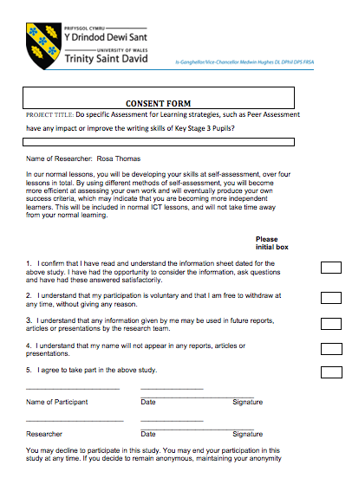
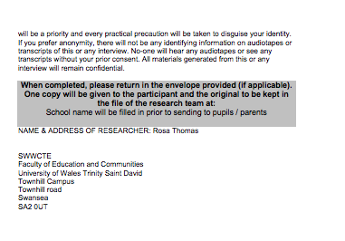

Appendix B

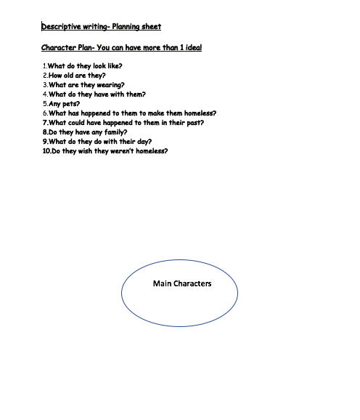

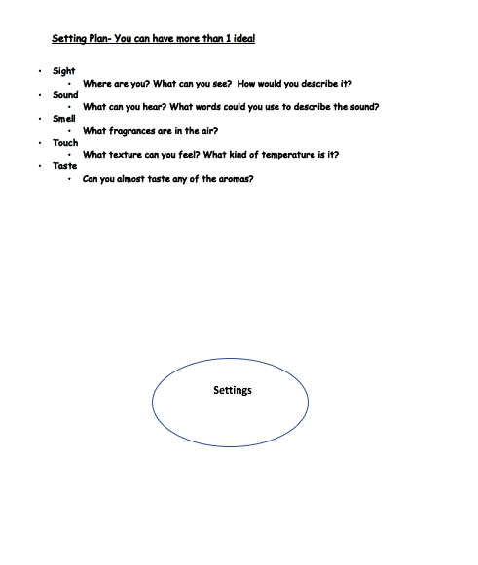

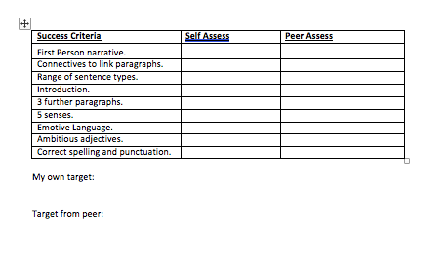
Appendix C

Appendix D
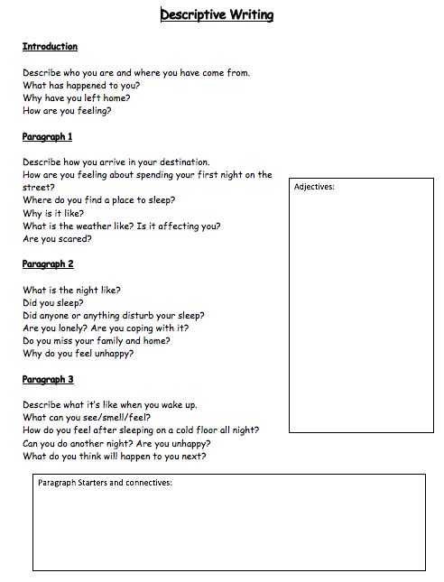

Appendix E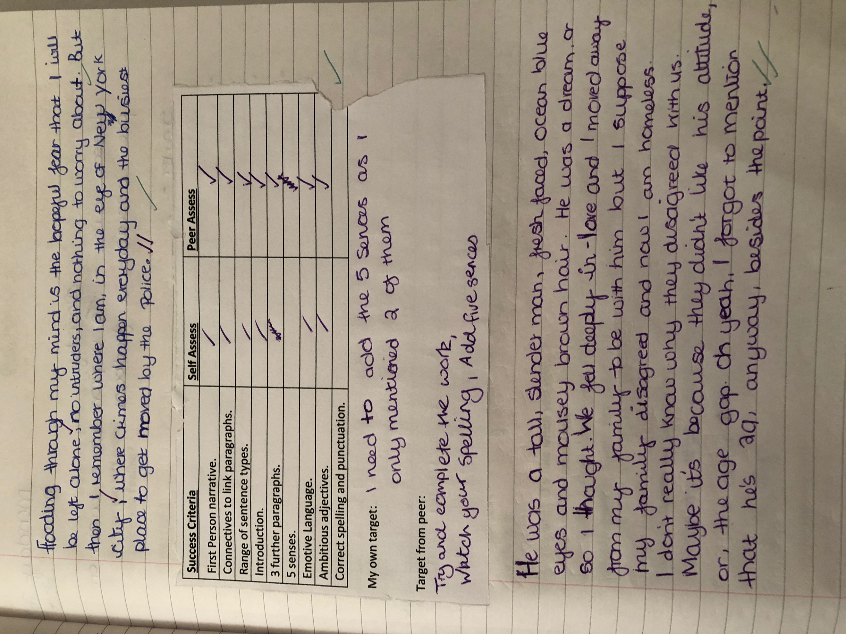

Appendix F

Appendix G

