425BCE- Cleon in the Battle of Sphacteria

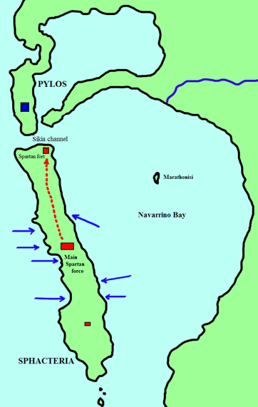
The Commanding Officer Demosthenes occupied Pylos, which was 50 miles from Sparta itself, in Peloponnesian territory. The island of Sphacteria was located opposite of Pylos and was heavily covered by trees. Demosthenes guessed that the Spartans would take refuge on the Sphacterian terrain and so attacked (Freidman, 2013). It can be assumed that the Spartans wanted looked for protection on the island of Sphacteria because of the massive amounts of shelter that it allowed. This meant that even though the Spartans didn’t have an upper hand in numbers they did have the protection of the environment which would conceal their movements from the Athenian army.

Figure 1: Spacteria. (Image from: https://en.wikipedia.org/wiki/Battle_of_Sphacteria#/media/File:Battle_of_sphacteria.png)

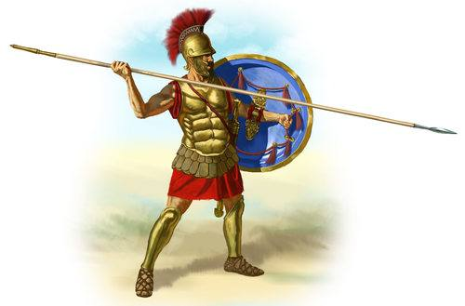
Political difficulties in Athens at this time meant that a new Commander was appointed to take charge of the Athenian troops as a replacement for Demosthenes (Freidman, 2013). This commander was called Cleon and he chose Demosthenes to be his partner for the battle. Demosthenes had previous experience when he was attacked by the Aetolians (Thucydides). He was left surrounded and lost many men. It can therefore be deduced that Cleon most likely chose Demosthenes to be his partner because of said previous experiences. He would have also had knowledge of the current affairs for what was going on in terms of Pylos and Sphacteria as it was him that was leading the previous troops. Although, Thucydides has been said to have had a poor opinion of Cleon, he still describes the success at Sphacteria as “the highest point of Athenian fortune” in reference to the Archidamian war (Marshall, 1984, pp 20). This allows the inference that Cleon’s defeat of the Spartans was something highly thought of and would have put him very much in a powerful position when he would have returned to Athens and Athenian Democracy.

Figure 2: Spartan Hoplite Soldier (Image from: https://www.ancient.eu/uploads/images/152.jpg?v=1485680514)

An Athenian troop took refuge on a desolate part of the island currently inhabited by the Spartans to cook food (Freidman, 2013). It catastrophically ended in a fire meaning that all of the woodland area burnt down and so the Spartans were left with no protection from the Athenian eyes. This is when Demosthenes saw his chance to attack and how he could seek redemption from his past failed attempts with the Aetolians. He used heavy troops and used the same concepts and tactics that the Aetolians used. The Athenians caught the Spartan hoplites by surprise resulted in their death of them fleeing. The Athenians then made for higher ground and so when the Spartans attacked, they could gradually make more casualties (Freidman, 2013). These hoplite soldiers were much different to the Athenians. They had been raised to fight and were willing to die rather than submit and show surrender (Freidman, 2013). Therefore, when the Athenians took control and managed to make the Spartans surrender it meant that the Spartans lost lots of confidence and this impacted the entire Peloponnesian League and as a result gave the Delian league more faith that they could dominate.

As a result, Cleon can be said to have not been as important in the Battle of Sphacteria than Demosthenes was because it was Demosthenes who took control of overthrowing the Spartans and he who made the timing of when to attack.

