

Module Code: ECES5014C
Assignment Title: Learning in Alternative Learning Environments Portfolio
Student Name: Cassi Herbert
Student Number: 2403806
Submission Date: 03.08.26
Word count: 4000

Content Page
Introduction and overview 3, 4

Analysis of terminology 5

Alternative Learning Environment 1: Outdoor school 6
Activity: Numeracy through water play 6
Purpose of Activity 7
Learning Outcomes 8
Theoretical Links 8
Critical Evaluation Strengths & Limitations 9
Application to Practice 10
Adaptation of activity for ALN learner & Different Age Groups 10
Overall Judgement 12
Alternative Learning Environment 2: Montessori Practice 12
Activity: Numeracy through water play 12
Purpose of Activity and Learning Outcomes 12
Theoretical Links 13
Critical Evaluation Strengths & Limitations 14
Application to Practice 14
Overall Judgement 15
Alternative Learning Environment 3: Steiner Waldorf framework 15
Activity: ‘Cawl’ making 15
Purpose of Activity 16
Learning Outcomes 16
Theoretical Links 17
Critical Evaluation Strengths & Limitations 17
Application to Practice 18
Overall Judgement 19

Conclusion 19

Reference List 20

Introduction and overview
This portfolio will discuss the following alternative learning environments: Outdoor learning, Montessori schools and the Steiner Waldorf framework. The main aim of the topic is to explore and critically evaluate various environments that differ from the educational norm. These alternative environments are important to progress forward in education and teaching. They change from the idea of 'one size fits all' and allows pupils who learn better in non-traditional ways to also thrive. They accommodate diverse learning styles, emotional needs, and personal circumstances, fostering both academic and holistic personal growth (Insight, 2026). The term ‘alternative education’ can be defined as schools or programmes that are set up by states, schools, districts, or other entities to serve young people who, for a variety of reasons are not succeeding in a traditional school environment (Ruzzi and Kraemer, 2006, cited in Miller, 2023).

The module learning outcomes requires engagement with literature and lecture resources to “have a broad and balanced knowledge of the fundamental aims, concepts, values and contexts of experiential learning.” Experiential learning is a learner-centered approach that emphasises learning through direct experience, reflection, and active engagement (Dewey, 1938; Kolb, 1984). Its fundamental aim is to help learners construct knowledge by connecting theory with real-world practice, developing critical thinking, problem-solving skills, and lifelong learning habits (Kolb, 1984; Simply Psychology, 2025). Kolb (1984) argues that knowledge is created through the transformation of experience rather than through passive reception of information.

A key concept of experiential learning is Kolb's Experiential Learning Cycle, which consists of four stages: Concrete Experience, Reflective Observation, Abstract Conceptualisation, and Active Experimentation (Kolb, 1984). Learners engage in an experience, reflect on it, develop understanding, and then apply new knowledge in practice (Kolb, 1984; Cogn-IQ, 2025). The core values underpinning experiential learning include active participation, reflection, personal growth, collaboration, and learner autonomy (Dewey, 1938; Kolb, 1984). These values encourage learners to take ownership of their learning and develop confidence, adaptability, and self-awareness (Bruner, 1966; Vygotsky, 1978).

Experiential learning occurs across diverse contexts, including schools, higher education, workplace training, outdoor education, community projects, and professional practice (Kolb, 1984; Jucker and von Au, 2022). It is particularly effective in developing practical skills by enabling learners to apply knowledge in authentic situations and reflect upon the outcomes (Dewey, 1938; Jucker and von Au, 2022).

The three proposed activities outline innovative approaches to educational practice, the curriculum, and use of learning environment and teaching materials. Whilst thorough reflection is undertaken on the role and status of experiential learning within educational policy and practice, the relationship between outdoor learning as an alternative learning environment is less prevalent within the portfolio. To evaluate the effectiveness of the alternative learning environments outlined within the three activities, a comparison with the expectations of the Curriculum for Wales was established. From this, we learn about similarities and differences in curriculum expectations.

Analysis of terminology

Terminology | Definition | Source
Experiential learning | Experiential learning is an educational approach that emphasizes learning through experience, allowing students to engage actively with material within and beyond traditional classroom settings | Weinstein, N. (2019) Experiential Learning. Available at: https://www.ebsco.com/research-starters/education/experiential-learning (Accessed: 17 July 2026).
Alternative learning environ-  ments | Alternative education refers to the provision of alternative routes for children who have missed out on basic education or are unable to complete it through normal schooling. It aims to make basic education accessible to all by offering different learning pathways. | Teachers institute (2025) Understanding the Concept and Scope of Alternative Education. Available at: https://teachers.institute/alternative-education/alternative-education-concept-scope/ (Accessed: 17 July 2026).
Outdoor learning | Outdoor learning is an active, experiential approach to learning, that involves being outdoors as a central part of the experience. It seeks to use the outdoor environment as a vehicle for transforming the experience into changes. | Harvey, D. (2012) What is outdoor learning? Available at: https://www.outdoor-learning-research.org/Portals/0/Research%20Documents/Horizons%20Archive/H57.WhatIsOutdoorLearning.pdf (Accessed: 17 July 2026).

Alternative Learning Environment 1: Outdoor school

Activity: Numeracy through water play

The activity involves reception pupils exploring volume and capacity through water play at an outdoor volume discovery corner. Pupils can explore different volume and capacity of different containers of various sizes and shapes e.g. tall, short, wide and narrow.
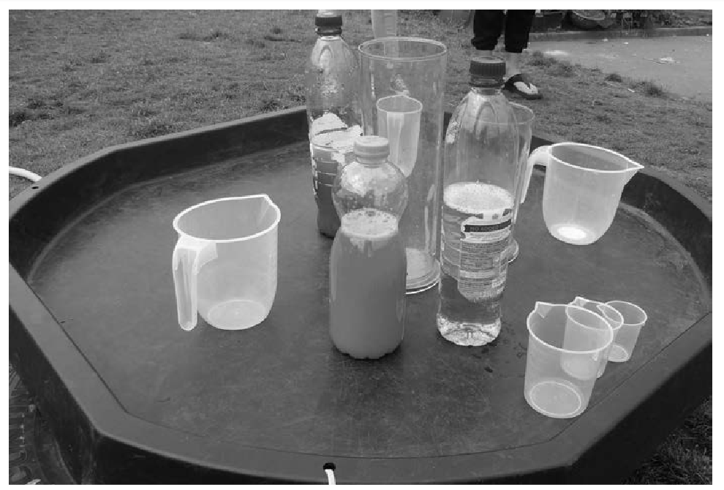
Keith (2017)
Through filling, emptying and refilling these containers pupils will develop their curiosity skills and develop suitable language vocabulary such as “full”, “empty”, “half-full”. James (2026) suggests the provision of prompts, such as questions, to enhance the learning environment and independence e.g.
Which container is the tallest?
Which container is the biggest?
Which container is the smallest?
On providing measuring equipment such as spoons, egg cups, ladles, cups etc., pupils can practice their number skills by measuring and counting the quantity of water and keeping a record. Pupils need to be able to measure accurately using these tools (Robertson, 2017). In doing so, pupils can consider:
Which container holds the most water?
Which container holds the least water?
For non-readers, these questions can be accessed through talking buttons. Adding food colouring to the water can or may also enhance the learning as this will highlight the waterline.
Purpose of Activity
While the twelve pedagogical principles apply to the curriculum design for all learners within the Curriculum for Wales, Welsh Government advise that particular attention should be paid to the following key features, which are essential at Progression step 1 period of learning:
- play and play-based learning
- being outdoors
- observation
- authentic and purposeful learning (Education Wales, 2023b).
Entwined with the above guidance is the UN Convention on the Rights of the Child (2022, quoted in UNICEF, no date) that states “Article 31 (leisure, play and culture) Every child has the right to relax, play and take part in a wide range of cultural and artistic activities.”
Furthermore, Jucker and von Au (2022) finds that:
Mounting evidence indicates that real-world learning outside the classroom contributes to unlocking the full potential of learners. Since learning in and with nature takes place outside, in real, often unpredictable situations, which require quick comprehension, reaction, dialogue among each other, reflection and solution orientation, learning with nature contributes specifically to the competencies that we humans increasingly need in order to deal with the challenges we face in the twenty first century.
While Ellis et al. (2024) assert that:
providing regular access to safe, outdoor spaces where teachers facilitate well thought out opportunities for children to learn, consolidate and extend their learning, whilst connecting with nature provides a valuable pedagogical approach. It can enrich curriculum delivery, whilst also providing opportunities to develop important skills such as self-regulation, resilience, and empathy.
Crosser (2012) agrees, although fears that “water tables are becoming an endangered species, and in too many programmes, children spend much less time outdoors than they used to.”

Ellis et al. (2024) challenges that providing children with the opportunity to explore and play in the outdoor environment is not, in itself, enough” and advise that, “To achieve the level of outdoor learning that really benefits children, teachers need to be skilled at implementing outdoor learning as a pedagogy.”

Learning Outcomes:
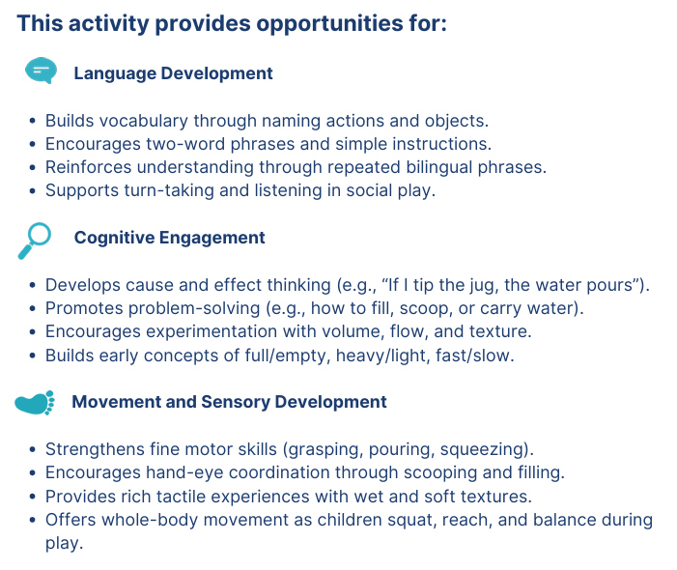
Table 1: Pour and puddle explore through playful, interactive learning (Early Years Wales, no date).

Theoretical Links
The’ Numeracy through water play’ activity is strongly influenced by Piaget’s Constructivist Theory. Piaget (1952) argued that children construct knowledge through active, hands-on experiences. As pupils fill, empty and compare containers, they explore the mathematical concepts of volume and capacity through concrete experiences, supporting cognitive development and early problem-solving skills. The use of questioning encourages pupils to develop logical thinking and make predictions about which containers hold more or less water.
Vygotsky’s Sociocultural Theory (1978) is also evident, as learning is enhanced through social interaction and adult scaffolding. Teacher prompts such as “Which container holds the most water?” support pupils within their Zone of Proximal Development (ZPD), enabling them to develop mathematical language including full, empty and half-full. Talking buttons further promote accessibility and communication for non-readers.

The activity also reflects Bruner’s Discovery Learning Theory (1966), whereby children learn through exploration and enquiry. The open-ended nature of water play encourages curiosity, investigation and independent thinking.

From a social and emotional perspective, Bandura’s Social Learning Theory (1977) highlights how children learn by observing and modelling the actions of peers. Collaborative exploration promotes turn-taking, cooperation and confidence. Furthermore, the Curriculum for Wales recognises play-based learning as fundamental to developing cognitive, social, emotional and communication skills through authentic, engaging experiences (Education Wales, 2023b).
.
Critical Evaluation
Strengths:
A key strength of this activity is that it provides a practical, hands-on approach to developing mathematical concepts of volume and capacity through meaningful outdoor play. By filling, emptying and comparing containers, children can explore abstract mathematical ideas in a concrete way, supporting their understanding of measures and mathematical language such as full, empty and half-full (Keith, 2017). The use of questioning prompts encourages critical thinking, prediction and problem-solving, while measuring tools enables learners to practice counting and recording quantities accurately. Outdoor learning can increase engagement, motivation and communication skills, while providing authentic opportunities to apply numeracy in real-life contexts, supporting the aims of the Curriculum for Wales (Summers, no date).
Limitations:
A potential weakness is that learning outcomes may vary depending on pupils' prior mathematical knowledge and their ability to measure accurately. Robertson (2017) highlights that children require support to use measuring tools correctly; therefore, misconceptions about volume and capacity may arise without adult guidance. Additionally, some pupils may focus more on the sensory and play aspects of water exploration than intended mathematical learning. Practical challenges such as weather conditions, spillages and limited resources may also reduce the effectiveness of the activity. Furthermore, the Ellis et al. (2024) notes that evidence regarding the direct impact of outdoor learning on academic attainment remains limited, meaning strong pedagogical planning is essential.
Application to Practice
Table 2 suggests how a teacher could prepare resources to develop mathematical skills in an outdoor environment:
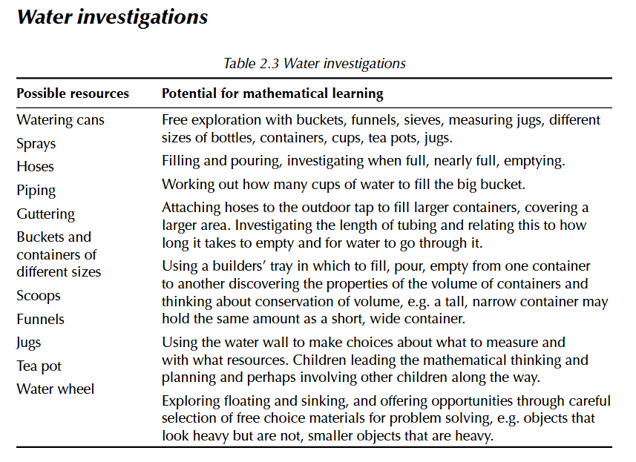
Table 2: What are the features of an enriched environment? (Keith, 2017).

Adaptations of activity for:
ALN learners
To ensure inclusion, the activity can be adapted through visual, sensory and physical support (Education Endowment Foundation, 2025). Visual symbol cards showing words such as full, empty, more and less can support learners with communication difficulties, while talking buttons can provide verbal instructions and questions. For pupils with sensory sensitivities, alternatives such as coloured rice or sand may be offered, or gloves provided during water play. Containers and equipment should be placed at accessible heights for learners with physical needs. Adult modelling, simplified questions and peer support can further scaffold learning, enabling all pupils to engage with concepts of volume, capacity and counting successfully.
Different Age Groups
Adding tubing and guttering to water play supports Progression Step 2 learners by encouraging investigation, problem-solving and collaborative learning (Growing Together, no date). Children explore how water moves through different pathways, developing understanding of forces, gravity and flow within the Science and Technology Area of Learning and Experience (Education Wales, 2020). They can measure lengths, compare volumes and predict outcomes, supporting mathematical reasoning and numeracy skills. Open-ended construction promotes creativity, critical thinking and perseverance while fostering the Curriculum for Wales Four Purposes, particularly ambitious, capable learners and enterprising, creative contributors. This hands-on activity encourages learners to test ideas, evaluate solutions and communicate findings effectively (Welsh Government, 2021).
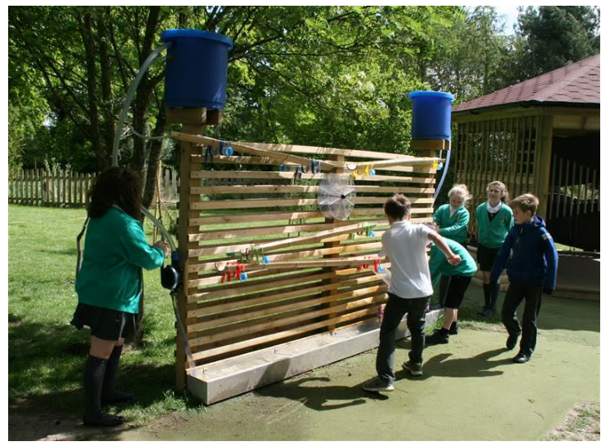
(Turner, 2015).
Overall Judgement
Overall, this is an effective outdoor classroom activity for developing early numeracy, provided it is carefully planned, scaffolded and supported by adults. Its practical, inclusive nature justifies its use.
Alternative Learning Environment 2: Montessori Practice
Activity: Phonics and Letter Formation
Lillard (2021) observed the following activity within a Montessori setting:
Children are seated in a semicircle around a teacher, who holds up small pink (for vowels) and blue (for consonants) wooden boards, each with a different letter on it, cut out of sandpaper and in cursive. The teacher holds up the letter and asks what it is, and children chime in with the sound it makes, like, ‘buh’ for the b. She then asks them for words that start with ‘buh’ and the children come up with a variety of words, bee, ball, bottle, and so on. She also shows how to trace the sandpaper with one’s finger in the same way one would write the letter. Children copy her motion, one by one (Lillard, 2021).
Purpose and Learning Outcomes
Lillard (2021) advocates “Montessori” as “a contemporary alternative education” that “exists squarely in the more modern systems approach.” Within the learning environment, “children are free to choose on a daily basis with what activities to engage, with whom, and for how long”, although Lillard (2021) emphasises that “there are strict rules and guidelines, within which children are free.”

Montessori practice teaches language development through phonics, as outlined in the activity (Thomas and Lewis, 2020). Although reading, writing and mathematics can be introduced at an early age within the Montessori pedagogy, it is actioned only when a child is ready and demonstrates an interest (Thomas and Lewis, 2020).
The phonics activity promotes cognitive development by strengthening pupils’ letter recognition, phonemic awareness, and ability to connect sounds with words, which are key foundations for early reading and writing (Schlesinger and Gray, 2017). It also develops memory and problem-solving as children recall words beginning with specific sounds. Socially, children learn to listen to others, take turns, and participate in group discussions, encouraging cooperative learning. Emotionally, successfully identifying letters and sounds can increase confidence and motivation to engage with reading and writing tasks. Tracing the sandpaper letters also supports fine motor control and independence, helping pupils build resilience through repeated practice and gradual skill mastery.
Theoretical Links
Lillard (2021) recognises Montessori as “a modern theorist in the sense of approaching child development as a constructive enterprise, a reciprocal interaction between the child’s biology and the environment at many levels. Furthermore, Lillard (2021) recognises that Montessori “collapses the tensions in two controversies in early education today: structure versus freedom, work versus play, because the work is playful, and a tight structure envelops the freedom.” As a result of her medical background, Lillard (2021) justifies how Montessori “approached children with deep appreciation of the body and brain as physical entities responding to and with the environment.”

The Association Montessori Internationale (no date, quoted in Archer, 2024) outline that “a Montessori pedagogue is responsible for creating ‘a hands-on, self-paced, collaborative, and joyful classroom’”, whilst the ‘prepared environment’ is described as having:
accessible furniture, a variety of workspaces, and scientifically designed materials displayed for free choice of activity. These materials support concrete exploration which leads to both practical skills and abstract knowledge. Such exploration is initiated through minimalist lessons offered by the trained Montessori teacher followed by hands-on, self-directed, and self-correcting learning which can be individual, collaborative, or peer-to-peer (Association Montessori Internationale, no date, quoted in Archer, 2024).
To conclude, Archer (2024) acknowledges the following “features as hallmarks of authentic Montessori practice”, as outlined by the Association Montessori Internationale (no date):
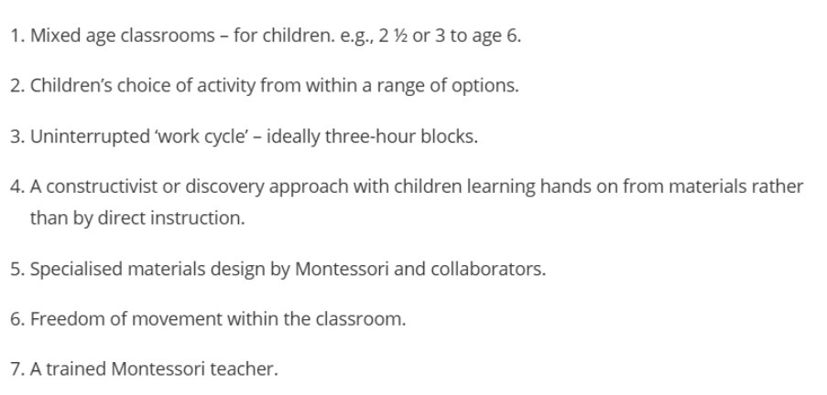
Critical Evaluation
Strengths:
The phonics activity is effective because it combines visual, tactile, auditory, and kinesthetic learning, helping pupils connect letter shapes with their corresponding sounds. The use of sandpaper letters encourages active engagement and supports the development of early writing skills through multisensory exploration. Research suggests that multisensory phonics instruction strengthens letter–sound correspondence and promotes early literacy development (Schlesinger and Gray, 2017). By asking pupils to identify sounds and generate words, the teacher also develops phonemic awareness and vocabulary. The activity particularly benefits young learners and children with diverse learning styles, as it offers multiple ways to access and reinforce foundational reading and writing skills.
Limitations:
Despite its benefits, the phonics activity has some limitations. The specialised sandpaper letters and wooden boards may be costly to purchase and maintain, particularly in larger settings. Inclusion issues may arise for pupils with visual impairments, fine motor difficulties, sensory sensitivities, or limited English proficiency, who may require adaptations to access the activity fully. Additionally, the whole-group format may not provide sufficient support for learners with ALN who need more individualised instruction. Safeguarding and practical concerns include managing children as they take turns tracing letters and ensuring materials are used safely. Furthermore, some learners may find the repetitive nature of the activity disengaging or insufficiently challenging.
Application to Practice
Estyn (2026) recognises effective practice by Ysgol Bro Preseli to improve pupils’ reading skills, including phonic intervention:
Reading begins at a very early stage with Welsh phonics schemes and, later, English phonics programmes, which support the acquisition of English skills and enables staff to monitor progress regularly. The school ensures a wide variety of books to meet the needs and interests of all learners.
A culture of reading is developed through various initiatives, including a weekly reading club led by the sixth form in the primary sector, book exchange campaigns, readathons’ and creative literacy and reading activities.
To promote independent reading, teacher-led reading takes place regularly, with whole class novels covering a wide range of themes. There are regular opportunities for group reading and mutual reading, with a focus on expanding vocabulary, understanding and enjoyment.
For pupils with lower reading skills, additional support is provided through interventions and various reading development programmes, which provide opportunities to tailor interventions and respond directly to learners’ difficulties (Estyn, 2026).

Overall Judgement
Overall, the Montessori phonics activity is an effective method for developing early literacy skills through multisensory learning. It is most effective when delivered by a skilled practitioner, supported by appropriate resources, and adapted to meet diverse learning needs. Additional differentiation may be required to ensure full inclusion and engagement.

Alternative Learning Environment 3: Steiner Waldorf framework
Activity: ‘Cawl’ making

A group of children gather around the cooking table to prepare vegetables for making ‘cawl’ and grasp mathematical skills and language in a practical manner as part of daily life. Real life equipment is provided such as small knives (as those used for eating school lunch), peelers and chopping boards. The educator may use the opportunity to discuss mathematical concepts such as shapes (carrot circles); measuring quantity (more/ less or grams for those who can read weight); addition and subtraction (with consideration to pupil voice in terms of favourite and least favourite vegetables). The concept of preservation may be approached on observing the vegetables turning colour when peeled and out of water.
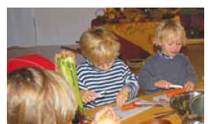(Clouder, 2009)
Purpose
Clouder (2009) outlines the learning and development principles within the Steiner Waldorf early childhood curriculum. It considers the “whole child” and promotes the “interdependence of physical, emotional, social, spiritual and cognitive development” and allows children to “develop these capacities at their own pace within a well-structured and child-friendly environment” (Clouder, 2009). The approach emphasises the need for “young children to experience the relevance of their world before they separate themselves from it and begin to analyse it in a detached way”. Furthermore, Clouder (2009) explains that “The learning experience of children under the age of seven therefore is integrated and not subject-based” or theme based as is common in early years planning (Barnes, 2015).

Learning Outcomes
Steiner (1924, quoted in Clouder, 2009) emphasised that the approach “does not educate the child for the age of childhood, we educate him for his whole earthly existence”. Steiner’s holistic, integrated approach resonates with Curriculum for Wales by fostering healthy, confident individuals, ambitious learners, ethical citizens, and creative contributors through experiential learning, wellbeing, child-centred development, and lifelong growth aligned with the four purposes (Welsh Government, 2021, Clouder, 2009).
The activity promotes:
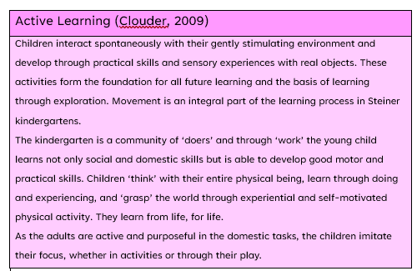

Theoretical Links
The ‘cawl’ making activity strongly reflects Dewey’s (1938) theory of experiential learning, as children learn through meaningful real-life experiences. Preparing vegetables for ‘cawl’ allows children to engage in “learning by doing,” making mathematical concepts such as counting, measuring, and comparing quantities relevant to everyday life rather than abstract ideas.
The activity also aligns with Kolb’s Experiential Learning Cycle (1984). Children gain concrete experience through peeling and chopping vegetables, reflect on changes such as vegetables turning colour, developing abstract concepts about preservation and measurement, and apply new understanding through continued participation in cooking tasks.

Furthermore, Vygotsky’s Sociocultural Theory (1978) highlights the importance of learning through social interaction. Discussions with peers and educators about favourite vegetables, shapes, weights, and quantities provide opportunities for language development and collaborative problem-solving. Through adult questioning and guidance, children work within their Zone of Proximal Development, extending mathematical and scientific understanding beyond what they could achieve independently.

Critical Evaluation
Strengths:
The ‘cawl’ making activity is effective because it embeds mathematical, scientific, and language learning within a meaningful real-world context. Children actively engage with counting, measuring, comparing quantities, and discussing observations, which promotes deeper understanding than isolated classroom tasks. Dewey (1938) argued that learning is most effective when connected to authentic experiences, while Kolb (1984) highlighted the value of hands-on learning for knowledge construction. The collaborative nature of cooking supports communication, vocabulary development, and problem-solving through social interaction, reflecting Vygotsky’s (1978) emphasis on guided learning. This particularly benefits young learners by enhancing engagement, confidence, practical life skills, and cross-curricular understanding.

Limitations:
Despite its benefits, this activity presents several limitations. The use of knives and peelers requires close adult supervision, creating safeguarding concerns and increasing staffing demands. Practical costs associated with ingredients, equipment, and food hygiene requirements may also restrict implementation. Children with fine motor difficulties, sensory sensitivities, or certain additional learning needs may find peeling and chopping challenging without adaptations. Furthermore, allergies and dietary restrictions must be carefully managed to ensure inclusion and safety. Although hands-on learning is engaging for many children, some learners may prefer visual, verbal, or structured approaches, meaning the activity may not suit all learning preferences equally.

Application to Practice
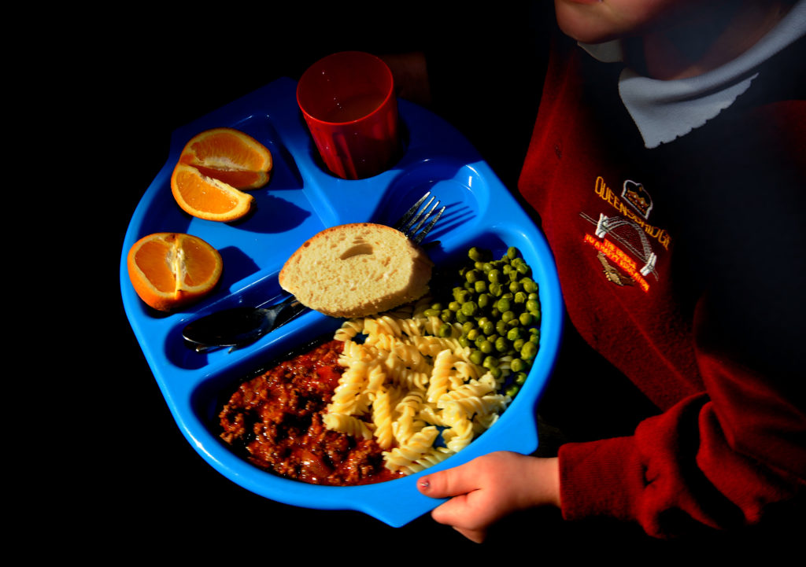 (Devlin, no date)

Nation Cymru (2026) explains how primary school pupils can help to shape new healthy school menu:
Primary school pupils across a Welsh county are learning how to cook and taste-testing one of the recipes which will be introduced to their new school menu in the autumn.

Pupils were given the practical lesson in cooking and were able to give their feedback on the meals, through a collaboration between the catering team at Bridgend County Borough Council, Bridgend Sustainable Food Partnership and The Cookalong Clwb. Cookalong Clwb session is running in eleven primary schools.

As well as learning about cooking pasta and a seven-vegetable tomato sauce, the pupils are also learning about the importance of Welsh-grown vegetables being used in school kitchens.

The Welsh Veg in Schools programme is a partnership between schools and Welsh growers, working to align what is served by schools with what we are growing in Wales.

The new school menu has been developed in line with Welsh Government’s latest Healthy Eating in Schools regulations. This will see at least two portions of vegetables and one portion of fruit provided every day, with restrictions on unhealthy options such as fried food and pastries. “This initiative supports their health and development, fuels their learning and sets them up with healthy eating habits for the future” according to Councillor Martyn Jones, Cabinet Member for Education and Young People. This was further commended by Lynsey Lewis, a senior teacher at Betws Primary School who noted, “It’s been a fantastic practical lesson, and they’re learned a lot about where our food comes from and the veg that we’re growing in Wales specially for our school kitchens” (Nation Cymru, 2026).

Overall Judgement
Overall, the ‘cawl’ making activity is highly effective in promoting holistic, experiential learning through meaningful real-life experiences. Its success depends on appropriate adult supervision, inclusive adaptations, and effective risk management. Despite some practical and accessibility challenges, the educational benefits outweigh the limitations, making it a valuable pedagogical approach for early years practice.

Conclusion

This portfolio has explored three alternative learning environments: outdoor learning, Montessori education, and the Steiner Waldorf approach, demonstrating how each offers valuable alternatives to traditional educational models (Thomas and Lewis, 2020; Clouder, 2009; Miller, 2023). Collectively, these approaches challenge the notion of a "one-size-fits-all" education system by recognising the diverse learning needs, interests, and developmental pathways of children (Education Endowment Foundation, 2025; Miller, 2023). Through the critical analysis of the three activities, it is evident that alternative learning environments can promote both academic achievement and holistic development by placing the learner at the centre of the educational experience (Insight, 2026; Ruzzi and Kraemer, 2006).

A key theme throughout the portfolio has been the significance of experiential learning. Drawing on the work of Dewey (1938) and Kolb (1984), all three activities enabled learners to construct knowledge through direct experience, reflection, and active participation. Whether exploring mathematical concepts through water play (Keith, 2017; Early Years Wales, no date), developing literacy skills through a Montessori phonics sessions (Lillard, 2021; Archer, 2024), or engaging in practical cooking experiences within a Steiner-inspired environment (quoted in Clouder, 2009), learners were provided with meaningful opportunities to connect theory with real-life contexts. These approaches reflect the core values of experiential learning, including autonomy, collaboration, curiosity, reflection, and personal growth (Dewey, 1938; Kolb, 1984; Vygotsky, 1978).

The comparison with the Curriculum for Wales further highlighted significant alignment between alternative educational approaches and contemporary educational priorities (Welsh Government, 2021; Education Wales, 2020). Each activity supported the Four Purposes by encouraging children to become ambitious, capable learners, healthy and confident individuals, ethical citizens, and creative contributors (Welsh Government, 2021; Education Wales, 2023b). Although challenges relating to resources, accessibility, staff expertise, and evidence of impact remain, the educational benefits outweigh these limitations (Education Endowment Foundation, 2025; Ellis, Waite and Smith, 2024). Overall, alternative learning environments offer powerful and inclusive opportunities for enhancing children's learning, wellbeing, engagement, and lifelong development, reinforcing the importance of diverse pedagogical approaches within modern education (Jucker and von Au, 2022; Miller, 2023).

Reference list
Archer, N. (2024) 'Walking a desire track: Montessori pedagogy as resistance to normative pathways', Pedagogy, Culture and Society, 32(4), pp. 1079-1097. Available at: https://doi.org/10.1080/14681366.2024.2355097 (Accessed: 13 July 2026).

Bandura, A. (1977) Social Learning Theory. Prentice Hall.

Barnes, J. (2015) Cross-curricular learning 3-14. 3rd edn. Sage Publications.

Bruner, J.S. (1966) Toward a Theory of Instruction. Harvard University Press. Available at: https://archive.org/details/towardtheoryofin00brun (Accessed: 11 July 2026).

Clouder, C. (2009) Guide to the Early Years Foundation Stage in Steiner Waldorf Early Childhood Settings. Available at: https://foundationyears.org.uk/files/2011/10/Guide_to_the_EYFS_in_Steiner_Wardorf_settings1.pdf (Accessed: 16 July 2026).

Cogn-IQ (2025) Experiential Learning: Kolb's Cycle, Styles and Evidence. Available at: https://www.cogn-iq.org/learn/theory/experiential-learning/ (Accessed: 18 July 2026).

Crosser, S. (2012) 'Making the most of water play', Community Playthings, June. Available at: https://www.communityplaythings.co.uk/learning-library/articles/making-the-most-of-water-play (Accessed: 11 July 2026).

Devlin, A. (no date) Healthy school dinner. Available at: https://nation.cymru/news/primary-school-pupils-help-shape-new-healthy-school-menu/ (Accessed: 16 July 2026).

Dewey, J. (1938) Experience and Education. Macmillan.

Early Years Wales (no date) Pour and puddle: explore through playful, interactive learning. Available at: https://www.earlyyears.wales/sites/default/files/water_play_1.pdf (Accessed: 11 July 2026).

Education Endowment Foundation (2025) Special Educational Needs in Mainstream Schools. Available at: https://educationendowmentfoundation.org.uk/education-evidence/guidance-reports/send (Accessed: 11 July 2026).

Education Wales (2020) Science and Technology: Descriptions of Learning. Available at: https://hwb.gov.wales/curriculum-for-wales/science-and-technology/descriptions-of-learning/ (Accessed: 11 July 2026).

Education Wales (2023a) Pedagogical Principles and Progression Step 1 Guidance. Available at: https://hwb.gov.wales/curriculum-for-wales (Accessed: 18 July 2026).

Education Wales (2023b) Enabling learning. Available at: https://hwb.gov.wales/curriculum-for-wales (Accessed: 11 July 2026).

Ellis, C., Ellis, R., Dobson, L., O'Leary, S. and Williams, A. (2024) ‘Outdoor learning within the primary curriculum: a ‘fringe add-on or mainstream pedagogical practice’?’, Wales Journal of Education, 26(2), pp. 140–152. Available at: https://journal.uwp.co.uk/wje/article/697/galley/608/view/ (Accessed: 11 July 2026).

Estyn (2026) 'Whole-school strategy to improve pupils’ reading skills', Effective Practice, 13 July. Available at: https://estyn.gov.wales/improvement-resources/whole-school-strategy-to-improve-pupils-reading-skills/ (Accessed: 14 July 2026).

Estyn (2026) ‘Whole-school strategy to improve pupils’ reading skills’, Effective Practice, 13 July. Available at: https://www.estyn.gov.wales (Accessed: 18 July 2026).

Growing Together (no date) '15 water play activity set ups', Growing Together, 10 September. Available at: https://growingtogetherearlyyears.co.uk/blog/15waterplayactivitysetups (Accessed: 11 July 2026).

Growing Together (no date) Water play with tubing and guttering. Available at: https://www.growingtogether.org.uk (Accessed: 18 July 2026).

Harvey, D. (2012) What is outdoor learning? Available at: https://www.outdoor-learning-research.org/Portals/0/Research%20Documents/Horizons%20Archive/H57.WhatIsOutdoorLearning.pdf (Accessed: 17 July 2026).

Insight (2026) Benefits of Alternative Learning Environments. Available at: https://www.insight.com (Accessed: 18 July 2026).

James, C. (2026) 'Volume activities for kids: learn volume with water play', Nurture Store, 1 July. Available at: https://nurturestore.co.uk/learning-about-volume-activity-using-water/ (Accessed: 7 July 2026).

James, C. (2026) ‘Volume Activities for Kids: Learn Volume with Water Play’, NurtureStore, 1 July. Available at: https://nurturestore.co.uk/learning-about-volume-activity-using-water/ (Accessed 7 July 2026).

Jucker, R. and von Au, J. (2022) High-Quality Outdoor Learning: Evidence-Based Education Outside the Classroom for Children, Teachers and Society. Springer.
Keith, L. (2017) Developing Young Children's Mathematical Learning Outdoors: Linking Pedagogy and Practice. Routledge. Available at: https://www.taylorfrancis.com (Accessed: 11 July 2026).

Kolb, D.A. (1984) Experiential Learning: Experience as the Source of Learning and Development. Prentice Hall. Available at: https://books.google.com/books/about/Experiential_Learning.html?id=zXruAAAAMAAJ (Accessed: 18 July 2026).

Lillard, A.S. (2021) Montessori: The Science Behind the Genius. 4th edn. Oxford University Press.

Lillard, A.S. (2021) 'Montessori as an alternative early childhood educational approach', Early Child Development and Care, 191(7-8), pp. 1196-1206. Available at: https://doi.org/10.1080/03004430.2020.1832998 (Accessed: 13 July 2026).

Miller, P. (2023) Alternative Education: Supporting Learners Beyond Traditional Schooling. Routledge.

Nation.Cymru (2026) 'Primary school pupils help shape new healthy school menu', Nation Cymru, 13 July. Available at: https://nation.cymru/news/primary-school-pupils-help-shape-new-healthy-school-menu/ (Accessed: 16 July 2026).

Piaget, J. (1952) The Origins of Intelligence in Children. International Universities Press.
Robertson, J. (2017) The Dirty Teaching Handbook. Independent Thinking Press.

Ruzzi, B.B. and Kraemer, J. (2006) Academic Programs in Alternative Education. National Center on Education and the Economy.

Schlesinger, N.W. and Gray, S. (2017) 'The impact of multisensory instruction on learning letter names and sounds, word reading, and spelling', Annals of Dyslexia, 67(3), pp. 219-258. Available at: https://doi.org/10.1007/s11881-017-0140-z (Accessed: 13 July 2026).

Simply Psychology (2025) Kolb's Learning Styles and Experiential Learning Cycle. Available at: https://www.simplypsychology.org/learning-kolb.html (Accessed: 18 July 2026).

Summers, S. (no date) Mathematics and Numeracy. Available at: https://www.csc-cronfa.cymru/api/storage/985d9144-ffc8-4f2e-9ab7-0446ea7c018c/10.%20Outdoor%20learning%20for%20maths.pdf (Accessed: 11 July 2026).

Teachers institute (2025) Understanding the Concept and Scope of Alternative Education. Available at: https://teachers.institute/alternative-education/alternative-education-concept-scope/ (Accessed: 17 July 2026).

Thomas, A. and Lewis, A. (2020) An Introduction to the Foundation Phase: Early Years Curriculum in Wales. Bloomsbury Academic. Available at: https://doi.org/10.5040/9781474264310 (Accessed: 13 July 2026).

Thomas, P. and Lewis, F. (2020) Understanding Montessori Education. Sage.
Turner, D. (2015) 'Outdoor learning and play', Pentagon Play, 4 September. Available at: https://www.pentagonplay.co.uk/news-and-info/the-benefits-of-sand-and-water-play (Accessed: 11 July 2026).

UNICEF UK (no date) UN Convention on the Rights of the Child. Available at: https://www.unicef.org.uk/what-we-do/un-convention-child-rights/ (Accessed: 18 July 2026).

Vygotsky, L.S. (1978) Mind in Society: The Development of Higher Psychological Processes. Harvard University Press.

Weinstein, N. (2019) Experiential Learning. Available at: https://www.ebsco.com/research-starters/education/experiential-learning (Accessed: 17 July 2026).

Welsh Government (2021) Curriculum and Assessment (Wales) Act 2021, Section 2: The Four Purposes. Available at: https://www.legislation.gov.uk/asc/2021/4/section/2/enacted (Accessed: 16 July 2026).

