Title: The Influence of Marketing Strategies on Hotel Occupancy Rates: A Study of Delta
by Marriott Newcastle Gateshead
Student Name:Andreea Catalina Mecic
Student Number:2215573
Lecture Name: Christopher Wilkin
Module Name: Hotel Placement Research Project
Module code: BMIH6008

Declaration
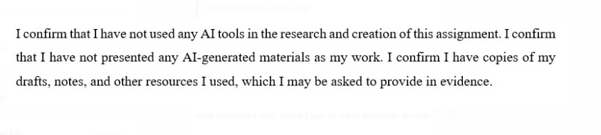

Acknowledgements
I am thankful to everybody who supported me amid this research project. Firstly, I owe a obligation of gratitude to my scholastic administrator for giving me with priceless direction, encouragement, and down to earth lessons amid this extend. Much appreciated for making a difference me think about for my situation. I am thankful to Delta Lodgings by Marriott Newcastle. I may conduct this consider since they collaborated, advertised their conclusions, and taken an interest within the venture. I appreciate my companions and coworkers for supporting and persuading me amid this travel. I am thankful to my family and friends for their faithful support, resilience, and conviction in my capacity to total this.

Abstract
The study investigates how marketing techniques used by Delta by Marriott Newcastle Gateshead, specifically digital and online channels, shape customers’ opinions and decision to book. Since the hospitality field is getting more competitive, companies must see how marketing impacts customer decision-making to grow successfully. The subject of study relies on shifting customer behavior, greater digital usage and an growing utilization of resources produced by users, prizes and tailored messaging in marketing. Its central purpose was to find out how social media, emails, loyalty programs, limited time offers, reviews and the brand image themselves impact customer decisions and behavior. Structured surveys were used in this research by sending them to guests who had booked the hotel in the last 12 months. All 219 valid replies were examined to find out how the hotel’s marketing approaches work for different kinds of guests. Results found that most customers at the hotel are individuals between the ages of 35 and 64 and around three-quarters are female. While some respondents said that email campaigns and social media influenced their bookings, quite a number believed these channels made little difference to their decisions. Nearly half of the travelers believed that marketing was not directly involved in their choice to stay there and significant numbers said they discovered the hotel in other ways. Ultimately, online reviews and membership to loyalty schemes were recognized by over half of those surveyed as having an important effect on whether they book a room. Analyzing the results, we see that opinions on how easily consumers can use websites and how correct the advertising is different. Although a number of people found the online process easy and the ads accurately represented the event, there were also customers who had problems or were unsure. Still, the way guests view the hotel’s brand and its staff shows that the internal service is aligned with what the brand promises. From these results, the report states that Delta by Marriott Newcastle Gateshead is successfully using loyalty programmes and managing its online reputation, yet there is still a lack of effort in digital interaction and relevant messaging. Most customers don’t seem to be affected by standard marketing, suggesting that companies should rely more on data, personalise their marketing and better segment their customers. Website ease of use, similarity in content across pages and a stronger social media approach are suggested as improvements. The report proposes actions such as improving target marketing, updating digital tools, modifying advertising and using customer feedback to keep optimising marketing efforts. When marketing communications match what customers expect and do, the hotel will likely see more visibility, greater customer satisfaction and higher conversion rates for bookings. The study presents a complete assessment of existing practices and outlines a route for UK hospitality to improve its customer-focused marketing.

Table of Contents
1 Chapter 1: Introduction 7
1.1 Background of Delta Hotels by Marriott Newcastle Gateshead 7
1.2 Research aims and objectives 7
1.3 Research Questions 8
1.4 Overview of the case study 8
2 Chapter 2: Literature Review 10
2.1 Marketing Strategies in the Hotel Industry 10
2.2 Measuring Hotel Performance and Occupancy 10
2.3 Digital Marketing and Its Role in Hotel Performance 11
2.4 Theoretical and Conceptual Framework 12
2.4.1 SWOT ANALYSIS 12
2.4.2 Relationship Marketing Theory 14
2.5 Research Gap 14
3 Chapter 3: Methodology 15
3.1 Research philosophy and design 15
3.2 Research method and research approach 15
3.3 Data collection method and analysis 16
3.4 Sampling technique 16
3.5 Ethical consideration 17
4 Chapter 4: Findings and Discussion 18
4.1 Findings 18
4.2 Discussion 31
5 Chapter 5: Conclusion and Recommendations 35
5.1 Conclusion 35
5.2 Recommendations 36
6 References 41
7 Appendix 51
7.1 QUESTIONNAIRE 51
7.2 RESPONSES 56

Chapter 1: Introduction

Background of Delta Hotels by Marriott Newcastle Gateshead
Hospitality is essential and active in the global economy, covering housing, cuisine and customer service (Tabenska, 2022). The industry supports tourism, provides jobs and boosts both the local and national economy. Over the past few years, the industry has seen major changes due to new technologies, new things consumers want and more focus on sustainability and customised guest experiences (Pencarelli, 2020). Moreover, I had the opportunity to observe and take part within the ordinary exercises of a around the world celebrated lodging beneath my arrangement at Delta Inns by Marriott Newcastle Gateshead (Marriott Bonvoy, 2016). Since the market is so competitive, my time in the field taught me about both the problems and new trends affecting hotels (Veal et al., 2001). This study is important because it shows how such a hotel alters its service systems and operations to react to modifications in the sector such as digital tools, more involved guest relationships and focusing on sustainability (Kolobkova et al., 2021). The hospitality industry must combine old-fashioned service with new improvements (Carlbäck, 2022). For this research, we look into these trends by studying a case study, helping us understand how a leading hotel like Delta by Marriott is responding to changes in hospitality (Marriott Bonvoy, 2016). Any discoveries made could help enhance operations, make guests happier and guide future plans for the company.

Research aims and objectives
The aim of this project is to critically analyses the impact of marketing strategies on the occupancy rates of Delta by Marriott Newcastle Gateshead, and to evaluate the effectiveness of different marketing channels in driving bookings and customer engagement.
- To determine the current marketing strategies employed by Delta by Marriott Newcastle Gateshead.
- To identify the effectiveness of various marketing channels in influencing customer booking behavior and increasing occupancy rates.
- To provide recommendations for optimizing marketing strategies based on the analysis to improve the hotel’s occupancy rates, particularly during off-peak seasons.

Research Questions
Q1: How to determine the current marketing strategies employed by Delta by Marriott Newcastle Gateshead?
Q2. How to identify the effectiveness of various marketing channels in influencing customer booking behaviour and increasing occupancy rates.

Overview of the case study
Delta Hotels by Marriott Newcastle Gateshead is a stylish, luxury hotel that is positioned in Gateshead, close to Newcastle upon Tyne (NEWCASTLE UPON TYNE, 2022). Since it’s on the Quayside and not far from the city’s landmarks and business centers, the hotel is popular with business people, tourists and visitors at events (Collis et al., 2004). As a Marriott company, Delta aims to give guests streamlined service, stylish comfort and values simplicity and quality in travel (Emara et al., 2023). Guests have access to 161 comfortable rooms, a place to exercise, meeting and event spaces and an on-site restaurant and bar at the Newcastle Gateshead location (Muldoon-Smith et al., 2024). The hotel is vital for nearby travel and business communities because it helps boost tourism locally (Ziyae et al., 2021). Because it places such importance on good service and happy guests, it is considered a strong contender in the North East hotel market. The guests at the hotel are corporate travelers for business events, tourists coming to explore and event guests here for weddings or social occasions (Garner and Kim, 2022). According to the study of Alhazzani et al. (2021), location close to transport, modern art and big venues makes the city more attractive to various visitors. This case study looks at how Delta Hotels by Marriott Newcastle Gateshead runs its operations and provides customer experiences as the industry evolves (Buhalis et al., 2022). The investigation targets to gain useful understanding of modern hotel management and service innovation by studying actual challenges from the workplace.

Chapter 2: Literature Review

Marketing Strategies in the Hotel Industry
The hotel industry has adjusted its marketing approaches due to worldwide changes, the shifting wishes of consumers and more competitors (Altinay and Arici, 2021). This research group, led by Kim (2023), indicates that strongly differentiating a hotel in a crowded market depends on how it organises market segments, separates its brand and offers its services. Many international hotel chains, such as Marriott International, appeal to different crowds by offering several brands (Horozhankina et al., 2024). The brand is designed for business and leisure guests who expect simple services at a great price, and it is situated between limited-service and luxury hotels (Kim et al.,2021).
Hotel marketers in the UK must understand each market’s traits and remain true to the global brand standards (Foroudi, 2020). According to the study by Gelbman (2021), regional cities must carefully balance their stock selection because consumer tastes often differ from those in urban centres. However, research is still modest on how companies like Delta customise their ideas for places like Newcastle. Studies by Ampountolas et al. (2020) suggest that many hotels in regional areas base their marketing on value to interest price-sensitive people. Still, little has been written on how this model fits with well-known brands such as Delta.

Measuring Hotel Performance and Occupancy
The main methods used in the hotel industry to measure success are calculating occupancy rate, average day rate (ADR) and revenue per available room (RevPAR). They are needed to cheque how well the company is doing financially and how efficiently it operates (Remy et al., 2023). Olson et al. (2021) believe that connecting marketing planning with how to judge results is necessary for hotels to succeed and plan ahead. Having these metrics enables researchers to cheque how well the Delta by Marriott Newcastle Gateshead is performing in the area.
Although performance indicators are often used in industry reports, academic researchers have said that these indicators do not measure how guests feel about a brand (Khan et al., 2020). Based on the research done by Anagnostopoulou et al. (2020), financial records and guest feedback help people understand how the hotel is performing. It is common in regional cities that well-known companies are not always the leading names in their field (Alexander et al., 2020). There are very few research studies about how to measure urban areas outside the main cities, compared to the abundance of studies on capital cities or tourism venues (Gan et al., 2021). People are therefore not sure exactly how branded hotels function in Newcastle Gateshead, especially now that the town is expanding as a centre for both culture and business tourism (Sáblíková, 2023).

Digital Marketing and Its Role in Hotel Performance
The emergence of digital marketing has profoundly reshaped how hotels now use new methods to attract customers, control their reputation online and judge their return on marketing investments (Steenkamp, 2020). Garcia et al. (2021) explain that nowadays, online travel agencies (OTAs) and review websites play a key role in shaping how and where we book our trips. Delta by Marriott, along with other brands owned by Marriott, combines social media engagement, improving SEO ranking and using a loyalty program in its marketing (Mathews et al., 2021). Such campaigning aims to attract direct reservations and make people more aware of the brand (Hujić and Salihić, 2020).
Scholars have also given significant attention to user-generated content and reputation management in web spaces (Kitsios et al., 2022). In mid-range hotels, where perceived value is essential, online reviews significantly impact what guests choose. Because of the Delta by Marriott Newcastle Gateshead, it is possible to discuss how digital marketing shapes its market standing among surrounding competitors (Czinkota et al., 2021). Still, little research looks at how digital marketing works for individual hotel chains in secondary cities, paying special attention to improved visibility, attracting new customers and increasing returning visitors (Kumar, 2021). Moreover, research is not abundant on how digital strategies are changed to suit regional boards, local events or getting involved with cultural groups (Elisabetta Del Soldato and Massari, 2024). Given that both Newcastle and Gateshead rely so much on place-based marketing featuring heritage, culture and business, it’s surprising this factor was not mentioned (Grimshaw and Mates, 2021). More studies are needed to explore how Delta’s online presence fits into its marketing plans and improves the local relationship with customers.

Theoretical and Conceptual Framework

SWOT ANALYSIS
STRENGTHS  - Being owned by Marriott International, Delta by Marriott receives immediate brand awareness and access to Marriott Bonvoy, a worldwide customer loyalty program that translates into improved guest retention (Vinod, 2022).  - Delta hotels are built with a view to functionality and customer experience, such as built-in free high-speed Wi-Fi, large rooms, business centres, and flexible meeting spaces and services that suit corporate and event tourism very well (Hudson, 2017). | WEAKNESSES  - Delta is unknown in the UK compared to Marriott's luxury and flagship brands. Being a North American brand, consumer awareness within the UK, particularly beyond key city centres, might be underdeveloped (Pinder, 2023).  - Delta's business model is skewed towards corporate travellers, which can be problematic during economic crises or unexpected business tourism setbacks, like during the COVID-19 pandemic (Musavengane and Zhou, 2021).
OPPORTUNITIES  - Delta is positioned to benefit from the regional effort, especially as a mid-range choice for tourists looking for brand reliability (Samuels and Platts, 2020).  - Delta can create greater local visibility through digital campaigns, influencer partnerships, and local institution and event sponsorships (Okonkwo et al., 2023). | THREATS  - The growth of boutique hotels and short-term vacation rentals brings additional competitive pressure, especially in attracting leisure travellers (Soh and Seo, 2021).  - As a mid-scale hotel, Delta is likely exposed to inflationary pressures affecting operational expenses and discretionary travel budgets.

Relationship Marketing Theory
According to relationship marketing theory, a business can increase customer lifetime income and decrease customer churn by establishing enduring relationships with its clients (Rosário and Casaca, 2023). This theory is most relevant for the hospitality sector because people tend to book hotels often, and it is very costly to win over new customers (George, 2025). According to Abid et al. (2022), the Commitment-Trust Theory of Relationship Marketing, trust and commitment help lead from marketing to customer loyalty. When used by Delta by Marriott Newcastle Gateshead, the framework helps examine how sticking to the brand, loyalty rewards, modern ways of reaching out, and improved service contribute to better guest relationships. Understanding how these strategies match or differ for business and leisure customers will be important since Delta serves both groups (Moskaleva, 2020).

Research Gap
There is already much information about hotel marketing, service and use of digital tools, yet gaps exist in putting these insights to use in places like Newcastle Gateshead. Researchers generally examine hotels in a chain or concentrate on large city properties. There has been very little research on Delta by Marriott, which operates as a mid-tier brand in a UK city, seeing increased growth in its culture and conference areas. Few studies have examined how global hotel chains change their marketing for regions while staying connected to their brand (Yacoub and ElHajjar, 2021). Like chain hotels, nothing is known about how digital marketing affects branded hotels in regional cities in terms of attracting and retaining customers (Ibrahim et al., 2021). Especially when the chain hotels face competition from small, local boutique hotels and established competitors worldwide (Rossidis et al., 2021).
The missing gap from academic discussions is research that explores how relationship marketing improves customer actions and financial results in UK hospitality (Bilgihan et al., 2024). Moreover, this study can examine its marketing methods, performance results, and customer involvement.

Chapter 3: Methodology

Research philosophy and design
The research is based on positivism, which believes reality can be observed and checked scientifically. Hospitality researchers often turn to positivism to collect factual and numerical information about customers (Thi et al., 2025). In accordance with the studies of Seidu et al.(2021), the use of the philosophy is justified since it guides the testing of relationships between various elements to improve hotel occupancy rates in a proper way (JONES, 2022). When it comes to design, the research begins with a proven theory that marketing affects occupancy and is then proven using actual data from hotel guests (Çınar et al., 2020). Doing a large survey in the hospitality industry, following this approach, is great for finding answers to specific questions and answering scientifically determined hypotheses. Because of this plan, it is possible to understand bookings with objectivity, accuracy and the chance to replicate the results.

Research method and research approach
This approach is chosen because it creates the chance to measure responses statistically and diagnose any trends within guests’ actions. When looking at the impacts of various marketing strategies on consumers, quantitative research excels since it gives clear and statistical information (Acharjee and Ahmed, 2023). The research strategy being used is a deductive approach (Fife and Gossner, 2024). It starts by reviewing what is already known about hospitality marketing and how occupancy rates change, and then uses these principles to better understand Delta by Marriott Newcastle Gateshead. Using this method helps handle big datasets and supports creating results that can be applied to other groups, (Batko and Ślęzak, 2022).

Data collection method and analysis
The data for this study were collected using questionnaire surveys, a convenient way to involve many respondents quickly (Mazhar et al., 2021). A questionnaire including only closed-ended questions was distributed among hotel guests, regardless of whether they were current or past customers (Aladwan., 2022). We made it easy for respondents to participate by using Google Forms online. Data collected was analysed by calculating descriptive statistics and doing correlation analysis to see how social media, email campaigns and loyalty programmes affect booking behaviour. The study investigates things that make a difference in occupancy rate, in keeping with accepted hospitality research methods (Davahli et al., 2020). To make sure the study findings were trustworthy, we used SPSS to analyse the data.

Sampling technique
The study carried out a non-probability convenience sampling. This was the chosen approach because of practical limitations and because hotel guests were the main group who could take part during the study at the Delta by Marriott Newcastle Gateshead. Even though sampling bias might occur using this method, it can be used in exploratory hotel research when randomised samples are not (Makri and Neely, 2021). A total of 150 participants were aimed for, as per the guidelines to have enough data for statistics in such studies. We invited guests from different groups to see what their opinions were on how well the hotel’s marketing worked.

Ethical consideration
The research was conducted in line with ethical rules, people involved in the study were completely informed and agreed to participate after giving their informed consent. All participants’ responses were kept secret, and data was stored in agreement with the UK General Data Protection Regulation (GDPR). The university approved the research ethically before any data was collected, and the study was free of coercion and deception (Aluko-Arowolo et al., 2022). If anyone wanted to stop, they were free to withdraw at their own choice, and so all activities were voluntary.

Chapter 4: Findings and Discussion

Findings
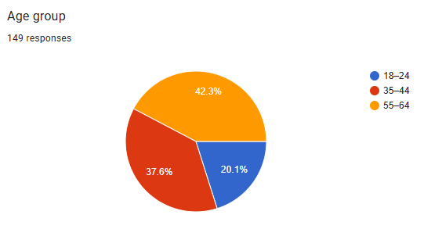
Figure 1 Age group
According to the display in Figure 01, 42.3% choose 55 to 64 as their age category, 37.6% choose 35 to 44 and 20.1% choose 18 to 24.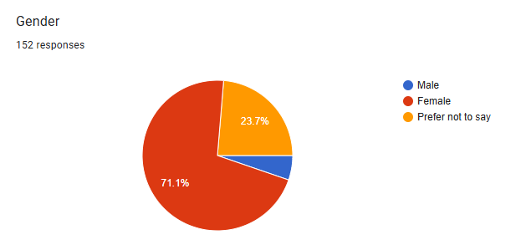
Figure 2 Gender
The majority, a significant 71.1%, identified as Female. The smallest group, a tiny sliver, was identified as Male. Overall, the survey respondents were mainly female, with a notable number choosing not to specify their gender, and a minimal representation of male respondents.

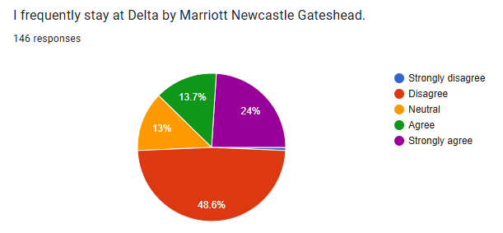
Figure 3 Customer Opinion stay at hotel
The majority of respondents select Disagree. (48.6%) represents respondents who disagree with the statement. Significant Number Strongly Agree, the second largest segment (24%), indicates that a critical portion of defendants strongly approve with the declaration. Agreeable Portion: Another 13.7% of responders concur with the assertion. Neutral Stance: A smaller portion (13%) of respondents holds a neutral opinion. Smallest Group Strongly Disagrees: The smallest segment represents those who strongly disagree (a very small sliver, likely less than 1% given it's visually the smallest and no exact percentage is provided).
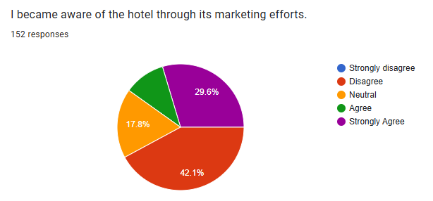
Figure 4 Awareness of Hotel through Marketing
Responses to the statement are depicted in the pie chart "I became aware of the hotel through its marketing efforts," based on 152 responses. The largest portion of respondents, at 42.1%, disagreed with this statement, suggesting that they likely learned about the hotel through other means. Conversely, a substantial 29.6% strongly agreed that the hotel's marketing efforts were how they became aware of it. An additional 17.8% remained neutral on the subject, while 10.5% agreed with the statement. A small fraction of respondents strongly disagreed. Overall, while a significant portion of people attribute their awareness of the hotel to its marketing, the largest group indicates that they discovered the hotel through different channels.
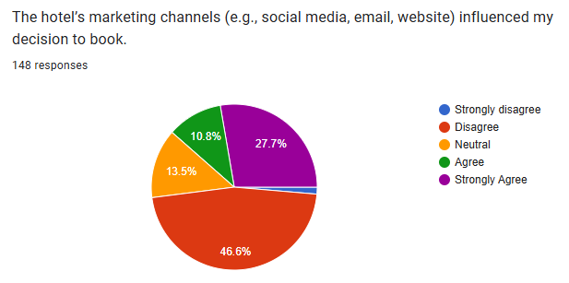
Figure 5 Influence of Online Marketing Channels
This pie chart summarises how much the hotel's online marketing (like social media, emails, and its website) influenced people's decision to book a stay, based on 148 responses. It seems like most people, almost half (46.6%), disagreed that these marketing channels played a big role in their choice. However, a pretty good chunk of people (27.7%) strongly agreed that the hotel's online marketing did influence them to book. There were also some people who were neutral (13.5%), meaning it probably wasn't a major factor for them. A smaller group agreed (10.8%) that the online marketing had some influence. Finally, a small sliver of people strongly disagreed. So, while a significant number of guests were swayed by the hotel's online presence, the largest group suggests that other factors were more important in their booking decision.
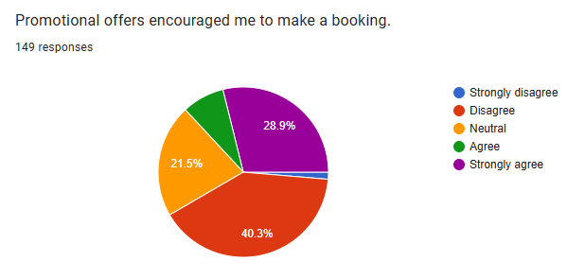
Figure 6 Impact of Special Offers and Deals
This pie chart shows how much special deals and offers encouraged people to book a stay at the hotel, based on 149 responses. It looks like the biggest group of people (just over 40%) disagreed that these promotional offers were a big reason they booked. However, a large group (almost 29%) strongly agreed that the offers encouraged them to make a booking. There's also a noticeable chunk of people who were neutral (about 21.5%), meaning the offers probably weren't a deciding factor for them. A smaller group (just over 8%) agreed that the promotions played a role. Only a tiny fraction strongly disagreed. So, while many guests were motivated by promotional offers, the largest group suggests that other reasons were more important in their decision to book.
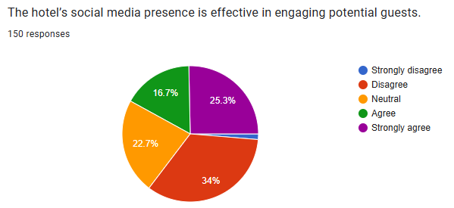
Figure 7 Effectiveness of Hotel’s Social Media
This pie chart shows what 150 people thought about how well the hotel's social media keeps potential guests interested. The biggest group, about one-third of respondents (34%), disagreed that social media was effective. However, a significant portion, just over a quarter (25.3%), strongly agreed it was effective. There was also a notable group (22.7%) who felt neutral, meaning they didn't have a strong opinion either way. A smaller group (16.7%) agreed with the statement, and only a tiny fraction strongly disagreed. So, while a good number of people find the hotel's social media engaging, the largest group of respondents doesn't seem to think it's particularly effective at drawing in potential guests.

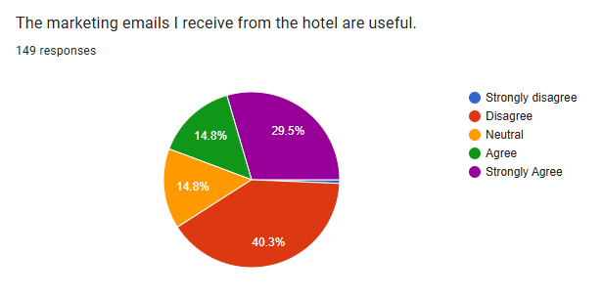
Figure 8 Usefulness of Marketing Emails
This pie chart shows what 149 people thought about the usefulness of the marketing emails they get from the hotel. The biggest group, a solid 40.3%, disagreed that these emails were useful. However, a pretty significant portion, almost 30% (29.5%), strongly agreed that the marketing emails were useful. There were also equal groups (14.8% each) who felt neutral about the emails or who agreed they were useful. Only a very small number strongly disagreed. So, it looks like there's a split opinion: while a large chunk of people don’t find the hotel's marketing emails helpful, a nearly as large group actually finds them very useful.
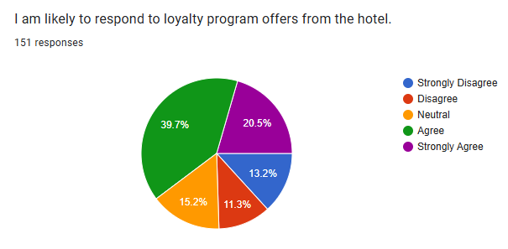
Figure 9 Engagement with Loyalty Program Offers
This pie chart shows what 151 people think about whether they're likely to take up offers from the hotel's loyalty program. The biggest chunk of people, almost 40% (39.7%), agreed that they would likely respond to these offers. This is followed by a significant group (20.5%) who strongly agreed, meaning they are very likely to engage with loyalty program offers. On the other hand, a noticeable portion (15.2%) remained neutral, suggesting the offers don't strongly sway them one way or another. A smaller group (13.2%) strongly disagreed, and an even smaller group (11.3%) simply disagreed. Overall, the data suggests that a large majority of respondents are either willing to or very likely to engage with the hotel's loyalty program offers, indicating it's a generally effective way to encourage repeat business (Koo et al., 2020).
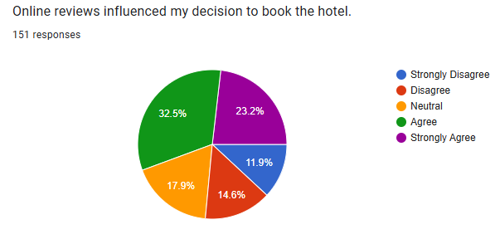
Figure 10 Influence of Online Reviews on Booking Decision
This pie chart shows how much online reviews influenced 151 people's decision to book the hotel. The largest group, almost one-third (32.5%), agreed that online reviews played a role in their booking. A significant portion, 23.2%, strongly agreed, meaning reviews were a very important factor for them. On the other hand, a noticeable group (17.9%) remained neutral, suggesting reviews weren't a major influence. Smaller groups either disagreed (14.6%) or strongly disagreed (11.9%) that online reviews influenced their decision. Overall, the data indicates that online reviews are a strong influencing factor for a majority of guests, but there's also a considerable number for whom reviews were not a primary consideration.
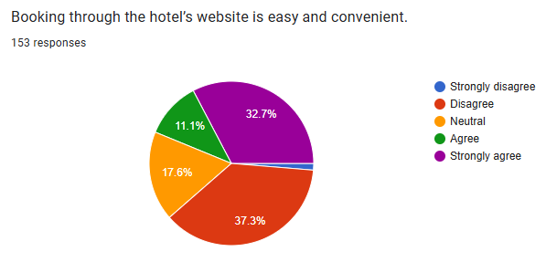
Figure 11 Ease and Convenience of Booking through Website
This pie chart summarises what 153 people thought about how easy and convenient it is to book through the hotel's website. The largest group, a significant 37.3%, disagreed that booking through the website was easy and convenient. This suggests a potential area for improvement. However, a good number of people, almost one-third (32.7%), strongly agreed that the website booking process was easy and convenient. There was also a noticeable group (17.6%) who felt neutral about it, and a smaller group (11.1%) who simply agreed. Only a tiny fraction strongly disagreed. Overall, while a large portion of respondents found the website booking difficult, a nearly equally large group had a positive experience, indicating a mixed perception of the website's ease of use (Foris et al., 2019).
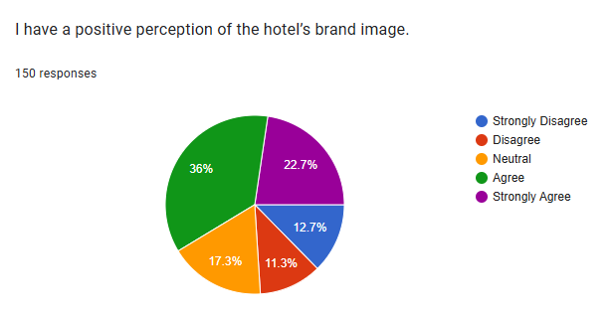
Figure 12 Perception of Hotel’s Brand Image
This pie chart shows what 150 people think about the hotel's overall image or how they see the brand. It looks like the biggest group, a solid 36%, agreed that they have a positive feeling about the hotel's brand. A significant number, almost a quarter (22.7%), strongly agreed, meaning they have a very good impression of the hotel's brand. On the other hand, some people felt neutral (17.3%), neither positive nor negative. There were also groups who disagreed (11.3%) or strongly disagreed (12.7%) with having a positive perception. The majority of respondents, according to the data, appear to have a favorable opinion of the hotel's brand image, while a lesser percentage had neutral or unfavorable views.

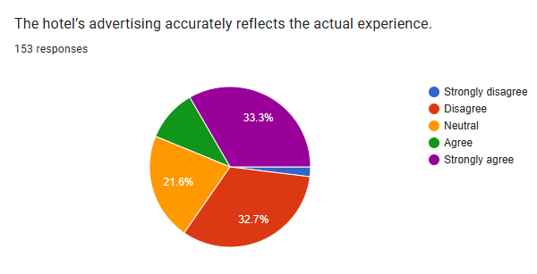
Figure 13 Accuracy of Hotel’s Advertising
This pie chart shows what 153 people thought about how well the hotel's advertising matches up with what the actual experience is like. The two largest groups are quite similar in size: 33.3% strongly agreed that the advertising accurately reflects the experience, and 32.7% disagreed that it does. This indicates a very divided opinion. A notable portion, 21.6%, remained neutral, suggesting they didn't have a strong feeling either way about the accuracy of the advertising. Only a small group agreed (not explicitly shown but visually small) or strongly disagreed (visually a tiny sliver). Overall, the results are split almost evenly between those who feel the advertising is accurate and those who feel it is not, highlighting a significant gap in perception.
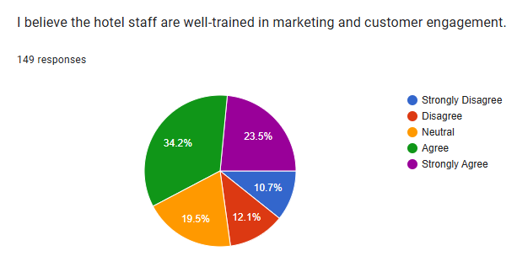
Figure 14 Training of Staff in Marketing and Customer Engagement
This pie chart shows what 149 people think about whether the hotel staff are well-trained in marketing and engaging with customers. The largest group, about one-third (34.2%), agreed that the staff are well-trained. Following closely, a significant portion (23.5%) strongly agreed, indicating a strong belief in the staff's training. However, a notable group (19.5%) remained neutral, suggesting they might not have a strong opinion or enough information to judge. Smaller portions either disagreed (12.1%) or strongly disagreed (10.7%). Overall, the majority of respondents believe the hotel staff are well-trained in marketing and customer engagement, but there's still a noticeable segment that is neutral or holds a negative view (Abdelhamied, 2019).
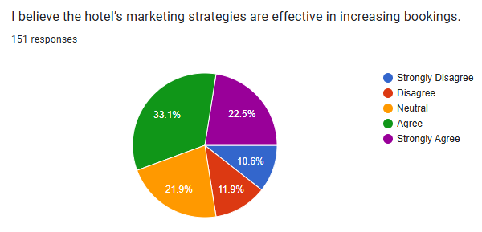
Figure 15 Effectiveness of Marketing Strategies in Increasing Bookings
This pie chart shows what 151 people think about whether the hotel's marketing strategies actually help increase bookings. The largest group, about one-third (33.1%), agreed that the marketing strategies are effective. A significant portion, 22.5%, strongly agreed, indicating a strong belief in the effectiveness of these strategies. However, a notable group (21.9%) remained neutral, suggesting they're unsure or don't have a strong opinion. Smaller groups either disagreed (11.9%) or strongly disagreed (10.6%). Overall, while a majority of respondents believe the hotel's marketing strategies are effective in boosting bookings, there's still a considerable segment that is neutral or holds a negative view.

Discussion
In addition to closely analyzing the impact of marketing methods on Delta by Marriott Newcastle Gateshead's occupancy rates, this study places a strong emphasis on evaluating how different marketing strategies influence customer booking behavior. Since hotels now depend more on online solutions, changing customer wishes and technology, the study looked at how effective digital and traditional marketing approaches are.
Data from the surveys was used to answer the research questions mentioned above. Information from the field points out that to achieve higher visibility, hotels now rely more on digital marketing and building close relationships with clients (Altinay and Arici, 2021; Kim et al., 2021). As a result, hotels ought to target specific groups of people and change their services to match guest expectations. Results revealed that although Delta relies on loyalty programs, ratings sites, advertisements through email and their brand message, customers have uneven reactions to the campaigns. There seems to be a discrepancy between marketing outreach and perceived customer value. (Loku and Loku, 2025). A significant percentage of respondents stated that marketing had little impact on their booking decisions. This inconsistency strengthens Foroudi's (2020) claim that local demands and worldwide branding strategies don't always align, so localised hotel branding frequently lacks resonance. Similarly, Ampountolas et al. (2020) discovered that regional cities' views of value and pricing influence choices more than high-level brand messages.
Despite the industry's broad use of digital marketing, many respondents seem to doubt Delta's efficacy in Marriott Newcastle Gateshead's efforts. According to Steenkamp (2020) and Garcia et al. (2021), a key component of contemporary hotel marketing is the move towards direct engagement through digital media and online reputation. However, according to the study's statistics, many visitors were unaffected by emails or social media posts, indicating a disconnect between the theory and practice of digital marketing (Dudek et al., 2024). The significant impact of internet reviews on participants' reservations supports contention that user-generated information and reviews frequently impact visitor decisions more than direct marketing. Reviews confirmed Kumar's (2021) finding that visitors in secondary cities relied more on peer material than corporate messaging, providing social proof that marketing activities fell short of. According to Rosário and Casaca's (2023) relationship marketing theory, which emphasises that consistent consumer interaction fosters loyalty and boosts long-term revenue, loyalty programs were among the most well-received tactics. The Commitment-Trust Theory by Abid et al. (2022), which suggests that trust and commitment via repeated contacts increase customer retention, is supported by the higher likelihood of booking reported by respondents who were members of loyalty programs or who took advantage of these offers. This implies that spending money on loyalty marketing could result in better occupancy rates than general efforts, such as Delta by Marriott Newcastle Gateshead. Additionally, self-congruity and consistent brand experiences improve customer satisfaction, as Kim (2023) pointed out. In this regard, Delta received comparatively positive feedback about staff alignment with marketing messages and brand perception.
The study also highlights how essential internet reviews are, as many respondents said they significantly impact their reservation choices. According to Anagnostopoulou et al. (2020), online reputation and profitability are directly correlated, and this analysis supports that finding in the Delta situation. However, a sizable neutral or negative portion also raises the possibility that the hotel may not be making the most of its online image. This aligns with the findings of Garner and Kim (2022), who noted that preserving a competitive advantage in the hospitality industry requires regular monitoring and control of user-generated material. In this case, the marketing staff seemed less proactive in incorporating comments into upcoming initiatives, even though reviews were influential. There were differing views on the usefulness and dependability of digital resources, such as the hotel's website. Given that digital reservations rule the modern hospitality industry, this points to operational gaps in the customer journey, which are critical (Olson et al., 2021). Although some respondents thought the website was convenient, others encountered issues, suggesting that the design needs to be improved. In this instance, Delta's digital infrastructure seems to be at odds with the expectations of Green and Tran (2023), who contend that frictionless digital interactions improve RevPAR and guest happiness. The results of this investigation could be explained by the literature by Gan et al. (2021), which cautions that regional hotels frequently do poorly on digital optimisation because of staffing and budgetary limitations. Staff training and alignment with marketing initiatives are other factors that influence the guest experience (Maraj Rahman Sofi et al., 2024). Most respondents thought hotel employees had received adequate training in engagement and marketing, indicating that internal operations align with brand claims. This supports the focus placed by Rosário and Casaca (2023) on internal marketing as the cornerstone of the compelling outward message. Nonetheless, there are still differences in how accurate people believe advertisements to be, as evidenced by the almost equal distribution of visitors who thought the ads were realistic and those who didn't. This contradiction highlights the mismatch between promotional material and real service provision, supporting assertion that customer trust largely depends on authenticity.
Additionally, research by Ziyae et al. (2021) and Veal et al. (2001) indicates that rural hotels must employ flexible marketing techniques due to particular challenges. Generic promotional offers were viewed as less successful in Delta's case, supporting the claim made by Kim et al. (2021) that value-driven, customised advertising is more persuasive than general discounting. Promotions should emphasise immersive and bundled services rather than just cash incentives, as the statistics showed that many respondents were uninterested in special offers. This necessitates a change to more value-driven and locally focused advertising, as suggested by Gelbman (2021), who emphasised the importance of experience marketing in local hospitality settings. The present marketing approach seems to be moderately successful, especially regarding online reputation and loyalty programs, but it lacks digital personalisation and targeting. Marketing initiatives must become more data-driven and customer-focused due to the hospitality sector's competitive nature and consumers' rising digital expectations (Camilleri, 2020). The results indicate that increasing booking conversion rates and boosting overall hotel performance depend on attaining alignment between digital communication, service delivery, and guest expectations.

Chapter 5: Conclusion and Recommendations

Conclusion
Conclusively, the impact various marketing methods on how much people purchase rooms at Delta by Marriott Newcastle Gateshead are occupied. Its purpose was to learn about which Hotel marketing actions were being followed, and analyzed the methods to understand their impact on occupancy study the results to find out if rooms support repeat business from customers. The results of the study prove that hotel occupancy rates are directly affected by marketing, as previous work has stated (Foroudi, 2020). Using a combination digital marketing, brand management, and CRM helped Delta Newcastle Gateshead successfully attracted and retained customers. Evidence from the literature demonstrates that using all marketing platforms helps hotels get noticed and interact better with customers which increases bookings and boosts the number of rooms rented (Olson et al., 2021). Online reputation management was emphasized in the research, as good reviews and an active online existence straight away influenced how full a hotel was, like what the earlier studies by Garcia et al. (2021) also summed up. Taking part actively on TripAdvisor and Booking.com helped Delta win the trust of consumers which affected their decision to book (Ibrahim et al., 2021). In addition, it was found that special marketing programs help companies achieve higher customer retention. This follows the commitment-trust theory which explains why strong customer relationships can be built by having trust and commitment (Abid et al., 2022). Marriott Bonvoy helped Delta build loyalty among its customers and supported a constant flow of occupants in the hotels (Marriott Bonvoy, 2016). On the other hand, competition within the hotel market, seasonal changes in demand and external shocks—including COVID-19—have also affected the number of occupied hotel rooms and reveal how hospitality marketing is both dynamic and really complex (Denizci Guillet and Chu, 2021). Flexibility in marketing plans during these interruptions was evidence of the resilience key to Delta’s ongoing success (Altinay and Arici, 2021). All things considered, this study finds that having a strong marketing plan, including digital, brand, personal and change-aware strategies, helps hotels increase guest occupancy. Thus, this study improves knowledge in hospitality marketing effectiveness and supports using marketing to increase hotel occupancy (Kim et al., 2021).

Recommendations
As a result of these findings, we propose three suggestions to make Delta’s marketing more effective and increase occupancy rates. Each proposal is provided with an evaluation of what works well, what does not and what issues it faces.
- Enhance Digital Marketing through Advanced Data Analytics and Personalization
In order to get better marketing results and higher occupancy rates, Delta ought to use more advanced tools for data analysis. With big data, the hotel can assess customer preferences better and carry out marketing that is tailored for them. Offers that are tailored to each customer often lead to higher engagement, satisfaction, loyalty and people choosing to book travel services more than once (Parihar and Dawra, 2020). Using marketing data helps focus the budget on valuable groups of customers, while watching campaigns closely helps marketers make rapid adjustments when needed. But, before businesses can use these investments, they must pay high costs for the technology and hire skilled staff and they need to ensure privacy to avoid affecting their reputation.
Additionally, since the outcomes depend on both useful data and successful data integration, it can become challenging to implement these projects in many sectors. As well as the known benefits and problems, the hospitality sector is getting advanced technology which shapes the expectations of customers. Today, people looking for a hotel expect a customized and effortless part of their booking right from the website. Because of this, Delta’s use of data analytics and personalization tools can help the hotel separate from its competitors in the market. For example, a company may run predictive analytics to set the best prices and ads, forecast possible spikes in demand, offer communication at suitable times and create packages that exactly fit the interests of business travelers, families and leisure tourists. In order to get better marketing results and higher occupancy rates, Delta ought to use more advanced tools for data analysis. With big data, the hotel can assess customer preferences better and carry out marketing that is tailored for them. Offers that are tailored to each customer often lead to higher engagement, satisfaction, loyalty and people choosing to book travel services more than once. Using marketing data helps focus the budget on valuable groups of customers, while watching campaigns closely helps marketers make rapid adjustments when needed. But, before businesses can use these investments, they must pay high costs for the technology and hire skilled staff and they need to ensure privacy to avoid affecting their reputation. Also, if AI and machine learning are part of data analytics platforms, it can refine and boost the accuracy of marketing. With AI helping, recommendation systems recommend suitable rooms, various features or offers, matching what customers liked which encourages them to continue and makes conversions more likely. With AI, chatbots and virtual assistants can help customers directly and give them personal support, before they have even left for the hotel. Nonetheless, Delta needs to focus on both data governance and cybersecurity as well. Following data protection laws, including the GDPR, is necessary to keep customer faith and protect the company from problems with the law. If companies are clear about how they handle data and privacy, customers are more likely to welcome personalization without thinking it’s too intrusive. Educating employees about data ethics and implementing tough policies for controlling data are essential things to do.
- Strengthen Online Reputation Management and Social Media Engagement
In addition, Delta can make an effort to get more customers to review their brand online and participate on various social media channels. The presence of positive online reviews increases trust and reservations, demonstrating why reputation management matters a lot right now. Using social media is an affordable way to keep in touch with guests who booked before and encourage future guests to become loyal to the brand. Responding quickly to comments and making your content interactive can make your brand more appreciable. Yet, it’s important to constantly watch for negative feedback on social media, so the company must assign these tasks to experts. It’s worth mentioning that social media engagement may work better for some groups than others and too much reliance on online ads might drive away people who still enjoy other marketing styles. Other than asked for reviews, the role also includes interpreting with customers to form real relationships they can rely on. Delta ought to encourage its guests by adding bonuses and surprises when guests leave positive reviews. Follow-up with guests by sending more emails after check out, use online surveys and involve guests in making content for social media. They help collect more reviews, improve their quality and help build a supportive group of loyal customers. Besides, Delta needs to use clear communication and an understanding approach to handle negative feedback. Resolving concerns lodged by guests on social media shows they care about customer experiences which may change a disgruntled guest to a loyal guest. Providing social media and crisis communication training is important so that staff reply to situations the right way, consistently and protected by the brand’s style. By telling themed stories, Delta may feature the unique experiences guests can have, local sites to explore and company operations. Travel operators can engage and draw the attention of younger users by blending video, live streams and polls found on Instagram, Facebook and TikTok. Teaming up with influencers and travel bloggers who match Delta’s principles adds exposure and makes the brand look more credible in the eyes of new customers.
- Expand Loyalty Programs and Partnership Marketing
The process of improving and growing Delta’s loyalty programs is very important which can be done by introducing tiered offers, special deals and partnering with nearby businesses. Clear loyalty programs help people stay loyal and increase the value they offer the business over time. Better guest experiences and expanded reach can come from Delta working with local companies which also helps set Delta apart from rivals through interesting rewards. Still, if loyalty programs are not carefully explained, they may seem confusing and handling partnerships takes effort which can raise overall operating costs. The key for their success is regular management and attractive rewards and some travelers may not benefit much from them if they do not travel often. Therefore, Delta ought to focus on meeting the changing objectives of its loyalty program members. Today, more and more buyers are attracted to experiences instead of just looking for savings or rewards programs. Offering VIP experiences, select tours or wellness packages is a potential way for Delta to improve the travel experience without providing increased spending money. Custom rewards can lead to closer bonds and encourage customers to spread good word of the brand. Also, Delta has a chance to make loyalty program operations smoother and encourage stronger engagement with its users by using technology. Apps that help users earn points, offer tailored promotions and let them redeem quickly increase the chance they will participate regularly. Using customer analytics along with loyalty data helps businesses send users targeted communications at the right time. It is important that partnership marketing supports the hotel’s brand and matches the type of guests who stay. Partnering with nearby restaurants, entertainment venues, transporters and cultural groups can result in packages that give guests a rich experience and help the local economy. Thanks to these partnerships, Delta customers receive special privileges, while travelers using partners can find Delta and its advantages. Still, Delta should personally select its partners to ensure their brand matches and to preserve good services. Reaching agreements and encouraging regular communication helps you manage what’s expected and solve any problems quickly. To improve these programs, it helps to track the results using repeat booking rates, customer satisfaction points and extra revenue generated, as well as other key performance indicators.
So, implementing these suggestions will help Delta by Marriott Newcastle Gateshead maintain and raise occupancy levels in a fast-changing and competitive market. Adjusting strategies often will be necessary because consumer tastes and market situations change all the time. Research in the future could explore the long-lasting effects of innovative technologies suh as AI and machine language, on hospitality marketing, helping to enhance hotel performance.

References
‌ Abid, M.F., Siddique, J., Gulzar, A., Shamim, A., Dar, I.B. and Zafar, A. (2022). Integrating the Commitment-Trust Theory to Gauge Customers Loyalty in Riding Services. Journal of Promotion Management, 29(3), pp.1–33. doi:https://doi.org/10.1080/10496491.2022.2143987.
‌ Collis, J., Jarvis, R. and Skerratt, L. (2004). The demand for the audit in small companies in the UK. Accounting and Business Research, 34(2), pp.87–100. doi:https://doi.org/10.1080/00014788.2004.9729955.
Abdelhamied, H.H.S. (2019). The Impact of Training Activities on Quality of Service, Customer Satisfaction and Behavioral Intention. Journal of Tourism and Hospitality Management, [online] 7(1). doi:https://doi.org/10.15640/jthm.v7n1a14.
Acharjee, S.K. and Ahmed, T. (2023). The impact of social media on tourists’ decision-making process: An empirical study based on Bangladesh. Journal of Social Sciences and Management Studies, 3(1), pp.56–71. doi:https://doi.org/10.56556/jssms.v3i1.685.
Aladwan, K., Khalid, M. and Aladwan, R. (2022). Service quality during the COVID-19 pandemic: An empirical study. Qmu.ac.uk. [online] doi:https://doi.org/2521-1870.
Alexander, A., Teller, C. and Wood, S. (2020). Augmenting the urban place brand – On the relationship between markets and town and city centres. Journal of Business Research, 116, pp.642–654. doi:https://doi.org/10.1016/j.jbusres.2019.02.013.
Alhazzani, M., Alhasoun, F., Alawwad, Z. and González, M.C. (2021). Urban attractors: Discovering patterns in regions of attraction in cities. PLOS ONE, 16(4), p.e0250204. doi:https://doi.org/10.1371/journal.pone.0250204.
Altinay, L. and Arici, H.E. (2021). Transformation of the hospitality services marketing structure: a chaos theory perspective. Journal of Services Marketing, ahead-of-print(ahead-of-print). doi:https://doi.org/10.1108/jsm-01-2021-0017.
Aluko-Arowolo, S., Lawal, S.A., Adedeji, I.A. and Nwaobilor, S. (2022). Ethical Relativism and Circumstances of Social and Cultural Contingencies on Informed Consent in the Conduct of Research: Clinical Trials in Nigeria. Asian Bioethics Review, [online] 15(1), pp.37–52. doi:https://doi.org/10.1007/s41649-022-00223-4.
Ampountolas, A., Shaw, G. and James, S. (2020). Examining the relationships between market indicators and hotel pricing approaches. Tourism Economics, 27(8), p.135481662092522. doi:https://doi.org/10.1177/1354816620925225.
Anagnostopoulou, S.C., Buhalis, D., Kountouri, I.L., Manousakis, E.G. and Tsekrekos, A.E. (2020). The impact of online reputation on hotel profitability. International Journal of Contemporary Hospitality Management, [online] 32(1), pp.20–39. doi:https://doi.org/10.1108/ijchm-03-2019-0247.
Anil Bilgihan, Hanks, L., Nathan Discepoli Line and Makarand Amrish Mody (2024). Hospitality marketing research: bridging the practical gap. International journal of contemporary hospitality management. doi:https://doi.org/10.1108/ijchm-09-2023-1351.
Batko, K. and Ślęzak, A. (2022). The use of Big Data Analytics in healthcare. Journal of Big Data, [online] 9(1). doi:https://doi.org/10.1186/s40537-021-00553-4.
Buhalis, D., Lin, M.S. and Leung, D. (2022). Metaverse as a driver for customer experience and value co-creation: implications for hospitality and tourism management and marketing. International Journal of Contemporary Hospitality Management, 35(2), pp.701–716.
Camilleri, M.A. (2020). The use of data-driven technologies for customer-centric marketing. International Journal of Big Data Management, [online] 1(1), p.50. doi:https://doi.org/10.1504/ijbdm.2020.106876.
Carlbäck, M. (2022). The EA-Approach; a Customer-Centered Management System to Produce, Manage, and Assess Relevant Experiences for the Hospitality and Tourism Industry. Contemporary Approaches Studying Customer Experience in Tourism Research, pp.131–144. doi:https://doi.org/10.1108/978-1-80117-632-320221014.
Çınar, K., Yetimoğlu, S. and Uğurlu, K. (2020). The role of market segmentation and target marketing strategies to increase occupancy rates and sales opportunities of hotel enterprises. In Strategic Innovative Marketing and Tourism: 8th ICSIMAT, Northern Aegean, Greece, 2019 (pp. 521-528). Springer International Publishing. doi:https://doi.org/10.1007/978-3-030-36126-6_58.
Czinkota, M.R., Masaaki Kotabe, Demetris Vrontis and Riad, M. (2021). Marketing Planning. Springer texts in business and economics, [online] pp.43–90. doi:https://doi.org/10.1007/978-3-030-66916-4_2.
Davahli, M.R., Karwowski, W., Sonmez, S. and Apostolopoulos, Y. (2020). The Hospitality Industry in the Face of the COVID-19 Pandemic: Current Topics and Research Methods. International Journal of Environmental Research and Public Health, [online] 17(20), p.7366. doi:https://doi.org/10.3390/ijerph17207366.
Denizci Guillet, B. and Chu, A.M.C. (2021). Managing hotel revenue amid the COVID-19 crisis. International Journal of Contemporary Hospitality Management, 33(2), pp.604–627. doi:https://doi.org/10.1108/ijchm-06-2020-0623.
Dudek, A., Jaremen, D.E., Izabela Michalska-Dudek and Pavlina Pellesova (2024). Exploring travel agencies customers’ loyalty motives throught machine learning analysis. E+M Ekonomie a Management, 27(2), pp.201–220. doi:https://doi.org/10.15240/tul/001/2024-2-012.
Elisabetta Del Soldato and Massari, S. (2024). Creativity and digital strategies to support food cultural heritage in Mediterranean rural areas. Euromed Journal of Business. doi:https://doi.org/10.1108/emjb-05-2023-0152.
Emara, O.A.M., Halim, H.T., El-Deeb, M.S. and Halim, Y.T. (2023). Toward a sustained recovery of the lodging sector: a management path to lessen the Corona Variants upshots. Future Business Journal, [online] 9(1). doi:https://doi.org/10.1186/s43093-022-00171-3.
‌Fife, S.T. and Gossner, J.D. (2024). Deductive Qualitative Analysis: Evaluating, Expanding, and Refining Theory. International Journal of Qualitative Methods, [online] 23. doi:https://doi.org/10.1177/16094069241244856.
Foris, D., Tecau, A.S., Hartescu, M. and Foris, T. (2019). Relevance of the features regarding the performance of booking websites. Tourism Economics, 26(6), pp.1021–1041. doi:https://doi.org/10.1177/1354816619845790.
Foroudi, P. (2020). Corporate brand strategy: Drivers and outcomes of hotel industry’s brand orientation. International Journal of Hospitality Management, 88(1), p.102519. doi:https://doi.org/10.1016/j.ijhm.2020.102519.
Gan, C., Voda, M., Wang, K., Chen, L. and Ye, J. (2021). Spatial network structure of the tourism economy in urban agglomeration: A social network analysis. Journal of Hospitality and Tourism Management, 47, pp.124–133. doi:https://doi.org/10.1016/j.jhtm.2021.03.009.
Garcia, G., Dos Anjos, S. and Dogan, S. (2021). Online Travel Agencies and Their Role in the Tourism Industry. Advances in Hospitality and Tourism Research (AHTR), 10(3). doi:https://doi.org/10.30519/ahtr.865546.
Garner, B. and Kim, D. (2022). Analyzing user-generated content to improve customer satisfaction at local wine tourism destinations: an analysis of Yelp and TripAdvisor reviews. Consumer Behavior in Tourism and Hospitality, 17(4), pp.413–435. doi:https://doi.org/10.1108/cbth-03-2022-0077.
Gelbman, A. (2021). Tourist Experience and Innovative Hospitality Management in Different Cities. Sustainability, [online] 13(12), p.6578. doi:https://doi.org/10.3390/su13126578.
George, R. (2025). Quality Service Experiences Through Internal and Relationship Marketing. Marketing Tourism and Hospitality, pp.385–413. doi:https://doi.org/10.1007/978-3-031-65983-6_13.
Gkikas, D.C. and Theodoridis, P.K. (2024). Predicting Online Shopping Behavior: Using Machine Learning and Google Analytics to Classify User Engagement. Applied Sciences, [online] 14(23), pp.11403–11403. doi:https://doi.org/10.3390/app142311403.
Green, S. and Tran, X. (2023). Effects of Luxury Hotel Guests’ Feedback on Average Daily Rate (ADR), Revenue Per Available Room (RevPAR), and Goodwill – An Empirical Study in Pensacola. Lecture Notes in Computer Science, pp.444–454. doi:https://doi.org/10.1007/978-3-031-48060-7_33.
‌Grimshaw, L. and Mates, L. (2021). ‘It’s part of our community, where we live’: Urban heritage and children’s sense of place. Urban Studies, [online] 59(7), pp.1334–1352. doi:https://doi.org/10.1177/00420980211019597.
Horozhankina, N., Korneyev, M. and Farzullaev, R. (2024). Marriott International’s place in international hotel chains. Umsf.dp.ua. [online] doi:https://doi.org/2706-9079.
Hudson, S. and Hudson, L. (2017). Marketing for Tourism, Hospitality and Events. SAGE.
Hujić, N. and Salihić, F. (2020). MARKETING IN TOURISM - DIRECT MARKETING AS MARKETING COMMUNICATIONS TECHNOLOGY. STED JOURNAL, 2(1). doi:https://doi.org/10.7251/sted2002089h.
Ibrahim, Y., Abbas, T. and Kamal, M. (2021). The Impact of Online Communities-based Social Customer Relationship Management (S-CRM) on Customer Loyalty and Brand Image on Hotels. Journal of Association of Arab Universities for Tourism and Hospitality, 0(0). doi:https://doi.org/10.21608/jaauth.2021.84867.1202.
Jinkyung Jenny Kim (2023). Brand personality of global chain hotels, self-congruity, and self-discrepancy on customer responses. International Journal of Hospitality Management, 114, pp.103565–103565. doi:https://doi.org/10.1016/j.ijhm.2023.103565.
JONES, P. (2022). A Review of the UK’s Tourism Recovery Plans Post COVID-19. Athens Journal of Tourism, [online] 2021, pp.1–9. doi:https://doi.org/10.30958/ajt.X-Y-Z.
Khan, R.U., Salamzadeh, Y., Iqbal, Q. and Yang, S. (2020). The Impact of Customer Relationship Management and Company Reputation on Customer Loyalty: the Mediating Role of Customer Satisfaction. Journal of Relationship Marketing, 21(1), pp.1–27.
Kim, J., Kim, S.I. and Lee, M. (2021). What to Sell and How to Sell Matters: Focusing on Luxury Hotel Properties’ Business Performance and Efficiency. Cornell Hospitality Quarterly, 63(1), p.193896552110202. doi:https://doi.org/10.1177/19389655211020254.
Kitsios, F., Mitsopoulou, E., Moustaka, E. and Kamariotou, M. (2022). User-Generated Content in Social Media: A Twenty-Year Bibliometric Analysis in Hospitality. Information, [online] 13(12), p.574. doi:https://doi.org/10.3390/info13120574.
Kolobkova, V.A., Romanov, A.A. and Frolova, E.A. (2021). Digital Technologies in the Hotel Industry: New Prospects for Sustainable Development. Studies in Systems, Decision and Control, [online] 314, pp.387–394. doi:https://doi.org/10.1007/978-3-030-56433-9_41.
Koo, B., Yu, J. and Han, H. (2020). The role of loyalty programs in boosting hotel guest loyalty: Impact of switching barriers. International Journal of Hospitality Management, 84, p.102328. doi:https://doi.org/10.1016/j.ijhm.2019.102328.
Kumar, P. (2021). Hospitality and Tourism Information Technology. USF M3 Publishing, LLC. doi:https://doi.org/10.5038/9781732127593.
Loku, N. and Loku, A. (2025). Exploring Consumer Behaviour and Perceptions: The Role of Enterprise Social Responsibility in Kosovo’s Developing Market. Central European Public Administration Review, 23(1), pp.233–248. doi:https://doi.org/10.17573/cepar.2025.1.09.
Makri, C. and Neely, A. (2021). Grounded Theory: A Guide for Exploratory Studies in Management Research. International Journal of Qualitative Methods, [online] 20. doi:https://doi.org/10.1177/16094069211013654.
Maraj Rahman Sofi, Bashir, I., Alshiha, A., Emad Alnasser and Sultan Alkhozaim (2024). Creating Exceptional Guest experiences: the Role of Engagement and Relationship Building in Hospitality. Journal of Hospitality and Tourism Insights, 8(3). doi:https://doi.org/10.1108/jhti-04-2024-0318.
Marriott Bonvoy. (2016). Delta Hotels Newcastle Gateshead. [online] Available at: https://www.marriott.com/en-us/hotels/nclmd-delta-hotels-newcastle-gateshead/overview/https://www.marriott.com/en-us/hotels/nclmd-delta-hotels-newcastle-gateshead/overview/ [Accessed 23 May 2025].
Mathews, S., Prentice, C., Tsou, A., Weeks, C., Tam, L. and Luck, E. (2021). Managing eWOM for hotel performance. Journal of Global Scholars of Marketing Science, 32(3), pp.1–20. doi:https://doi.org/10.1080/21639159.2020.1808844.
Mazhar, S.A., Anjum, R., Anwar, A.I. and Khan, A.A. (2021). Methods of Data Collection: a Fundamental Tool of Research. Journal of Integrated Community Health, 10(1), pp.6–10. doi:https://doi.org/10.24321/2319.9113.202101.
‌Moskaleva, A. (2020). Marketing strategies for attracting tourists from Russia, Finland and Estonia. Case company Delta Apartments. Theseus.fi. [online] doi:http://www.theseus.fi/handle/10024/338916.
Muldoon-Smith, K., Moreton, L. and Loxley, J. (2025). Lo-Fi Adaptive Re-Use in the Ouseburn Valley: What the Physical Materiality of Everyday Historical Industrial Buildings Can Tell Us About Sustaining Cultural and Creative Clusters. Buildings, 15(3), p.427. doi:https://doi.org/10.3390/buildings15030427.
Musavengane, R. and Zhou, Z. (2021). Political crises and tourism in Sub-Saharan Africa: destination recovery post-coup d’état. International Journal of Tourism Policy, 11(1), p.52. doi:https://doi.org/10.1504/ijtp.2021.114455.
NEWCASTLE UPON TYNE (2022). Delta Hotels By Marriott Newcastle Gateshead Swalwell. [online] Hotels-newcastle-upon-tyne.com. Available at: https://newcastle-gateshead-marriott-hotel-metrocentre.hotels-newcastle-upon-tyne.com/en/ [Accessed 28 May 2025].
Okonkwo, I., Mujinga, J., Namkoisse, E. and Francisco, A. (2023). Localization and Global Marketing: Adapting Digital Strategies for Diverse Audiences. Journal of Digital Marketing and Communication, [online] 3(2), pp.66–80. doi:https://doi.org/10.53623/jdmc.v3i2.311.
Olson, E.M., Olson, K.M., Czaplewski, A.J. and Key, T.M. (2021). Business Strategy and the Management of Digital Marketing. Business Horizons, 64(2), pp.285–293. doi:https://doi.org/10.1016/j.bushor.2020.12.004.
Parihar, P. and Dawra, J. (2020). The role of customer engagement in travel services. Journal of Product & Brand Management, 29(7), pp.899–911. doi:https://doi.org/10.1108/jpbm-11-2018-2097.
Pencarelli, T. (2020). The digital revolution in the travel and tourism industry. Information Technology & Tourism, [online] 22(3), pp.455–476. Available at: https://link.springer.com/article/10.1007/s40558-019-00160-3.
Pinder, D. (2023). The U.K. airport luxury brand store: The lure of luxury in a transitory environment - ePrints Soton. Soton.ac.uk. [online] doi:https://eprints.soton.ac.uk/476755/1/PhD_Thesis_Debbie_Pinder_29_6_23.pdf.
Remy, D., Huey Chern Boo and Tee, S. (2023). FROM TRADITIONAL TO NEW HOTEL REVENUE MANAGEMENT METRICS: AN EXPLORATORY STUDY ON THE POTENTIAL OF NREVPAR AND REVPAC. Tourism and Hospitality Management, 29(2), pp.221–233. doi:https://doi.org/10.20867/thm.29.2.6.
Rosário , A. and Casaca , J.A. (2023). Relationship Marketing and Customer Retention - A Systematic Literature Review. Studies in Business and Economics, [online] 18(3), pp.44–66. doi: https://doi.org/10.2478/sbe-2023-0044.
Rossidis, I., Belias, D. and Vasiliadis, L. (2021). Strategic Hotel Management in the ‘Hostile’ International Environment. Culture and Tourism in a Smart, Globalized, and Sustainable World, pp.325–336. doi:https://doi.org/10.1007/978-3-030-72469-6_21.
Sáblíková, H. (2023). The Role of Cultural Life in a Small Town in Eastern Bohemia, and Its Potential Development of Cultural Tourism. Land, 12(4), p.751. doi:https://doi.org/10.3390/land12040751.
Samuels, K.L. and Platts, E.J. (2020). An Ecolabel for the World Heritage Brand? Developing a Climate Communication Recognition Scheme for Heritage Sites. Climate, [online] 8(3), pp.38–38. doi:https://doi.org/10.3390/cli8030038.
Seidu, S., Opoku Mensah, A., Issau, K. and Amoah-Mensah, A. (2021). Does organisational culture determine performance differentials in the hospitality industry? Evidence from the hotel industry. Journal of Hospitality and Tourism Insights, ahead-of-print(ahead-of-print). doi:https://doi.org/10.1108/jhti-11-2020-0208.
Soh, J. and Seo, K. (2021). An Analysis of The Impact of Short-Term Vacation Rentals on the Hotel Industry. Journal of Hospitality & Tourism Research, 47(4), p.109634802110191. doi:https://doi.org/10.1177/10963480211019110.
Steenkamp, J.-B.E.M. (2020). Global Brand Building and Management in the Digital Age. Journal of International Marketing, [online] 28(1), pp.13–27. doi:https://doi.org/10.1177/1069031X19894946.
Tabenska, O., (2022). Infrastructural support of the hospitality industry in the conditions of global economic integration. Problems and prospects of development of hotel and restaurant and tourist industry in the conditions of integration processes. Monograph.–Primedia eLaunch, Boston, USA, 2022. Р. 223-315. DOI 10.46299/979-8-88831-930-7.7.
Thi, H., Thuy-An Phan-Thi, Nguyen, B.T. and Nguyen, T.Q. (2025). Mining online hotel reviews using big data and machine learning: An empirical study from an emerging country. Annals of Tourism Research Empirical Insights, [online] 6(1), pp.100170–100170. doi:https://doi.org/10.1016/j.annale.2025.100170.
Veal, A.J., Jenkins, J., Henderson, K.A., McDonnell, I. and Veal, A.J. (2001). Book Reviews. Annals of Leisure Research, 4(1), pp.95–106. doi:https://doi.org/10.1080/11745398.2001.10600893.
Vinod, B. (2022). Introduction to Hotel Revenue Management. Management for Professionals, [online] pp.1–50. doi:https://doi.org/10.1007/978-3-031-14302-1_1.
Yacoub, L. and ElHajjar, S. (2021). How do hotels in developing countries manage the impact of COVID-19? The case of Lebanese hotels. International Journal of Contemporary Hospitality Management, 33(3), pp.929–948. doi:https://doi.org/10.1108/ijchm-08-2020-0814.
Ziyae, B., Sadeghi, H. and Golmohammadi, M. (2021). Service innovation in the hotel industry: the dynamic capabilities view. Journal of Enterprising Communities: People and Places in the Global Economy, ahead-of-print(ahead-of-print). doi:https://doi.org/10.1108/jec-12-2020-0205

Appendix

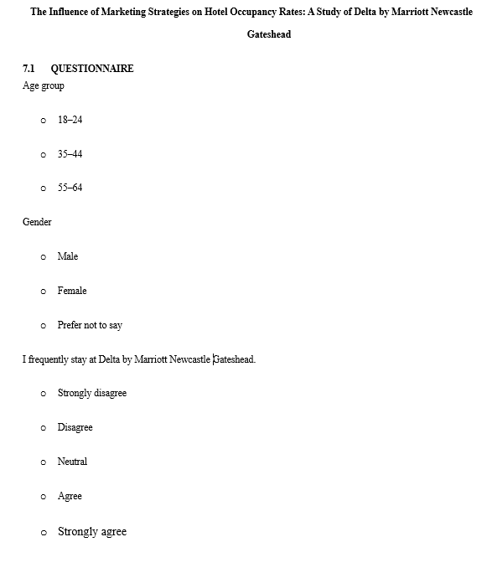
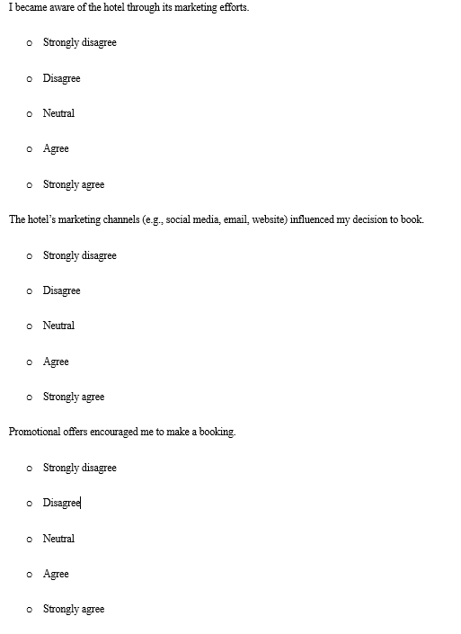

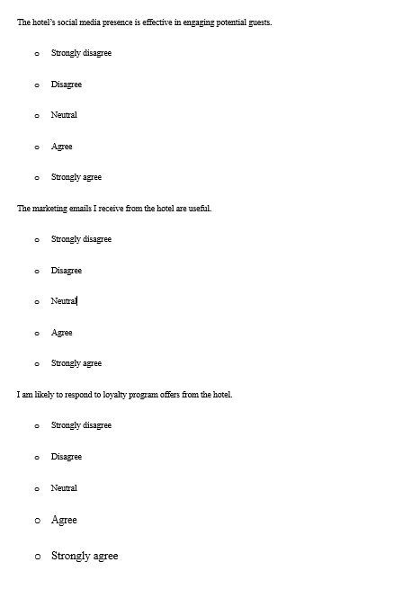

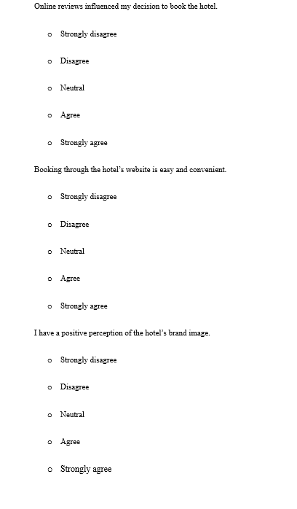
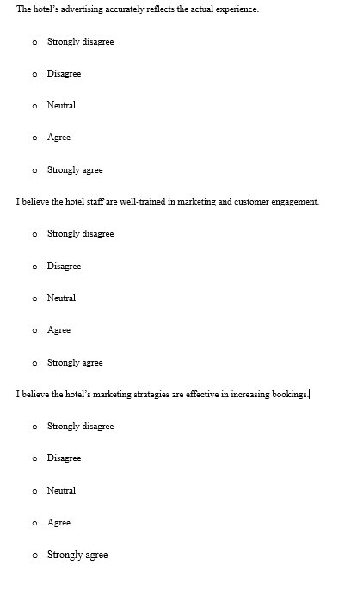

RESPONSES


