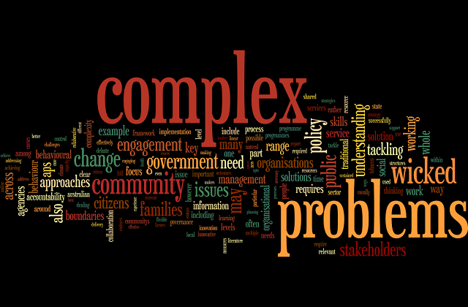
Final Report
Olga Jarmusevica - 2115871
Charles Nimoh | Problem Solving and Decision Making | BMSW 4004

Introduction:
This report explains about nature and impact of the staff shortages. Staff shortage is the biggest problem for Proper Care, UK because waiting list will be growing, and the clients did not receive appropriate service. Therefore, need to make sure that salary is high enough to keep all the staff.
Furthermore, it’s described how staff shortages affect on employees and businesses. Also, it’s expounded PESTLE analysis of factors to the general problem.
Fishbone diagram visually shows to us what lead to a staff shortage. The diagram presenting four groups.
At the end of this report can be seen a solution of the complex problems and a plan to resolve it. Moreover, discussion of success indicator of effective decision made.
Let’s talk about staff shortages:
NHS hospitals reported of 100,000 staff shortages. In one year, 1,584 more nurses and health visitors are left their rules because of concerns about Brexit.
Staff shortage is when employers have difficult to recruit a good, qualified staff. There are not enough candidates for appropriate rules.
Impact of staff shortages on the employees can affect because of tiredness. Employees overworked their normal hours, they become more tired than usual in this case they sleep less and stress more. Therefore, employees can’t concentrate, they do more mistakes, what is not allowed in NHS, because those mistakes can be fatal for some people lives. For example: overdose in medication or given in a wrong time.
Because of this circumstance employees trying to find a different job, almost with out stress with appropriate working hours.
This situation impact on employers’ business. Because of the staff shortages they can’t afford product delivery on time. Customers become unhappy with this service and refuse to work with this company anymore and are looking for another supplier. Therefore, employers lose those clients, lose contracts, they lose money. Too many companies become a bankrupt.

PESTLE:
The PESTLE analysis study the main factors that impact on organisations. PESTLE helps organisation to identify main factors which can effect on decision making.
Political stands for government policy(covid) and Brexit. Politics do not prevent quick enough spread of Covid. Moreover, government policy was delayed and covid spread quicker. Therefore, numbers of ill people raise higher every day, and, on this case, employees cannot afford to get back to work early than after two weeks’ time. Some of the employees stayed at home longer than they expected, because of this epidemy organisations have a staff shortage. Was not enough people in a working places and other employees overworked their hours.
Brexit took many working places who came from abroad. When politics made a new policy, boarder where closed and employees, who came here before to work, start searching for a new job, because it is become more harder for them to get here. Many people return home to those families. This were a big loose for some companies. Therefore, some organisations closed and some of them become a bankrupt.
Economic stands for inflation and unemployment rates. Inflation rates go up, in this case all the products become expensive, petrol prices rise so quickly. Moreover, prices on electricity and gas become so high. Employees cannot afford a long trip to work or paying for their bills. Therefore, they tried to find work with higher rates or close to their houses within walking distance.
Unemployment rates are rising, because too many people without job. The government remove bursary pay and high numbers of people cannot afford pay for a study to get a qualification. Therefore, people cannot find a good paid job. That’s why numbers of unemployed rising.
Social stands for age and population. It is hard to find job for older people. Almost companies hire a younger people, because they learn quicker, do their job quicker and on this case all the tasks will be completed in an appropriate time. That’s mean all the customers get their orders in their expectation day.
Population in a small part of country critically low. There are not many types of vacancies and employees haven’t got enough opportunities growing in a career. Therefore, younger people searching for a better opportunity in bigger cities and there are staying just older people. That’s mean, because of this case employers straggle to find a staff they need it. The older people do their job slower than youngest, and they need more training. In this case, employers need to spend more time to feel up all the vacancies.
Technology stands for upgrades, innovation, and social networking. All the programmes have an upgrade. It is difficult to understand for older people, they need more training than youngest. Technology is growing together with people. Youngest employees understand much quicker how the systems works, because they are growing up with each upgrade. They are more flexible with technology, because of social networking. Youngest people staying online more than in real life. They learn all the main keys of online system.
Legal stands for discrimination law and immigration law. This include anyone who is working for the NHS and private. Discrimination is the worst part of teamwork. NHS need to make sure there is no discrimination between staff. There are different types of discrimination: age, disability, gender, religion, race etc. All the employees should be respectful to each other. Moreover, employers must take care of all the staff. They must arrange more meetings to check how employees communicate between all the staff and clients.
Immigration law help people from another country working here. The governments open visa for immigrants. Therefore, they can enter this country legal. Moreover, when visa expired, employees can reapply for it if they are still working in this country. They must send proof where they work and leave and stay without criminal records.
Environmental stands for health accident, climate change and pollution. Employees can get a heart attack or gain into hospital; on this occasion they cannot get to work. Also, heavy rain, storm or global warming can stop employees of getting to work. Therefore, organisations cannot deliver appropriate services to a customer. They lose a clients and money, because of the staff shortage.
Fishbone Diagram:
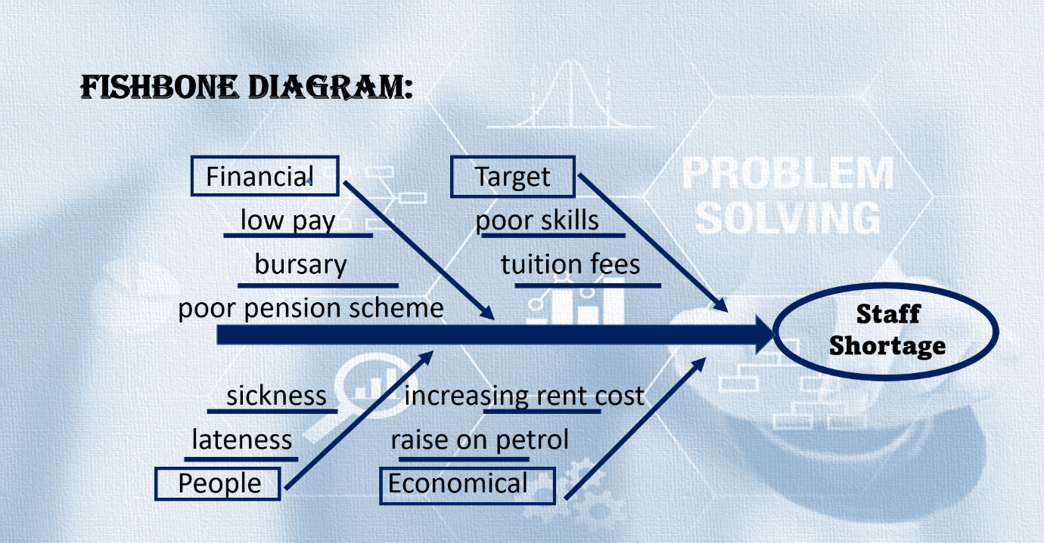
Fishbone Diagram is a visual method to look on problem and effects. Diagram can be made easily. Firstly, need to identify main problem. Secondly, need find out main factors that involved in this problem. Also, need identify main causes and then explore diagram.
On this diagram the main problem is Staff Shortage. There is four group that lead to a staff shortage: financial, target, people and economical. When employees get low pay salary, they cannot manage all the bills to pay, and they are searching for better paid job. Cancelation on bursary lead people stay with out qualification and without work. Poor pension scheme push staff to search for a different opportunity in another places. Moreover, because of high tuition fees, people cannot afford payments, and on this occasion, they have poor skills knowledge. Also, there is raise on petrol and rent. Employees with a low income tried find another job close to their homes, to spend less on a petrol and afford all the payments. Pandemic occurs on employee’s health. Too many people stay off work, because of the health problems. Also, to save money people walking to work and coming late.
Therefore, there is a staff shortage all over the places, because of all this problems people looking for a better job, that suit their needs.
Solution:
The best solution on this problem is to increase salaries. The main problem is low income. Employees left current jobs and looking for better options, because they cannot afford all the bills, food, petrol etc. All the prices raise so quick. To control staff shortage, need to raise payments for each employee. Also, government needs to return bursary pays. People cannot afford to pay for a study high amount of money. Therefore, they cannot find a good work, because they haven’t got appropriate qualifications. Moreover, staff should be rewarded for hard work. Reward will be another solution on problem. Reward can be as a cash or thank you letter or extra day off. People push on their work if they know what they get. Everyone would like to receive some extra. It is good competition for the employees and good opportunity for a business. The more people will be rewarded, the more people want to get that reward too. That’s mean employees will appreciate it and will be working more accurate and harder. Therefore, the business will run more effective, and the customers will be happier. Everyone will get all they want. Employees will get a reward, employers good quality job, and a customer’s quicker delivery. Also, to receive a qualified work, employers need to do a training. Training new staff is a bonus for businesses because employees will know what and how need to work. Therefore, they do less mistakes and they produce quality work. Moreover, employers should send all the staff for qualification upgrades. Each study gave them new knowledge and organisation more profit, because the better staff work, the more money company get.
To cut down a staff shortage need to stick to a plan:
Firstly, need divided people in two groups. First group is qualified workers and second group - workers with not enough experience. Secondly, need raise salary for a first group and pay for level up qualifications for a second group. Second group will gain qualification and will work hard for the extra pay. Moreover, all new staff must receive training before start to make less mistakes. Company loses some money from the start, but later they gained even more than they spent. Company receives qualified workers and excellent work. This will work more if employers reward their employees. It can be employee assistance or recognition program, or it can be monetary or non-monetary rewards. The better reward is, the better work will be.
- Problem - Increasing numbers of staff shortage
- Solution – Raise wages and pay for qualification update
- Outcome – Staff working hard, business growing up
Conclusion:
On the conclusion need to say that employers need to take care of the staff. They need to make sure all the work are divided of the same amount to everyone, and staff not overworked, do not have too much stress and do not be so tired. All the staff members need to have a passion to go back tomorrow at the same work again, then work productivity and quality will be better. Moreover, employers need to raise salary, pay for qualification upgrade, and staff training. This will help to keep all the staff at place and produce quality work and deliver good customer service to the clients. Employees will stay and work hard when they get a good pay. Also, they appreciate when employers take care of them, they gave back as much as they can. Therefore, it is important to listen your staff and try to advise.

Reference List:
- Combes, J-B., Elliot, R F., Skatun, D. (2018), Hospital staff shortage, Vol.50(60), p.6547-6552, London.
- Shinde, D D., Ahirrao, S., Prasad, R. (2018), Fishbone Diagram, Vol.100(2), p.653-664.
- Kramer, N., Stahl, L. (2003), Nursing Shortage, Columbia Broadcasting system.
- Doult, B. (2002), Defence staff shortages “leave UK’ unfit to fight’, Vol.16(49), p.8-8, London: BMJ Publishing Group LTD.
- Coombes, D. (2017), UK needs to take responsibility for its staff shortage, p.41-47, Stratford – Upon – Avon: Road Transport Media LTD.
- Wright, R. (2019), Staff shortages make it hard work for UK employers, London: The Financial Times Limited.
- The Week UK, (2022), The NHS trusts under most pressure amid staff shortages and rising Covid cases, Newstex.
- Adair, J-E, (2016), Decision making and problem solving, 3rd edition, KoganPage.

