Research question: How does the use of a multiple-choice starter effect pupil engagement during a lesson?

 | Target | What I have done in this assignment.
Target 1 | I was set the verbal target of continuing in the way that I did in the previous assignment. | I have tried to engage with a wider range of literature whilst maintaining the criticality in my explanations and the fluency of my writing.

Appendices
Appendix 1 – Brookfield method for critical reflection (Brookfield, 2017)
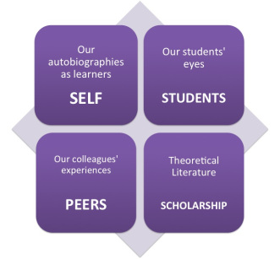
1a: The Brookfield model of critical reflection illustrating the four lenses through which to view the data (Brookfield, 2017)

Self: Learning journal, students work, any extension work, plickers data | Students: Information from interview and from peer observation
Peers: Use of findings from the lesson and discussion afterwards | Scholarship: Topics of starters (specifically multiple choice), classroom engagement, pupil lead activities, learning environments

1b: The Brookfield model of critical reflection highlighting specific purposes and location for evidence to be considered (Brookfield, 2017)
Self | Student
Peers | Scholarship

1c: Blank proforma based on the Brookfield method to make notes on the empirical evidence collected as illustrated in appendix 1b (Brookfield, 2017)

Scott Clarke & David Battell | 1 | 2 | 3
Did each pupil attempt the starter?
Score?
Did the pupil ask questions through the lesson on the topic?
Did the pupil understand each task? Were there constant follow-ups?
Did the pupil ask for extension work?
Was each task started?
Was each task finished?
Was there any unwelcome chatting?
Are there any active listening skills present?
Is there any copying occurring?
Has the child earned any behaviour points? (Positive or negative)
Has the pupil earned a restorative practice meeting?
Has the pupil been spoken to about behaviour previously in lessons?
How did the child perform in the plenary activity?
Did they show progress of learning/understanding?
Appendix 2 – Exemplar observation schedule and interview questions

2a: Blank observation schedule used to capture observational data within the classroom during the lesson study: Space on the back dedicated to additional notes
S. Clarke & D. Battell | 1 | 2 | 3
How did you feel coming into the lesson?
How did you feel about having a quiz at the start of the lesson?
What would you prefer to do as a starter?
Why?
How did you feel about the lesson after the starter?
What did you think about the difficulty of the tasks?
What did you learn during the lesson?
How do you know?
Did you enjoy any part of the lesson?
Why?
Did you find any of the lesson difficult?
Why?

2b: Blank semi-structured interview question sheet capturing answers to both open and closed questions with room on the reverse dedicated for additional notes
Appendix 3 – Consent and information forms
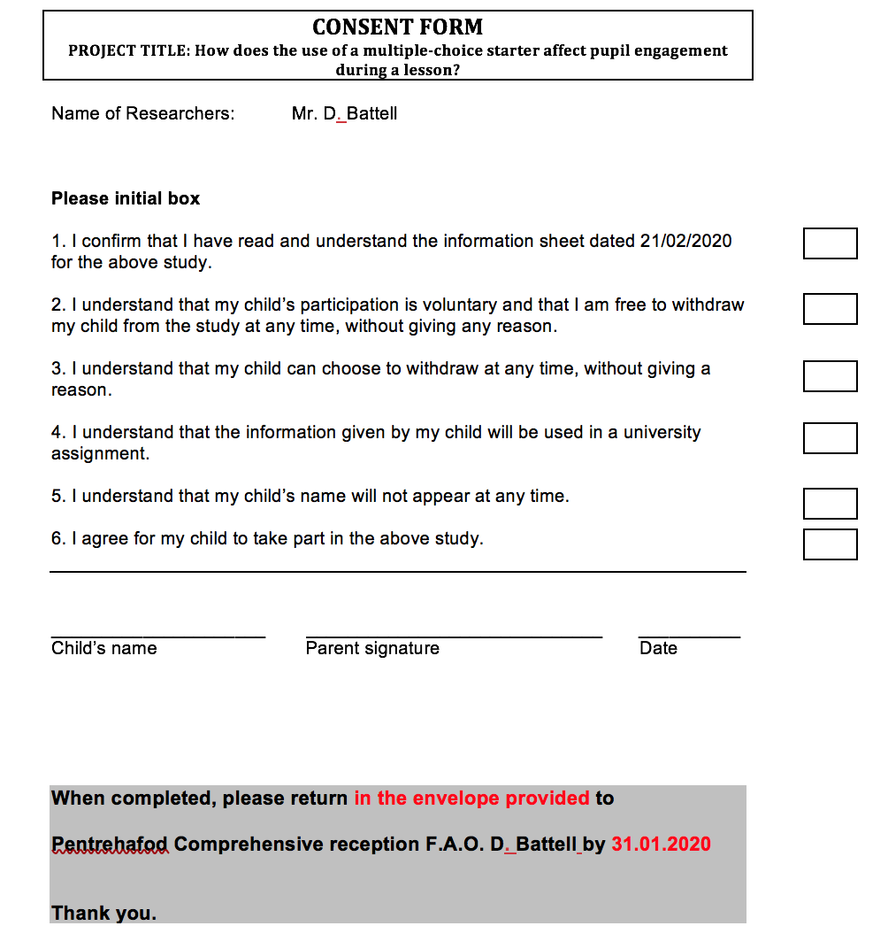
3a: Consent form that had been sent to parents via students and returned completed. Only completed forms returned made students viable to be a part of the research.

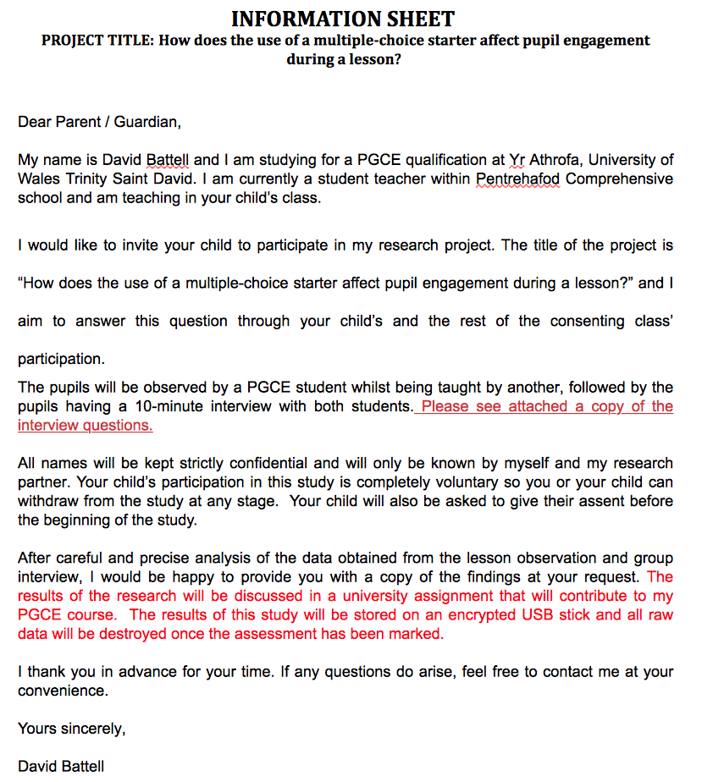

3b: Accompanying information sheet sent along with consent form and a copy of the interview questions (appendix 2b) for parents to understand full breadth of research their child may be involved in.

Appendix 4 – Raw data from lesson study from both researchers involved
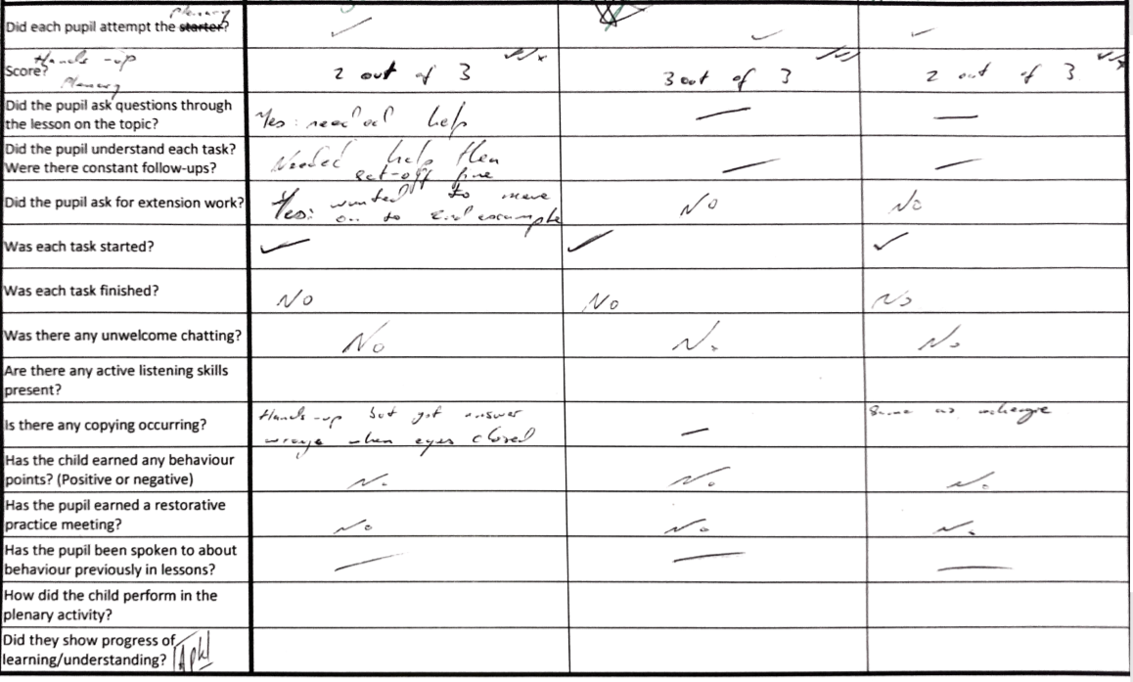
4.a.1 Observation data from D. Battells lesson (S. Clarkes notes)
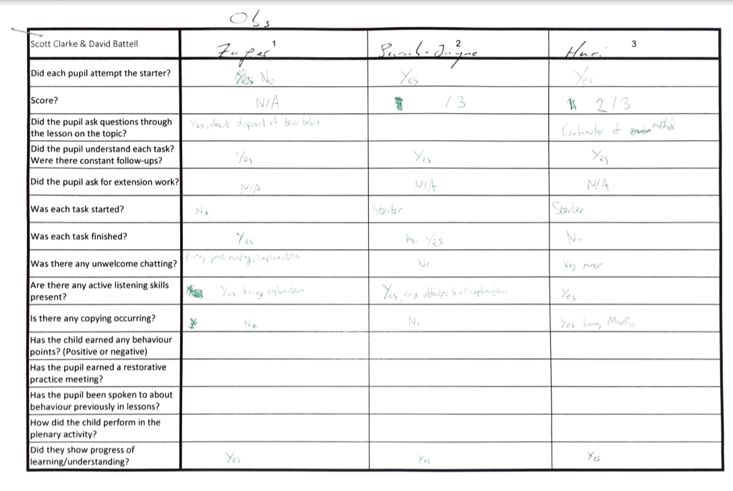
4.a.2 Observation data from S. Clarkes lesson (D. Battells notes)
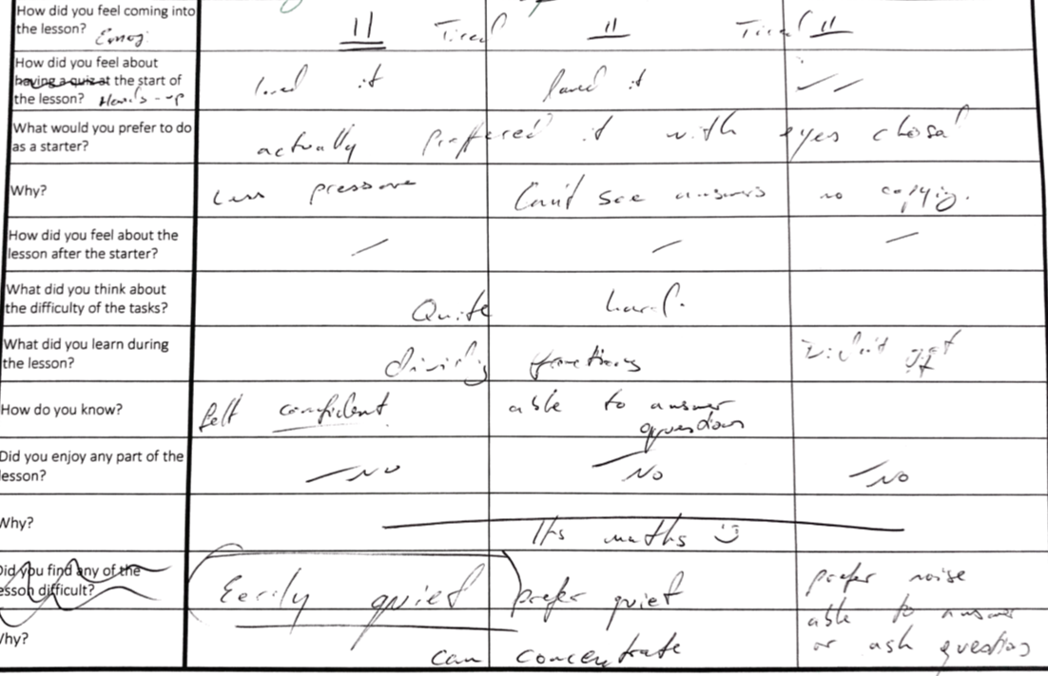
4.b.1 Interview answers from D. Battells lesson (S. Clarkes notes)
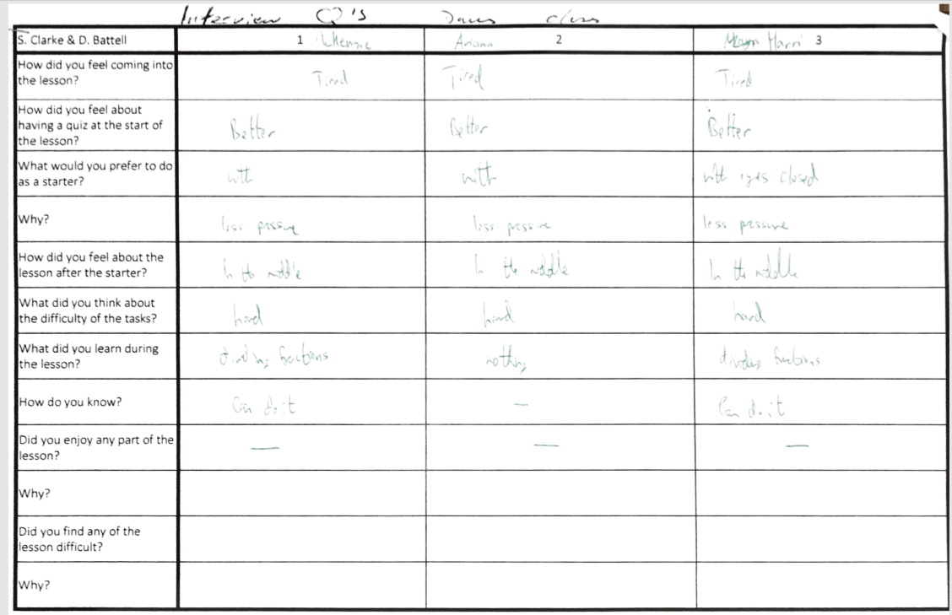
4.b.2 Interview answers from D. Battells lesson (D.Battells notes)
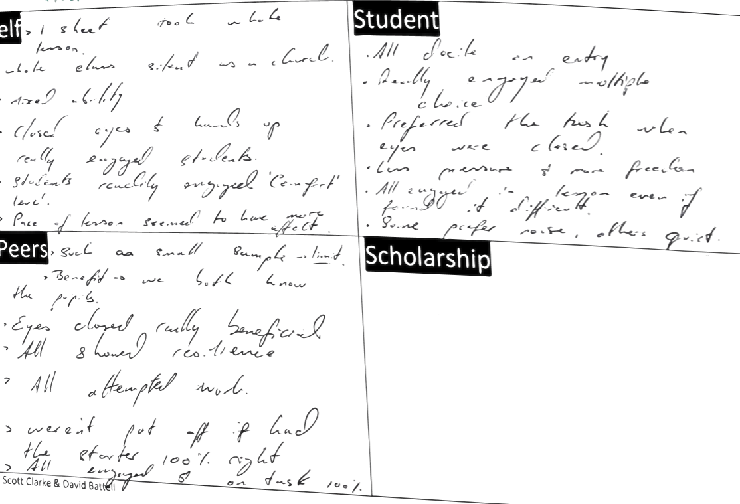
4.c.1 Discussion and reflection notes of D. Battells lesson (S. Clarkes notes)
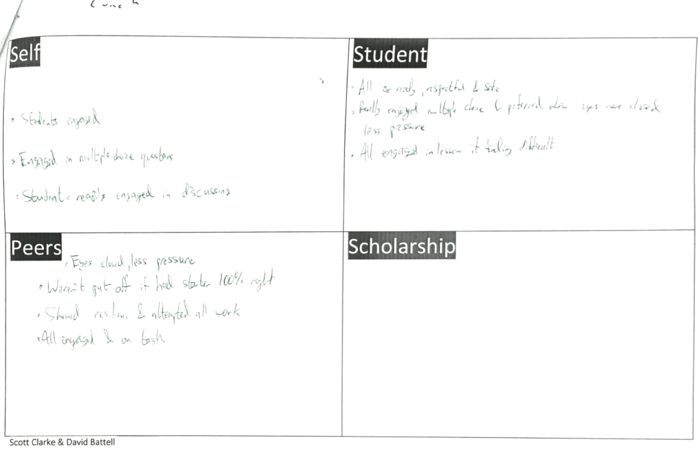
4.c.2 Discussion and reflection notes of D. Battells lesson (D.Battells notes)
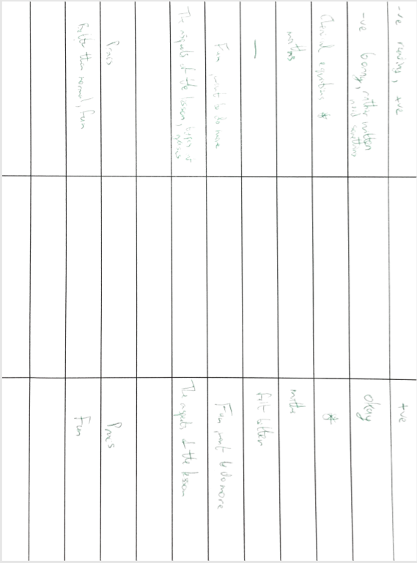
4.d.1 Interview answers from S. Clarkes lesson (D.Battells notes)
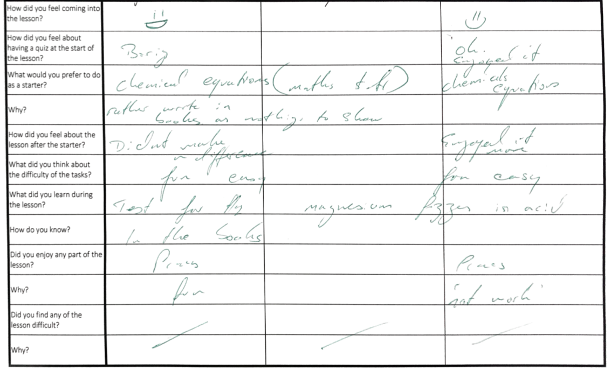 4.d.2 Interview answers from S. Clarkes lesson (S. Clarkes notes)
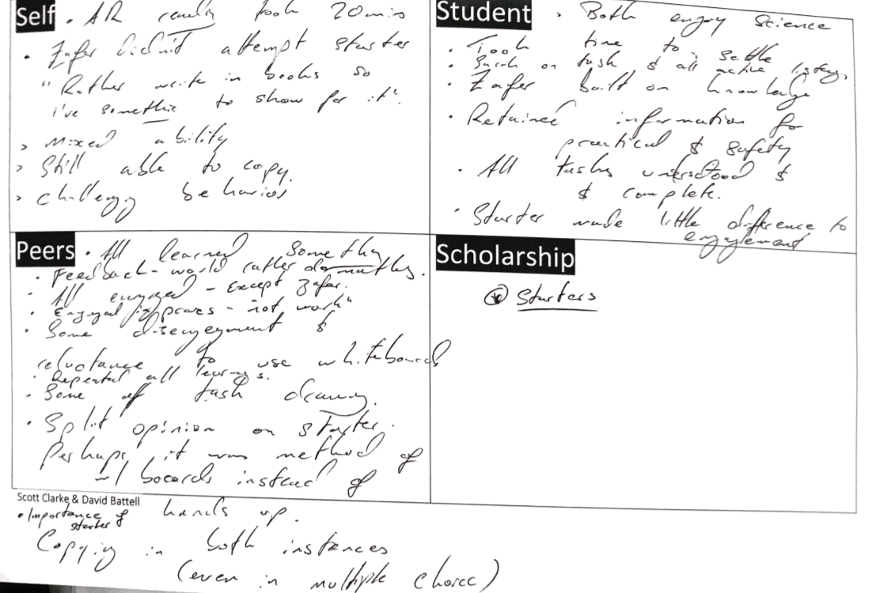
4.e.1 Discussion and reflection notes of S. Clarkes lesson (S. Clarkes notes)
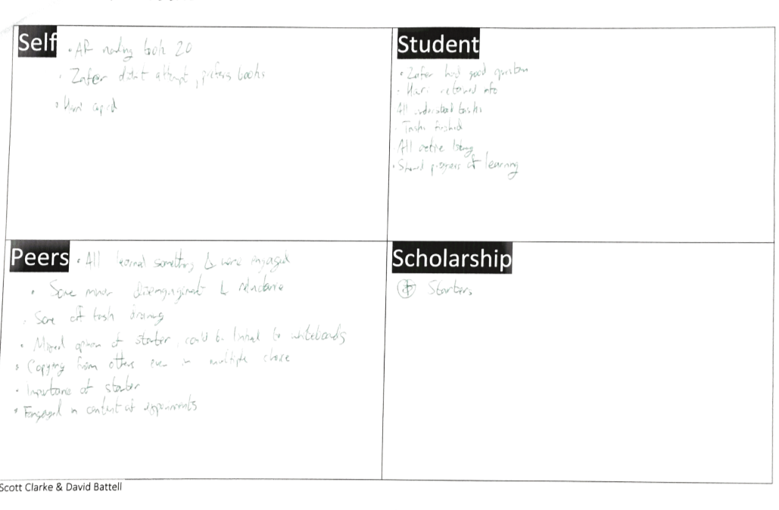
4.e.2 Discussion and reflection notes of S. Clarkes lesson (D.Battells notes)

