
Programme: Master of Business Administration
Module: Marketing Management
Module code: LCMB7024
Title: Assesment Component 2: Marketing Portfolio
Word count: 2688
Lecturer : Dian Mayasari (Birmingham)
Student Name : Sharaf Uddin
Student ID: 2438922
Submission Date-17/12/2025

Table of Contents
1. New brand concept and STDP for IKEA UrbanGrow 3
1.1 Segmentation 4
1.2 Targeting 5
1.3 Differentiation 6
1.4 Positioning 6
2. Marketing mix strategy for IKEA UrbanGrow (7Ps) 7
2.1 Product 7
2.2 Price 7
2.3 Place 8
2.4 Promotion 9
2.5 People 9
2.6 Process 9
2.7 Physical evidence 10
3. Marketing strategy pitch: IKEA UrbanGrow 10
4. Reflective statement 11
References 13

List of Figures
Figure 1: Indoor farming market size by region, 2018–2030 (US$B). Source: Grand View Research (2024). 4
Figure 2: Indoor farming market share by growing mechanism, 2024 (%). Source: Grand View Research (2024). 5

1. New brand concept and STDP for IKEA UrbanGrow
IKEA is an international home furnishing retailer with a vision of developing a better everyday life of the many people. Its business model integrates functional and well-designed products, accessible prices, and gradually incorporating sustainability in sourcing, operations, and customer solutions by using a combination of democratic design, flat-pack logistics, and omnichannel retail (IKEA 2024; Kotler and Keller 2023). The category that can fit into this strategic direction is the indoor farming and smart gardening as it is associated with home improvement, wellbeing and sustainable living at its core located in the home.
UrbanGrow is a proposed concept of a new IKEA brand which incorporates hydroponic growing solutions into modular equipments that can be used in the kitchen and in tiny residential spaces. The brand has compact and plug and play systems that have LED lighting, water circulation and growing pods that fit standard IKEA kitchens and shelfs. A companion application is one that gives easy notification and growing recipes and connections to refills of seeds and nutrients. UrbanGrow is being offered as an everyday solution, which allows urban homes to plant fresh herbs and green leafy vegetables right at home, even in a small apartment, and improve the look and feel of their homes.
The market trends indicate the strength of the concept. With urbanisation, food price uncertainty and a worry regarding the quality and availability of food, the market of the indoor farming is expanding (Grand View Research 2024; IMARC Group 2024). Simultaneously, the ownership of smart homes in Europe only increases, particularly in relation to connected lighting and devices that can automate routine (Statista 2025; Deloitte Digital 2024). Surveys of consumers indicate that a large proportion of households are longing to live in more sustainable ways, eat healthier and put more greens at home, whereas they have no time, knowledge and space (Euromonitor International 2024; Allied Market Research 2024). These changes provide a promising environment to an indoor growing system, which eliminates the complexity and is aesthetically in keeping with the existing furniture. According to Figure 1, the market of indoor farming will expand intensively in all significant regions in the course of 2030 (Grand View Research 2024).
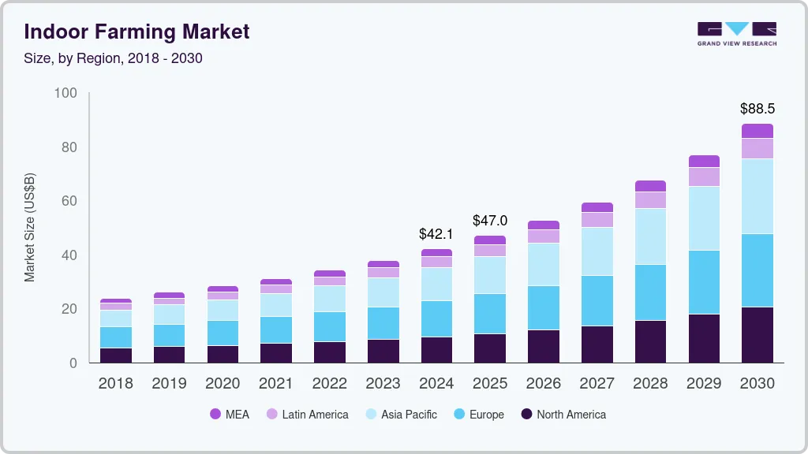
Figure 1: Indoor farming market size by region, 2018–2030 (US$B).
Source: Grand View Research (2024).

1.1 Segmentation
The market can be split into segments based on the STP principles in a demographic, geographic, psychographic and behavioural segmentation (Kotler and Keller 2023).
Demographic: The targeted audience is adults who are comparatively 25 to 45 years old, who are usually two-income families, students and young families with middle to moderate income. Some are tenants or first-time house buyers.
Geographic: Cities and the peri-urban regions in European nations that have good stores and e-commerce possibilities of IKEA. Household is usually unspacious and there is no much space, neither in balconies nor gardens.
Psychographic: Home conscious, environmentally conscious, and healthy eating design conscious consumers. They are comfortable with basic digital technology, they love cooking their own meals at home and are willing to use new lifestyle products that can be valuable to their wellbeing.
Behavioural: Customers who already purchase IKEA kitchens, storage and home accessories; users of smart speakers and connected lights; purchasers of fresh herbs, salad mixes and organic produce; and those who have either bought or thought about indoor plants or countertop gardens.
On the one hand, according to secondary sources, younger urban professionals and families, which value convenience and appearance as much as ecological advantages, are particularly followers of adoption (Euromonitor International 2024; Statista 2025). According to Figure 2, the largest portion of the indoor farming market by growing mechanism in 2024 will be hydroponics, which supports UrbanGrow's focus on hydroponic systems.
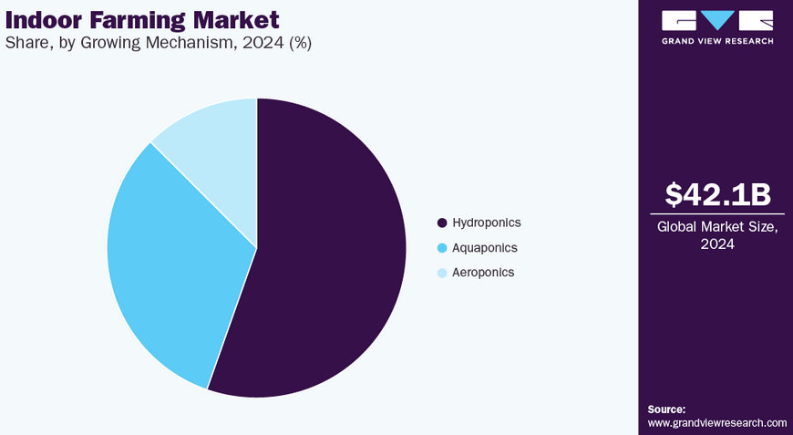
Figure 2: Indoor farming market share by growing mechanism, 2024 (%).
Source: Grand View Research (2024).

1.2 Targeting
From these segments, UrbanGrow focuses on a primary target:
Urban, design conscious European households aged 25–40 who live in small homes, enjoy cooking, care about sustainability and already shop at IKEA.
This group regularly visits IKEA stores or its website, is used to modular furniture and values practical products that are easy to assemble and maintain. They are interested in fresh ingredients and greener lifestyles but may feel intimidated by gardening. For them, the key value drivers are simplicity, reliable results, aesthetic integration with their kitchen and a reasonable total cost per harvest.
A secondary target includes students and young couples furnishing their first apartment. They are price sensitive but open to entry-level systems, starter sets and promotions linked to kitchen purchases.

1.3 Differentiation
The indoor smart gardening market is currently led by specialist brands that position their systems as high-tech lifestyle devices. Many offer strong horticultural performance but can be expensive, visually isolated from existing furniture and limited to online sales (Grand View Research 2024; Market US 2022). UrbanGrow differentiates itself through several levers:
Furniture integration: Systems are designed to fit seamlessly into IKEA kitchens and shelving so they look like part of the home, not a gadget.
Democratic pricing: IKEA’s scale and supply chain allow lower prices than many pioneers, making indoor growing accessible to the “many people” rather than a niche audience.
Everyday service: The IKEA Home Smart app and IKEA Family ecosystem can deliver simple guidance, refills and after-sales service, rather than complex horticultural dashboards.
Sustainability credibility: The brand can build on IKEA’s wider sustainability agenda in materials, energy efficiency and circular design, including repairability and recyclable packaging (IKEA 2024; Spherical Insights 2024).
Differentiation therefore relies less on unique components, which are increasingly commoditised, and more on integration, reliability, accessibility and sustainability of the total offer.

1.4 Positioning
Based on the above, the positioning of UrbanGrow can be articulated as:
For urban households who want fresh herbs and a calmer, greener home without gardening expertise, IKEA UrbanGrow is an integrated indoor gardening system that delivers reliable harvests in small spaces through simple digital guidance and affordable refills. Unlike specialist smart gardens, UrbanGrow fits seamlessly into IKEA kitchens and living areas, is widely available in-store and online, and is designed for long-term, repairable use with transparent sustainability.
This positioning aligns the brand with the broader trend toward home wellness and sustainable living, while remaining consistent with IKEA’s emphasis on functional, beautiful and affordable solutions.

2. Marketing mix strategy for IKEA UrbanGrow (7Ps)
Because UrbanGrow combines a physical product with ongoing service elements such as refills and app support, the 7Ps service marketing mix provides an appropriate framework (Parasuraman, Zeithaml & Berry 1988; Kotler & Keller 2023).

2.1 Product
The UrbanGrow product range consists of three modular hydroponic units:
- A compact countertop unit for herbs and microgreens.
- A mid-sized unit that fits into existing IKEA shelving or wall systems.
- A taller unit suitable for integration into kitchen layouts or pantry spaces.
All models include energy efficient LED grow lights, low-noise pumps, water reservoirs and simple plug-and-play growing pods. Sensors monitor water level and, in higher models, temperature and conductivity to support stable growth, reflecting technological trends in indoor farming (Grand View Research 2024; IMARC Group 2024). The companion IKEA Home Smart app provides care reminders, simple growing “recipes” and notifications when refills are recommended.
Sustainability is embedded in the product design. Units use durable, recyclable materials where possible, and are designed for modular repair rather than full replacement. Starter kits are packaged using FSC certified cardboard and limited plastics (IKEA 2024). Refill pods prioritise herbs and leafy greens commonly used in European cooking to link directly to meal preparation. Clear user instructions and QR-linked micro-videos address the main adoption barrier in this category, which is fear of failure and perceived complexity (Euromonitor International 2024).

2.2 Price
Pricing follows a good–better–best structure to accommodate different budgets:
An accessible entry-level unit priced to encourage impulse addition to a kitchen or storage purchase.
A mid-range unit for families that need higher yield.
A premium configuration integrated into full kitchen solutions.
The strategy combines value-based pricing and penetration pricing. Hardware margins are kept moderate to build the installed base, while refills and complementary accessories (such as herb jars, scissors and recipe books) generate recurring revenue, in line with broader indoor farming business models (Market US 2022; Allied Market Research 2024). IKEA Family members receive discounts on refills and occasional free seed packs to support first harvest success.
Given cost-of-living pressure in many European cities, communication focuses on cost per harvest, reduced waste compared to buying herbs that spoil, and emotional value such as enjoyment and wellbeing, rather than promising full food self-sufficiency.

2.3 Place
UrbanGrow leverages IKEA’s omnichannel distribution infrastructure (Deloitte Digital 2024). Key elements include:
In-store Green Hubs within kitchen and dining showrooms where live UrbanGrow units display thriving plants. Customers can see, touch and taste results, which reduces perceived risk.
Store layout integration so units appear naturally on worktops, wall systems and trolleys in room sets, helping customers visualise placement at home.
Online channels including the IKEA website, app and third-party marketplaces where appropriate. Product configuration, customer reviews and AR visualisation tools help customers explore sizes and placements remotely.
Click-and-collect and home delivery using existing logistics networks, including flat-pack packaging that fits standard IKEA delivery processes.
Roll-out prioritises countries with high urbanisation, strong IKEA brand equity and good broadband and smartphone penetration, aligning with smart home adoption patterns in Europe (Statista 2025).

2.4 Promotion
Promotion has two main objectives: to build awareness of the category and to position UrbanGrow as the simple, credible choice. The communication mix includes:
In-store demonstrations and workshops where staff show basic setup, maintenance and harvesting, addressing knowledge barriers. Digital campaigns across social media and IKEA’s owned channels that feature short videos of real households using UrbanGrow in everyday cooking, emphasising ease and atmosphere rather than technical features (Euromonitor International 2024). Content marketing with recipes, seasonal planting guides and tips integrated into the app and website.
Collaboration with food, sustainability and interior design influencers who can show how UrbanGrow fits into stylish small homes and supports lower-waste cooking.
Messages highlight fresh taste, reduced waste, calming greenery and credible sustainability, avoiding exaggerated self-sufficiency claims. Sustainability claims are backed by transparent information on energy use, materials and repairability (IKEA 2024).

2.5 People
The quality of services is vital since a large number of customers will be new to indoor growing. The IKEA employees in the kitchens and Green Hubs are certified as the UrbanGrow guides with a basic horticulture and troubleshooting practices. They play the role of explaining the system working, contain expectations on yields and calm down.
Support services post-sale include online chat, telephone and the app, which is fast to substitute faulty pods or parts in new use, building trust. Reliability, responsiveness and empathy as training and performance metrics reflect aspects of service quality dimensions that have been described in the SERVQUAL model (Parasuraman, Zeithaml and Berry 1988).

2.6 Process
The customer journey is designed to reduce friction at each stage:
1. Discovery: Customers encounter UrbanGrow in inspirational room sets and online. Clear signage and short videos explain the concept in simple language.
2. Purchase and assembly: Packaging includes straightforward, visual instructions consistent with IKEA’s flat-pack tradition. QR codes link to short setup videos.
3. Onboarding: The first thirty days are structured as a guided “first harvest journey” with reminders at key milestones, such as topping up water or thinning seedlings.
4. Refills and upgrades: When the app detects approaching harvest or depleted pods, it prompts customers with simple refill options. Refills are easy to add to regular IKEA orders.
5. Issue resolution: Clear processes for returns, repairs and component replacement minimise frustration.
These processes help translate a potentially complex activity into a manageable habit, which is essential for repeat refills and long-term satisfaction (Grand View Research 2024; Deloitte Digital 2024).

2.7 Physical evidence
Physical evidence supports the intangible aspects of service. In-store, healthy plants under UrbanGrow lights, clean units, and appealing kitchen settings demonstrate reliability and aesthetic fit. Packaging uses natural colours, simple typography and sustainability cues consistent with IKEA’s brand. The app interface is uncluttered, with intuitive icons and minimal permission requests, which reassures privacy conscious users in Europe.
The presence of UrbanGrow in IKEA’s showrooms, catalogues and online galleries signals that it is a mainstream home improvement solution rather than a niche gadget. This visual and experiential evidence reinforces the positioning and closes the gap between abstract sustainability aspirations and tangible daily practices.

3. Marketing strategy pitch: IKEA UrbanGrow
Urban life is getting smaller, faster and more stressed, yet people still want fresh, flavourful food and a greener home. Most of them lack gardens, time and gardening confidence. At the same time, the indoor farming and smart home markets are growing rapidly, driven by technology advances, higher food prices and stronger interest in sustainable living (Grand View Research 2024; Statista 2025).
IKEA UrbanGrow transforms this tension into an opportunity. It is a new brand of modular indoor growing systems that integrates directly into IKEA kitchens and storage. Customers choose a compact unit, click in pre-seeded pods, add water and let efficient LED lights and a quiet pump do the work. A simple IKEA Home Smart app guides the first thirty days so that even complete beginners achieve a successful harvest.
The business model combines affordable hardware with recurring revenue from seeds and nutrients. IKEA’s stores become Green Hubs where customers can see, touch and taste real results, while the global logistics network ensures easy refills and spare parts. UrbanGrow strengthens IKEA’s kitchen offer, drives extra store visits and builds deeper loyalty through subscriptions, all while supporting the company’s sustainability ambitions.
UrbanGrow is therefore not just another gadget. It is a scalable way to put fresh herbs, calmer greenery and more sustainable habits into millions of small homes, in line with IKEA’s purpose of creating a better everyday life for the many people.

4. Reflective statement
Developing the UrbanGrow brand strategy required applying marketing frameworks to a real company and an emerging category. Starting from secondary data on indoor farming, smart homes and European consumer trends, I had to move beyond a descriptive macro-environment analysis and translate those forces into a concrete customer segment, value proposition and marketing mix. Using the STDP model and the 7Ps helped me break down a complex opportunity into manageable decisions about who to serve, what to offer and how to deliver it (Kotler & Keller 2023).
One key learning was the importance of aligning differentiation with the company’s existing capabilities. In earlier work I focused heavily on technology and the distinction between pioneers and followers in the indoor farming category. In this assignment, I had to reframe that thinking through IKEA’s strengths in democratic design, store experience and logistics. This shift made the strategy more realistic and showed me how internal resources and brand identity constrain and enable marketing choices.
It also improved my research and critical thinking abilities. I needed to generalize market reports, retail research, sustainability reports and consider which of the trends were realistic, actually usable to UrbanGrow, like smart home penetration as well as cost-of-living pressures, instead of just enumerating statistics (Grand View Research 2024; Deloitte Digital 2024; IKEA 2024). The experience of writing the pitch also taught me to focus on the most interesting arguments to present to investors and customers with a constrained word count, thereby making it easier to articulate and sell an idea of value in a more persuasive manner.
Should I replicate the same project, I would include primary research to challenge and clarify my assumptions. The demand drivers, price sensitivity and barriers to adoption could be confirmed by interviews or brief surveys of IKEA shoppers in urban settings. To find the points of possible friction earlier, I would also visualize the customer journey more, such as through service blueprints or customer journey maps. Lastly, I would rehearse the pitch and tighten it down to finalize it using the feedback so that the spoken reading is just as articulate as the written script.
On the whole, the assignment helped me become more proficient in linking the environmental analysis and brand development together, putting a marketing theory into practice and critically examining my own work and studying.

References
Allied Market Research (2024) Indoor farming market size, share and forecast 2024 to 2032. Available at: https://www.alliedmarketresearch.com/indoor-farming-market (Accessed: 1 November 2025).
Deloitte Digital (2024) European retail omnichannel report 2024. London: Deloitte Insights.
Euromonitor International (2024) Home gardening trends in Europe 2024. London: Euromonitor.
Grand View Research (2024) Indoor farming market size, share and trends analysis report by facility type, technology, component, crop type, region, and segment forecasts 2024 to 2030. Available at: https://www.grandviewresearch.com/industry-analysis/indoor-farming-market (Accessed: 1 November 2025).
IKEA (2024) IKEA sustainability report FY2024. Available at: https://www.ikea.com/global/en/images/IKEA_Sustainability_Report_FY_24_2025_01_27_2c35989733.pdf (Accessed: 1 November 2025).
IMARC Group (2024) Indoor farming market 2024 to 2033. Available at: https://www.imarcgroup.com/indoor-farming-market (Accessed: 1 November 2025).
Kotler, P. and Keller, K.L. (2023) Marketing management. 16th edn. Harlow: Pearson.
Market US (2022) Indoor farming market size, share and trends 2022 to 2032. Available at: https://market.us/report/indoor-farming-market/ (Accessed: 1 November 2025).
Parasuraman, A., Zeithaml, V.A. and Berry, L.L. (1988) ‘SERVQUAL: a multiple item scale for measuring consumer perceptions of service quality’, Journal of Retailing, 64(1), pp. 12–40.
Porter, M.E. (1985) Competitive advantage: creating and sustaining superior performance. New York: Free Press.
Spherical Insights (2024) Vertical farming market insights and forecast to 2032. Available at: https://www.sphericalinsights.com/reports/vertical-farming-market (Accessed: 1 November 2025).
Statista (2025) Smart home device adoption in Europe 2025. Available at: https://www.statista.com/topics/4768/smart-home-europe/ (Accessed: 1 November 2025).

Appendix

