Student Name: Vasile Florin Buzan
Number:2222994
Module name:Hote; Placement – Food & beverage operation
Module code:BMIH4002
Assignment title:Menu Engineering FINAL



Part 1:
Hotel Trinity is coming up with a new restaurant concept of ‘Garden Bistro’ which mainly focuses on offering a green (natural) and organic menu in regards to the ongoing trend of healthy eating (Bertan, 2020) . It aims to offer dishes to its diet conscious customers while using fresh ingredients directly from the farm (Braswell, 2018) . The ambiance of the new restaurant will be aesthetic and open, with the seating arrangement on lush green garden (J. Kozdrój a, 2019) with fresh and airy atmosphere with plants in each corner. Creating such an environment will automatically apprehend the dine-in customers’ mood and they’re more likely to sit and chill while ordering their favorite delicious food.
The target audience of Hotel Trinity will be the people aged between 20 to 45 years of males and females from all walk of life with an above average source of income. The people will mainly be the ones who are more concentrated about healthy eating, green food (Thi Thu Huong Nguyen 1, 2019) in a relaxed fresh environment (Jianming Wang, 2020). The restaurant will be appreciated by the ones who prefer organic food made of natural ingredients and acceptable practices related to eating food. All in all, Hotel Trinity aims to offer sustainable food options made of farm to dining’ ingredients to health conscious individuals.
Such a menu was put into effect in order to satisfy those people that prefer to have a range of food options that satisfies their choice of staying healthy while having dishes made up of naturally and locally sourced ingredients (Igual, 2019) along with combating their dietary preferences. Such an idea supports the local farmers and eradicates any transportation costs of raw materials. The aim is also to satisfy the people with best meals via emphasizing use of organic and fresh seasonal ingredients (Neale J. Slack, 2021) Moreover, the menu designed will attract a large number of individuals due to a special section for nutrition and special dietary requirements, vegetarian and vegan.
Following principles were considered while designing the menu (Stephanie Q. Liu a, 2019), firstly, since the target audience is people with healthy eating habits therefore the menu mainly targets to cater such a demand with aligned pricing. Secondly, the menu is designed thoroughly to offer a wide variety to choose from either starters, main course, deserts, beverages or vegan and vegetarian nutritious section, anyone can find something according to their taste (Marcia C. de Oliveira Otto, n.d.). Moreover, the menu is designed in an appealing way for the readers with attractive pictures, the uniqueness is also because of giving a natural touch to the items in the desert menu.
Part 2: (Anon., n.d.)
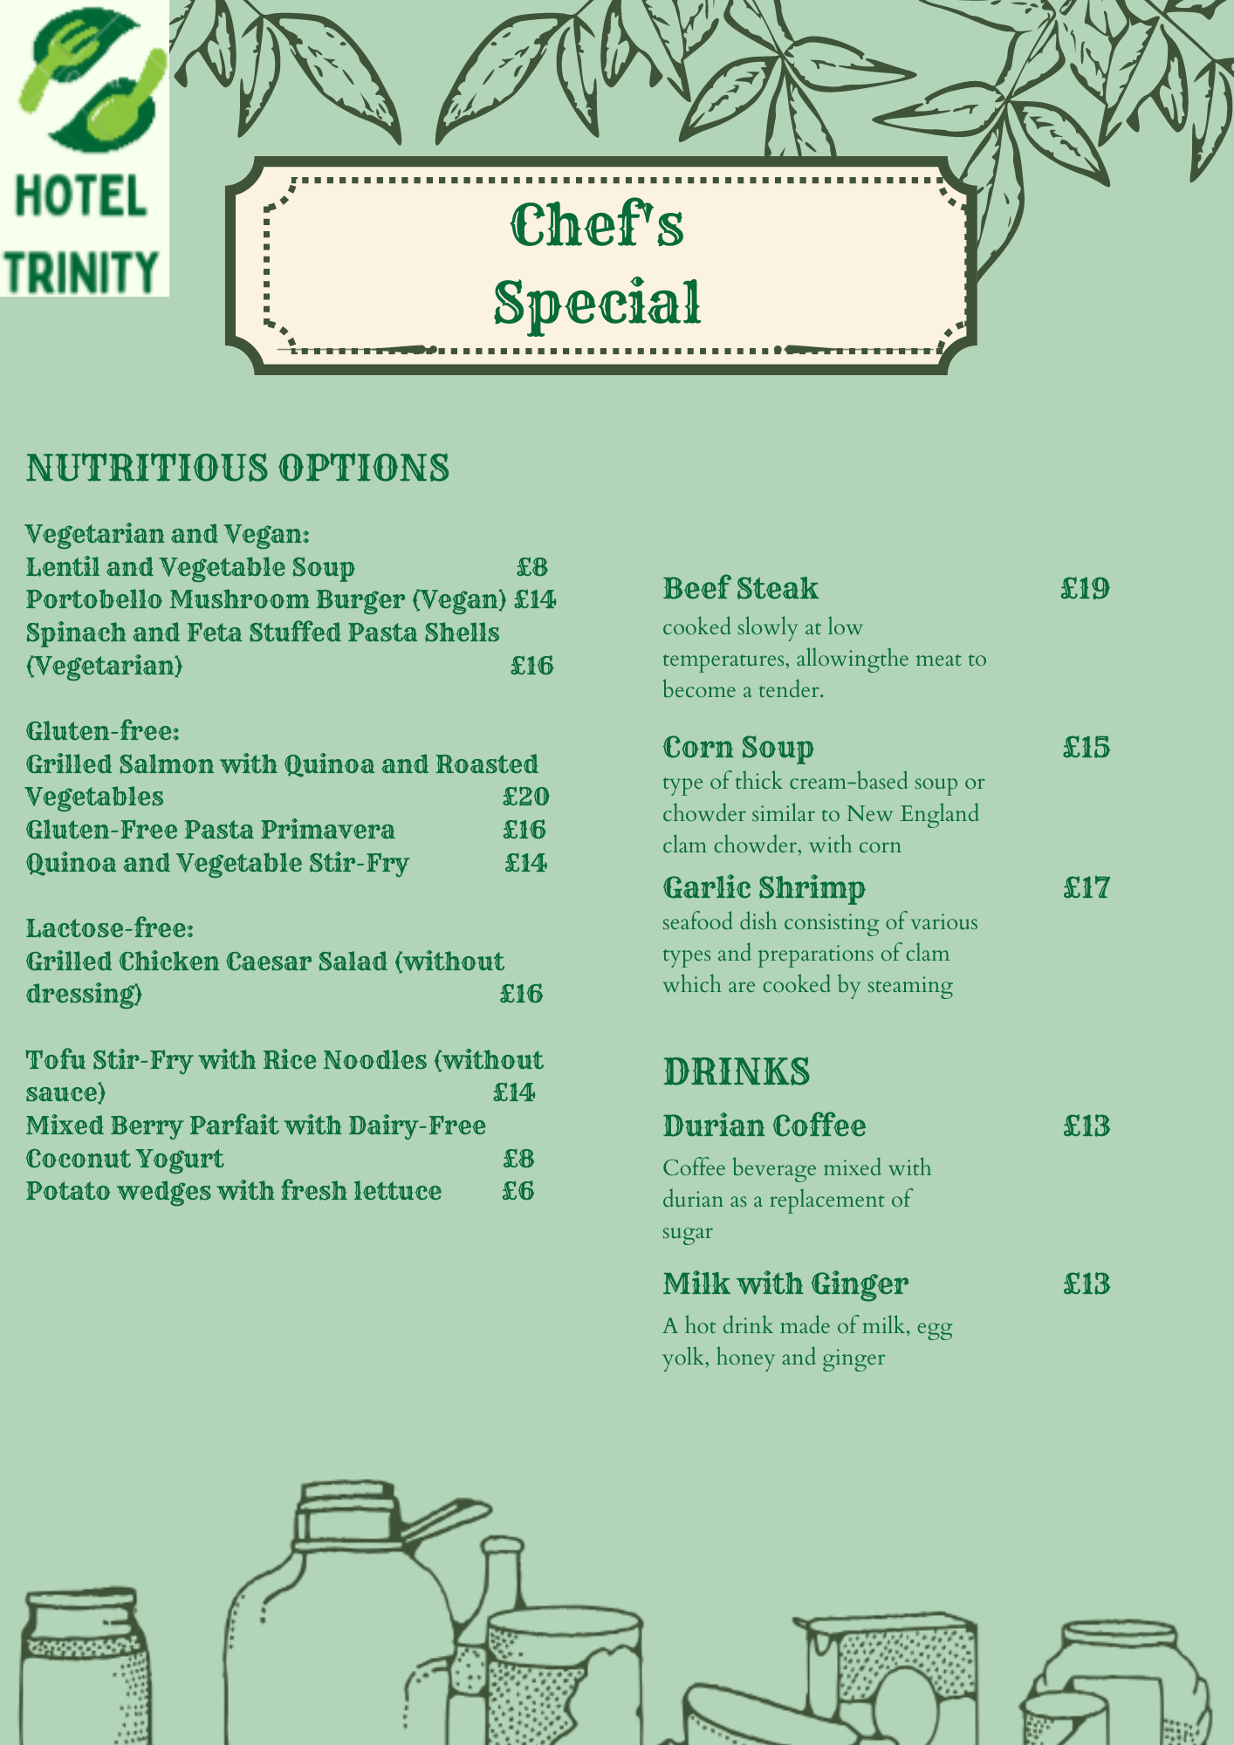

References
Anon., n.d. 26 healthy restaurants in London that you need to try. [Online]
Available at: https://www.squaremeal.co.uk/restaurants/best-for/healthy-restaurants-london_9484
[Accessed 01 Dec 2021].
Bertan, S., 2020. Impact of restaurants in the development of gastronomic tourism. International Journal of Gastronomy and Food Science, Volume 21.
Braswell, T. H., 2018. Fresh food, new faces: community gardening as ecological gentrification. [Online]
Available at: https://link.springer.com/article/10.1007/s10460-018-9875-3
Igual, M., 2019. Novel Ingredients Based on Grapefruit Freeze-Dried Formulatrions: Nutritional and Bioactive value. foods.
J. Kozdrój a, K. F. b. D. R. b., 2019. Assessment of bioaerosols in indoor air of glasshouses located in a botanical garden. Building and Environment, Volume 166.
Jianming Wang, N. N. a. X. B., 2020. Exploring the Roles of Green Food Consumption and Social Trust in the Relationship between Perceived Consumer Effectiveness and Psychological Wellbeing. International Journal of Environmental Research and Public Health.
Marcia C. de Oliveira Otto, C. A. A. J. L. D. E. P. F. D. M. G. R. J. W.-R. A. H. L., n.d. Dietary Diversity: Implications for Obesity Prevention in Adult Populations: A Science Advisory From the American Heart Association. [Online]
Available at: https://www.ahajournals.org/doi/10.1161/CIR.0000000000000595#d1e623
[Accessed 2018].
Neale J. Slack, G. S. J. A. R. L. K. M. Y. S., 2021. Influence of fast-food restaurant service quality and its dimensions on customer perceived value, satisfaction and behavioural intentions. British Food Journal.
Stephanie Q. Liu a, S. C. b. A. S. M. c., 2019. Love is in the menu: Leveraging healthy restaurant brands with handwritten typeface. Journal of Business Research, Volume 98.
Thi Thu Huong Nguyen 1, 2. Y. 1. N. 3. W. J. 4. a. K. C. 5., 2019. Greenwash and Green Purchase Intention: The Mediating Role of Green Skepticism. [Online]
Available at: https://www.mdpi.com/2071-1050/11/9/2653

