UWTSD

Course: BA BUSINESS MANAGEMENT

Module: Introducing the Modern Workplace

Group Report – Amazon company

Year 1, Term 2
Assessment 2

Students ID: 1905516, 1908497, 1905519, 1909419, 1904047

Lecturer: Rexon Nting

Submission date: 13.05.2020

Introduction:

This group report is concentrated on researching and analysing on the below key areas of Amazon company:
- Background/outline of Amazon.

- Goals and objectives (why they are important and how they are established).

- Leadership and management behaviours of Amazon.

- Group and team behaviours.

- Motivation and perception of Amazon.

At the end is included appendix with group presentation photo slides also focused on the same key areas about Amazon.

Group refers to a cluster of two or more individuals formed to achieve specific objectives. Groups’ members share information with each other and perform individual jobs that ultimately leads to fulfilment of a specific purpose (Brooks, 2018). Team refers to group that generates synergy through coordinated efforts pooled together to achieve specific objective. Team members have individual and mutual accountability within team towards ensuring collective performance (Shaw, 2017). Organisations like Amazon must gain adequate cognizance about group and team behaviour to achieve their objectives more effectively.

Amazon.com – Background (Dimitrina Petrova – 1905516)

Over the last twenty years one of the technology giant – Amazon has inspired a lot of connections, prosperity and discovery than the entity in history. As an online retailer, Amazon.com was founded by Jeff Bezos in July 1994 (NASDAQ 2019). For Bezos the main reasonable product for selling online was initially the book. Amazon was not the first online book seller; however, the company was the first one that promised to deliver the product directly to the consumer. (Nguyen, 2019) This is the start of the electronic giant and it went public in 1997 as an electronic book manufacturer. The electronic services it started providing became iconic example of electronic market. (Hall, 2018)
The head office is based in Seattle, Washington. Bezos strategically chose that location because the main technological giant – Microsoft was also based in Seattle. (Hall, 2018)
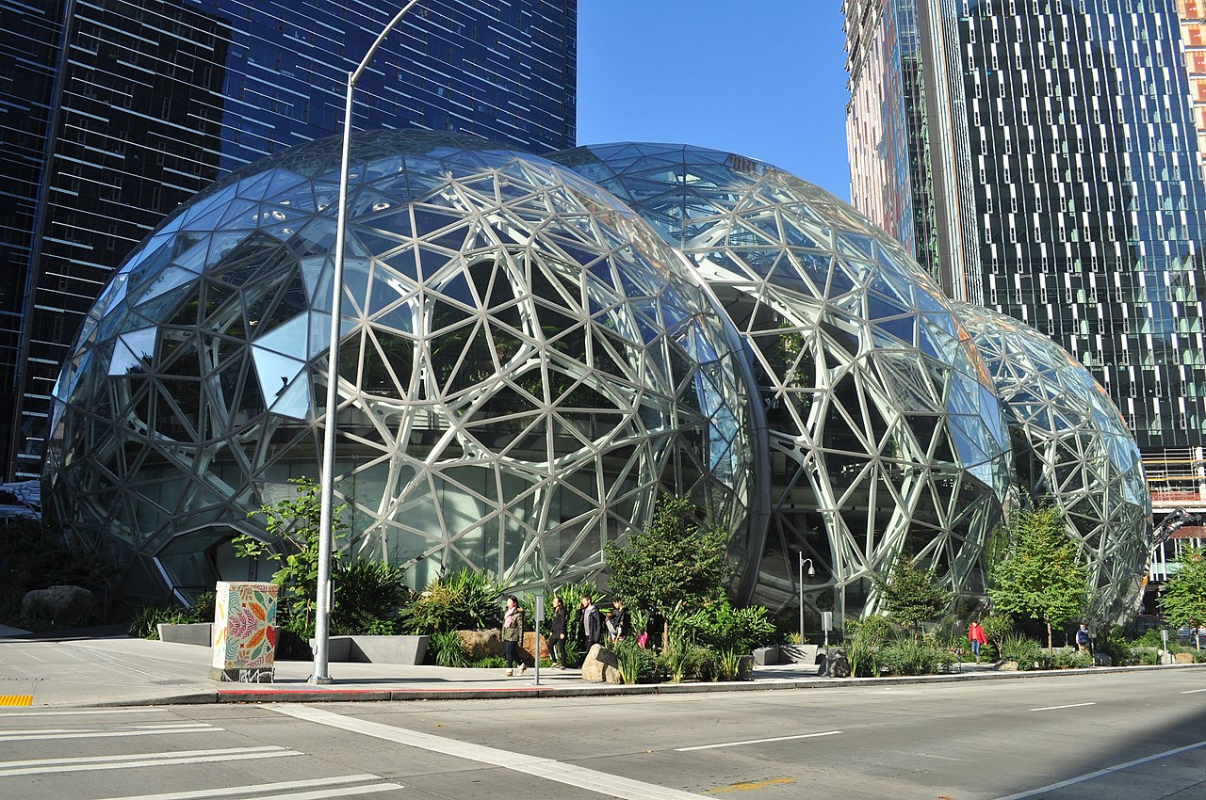

Amazon’s Head office in Seattle

Amazon is huge online-based enterprise that advertises its customers a lot of choice for sale, such as: movies, toys, books, music, houseware, electronic devises and other goods. The service that Amazon provides could be either direct or indirect. (Hall, 2018)
The main profit that Amazon makes in the market is introducing Kindle, the e-book that had a huge influence over the book lovers. The massive promotion of this device led Amazon into a histrionic evolution in e-book publishing. Therefore, this curved the company into a disrupted strength in book-publishing market (Montgomery, 2019)
The business strategy of Amazon was impolitely disregarded by the financial analysts and journalist due to already existent competition on the market. Due to its new entrance in e-commers industry, Amazon.com declined its profit for the first quarter of 2001. (Hall, 2018). Although, Bezos’ success dream was to ‘’Get Big Fast’’ and put this slogan as a new print on all the employee’s T-shirts. Practically, Amazon grew up rapidly and managed to reach 1,000,000 shopper’s account after its second year of operation. In 1996 the company’s revenue flew after $15,7 million to $148 million one year later. (Hall, 2018).
Jeff Bezos was pronounced for Person of the Year in Time’s magazine in 1999. (Time Magazine,1999) The corporation started its expansion very quick in some other areas, too. As an example, Amazon associate program involves Web sites that sales merchandising, however Amazon only place the order and then pay brokerage. Exactly this program increased the profit od the company rapidly (NASDAQ 2019). Another initial strategy of the company was adopted in 1998 to start trading videos and music. This led the company to a huge success and raised an opportunity for international operations. Therefore, in 1999 Amazon had contracts with online booksellers from Germany and United Kingdom. (Geer, 2018)
As per Bezos’ words ‘’To sustain its growth, Amazon needed more than private investors to underwrite the expansion.’’ Consequently, after founding the company, Amazon’s revenue has started increasing form $54 million on the market. (Hill,2018)
Amazon’s priority is to gain loyalty form its customers loyalty and maximize its effectiveness. Although, offering variety of products, the company provides a personalisation tools that recommends additional goods to be bought based on previous purchasing information of the same customer. (Hill, 2018) Another strategic tool of Amazon is the publicity of customer’s reviews and especially the products they have implemented through the website. This tool also helps consumers to find whatever best suits their needs and it is named ‘’community of consumers’’. (Hill, 2018)

‘’The Kindle Shakes Up Publishing’
Kindle is an Android-powered portable e-book that is developed by Amazon as one of its own creatures in 2007. For the e-book market, the outline of Kindle started building the tensions between Amazon and publishers. (Miller and Bosman) The main argument between both sides was the cost of e-book that Amazon wanted to sell comparing with the lower price of the new printed books. Therefore, in 2010 the crack between Amazon and publishers regarding the e-book price had increased. Amazon was directly threatened by one of the publishing companies – Macmillan Books as stated that they will pull all their books from Amazon’s web site. In fact, Amazon surrendered and let the publishing companies to put their own e-book charges that are sold via Amazon.com (Miller and Bosman, 2011)
Kindle 2, 2009.Amazon.com, Inc.

Amazon Encore is the company’s first publishing line that has been introduced to the market in 2009. (Hill,2018) The purpose of this line was to let everyone publishing their own electronic books. In 2011 Kindle were beating all printed books in terms of sales. In fact, this led Amazon.com of launching its new ambition called ‘’Amazon Publishing’’ where the company’s goal was to distribute its own titles. After this key step of Amazon, now the company is a key player in book publishing commerce. (Mille and Bosman, 2011)
In 2017 Amazon was very successful and managed to buy Whole Foods Market, INC. for over $13 billion. (Butler and Wood, 2017)

The story about the Company Logo
The current logo of Amazon is demonstrating a smile that connects the letters A and Z. This is an illustration of the company’s mission to make people happy when receiving their products though the post. However, before this world-known logo, there were a few other logos that were describing the company better at the time of its achievements. (Nguyen, 2019)


Since the beginning of the company, originally the logo was created using the first letter of the alphabet – ‘’A’’ with silhouette of a river Amazon inside the letter. The symbolic of the river is that territory of America where river Amazon is. (Nguyen,2019)



However, in 1997 this version has been replaced by ‘’amazon.com’’ accomplished by the motto ‘’Earth’s Biggest Bookstore’’ and the year of its introduction. (Nguyen, 2019)


The logo type familiar to most of the people nowadays including the curved yellow line underneath was firstly introduced in 1998. The line starts from the beginning of the logo and finishes at the very end. (Nguyen, 2019)


The renown logo with the smile was adopted in 2000. This is an excellent example of how important it is to have versatile logo. Bezos purposed to use the smile as a design element on the shipping boxes and use them as marketing vehicle and to ‘’deliver smiles to doors’’. (Nguyen, 2019)

(Goals and Objectives of Amazon) Marina Stefanovska – ID 1908497
Objectives
The main objectives of Amazon.com are to be the largest company in the world that offers a customer-centered service. By the use of the internet and technology, amazon.com will continually raise its customers' bar and help them to find and buy any product. Amazon.com also empowers businesses and innovators to maximize their success.
The importance of this objective is to empower clients and organizations more so in America and the United Kingdom, digitally, to improve their living standards. Improved living standards will also spearhead the nation in economic wellness and competition in the global economy. Amazon.com tends to exploit the technological infrastructure in providing services that improve the experiences of its customers and help them improve their economic standards. This will, in turn, help in building their countries' economic growth and propel it in the economic competition. Amazon.com was so focused on the use of the internet to reach out to its clients that it also placed itself in a strategic internet location in Seattle, Washington DC, where a technological giant, Microsoft, is also based. Amazon.com is working closely with all the technology companies to archive its long time objectives.
Amazon.com also advertises its products to its clients and giving them choices ranging from movies and series, books which were their first online product, music, houseware, electronics, and other goods. They structured themselves in a manner that will effectively benefit their clients direct or indirectly. Amazon came into existence as an e-book publishing. It brought about an evolution in the electronic book publishing by promoting the sector by introducing Kindle application that influenced the reading community largely, and this brought amazon.com into the map.
The GROW model is a guideline into archiving long term business objectives and also helping individuals in improving their abilities and formulating plans that will help them archive their goals. The goal model involves four stages that include; having and developing a career goal, the current trends and reality in archiving it, obstacles that may tend to slow down success and how to overcome them and having options, lastly, the will. There has to be a will to do something to archive one's goals. Using the GROW model, one learns by experience and reflections, making choices, and pursuing the choices (Watts, 2013). Using the GROW model in achieving your career objectives, there are four stages that one has to consider and to get a sense of direction and focus on archiving it. These stages include;
The stage of goal
In this stage, the organization needs to set long term goals and short term goals and achievements. Goals need to be specific, measurable in terms of time and other metrics; goals need to be acceptable, realistic, and timely. (SMART). When amazon.com was making its goals, it considered a lot of facts that will help them archive their goals; what was more important was to empower their clients through the use of the internet. Amazon.com wanted to archive its goal of becoming the world's largest company that will be offering online marketing and a customer-centric organization that will help in boosting the country's economy (NASDAQ, 2019).
The reality stage is the ability to understand the organization's current position. The organization needs to do a self-evaluation test and identify what was holding it back from its potential. Obstacles are identified, and fears noted. When these are dealt with, then the organization is ready to propel. Amazon.com was founded in 1994 when technology was still fresh and unknown to many, but its future was big and astonishing. Amazon noted this secret and understood its potential this would increase its returns and achieve its goals. In this era, there were other companies that hard the same idea and they were operational, but what was holding this organization back was the lack of customer-centred services. These were the main reason why amazon had itself stuck back in those days, and once they understood this, they made a difference as it is evident (Montgomery, 2020).
Stage of options
Once amazon understood its problems that were setting it back, it had options that will help in solution-finding. It formulated strategies that helped it grow; first, it launches Kindle that puts it on the map that leads to its trend and becoming famous, it re-invested its profits and advertised itself by its employees, after e-books, it entered to the world of music and movies that made them enter into agreements with other giant companies. When they wiped out their obstacles, they advanced very first. This procedure of archiving their goals had a few cons that never slowed the process (Montgomery, 2020).
Stage of Will
This is the last stage of implementing the only option that is assumed to be the best, and all focus is on it. Amazon.com had only one option, to grow big fast. Amazon worked with technological companies to archive their technological breakthrough. The only obstacle that amazon hard in its growth is how to win the loyalty of its clients, but they were motivated by the fact that they were the first company to offer patient-cantered services. This achievement was archived by surrounding itself with all the raw resources it needed, such as Microsoft Company that helped it in archiving its goals (Butler, 2020).

Leadership and management behaviours at Amazon-
Petya Elchinova - ID 1905519
The success of the Amazon Company has been remarkable hence sparking questions on the leadership of the company. They must be incredible! Bezos is viewed as an incredible business leader who not only focuses on value creation but also profitability. While analyzing Bezos' personality traits, the Big Five personality trait model is essential for effective results and accuracy. With regards to neuroticism, Bezos seems emotionally stable - he is willing to take risks and is not afraid of failure. His extraversion is expressed in his bold entrepreneur demeanor and his enthusiasm for innovation. Bezos’ openness to experience comes through his recognition of creative ideas (Ritala, et. al, 2014). He is not easily satisfied with his company’s achievements and always searches for new opportunities. Finally, Bezos conscientiousness is reflected in his work ethic and the fact that he is very organized. However, he can be insistent as he has a strong attention to detail. In addition, Judge’s research revealed that extraversion- sociability and dominance- as well as conscientiousness - achievement and dependability- are traits greatly related to leadership. Extraversion is the most important attribute leaders should possess, and it largely fits the description of Bezos' leadership style. The figure below illustrates Amazon’s growth rate compared to other e-commerce companies in the US. It is evident from the figure below that the company has been able beat its competitors in the e-commerce market hence having a promising growth rate and market share (DONICI, 2012).
Bezos has been an outstanding transformational leader since the beginning of Amazon. He has been able to exhibit this leadership style by influencing his employees to raise their awareness of expected work results. However, these traits can be subdivided into four dimensions, which include inspirational motivation, idealized influence, individualized consideration, and intellectual stimulation. Bezos are primarily concerned with his customers, and he prioritizes their needs (Pfeffer, 2016). He makes sure that his employees continuously address both major and minor issues like delays, out of stock products as well as defects. In contrast to many managers, Bezos is seen as a leader who puts his concerns on the attention to detail as well as production to satisfy his customers. Bezos’ obsessive nature of satisfying the customers, and high expectations of employees executing their tasks, can show him to be a micro-manager.
Moreover, his transformational leadership can also be attributed to the way he inspires his employees to generate new ideas and creative solutions for the company. Jeff Bezos strongly upholds that the "disagree and commit" approach saves time and allows the employees to arrive at a mutual agreement once a final decision has been made. This of course may create a lack of group coherence and escalate disagreements among colleagues (Solanki, 2019) Nonetheless, Jeff Bezos does not approve of the notion of social cohesion and is understanding about that until a decision has been made. Various media outlets portray Jeff Bezos as genius, eager, and a man with a vision. He is seen as a magnetic and radical innovator who forever changed the e-commerce business environment.
Bezos' leadership style consist of micromanaging his employees and holding them to high expectations of meeting the high standards he sets for his business. For the transactional leader achieving short-term operational goals is of great importance. He would also use disciplinary power - Rewards or Punishment – in order to influence the performance of his employees. His leadership style on employees and teamwork is more inclined to authoritarian compliance. He enforces his believes and ideals to new employees in a move to have them adapt to the “Amazon way” of working. He lacks the degree of individualized consideration for his employees. For instance, studies in 2015 report that Amazon has a system of ranking its employees, and those with low monthly performance ratings are released. Relatively, Bezos ensures the continued growth of Amazon Company by running the goals and direction for the organization. As designated in organizational development cycles, formalization is vital, and it requires the designation of duties and authorities, especially by top management (Solanki, 2019).
Nevertheless, his less concern about the well-being of the company's employees has raised so much criticism on Bezos' leadership and managerial capabilities. This criticism has made many think that Benzos is a situational leader. Situational leadership affirms the need for leadership flexibility and adaptability when managing employees with different capabilities and motivations (Yu, 2012). However, this leadership theory can prove to be counterintuitive as Jeff Bezos adopt the traits of a micro-manager, operating in a top-down manner and becoming more autocratic over time. Jeff Bezos can be seen taking an authoritarian and transactional approach to his management style.
What makes a leader effective is employing a good and pertinent leadership style and building a following. In Amazon Bezos utilizes an exceptional leadership style. As a leader, he aligns the organization’s corporate culture with its strategic plan of being the best e-commerce retail company. Furthermore, Bezos is flexible, he can adapt to diverse environments and exhibit pragmatic leadership skills such as integrity, transparency, respect, vulnerability, as well as growth. An example of this is during the recession, he steered the company towards success while other companies went under. His leadership and management skills have been extremely beneficial in managing conflict within the organization itself. For example, he supports junior employees to make their arguments and assign leadership roles to junior staff. He also employs two-way communication, which is a significant characteristic of Hersey-Blanchard’s situational leadership.

Group and Team Behaviours at Amazon- Dan Gheorghe Fillimon – ID 1909419

Group refers to a cluster of two or more individuals formed to achieve specific objectives. Groups’ members share information with each other and perform individual jobs that ultimately leads to fulfilment of a specific purpose (Brooks, 2018). Team refers to group that generates synergy through coordinated efforts pooled together to achieve specific objective. Team members have individual and mutual accountability within team towards ensuring collective performance (Shaw, 2017). Organisations like Amazon must gain adequate cognizance about group and team behaviour to achieve their objectives more effectively.
Different types of groups/teams at Amazon may include simple work, administrative, cross-departmental, process, self-managed and virtual groups/teams (Wilson, 2018). Amazon has its own terminology of self-managed teams that are known as ‘Two-Pizza Teams’. Amazon has adopted concept of ‘Two-Pizza Teams’ to motivate employees, provide opportunity and inculcate sense of entrepreneurship. Team size is kept small so that the members may be fed with two pizzas (Schermerhorn & Bachrach, 2017). Two-Pizza teams are build based on competencies rather than for a specific project. Teams are multidisciplinary, enjoy autonomy and have limited interaction with others in Amazon. For example, California based Lab126 team of Amazon creates innovation for its devices, which are later tested in Seattle (Amazon, 2020). Such separation enables teams to remain away from present legacy and create disruptions to existing business practices.
Amazon has established formal channels like Application programming interfaces (APIs) that allows integration between teams and sharing of capabilities. Leadership provides broad guidelines in the form of ‘Forcing function’ to teams for achieving the desired objective (Guardian, 2020). Teams are free to manoeuvre and propose the best possible idea/alternative to the management. Every group/team is required to present a brief ‘Narrative’ to get a formal approval from management to put their ideas into action. Amazon ensures that sufficient brainstorming and group discussion take place for arriving at the right decision. As shown in figure 1, Amazonians may be assigned any of the nine roles as per their capabilities and as per need of the group/team.

Roles at Amazon

Figure 1: Made by Student (2020), Adapted from (Burns, 2017)

Creative and imaginative individuals with an acumen towards solving problems are assigned role of Plant. Individuals with expertise in communication, relationship building and exploring opportunities occupy role of Resource Investigator. Employees acting as coordinator are required to clarify objectives and promote decision making. Employees having dynamic/inspiring personalities that overcome obstacles and thrive on pressure are assigned role of Shaper. Individuals having strategic and judicious approach in selecting the best alternatives are placed as Monitor-Evaluator (Burns, 2017). Co-operative and perceptive individuals who are averse to conflicts and tend to follow instructions are used as Team Worker.
Role of Implementer in a group/team is assigned to those individuals who are efficient, conservative and possess ability to turn ideas into actions. Meticulous employees who meet deadlines and ensure that every work is error free are kept as Completer/Finisher. Individuals having specialised skills who are dedicated and self-motivated are assigned the role of Specialist. Amazonians working in a group/team strive to fulfil all the responsibilities as per their assigned role, in order to achieve objectives of group/team. Every individual in team is fully committed to achieve synergy and the objectives of team (Buchanan & Huczynski, 2019). They trust, collaborate and hold mutual accountability for performance of group/team.
Amazon strives to promote spirit of ownership and entrepreneurship amongst its employees. Amazon has been able to maintain high level of trust and comfort amongst the leadership team. Success of Amazon may be attributed to the stability provided by the leadership team in the highly competitive retail sector. Leadership team at Amazon sets the strategic objectives to be achieved and various teams strive to achieve the goals. In order to focus on strategic objectives, Amazon has formed separate groups along with a dedicated Chief Executive Officer (CEO). For example, Amazon Web Services (AWS) operates with Mr. Andrew Jassy as its CEO (Yeung & Ulrich, 2019). Leaders at Amazon endeavour to establish effective teams keeping in mind the context, composition, work design and process requirements (Amazon, 2020). Teams at Amazon strive to get questions from leadership and look for optimum solutions and in the process elevate themselves from good to great. Consequently, synergy of different teams gets accumulated and ensures an unmatched competitive advantage for Amazon.
Amazon has adopted decentralisation coupled with hierarchical organisation structure. Such an approach enables Amazon to build small teams specifically focussed to achieve a particular objective. Teams empower the employees to take control of the organisation from the management. Amazon strives to promote positive team behaviours to improve productivity, foster teamwork and team synergy (Guardian, 2020). At the same time, it encourages team members to disagree and put their point of view in an appropriate manner. Moreover, Amazon endeavours to reject negative team behaviours that decrease efficiency, create friction and cause anxiety. Further, Amazon strives for continuous improvement in the standard of performance of its staff. Consequently, teams and individuals within teams are expected to set higher benchmarks of performance each day.
Amazon endeavours to promote diversity and inclusion within the groups by recruiting talent from various companies and educational institutes across the globe. Amazon strives to promote gender equality and its leadership team has five female members (Amazon, 2020). To promote engagement amongst groups, Amazon has formed several affinity groups such as Black Employee Network (BEN) and Amazon Women in Engineering (AWE). Amazon has undertaken various initiatives to help members in groups such as ‘Career Choice’ program that ensure funding for adult education programmes. In 2019, LinkedIn had recognised Amazon as one of the best companies to work in nine countries including United Kingdom (BBC, 2020). Amazon ensures effective management of behavioural elements and human relations to increase efficiency of group/team members. Group dynamics, employee expectations and conflict are effectively handled to ensure harmony in groups/teams. Amazon ensure that high standards of performance expectations are allocated to various groups/teams. Amazon influences group and team behaviour by plethora of organisational interventions such as work from home, flexi-working, paid time-off, paid holidays, sick pay, maternity leave, pension plan, medical and life insurance (Amazon, 2020). Moreover, performance management system at Amazon is designed to continuously promote group/team working amongst Amazonians.

Motivation and Perception of Amazon- Ivanka Nikolova 1904047

Motivation is the internal driving source that helps people to achieve their goals in order to fulfil some expectations or needs. In any workplace, employees are the backbone that holds the business together. They perform the essential tasks that make sure that the company long terms goals are successfully implemented. It is essential to create a shared mission and ideology within the company to create a sense of community (Dressler,1999)
As we have already identified that motivation is one of the critical factors for any company. Every successful company makes it a priority to ensure the employees are motivated. They are multiple factors that can impact on employee motivation. Exciting projects, learning and career growth, work environment and of course money. Amazon has identified the vital role of the money aspect.
Furthermore, most new employees receive a base salary and RSUs. New joiners also get a bonus paid over two years. Amazon has understood that the money is not a significant motivator once the person has earned it. However, the hope for extra money is a great motivator. They did not adopt the cash bonus payments approach. It is a system that is applied from the top to the bottom level of the company (Forbes, 2019)
Another motivational benefit is the career choice programme helping employees with tuition fees, textbooks and earning certificates. Furthermore, to make it easy for all associates wanting to take part, many classes are held in the Amazon facilities. They are a variety of courses available to take. The type of motivation that gives the employees a sense of achievement and recognition. (Hertzberg,1999)
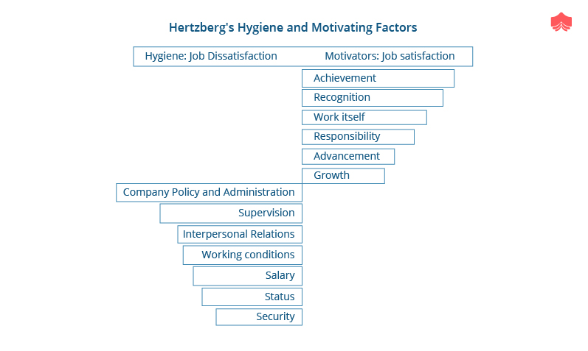
One of the strategies to motivate the workforce in the company is by storytelling. Jeff Bezos has banned slide presentation for all Amazon meetings. Instead, he encouraged people to tell stories in small groups. The meetings usually start with a structured memo, not circulated in advance. Moreover, indeed after 30 min of silent reading and analysing the meeting will continue with an open discussion. They are encouraging creative thinking and a sense of success in the employees(Observer,2019)

Amazon is a company that creates a culture of a variety of motivational strategies from financial to learning. Furthermore, if we analyse the Maslow’s approach known as “Value Pyramid” (Maslow,1943), He bases his theory on five categories, including psychological, safety, social, esteem and self-actualisation. Managers are using the model to engaged and motivate the employees who will make a greater contribution to the business. The value Pyramid applies a similar theory for customers and their relationship with services. The Maslow’s Pyramid comprises four different categories of around 30 elements of value.
- Hypothesis one is based on the companies who perform well across multiple elements of different value would have more loyal customers. The result is based on the theory the higher scores across the four elements of value had on average three times the Net Promoter Score of companies with just one high score and 20 times more Net Promoter Score of customers with none.
- Hypothesis two is based on companies scoring well on multiple elements would grow revenue at a faster rate than others. As a result, company with high scores on four or more elements of value had a recent growth around 4 times gater than the companies with only one high score.
.

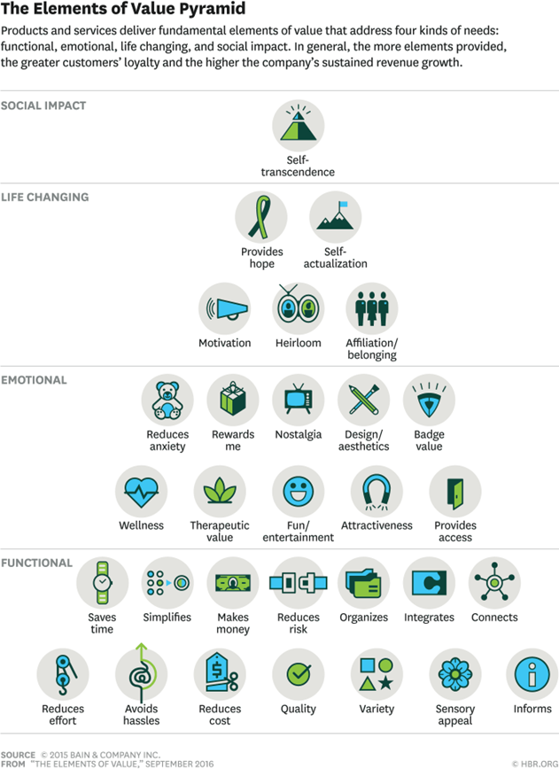

Is not surprising that digital businesses like Amazon scored higher and addressed more ‘elements of value than bricks; that is why digital transformation continues to be the highest priority for companies. The actual digital experience, when described from a customer perspective, is all about adding value through hassle-free service, simplified interaction and time saving online processes.
If we take as an example traditional product such as gas, on its own the product, satisfy the basic human needs for warmth and fire. However, if we apply the digital influence of devices such Nest and suddenly it scores against some unlikely elements such as reducing the anxiety. The actual device can act as a security monitor, reporting and senses every motion in a customer empty house. Using value as a critical driver for the products and services enhancement is not new. Nevertheless, sometimes business becomes victims of their success and lose sight of what value means for a customer. We can confirm that for Amazon, customer satisfaction is a priority. The company is driven by continually improving and implementing a system for a customer’s feedback. As part of customer satisfaction, Amazon is continuously looking into ways to improve the employees working experience.
Digital companies as such as Amazon are changing the landscape of the way people shopping and consuming products. For example, the music or books. Replacing the traditional way of the and bringing value to the over experience, changing the perception of the consumer.
Despite the efforts of many sources to provoke Amazon because of the working conditions, we can conclude that it is still a desirable place to work. It is continuously innovating and changing the landscape of the customer and employee’s perception. Amazon has been criticised on many occasions for the working conditions and motivation. Especially on the lower levels of the company structure. The programmes design for everyone, even not the full-time staff to increase motivation is an example of the company vision. Such as equal opportunity for everyone and motivating the employs through career developing programmes. In conclusion, we can identify the growing demand for a digital company like Amazon. The market and customer need increasing the online purchases and changing the perception for a shopping experience.

Conclusion:

In conclusion, under Jeff Bezos’ leadership, Amazon employs a winning strategy in several different ways. Firstly, its consumer-oriented focus allows the company to address the need to broaden its market base. With its customers in mind, the company made it cost-effective and easy to purchase products online using strategic alliances and technological innovation. Secondly, the strategy is a fit to Amazon’s leading position in the online retail industry, despite the competition of rivals like the established retail companies Wal-Mart or Target. As a pioneer in the e-commerce industry, Amazon was able to get the upper hand and refined online purchasing to make it not only convenient, but also trustworthy and secure. Amazon’s leadership has favourably displayed the importance of teamwork to guarantee its competitive ability and sustainability. Amazon understands the importance of happy and united teams to reach its goals and get better results. Amazon is doing the best they can to promote and support the forming of effective groups and teams within the company.

References:

Amazon, 2020. Amazon. [Online] Available at: https://www.amazon.com/
[Accessed on: 30.04.2020].

BBC, 2020. BBC. [Online] Available at: https://www.bbc.com/
[Accessed on: 30.04.2020].
Buchanan, D. A. & Huczynski, A. A., 2019. Organizational Behaviour. London: Pearson UK.
Burns, P., 2017. New Venture Creation: A Framework for Entrepreneurial Start-Ups. London: Macmillan Education UK.

Butler, S. a. (2020). The Guardian. Available at: amazon to buy whole food market in $ 13.7bn deal: https://www.theguardian.com/business/2017/jun/16/amazon-buy-whole-foods-market-organic-food-fresh . (Accessed on: 29.04.2020)
Butler S. and Wood Z., (2017); The Guardian, 2017 June the 16th, Sarah Butler and Zoe Wood, ‘’ Amazon to buy Whole Food Market in $13.7bn deal’’, Available at: https://www.theguardian.com/business/2017/jun/16/amazon-buy-whole-foods-market-organic-food-fresh, Accessed on 10.04.2020

Brooks, I., 2018. Organisational Behaviour: Individuals, Groups and Organisation. London: Pearson UK.

DONICI, A.N., MAHA, A., IGNAT, I. and MAHA, L.G., 2012. E-Commerce across United States of America: Amazon. com. Economy Transdisciplinarity Cognition, 15(1).
Dresssler G (1999) ' How to Earn Your Employees' Commitment', The Academy of Management Executives, (), pp. 58-62 [Online]. Available at: (Accessed: 20th April 2020).

Ferracone R (2019) 'Dare to be different the case of amazon', Forbes, 23 April, p.

Geer, T. (2018) ‘’The Proposed acquisition of the book depository by Amazon’’, page 5, Available at: https://www.booksellers.org.uk/BookSellers/BizFormFiles/29788752-0d01-4d2d-9b8c-aa187c8bbf86.pdf, Accessed on 08.04.2020

Guardian, 2020. Guardian. [Online] Available at: https://www.theguardian.com/
[Accessed on: 30.04.2020].
Hall M. (2018)‘’Amazon.com’’, Encyclopaedia Britannica, Available at: https://www.britannica.com/topic/Amazoncom, Accessed on 08.04.2020

Herzberg, F (1972) Motivation to Work, 2nd edn., international: John Wiley & Sons Inc; .

Ladd B (2019) 'Amazon CEO Jeff Bezos Believes This Is the Best Way to Run Meeting', Observer, 06 October, p.
Maslow A.H (1943) A Theory of Human Motivation.
Miller C.C. and Bosman J., (2011), May the 21st, The New York Times, ‘’E-books outsell Print books at Amazon’’, Available at: http://tony-silva.com/eslefl/miscstudent/downloadpagearticles/ebooksales-nyt.pdf, Accessed on 10.04.2020

Montgomery B., (2019), August the 8th, The Atlantic, ‘’The Amazon Publishing Juggernaut’’, Available at: https://www.theatlantic.com/technology/archive/2019/08/amazons-plan-take-over-world-publishing/595630/, Accessed on 08.04.2020

Montgomery, B. (2020). The Atlantic. Available at: The amazon Publishing Juggernaut: https://www.theatlantic.com/technology/archive/2019/08/amazons-plan-take-over-world-publishing/595630/ . (Accessed on: 29.04.2020)
NASDAQ, (2019), Amazon’s annual report, available at: https://secfilings.nasdaq.com/filingFrameset.asp?FilingID=13184158&RcvdDate=2/1/2019&CoName=AMAZON%20COM%20INC&FormType=10-K&View=html Accessed on 08.04.2020

Nguyen, J., (2019) July 5th, Market Place, ‘’How Amazon’s logo reflects its evolution’’, available at: https://www.marketplace.org/2019/07/05/how-amazons-logos-reflect-its-evolution/ Accessed on 10.04.2020
Pfeffer, J., 2016. Why the assholes are winning: Money trumps all. Journal of Management Studies, 53(4), pp.663-669

Ritala, P., Golnam, A. and Wegmann, A., 2014. Coopetition-based business models: The case of Amazon. com. Industrial Marketing Management, 43(2), pp.236-249.
Schermerhorn, J. R. J. & Bachrach, D. G., 2017. Exploring Management. New Jersey: John Wiley & Sons.
Shaw, R. B., 2017. Extreme Teams: Why Pixar, Netflix, Airbnb, and Other Cutting-Edge Companies Succeed Where Most Fail. New York: AMACOM.
Solanki, K., 2019. ‘To what extent does Amazon. com, Inc success be accredited to its organizational culture and ND Jeff Bezos's leadership style?. Archives of Business Research, 7(11), pp.21-40
Time Magazine, (1999) December the 27th – ‘’Person of the Year’’, Available at: http://content.time.com/time/covers/0,16641,19991227,00.html, Accessed on 09.04.2020

Watts, M. &. (2013). Growing the I and We in transformational leadership. the GROW model, coaching Psychology.
Wilson, F. M., 2018. Organizational Behaviour and Work: A Critical Introduction. Oxford: Oxford University Press.
Yeung, A. & Ulrich, D., 2019. Reinventing the Organization: How Companies Can Deliver Radically Greater Value in Fast-Changing Markets. Boston: Harvard Business Press.
Yu, Q. (2012). Brief Talk on Amazon’s Strategies in Corporate Entrepreneurship.

APPENDIX: ppt group presentation of AMAZON company:


