

Case Study on Emotional Intelligence in Workplace

Student name: Julia Mansell
Student number: 2110746
Module code: BMSW6106
Lecturer: Essa Bah

Contents
Introduction 3
Role of Emotional Intelligence in the Workplace 3
The Importance of the Components of EMOTIONAL INTELLIGENCE 4
Models of Emotional Intelligence 6
Goleman’s Model of Emotional Intelligence 6
Mayer and Salovey’s Model of Emotional Intelligence 8
Bar-On Model of Emotional Intelligence 9
Developing Emotional Intelligence by Using Mindfulness and Relationship Management 10
Recommendations 12
Conclusion 13
Reference List 14

Introduction
Sapphire Enterprises (SE), a UK-based manufacturing firm with a global presence, known for its respect, integrity, and excellence values, has experienced significant changes since its acquisition by private equity. Under COO Daniel, the focus has shifted to preparing for an Initial Public Offering (IPO) by emphasising bottom-line performance. This new management style has clashed with the existing company culture, as highlighted in a recent meeting with Anita and her colleagues.
This report explores the way forward for Daniel and the team using three recommended models related to Emotional Intelligence (EI) and the workplace. Emotional intelligence (EI) is increasingly acknowledged as crucial for achieving personal and professional success. Mastering the ability to recognise and regulate one's own emotions, along with understanding and influencing the emotions of others, can profoundly affect workplace interactions, leadership effectiveness, and overall organisational performance (Landry, 2019).
This report investigates the core aspects of emotional intelligence. According to Goleman (1995), emotional competence is a learned ability rooted in emotional intelligence that leads to exceptional performance. Emotional intelligence underpins the potential to acquire practical skills associated with its five core elements: Self-Awareness, Motivation, Self-Regulation, Empathy, and Proficiency in Relationships. Additionally, it examines practical methods for enhancing emotional intelligence through mindfulness and effective relationship management.
The final section offers a set of recommendations that highlight the significance and benefits of integrating mindfulness practices into the workplace. By examining these insights, the report seeks to provide useful guidance on enhancing emotional intelligence to achieve improved results for both individuals and the organisation.

Role of Emotional Intelligence in the Workplace
Emotional intelligence has gained significant attention among business leaders due to its substantial impact on the workplace. Effective self-assessment and conflict management are key aspects of emotional intelligence that can enhance organisational effectiveness. Traditionally, emotions such as negligence, avoidance, irrationality, and the inability to self-regulate were seen as negative factors within organisational life. However, recent research by organisational scholars highlights the positive role emotions can play in the workplace. The "texture" of organisational environments and their impact on individuals' thoughts and feelings emphasises the importance of emotional considerations. High-performing organisations are those where emotions are effectively managed, developed, or appropriately addressed. Although emotions have often been viewed as irrelevant to job performance, they can significantly influence and either hold back or support effective performance (Khalili, 2012).
Achieving success in any field, such as management, psychology, law, medicine, engineering, or banking, requires more than just technical expertise. Individuals who excel are typically easy-going, flexible, and optimistic, exhibiting high emotional intelligence (EI). EI involves managing negative emotions like anger, self-doubt, stress, and anxiety, and fostering positive ones like confidence, empathy, and sociability. Over the past decade, EI has gained significant interest from academics and HR professionals worldwide. Developing EI skills is crucial but often overlooked in skills development programs. Properly managed emotions can drive trust, loyalty, and commitment, leading to productivity gains, innovation, and accomplishments. EI enables individuals to recognise and manage their own and others' emotions, making informed choices for thinking and action. It involves the ability to monitor and regulate emotions and use this information to guide behaviour. Personal EI can vary by age, development level, and gender. It is the ability to understand underlying feelings in interpersonal communication and respond thoughtfully rather than impulsively. At its best, EI is about influencing without manipulation, perceiving and legitimising emotions, and balancing logic, intellect, and technical analysis. EI is increasingly recognised as essential in organisational change, stress management, and life satisfaction. Emotions and related behaviours are now fundamental to building an effective organisational culture (Caruso, 2013).
A 2011 study revealed that participants trained in key emotional competencies exhibited lasting development in emotional intelligence. They also saw improvements in physical and mental well-being, better social relationships, and reduced cortisol (stress hormone) levels. To boost workplace performance through better emotional intelligence, focus on developing skills in five key areas should be applied: self-awareness, self-regulation, social skills, empathy, and motivation (Chery, 2022).

The Importance of the Components of EMOTIONAL INTELLIGENCE
In below Table 1, the 5 components of EI and ways to their development are uncovered.

Self-awareness | Recognition and understanding of your own emotions.  Reflecting on how emotions influence your responses and decisions.  To improve self-awareness:  - Assess emotional strengths and weaknesses.  - Identify ways to manage feelings like impatience, anger, and annoyance.  - Avoid making rash decisions based on temporary feelings.
Self-regulation | Self-regulation is essential for managing emotions and it allows adaptation to changing situations. It is the way to express emotions appropriately rather than impulsively.  To improve self-regulation:  - Find stress-relief techniques, such as hobbies or physical exercise.  - Stay calm and accept that not everything is controllable.  - Think before making decisions to consider all possibilities calmly and rationally.
Social skills | Recognition of others' emotions allows for appropriate responses. Strong social skills enable team play and leadership roles.  To enhance social skills:  - Actively listen: Show attention, ask questions, give feedback.  - Pay attention to nonverbal communication (body language).  - Avoid office drama, instead reduce tensions and solve problems.
Empathy | Empathy involves appropriate responses to others' feelings.  It helps to understand the dynamics between colleagues and supervisors.  To improve empathy:  - See from others' perspectives: Avoid letting disagreements escalate by considering their viewpoint.  - Mind your responses: Allow others to share ideas & acknowledge their input.
Motivation | Individuals are driven by personal fulfilment and passion rather than external rewards. Highly successful people are often motivated by their passion for their work.  To enhance motivation:  - Focus on Enjoyable Aspects at your workplace  - Maintain a Positive Attitude to inspire and motivate others
Table 1: Components of EI and improvement tips (Cherry,2022).
Emotional Intelligence (EI) was introduced by Daniel Goleman in his 1995 bestseller. Goleman's work spurred further scientific investigation into EI, although there is still debate and various models exist regarding its definition and impact (Neubauer and Freudenthaler, 2005). In the next section, three models of Emotional Intelligence are chosen to use for the Case Study of Sapphire Enterprises, to enhance workplace abilities for Anita, Daniel and their colleagues.

Models of Emotional Intelligence
According to Kanesan and Fauzan (2019), emotional intelligence models are typically classified into three types: the ability model, the mixed model, and the trait model, each defined by different theorists such as Bar-On, Goleman, Petrides, Salovey, and Mayer. Broadly, these models describe emotional intelligence as involving personal intelligence and social intelligence.

Goleman’s Model of Emotional Intelligence
The decision to adopt this Emotional Intelligence (EI) model is based on several compelling reasons outlined in Table 2:
Reasons | Description
Comprehensive Coverage | The model includes key EI components like self-awareness, self-regulation, motivation, empathy, and social skills, providing a holistic understanding of emotional intelligence.
Practical Application | It is widely used across various fields such as psychology, education, business, healthcare, and social work, demonstrating its versatility and relevance.
Research-Based | Supported by extensive studies in psychology and neuroscience, the model's components and effectiveness are validated by scientific evidence.
Global Recognition | The model is globally recognised and accepted, indicating its reliability and universal applicability across different cultures and populations.
Developmental Focus | Emphasising that EI can be developed; the model provides practical strategies and tools for improving emotional and social competencies.
Leadership Enhancement | High EI is linked to effective leadership, aiding in better team motivation, stress management, and interpersonal dynamics, thereby improving organisational performance.
Practical Case Studies | The model includes real-world examples, illustrating its successful application and providing concrete evidence of its effectiveness.
Cultural Adaptability | The model is flexible and can be tailored to suit diverse cultural norms and values, ensuring its relevance in various contexts.
Table 2: The Advantages of the use of Goleman’s model in the Workplace (Wind4change,2024).
By choosing this EI model, Sapphire Enterprises can benefit from a comprehensive, scientifically validated, and adaptable framework for enhancing emotional intelligence, leading to improved professional outcomes when preparing for an Initial Public Offering.
Goleman's original Emotional Intelligence (EI) model initially included 27 competencies, later refined to 18 through research. EI is defined as demonstrating competencies in self-awareness, self-management, social awareness, and social skills effectively. A competency is seen as a set of related behaviours centred around an objective, differentiating various behaviours. The model identifies competencies associated with awareness and management of oneself and others (Kanesan and Fauzan, 2019). Goleman’s refined model is shown in Figure 1.
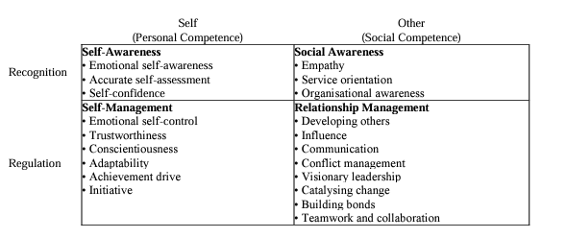
Figure 1: Goleman’s refined model of EI (Kanesan and Fauzan, 2019).
Application to the Case Study
- Self-awareness: Anita should recognise her emotions and those of her colleagues during the meeting. This awareness will help her understand the frustration caused by Daniel's attitude.
- Self-Regulation: Anita must manage her response to Daniel's rejection of her ideas. By staying calm and composed, she can respond constructively rather than reactively.
- Empathy: Understanding Daniel's perspective and his need for control can help Anita and her colleagues approach him in a way that might make him more open to new ideas.
- Social Skills: Anita can utilise her social skills to improve communication and collaboration within the team. She can encourage a more open dialogue by engaging her colleagues and fostering a supportive environment.

Mayer and Salovey’s Model of Emotional Intelligence
Mayer and Salovey's 1997 model of Emotional Intelligence (EI) redefined EI as a mental ability distinct from personality traits. They describe EI as the ability to perceive, appraise, and express emotions; to generate feelings that support thought; to understand emotions and emotional knowledge; and to regulate emotions to foster emotional and intellectual growth. The model divides EI into two main areas: experiential and strategic. The experiential area includes perceiving and using emotions, while the strategic area encompasses understanding and managing emotions. Each area is further divided into branches that represent a sequence of psychological processes, progressing from basic to complex abilities (Grunes, et al., 2014), as outlined in Figure 2.
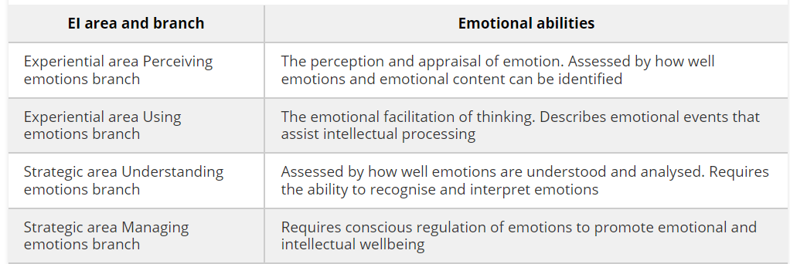
Figure 2: Areas, branches and Abilities of Mayer and Salovey’s Model of Emotional Intelligence (Grunes, et al., 2014).
Application to the Case Study
- Perceiving Emotions: Anita should accurately measure the emotional atmosphere of the meeting and recognise signs of frustration and disengagement among her colleagues.
- Understanding Emotions: By understanding the underlying reasons for Daniel's resistance to new ideas, Anita can address his concerns more effectively and present her ideas in a way that aligns with his goals.
- Using Emotions: Anita can leverage her awareness of the group's emotional state to guide the conversation toward more collaborative and positive interactions.
- Managing Emotions: Anita and her colleagues need to manage their own emotions and the overall emotional climate of the meeting. This includes staying calm, promoting open communication, and finding ways to re-engage Daniel productively.

Bar-On Model of Emotional Intelligence
The Bar-On model defines emotional-social intelligence as a blend of emotional and social competencies, skills, and facilitators that influence intelligent behaviour. This model is measured through self-report and 360-degree feedback assessments. It emphasises the capacity to identify and handle emotions, connect with others, adjust to changes, address personal and relationship issues, and manage daily challenges and stressors. Key aspects of the Bar-On model include its strong psychometric properties, rigorous development, and applicability across various domains, including organisational settings and human performance. The model has been shown to predict a wide range of behaviours and performance outcomes and highlights that EI factors can be developed and enhanced (Bar-On, 2007). Its dimensions and subscales can be found in below Figure 2.
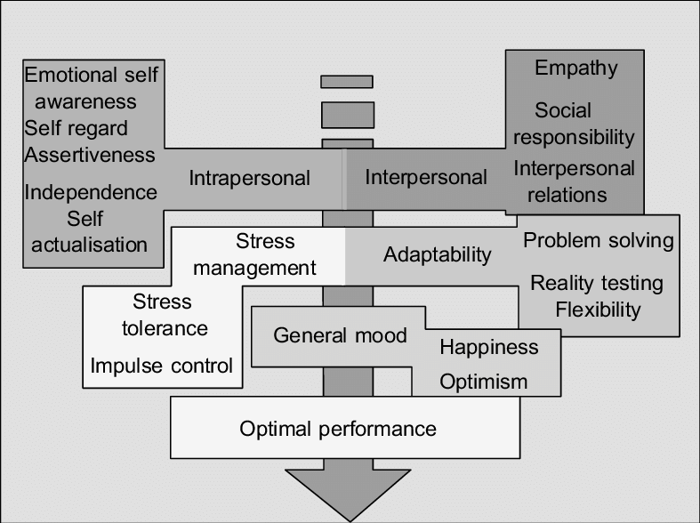
Figure 2: Dimensions and Subscales of Bar-On Model (Van der Merve, et al.,2005)
Application to the Case Study
- Intrapersonal Skills: Anita should prioritise self-awareness and self-expression to communicate her ideas clearly and assertively.
- Stress Management: Managing stress and maintaining resilience in the face of rejection are crucial for Anita and her team. This will help them stay focused and constructive during the meeting.
- Adaptability: Being flexible and adaptable in their approach will enable Anita and her colleagues to present their ideas in alternative ways and achieve their objectives.
- Interpersonal Skills: Building strong relationships with colleagues can help Anita create a united front when presenting new ideas to Daniel.
- General Mood: Maintaining an optimistic outlook can keep Anita and her colleagues motivated and engaged, even when facing resistance from Daniel.
The following section will explore how mindfulness and relationship management can be utilised within the framework of emotional intelligence.

Developing Emotional Intelligence by using Mindfulness and Relationship Management
Mindfulness is the ability to regulate attention fluidly and voluntarily, helping individuals stay focused on the present and avoid distressing thoughts. It promotes adaptive emotion regulation and has been shown to enhance psychological well-being through deprivation, acceptance, exposure, and self-regulation. Mindfulness involves observing emotions without judgment or self-censorship, which increases the accuracy of emotional appraisal. Emotional intelligence is the ability to perceive, understand, regulate, and harness emotions in oneself and others. It involves managing oneself and relationships effectively. Mindfulness enhances this capability by reducing rumination, thought suppression, and other negative thinking patterns, fostering better emotional outcomes (Chhabra and Kaur, 2013).
The 2008 INSEAD report explored ways for organisations to enhance their social responsibility, focusing particularly on executive education and interventions aimed at changing managerial behaviour. The findings showed that traditional executive education methods, which included engaged discussions and case analyses, did not significantly encourage managers to make more socially responsible decisions. However, coaching programs that utilised meditation (mindfulness) techniques, even without discussing CSR topics, significantly increased the likelihood of managers acting in socially responsible ways. Additionally, a non-traditional training intervention based on hatha yoga techniques, such as postures and relaxation, positively influenced socially responsible behaviour among managers (Chapman, 2011).
A negative workplace atmosphere significantly hampers productivity, job satisfaction, and trust. A UNC research team found that 53% of employees lose work time worrying about past or future confrontations with coworkers, 37% reduce their commitment due to hostility, 28% avoid confrontational colleagues, and 22% put less effort into their work because of these conflicts. To address this, it's important to recognise and analyse one's attitude as a potential source of conflict. Empathy plays a crucial role in understanding that annoying behaviours often stem from others' frustrations and suffering. Additionally, viewing conflicts as opportunities to enhance patience and interpersonal skills can lead to positive responses rather than defensiveness. Taking time before responding to difficult interactions can prevent impulsive reactions that exacerbate tension. Acknowledging one's role in others' negative behaviour and practising assertive communication—expressing needs confidently and without offending—are key to preventing and managing workplace conflict (Dumbravă, 2011).
Relationship management, a core behaviour of emotional intelligence, builds on self-awareness, self-management, and social awareness. Self-awareness allows us to recognise our emotions and understand their impact on others. Self-management involves controlling our emotions and choosing appropriate responses. Social awareness is about identifying and understanding others' emotions. With these foundations in place, relationship management skills can be developed. This involves using our emotional awareness to manage interactions successfully, build trust, handle conflicts, and foster productive relationships.
To enhance relationship management:
- Stay open and curious by sharing information and showing interest in others.
- Show appreciation and humility through simple gestures like saying 'thank you.'
- Respond to feedback with a learning mindset, seeing it as an opportunity to grow.
- Build trust by being consistent and reliable.
- Demonstrate empathy by acknowledging others' feelings without judgment.
- Show care through actions, expressing gratitude, and appreciation.
Improving these skills boosts emotional intelligence, crucial for effective management and leadership (Owoade, 2022).

Recommendations

- Incorporate Mindfulness Training:
  - Offer mindfulness workshops and training sessions to employees.
  - Introduce meditation sessions or mindfulness exercises as part of the daily routine.
  - Encourage employees to take short mindfulness breaks to reduce stress and enhance focus.
- Promote Self-Awareness and Self-Regulation:
  - Encourage employees to reflect on their emotional strengths and weaknesses.
  - Provide tools and resources for managing stress, such as mindfulness apps or access to quiet spaces.
  - Train employees to pause and consider their emotional responses before reacting in high-pressure situations.
- Enhance Social Skills and Empathy:
  - Foster a culture of active listening and empathetic communication.
  - Organise team-building activities that focus on understanding and respecting diverse perspectives.
  - Implement feedback mechanisms that allow for constructive and empathetic exchanges.
- Strengthen Relationship Management:
  - Encourage open and curious interactions by sharing information and showing genuine interest in others.
  - Promote appreciation and humility through simple gestures like saying 'thank you.'
  - Develop trust by being consistent and reliable, and by following through on commitments.
- Respond to Feedback with a Learning Mindset:
  - Teach employees to view feedback as an opportunity for growth rather than criticism.
  - Provide training on how to give and receive feedback effectively.
  - Encourage a culture where feedback is seen as a positive and integral part of professional development.

Conclusion
By integrating mindfulness practices into the workplace, Strategies for Relationship Management Enhancement and the application of the Three Models of Emotional Intelligence analysed in this report, Sapphire Enterprises can enhance emotional intelligence among its employees. This will lead to better self-awareness, self-regulation, social skills, empathy, and relationship management. These improvements will help SE navigate the cultural changes and performance pressures associated with the transition to an IPO, ultimately fostering a more coordinated and effective organisational culture.

Reference List
Bar-On, R., (2007) The Bar-On model of emotional intelligence: A valid, robust and applicable EI model. Organisations and People.
Caruso, D.R., et al., (2013) Emotional intelligence in the workplace. In Emotional intelligence in everyday life (pp. 187-205). Psychology Press.
Chapman, M., (2011) Mindfulness in the workplace: what is all the fuss about. Counselling at Work, 74, pp.20-24.
Chhabra, H.K. and Kaur, S., (2013) Mindfulness, emotional intelligence and stress: A correlational study. Indian Journal of Positive Psychology, 4(3), p.426.
Cherry, K. (2022) Utilizing Emotional Intelligence in the Workplace. Available at: https://www.verywellmind.com/utilizing-emotional-intelligence-in-the-workplace-4164713 (Accessed: 22 July 2024).
Dumbravă, G., (2011) Workplace relations and emotional intelligence. Annals of the University of Petroşani. Economics, 11(3), pp.85-92.
Goleman, D., (1998) Working with emotional intelligence. Bantam
Grunes, P., et al., (2014) To what extent is the Mayer and Salovey (1997) model of emotional intelligence a useful predictor of leadership style and perceived leadership outcomes in Australian educational institutions?. Educational Management Administration & Leadership, 42(1), pp.112-135.
Kanesan, P. and Fauzan, N., (2019) Models of emotional intelligence: A review. e-BANGI Journal, 16(7).
Khalili, A. (2012) ‘The role of emotional intelligence in the workplace: A literature review’, International journal of management., 29(3).
Landry, L. (2019) Why Emotional Intelligence is Important in Leadership. Available at: https://online.hbs.edu/blog/post/emotional-intelligence-in-leadership (Accessed: 22 July 2024).
Neubauer, A.C. and Freudenthaler, H.H., (2005) Models of emotional intelligence. Emotional intelligence: An international handbook, 2005, pp.31-50.
Owoade, B. (2022) Six Actions for Developing Relationship Management skills. Available at: https://medium.com/management-matters/six-actions-for-developing-relationship-management-skills-d9afa016ae89 (Accessed: 23 July 2024).
Van der Merwe, P.R., et al., (2005) Measuring emotional intelligence (EQ): a construct comparison between the Bar-On EQ-i and the OPQ32i EI report. Southern African Business Review, 9(2), pp.34-50.
Wind4change (2024) Emotional Intelligence at Work by Daniel Goleman: Self-Mastery-Part 1. Available at: https://wind4change.com/emotional-intelligence-daniel-goleman-work-self-mastery/ (Accessed: 22 July 2024).

