Assignment 1: E-Portfolio.
Samuel Langdown
2214267
BENG2-PT Embedded Electronic Systems
Learning in the Digital Era (Computing & Electronics)
Table of Contents
E-Portfolio 2
Task 1 3
Task 2 4
Task 3 5
Task 4 6

E-Portfolio

https://sites.google.com/view/samuel-langdown/home
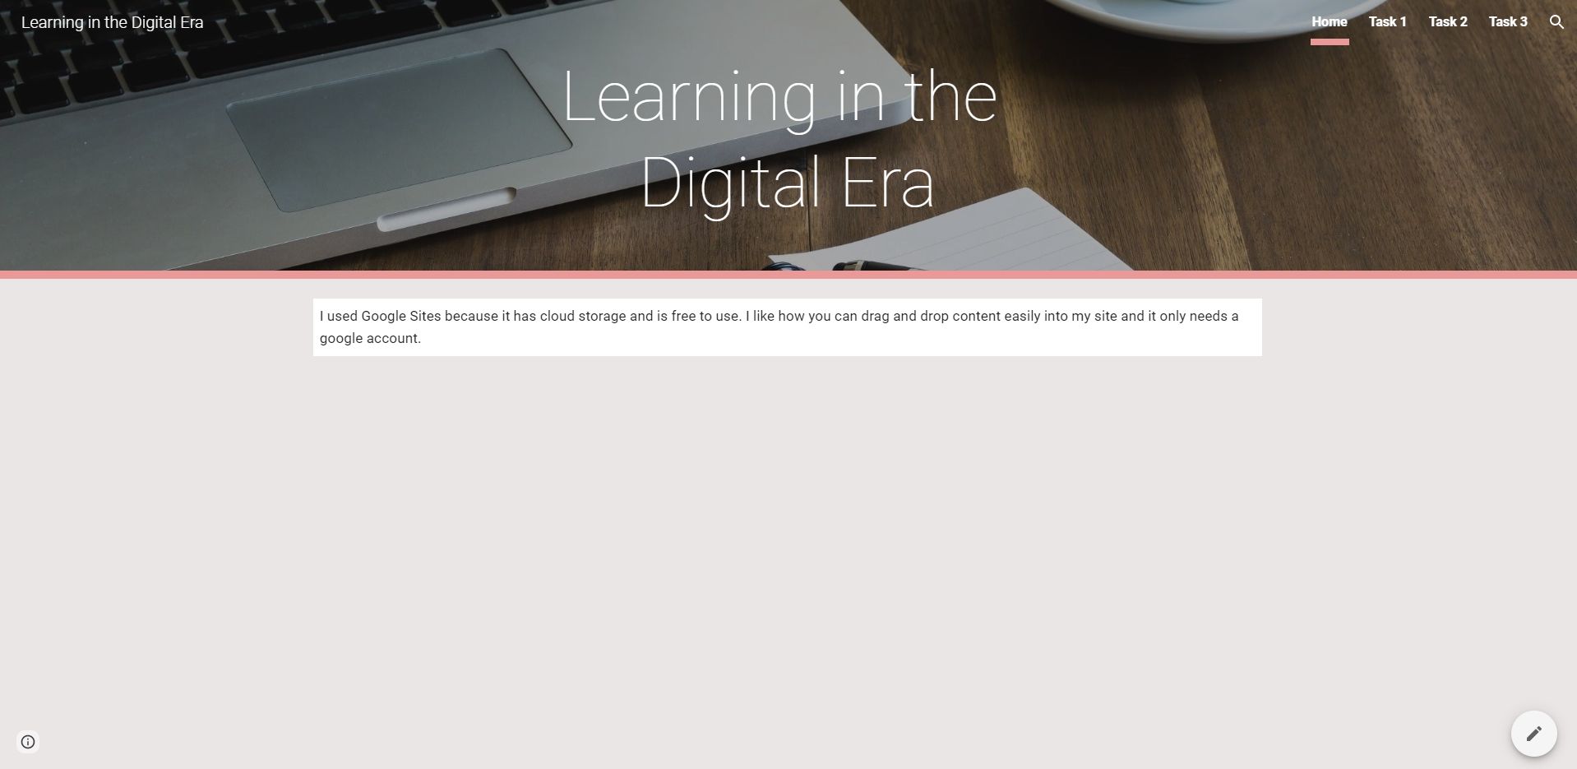

Task 1

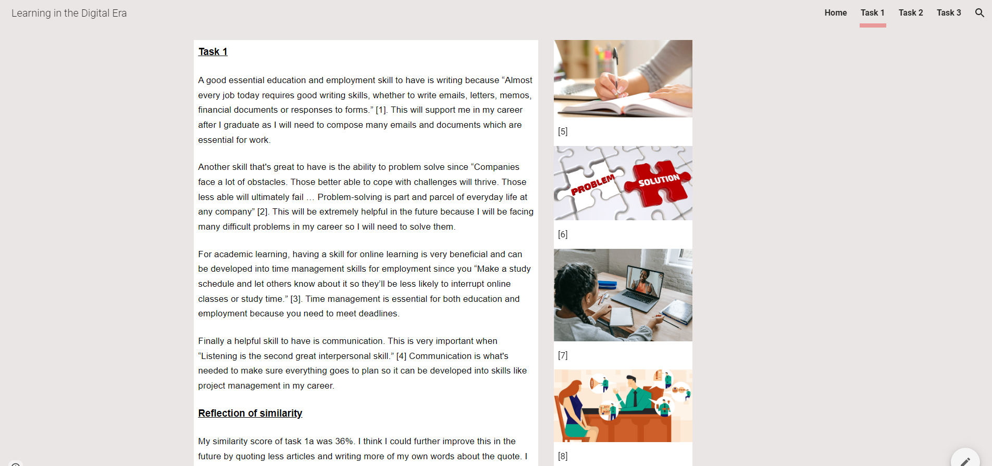
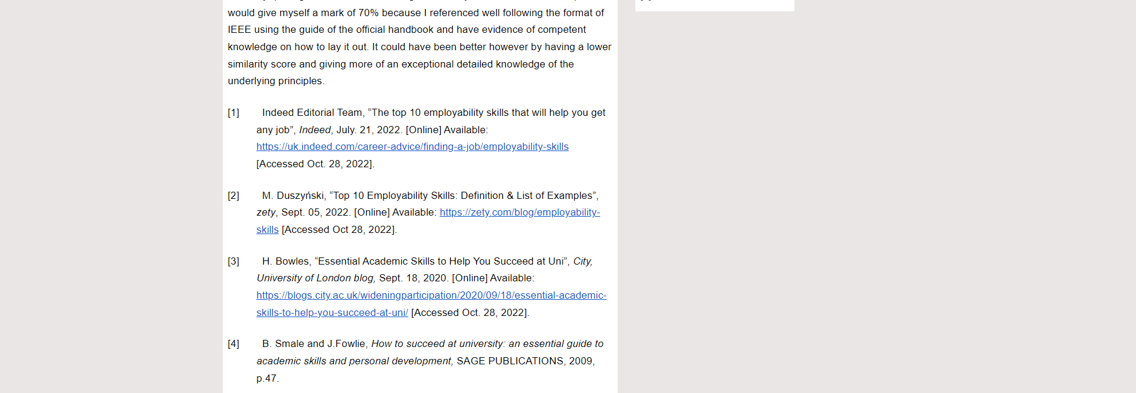
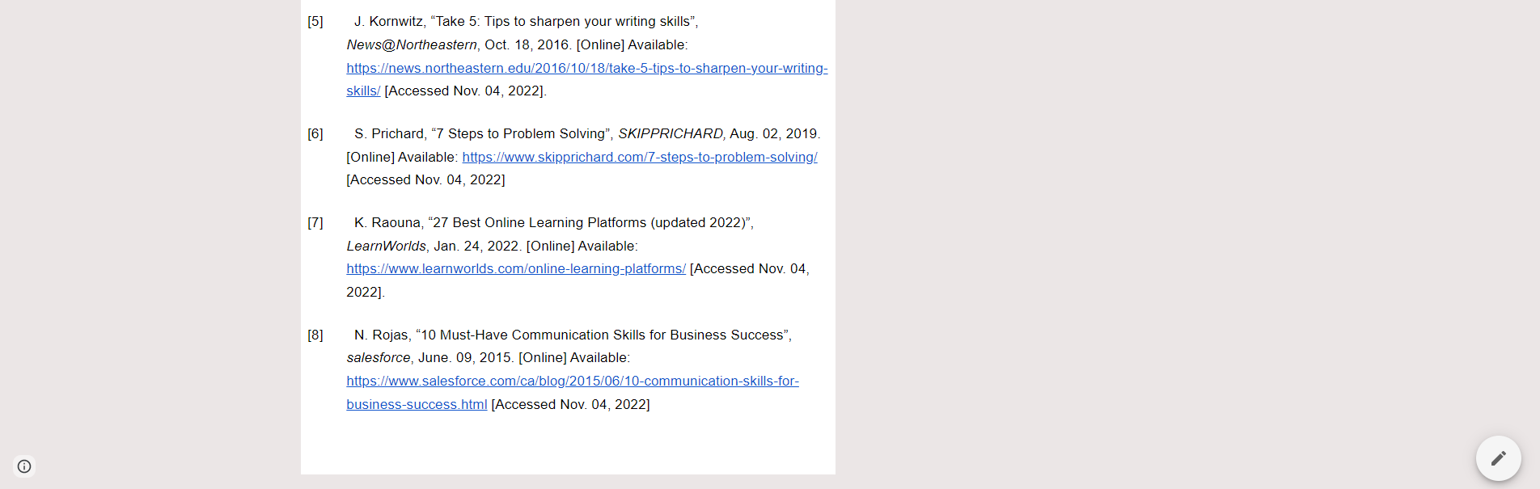

Task 2

https://docs.google.com/presentation/d/10DOuj6-q29dCbHbjLnZBnwQmbHiRloE-rsiQK9wHvmA/edit?usp=sharing
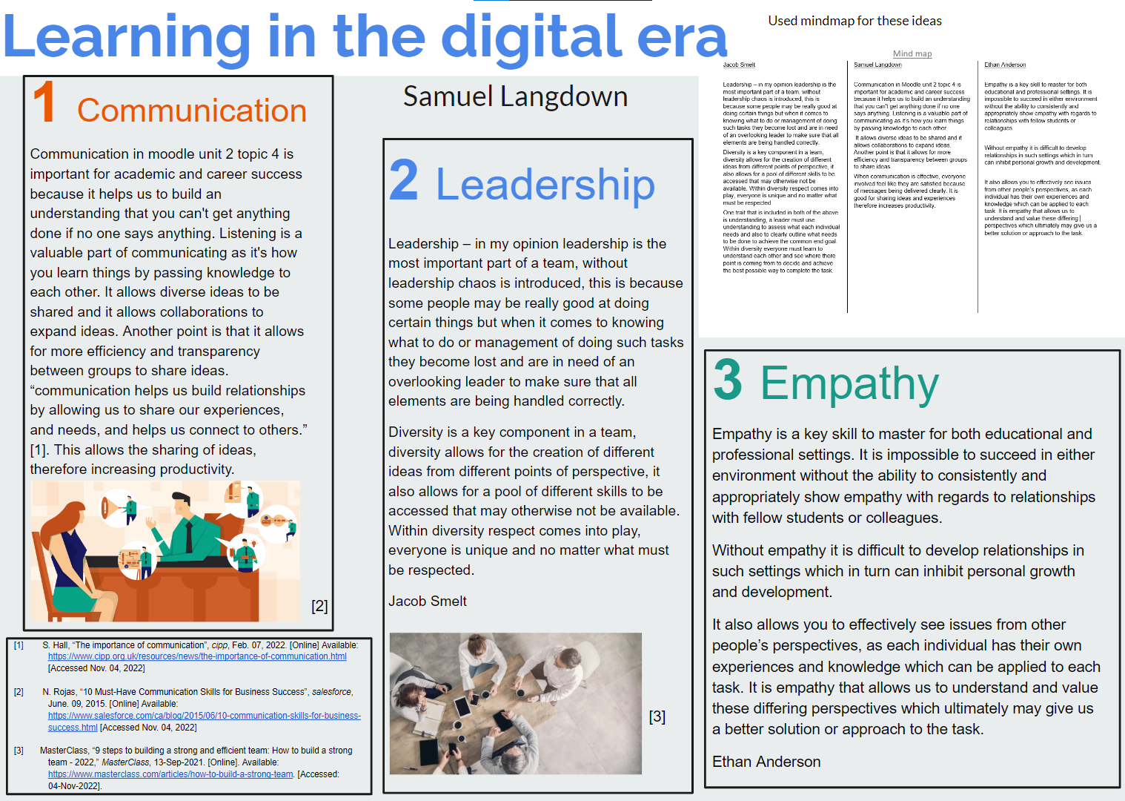

Task 3

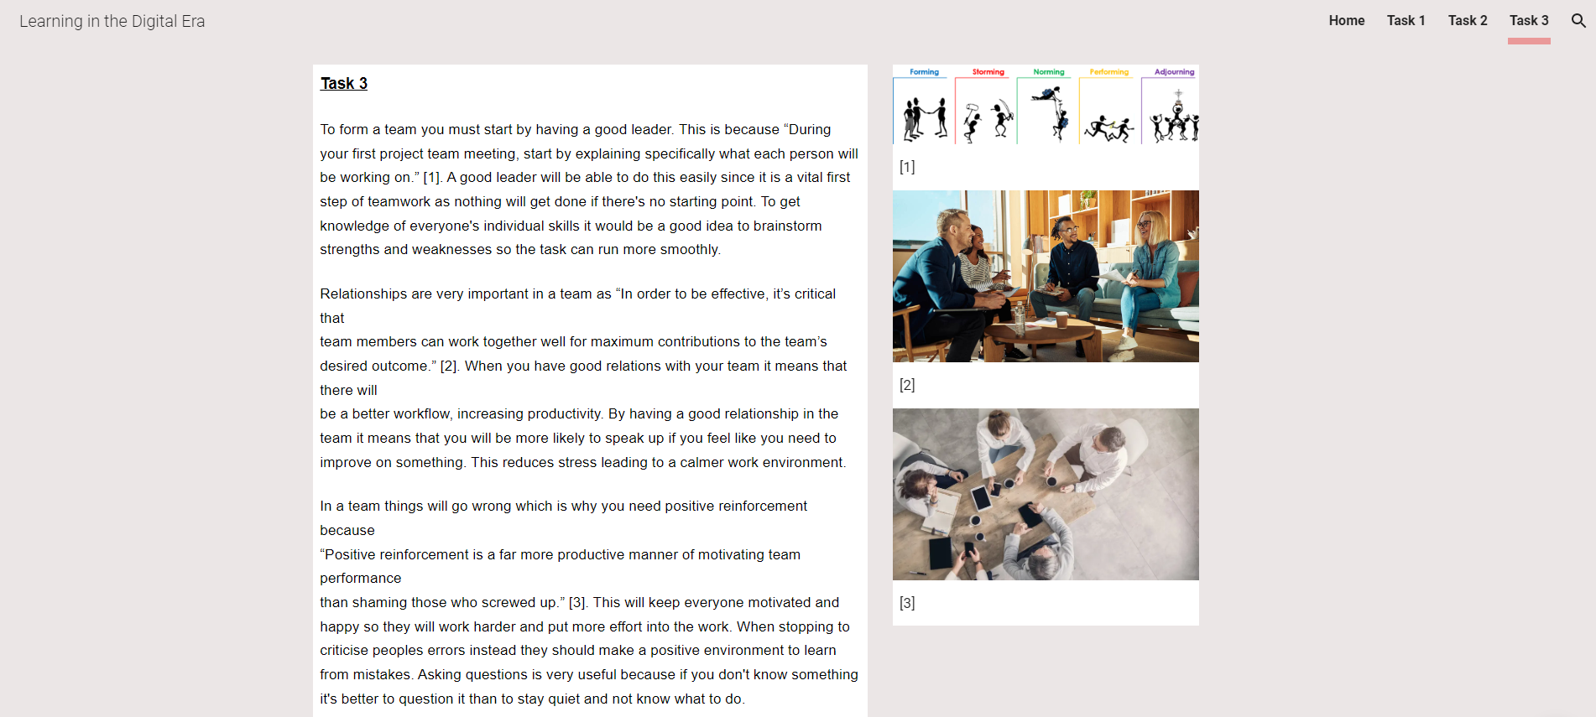
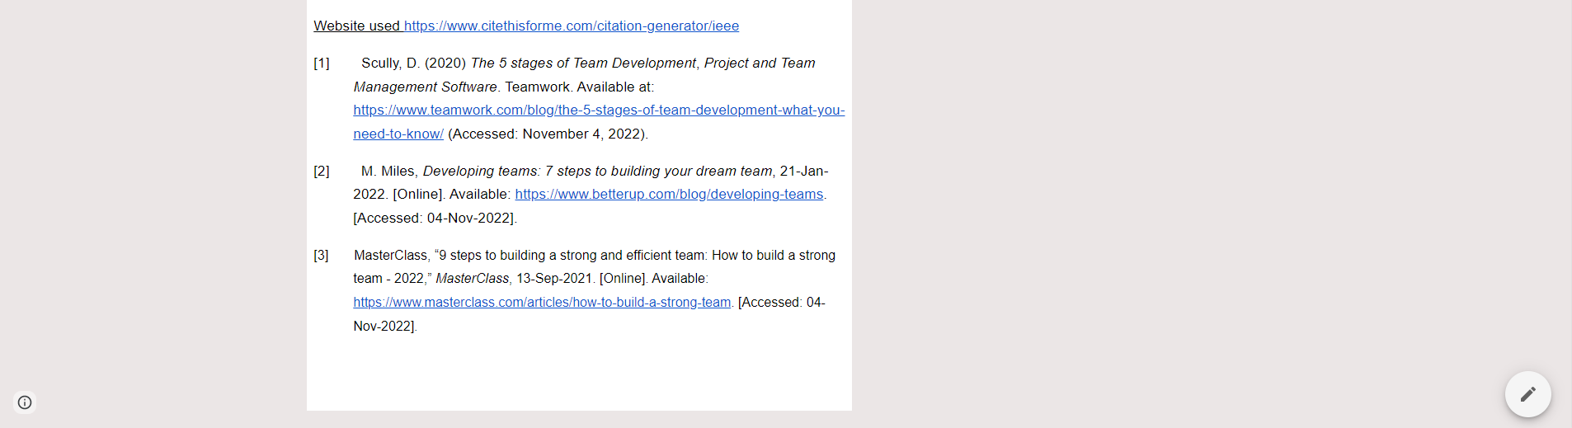

Task 4



