Student Name: Aida Lamer
Student ID Number: 1706552
Module: Information Engineering
Module Code: ACCB4013
Lecturer: B Holland

Database Design (The Book Store)

Task 1
In the following task, I will be discussing the database design and implementation for Dylan’s Book Store.
Entity Relationship Diagram
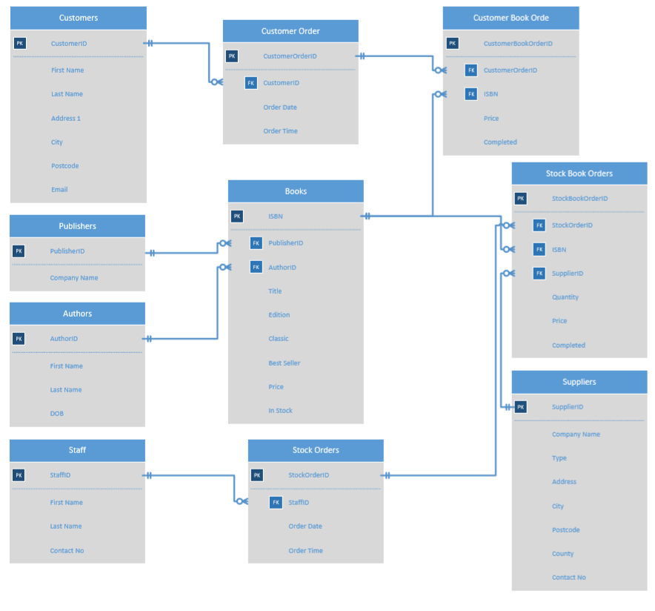
Figure 1 - Final Entity Relationship Diagram

It is important to create the correct tables, fields and foreign keys in order to have a well-designed database. This helps to store and organise product, employee and customer data. The tables, fields and its properties:
- Authors
This table will be created in order to store the individual author data that would later on be used by the “Books” table. The fields that I will be using are author ID, first name, last name and DOB. The primary key will be Author ID. There will not be a foreign key in this table.
- Publisher
Stores the individual publishers’ details which will then be used by the “Books” table. The fields I will be using are Publisher ID and Company Name. The primary key will be Publisher ID and there is no foreign key.
- Books
This is where the details of the individual books will be stored. The fields that I will be using are ISBN, publisher ID, author ID, title, edition, classic, best seller, price and in stock. The primary key will be ISBN, because each individual book has its own ISBN number. There will be two foreign keys in this table, Publisher ID and Author ID. The relationship between Authors and Books will be one-to-many which means that multiple books can have the same authors. The relationship between Publishers and Books will also be one-to-many which means that multiple books can have the same publishers.
- Customers
This will store the customer’s details. The fields I will be using are Customer ID, First Name, Last Name, Address 1, City, Postcode, Email. The primary key will be Customer ID and there will not be any foreign keys.
- Customer Orders
Stores the individual order data including who placed the order and when they placed the order. The fields that I will be using are customer order ID, customer ID, order date and order time. The primary key will be Customer Order ID, and the foreign key is Customer ID. The relationship between Customers and Customers Orders will be one-to-many which means that each customer can have multiple orders.
- Customer Book Orders
Stores the details of an order, including the book, the book’s price, and if order is shipped. The fields that I will be using are Customer Book Order ID, Customer Order ID, ISBN, Price and Completed. The primary key will be Customer Book Order ID that identifies each individual order detail, and the foreign keys are going to be Customer Order ID and ISBN. Customer Orders and Customer Book Orders will have a one-to-many relationship because one customer order can have multiple orders allocated to them. This means that one customer is allowed to order multiple books using a single order. The relationship between Books and Customer Book Orders is one-to-many because each book can on multiple orders.
- Staff
This is where the book store’s staff information will be stored. The fields that I will be using are Staff ID, First Name, Last Name and Contact No. The primary key will be Staff ID, and there will not be any foreign keys.

- Suppliers
This will store the book suppliers’ data. The fields that I will be using are Supplier ID, Company Name, Type, Address, City, Postcode, Country and Contact No. The primary key will be Supplier ID and there will not be a foreign key.
- Stock Orders
This table will store the information about a stock order, including who placed the order and when the order was placed. The fields I will be using are Stock Order ID, Staff ID, Order Date and Order Time. The primary key is going to be Stock Order ID, and the foreign key will be Staff ID because one member of staff can make multiple orders. Because of this, there will be a one-to- many relationship between Staff and Stock Orders.
- Stock Book Orders
This will store the Book Store’s Stock Orders’ details that includes what books were ordered, the quantity, the price, as well as the supplier’s information. The fields I will be using are Stock Book Order ID, Stock Order ID, ISBN, Supplier ID, Quantity, Price and Completed. The primary key will be Stock Book Order ID and the foreign keys will be Stock Order ID, ISBN and Supplier ID. The relationship between Stock Orders and Stock Book Orders is one-to-many because you can place order for multiple books on the same order. The relationship between Books and Stock Book Orders will also be one-to-many, because one book can be on multiple orders. Finally, Suppliers and Stock Book Orders also have a one-to-many relationship because one supplier can be associated with multiple orders.
User Requirements
There are a number of specifications that the database should have. The user will have the ability to add and delete any information from any table. To achieve this, cascade delete will be enabled, so if one customer is deleted from the system, then all ongoing and previous orders that the deleted customer was associated with will also be deleted. The book, stock, order and customer details data will be stored in the tables and will available to view through forms. Ongoing customer orders will be stored in the tables and will be available to view through forms. The book’s details will be stored in the tables and a query will be able to search for selected book titles. The user will also be able to print out relevant reports.
Normal forms
First Normal Form (1NF)
First rule is single valued attributes which states that table attributes should only contain single data and they cannot contain multiple values. In order to achieve this, I separated my tables into multiple columns. For example, the customer will be asked for “First Name” and “Last Name” and they are kept in separate columns.
The second rule is that attribute domain should not change. This means that one field cannot store more than one data type. For example, in the Author’s table there is a date of birth field which will not allow you to input anything other than date of birth. All the other tables will satisfy this rule by having a specific datatype enforced on each field.
The third rule is unique name for attributes. Within the tables that I created there each field name will have unique name.
The fourth rule states that order does not matter. In this case, my data won’t be stored in the tables in order. [1]
Second Normal Form (2NF)
The first rule of 2NF is that tables should be in the First Normal Form.
The second normal form rule states there should be no partial dependency. I achieved this by separating the values to be stored in the appropriate tables. [2]
Third Normal Form (3NF)
The first rule of 3NF is that tables should be in the Second Normal Form.
The second rule of the third normal form states that the tables should not have Transitive Dependency. The table design for the book store avoids transitive dependency by carefully constructing the tables. [3]

Task 2
Table Design
The following section shows the chosen tables, field name, data types, and any rules enforced on input.
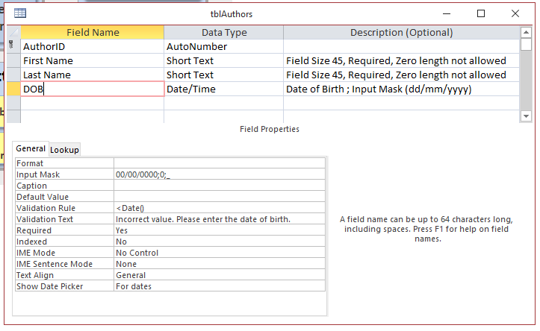
- tblAuthors
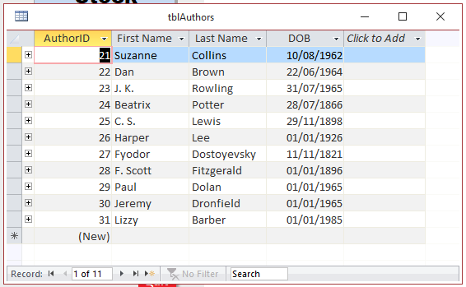
- Populated [4][5]

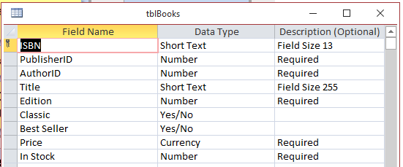
- tblBooks

- Populated [4][5]
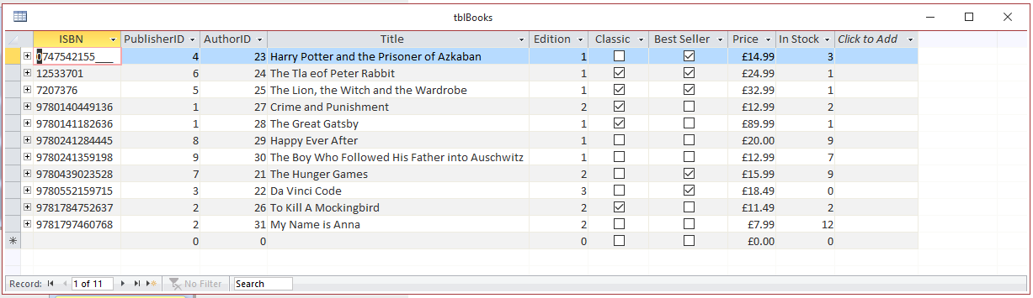

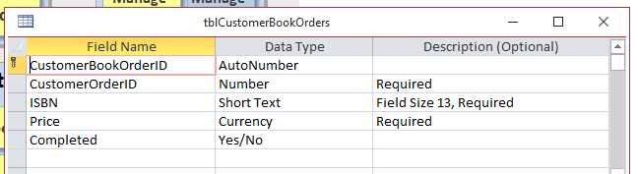
- tblCustomerBookOrders

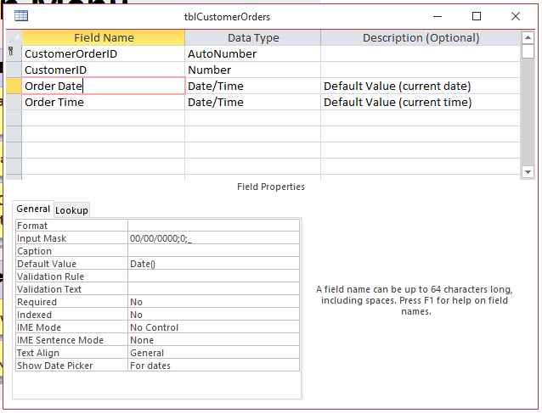
- tblCustomerOrders

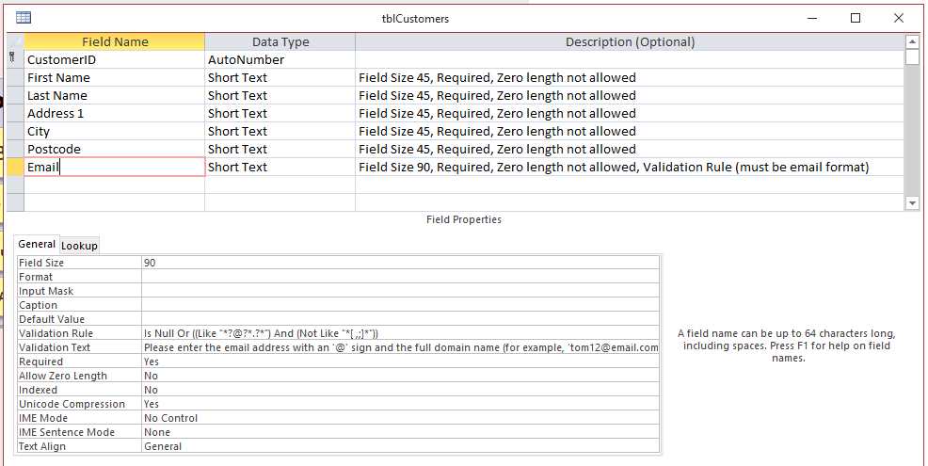
- tblCustomers

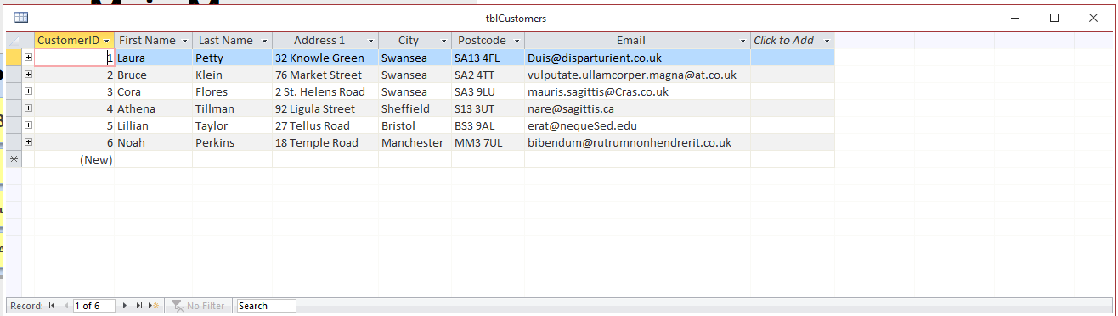
- Populated

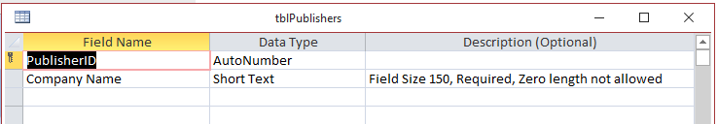
- tblPublishers

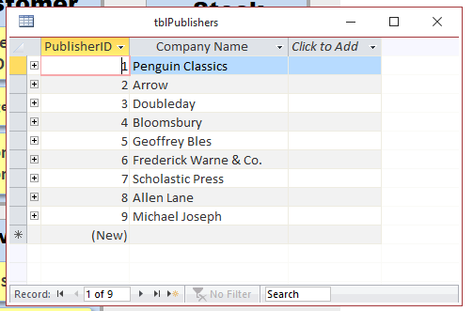
- Populated [4][5]

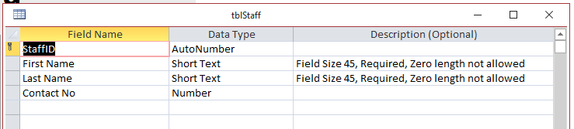
- tblStaff

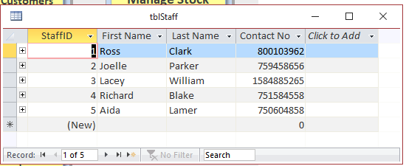
- Populated

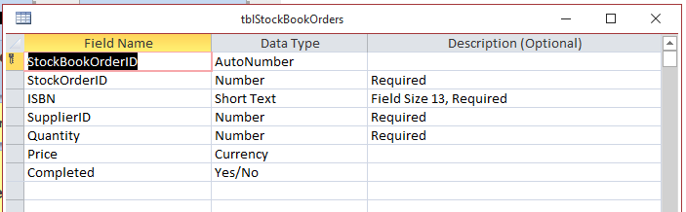
- tblStockBookOrders

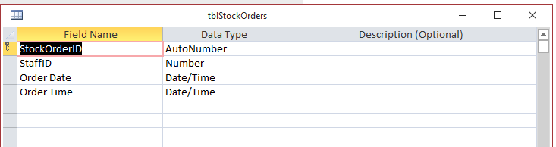
- tblStockOrders

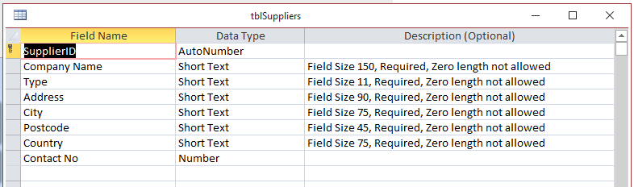
- tblSuppliers

- Populated [6]
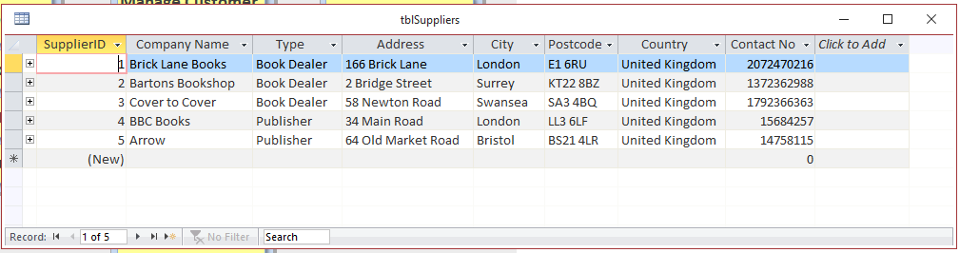

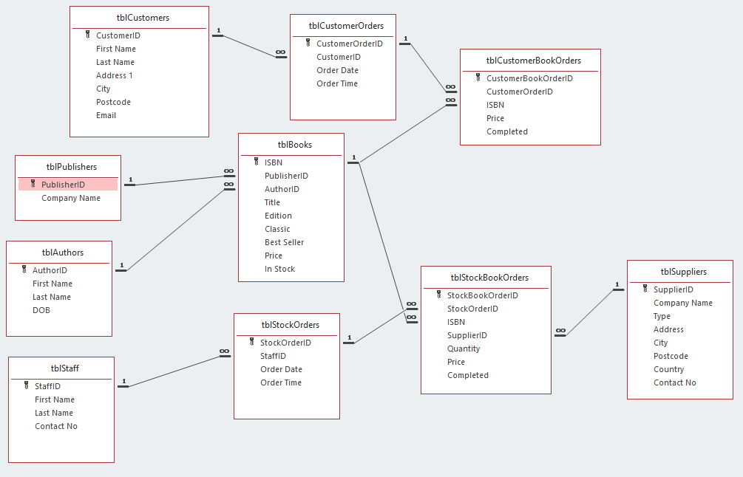
Relationship Diagram

SQL
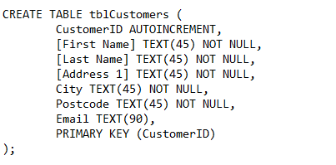
- Creating tblCustomers

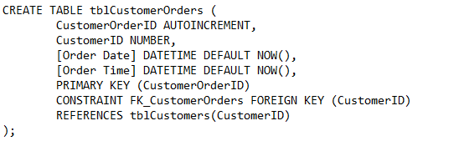
- Creating tblCustomerOrders

- Inserting data to tblCustomers

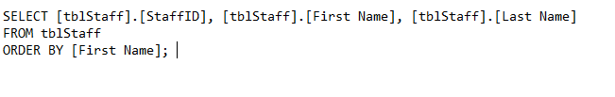
- Query Staff data for ComboBox

- Query Book data for ComboBox

Forms
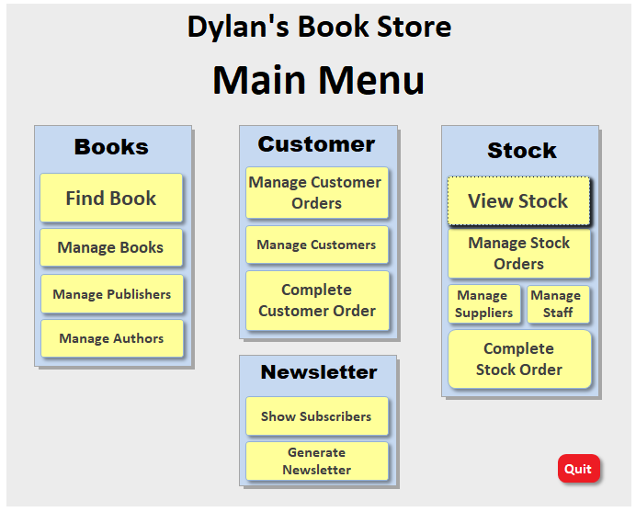
- frmMain

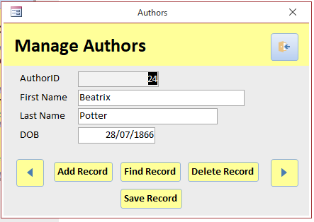
- frmAuthors

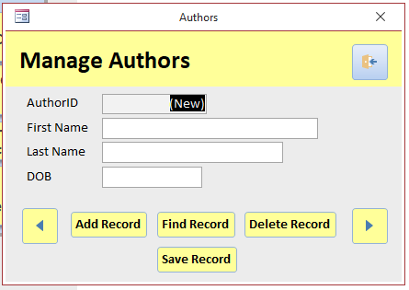
After selecting Add Record on frmAuthors

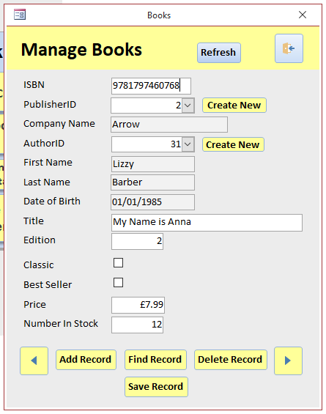
- frmBooks

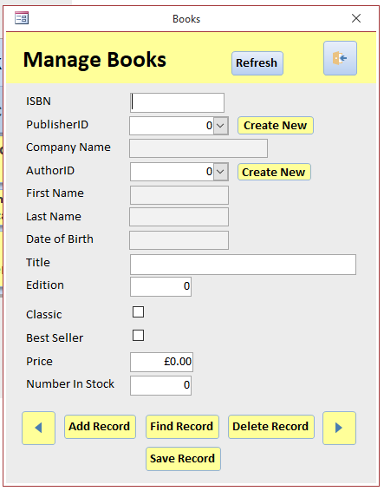
After selecting Add Record on frmBooks

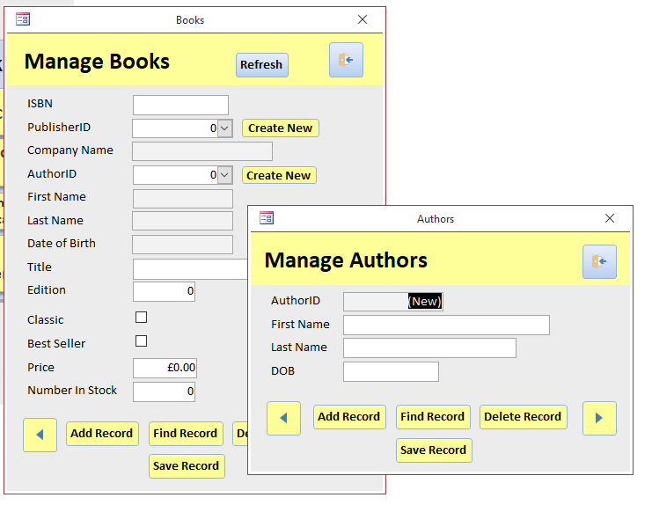
After selecting Create New (author) on frmBooks

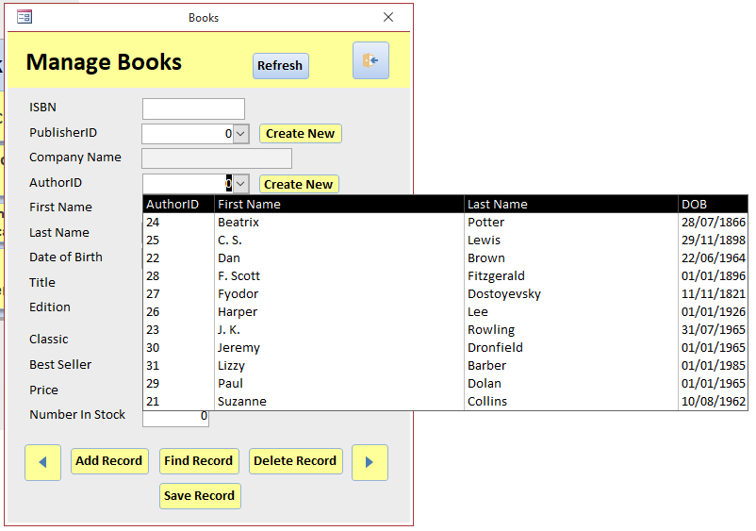
After selecting AuthorID ComboBox on frmBooks

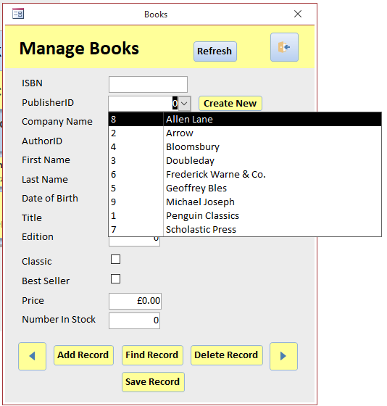
After selecting PublisherID ComboBox on frmBooks

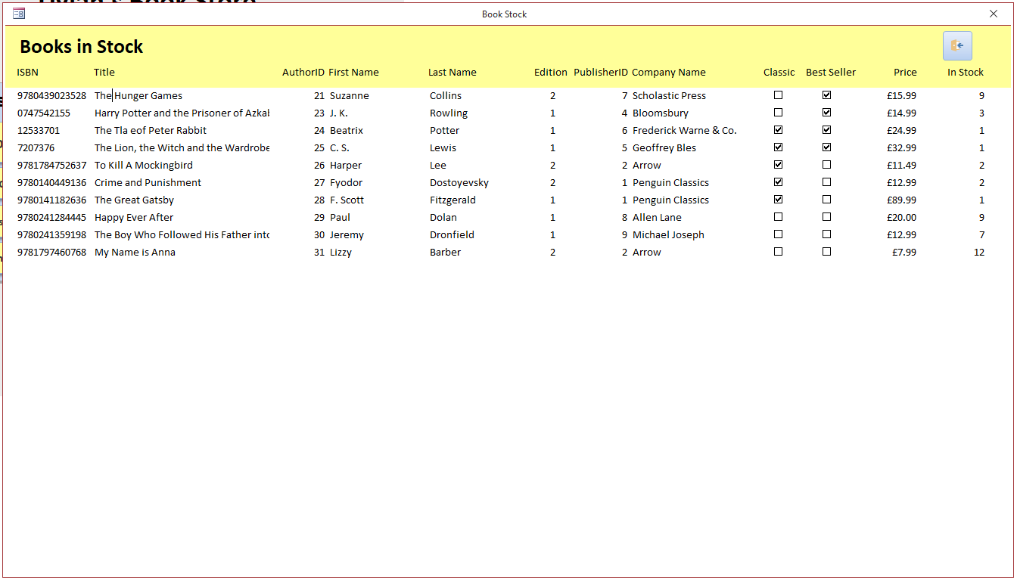
- frmBookStock

- Query used for frmBookStock to display only available Books
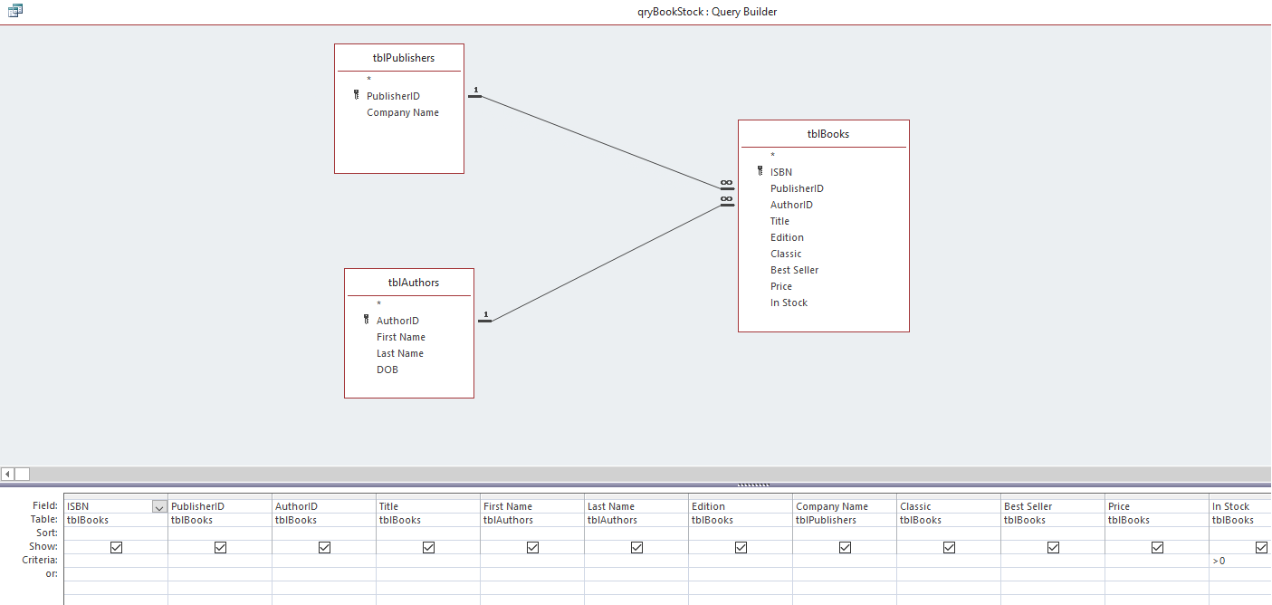

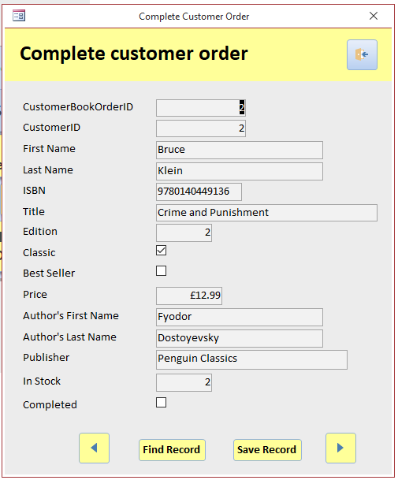
- frmCompleteOrder

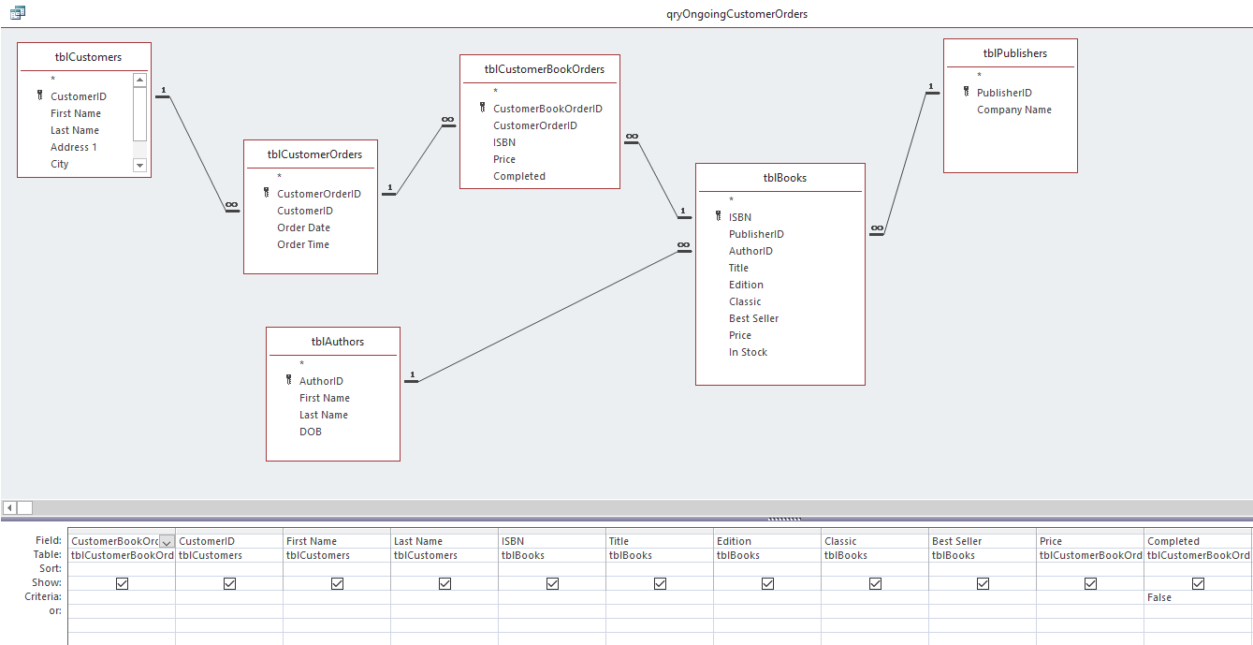
- Query to find Ongoing Customer Orders for frmCompleteOrder

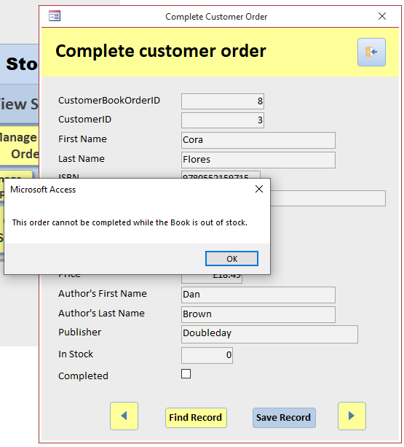
- Warning when book out of stock frmCompleteOrder

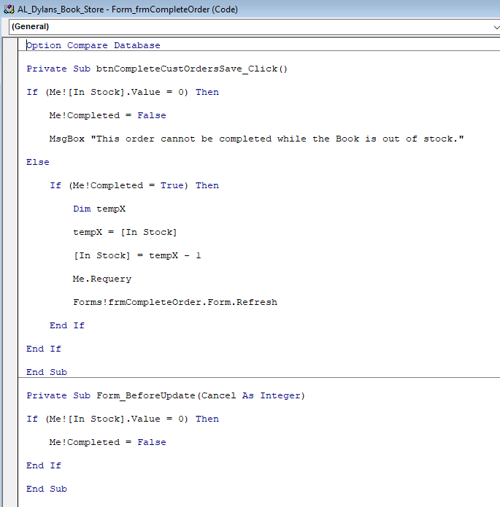
- VBA Code for frmCompleteOrder (reduce number in stock)

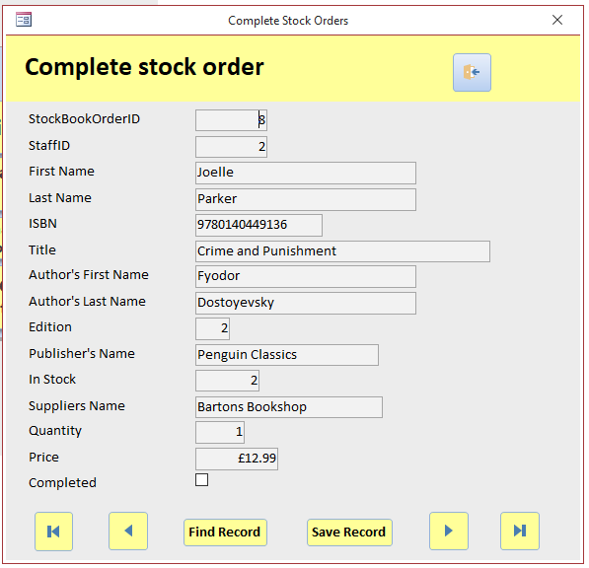
- frmCompleteStockOrders

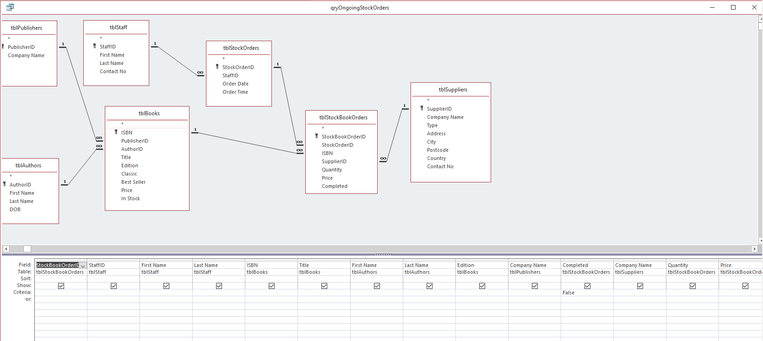
- Query for frmCompleteStockOrders

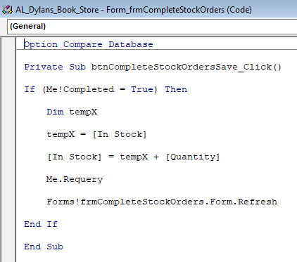
- VBA code for frmCompleteStockOrders (increase number in stock)

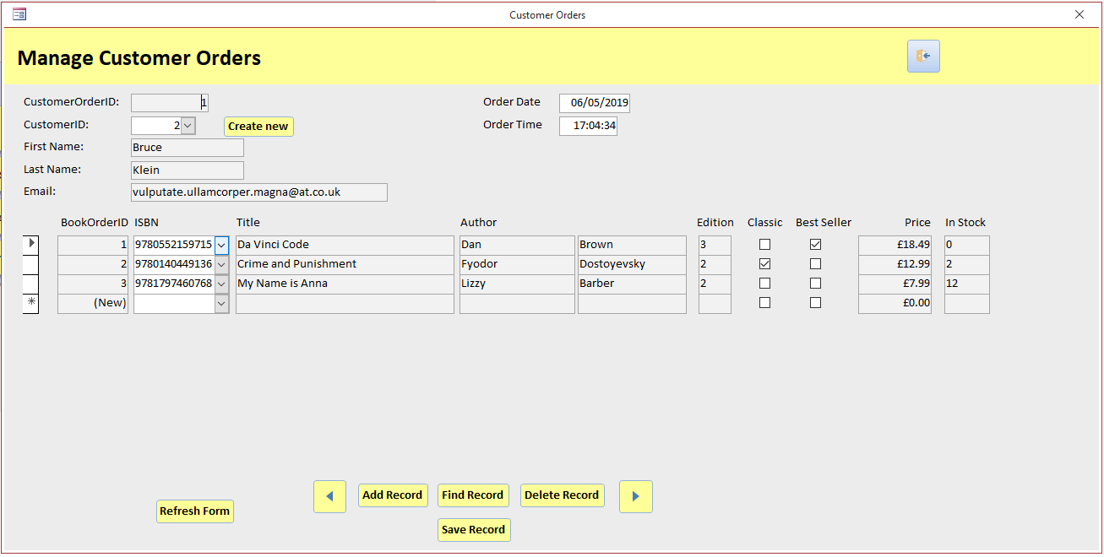
- frmCustomerOrders and sfrmCustomerBookOrders (using Embedded Forms)

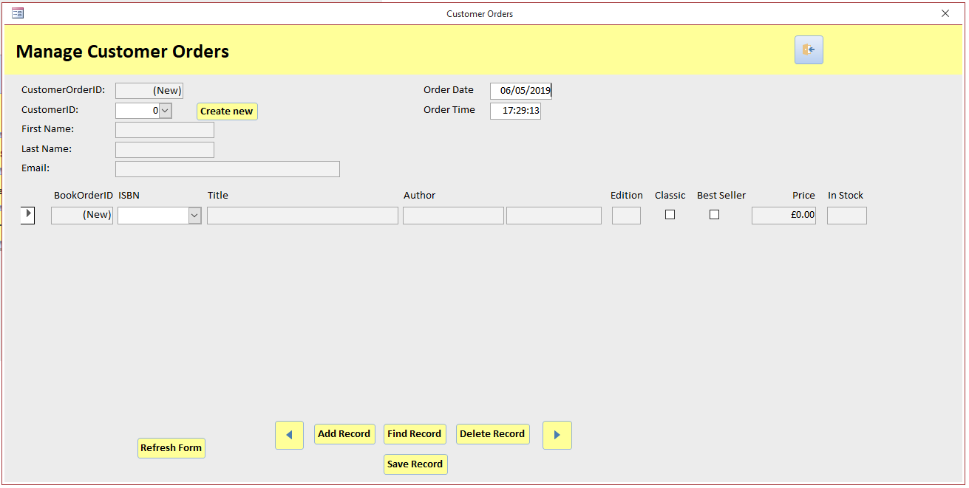
- Add Record frmCustomerOrders

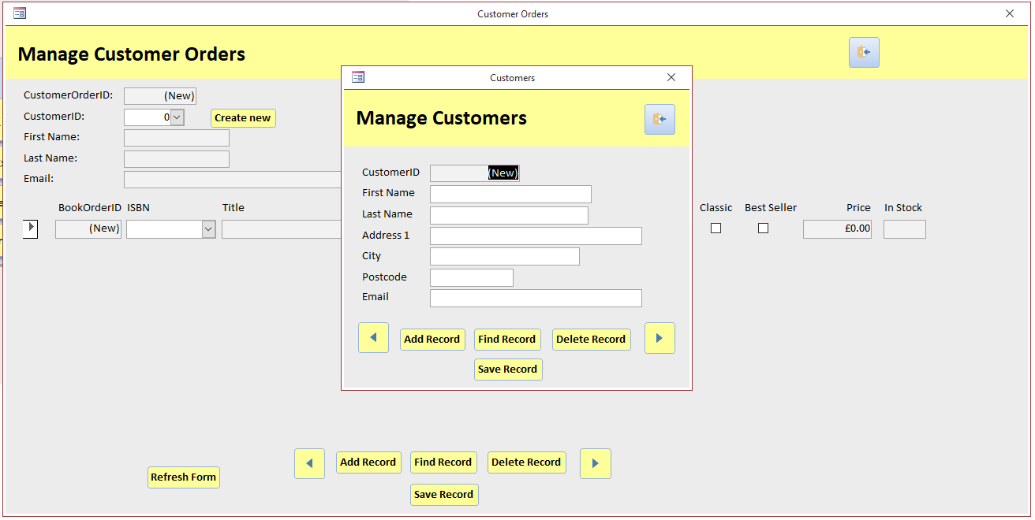
- CreateNew Customer frmCustomerOrders

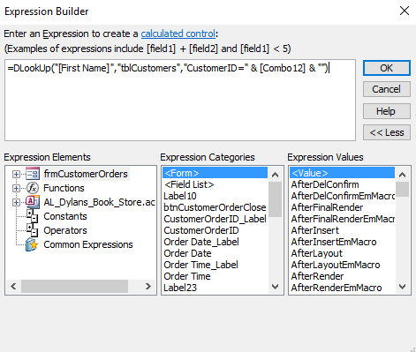
- Function to display Staff details frmCustomerOrders

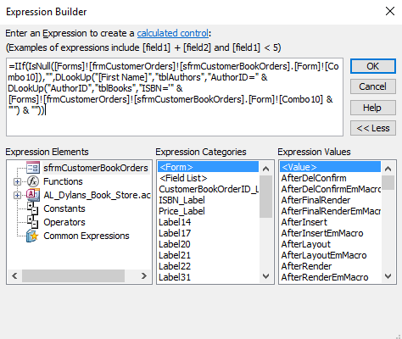
- Function to display Book Author’s first name sfrmCustomerBookOrders

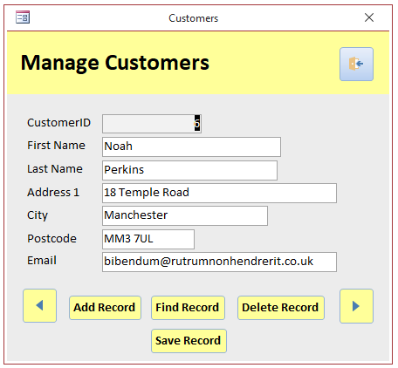
- frmCustomers
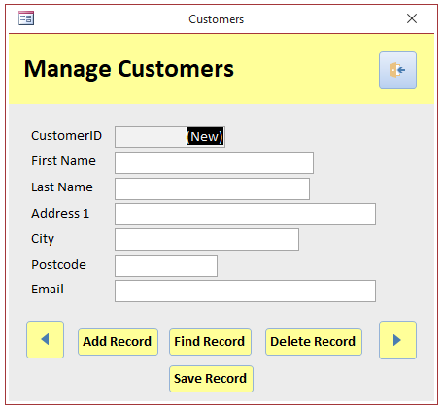
- Add Record frmCustomers

- frmPublishers
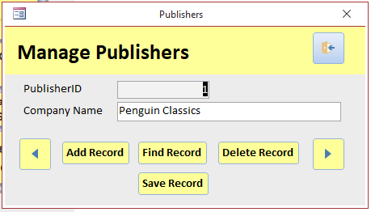

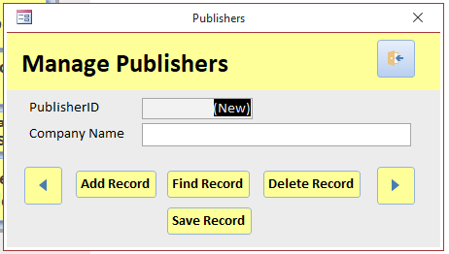
- Add Record frmPublishers

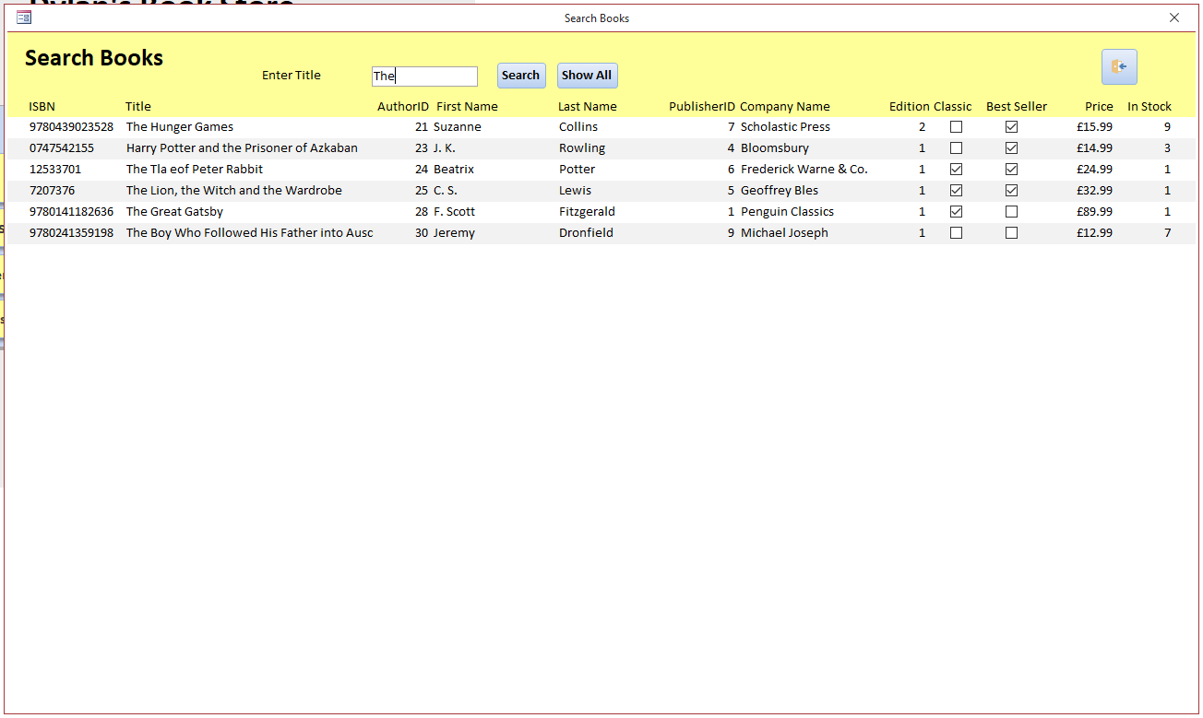
- frmSearchBooks

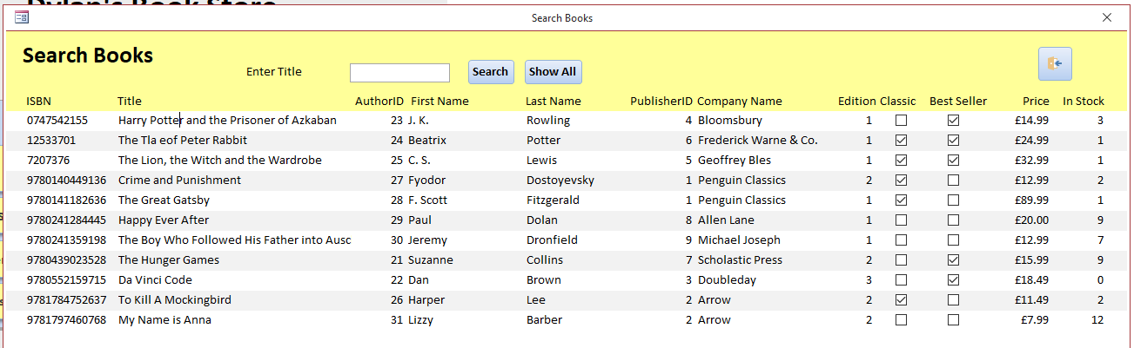
- Show All frmSearchBooks

- VBA frmSearchBooks
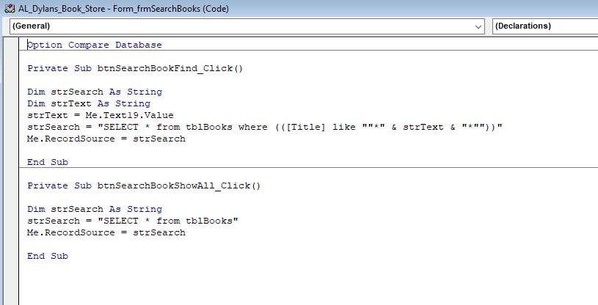

- frmStaff
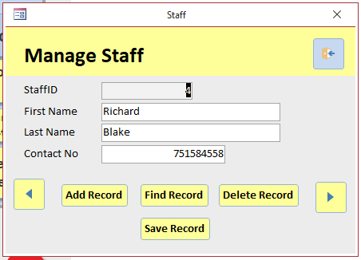

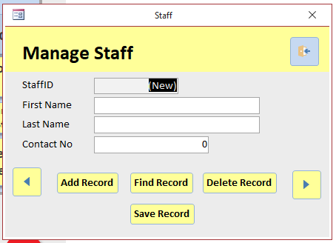
- Add Record frmStaff

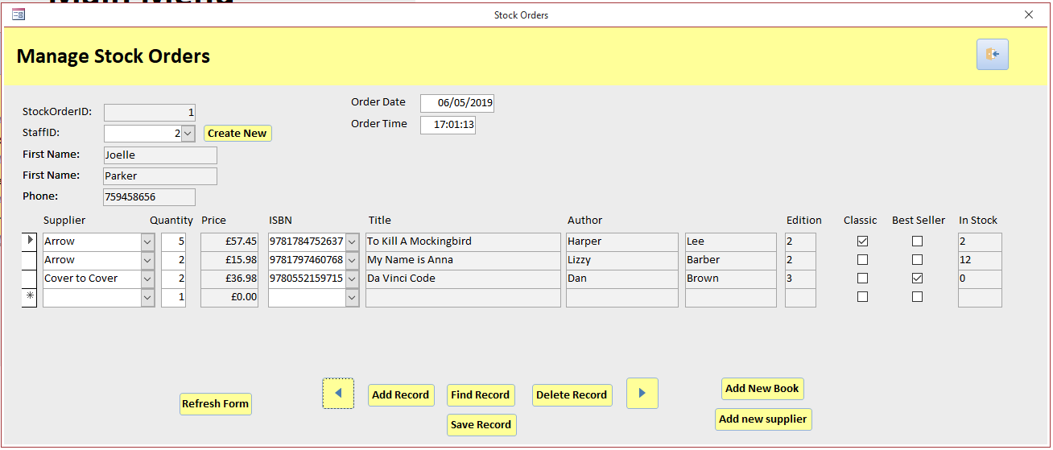
- frmStockOrders and sfrmStockBookOrders (using Embedded Forms)

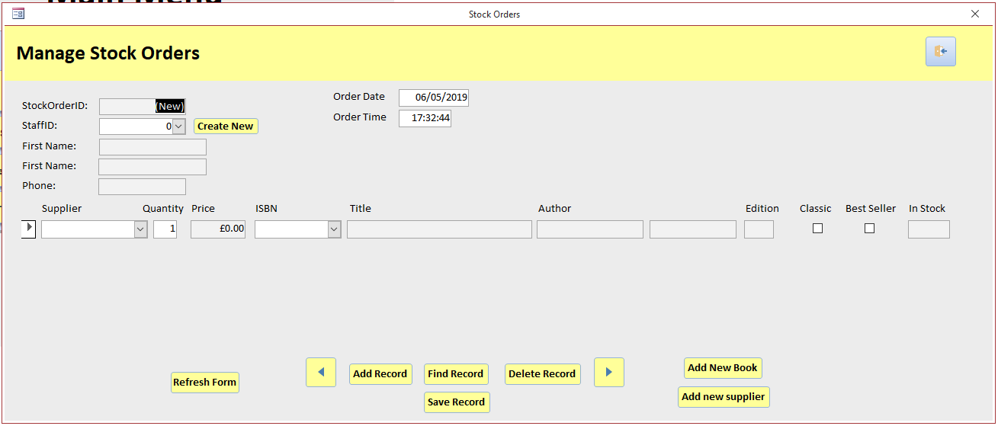
- Add Record frmStockOrders

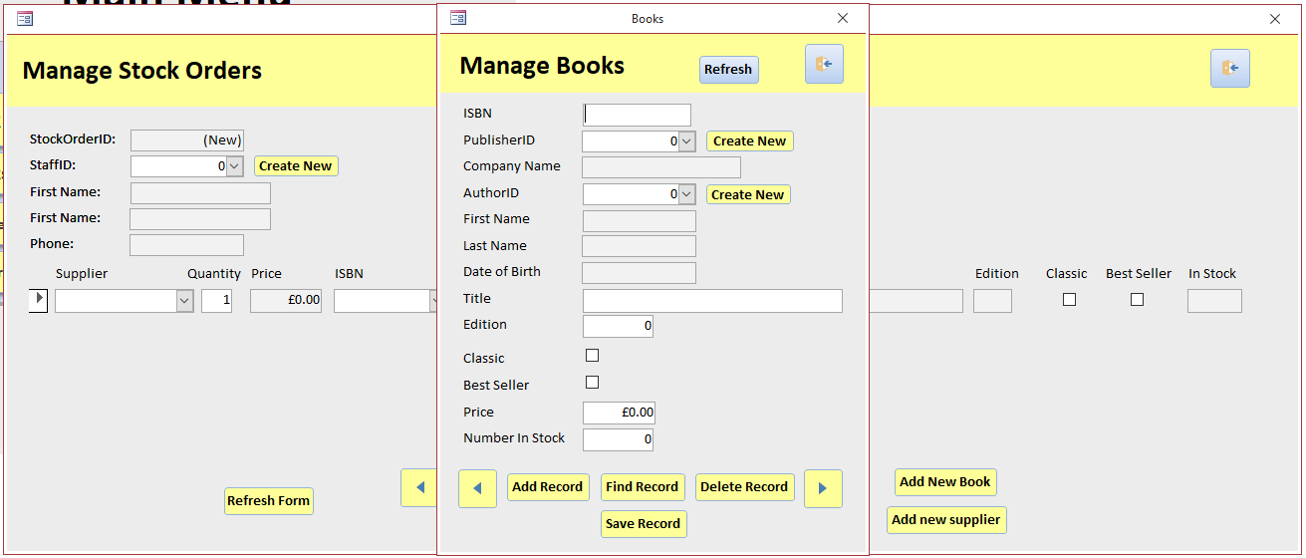
- New Book Record frmStockOrders

- New Book Author Record frmStockOrders

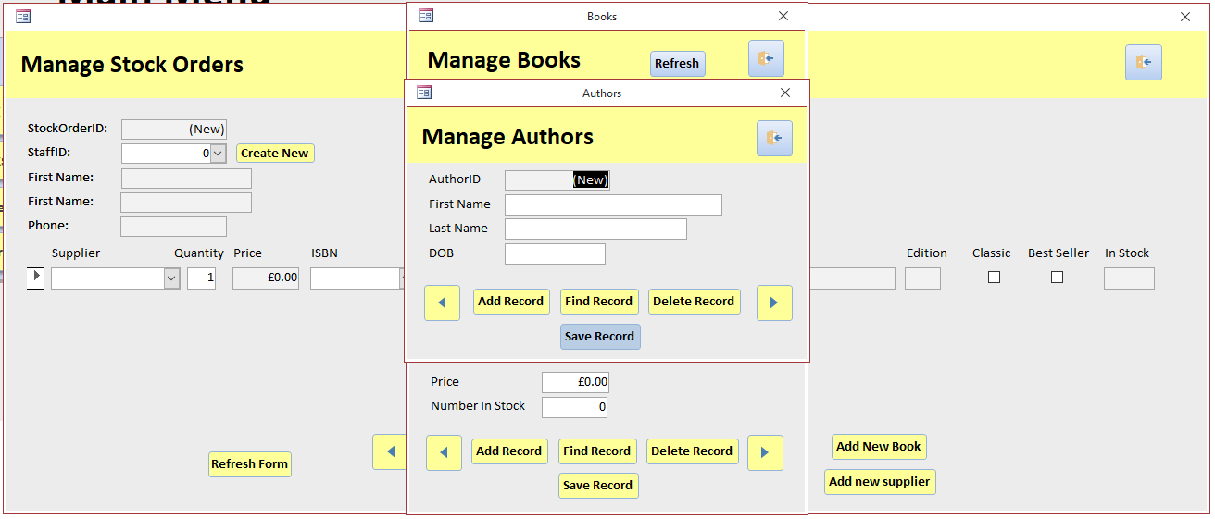

- New Staff Record frmStockOrders
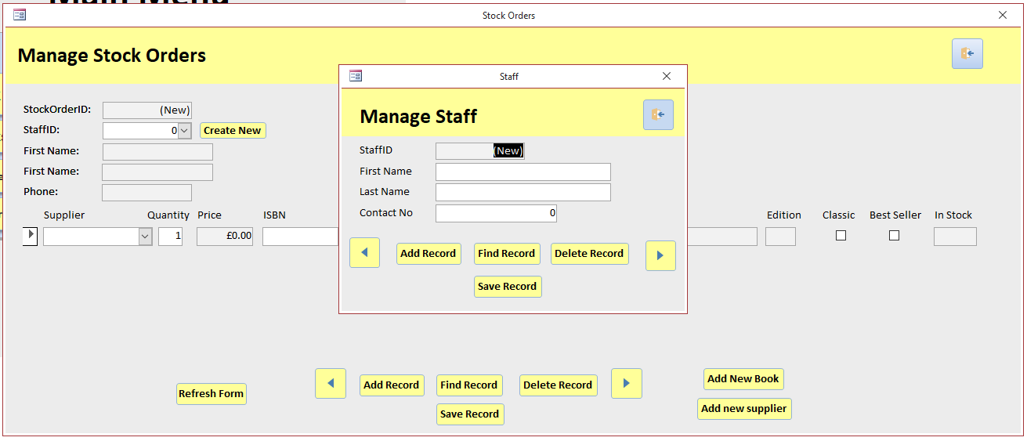
- New Supplier Record frmStockOrders

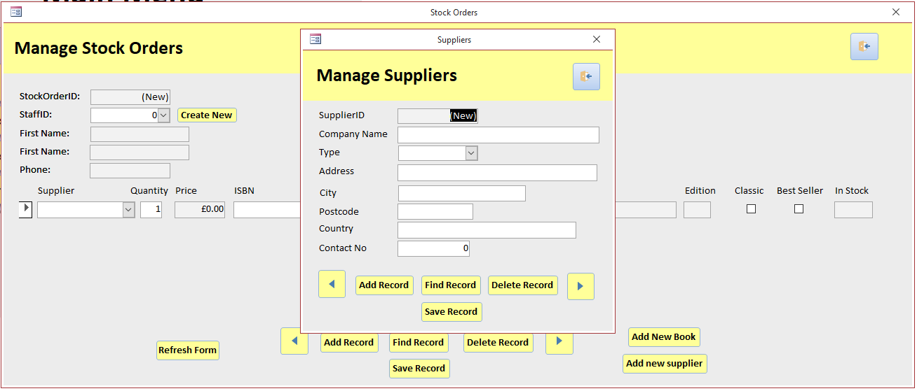

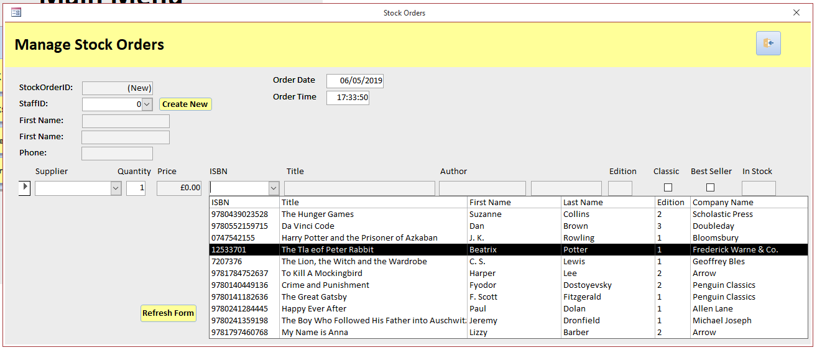
- Book ComboBox sfrmStockBookOrders

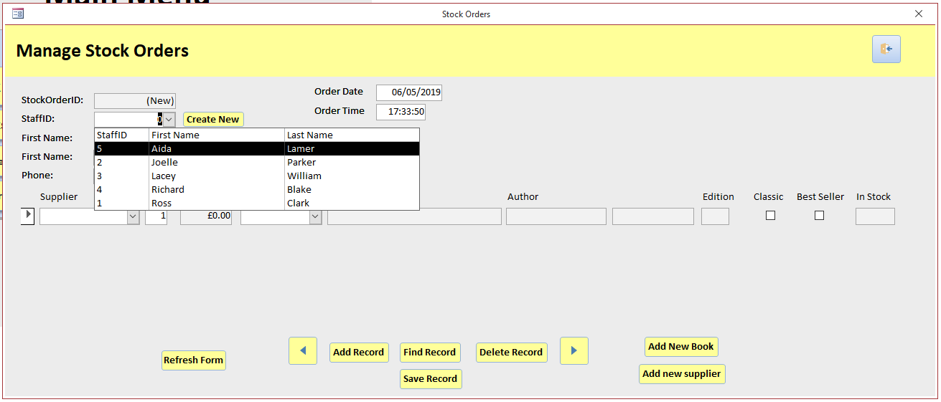
- Staff ComboBox frmStockOrders

- Supplier ComboBox sfrmStockBookOrders
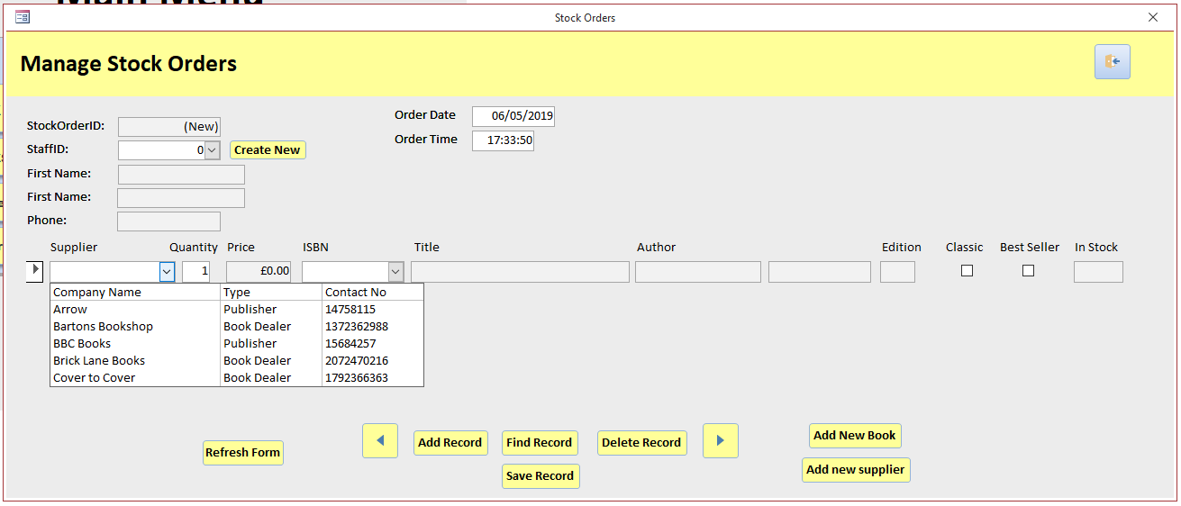

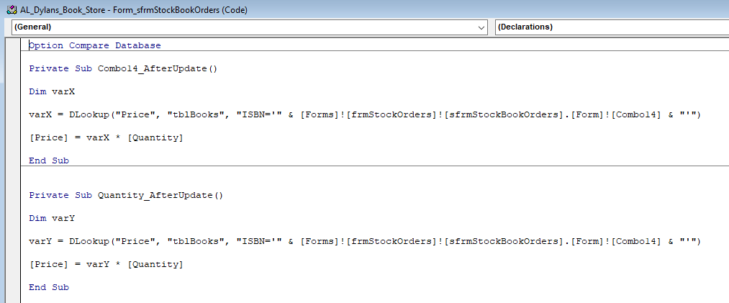
- VBA Calculation sfrmStockBookOrders

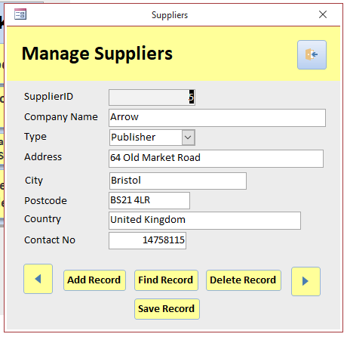
- frmSuppliers

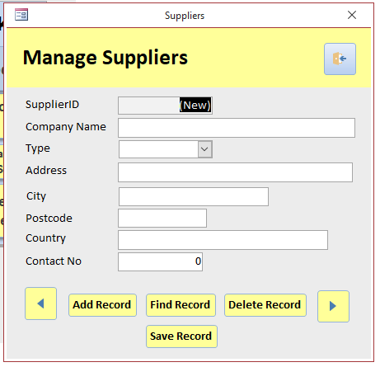
- Add Record frmSuppliers

- Type ComboBox frmSuppliers
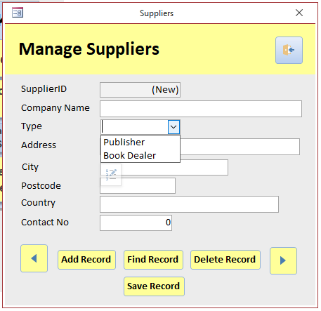

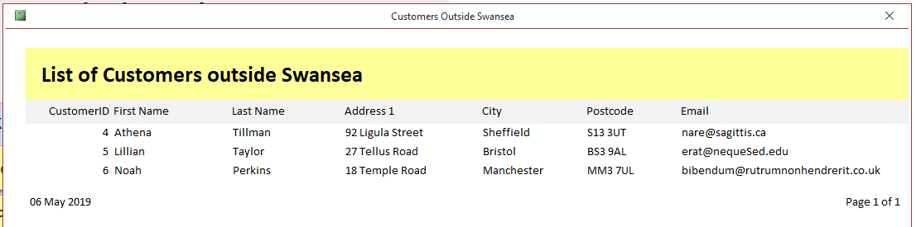
- rptCustomerOutsideSwansea

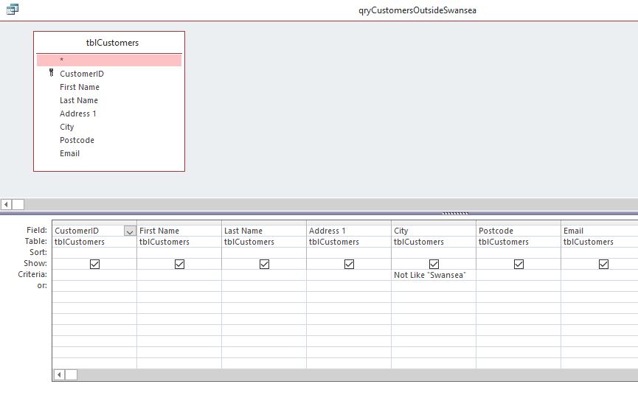
- Query rptCustomerOutsideSwansea

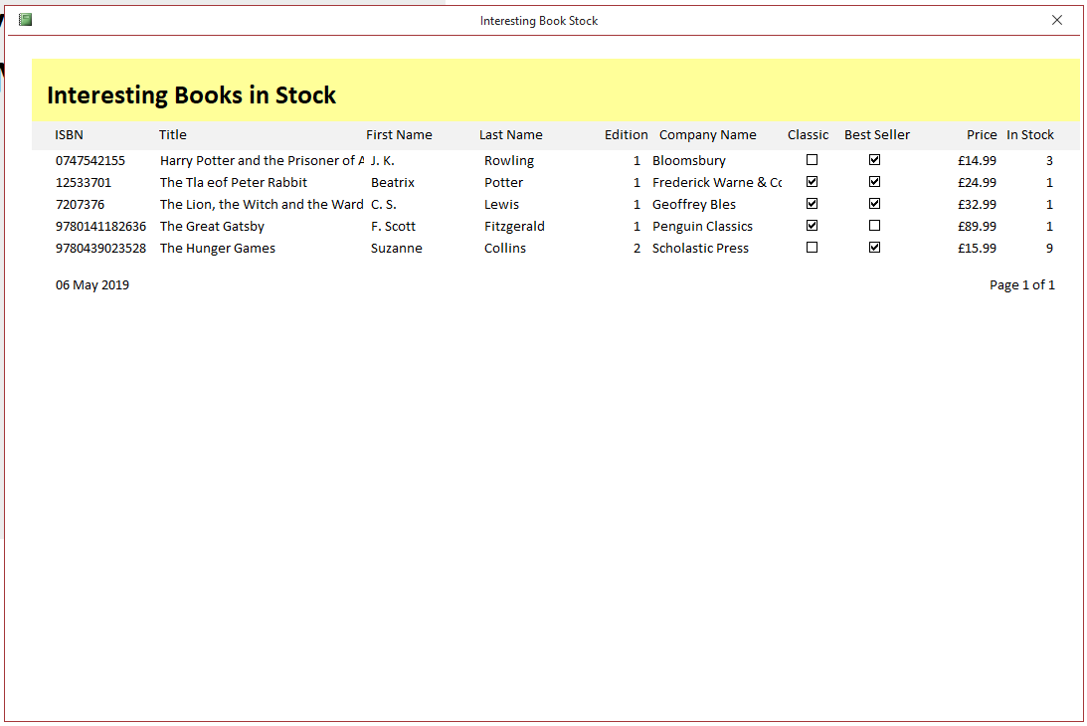
- rptInterestingBookStock

- Query rptInterestingBookStock
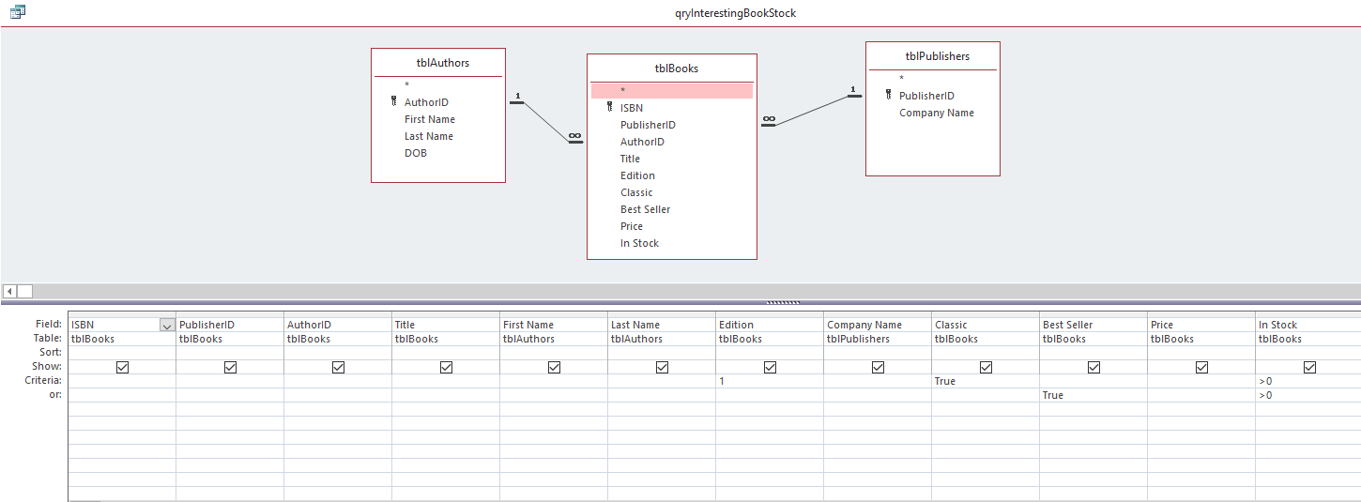

User guide
Home

Manage Customer Orders
Member of staff must fill out the white fields. Combo boxes are refreshed using the Refresh Form button. Staff also have the ability to add new customers. Exit takes the user back to Home. Depending on what book is selected, the price changes automatically.

Complete Stock Order

Shows all the uncomplete orders. By ticking “Completed” check box and pressing “Save Record” it will remove it from the uncompleted stock order. It also increases the number of “In Stock” number by the specified quantity.

Complete Customer Order

Shows all uncomplete customer orders. By ticking “Completed” check box and pressing “Save Record”, it will remove it from the uncompleted customer order list, and reduce the number in stock by 1.

Manage Books

The user can manage all the books stored in the system. They can also refresh the page, exit, go back, go forward, add record, find record, delete record and save record. If an additional author or publisher should be added, select “Create new”. Everything apart from the grey fields must be completed.

Manage Stock Orders

Member of staff must fill out the white fields. Combo boxes are refreshed using the Refresh Form button. Staff also have the ability to add new books and suppliers. Exit takes the user back to Home.

Depending on what book the user selects and the quantity, the price will automatically adjust.

Manage Suppliers
Members of staff can manage suppliers. They must fill out the white fields shown. Exit takes the user back to Home.
Manage Customers
Staff can also manage customers. By “Add Record” they have the ability to create a new customer. “Find record” allows staff to locate customers previously saved. “Delete Record” allows staff to delete customer’s records. “Save Record” allows staff to save the data input. Exit takes the user back to Home.

Manage Publishers

Allows staff to add record, find record, delete record and save the record of publishers. White fields must be completed. Exit takes you back to the home page.
Manage Authors

Allows staff to add, find, delete and save data of authors. White fields must be completed. Exit takes the user back to Home.

Manage Staff

This allows employees to add, find, delete and save records on their staff. The white fields must be completed. Exit takes the user back to Home.
Generate Newsletter
Shows all classic editions and best sellers. Also shows stock availability.

View Stock

Shows all books available. No alterations are enabled.
Find Book

User can search by book title.
Quit
Closes Dylan’s Book Store database completely.

References
[1] "First Normal Form (1NF) of Database Normalization | Studytonight", Studytonight.com, 2019. [Online]. Available: https://www.studytonight.com/dbms/first-normal-form.php [Accessed: 05- May- 2019].
[2] "Second Normal Form (2NF) of Database Normalization | Studytonight", Studytonight.com, 2019. Available: https://www.studytonight.com/dbms/second-normal-form.php [Accessed: 05- May- 2019].
[3] "Third Normal Form (3NF) of Database Normalization | Studytonight", Studytonight.com, 2019. Available: https://www.studytonight.com/dbms/third-normal-form.php [Accessed: 05- May- 2019].
[4] “Must-reads of 2019: the best new books of the year | Penguin”, Penguin.co.uk, 2019. Available: https://www.penguin.co.uk/articles/2018/dec/must-reads-and-best-books-to-buy-in-2019/ [Accessed: 06- May- 2019].
[5] “100 must-read classic books, as chosen by our readers | Penguin”, Penguin.co.uk, 2019. Available: https://www.penguin.co.uk/articles/2018/100-must-read-classic-books/ [Accessed: 06- May- 2019].
[6] “List of all bookshops | Loveyourindie, Loveyourindie.com”, 2019. Available: https://loveyourindie.com/shops/list-of-all-bookshops/ [Accessed: 06- May- 2019].

