Foreign Languages & Cultural Awareness
BMIH5003

Intercultural Competence
Report

Student name: Gabriela Iuliana Matei
Student id: 2126974
Lecturer: Giulia Chifari
Word count:

- Executive summary
Examining the cultural and leadership dynamics at the Multicultural Hotel & Spa in London, this paper focuses on the integration of Turkish staff members into a team that is primarily British. Using the results of the GLOBE Project, the study identifies important cultural distinctions that affect team dynamics and leadership styles, such as power distance, individuality vs collectivism, and uncertainty avoidance. Turkish staff members, used to hierarchical and group environments, are said to have trouble adjusting to the British tendency for participative and egalitarian management. The paper advises putting in place customised cross-cultural training, conflict resolution seminars, and team-building exercises to deal with these issues. The hotel wants to keep up its excellent levels of guest service and operational efficiency, hence these programmes are designed to promote cultural sensitivity, improve communication, and create a cohesive team environment.

Contents
0. Executive summary 2
1. Introduction 4
2. Cultural differences between England and Turkey 4
3. Cultural and leadership study 5
4. Challenges of intercultural leadership 7
5. Conclusion 8
6. Recommendations 8
7. References 9

- Introduction
In hospitality, cultural knowledge and foreign language proficiency are essential since they enable efficient communication and understanding between staff members and visitors from different origins, which increases guest happiness and loyalty (Christiansen, Branch and Karkowska, 2020). The Multicultural Hotel & Spa in London takes great satisfaction in welcoming variety and offering visitors from all over the world first-rate service. As the recently hired General Manager, we have to go to the branch in the selected nation to learn more about their culture and operations so that can better integrate their staff into the London team. This paper attempts to investigate cultural differences, examine leadership philosophies, and foresee difficulties in cross-cultural leadership in the hotel industry.

- Cultural differences between England and Turkey
Turkey's higher Power Distance points to a more hierarchical approach with obvious distinctions in authority and communication, while England's lower Power Distance indicates a cultural tendency towards egalitarianism and a flatter management structure (Globe Project, 2020). This distinction suggests that, compared to the British predilection for cooperative and participatory methods, Turkish employees may expect more direct instructions and a top-down decision-making process (Hofstede, Hofstede, and Minkov, 2010). Furthermore, whereas individualistic British culture greatly values personal achievement and individuality, Turkey's collectivist orientation emphasises group loyalty and decisions that benefit the group (Globe, 2020). Moreover, the UK's lesser Uncertainty Avoidance score than Turkey points to a more accommodating attitude to regulations and practices and a higher tolerance of ambiguity (Hofstede Insights, 2024). This might be a cultural flexibility to adjust to new circumstances and a willingness to improvise, in contrast to the Turkish inclination for regimented settings and precise rules. In hospitality situations, where Turks would carefully follow official procedures and British people could exhibit a more laid-back engagement style, such variations can have a big impact on visitor interactions and service performance (Hampden-Turners and Trompenaars, 2020). Critical cultural differences are also highlighted by the difference in humane orientation, where Turkey, with its greater focus on community and relationships, may value warmth and personal connection in guest interactions more than the British approach, which may be more formal and reserved (GLOBE Project, 2020). Effective management of multicultural teams depends on a knowledge of these cultural foundations, which can also direct the creation of training programmes that address these variations and guarantee that service standards are upheld while honouring local quirks (Deresky, 2017).
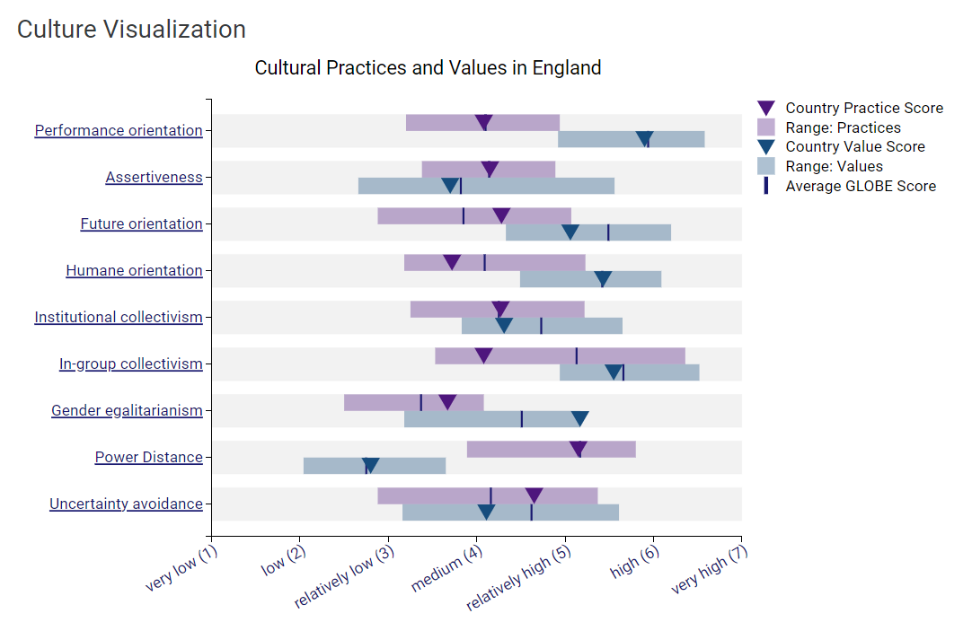
Fig 1. Globe Project (2020). Cultural Practices and Values in England
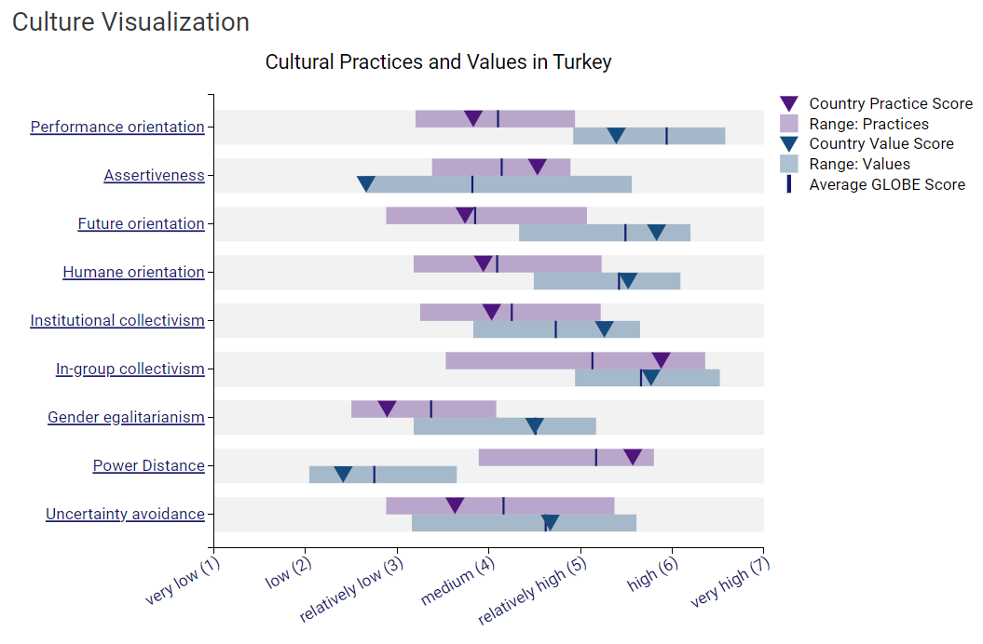
Fig 2. Globe Project (2020). Cultural Practices and Values in Turkey

- Cultural and leadership study
Any multicultural environment's operational and cultural fabric is held together by its leadership. Turkey and the UK have somewhat different leadership tastes, as the GLOBE Project (2020) makes clear, and if this is not handled well, there may be conflict. Turkish leaders often have a team-oriented and charismatic approach; participative leadership is not as important. In Turkey, a collectivist culture where respect for hierarchical systems and group cohesiveness are valued, this approach can be quite successful (Issa, 2005). On the other hand, leadership styles in the UK are more participative, promoting employee participation and collaborative decision-making, where individualism and lesser power distance are more common (Wang, Hou and Li, 2022). Although leadership styles directly influence team management and decision-making, the underlying cultural values and practices define the larger context in which these leadership styles either thrive or fail (Deresky, 2017). Lower Uncertainty Avoidance and higher Individualism in the UK point to a flexible, innovative culture that respects personal success and accepts ambiguity. But Turkey's greater Power Distance and Collectivism produce an environment where group harmony, role clarity, and organisation are critical (Hostede Insights, 2024). In the setting of hospitality, where both guest engagement and back-of-the-scenes activities must be precisely calibrated and flexible, leadership arguably becomes even more important. Effective functioning of a diverse team depends on leaders modelling and enforcing the cultural adaptation required in addition to setting the operational pace. They have to interpret and act as mediators between various work styles and cultural expectations, hence for quick operational success, leadership flexibility is crucial (Christiansen, Branch and Karkowska, 2020). This does not, however, lessen the need of recognising and incorporating cultural variances, which provide the foundation for long-term strategic alignment and cohesiveness of the team. To create an inclusive and productive work culture, effective leadership in a multicultural setting must be well informed by an awareness of these cultural subtleties (Abramson and Moran, 2018). Both elements are therefore unquestionably crucial, however in a multicultural integration situation within the hospitality industry, the emphasis may be significantly more on first adjusting and aligning leadership styles to swiftly stabilise team relations and guarantee seamless daily operations.
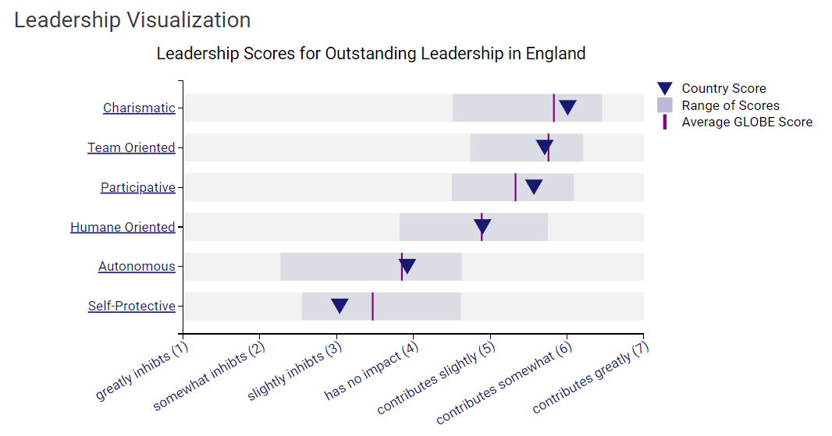
Fig 3. Globe Project (2020). Leadership Visualisation England.
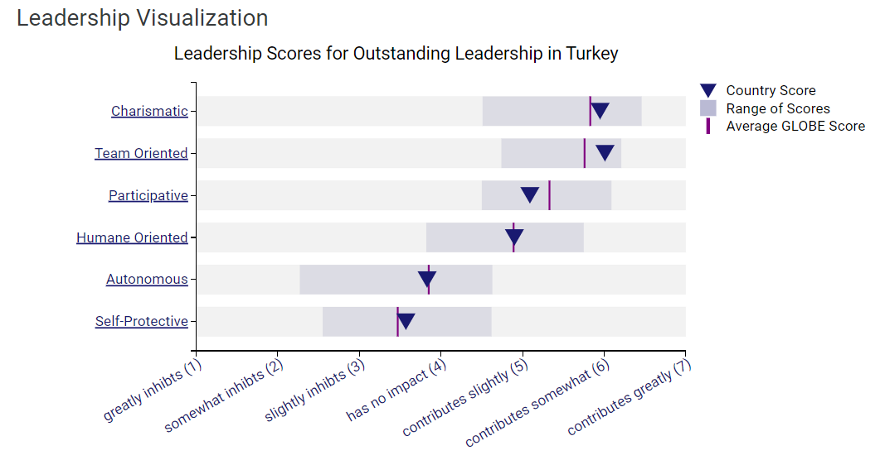
Fig 4. Globe Project (2020). Leadership Visualisation Turkey

- Challenges of intercultural leadership
Within an environment like the Multicultural Hotel & Spa in London, which integrates Turkish staff into a British background, intercultural leadership in the hospitality sector poses unique problems. Conflict can result from different leadership philosophies and cultural norms about decision-making and power distance. Because of Turkey's greater power gap, management methods there may usually stress directive leadership and hierarchical organisations (Hofstede, Hofstede and Minkov, 20100). Because the UK has a lower power distance than Turkey, this strategy may go against the expectations of British workers for more participative, egalitarian leadership styles that value individual contribution and group decision-making (Wang, Hou and Li, 2022). Such differences can cause miscommunication and weaken team cohesion since Turkish leaders may see British staff's suggestions as undermining authority, while British staff may see the Turkish leadership style as unduly authoritative.

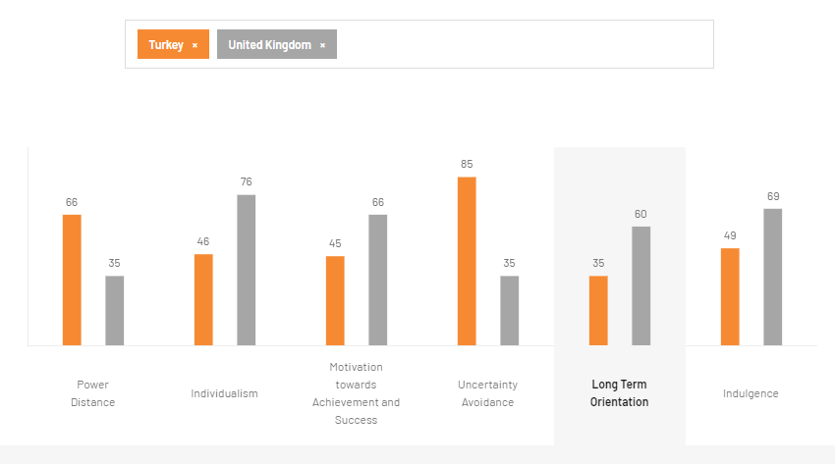
Fig 5. Hofstede Insights Comparison Tool (2024). England vs. Turkey
- Conclusion
In conclusion, intercultural leadership at the Multicultural Hotel & Spa, merging Turkish and British workers, demonstrates the necessity to resolve considerable cultural and leadership gaps. Successfully managing these variances is vital for sustaining effective operations and ensuring that the multicultural workforce can continually deliver high service standards.

- Recommendations
The Multicultural Hotel & Spa should introduce thorough cross-cultural training programmes designed especially to handle the cultural quirks between Turkish and British employees in order to improve the efficacy of its intercultural leadership. These programmes ought to concentrate on fostering communication and cultural empathy that can help to reconcile the different expectations at work and leadership styles (Abramson and Moran, 2018). Leaders can also be better equipped to handle and lessen conflicts resulting from cultural differences by implementing conflict resolution seminars (Ting-Toomey, 2012). Organising frequent team-building exercises that encourage respect and understanding between different team members will also help to create a more cohesive workplace. In keeping with the hotel's dedication to excellence in hospitality, these programmes will not only improve team dynamics but also increase guest service (Kozlowski and Ilgen, 2019).

- References
- Abramson, N.R. and Moran, R. (2018) Managing Cultural Differences: Global Leadership for the 21st Century. 10th Ed. Abingdon: Routledge.
- Christiansen, B., Branch, J.D. and Karmowska, J. (2020) Cultural Factors and Performance in 21st Century Businesses. Hershey : IGI Global.
- Deresky, H. (2017) International Management: Managing Across Borders and Cultures: Text and Cases. 9th Ed. Harlow: Pearson Education Ltd.
- GLOBE (2020). Results - England GLOBE Project. [online] Globeproject.com. Available at: https://globeproject.com/results/countries/GBR%3Fmenu=list.html#list.
- Globeproject (2020). Turkey Results - GLOBE Project. [online] Available at: https://globeproject.com/results/countries/TUR%3Fmenu=list.html [Accessed 1 Jun. 2024].
- Hampden-Turner, C. and Trompenaars, F. (2020) Riding the Waves of Culture. 4th Ed. London: John Murray Press.
- Hofstede Insights (2024). Country comparison tool. [online] www.hofstede-insights.com. Available at: https://www.hofstede-insights.com/country-comparison-tool?countries=turkey%2Cunited+kingdom.
- Hofstede, G., Hofstede, G.J. and Minkov, M. (2010) Cultures and organizations: software of the mind. 3 rd Ed. New York: McGraw-Hill.
- Issa, T. (2005). Talking Turkey: The Language, Culture and Identity of Turkish Speaking Children in Britain. [online] Google Books. Trentham Books. Available at: https://www.google.co.uk/books/edition/Talking_Turkey/aMWA-QFxnLoC?hl=en&gbpv=1&dq=turkish+culture+in+uk&pg=PR7&printsec=frontcover [Accessed 1 Jun. 2024].
- Kozlowski, S.W.J. and Ilgen, D.R. (2019). Enhancing the Effectiveness of Work Groups and Teams. Psychological Science in the Public Interest, [online] 7(3), pp.77–124. doi:https://doi.org/10.1111/j.1529-1006.2006.00030.x.
- Ting-Toomey, S., 2012. Understanding intercultural conﬂict competence: multiple theoretical insights. In The Routledge handbook of language and intercultural communication (pp. 289-305). Routledge.
- Wang, Q., Hou, H. and Li, Z. (2022). Participative Leadership: a Literature Review and Prospects for Future Research. Frontiers in Psychology, [online] 13(1). Available at: https://www.ncbi.nlm.nih.gov/pmc/articles/PMC9204162/.
‌

