University of Wales Trinity Saint David

School of Engineering



Engine Rotating Assembly CAE Analysis

Structural Design & Fluid Analysis (ACHA6010)
BEng Motorsport Engineering

Franklin Spencer Tim Attwood
2004876
December 2023

Table of Contents
Table of Figures and Tables 2
Tables 2
Figures 2
1 Introduction 3
2 CAE Validation 4
2.1 Cantilever Test 4
2.2 Analytical Study 5
2.2.1 Deformation 5
2.2.2 Stress 6
2.3 Computational Study 7
2.4 Impact of Mesh Sizing 8
3 CAD Model and Assembly 10
4 CAE Simulation 11
4.1 Engineering Data 11
4.2 Rigid Dynamics 13
4.3 Static Structural – Without Thermal Load 15
4.3.1 Total Deformation 15
4.3.2 Equivalent Stress 15
4.4 Steady State Thermal 16
4.5 Static Structural - With Thermal Load (Fully Linked System) 17
4.5.1 Total Deformation 17
4.5.2 Equivalent Stress 18
4.6 Static Structural - With Thermal Load and Combustion Pressure 19
4.6.1 Total Deformation 19
4.6.2 Equivalent Stress 19
5 Conclusion 20
6 References 21

Table of Figures and Tables

Tables
Table 1 - Mesh size effect on deformation and stress 8
Table 2 - Material properties table in Ansys 11
Table 3 - Temperature dependent young's modulus table from Ansys 11
Table 4 - Provided thermal boundary conditions for piston 16

Figures
Figure 1 - Cantilever beam - point load at free end equations and diagram (StructX, 2022) 4
Figure 2 - Beam stress equation (SkyCiv Engineering, 2023) 4
Figure 3 – Beam deformation - 2.5mm mesh 7
Figure 4 - Beam stress - 2.5mm mesh 7
Figure 5 - Mash size effect on stress and deformation graph 8
Figure 6 - Rotating assembly CAD assembly 10
Figure 7 - Rotating assembly mates 10
Figure 8 - Temperature verses young's modulus graph from Ansys 12
Figure 9 - Rigid body model tree 13
Figure 10 - Rigid body results 14
Figure 11 - Rigid body piston coordinates 14
Figure 12 - Total deformation of piston without thermal load 15
Figure 13 - Equivalent stress of piston without thermal load 15
Figure 14 - Temperature study of piston 16
Figure 15 - Fully linked project schematic 17
Figure 16 - Total deformation of piston with thermal load 17
Figure 17 - Equivalent stress of piston with thermal load 18
Figure 18 - Total deformation of piston with thermal load and combustion pressure 19
Figure 19 - Equivalent stress of piston with thermal load and combustion pressure 19

Introduction
Computer aided engineering (CAE) refers to the use of computer software and simulations to aid in engineering analysis, design, optimization, and manufacturing. CAE often goes hand in hand with computer aid design (CAD) and it is possible to carry out the entirety of a product development using only CAD and CAE however there are still many limitations when it comes to simulations meaning real world testing a validation is almost always carried out before a product release. During this report an investigation will take place to validate the simulation software used (Ansys in this case) and perform kinematic and structural analysis with and without thermal influence. The components being tested are internal combustion engine components, the parts include a crankshaft, connecting rod, gudgeon pin and piston, these components form the bottom end rotating assembly. All the components are subject vast temperature ranging and forces however this investigation will focus on only one component, the piston.

CAE Validation
To ensure Ansys will produce reliable and accurate results 2 validation tests were performed on a cantilever beam, a maximum deformation test and a maximum stress test.

Cantilever Test
The cantilever beam used to validate Ansys is 20mm x 20mm solid square bar with a length of 500mm, the beam is fixed at one end and free floating at the other. The material used for the tests is structural steel which happens to be the default material in Ansys. A force of 1000N is applied at the free end and the equations below will be used to for the analytical study.
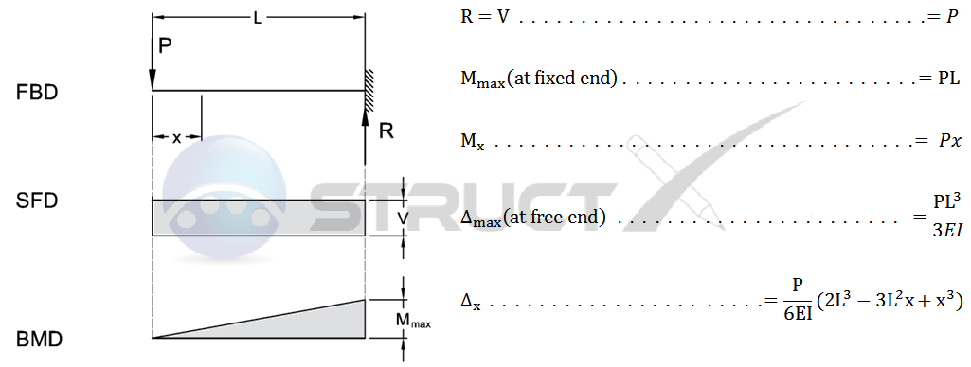
Figure 1 - Cantilever beam - point load at free end equations and diagram (StructX, 2022)
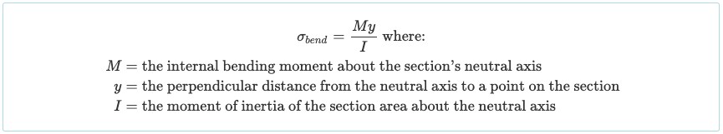
Figure 2 - Beam stress equation (SkyCiv Engineering, 2023)

Analytical Study

Deformation
$$δ_{B}=\frac{FL^{3}}{3EI}$$
Force (F) = 1000N
Length (L) = 500mm
Young’s Modulus (E) = 200x10¹¹ Pa
Second Moment of Area (I) = ?
$$I= \frac{bh^{3}}{12}$$
Base (b) = 20mm
Height (h) = 20mm
$$I= \frac{20 * {20}^{3}}{12}$$

$$I= 13333.33mm^{4}$$

$$δ_{B}=\frac{FL^{3}}{3EI}$$
Force (F) = 1000N
Length (L) = 500mm
Young’s Modulus (E) = 200x10³ MPa
Second Moment of Area (I) = 13333.33mm⁴
$$δ_{B}=\frac{1000 *{500}^{3}}{3 *\left(200* {10}^{3}\right)*13333.33}$$

$$δ_{B}=15.625 mm$$

Stress
$$σ= \frac{yM}{I}$$

Distance from Centre of Beam to Surface (y) = 10mm
I = 13333.33mm⁴
Bending Moment (M) = ?

$$M=F*L$$
M = 500x10³ N/mm

$$σ= \frac{10 *(1000 *500)}{13333.33}$$

$$σ=375 N/{mm}^{2}$$

$$σ=375*{10}^{6} Pa$$

Computational Study
The beam is created in Solidworks and saved as a .STEP file which Ansys can open easily. A static structural system is created, the CAD file of the beam is selected as the geometry then for the initial test the mesh is set to 2.5mm. The beam is fixed at one end then a force of 1000N is applied to the other. Two solution output are created: total deformation and equivalent stress. The scenario is then solved with the results shown below:
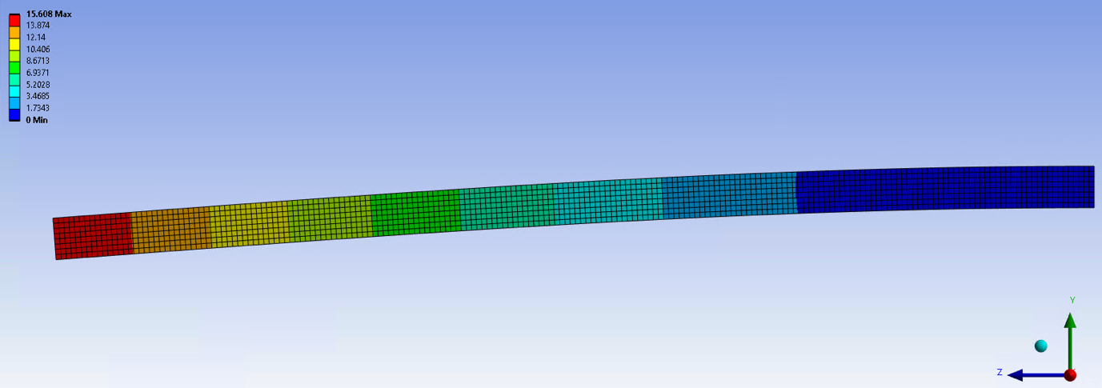
Figure 3 – Beam deformation - 2.5mm mesh
According to the analytical study there should be a maximum deformation of 15.625mm where Ansys gives a result of 15.608mm (0.1% off calculated value).
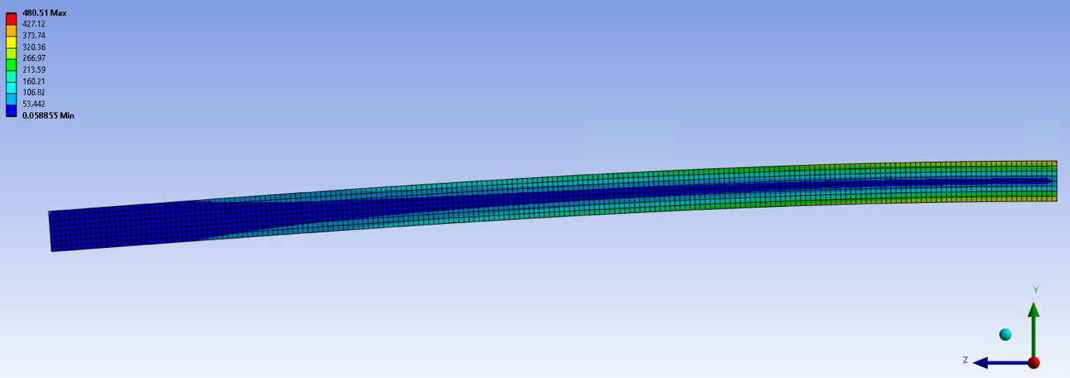
Figure 4 - Beam stress - 2.5mm mesh
For the beam stress the calculated value is 375 N/mm² and Ansys is over prediction by about 28% with a result of 480.51 N/mm².

Impact of Mesh Sizing
Mesh sizing is a critical aspect of finite element analysis (FEA) and according to Punjab (2015) has a significant impact on the accuracy and efficiency of simulation results. The size of the mesh elements directly influences the fidelity and speed of the simulation. Fine meshing generally provides more accurate results, especially in areas with high stress and allows for better representation of the actual behaviour of the structure. However, overly fine meshing can lead to increased computational costs and longer simulation times without significant improvement in accuracy.
Table 1 - Mesh size effect on deformation and stress
Mesh Size (mm) | Maximum Total Deformation (mm) | Maximum Equivalent Stress (Pa)
1 | 15.611 | 666.4
1.75 | 15.61 | 551.22
2 | 15.609 | 519.11
2.5 | 15.608 | 480.51
5 | 15.594 | 387.4
7.5 | 15.583 | 384.51
10 | 15.574 | 380.89
12.5 | 15.56 | 382.03
15 | 15.547 | 382.05
17.5 | 15.532 | 381.42
20 | 15.573 | 362.18
25 | 15.555 | 359.15
30 | 15.538 | 356.23
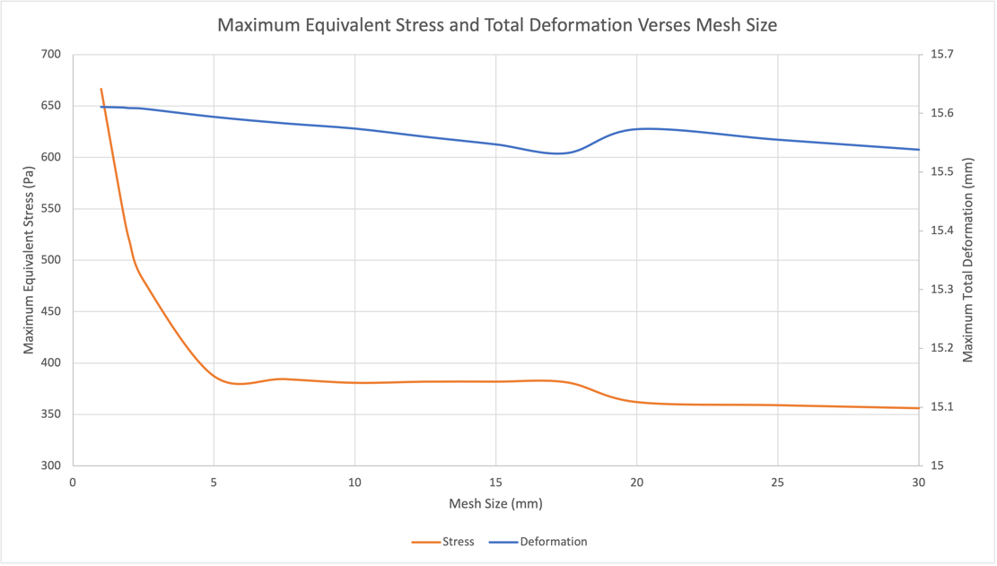
Figure 5 - Mash size effect on stress and deformation graph
The above table and graph shows the variation of deformation and stress values based on the mesh size ranging from 1mm through to 30mm. Evidently the mesh size doesn’t cause much variation (0.079mm variation), however for the stress values there is a large variation of 310.17 N/mm². Looking at the analytical results a mesh size between 17.5mm and 20mm would be closest to the calculated value of 375 N/mm² but contradicts the theory that a fine mesh would give improved accuracy, in fact for this simple beam it has worked in an opposite manner.

CAD Model and Assembly
The engine components CAD files were provided however the engines rotating assembly needed to be compiled into a Solidworks assembly file to be using to simulate the kinematics in Ansys. Below is the fully assembled bottom end for cylinder number one and the design tree showing the different components. There is no need to include the other three cylinders as it will be assumed that they will experience identical conditions to cylinder number one.

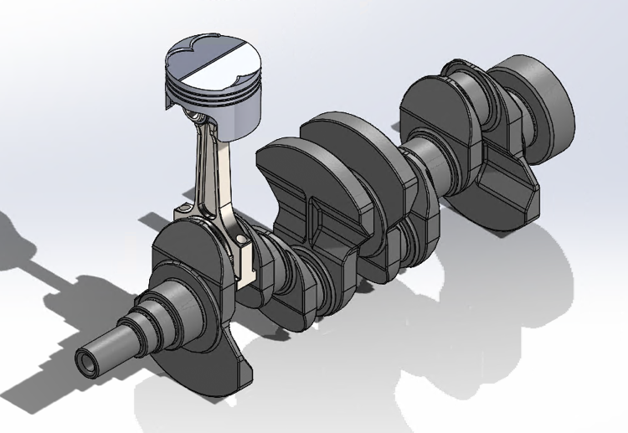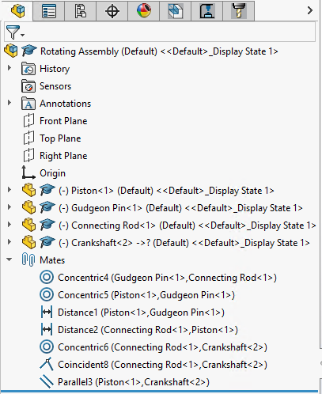
Figure 6 - Rotating assembly CAD assembly
Figure 7 - Rotating assembly mates
Since the accuracy of this assembly is critical to achieving reliable and accurate simulation data, it is imperative that the mates between each component in Solidworks are as realistic as possible. Even though Ansys does not import the mates for its geometry they dictate the position of the components which do get imported, so mates like “Distance 1” that centres the gudgeon pin in the piston are important to ensure all the components are in the correct position relative to each other.

CAE Simulation

Engineering Data
The engineering data contains the materials selected for future systems, in this case the material properties for 6061 -T6 aluminium are provided therefore a custom material needs to be made and the material properties entered. This can be seen below:
Table 2 - Material properties table in Ansys
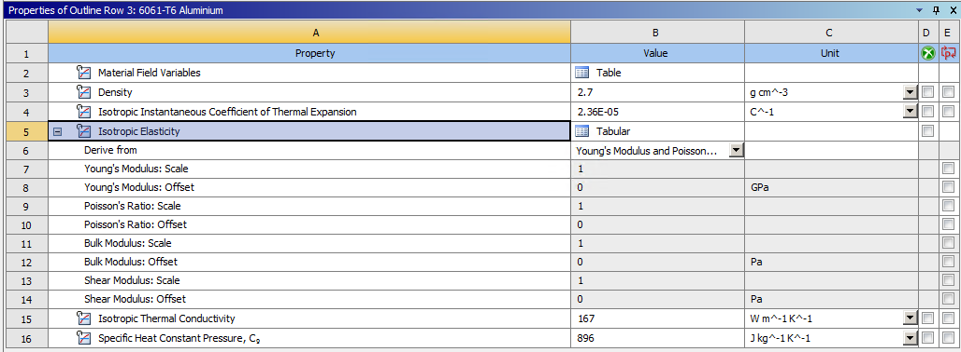
Table 3 - Temperature dependent young's modulus table from Ansys
Since the young’s modulus values provided correspond to a temperature these values are entered in a tabular form as can been seen below:
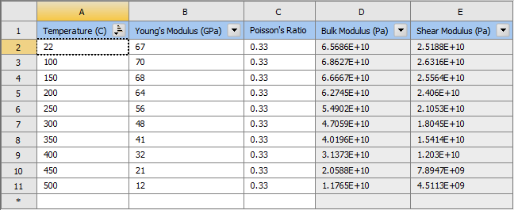

Once the young’s modulus and temperature values are set Ansys plots the following graph creating linear links between the points, this graph data is heavily used in thermal studies.
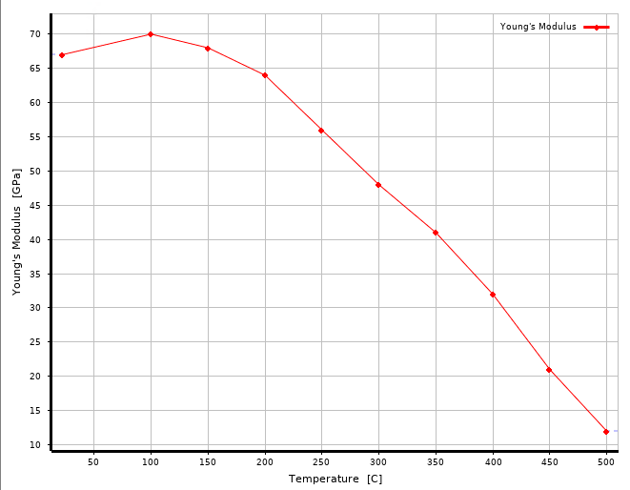
Figure 8 - Temperature verses young's modulus graph from Ansys

Rigid Dynamics
The rigid dynamics system performs transient structural analysis and will be used to calculate the forces exerted on the piston due to the motion of the components. The rotating assembly file is loaded into the geometry section of the solver and Ansys automatically converts the Solidworks mates into contacts. However, in most cases the contacts Ansys sets up are not correct and it is best practice to create contacts and/or joints from scratch, this ensures the model is setup the way it is intended to be. Joints tend to be the best method to connect bodies together due to the array of joints that can be used and are favourable over contacts because contacts can be setup over a large distance which is unrealistic and are able to separate. Below is the model tree for this system and looking at the joint folder shows the joints made between components and 2 joints to ground. These ground joints are to restrain certain components in a particular axis, in this case there is a revolute joint which fixes the crankshaft to ground but still allows it to rotate, and then there is a general joint which restricts the piston so it can only move up and down.
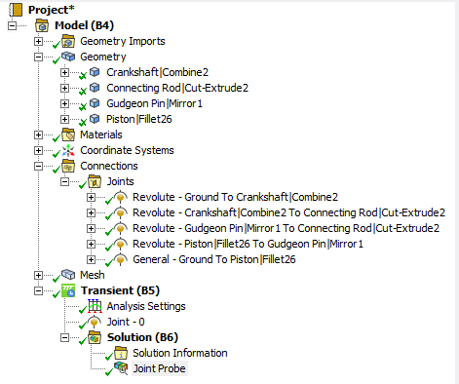
Figure 9 - Rigid body model tree

Using the crankshaft to ground joint, a rotational velocity of 4000 RPM can be applied to the joint which will cause the reciprocating action of the assembly to operate. Once solved the result of the joint forces are plotted below with the one of the peak forces selected and its corresponding table row highlighted, this row is then saved to be used later in a static structural system.
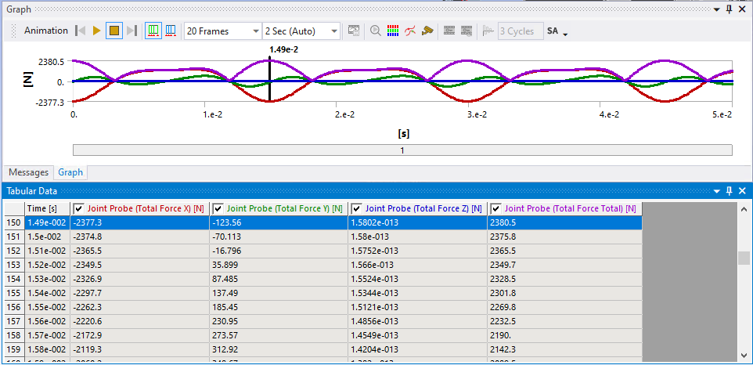
Figure 10 - Rigid body results
Looking at the piston’s local axis below it’s evident that the main force takes place on the x axis and due to the orientation of the axis when the piston exerts a force away from the crankshaft the force reading will be negative which corresponds to the above x axis force.
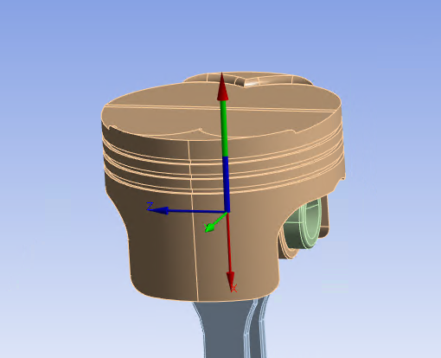
Figure 11 - Rigid body piston coordinates

Static Structural – Without Thermal Load
Taking the forces from the rigid body system and applying them to a static structural system will show the total deformation and equivalent stress caused by the piston forces. For the static structural system to solve this all the other bodies except for the piston are suppressed and the piston stiffness behaviour is changed to flexible. The mesh for the piston is set to 4mm everywhere except for the crown which is set 2mm to hopefully give more detail since this will be the hottest section of the piston when it comes to the thermal study.

Total Deformation
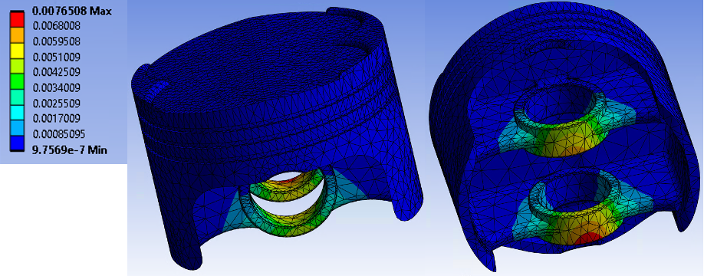
Figure 12 - Total deformation of piston without thermal load
Looking at the above diagram at first glance one might think there is a large amount of deformation on the thinnest part of the gudgeon pin bore however looking at the scale the red sections are 0.0076mm.

Equivalent Stress
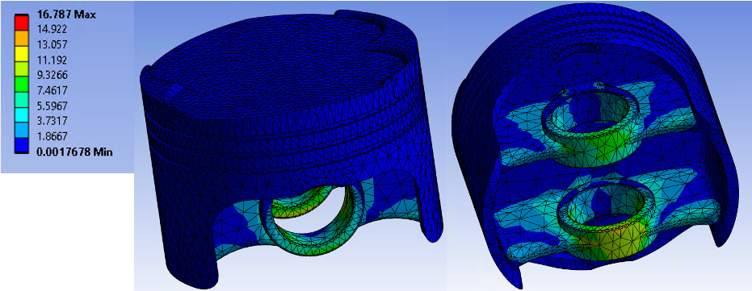
Figure 13 - Equivalent stress of piston without thermal load
Just like the deformation result the peak stress is situated on the thinnest part of the gudgeon pin bore and experiences forces around 10 to 15 Pa.

Steady State Thermal
The table below show the thermal conditions each part of the piston experiences, these values are provided with the piston CAD file. A steady state thermal study is added to the system and the average values below are entered for the appropriate area of the piston.
Table 4 - Provided thermal boundary conditions for piston
Thermal Boundary Conditions
Location | Heat Transfer Coefficient (W/m² * °C) |  |  |  |  | Temperature (°C)
Location | 1 | 2 | 3 | 4 | Average | 1 | 2 | 3 | 4 | Average
Crown | 600 | 350 | 500 | 540 | 497.5 | 928.5 |  |  |  | 928.5
Crown Side | 500 | 540 | 350 | 400 | 447.5 | 250 | 650 | 500 | 300 | 425
Top Groove | 300 | 650 | 200 | 600 | 437.5 | 180 | 150 | 180 | 250 | 190
Middle Groove | 300 | 650 | 200 | 600 | 437.5 | 180 | 150 | 180 | 250 | 190
Oil Groove | 260 | 520 | 175 | 400 | 338.75 | 165 | 150 | 170 | 170 | 163.75
Underside | 1500 | 750 | 250 | 200 | 675 | 95 | 90 | 90 | 90 | 91.25
Skirt | 1000 | 400 | 150 | 300 | 462.5 | 110 | 110 | 120 | 90 | 107.5

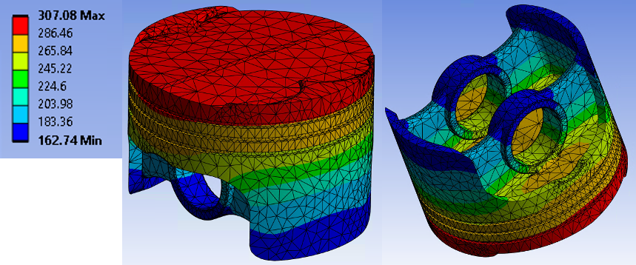
Figure 14 - Temperature study of piston
The thermal study shows a heat map of the piston with, as expected, the crown of the piston absorbing the most thermal energy. Like the rigid body forces the piston’s thermal environment is taken to be used in another static structural.

Static Structural - With Thermal Load (Fully Linked System)
Now all the systems are linked together as seen below perform an analysis on the piston.
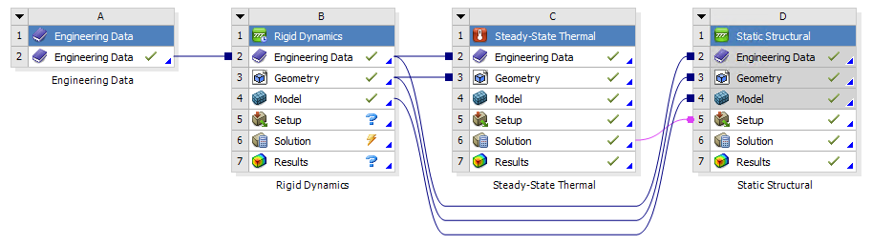
Figure 15 - Fully linked project schematic

Total Deformation
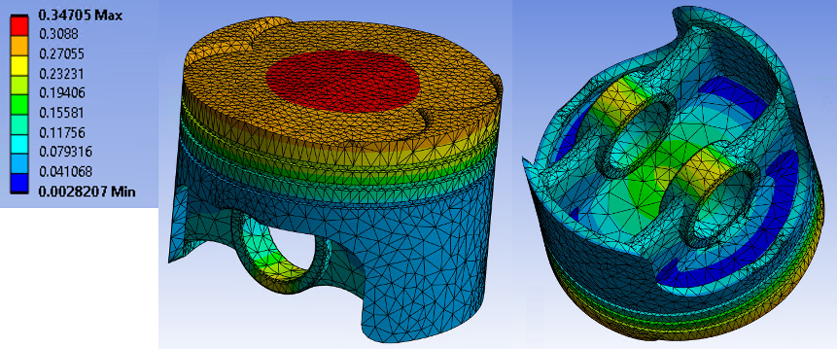
Figure 16 - Total deformation of piston with thermal load
Looking at the total deformation of the piston, now there is thermal loading taken into account Ansys shows 0.34mm of deformation over the centre of the crown and looking at the underside of the piston it is evident as to why, there is a dish on the underside of the crown in-between the gudgeon pin bores. This makes the centre of the crown to be the thinnest section, the dish may be there to reduce the pistons mass but more likely it is to accommodate the connecting rod small end.

Equivalent Stress
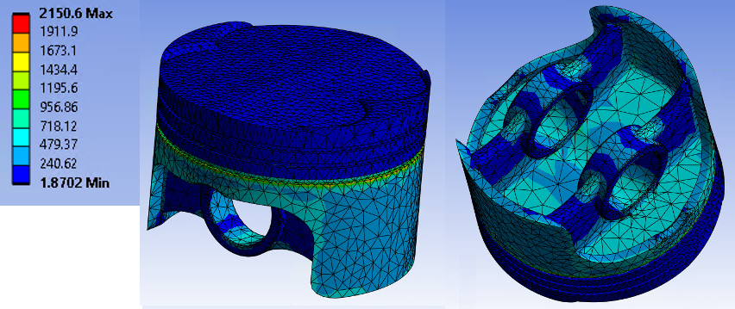
Figure 17 - Equivalent stress of piston with thermal load
When looking at the stress map oddly enough the most amount of stress seems to occur on the lower section of the oil control ring groove. This may be due to the cooling effect the lubricating oil has on the piston because this area of stress is not highlighted on the structural study done without thermal loading.

Static Structural - With Thermal Load and Combustion Pressure
It is not uncommon for a 4-cylinder engine to produce maximum torque in the 3000 to 4000 RPM range and peak torque is often when peak cylinder pressure occurs. In this case peak cylinder pressure was taken to be 100 Bar (10 MPa) and to simulate this a pressure force was added to the crown of the piston of 10 MPa.

Total Deformation
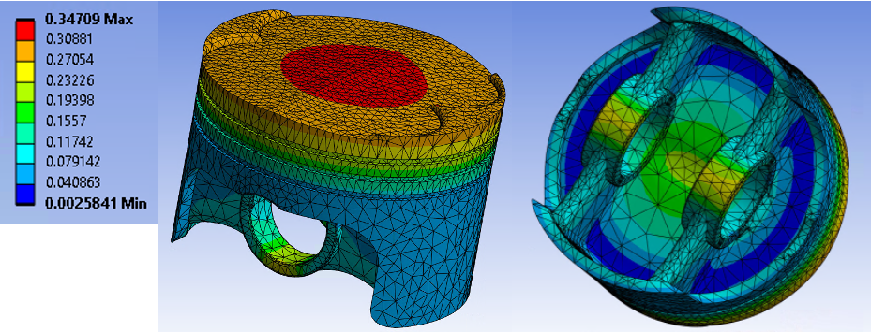
Figure 18 - Total deformation of piston with thermal load and combustion pressure
Adding the combustion pressure only changed the maximum deformation by 0.00004mm and did not expose any other areas of high deformation values.

Equivalent Stress
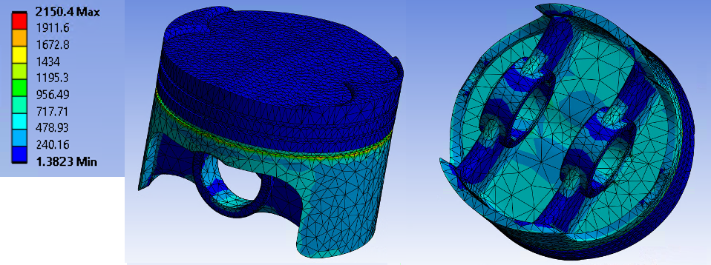
Figure 19 - Equivalent stress of piston with thermal load and combustion pressure
As the maximum deformation did not change much it is expected that the stress will not change much either, and looking at the stress map it doesn’t exposes any areas and interestingly the maximum stress drop slightly from 2150.6 Pa (without combustion) to 2150.4 Pa (with combustion). More research would need to go into this result but the slight decrease in stress may be because the combustion pressure may be equalising the pistons kinematic forces.

Conclusion
In conclusion, it is evident from this investigation that using CAE opens up lot of opportunities to quickly and very cheaply simulate and develop a component. Doing this kind of research and development not only saves costs to the manufactures but it is also seen as more sustainable due to less wastage compared to real world testing. In addition, especially evident with the thermal loading, the more information you give the software the more in-depth and realistic the results tend to be. However, it is critical to note that the results seen in these simulations do not directly line up with analytical studies and real-world testing meaning for product which need a low failure rate real world testing may still be more cost effective due to the product have less failures. Using a combination of CAE development and real-world test is by the best way to go but can also work out a being more expensive than choosing one or the other.

References
Punjab, J. (2015) Effect of Mesh Size on Finite Element Analysis of Beam
Volume 2, Issue 12
pp. 8 – 10
Available at: https://www.internationaljournalssrg.org/IJME/2015/Volume2-Issue12/IJME-V2I12P102.pdf
(Accessed: 13/12/2023)

SkyCiv Engineering (2023) Calculating Bending Stress of a Beam Section
Available at: https://skyciv.com/docs/tutorials/stress-tutorials/calculate-bending-stress-of-a-beam-section/
(Accessed: 11/12/2023)

StructX (2022) Cantilever Beam - Point Load at Free End
Available at: https://structx.com/Beam_Formulas_022.html
(Accessed: 11/12/2023)

