Webinar links from SMR links to digital leaders, employees and customers

https://sloanreview.mit.edu/video/rethinking-customer-expectations-for-2022-and-beyond/

Rethinking Customer Expectations for 2022 and Beyond

George Westerman and Ally MacDonald May 12, 2022
To compete in the post-pandemic era, companies and managers must evolve their customer strategy.
After two years of uncertainty and rapid change, managers must rethink fundamental assumptions about how they do business — and especially about how they serve their customers. What has changed in what customers want? And what does that mean for the way you design customer experience?

Related Reading
G. Westerman, Why Digital Transformation Needs a Heart, MIT Sloan Management Review, Sept. 12, 2016.
G. Westerman, Rethinking Assumptions About How Employees Work, MIT Sloan Management Review, Oct. 28, 2021.
G. Westerman, Developing Strategy for New Customer Expectations, MIT Sloan Management Review, Dec. 06, 2021.
G. Westerman, The Questions Leaders Should Ask in the New Era of Digital Transformation, MIT Sloan Management Review, March 07, 2022.

In this webinar, MIT Sloan School senior lecturer George Westerman, author of “Developing Strategy for New Customer Expectations,” will look at ways companies and managers can rethink standard practices around customer experience and create strategies for effective decision-making in the post-pandemic era. He’ll share new research-driven insights on:

- The five assumptions companies often make about what customers want.
- The key questions to consider to evolve your leadership mindset for customers.
- Examples from companies that have transformed their approach to operations and customer experience.
- How companies can combine physical, virtual, and hybrid approaches for the future.
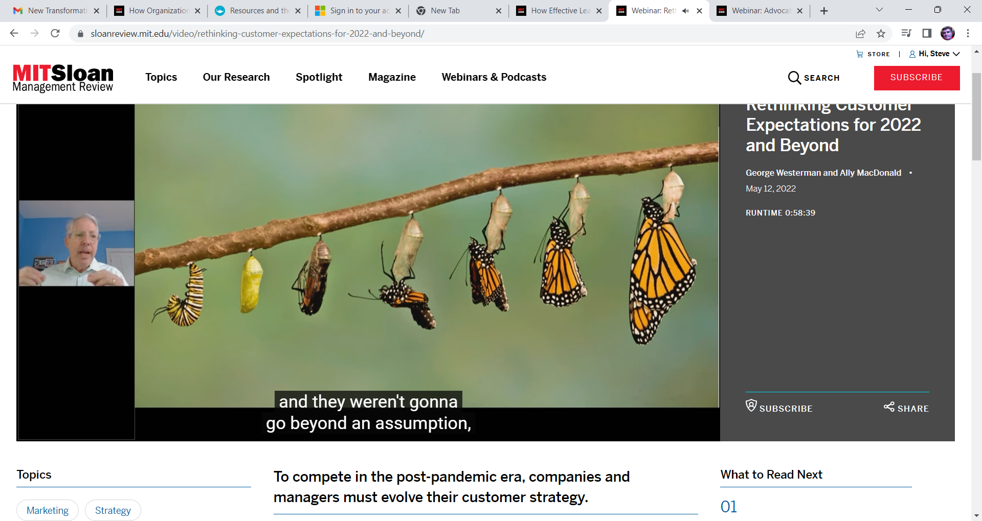


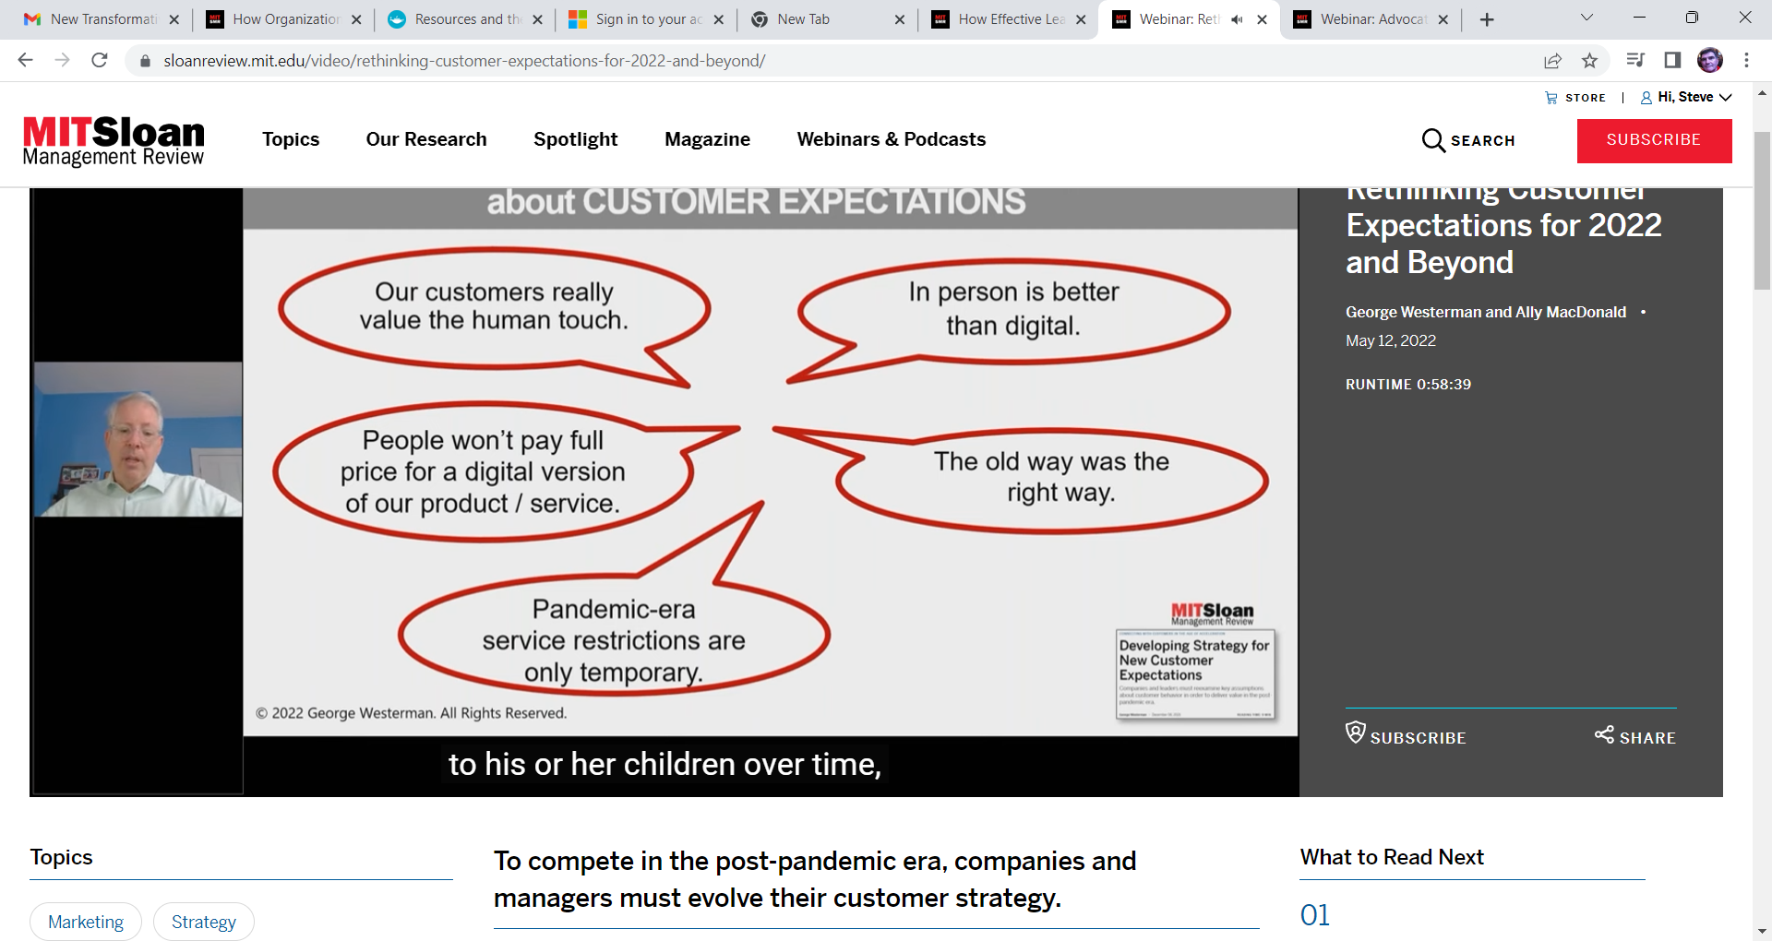
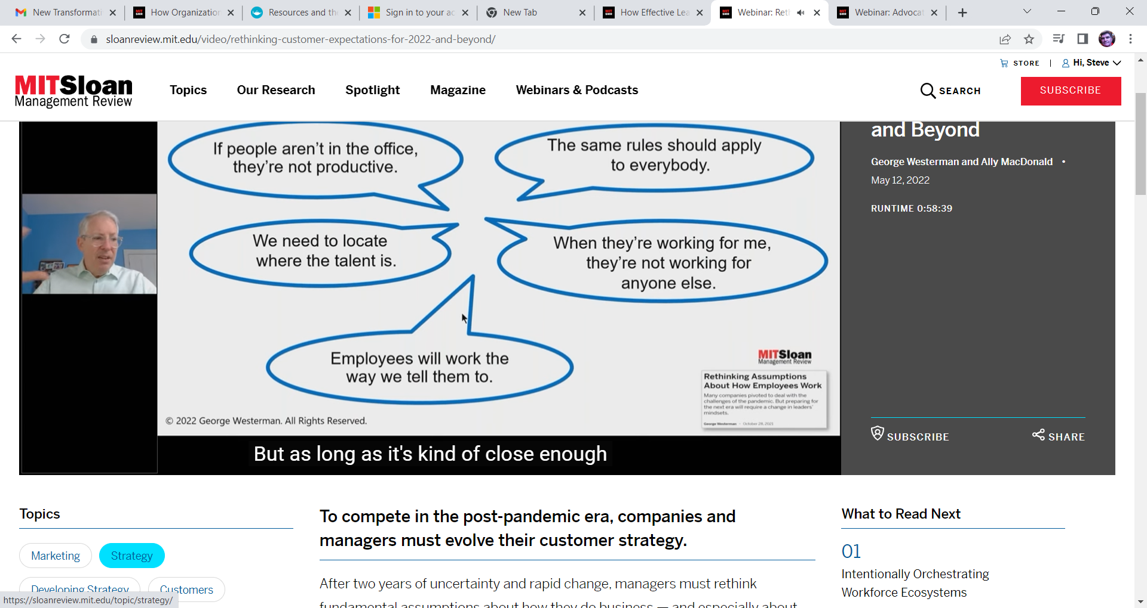
SG comment
Moore’s Law—technology doubles every 18-20 months…….where will we be? interesting poll of viewers on working digitally.
ABOUT THE AUTHORS
George Westerman (@gwesterman) is a senior lecturer with the MIT Sloan School of Management, principal research scientist for workforce learning in the MIT Jameel World Education Laboratory, and coauthor of the award-winning book Leading Digital: Turning Technology Into Business Transformation, published by Harvard Business Review Press. Ally MacDonald (@allymacdonald) is senior editor of MIT Sloan Management Review. She moderated the session.

https://sloanreview.mit.edu/video/bringing-customers-along-on-the-digital-journey/

Bringing Customers Along on the Digital Journey

Mohan Subramaniam and Elizabeth Heichler September 22, 2022

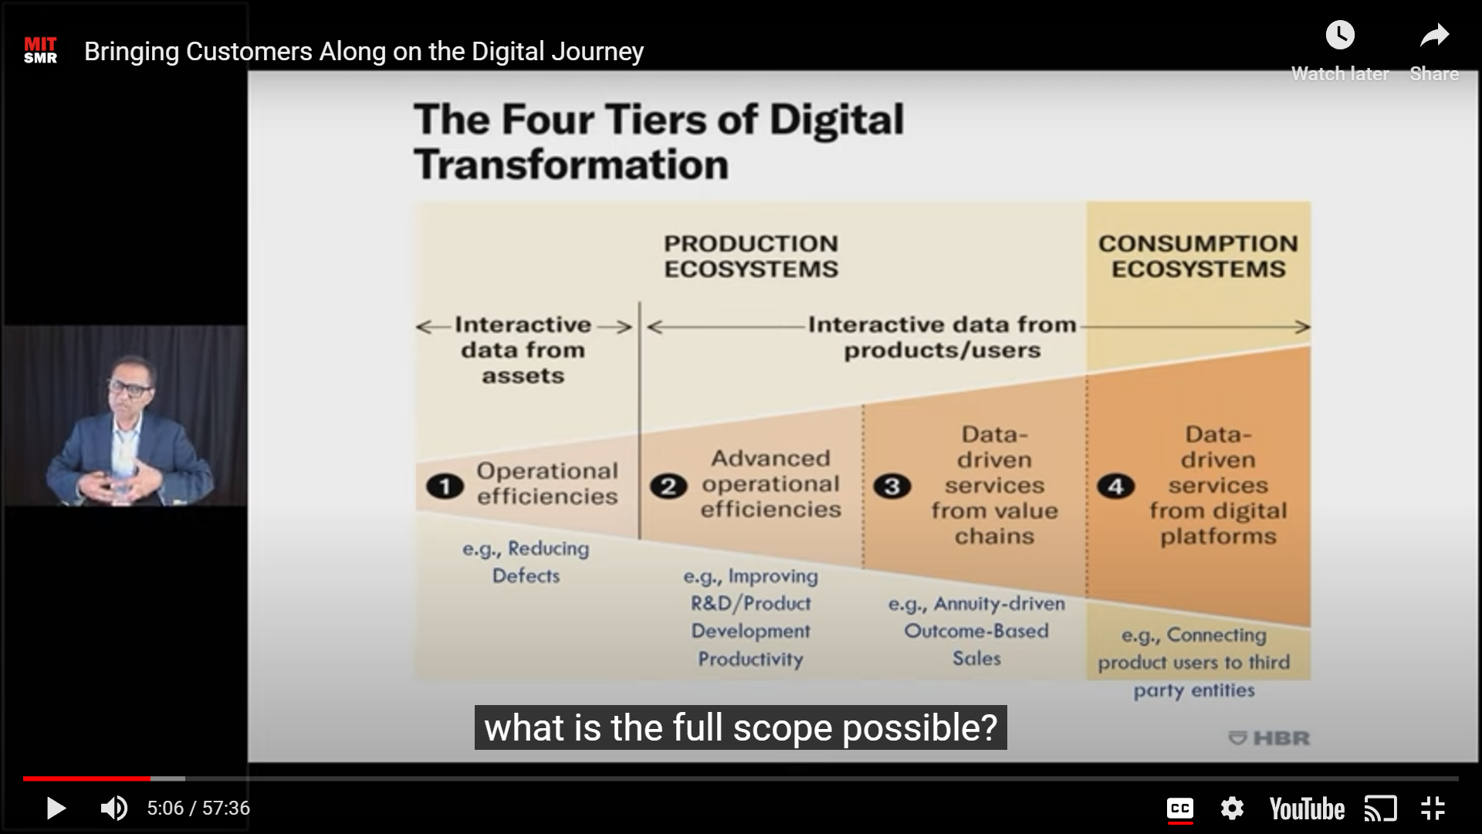

https://sloanreview.mit.edu/video/advocating-with-authenticity-brands-getting-it-right/

Advocating With Authenticity — Brands Getting It Right
Latia Curry and Elizabeth Heichler
January 08, 2021
Communicating a brand’s values to customers starts with internalizing them.
Today’s consumers expect more from brands. With more companies taking stances on political and social issues, it appears that sitting on the sidelines is no longer an option. But how can brands navigate the waters of brand advocacy in authentic ways that resonate with their customers?

Related Reading
L. Servodio and L. Curry, “Three Elements of Successful Corporate Social Justice Initiatives,” MIT Sloan Management Review, Dec. 1, 2020.

Please join Rally’s Latia Curry as she presents a “Brand Advocacy Map” to help guide companies through potentially fraught cultural and social terrain and to help brands “get it right” in their communications.
In this webinar, you’ll learn:
- The two most important levers for truly authentic brand advocacy.
- About case studies of brands doing advocacy across the spectrum — from missing the mark to successfully living their values.
- How to effectively measure advocacy success.

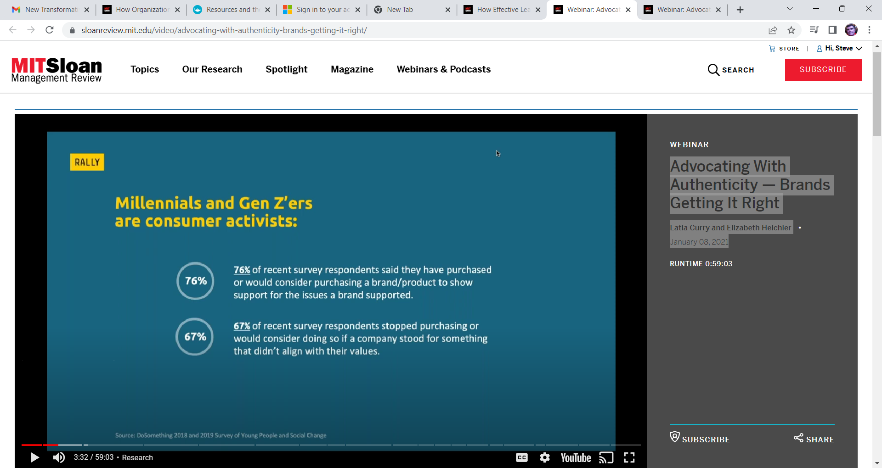
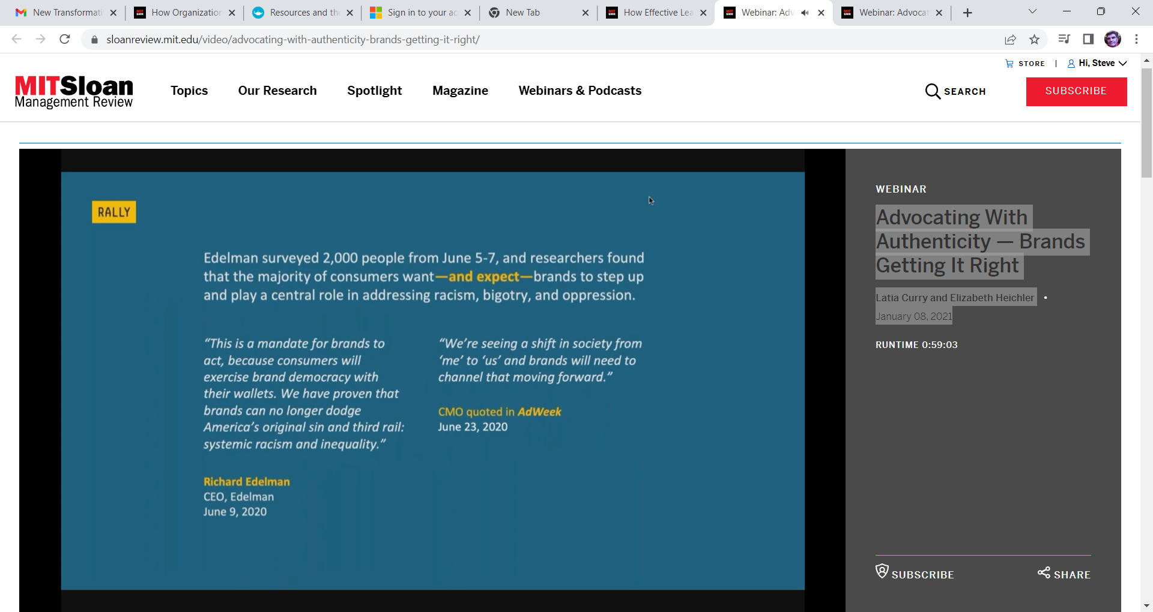

How Digital Transformation Disrupts Legacy Leaders
Michael Schrage, Benjamin Pring, and Allison Ryder
Future of Leadership in the Digital Economy
February 12, 2021
Hear the key findings from the MIT SMR-Cognizant 2021 Future of Leadership Global Executive Survey and Research Report.
Digitalization has won, but has leadership lost? Our research strongly suggests that ongoing digital transformation fundamentally challenges how leaders are seen, experienced, and understood by their workforce. Effective leadership must be better balanced with affective leadership that openly embraces greater purpose, transparency, and authenticity.

Related Reading
M. Schrage, B. Pring, D. Kiron, and D. Dickerson, “Leadership’s Digital Transformation: Leading Purposefully in an Era of Context Collapse,” MIT Sloan Management Review and Cognizant, January 2021.

Watch this webinar, which is based on the recent report, “Leadership’s Digital Transformation: Leading Purposefully in an Era of Context Collapse,” to learn:
- Leadership best practices from companies including Starbucks, Anheuser-Busch InBev, Best Buy, and Delta Air Lines.
- How leaders can — and should — credibly and authentically make purpose an organizing principle for engaging colleagues and associates. The speakers introduce an NPS-like metric as a simple, fast, and powerful conversation starter.
- How data-driven leaders can invest in greater self- and situational awareness using an “affective” digital dashboard.
- How leaders can visualize their networks, which offers powerful insight into leadership style and substance — not to mention a demonstrable reality check on DEI issues.
SG comment:
They take you through some of their recent reports…..saves you reading them??
Context collapse? References to history of technology disruption. Leading by example? Are you digitally ready?
Reversal leadership……technically adept team members mentoring their superiors???? Who are the leaders???
Sentiment- analysis………….????

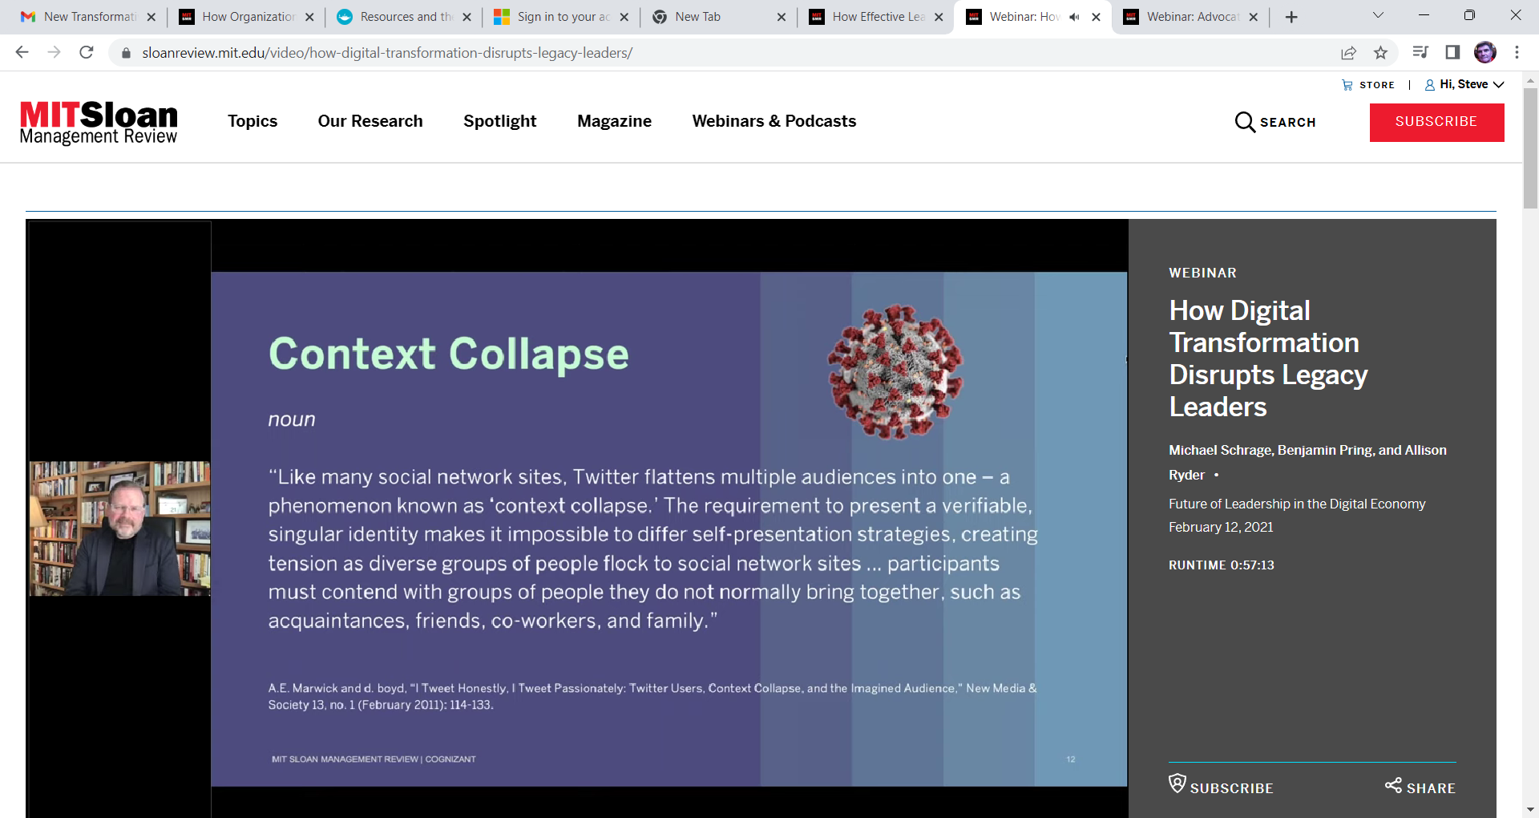
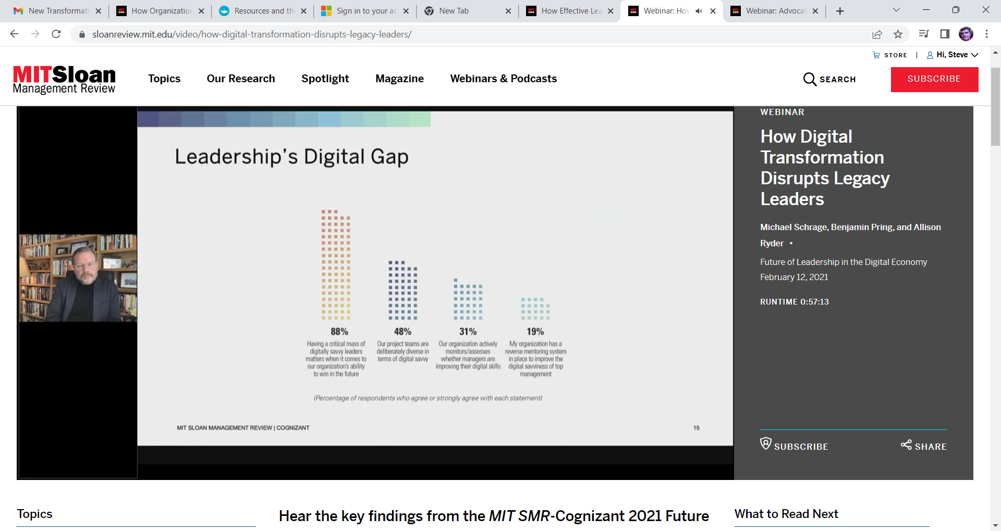

ABOUT THE AUTHORS
Michael Schrage is a research fellow at the MIT Sloan School of Management’s Initiative on the Digital Economy, where he does research and advisory work on how digital media transforms agency, human capital, and innovation. Benjamin Pring cofounded and leads Cognizant’s Center for the Future of Work. He is a coauthor of a number of bestselling and award-winning books on how new technologies are changing the future of work. Allison Ryder is the senior project editor of MIT Sloan Management Review. She moderated the session.

https://learn.nes.nhs.scot/60481
NHS digital leadership

Digital Health and Care
Supporting development of a digitally skilled workforce

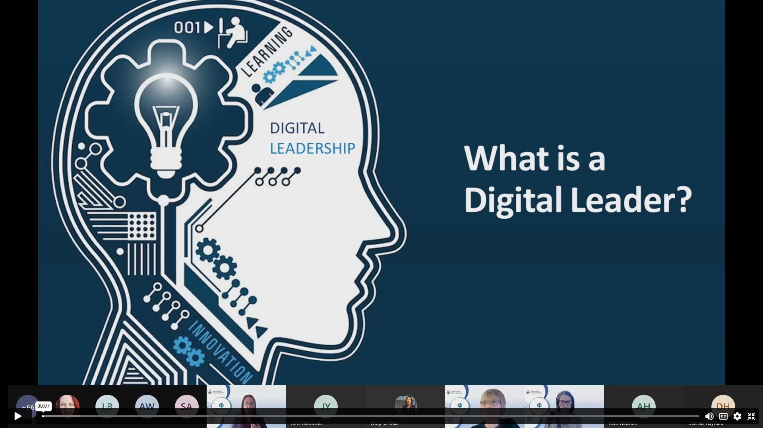

https://emeritus.org/blog/webinar-digital-transformation-and-leadership/



