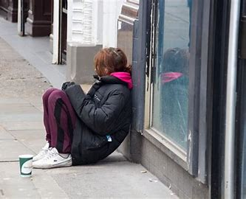

Community care and development

Youth homelessness
Kayleigh Burman | BMHP6002 | 13/12/2023

Contents page

- Introduction_____________________________________________________ 2
- youth homeless community______________________________________3&4
- The growth and development of homelessness and the projects involved ______________________________________________________________5&6
- Behavioral change within the homeless community in youths and challenges faced_________________________________________________7
- Homelessness background_______________________________________8&9
- The impact of homelessness on health ______________________________10
- The cultural effects and its interactions with wider society______________11
- challenges faced _____________________________________________12 &13
- Recommendations______________________________________________14
- Conclusion______________________________________________________15
- References__________________________________________________ 16 & 17

Introduction
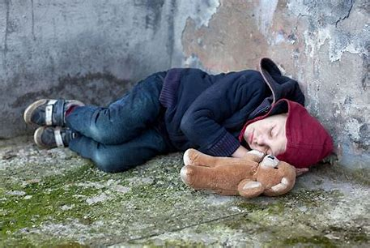

This paper will look at youth homelessness, what resources are available to help these people, how it has gotten worse over time, and its causes. It will go into the background of homeless individuals as well as occasions that have affected the development. It will assess the success and behavioral shift, highlighting obstacles and achievements. It will look at the number of homeless persons and their reasons. It will highlight the various approaches being taken to address this and the effects on young people's health. This report will look at areas in Wales.

Youth homelessness community

What is a community?
A community is made up of individuals who are connected by shared traits, interests, or life experiences. Geographical location, race, age, religion, or medical necessity are just a few of the characteristics that might characterize a community in relation to health, according to the definition that the National Institute for Health and Care Excellence established (Buck, Wenzel and Beech, 2018).
Youth homelessness
A person or family who lacks suitable, safe, or long-term housing is considered homeless. Contrary to popular belief, which holds that the term "homelessness" solely applies to those without a place of their own and who live on the streets, there are numerous ways to qualify as homeless, even if you do officially have a roof over your head. In the UK, there are apparently more than 270,000 homeless persons, many of them being children. However, given that many homeless persons go unreported and unaccounted for, these numbers may be drastically underestimating the actual prevalence of homelessness in the UK
(Murphy, 2022). Young people often experience homelessness because it’s safer to leave than to stay where they are – a choice no young person should have to make.
Homelessness sometimes means sleeping on the streets. However, many young homeless people are sleeping on floors or sofas, on night buses or in cars or sheds. This population is sometimes called the ‘hidden homeless. It can be less obvious than rough sleeping, but it’s just as risky and stressful for the young person experiencing it (Action for children,2023).

The growth and development of homelessness and the projects involved.
With support from the Welsh Government totaling £3.4 million, Housing Minister Julie James has unveiled 26 projects aimed at addressing youth homelessness. one of them, managed by Caer Las and Bridgend County Council, is more than £88,000 for a Youth Housing First project in Bridgend. More than £42,000 will be given to Dewis to help house young people in Neath, Caerphilly, and Torfaen who are vulnerable due to disability, care leavers, or past involvement in the juvenile justice system. With funds totaling over £84,000, Llamau will offer assisted housing for young people experiencing homelessness (Gov.Wales, 2019).

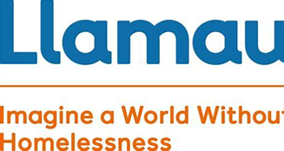

To make sure that no one must be homeless in Wales' second city under the current extraordinary circumstances, Pobl Group has joined forces with Swansea Council and its allies. The goal of this endeavor is to safeguard and provide for the homeless. They will be able to self-isolate if they become infected with the virus and will have access to medical care and other forms of support thanks to this effort (Pobl, 2020).


The Youth Homeless Early Intervention School service works with comprehensive schools, colleges, and youth clubs throughout Swansea to provide Personal and Social Education (PSE) lessons to educate young people on the realities of homelessness and living independently and to promote the services of the Youth Homeless Prevention Advisor and the Home Support and Mediation help available to ensure early intervention for young people facing accommodation issues (Barnados, 2023).



Behavioral change within the homeless community in youths and challenges faced.

Numerous factors, including family strife, child abuse, and neglect, can lead young people to become homeless. youth populations have unique requirements that call for customized solutions. To evaluate youth interventions' effects on social, health, and equitable outcomes, a comprehensive assessment of the literature on the subject is conducted (Wang et al., 2019).
Behavioral changes in young homeless people would be:
- Post traumatic stress syndrome.
- Depression
- Drug misuse
- psychiatric disorder
- poor physical health
- abuse
(Hodgson, Shelton and van den Bree, 2014)

HOMELESSNESS BACKGROUND

Since 2015–16, there has been a 21% increase in the number of households for which the Council is obligated to assist in finding housing after they were discovered to be homeless. 537 homes in 2015–16 increasing to 652 homes in 2017–18 (Neath Port Talbot Council, 2023).
Compared to the generally rising tendency seen in England, forms of "hidden" homelessness, such as concealed, cramped, and shared households, show a more varied pattern in Wales. With estimates of 119,000 concealed single-person homes, 10,000 concealed couples, and 10,000 lone parents in 2012, the number of disguised households in Wales remains relatively stable. In Wales, the number of sharing homes has increased in the past two years following a long-term fall. This indicator's fall and subsequent increase, albeit at a significantly lower level, have followed UK patterns. In Wales, there were roughly 16,000 shared houses in 2012. In Wales, almost 26,000 families were impacted by overcrowding in 2010 (The homelessness monitor, 2012).
It is, of course, a problem with Wales. The Welsh Government estimated that 51.9 persons out of 10,000 homes nationwide were homeless during the previous year. Homelessness is a much greater problem in Neath. The percentage of the population without a residence is significantly higher than the national average, with 88 persons per 10,000 households being classified as homeless. Neath Port Talbot has the highest rate of homelessness in Wales when accounting for the size and number of households within each local authority. With 86.3 persons per 10,000 households, Cardiff and Newport are right behind it and of that number, in Neath Port Talbot, there were 0.8 to 0 persons living in temporary housing for every 10,000 households as of March 2016 (Parry, 2017).
The "worst in decades" homelessness issue exists in Cardiff. The Office for National Statistics (ONS) reports that at least 11 homeless persons passed away in Wales in 2017. In Wales, the poorest districts have a homeless death rate that is more than three times higher than the least deprived places. Four of Wrexham's neighborhoods rank among the most impoverished in Wales, and the town was home to over half of all homeless deaths in the country in 2017 (BBC News, 2019).
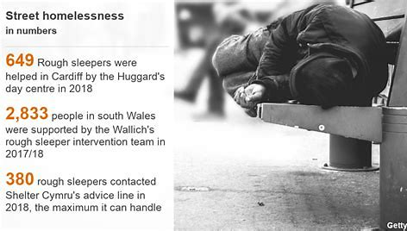

Households threatened to be homeless in 2015 to 2020.
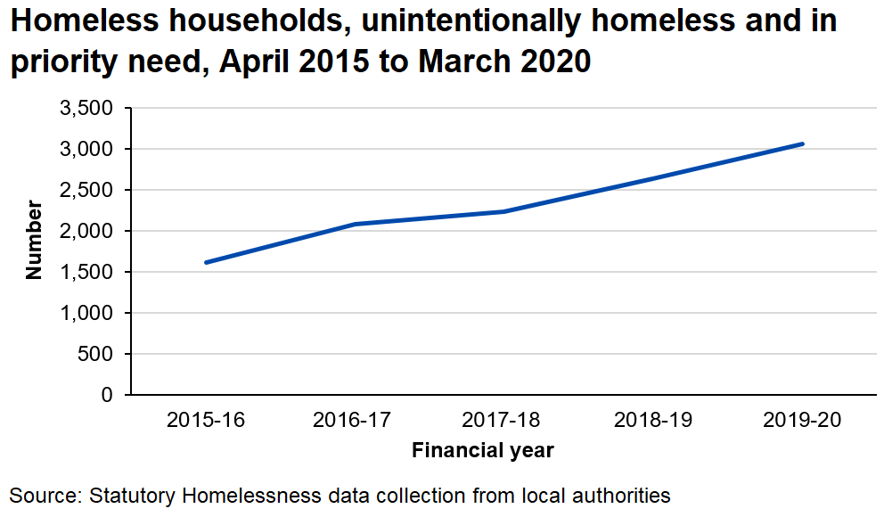
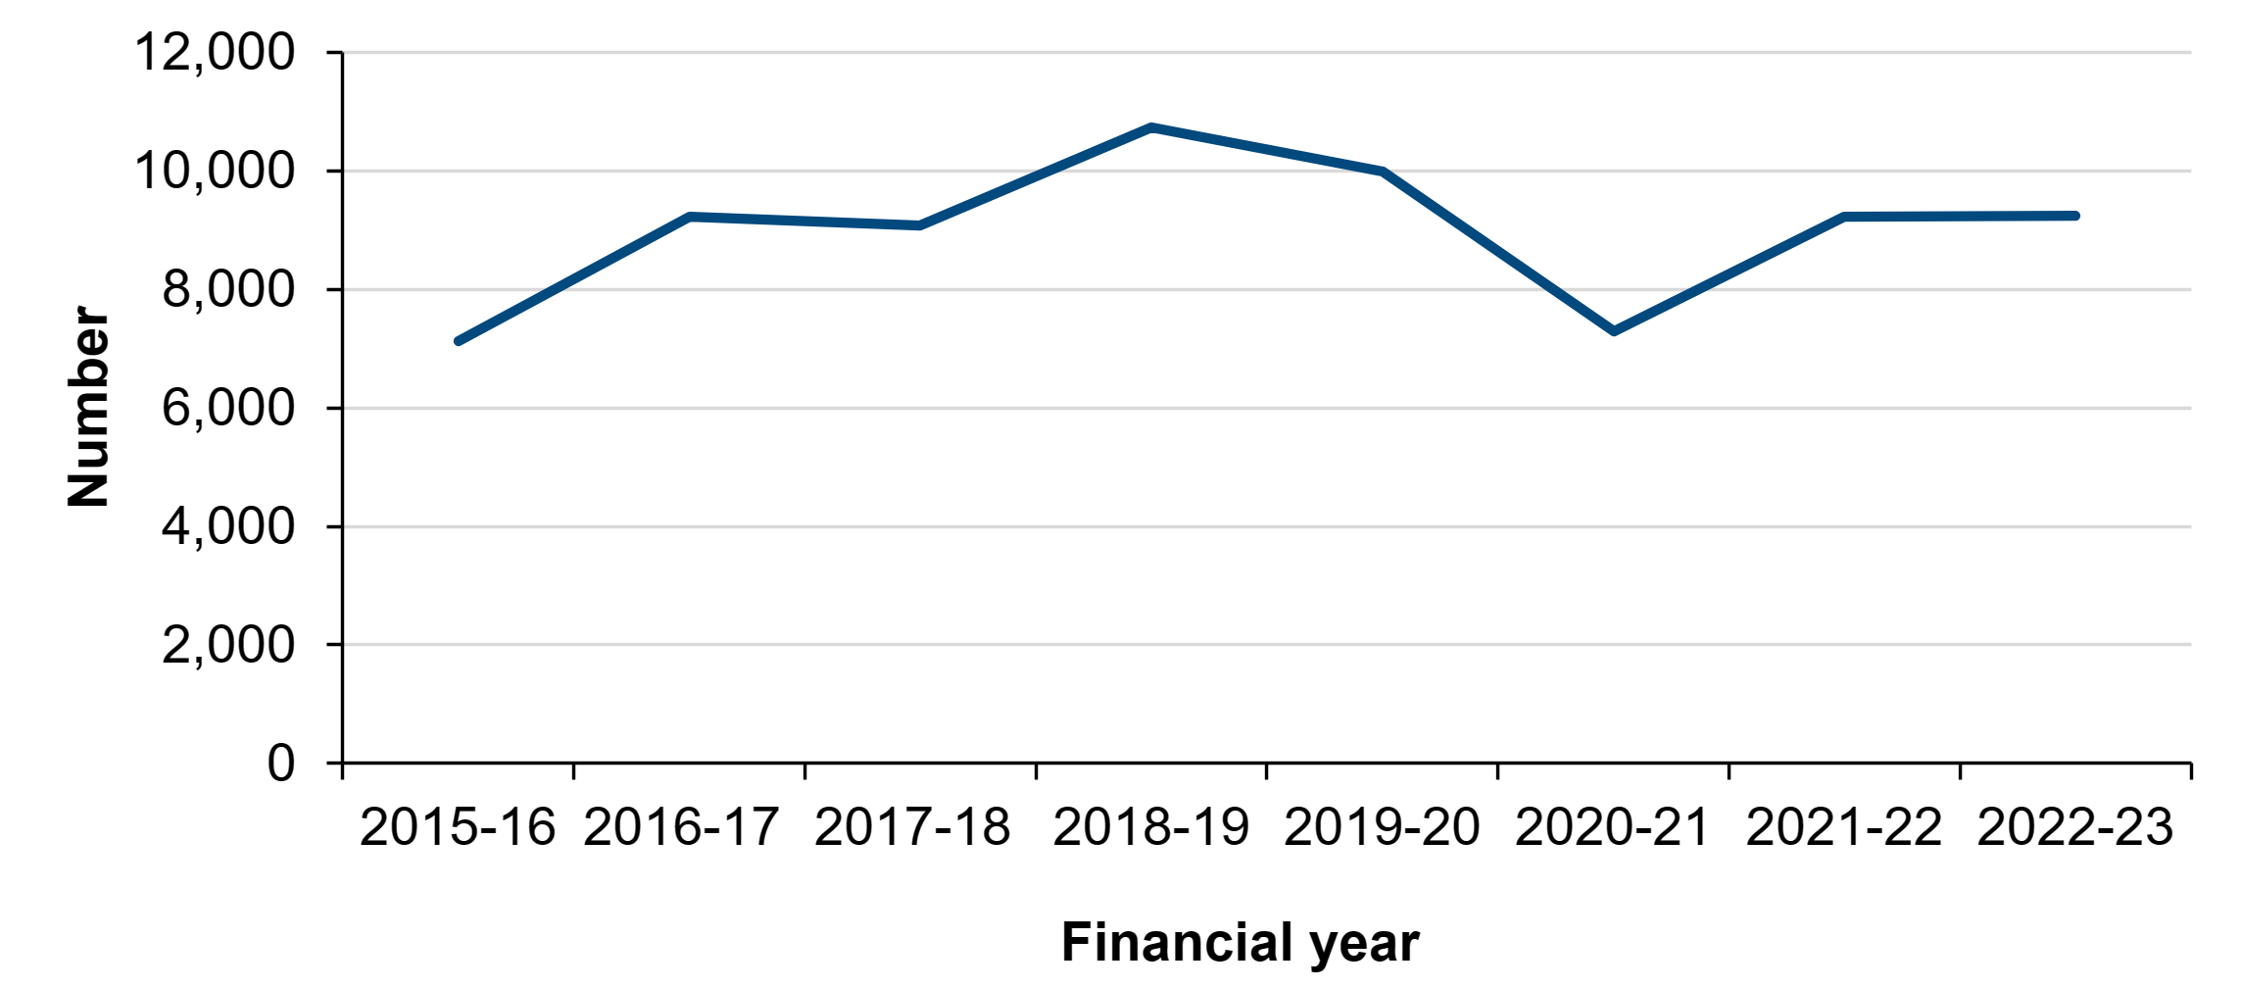

Households threatened to be homeless in 2015 to 2020 and households threatened with homelessness April 2-15 to March 2023 have shown significant increases. (Gov. Wales 2023).
The impact of homelessness on health.
The three social issues that Angelenos face most frequently are chemical dependency, unemployment, and homelessness.
Being homeless can result in loneliness as well as bad mental and physical health. Homelessness can also result in substance misuse and make it more difficult to get healthcare. Research indicates that homelessness is correlated with the complexity of an individual's difficulties and the difficulty of getting back on one's feet. Many times, homeless people have complicated medical issues. Men were 46 years old on average and women were 43 years old when they passed away. In the general population, this equates to 76 years for males and 81 years for women. A person can only access healthcare if they are enrolled with a general practitioner (Leng, 2017).
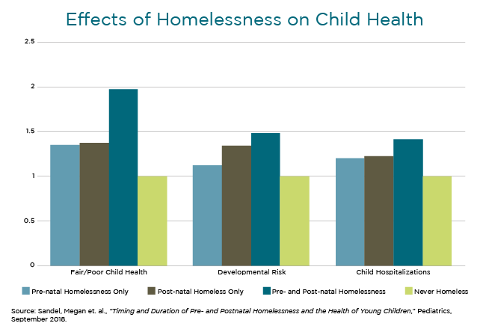(Synergy, 2023)
The cultural effects and its interactions with wider society.
Homelessness emotions are a result of social, cultural, and psychological issues, The factors that contribute to homelessness are multifaceted and frequently intersect. Structural factors including a lack of affordable housing, a weak economy, and a shortage of mental health services exacerbate social factors like addictions, family dissolution, and mental illness. Due to their dynamic relationships, these factors taken together have an impact on homelessness rates. The static nature of historic models has only partially succeeded in capturing these relationships (Mago et al., 2013).
Technology is a valuable tool that could enhance wellbeing and health. Because homeless people lack access to technology for communication or to learn about job openings, initiatives, or guidance, homeless people will have mental health issues and loneliness because of cultural influences and their interactions with the larger society. These people significantly affect others' lives since they are unable to communicate and do not receive support to get better (Rhoades et al., 2017).
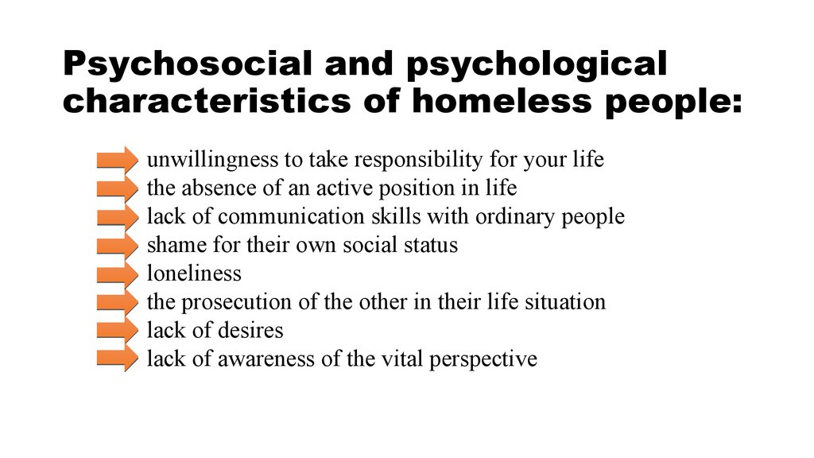

The community’s history and significant events that have impacted its development.
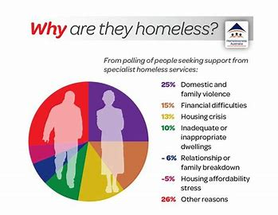
(Pinterest, 2023)

In Neath Port Talbot, the number of homeless persons has nearly tripled in the last 12 months.
The county had 203 homeless persons in 2017–18, up from 71 the year before, according to fresh data from the local government. Many variables are responsible for the significant growth.
Senior housing officer at Neath Port Talbot Council said that with the introduction of Universal Credit, registered social landlords like housing associations are becoming more selective about who they rent to, and the private rental market is contracting (Bradfield, 2018).
Housing has had an influence on homelessness across the board, which is pushing young people towards drug abuse. Thirty-seven percent of patients with opiate addiction who were beginning treatment did not own a home, the highest percentage of all four substance groups.
More than one in twelve (9%) new patients stated they were at risk of being homeless during the following eight weeks. The percentage of individuals with this risk who also had opiate addiction was 16%. Furthermore, only 5% of those with alcohol issues fit this description (Gov.uk, 2023).
One major effect of COVID-19 on homelessness was Since the beginning of the pandemic, there has been a constant influx of new homeless individuals into all three of these countries. Securing permanent and secure housing for individuals placed in emergency COVID-19 accommodation is a significant task for local authorities. The pandemic has made the structural obstacles that already existed worse, such as a shortage of available homes and a welfare system that ignores the root reasons of homelessness (Crisis, 2020).

Recommendations
- Resources for all young children to have a safe and stable place to live. This can be done through Safeguarding children and child protection (NSPCC, 2023)
- Better funding to tackle homelessness with the homeless prevention grants (GOV.UK, 2021).
- More projects coming together to help get them into work For those who are homeless and find it difficult to acquire the treatment and assistance they require, the NHS, local government, and other organizations must collaborate more closely (Iacobucci, 2022).

Conclusion
In general, the rate of youth homelessness has increased since the COVID-19 pandemic. This is regrettable, and finding figures is challenging because numbers fluctuate daily. Swansea has far more support than the communities near Port Talbot. The majority of homelessness is caused by housing associations or housing statuses; as a result, many children end up on the streets, experience behavioral changes, and choose the wrong path. All of this can be prevented with increased government support or initiatives that help these kids leave the streets. access to work-related grants.

References
Action for children (2023) What are the main causes of youth homelessness in the UK? Available at: https://www.actionforchildren.org.uk/blog/what-are-the-main-causes-of-youth-homelessness-in-the-uk/. Accessed on 14th December 2023
Barnardo’s. (2023). Barnardo’s Swansea Youth Homeless Prevention Service. [online] Available at: https://www.barnardos.org.uk/get-support/services/barnardos-swansea-youth-homeless-prevention-service#:~:text=The%20Youth%20Homeless%20Early%20Intervention%20School%20service%20works [Accessed 14 Dec. 2023].
BBC News (2019) Cardiff homelessness problem is the ‘worst in decades. (2019). BBC News. [online] 3 Mar. Available at: https://www.bbc.co.uk/news/uk-wales-47387720. Accessed on 14th December 2023
Bradfield, E. (2018). Homeless numbers triple in Neath Port Talbot in one year. [online] Wales Online. Available at: https://www.walesonline.co.uk/news/local-news/number-homeless-people-neath-port-14995444 [Accessed 14 Dec. 2023].
Buck, D., Wenzel, L. and Beech, J. (2018) Communities and health, The King’s Fund. The King’s Fund. Available at: https://www.kingsfund.org.uk/publications/communities-and-health.
Crisis (2020). The impact of COVID-19 on people facing homelessness and service provision across Great Britain (2020). [online] Crisis. Available at: https://www.crisis.org.uk/ending-homelessness/homelessness-knowledge-hub/services-and-interventions/the-impact-of-covid-19-on-people-facing-homelessness-and-service-provision-across-great-britain-2020/.
Fitzpatrick, S., Pawson, H., Bramely, G., Wilcox, S. & Watts, B. (2012) The Homelessness Monitor: Wales 2012. London: Crisis. Accessed on 15th December 2023.
Gov.uk (2023) Adult substance misuse treatment statistics 2022 to 2023: report. Accessed on 14th December 2023. Available at: https://www.gov.uk/government/statistics/substance-misuse-treatment-for-adults-statistics-2022-to-2023/adult-substance-misuse-treatment-statistics-2022-to-2023-report.
GOV.UK (2021). £316 million government funding boost to tackle homelessness. [online] GOV.UK. Available at: https://www.gov.uk/government/news/316-million-government-funding-boost-to-tackle-homelessness.accessed on 13th December 2023.
Iacobucci, G. (2022). Multi-agency approach is needed to improve services for homeless people, says NICE. BMJ, [online] 376, p.o706. doi:https://doi.org/10.1136/bmj.o706.accessed on 14th December 2023.
Leng, G. (2017). THE IMPACT OF HOMELESSNESS ON HEALTH A GUIDE FOR LOCAL AUTHORITIES. [online] Available at: https://www.local.gov.uk/sites/default/files/documents/22.7%20HEALTH%20AND%20HOMELESSNESS_v08_WEB_0.PDF.
Mago, V.K., Morden, H.K., Fritz, C., Wu, T., Namazi, S., Geranmayeh, P., Chattopadhyay, R. and Dabbaghian, V. (2013). Analyzing the impact of social factors on homelessness: a Fuzzy Cognitive Map approach. BMC Medical Informatics and Decision Making, [online] 13(1). doi:https://doi.org/10.1186/1472-6947-13-94.
Murphy, N. (2022). What is Homelessness? [online] CPD Online College. Available at: https://cpdonline.co.uk/knowledge-base/safeguarding/homelessness/.
Neath Port Talbot (2023) homelessness strategy 2018-2022. Accessed on 14th December 2023. Available at: https://www.npt.gov.uk/media/14919/neath-port-talbot-council-homelessness-strategy-2018-22.pdf?v=20210921151015.
NSPCC (2023). Safeguarding Children and Child Protection. [online] NSPCC Learning. Available at: https://learning.nspcc.org.uk/safeguarding-child-protection.accessed on 14th December 2023.
Parry, G. (2017). What life on the streets is like in Wales’ homeless capital. [online] Wales Online. Available at: https://www.walesonline.co.uk/news/local-news/life-streets-story-neaths-homeless-12739204 [Accessed 14 Dec. 2023].
Pobl (2020) Swansea project to ease the homelessness in the city. Accessed on 14th December 2023. Available at: https://www.poblgroup.co.uk/about-us/pobl-story/may-2020/swansea-project-to-help-ease-homelessness-is-city/.
Rhoades, H., Wenzel, S.L., Rice, E., Winetrobe, H. and Henwood, B. (2017). No digital divide? Technology use among homeless adults. Journal of Social Distress and the Homeless, 26(1), pp.73–77. doi:https://doi.org/10.1080/10530789.2017.1305140.
Wang, J.Z., Mott, S., Magwood, O., Mathew, C., Mclellan, A., Kpade, V., Gaba, P., Kozloff, N., Pottie, K. and Andermann, A. (2019). The impact of interventions for youth experiencing homelessness on housing, mental health, substance use, and family cohesion: a systematic review. BMC Public Health, [online] 19(1). doi:https://doi.org/10.1186/s12889-019-7856-0.
www.gov.wales. (2019). Projects to tackle youth homelessness announced by Julie James | GOV.WALES. [online] Available at: https://www.gov.wales/projects-tackle-youth-homelessness-announced-julie-james#:~:text=Housing%20Minister%20Julie%20James%20has%20announced%2026%20projects [Accessed 14 Dec. 2023].
www.gov.wales. (2023). Homelessness: April 2022 to March 2023 | GOV.WALES. [online] Available at: https://www.gov.wales/homelessness-april-2022-march-2023.

