

Programme: BA (Hons) Leadership and Management Skills for the Workplace
Module: Strategic Management for Business
Module code: LCLM 6001

Student ID: 2335151

Student Name: Cosmin Matei

Executive Summary
The report explores the scenario for Vodafone UK regarding its strategic transformation in maintaining its competitive advantage. A major connection remains connected through strategic partnerships in the process. The report highlighted the application of a new strategy, introduction of the 5G network and IoT platform to increase its product development. The strategic choice was identified from different Generic Strategies, Ansoff Matrix, SFA Matrix and Mendelow’s Matrix. The analysis showed the relevance of technological development while also improving the right approach towards gaining competitive advantage.
Table of contents
1. Introduction to Vodafone 3
1.1 Organisational overview 3
1.2 Purpose of the study 3
2. Evaluation of current market situation 4
2.1 SWOT Analysis 4
2.2 PESTEL Analysis 5
2.3 Porter’s Five Forces Analysis 8
3. Strategic Growth Options and Proposed Strategy 9
3.1 Potential strategic growth paths 9
3.2 Porter’s Generic Strategies (Alignment with Vodafone’s values) 10
3.3 Ansoff Matrix (Alignment with Vodafone’s values) 11
4. Strategy evaluation 12
4.1 Evaluation of the strategy 12
4.2 SFA 12
5. Stakeholder Analysis 13
5.1 Impact on the stakeholders 13
5.2 Stakeholder Engagement Plan (Mendelow’s Matrix) 13
6. Implementation and monitoring 14
6.1 Objectives 14
6.2 Action Plan 15
6.3 Key Performance Indicators 15
7. Conclusion 16
References 17

1. Introduction to Vodafone

1.1 Organisational overview
The organisational vision of Vodafone is to enrich the requirements of customers by integrating mobile communication processes with representation of Unique power (Vodafone, 2026). This reflects the significance of Vodafone to high-speed and accessible network service with the improvements in mobile communication among users. The mission of Vodafone includes the development of connections among users every day by providing high-speed network services (Vodafone, 2025a). This indicated the opportunity to pioneer digital, shared value, and influence sustainable growth in the context of mobile communication with better connectivity. The core value of Vodafone includes the enrichment of the passion of customers and employees, and represents high performance through technology-driven communication with flexibility and efficiency (Vodafone, 2026). Moreover, Vodafone focuses on providing rewards for enhancing personal accountability and empowering employee involvement by taking action-oriented decisions in the global market. Vodafone operates high-quality services for 27 million customers across Europe and Africa with the accessibility of a 5G network (Rudolph, 2025; Vodafone, 2025b) (Refer to Figure 1). This indicates significant growth and development of Vodafone with the opportunity to enhance operational efficiency, portfolio optimisation, and customer experiences.

Figure 1: Vodafone
(Source: Rudolph, 2025)

1.2 Purpose of the study
The aim of this study is to build concepts of the strategic management process based on an analysis of the case study of Vodafone. This study focuses on developing strategic implications of strategy through identifying opportunities and threats in the existing markets for Vodafone.

2. Evaluation of current market situation

2.1 SWOT Analysis
SWOT Analysis includes the strategic framework to determine the opportunities and threats in the business management, with the consideration of strengths and weaknesses (Namugenyi, Nimmagadda and Reiners, 2019). This section focuses on the analysis of the current internal environments of Vodafone using SWOT Analysis as a strategic framework.
Strengths | Weaknesses
- Stable market position with the involvement of large-scale customers and access to £32.34 billion (Elagina, 2025) (Refer to Figure 2).  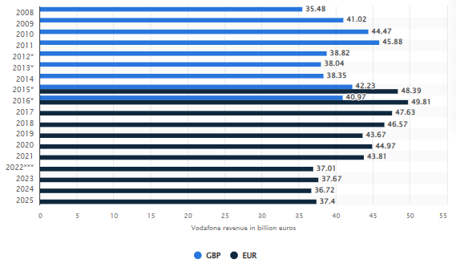  Figure 2: Revenue of Vodafone  (Source: Elagina, 2025)  - The £11 billion investment plan for the 5G network enhances the efficiency of the network exception by Vodafone (Rudolph, 2025)  - The integrated network service of Vodafone boosts the £102 billion UK economy (Vodafone, 2025c)  - The annual cost synergies of £700 million by Vodafone, increasing overall operational efficiency and overall profitability (Joshua, 2025) | - Organisational restructure by Vodafone impacts the overall performance of resistance among employees toward change and closed 650 stores (Sweney, 2025)  - Increasing competition in the markets of mobile communication impacts the overall performance of Vodafone (Pratley, 2024)  - The operational risk impacts the implementation of business by Vodafone for collaboration with the merger (Alex, 2025)
Opportunities | Threats
- Financial stability indicated the growth opportunity of business for Vodafone through technology innovation, including IoT and AI, to reach customers' demand  - The improvements of network service with investment in 5G connection indicate the opportunity of engaging customers' investments, with the opportunity to build a position in the competitive markets | - High-level competition creates complexity in building stability in the testing markets, with a focus on sustainability  - Closing of strores enacts the possibility of reducing market size with a reduction of customers' investments and overall performance
Table 1: SWOT Analysis
The above table reflects the possibility of an effective network expansion opportunity for Vodafone for investing in 5G network, cost synergies and integrating digital communication service. However, high-level competition and operational capacity may reduce the business growth for Vodafone.

2.2 PESTEL Analysis
The PESTLE framework remains crucial in determining the external elements to make the right decisions in the process (Thakur, 2021).
Political: According to the British Chambers of Commerce (2025), it has remained crucial in driving innovation and sustainability through a long-term connectivity strategy. Local councils and politicians are also integrated closely in the development of an advanced telecom environment for the advancement of 5G technology (Department for Science, Innovation and Technology, 2026). These key initiatives from the government reveal current opportunities for further expansion of telecom businesses.

Figure 2: UK Government’s digital handshake approach
(Source: Department for Science, Innovation and Technology, 2026)

Economic: The 3.2% inflation rate (refer to Figure 3) in November 2025 highlighted a critical Consumer Price Index, citing major consequences for consumption rate among the UK consumers (ONS, 2025). Current inflationary measures are critical as per exchange fluctuation rates and international transactions.
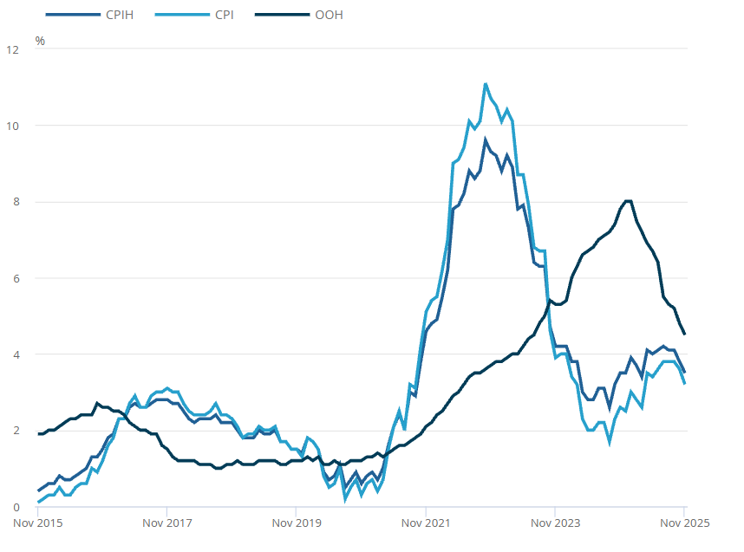
Figure 3: Consumer price inflation in the UK over the years
(Source: ONS, 2025)
Social: A massive rise in 4G and 5G demands among the UK customers has been noted, which underlines the significance of customer satisfaction as only 47% of the consumers are satisfied with current services while only 44% of them find the current services value for the money paid (Ofcom, 2026). Therefore, this highlights both challenges and opportunity in increasing the current service delivery.
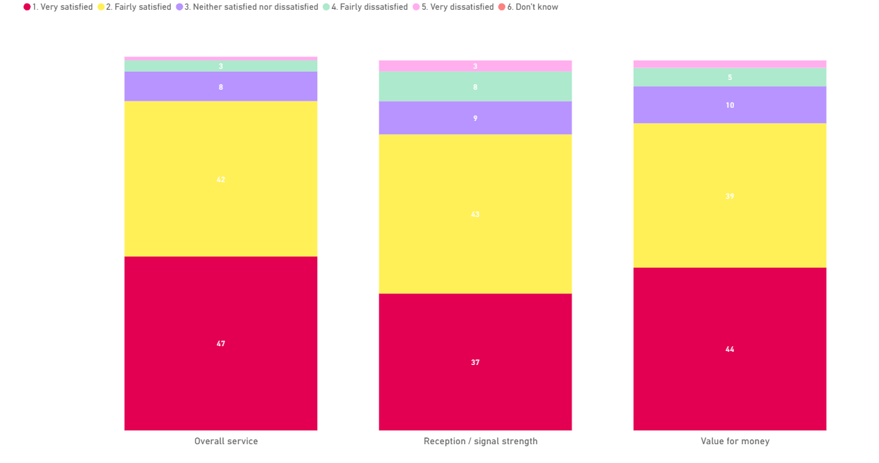
Figure 4: Customer satisfaction and value for money perceptions
(Source: Ofcom, 2026)
Technological: The UK government’s current infrastructural development plan, through investment, has remained critical for the overall opportunity perception.
Legal: Complying within the boundaries of the Data Regulation Protection Act 2018 and privacy concerns through telecom advancements have been critical. This can also be treated as a challenge for Vodafone in maintaining strict domestic adherence.
Environmental: Sustainability strategy and green business initiatives are expected from the customers and regulators, which must be incorporated deeply into the strategic digital transformation of the telecom industry.

2.3 Porter’s Five Forces Analysis
Porter’s Five Forces Analysis includes the strategic frameworks to determine the level of competition in the growing markets with the consideration of the power of competitors, suppliers and customers (Pangarkar and Prabhudesai, 2024). This section emphasises the analysis of the level of competition using Porter’s Five Forces framework.
Factors | Descriptions | Intensity
Threats from new entrants | - Required investments in the mobile communication business are £6.6 billion in the UK, concerning technology innovation for better connectivity (Comms Business, 2026). This indicates the requirements of high investments with financial risks for new entrants | Low
Threats from Substitute | - The application of SAP technologies by Deutsche Telekom AG helps to save £0.86 million focusing on the reduction of price in the acquisition of network service (SAP, 2025). This indicates the possibility of cost switching among customers | High
Bargaining power of customers | - The increasing Mobile data consumption with high-speed accessibility reflects the changed behaviours among customers (Government of UK, 2026). This indicates the requirements of innovation and technology advancements to reach switching tendency among customers | Moderate
Bargaining Power of Suppliers | - Contracts with suppliers help build business loyalty for operating mobile networks successfully (Majithia, 2025). This reflects the minimal possibility of price and quality-related negotiation | Low
Competitive Rivalry | - Existing competitors, including Deutsche Telekom AG, AT&T Inc, KDDI Corp and Telefonica SA, create competitive environments (Global Data, 2025) | High
Table 3: Porter’s Five Forces Analysis
The above analysis depicts the increasing level of competition for Vodafone from editing companies, including Deutsche Telekom AG, AT&T Inc, KDDI Corp., and Telefonica SA, with a cost-switching tendency among customers. However, the threat from new entrants and suppliers is very low due to the possibility of financial risks. The changed behaviours among customers reflect a moderate range of competitive challenges for Vodafone.

3. Strategic Growth Options and Proposed Strategy

3.1 Potential strategic growth paths
Undergoing strategic transformation in the organisation highlighted the Vodafone-Three Merger in 2025 and the investment for network expansion (Vodafone Group PLC, 2026). However, aligning a strategic path for the overall technical growth would be determined from diversification of the services. The foremost approach can be found in diversification, which can lead to the introduction of new products or services in different fields (Nguyen-Thi-Huong et al. 2023).
Another major approach to be aligned with Vodafone’s strategic path will be to identify possible entry in different markets. This perception can also be connected to the attraction of new customers who are not already in the target market of the business (Oluwaseun et al. 2024). An expansion in the market with local and international development would be very significant for Vodafone, which can be aligned with its growth strategy through the Vodafone-Three merger (Vodafone Group PLC, 2026). An expansion of the 5G network would determine the significance of the performance in the international market.

3.2 Porter’s Generic Strategies (Alignment with Vodafone’s values)
The Generic Strategies refer to the competitive alignment of the key features, which can include the elements of position and competitive advantage in the process.
The primary focus for Cost Leadership would be minimising costs in every aspect of business activities while continuing the business functions in the target market (Ali and Anwar, 2021). The significance of the Differentiation strategy can be identified based on the unique qualities that can be reciprocated based on the competitiveness and internal capabilities (Harri et al. 2025). The primary emphasis through the Focus strategic approach will be developed on the basis of specific market or target focus. The development of the 5G technology in the UK would be more suitable through the diversification strategy, which will require high research and development and technological investments.

Cost leadership | Diversification | Focus
- | Vodafone will differentiate itself from the rivals by providing an advanced 5G Network empowered by Internet of Things. This will diversify the internet speed, functionality and connectivity throughout the nation. | -
Table 1: Porter’s Generic Strategy

In achieving this strategic choice, Vodafone would be focused on corporate growth delivered through the introduction of new products or a service. In the contemporary instance, working on the 5G technology would be a varied service, as the significance of strategic movement with IoT will be highly competitive. As compared to the focus strategy, which will drive focus on both cost or presentation. On the other hand, the significance of cost leadership will also be ineffective due to high-cost implications during R&D of the 5G technology.

3.3 Ansoff Matrix (Alignment with Vodafone’s values)
The Product/ Market Expansion Grid to be developed for the enterprise remains connected to Ansoff Matrix. Peterdy (2022) highlights the significance of four distinct elements: market penetration, product development, market development and diversification to determine the attractiveness of the growth strategies for existing services and products.

Market penetration | Market development | Product development | Diversification
A deeper connection with the market is developed through the development of marketing initiatives, change in pricing tactics and also finding a different market (Peterdy, 2022). | This choice refers to the functional approach of meeting corporate success through existing products, however in a different market. | This will be oriented towards the development and enhancement of the current products and services (Peterdy, 2022). | The necessity of developing a smart move in the market would denote the differentiation approach, which indicates a massive growth opportunity through the integration of IoT and 5G technology.

Based on the above identification, it is known that the significance of the Diversification strategy would make a strongest impact on the product performance for Vodafone. While being less risky in the process, market development will increase the significance of maintaining an incremental shelf space in the market. Through a market development approach, Vodafone’s values of innovation, creativity and performance can be found in the domestic or international expansion. The focus on the market through the product development strategy might also remain less effective as it suggests that certain areas of product valuation for Vodafone might be reduced. Thus, focusing on the development of the 5G technology with primary emphasis on the competitiveness of the brand will be effectively driven through the diversification approach.

4. Strategy evaluation

4.1 Evaluation of the strategy
Moving on to growth options, market developments and service diversification approach is possible by investing in 5G infrastructure, the Internet of Things (IoT), smart city solutions and enterprise digital services. The improvement of digital services indicates the significant growth of business and influences revenue growth. In this context, the service diversification will enable the company to benefit from using the synergies resulting from the combination of both Vodafone's and Three's networks. As a result, the opportunity to invest £16.5 billion in a merger may lead to building a positive and strategic position and the largest operation by Vodafone (Rudolph, 2025). This endorses the opportunity to deliver strong and high-speed communication to UK customers in the upcoming days, overcoming competitive rivalry. Moreover, the service diversification by using IoT and 5G infrastructures indicates the possibility of becoming a leading network provider with the implementation of mobile communication processes and broadband connections as well. Moreover, the significant transformation of services with a diversification approach induces the possibility to develop a dynamic infrastructure in Vodafone by influencing network accessibility at a low price. For instance, the cost reduction process leads to influencing the growth of organic revenue of Vodafone from £9.51 billion to £9.77 billion, focusing on organisational growth by effective user improvements (Rudolph, 2025). This innovation indicates the opportunity to boost the overall performance and competitiveness of Vodafone by overcoming possible issues such as changed behaviours, high-level competition and financial risks. In this regard, the development of technology infrastructure with diversification of services and cost leadership reflects the opportunity for strategic growth of business for Vodafone.

4.2 SFA
SFA includes the systematic process to determine strategic options by measuring the suitability, acceptability and feasibility (Zolfani et al., 2022). The use of the SAF model is going to determine the strategic option for the implication of the overall performance of Vodafone.
Suitability: Vodafone can enhance the digital connectivity by effective contribution of the three mergers, focusing on improving network service, concerning product diversification. In these aspects, the combination of Three's networks of mergers with the network service of Vodafone may contribute to enforcing stable expansion, focusing on reaching the vision of becoming market leaders. In this regard, the communication by internet connection with Three's networks by Vodafone enables the opportunity to enhance digital connectivity using IoT and AI.
Acceptability: The enhancement of speed in the internet connection can ensure customer satisfaction with the enhancements of revenue, focusing on financial growth concerning product diversification. This may contribute to overcoming contemporary challenges in business with the enhancements of users' movements, focusing on long-term financial growth for Vodafone and customers with greater accessibility to strategic solutions.
Feasibility: Offering financial resources and technology capability through mergers indicates the significant growth of the business concerning product diversification. This may contribute to gaining the return on investment of up to £700 million by Vodafone through representing high-speed digital connectivity with the compensation of three mergers.

5. Stakeholder Analysis

5.1 Impact on the stakeholders
Stakeholder Theory assumes that organisations are expected to generate value for all stakeholders that are impacted by their decisions (Freeman, Dmytriyev and Phillips 2021). Vodafone Three's strategy has an impact on various stakeholder groups through providing a high-quality internet connection and meeting the requirements of customers. In this aspect, key stakeholders of Vodafone can benefit due to increasing financial growth and review to enhance user involvement in gesture accessible digital communication services. Users will be able to enjoy the expanded network area, high-speed 5G network connections and enhanced digital services. Technological innovations might have human resource development opportunities for employees. Moreover, partners and shareholders of Vodafone may benefit from the integrated technology solution due to enhanced share value and financial growth. As networks grow, business opportunities may be greater for suppliers and technology partners and increased rivalry for competitors. In addition, Government agencies and local communities benefit from the integrated Infrastructure, the contribution of Vodafone in Job creation and the inclusion of everyone in society through digital inclusion, focusing on the remarkable economic development. Thus, the strategic implication of mobile communication and digital connection may benefit customers, suppliers, government agencies, partners, employees and the local community, aligning with stakeholder theory.

5.2 Stakeholder Engagement Plan (Mendelow’s Matrix)
Stakeholders | Impacts | Power | Interests | Engagements plan
Shareholders | Approvals and financial input for strategic implementation | High | High | Face-to-face meeting
Partners | High-speed network and technology solution | High | High | Business Contracts
Suppliers | Technology solution | Low | High | Contractual documentation
Customers | Purchasing the Newark service of Vodafone and providing feedback and suggestions | Low | High | Social media communication
Employees | Active improvements in technology integration based on the allocated task | Low | Low | Face-to-Face meeting and video conference
Governments agency | Legal support | High | Low | Sharing documents
Local community | Support for infrastructure developments | High | Low | Social media communication
Table 4: Stakeholder analysis
 |  | Level of Interest
 |  | High | Low
Level of Power | High | Key Players | Keep Satisfied
Level of Power | High | Shareholders, Partners | Suppliers, Customers
Level of Power | Low | Keep Informed | Minimal Effort
Level of Power | Low | Government agency, Local community | Employees
Table 5: Mendelow’s Matrix
The effective involvement of partners, suppliers and shareholders may help to increase the accessibility of technology solutions with the reduction of financial crisis for long-term improvements. Governments' support and involvement of the local community in digital infrastructure influence the opportunity for network expansion of Vodafone.

6. Implementation and monitoring

6.1 Objectives
The objective for the advancement of business growth and perception through 5G technology and IoT will be as follows:
- To deploy and introduce the advanced 5G technology through IoT solutions across the UK by 2027 while achieving 95% consumer adoption and increasing IoT connections by 30%.

6.2 Action Plan
Action | Activities | Timeline | Responsibility
Expand 5G infrastructure | To invest in network towers and spectrum utilisation. | 2026-2027 | Network operations team
Develop IoT partnerships | To collaborate with different manufacturers and local authorities. | 2026-2027 | Business development team
Enhance network security | To work more on AI-driven cybersecurity systems. | Ongoing | IT and cybersecurity team
Develop workforce capabilities | To provide training and information in 5G and AI. | 2026 | Human resources team
Table 5: Action plan

6.3 Key Performance Indicators
Vodafone will seek performance indicators for various other domains and departments:
Network Performance:
- Achieve 95% in the UK population coverage by 2027.
- Increase mobile data speed by 40%.
IoT growth:
- Increase enterprise IoT connections by 30%.
- Launch at least 10 new IoT-enabled business solutions by 2028.
- Secure more than 20 strategic partnerships

Financial KPI:
- Generate 20% increase in revenue 5G connections only.
- Achieve target contribution towards £700 million annual merger synergies.

7. Conclusion
The analysis of the current market situation from the internal and external environment has determined an extensive connection with the strategic drivers for the business. Vodafone would determine the significance of the strategic choice in extending 5G technology by considering its partnership with Three. It was found from the strategic evaluation and growth options through different models that Vodafone would require a differential approach to make the right changes. The impact on stakeholders is also considered to be positive in making the right changes, as the influence of perceptions and considerations would make an immense impact on the choices.

References
Alex, R. R. (2025) Vodafone finalises merger with Three UK, to invest £11 billion over next 10 years, mint. Available at: https://www.livemint.com/companies/vodafone-finalises-merger-with-three-uk-to-invest-11-billion-over-next-10-years-11748850239390.html (Accessed: 16 June 2026).
Ali, B.J. and Anwar, G. (2021) ‘Porter’s Generic Competitive Strategies and its influence on the Competitive Advantage’. International Journal of Advanced Engineering, Management and Science, 7(6), pp.42-51.
British Chambers of Commerce (2025) Digital Revolution: Building the UK’s Digital Infrastructure. Available at: https://www.britishchambers.org.uk/wp-content/uploads/2025/11/BCC_BRO9800_DIGITAL_INFRASTRUCTURE_FINAL_DIGITAL.pdf (Accessed: 12 June 2026)
Comms Business (2026) Improved mobile connectivity could add £6.6 billion to UK economy. Available at: https://www.commsbusiness.co.uk/content/news/improved-mobile-connectivity-could-add-66-billion-to-uk-economy (Accessed: 15 June 2026).
Elagina, D. (2025) Revenue of Vodafone Group 2025| Statista, Statista. Available at: https://www.statista.com/statistics/241610/revenue-of-vodafone-since-2008/?srsltid=AfmBOooDPPpIw-bDKcX45n5iBM-KgiW0XRIsgoh6htu0JyMvNeo5q56t (Accessed: 16 June 2026).
Freeman, R.E., Dmytriyev, S.D. and Phillips, R.A., (2021) ‘Stakeholder theory and the resource-based view of the firm’, Journal of management, 47(7), pp.1757-1770.
Global Data (2025) ShieldSquare Captcha, www.globaldata.com. Available at: https://www.globaldata.com/company-profile/vodafone-group-plc/competitors/ (Accessed: 16 June 2026).
Government of UK (2026) Mobile Market Review: call for evidence, GOV.UK. Available at: https://www.gov.uk/government/calls-for-evidence/mobile-market-review/mobile-market-review-call-for-evidence (Accessed: 16 June 2026).
Harri, M., Maulana, M.K. and Dwiputri, R.M. (2025) ‘Differentiation Strategy: An Easy Way to Make Your Business Stand Out in the Market’, ISRG Journal of Economics, Business & Management, 3(5) pp.178-181.
Joshua (2025) Vodafone Reports FY25 Results: Strategic Overhaul and UK Merger Drive Growth Amid Challenges | Joshua Thompson, Joshua Thompson. Available at: https://joshthompson.co.uk/investing/vodafone-fy25-results-strategic-overhaul-uk-merger-growth/ (Accessed: 16 June 2026).
Majithia, K. (2025) VodafoneThree hands Ericsson, Nokia £2B UK contracts, Mobile World Live. Available at: https://www.mobileworldlive.com/ranvendors/vodafonethree-hands-ericsson-nokia-2b-uk-contracts/ (Accessed: 16 June 2026).
Namugenyi, C., Nimmagadda, S.L. and Reiners, T., (2019) ‘Design of a SWOT analysis model and its evaluation in diverse digital business ecosystem contexts’, Procedia Computer Science, 159, pp.1145-1154.
Nguyen-Thi-Huong, L., Van Nguyen, D. and Xuan Tran, L., (2023) ‘Diversification, government support, and firm performance’. Cogent Business & Management, 10(2), p.2215072.
Ofcom (2026) Communications Market Report 2025: Interactive Data. Available at: https://www.ofcom.org.uk/phones-and-broadband/service-quality/communications-market-report-2025-interactive-data (Accessed: 12 June 2026)
Oluwaseun, O.A., Oladele, K.J., Stephen, O., Oluwakemi, O., Oluwafunmilayo, A.O.A., Esitse, D.A. and Izegbuwa, T.N., (2024) ‘The Role of market development strategy on the performance of manufacturing small and medium enterprise owners in southwest Nigeria’. International Journal of Innovative Research in Science Studies, 7(2), pp.663-673.
ONS (2025) Consumer price inflation, UK: November 2025. Available at: https://www.ons.gov.uk/economy/inflationandpriceindices/bulletins/consumerpriceinflation/november2025 (Accessed: 12 June 2026)
Pangarkar, N. and Prabhudesai, R., (2024) ‘Using Porter's Five Forces analysis to drive strategy.’, Global Business and Organizational Excellence, 43(5), pp.24-34.
Pratley, N. (2024) Competition regulator’s backing for Vodafone-Three merger is a fair call, the Guardian. The Guardian. Available at: https://www.theguardian.com/business/nils-pratley-on-finance/2024/nov/05/competition-regulators-backing-for-vodafone-three-merger-is-a-fair-call (Accessed: 15 June 2026).
Rudolph, A. (2025) Vodafone-Three merger: what next after the creation of the UK’s largest mobile operator?, IG. Available at: https://www.ig.com/en/news-and-trade-ideas/vodafone-three-merger--what-next-after-the-creation-of-the-uk-s--250611 (Accessed: 16 June 2026).
SAP (2025) Deutsche Telekom AG – SAP Innovation Awards 2025, SAP. Available at: https://www.sap.com/documents/2025/03/3c9a5017-fc7e-0010-bca6-c68f7e60039b.html (Accessed: 14 June 2026).
Sweney, M. (2025) Newly formed VodafoneThree vows to create thousands of jobs, the Guardian. The Guardian. Available at: https://www.theguardian.com/business/2025/jun/12/newly-formed-vodafonethree-vows-to-create-thousands-of-jobs (Accessed: 15 June 2026).
Thakur, V. (2021) ‘Framework for PESTEL dimensions of sustainable healthcare waste management: Learnings from COVID-19 outbreak’. Journal of cleaner production, 287, p.125562.
Vodafone (2025a) Our mission, Vodafone. Available at: https://www.vodafone.com/our-company/our-mission (Accessed: 15 June 2026).
Vodafone (2025b) Our strategic priorities, Vodafone. Available at: https://www.vodafone.com/our-company/our-strategic-priorities (Accessed: 14 June 2026).
Vodafone (2025c) Welcome To Zscaler Directory Authentication, Vodafone.co.uk. Available at: https://www.vodafone.co.uk/newscentre/press-release/multibillion-pound-investment-deals-signed-to-build-uk-best-network/(Accessed: 16 June 2026).
Vodafone (2026) Mission & Vision | Vodafone PNG, Vodafone - PNG. Available at: https://vodafone.com.pg/about/about-us/vodafone-png/mission-vision (Accessed: 16 June 2026).
Vodafone Group PLC (2026) Vodafone to take full ownership of Vodafone Three. Available at: https://www.vodafone.com/news/newsroom/corporate-and-financial/vodafone-to-take-full-ownership-of-vodafone-three (Accessed: 13 June 2026)
Zolfani, S.H., Bazrafshan, R., Ecer, F. and Karamaşa, Ç., (2022) ‘The suitability-feasibility-acceptability strategy integrated with Bayesian BWM-MARCOS methods to determine the optimal lithium battery plant located in South America’, Mathematics, 10(14), p.2401.

