Component 2: Written Assignment Report
A Critical Evaluation of SDG 3 and SDG 13
Health, Wellbeing and Climate Action

Student Name: | Somia Kausar
Student ID: | 2239088
Module Name: | Health, Wellbeing and Sustainable Development
Module Code: | BMHP6030

Table of Contents
1. Introduction 3
2. Section 1 – SDG 3: Good Health and Wellbeing 4
2.1 Overview of SDG 3 4
2.2 Global policies 4
2.3 UK national policies 4
2.4 Local policies 5
2.5 Critical evaluation 5
2.6 Recommendations 6
3. Section 2 – SDG 13: Climate Action 7
3.1 Overview of SDG 13 7
3.2 Global policies 7
3.3 UK national policies 7
3.4 Local policies 8
3.5 Critical evaluation 8
3.6 Recommendations 9
4. Conclusion 10
5. References 11

1. Introduction
In 2015, the United Nations 2030 Agenda was introduced with a universal set of 17 Sustainable Development Goals (SDGs) to achieve three goals: eradicate poverty, protect the planet and promote wellbeing (United Nations, 2015). This report focuses on SDG 3, Good Health and Wellbeing, and SDG 13, Climate Action. The two goals are closely linked, with climate change affecting basic conditions which influence health: clean air, safe shelter, food security, water, heat protection and robust health services.
The purpose of the report is to critically assess evidence that has been gathered from international organisations, UK policy and Walsall on how global, national and local initiatives support SDG 3 and SDG 13. The report first looks at SDG 3 through the lens of climate-health risks and the Health Belief Model. It then analyses SDG 13 in terms of the Triple Bottom Line model and then makes recommendations. The main take-away is that health and climate action go hand-in-hand, but climate policies should be fair, and vulnerable communities should not be the ones paying for them.
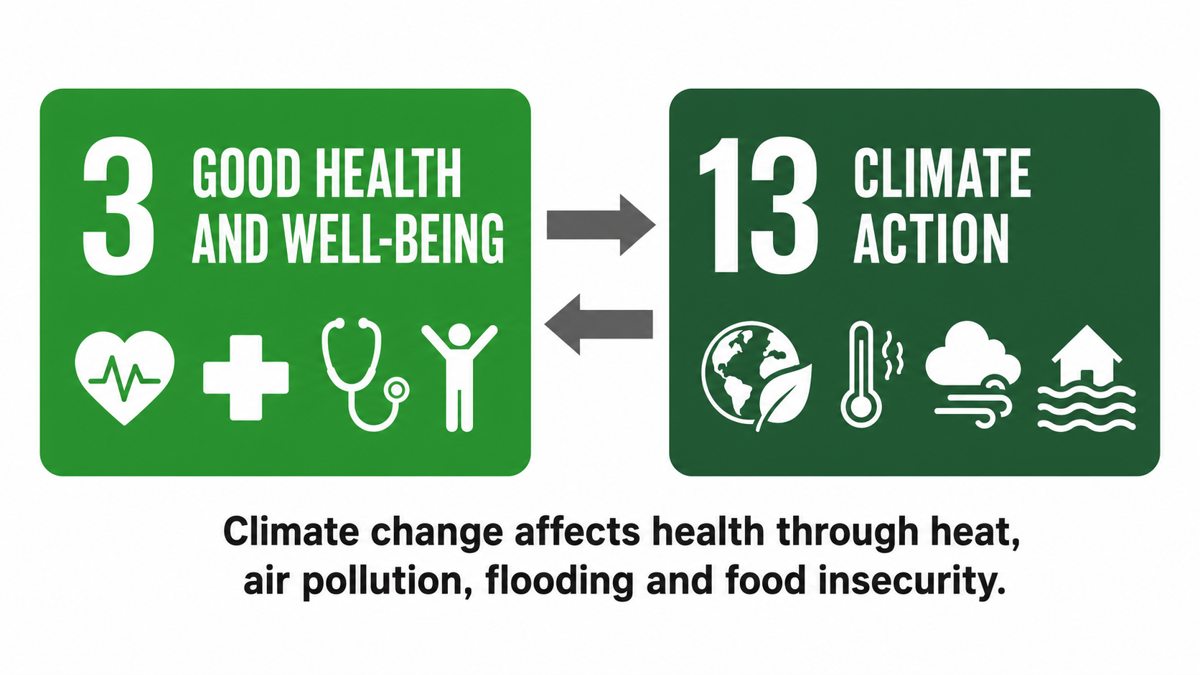
Figure 1: Link between SDG 3 and SDG 13
Source: Adapted from UN DESA (n.d.a; n.d.b).

2. Section 1 - SDG 3: Good Health and Wellbeing

2.1 Overview of SDG 3
SDG 3 is seeking to ensure healthy lives and promote wellbeing for all at all ages. This report views it from a climate-health perspective and not solely as access to hospitals. It aims at decreasing death rates, addressing NCDs, mental health, UHC and capacity to deal with health risks (UN DESA, n.d.a), among other goals. These targets are not easy to achieve in the face of climate change, as heat, air pollution, cold homes, flooding and food insecurity can lead to illness before people reach the NHS (World Health Organization, 2023a; UK Health Security Agency, 2024). Thus, SDG 3 should also contain a question about the readiness of health systems to environmental risks.

2.2 Global policies
Climate-resilient health systems are increasingly associated with SDG 3 at the global level. WHO’s operational guidance for climate-resilient and low-carbon health systems links health protection and surveillance, emergency preparedness, water and sanitation, energy use and workforce planning (World Health Organization, 2023b). This goes beyond limited clinical care. But across low-income countries, resilience is generally expected to be constructed on top of debt burden, lack of staff and unequal access to basic services. If these climate-health commitments are not backed by finance and technology, they can be just good words and not action.
However, it remains crucial that, even if a health system can respond to a heatwave, flood or disease outbreak, a person has the means to access health services in the first place. WHO’s UHC evidence reveals that billions of people still fail to access necessary services or afford them (World Health Organization, 2025a). Also, the SDG 3 issue is not limited to the number of clinics available, but whether services are resilient during climate shocks.

2.3 UK national policies
SDG 3 has a strong base in England as most care is delivered free at the point of delivery in the NHS. The 10 Year Health Plan’s emphasis on neighbourhood care, prevention and digital change can help work on climate and health by maintaining people’s health before a crisis occurs (Department of Health and Social Care, 2025). By improving community care, pressure on hospitals during heatwaves can be reduced, and illness caused by air pollution may be reduced in the long term. The challenge is that these aspirations remain reliant on funding, social care and workforce capacity.
National health policy must also become more environmentally conscious. The UKHSA Health Effects of Climate Change report indicates that heat, flooding, air quality and infectious disease risks will place additional strain on health and care systems (UK Health Security Agency, 2024). The Adverse Weather and Health Plan is helpful because it focuses on protecting communities from extreme weather (UK Health Security Agency, 2023). But if people live in overheated flats, cold housing or areas with poor transport, the advice is limited.

2.4 Local policies
In Walsall, SDG 3 is also shaped by environmental conditions. Prevention, children and young people’s wellbeing and mental wellbeing are all given importance in the Joint Local Health and Wellbeing Strategy (Walsall Health and Wellbeing Board, 2022). Local health work for climate-health should not only emphasise the promotion of healthy lifestyles, but also lower exposure to poor air, cold and damp housing, unsafe routes and limited green spaces. The public health and environmental role of Walsall Council is relevant to respiratory illness, cardiovascular stress and mental wellbeing, as these are linked to air quality and housing conditions (Walsall Council, 2025a).
The local connection to SDG 13 is thus functional and not ornamental. Warm homes, active travel, cleaner air and green space can all contribute to SDG 3 by helping to prevent illness before it becomes a health issue. It is important to note, however, that these improvements must be provided by local councils while operating under budget constraints. It can make health and climate strategies appear “joined up”, but residents may still continue to experience poor transport, fuel poverty or lack of green space. This matters because deprivation can make environmental health risks harder to avoid (Walsall Intelligence, 2025).

2.5 Critical evaluation
The Health Belief Model can be applied to climate-related health behaviour, such as following heat-health alerts, using air quality information or making use of local prevention services. The model focuses on perceived susceptibility, severity, benefits, barriers, cues to action and self-efficacy (Rosenstock, 1974). It is useful because when there is a perceived risk and trust in the message, people are more likely to take action. One of its drawbacks is that it can still become too focused on individual choice. If the flat gets too hot, it is not always possible to stay out of the heat, and if local routes are not safe for active travel, then walking or cycling is not a real option. This keeps the SDG 3 argument related to environmental conditions rather than service uptake only.
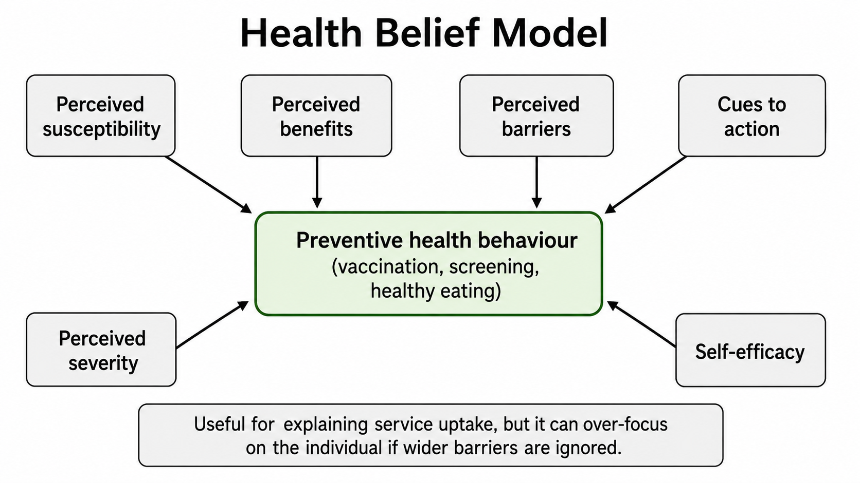
Figure 2: Health Belief Model and preventive health behaviour
Source: Adapted from Rosenstock (1974).

2.6 Recommendations
The response to SDG 3 policy should include climate risk, rather than leaving it to environmental teams as an additional concern. Health and care services need to identify who is at risk from heat, flooding, poor air quality and cold homes, and connect this to prevention issues. Local plans should make priority the provision of warm homes, shaded open spaces, cleaner ways to school, and early warnings and support for older people and people with long-term conditions.
The Health Equity Assessment Tool could be used to ensure that the groups most likely to benefit from prevention and climate-related health interventions are those most affected (Office for Health Improvement and Disparities, 2024). Funding should also be determined by health vulnerability, rather than population size only. This would make SDG 3 more clearly related to SDG 13, since minimising exposure to climate risks would become part of preventing illness.

3. Section 2 - SDG 13: Climate Action

3.1 Overview of SDG 13
In response to fighting climate change and its effects, SDG 13 calls for urgent action (UN DESA, n.d.b). It is closely connected to SDG 3 since climate change is now a health problem, as well as an environmental problem. According to WHO, selected climate-related factors could cause an additional 250,000 deaths each year between 2030 and 2050 (World Health Organization, 2023a). This shows that climate change is directly connected to health outcomes and pressure on health systems.

3.2 Global policies
The Paris Agreement is the main international climate change agreement, whose objective is to keep global warming below 2°C, and aim for 1.5°C (UNFCCC, 2015). It is good to have a common trajectory globally, but the weakness is that national commitments do not always match the level of risk. IPCC also indicates that risk grows with each extra degree of warming and that the most vulnerable populations will be the most exposed to these risks (IPCC, 2023). This then poses an ethical question: countries and communities with the lowest responsibility for emissions will be hardest hit in terms of health.

3.3 UK national policies
The UK is legally bound to achieve Net Zero by 2050 and the net zero programme of NHS England is directly linked to climate action and sustainability in the health service (NHS England, 2020). This is good, as the NHS is impacted by climate change and is also a major emitter. The use of greener procurement, greener states and greener travel to work will help to reduce emissions and enhance air quality. However, when maintenance backlogs, staffing pressures and rising demands are all present, NHS decarbonisation is a challenge.
The UKHSA Health Effects of Climate Change report indicates that the effects of heat, flooding, air quality and infectious diseases will impact health and care systems in the UK (UK Health Security Agency, 2024). Although national policy is moving in the right direction, adaptation is not always as clear as mitigation. Climate action is not just a carbon target – it is a health equity agenda. This is also seen in broader issues of slow progress in adaptation (Climate Change Committee, 2025).

3.4 Local policies
Walsall Council’s Net Zero 2041 Strategy is intended to support the borough to become cleaner, greener and healthier, with the benefits of the transition for all (Walsall Council, 2025b). This is relevant to SDG 3 since improved public transport, warmer accommodation, green jobs and green spaces can contribute to good health and wellbeing. But the term “just transition” needs to be put into practice. Climate policy may exacerbate health inequality if it increases costs to low-income households, or if the benefits of green jobs and transport improvements do not reach deprived areas.
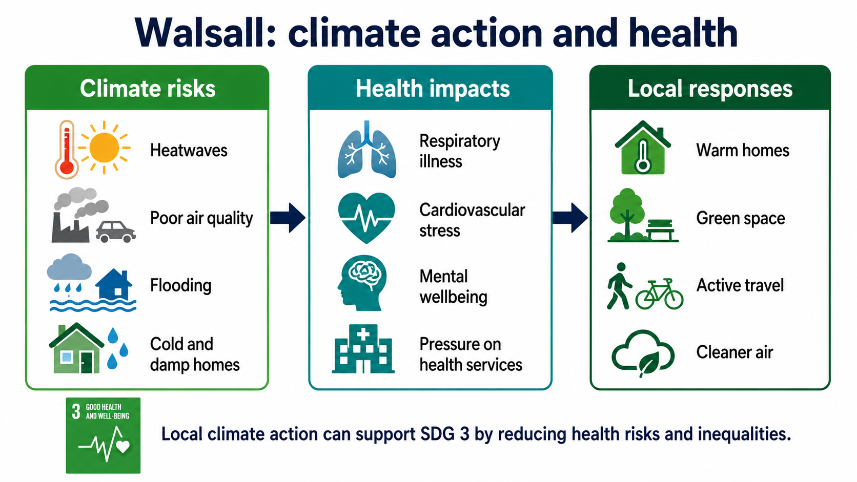
Figure 3: Local link between climate action and health in Walsall
Source: Adapted from Walsall Council (2025b) and Walsall Health and Wellbeing Board (2022).

3.5 Critical evaluation
The Triple Bottom Line (TBL) model can be used to assess SDG 13 as it involves people together with planet and prosperity (Elkington, 1997). It is good because it shows that climate action should not be solely focused on emissions, but health and livelihoods as well. It does have a problem in that it makes the three pillars look equal when, in reality, they are not always treated equally. Economic interests can be put first and health equity put afterwards. Any critical SDG 13 approach should therefore ask who benefits, who pays, and whether vulnerable groups are protected.
For instance, reducing emissions from transport can have a positive effect on air quality, but this will only be fair if there are affordable alternatives; otherwise, poorer drivers could be penalised. Therefore, the model is much stronger if coupled with a public health perspective. In the context of climate action, the reduction of asthma risks, vulnerability to heat, fuel poverty and social isolation is as important as carbon reduction. This will keep SDG 13 close to SDG 3 and not viewed as an environmental objective.
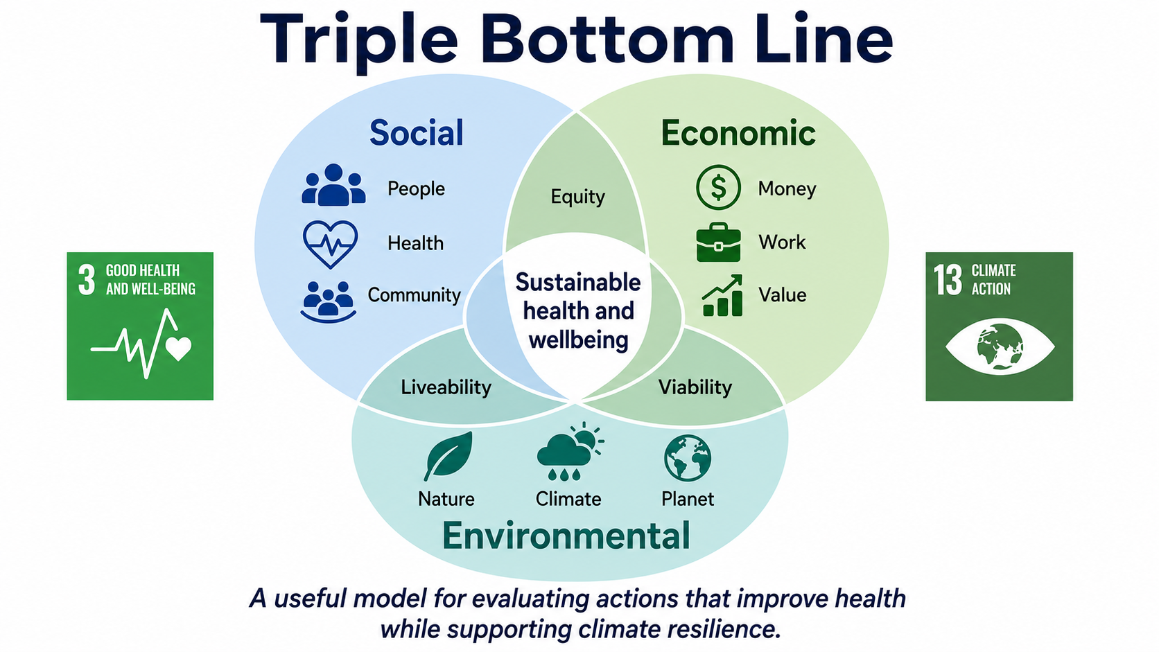
Figure 4: Triple Bottom Line model
Source: Adapted from Elkington (1997).

3.6 Recommendations
Policy review should be done before implementation to assess the health impact and inequality impact of SDG 13 policy. Local climate plans should target deprived areas, particularly heatwave planning, clean air, green space, affordable mobility and homes that are warm in winter and safe in heat. There is a need to ensure that prevention is part of the climate change response through NHS and council strategies.
Funding should be tailored to the needs of the area, with those areas that have less capacity to respond to climate risks receiving extra support. Progress should also be reported transparently, meaning citizens should be made aware of the health benefits of climate action, alongside carbon savings.

4. Conclusion
There is ongoing reinforcement between SDG 3 and SDG 13. Health programmes may provide benefits in the areas of survival, access and prevention, but climate change can pose risks to these gains through heat, poor air quality, flooding, food insecurity and service pressures. Health services and local governments can join in climate action through prevention, by making their estates sustainable and resilient, and by encouraging active travel and resilient communities.
The evidence from global policy, the NHS and Walsall shows that linking health and climate is possible, but it is not always consistent. The critical approach should not only deal with technical problems but also ask whether policies close health gaps. The best approach is to be integrated and to consider climate action as public health action. This involves linking UHC, prevention and community health to just climate adaptation and decarbonisation. If SDG 3 and SDG 13 are not connected, they risk becoming parallel pledges instead of a joined approach to sustainable health and wellbeing.

5. References
Climate Change Committee (2025) Progress in adapting to climate change: 2025 report to Parliament. Available at: https://www.theccc.org.uk/ (Accessed: 2 July 2026).
Department of Health and Social Care (2025) 10 Year Health Plan for England: fit for the future. Available at: https://www.gov.uk/government/publications/10-year-health-plan-for-england-fit-for-the-future (Accessed: 2 July 2026).
Elkington, J. (1997) Cannibals with forks: the triple bottom line of 21st century business. Oxford: Capstone.
Intergovernmental Panel on Climate Change (2023) Climate change 2023: synthesis report. Available at: https://www.ipcc.ch/report/ar6/syr/ (Accessed: 2 July 2026).
NHS England (2020) Delivering a net zero National Health Service. Available at: https://www.england.nhs.uk/greenernhs/publication/delivering-a-net-zero-national-health-service/ (Accessed: 2 July 2026).
Office for Health Improvement and Disparities (2024) Health Equity Assessment Tool (HEAT). Available at: https://www.gov.uk/government/publications/health-equity-assessment-tool-heat (Accessed: 2 July 2026).
Rosenstock, I.M. (1974) ‘Historical origins of the Health Belief Model’, Health Education Monographs, 2(4), pp. 328–335.
UN DESA (n.d.a) Goal 3: Ensure healthy lives and promote well-being for all at all ages. Available at: https://sdgs.un.org/goals/goal3 (Accessed: 2 July 2026).
UN DESA (n.d.b) Goal 13: Take urgent action to combat climate change and its impacts. Available at: https://sdgs.un.org/goals/goal13 (Accessed: 2 July 2026).
UNFCCC (2015) The Paris Agreement. Available at: https://unfccc.int/process-and-meetings/the-paris-agreement (Accessed: 2 July 2026).
United Nations (2015) Transforming our world: the 2030 Agenda for Sustainable Development. Available at: https://sdgs.un.org/2030agenda (Accessed: 2 July 2026).
UK Health Security Agency (2023) Adverse Weather and Health Plan. Available at: https://www.gov.uk/government/publications/adverse-weather-and-health-plan (Accessed: 2 July 2026).
UK Health Security Agency (2024) Health effects of climate change in the UK. Available at: https://www.gov.uk/government/publications/climate-change-health-effects-in-the-uk (Accessed: 2 July 2026).
Walsall Council (2025a) Public health and wellbeing information and local strategies. Available at: https://go.walsall.gov.uk/ (Accessed: 2 July 2026).
Walsall Council (2025b) Net Zero 2041 Strategy. Available at: https://go.walsall.gov.uk/ (Accessed: 2 July 2026).
Walsall Health and Wellbeing Board (2022) Joint Local Health and Wellbeing Strategy. Available at: https://cmispublic.walsall.gov.uk/ (Accessed: 2 July 2026).
Walsall Intelligence (2025) Deprivation. Available at: https://www.walsallintelligence.org.uk/home/demographics/deprivation/ (Accessed: 2 July 2026).
World Health Organization (2023a) Climate change. Available at: https://www.who.int/news-room/fact-sheets/detail/climate-change-and-health (Accessed: 2 July 2026).
World Health Organization (2023b) Operational framework for building climate resilient and low carbon health systems. Available at: https://www.who.int/publications/i/item/9789240081888 (Accessed: 2 July 2026).
World Health Organization (2025a) Universal health coverage (UHC). Available at: https://www.who.int/news-room/fact-sheets/detail/universal-health-coverage-(uhc) (Accessed: 2 July 2026).

