Integrating sustainable business practices: A strategic framework for growth through renewable energy, waste reduction management and responsible sourcing: A case study of DHL Selfridges

Lecturer : Dr Seyed Nasirpourosgoei

Adriana Mihaela Petcu
2126831
LCBB6000_BIRM

Table of contents

1. Introduction 3
1.1. Research aim and objectives 4
1.2. Research questions 4
1.3. Justification of the research 5
2. A review of literature 5
3. Methodology 7
3.1. Data collection 8
3.2. Data analysis 8
3.3. Comparative Framework 9
3.4. Limitations 9
4. Gantt Chart 10
References 11

Introduction

With growing environmental sustainability concern around the world, this has consequently compelled a variety of initiatives among businesses toward adopting sustainable practices ideally coupled with growth and social accountability. The transition into renewable energy, minimization of waste, and commitment to responsible sourcing are not only legally required but also strategically important in helping companies identify their corporate identity and sustain competitiveness in a market increasingly influenced by emerging standards and evolving norms on climate change. Sustainable operations in business lead to a reduction in carbon footprint, enhanced efficiency in operational activities, and improved branding, all of which can be crucial for organisations striving for success (Chen et al., 2017).
Consequently, the study formulates a strategic framework intended to assist businesses in executing sustainability practices, with an emphasis on the integration of renewable energy sources, efforts directed towards waste minimisation, and the ethical procurement of materials. Analysis of DHL Selfridges who has successfully integrated sustainability into their operations will provide realistic views on how such practices facilitate business growth while concurrently promoting environmental conservation. The findings of this study will consequently add to the arsenal of strategies available to other enterprises on how to balance profitability with social and environmental responsibility (Geissdoerfer, Savaget, Bocken and Hultink, 2016a).

Research aim and objectives

Generally, the overall aim of the research is to examine and assess the effectiveness of sustainable business practices as a strategic growth framework within the operations of DHL Selfridges. In particular, the research will investigate how operational efficiency and corporate reputation enhancement are linked with the adoption of renewable energy, waste reduction management, and responsible sourcing into the logistic operations at DHL Selfridges. Thus, an explicit focus of the study is how, through these three strategies, sustainability is being ‘executed’ in DHL Selfridges for value that reaps long-term benefits and that impact positive change on stakeholders (Epstein and Buhovac, 2014).
The three main objectives of the paper are (Hepburn et al., 2020):
- To evaluate the effect of renewable energy projects on the carbon footprint and operational efficiency at DHL Selfridges. This objective will be to investigate how much solar and wind energy help cut down energy consumption from unsustainable sources and decrease the environmental impact of the firm.
- To assess and manage waste-reduction management practices at DHL Selfridges, which will help optimize resources and save costs. The proposed objective will investigate how recycling, waste segregation, efficient packaging, and other similar strategies help in reducing waste and thus enhance operational effectiveness and reduce costs.
- To examine the effect of responsible sourcing practices on stakeholder trust and brand reputation at DHL Selfridges. This will concentrate on finding out how ethical sourcing supplier partnerships, and transparency can enhance client loyalty, investor confidence, and general public perception regarding DHL Selfridges as a sustainable entity.

Research questions

This research will answer the questions:
- How does the integration of renewable energy sources impact DHL Selfridges’ operational efficiency and long-term business growth?
- What are the most effective waste reduction management and responsible sourcing strategies that DHL Selfridges can implement to enhance sustainability and competitiveness in the market?

Justification of the research

Long-term growth, ecological responsibility, and competitive advantage considerations underpin the integration of sustainable business practices. Justification for the inquiry is warranted as sustainability has emerged as a global trend with increasing concerns over climate change, shifting consumer preferences, and high regulatory frameworks. Those organisations failing to adopt sustainable practices are at risk of impacting their brand reputation and forfeiting cost savings and operational efficiencies (Chen et al., 2017).
The research has a strong business orientation in that the three practices are evaluated purely for their strategic potential for expansion, without any reflection on their potential socio-environmental impacts. Indeed, many organisations struggle to reconcile their business operations with the demands of sustainability. Most organisations are facing hurdles in the implementation of sustainable business models as most of them can't balance between profitability and sustainability (López-Gamero, 2023).
The development of this framework aims to uncover actionable insights that assist organisations in aligning their operational practices with sustainability challenges, thereby reducing costs, enhancing supply chain resilience, and improving brand perception. The results obtained from this framework hold significant value for enterprises that seek to position themselves as leaders in the pursuit of a sustainable future (O’Gorman and MacIntosh, 2015).

A review of literature

Amongst all the environmental issues that are coming to the global fore, sustainability-related business practices started to get more recognition. There is also growing scrutiny of companies to provide financial returns yet minimize their environmental impact. This would make a literature review that consolidates ideas on renewable energy, waste minimisation, and ethical sourcing. These are the basic building blocks for any strategic plan geared towards sustainable development (Epstein and Buhovac, 2014).
A very important driving force is toward renewable sources of energy. Hepburn et al. (2020) argue that business corporations would have a high possibility of reducing greenhouse gas emissions by adopting solar and wind energy sources due to improved efficiency as a result of reduced energy cost, thus showing improvement ultimately in brand reputation.
Besides, literature has indicated that any organisation that can incorporate renewable energy resources is very likely to realise economies in the long run, thus acting as a boost toward general development and competitiveness. While most of the research studies deal predominantly with big companies, not enough is done to find ways whereby SMEs can overcome the high initial costs of renewable sources of energy (López-Gamero, 2023).
No comprehensive research has been carried out in trying to apply renewable energy solutions for SMEs while maintaining their financial viability. It would, therefore, be useful if more research was conducted into this subject in evolving cost-effective models and policies for small businesses (Epstein and Buhovac, 2014).
Probably the most important part would be the reduction of waste, but more and more attention is paid to the issue of the circular economy, which in principle seeks a model of reusing and recycling materials with extremely limited production of waste, in addition to what has been achieved so far. Studies indicate that initiatives aimed at cost reduction assist organisations in decreasing expenses while simultaneously enhancing resource efficiency and addressing their environmental obligations (Geissdoerfer et al., 2016a). Large corporations, such as Unilever and IKEA, have successfully integrated waste minimisation into their operations, resulting in measurable improvements in sustainability performance (Lewandowski, 2016).
Yet, these studies indicate that most business entities still are far from effectively minimizing waste, mainly because of a lack of appropriate infrastructure and the needed understanding of how to transition into a circular approach (Bocken et al., 2014). More specifically, the literature has also focused on manufacturing and consumer goods industries; hence, they have overlooked how much service-based industries could provide in waste reduction (Chen et al., 2017).
Further research into exactly how such service-based industries address specific challenges in their effort to reduce waste and explore ways to encourage and develop a circular economy approach within such enterprises.
Responsible sourcing refers to the acquisition of materials and services in manners that minimize significant environmental or social harm. In contemporary times, numerous studies have emphasized that the implementation of ethical sourcing is crucial for the efficient management of supply chains in sectors like fashion and electronics. The notion of consumer-driven responsible sourcing has a strong focus on transparency and ethics, since consumers demand that brands make these networks more transparent. Transparency will lead to more brand goodwill and customer loyalty, according to Huq et al. (2014).
While most of the large companies have embraced responsible sourcing, the small-scale companies are still backward, because in some cases, their facilities and capacities are limited with respect to effectively monitoring and evaluation of the supply chains (Lewandowski, 2016).
The global supply chain is rather complex; as such, complete transparency and accountability are hardly possible to achieve. Most of the literature on the topic has to do with the challenges of responsible sourcing from the perspective of big firms, leaving a big gap in terms of how SMEs might go about developing scalable and affordable strategies for responsible sourcing. Scarce research was found investigating responsible sourcing practices and transparency of supply chains adoptable by SMEs without huge costs in a globalised context (Geissdoerfer, Savaget, Bocken and Hultink, 2016a).
Most works on the adoption of sustainable practices indicate that firms which successfully integrate renewable energy solutions, waste minimisation, and ethical sourcing often benefit from more than one count through increased operation efficiency, hence reducing costs while increasing brand reputation. From an ethical and concern viewpoint, sustainability has emerged as a strategic driver of growth, influencing competitiveness and positioning in the market (López-Gamero, 2023).
However, not many works have come up that study how an all-round integration of such practices can be suitably effected. Most works have looked at renewable energy, waste minimization, and responsible sourcing one by one as discrete areas of sustainability rather than how these domains can be strategically fitted together to drive growth. Resource allocation, strategic goal alignment, and assessment of sustainability outcomes are also big hurdles in the path of integrating all three domains for most organisations (Epstein and Buhovac, 2014).
There is a severe lack of insight into how companies should actually develop a coherent strategy that embeds renewable energy, reduction of waste, and responsible sourcing to enable sustainable, long-term growth. These practices do require in-depth study to be integrated into one methodology and present an overall framework.

Methodology

This research uses a case study methodology with regard to the company DHL Selfridges. In this context, the secondary research is quite helpful; it provides the researcher with the opportunity to adopt other beneficial data, case studies, and relevant literature for the development of sustainable business practices (Saunders, Lewis and Thornhill, 2015).
The Saunders’ Onion is a very useful framework for examining the sustainable business practices including renewable energy, waste management, and responsible sourcing within the DHL Selfridges. This methodology starts by establishing a research philosophy, e.g., realism, to be able to capture both measurable impacts and deeper organisational insights. It then deals with strategic choices through a case to be used as a pedagogical device approach for in-depth analysis. The layers of the framework bring multiple methods for data collection; thus, enriching the understanding regarding the contribution of sustainability initiatives to growth and value in the long run (Saunders, Lewis and Thornhill, 2015).

Data collection

Sources for this research project can be gathered from various internet databases, trade-specific publications, learned journals, and the DHL Selfridges corporate sustainability reports. Other academic articles and case studies regarding the adoption of sustainable practices in logistics and retail industries could also be obtained from Google Scholar and Science Direct and from leading databases on businesses. The research is also based on case studies on DHL Selfridges such as “Sustainable Waste Management: Policies and Case Studies” by Ghosh (2020), “Integrating Sustainability into Corporate Strategy: A Case Study of the Textile and Clothing Industry Equally” by Peters and Simaens (2020) and “Strategy for integrating sustainability into business operations” by Dawkhar (2024). it is about official websites and corporate sustainability reports updating about renewable energy issues, such as the reduction of waste and responsible sourcing (Epstein and Buhovac, 2014).

Data analysis

In this respect, the present study will try to explore patterns, trends, and best practices relevant to the business sustainability strategy of DHL Selfridges. After obtaining the research data from various sources, the same will be analysed through a qualitative content analysis (Duignan, 2016).
Therefore, the focus of the analysis will concern principal projects either in terms of their implementation or those about to be implemented through comparative sustainability reports of the two companies and discuss their implication for both operational efficiencies and brand reputation. It is through this that these companies shall reach a way through which value realisation of innovations in renewable energies, waste management systems, and ethical sourcing practices shall come into play and contribute significantly to the crystallisation of recommendations that can be acted upon by other enterprises too (Epstein and Buhovac, 2014).

  - Comparative Framework

This paper examines various best practices regarding sustainability, comparing and contrasting such between the companies DHL Selfridges. Such differences in industrial challenges and resource allocation further shape the strategic emphases in unique ways, which shall be delineated herein. Based on the preceding, this research paper tries to provide guiding principles on how logistics and retail companies can seamlessly integrate sustainability into their operations. Thus, the current study explores how stakeholder involvement and partnership development have supported the sustainability of various initiatives (Saunders, Lewis and Thornhill, 2015).

Limitations

While informative, secondary research is, however, limited to the availability of recent data and biases of reporters of sustainability practices of companies. The heavy reliance on existing literature would thus suggest results indicative of these prior authors' points of view and analyses that may not manage to catch a true picture of the status quo or current challenges relating to companies (O’Gorman and MacIntosh, 2015).

  - Conclusion

The approach has been devised to give an all-round perspective on how DHL Selfridges embed the issue of sustainability within their operations. This analysis provides a background upon which the strategic framework developed herein is to be undertaken for possible adoption by other companies in their journeys of growth via renewable energy, waste reduction, and ethical sourcing. The aim of the following study is to discuss ways of effectively diffusing sustainable business strategy across industries, taking into consideration the already known knowledge and finding its practical applicability.

Gantt Chart

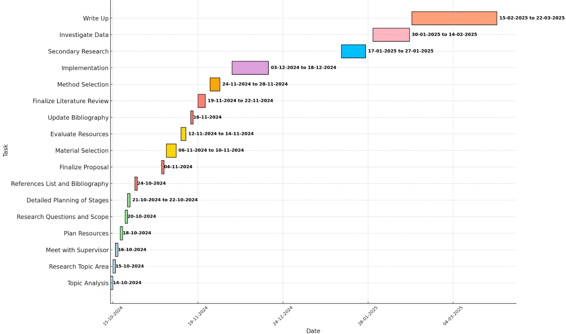

References

- Bocken, N.M.P., Short, S.W., Rana, P. and Evans, S., (2014). A literature and practice review to develop a 'sustainable business model' framework. Journal of Cleaner Production, 200, pp.483-498.
- Chen, L., Zhao, X., Tang, O., Price, L., Zhang, S., Zhu, W. (2017). Supply chain collaboration for sustainability: A literature review and future research agenda. Int. J. Prod. Econ.
- Dawkhar, S. S. and Pawar, S. R. (2024). Strategies for Integrating Sustainability into business operations. International Journal for Multidisciplinary Research, 3(1), 120-150
- Duignan, J. (2016). A Dictionary of Business Research Methods. Oxford University Press.
- Epstein, M.J. and Buhovac, A.R., (2014). Making Sustainability Work: Best Practices in Managing and Measuring Corporate Social, Environmental, and Economic Impact. 2nd ed. San Francisco: Berrett-Koehler Publishers.
- Geissdoerfer, M., Savaget, P., Bocken, N. and Hultink, E.J., (2016a). The Circular Economy – A new sustainability paradigm? Journal of Cleaner Production, 143, pp.757-768.
- Ghisellini, P., Cialani, C. and Ulgiati, S., (2016). A review on circular economy: The expected transition to a balanced interplay of environmental and economic systems. Resources, Conservation and Recycling, 151, pp.104-117.
- Ghosh, S. K. (2020). Sustainable Waste Management: Policies and Case Studies. Springer
- Hepburn, C., O’Callaghan, B., Stern, N., Stiglitz, J. and Zenghelis, D., (2020). Will COVID-19 fiscal recovery packages accelerate or retard progress on climate change? Oxford Review of Economic Policy, 36(Supplement 1), pp.S359-S376.
- Huq, F., Stevenson, M. and Zorzini, M., (2014). The role of supplier engagement in sustainable supply chain management: Evidence from the apparel industry. Journal of Business Research, 117, pp.156-166.
- Lewandowski, A., (2016). Designing the Business Model for Circular Economy: The Case of IKEA. Sustainability, 13(1), p.142.
- López-Gamero, M.D., (2023). The role of environmental and social practices in corporate social responsibility: A review. Sustainability, 11(10), p.2831.
- O’Gorman, K. and MacIntosh, R. (2015). Research Methods for Business and Management: A Guide to Writing Your Dissertation. 2nd ed. Goodfellow Publishers Limited
- Peters, J. and Simaens, A. (2020). Integrating Sustainability into Corporate Strategy: A Case Study of the Textile and Clothing Industry. Sustainability, 12, 6125
- Porter, M.E. and Kramer, M.R., (2019). Creating Shared Value: Competitive Advantage through Social Impact. Harvard Business Review, 97(1), pp.20-21.
- Saunders, M., Lewis, P. and Thornhill, A. (2015). Research Methods for Business Students (7th Edition). Pearson.

