University Of Wales

Trinity Saint David

Community Engagement

(LCBB4002)

Assessment 2

Name: Ivan Medarev
Student Number: 1920485
Module Title: Community Engagement
Module Lecturer: Riaz Bhatti
Assignment Title:
Best Practices of Community Engagement

Table of Contents
Introduction 3
Benefits of community engagement 3
Models and Frameworks of Community Engagement 4
The social ecological model of health 4
The active community engagement continuum 5
Diffusion of innovation 6
Community-based participatory research 7
Volunteers Engagement in Community Placement 7
Reflection on personal experience 8
Conclusion 9
References 11

Introduction
Community engagement can be defined as a process that promotes working in a collaborative way and via groups of individuals affiliated by geographic proximity, special interest, or related situations in order to address and tend to issues that affects the well-being of those individuals. It can be regarded as a powerful and potent mean that can be used to bring certain environmental as well as behavioral changes that have the potential to improve the community health along with its members (Baldus, Voorhees and Calantone, 2015, p.979). It often consists of coalitions and partnerships that can aid in the mobilization as well as allocation of resources and is at times responsible for influencing systems, acting as catalysts for changing policies; alter relationships between individuals, implementing useful programs and practices. Therefore, it can also be defined as a strategic process with an aim of working in collaboration with identified groups of individuals. These people or individuals in the first place might be connected by certain special interests, geographic locations, affiliation to identify as well as address problems that are responsible for jeopardizing their well-being in the long run (Bandy, 2016, p.37).

Benefits of community engagement
There are numerous potential benefits of implementing community engagement including getting engaged in community health service delivery, which can be significantly beneficial for both the community interests as well as the healthcare professionals (Evans, 2013, p.124). Some of the benefits include the following:
- An increased understanding about the health-related issues and local priorities by the consumer groups involved
- Improved and enhanced satisfaction of the consumer as well as the community
- Increased community investment and ownership
- Enhanced accountability regarding the public funds
- Introduction and maintenance of better-quality services (Habibi, Laroche and Richard, 2014, p.153)

Models and Frameworks of Community Engagement

The social ecological model of health
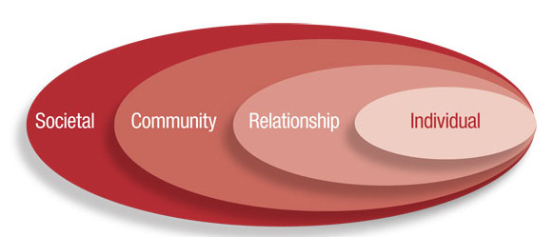
Figure 1: The social ecological framework of health
(Source: https://www.atsdr.cdc.gov)
According to me the social ecological model of health helps to perceive the concepts and importance of health on a broad basis. Furthermore, this focuses on multiple factors that might be hazardous for the general health in the long run. In 1947 this approach towards the health was developed by the Constitution of the World Health Organization, which as a whole considers physical, mental, and social well-being of different communities. According to this framework, health can be affected by individual interactions, or that between groups and communities, along with the social, physical, as well as political environments (Hollebeek, Juric and Tang, 2017, p.631).
Furthermore, according to Stokols (2013), there are four core principles related to the ways of social ecological model that can contribute towards the engagement of communities, which are as follows-
- Emotional well-being, health status, and social cohesion are primarily affected or influenced by social, physical, and cultural dimensions of the person’s or community’s environment. This also goes for personal attributes including psychology, behavior patterns, and genetics.
- A set of similar environments might have different effects on a person’s health, which in turn depends upon numerous factors, such as perceptions regarding the ability to control the financial resources and the environment itself.
- The individuals and groups under it operate in different environments, including neighborhood, workplace, geographic communities, and they influence one another.
- Environmental and personal leverage points exist, like physical environment, social norms, and available resources that put crucial influences on individual well-being their health (King et al. 2014, p.84).

The active community engagement continuum
As far I know this framework focuses on analyzing the community engagements and the significance of community in influencing lasting behavior change. The project team of Access, Quality and Use in Reproductive Health (ACQUIRE) developed this model, which was then backed up by the U.S. Agency for International Development.
This framework consists of three different levels of engagement across five characteristics related to the aspects of engagement. The given levels of engagement transverses from consultative to cooperative to collaborative and helps to shed light upon the realities of program and partnership programs. The stated three levels of community engagement can be implemented with the aid of certain activities based upon the same. The five engagement characteristics are as follows-
- The involvement of community in assessment
- Access to information
- Inclusion in decision-making
- Local capability to advocate to governing structures and other institutions
- Accountability of institutions to the public
Furthermore, according to me the framework, community engagement is more of an evolutionary process rather than a one-time event. The members of the community move closer to being agents of change themselves instead of change targets. This is especially true for each successive level of engagement, due to which the overall collaboration gets enhanced as well as the empowerment of the community. During the final levels of collaborations, the stakeholder as well as the community members is represented in an equal way in the formed partnership (Kumar and Kumar, 2020, p.101). Also, all the parties are mutually accountable for different aspects of the project.

Diffusion of innovation

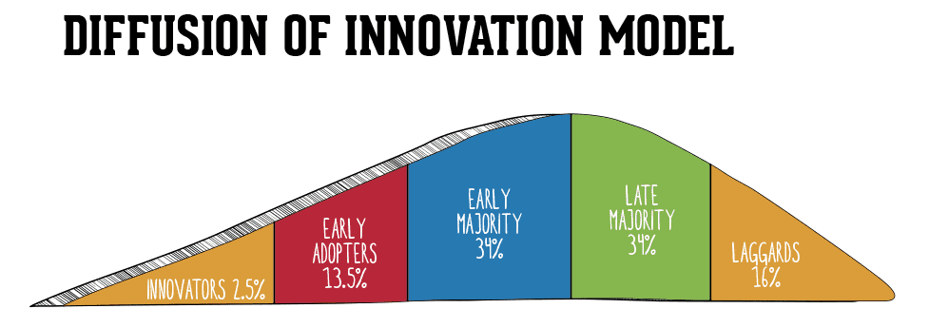
Figure 2: Diffusion of innovation framework
(Source: https://www.smartinsights.com)
Diffusion as defined by Everett Rogers (1995) can be stated as the process with the aid of which communication of innovation takes place via specific channels over the course of time among the members of a social system. On the other hand, communication can be defined as the process involving participants who create as well as share important information with each other in order to come to an understanding agreed from both sides, also known as a mutual understanding. For diffusion of innovation, the communication becomes associated with an idea or a new approach. The diffusion framework can be useful in giving shape to the community-engaged efforts that are essential to spread innovative practices in improvement of living conditions, including general health as well (Le Dantec, 2012, p.1352).
The given model can be utilized for being mindful of the awareness of different stages of diffusion, the varying responses to the concepts of innovations, and the traits promoting adoption, thereby helping the leaders align strategies according to the interests and readiness of the stakeholders. For the sake of example, a community-engaged campaign focused towards promotion of health might consist of awareness programs regarding the severity of a particular health issue, which according to Roger’s scheme is called knowledge. Other methods might include establishing an intervention initiative across the community, constructing the required infrastructure in order to retain the extensiveness of the service provisions, which would prove to be useful in reaching the members. Once it is done, the project can be evaluated at the lats stage, which is also known as confirmation according to Roger.

Community-based participatory research
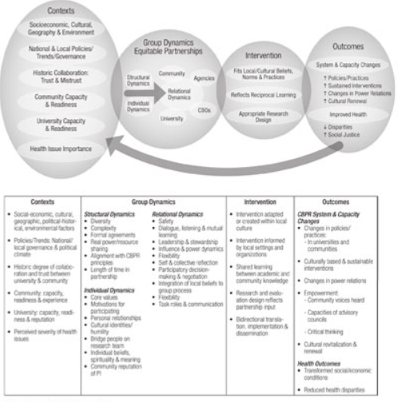
Figure 3: Community-based participatory research
(Source: https://www.atsdr.cdc.gov)
Community-based participatory research (CBPR) is one of the most popular frameworks of community engagement. It is considered as one of the highly evolved approach focused on the approach of collaboration. Furthermore, in this framework, all the collaborators heed toward the strong points that are brought to the partnership, and in this model the community participates actively regarding the majority of the aspects associated with the process of research. The primary aim of the framework is to achieve social altercations in order to improve health outcomes along with other issues that persists within the community, including health related disparities. Furthermore, the model of community-based participatory research helps to address four dimensions of CBPR, thus helping to outline the potential relationships between each of them (O'Mara-Eves et al. 2013, p.14). These types of models or frameworks are crucial to empirically assess or evaluate the practices related to the engagement of community along with disseminating potent approaches.

Volunteers Engagement in Community Placement
The best way to enhance the volunteering engagement in community placement during the COVD-19 pandemic is by offering online opportunities. This method will attract volunteers during COVID and provide online volunteering opportunities to them. This would particularly be helpful for those who are looking for volunteering experience and community placement during COVID. Online volunteering would offer volunteers the opportunity to gain personal and professional development by sharing different skills, knowledge, and ability through computers and smartphones.
Another improved method is the micro-volunteering, where the interested volunteers are offered a series of an easy task. These tasks are required to be done by them at any time and from anywhere. This method is the volunteers' flexible opportunity and an excellent supplement to traditional volunteering during COVID crises.

Reflection on personal experience
On the previous paper I have discussed about the strategies and techniques that are usually being implemented by Tesco to keep their stakeholders engaged. Additionally, their work and approach on community engagement over the course of these years is exceptional, which have allowed them to maintain good relationships with their stakeholders, including their customers, employees, and shareholders throughout. The study of this company has particularly helped me to gain insights on the interpersonal skills the employees must possess in order to give rise to a multicultural environment. The various models, theories, concepts, and ideas of community engagement taught in the class and the syllabus has helped me to access their various strengths and weaknesses, along with their suitable application to the corporate world. This would be helpful for me in the coming days of my career as I will be able to take major organizational decisions more actively, carefully, and quickly. During the course of the learning session, I have come to know about different skills that are needed for coming to a better level of community engagement, some of which are as follows-
- Robust meeting process skills
- Capacity to develop a meaningful vision, missions, and goals
- Ability to develop realistic and flexible objectives, group processes, and documentation
- Introducing and developing cycles of communication
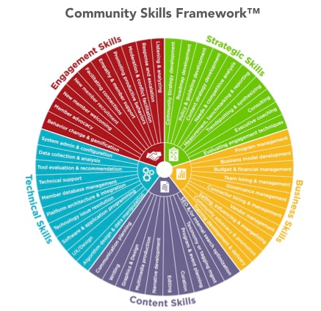
Figure 4: Community skills framework
(Source: https://communityroundtable.com)
Some of these skill sets have already achieved by me and need further developments and working upon. Other new skill sets like coming up with strong meeting process skills that are still unacquired needs to be developed with practice, discipline, patience, and commitment.
The community practices related to its engagement can be understood by the perception of its implications in various fields like health service provision, services related to housing, strategies regarding educational engagement, development of the local economy, planning policy, review, and more (Waterton and Watson, 2013, p.13). There are numerous sources of funding that are dependent upon submissions that provide the clear engagement of a community strategy. This is even true for the regeneration projects that are solely funded by the private sectors.

Conclusion
It can be concluded that community engagement promotes working in a collaborative way and via groups of individuals affiliated by geographic proximity, special interest, or related situations in order to address and tend to issues that affects the well-being of those individuals. The theory can be used to bring certain environmental as well as behavioral changes that have the potential to improve the community health along with its members. It generally consists of coalitions and partnerships that can aid in the mobilization as well as allocation of resources and is at times responsible for influencing systems, acting as catalysts for changing policies, alter relationships between individuals, implementing useful programs and practices. There are numerous benefits of community engagement, some of which includes improved and enhanced satisfaction of the consumer as well as the community and Introduction and maintenance of better-quality services. The models of community engagement presented here has helped ne to understand the ideas and concepts related to the topic along with the lessons learnt in the classes. I plan to develop my skill sets further, which in turn will help me in my coming days. Community engagement programs and practices are also termed as public or citizen participation or engagement that includes the various methods and ways to bring people together to work towards or address public importance. Brisbane Youth Services is the three-tier registered under the National Regulatory System- Community Housing. The organization is a housing provider for homeless youth and young families to find safe and stable housing and accommodation. Furthermore, with the aid of community engagement it can be ensured that the members of that community have access to valued social activities and settings, in a way so that they can feel they are being able to contribute positively and meaningfully to these community activities, thus developing functional capabilities enabling them to participate in them to the fullest extent.

References
Baldus, B.J., Voorhees, C. and Calantone, R., 2015. Online brand community engagement: Scale development and validation. Journal of business research, 68(5), pp.978-985.
Bandy, J., 2016. What is service learning or community engagement. Center for Teaching, Vanderbilt University. Available at https://cft.vanderbilt.edu/guides-subpages/teaching-through-community-engagement/ (Accessed: 28 November 2020)
Evans, M.P., 2013. Educating preservice teachers for family, school, and community engagement. Teaching Education, 24(2), pp.123-133.
Habibi, M.R., Laroche, M. and Richard, M.O., 2014. The roles of brand community and community engagement in building brand trust on social media. Computers in human behavior, 37, pp.152-161.
Hollebeek, L.D., Juric, B. and Tang, W., 2017. Virtual brand community engagement practices: a refined typology and model. Journal of Services Marketing.
King, K.F., Kolopack, P., Merritt, M.W. and Lavery, J.V., 2014. Community engagement and the human infrastructure of global health research. BMC medical ethics, 15(1), p.84.
Kumar, J. and Kumar, V., 2020. Drivers of brand community engagement. Journal of Retailing and Consumer Services, 54, p.101949.
Le Dantec, C., 2012, May. Participation and publics: supporting community engagement. In Proceedings of the SIGCHI Conference on Human Factors in Computing Systems (pp. 1351-1360).
O'Mara-Eves, A., Brunton, G., McDaid, G., Oliver, S., Kavanagh, J., Jamal, F., Matosevic, T., Harden, A. and Thomas, J., 2013. Community engagement to reduce inequalities in health: a systematic review, meta-analysis and economic analysis. Public Health Research, 1(4).
Rogers. E., 1995, Diffusion of Innovations, Available at https://web.stanford.edu/class/symbsys205/Diffusion%20of%20Innovations.htm (Accessed 27 November 2020)

Stokols, D., et.al, 2013, Enhancing the Resilience of Human–Environment Systems: a Social Ecological Perspective, Ecology and Society, 18(1), Available at https://www.researchgate.net/publication/270464590_Enhancing_the_Resilience_of_Human-Environment_Systems_a_Social_Ecological_Perspective
(Accessed: 05 December 2020)
Waterton, E. and Watson, S. eds., 2013. Heritage and community engagement: Collaboration or contestation?. Routledge.

