

CertHE in Business Skills

Student Name: Alysha Pearson
Student Number: (2545352)
Course Name: Digital Skills LCLM4002
Lecturer Name: Nishi Ramsurrun
Session: June 2026 Term

Table of Content
Contents
No table of contents entries found.

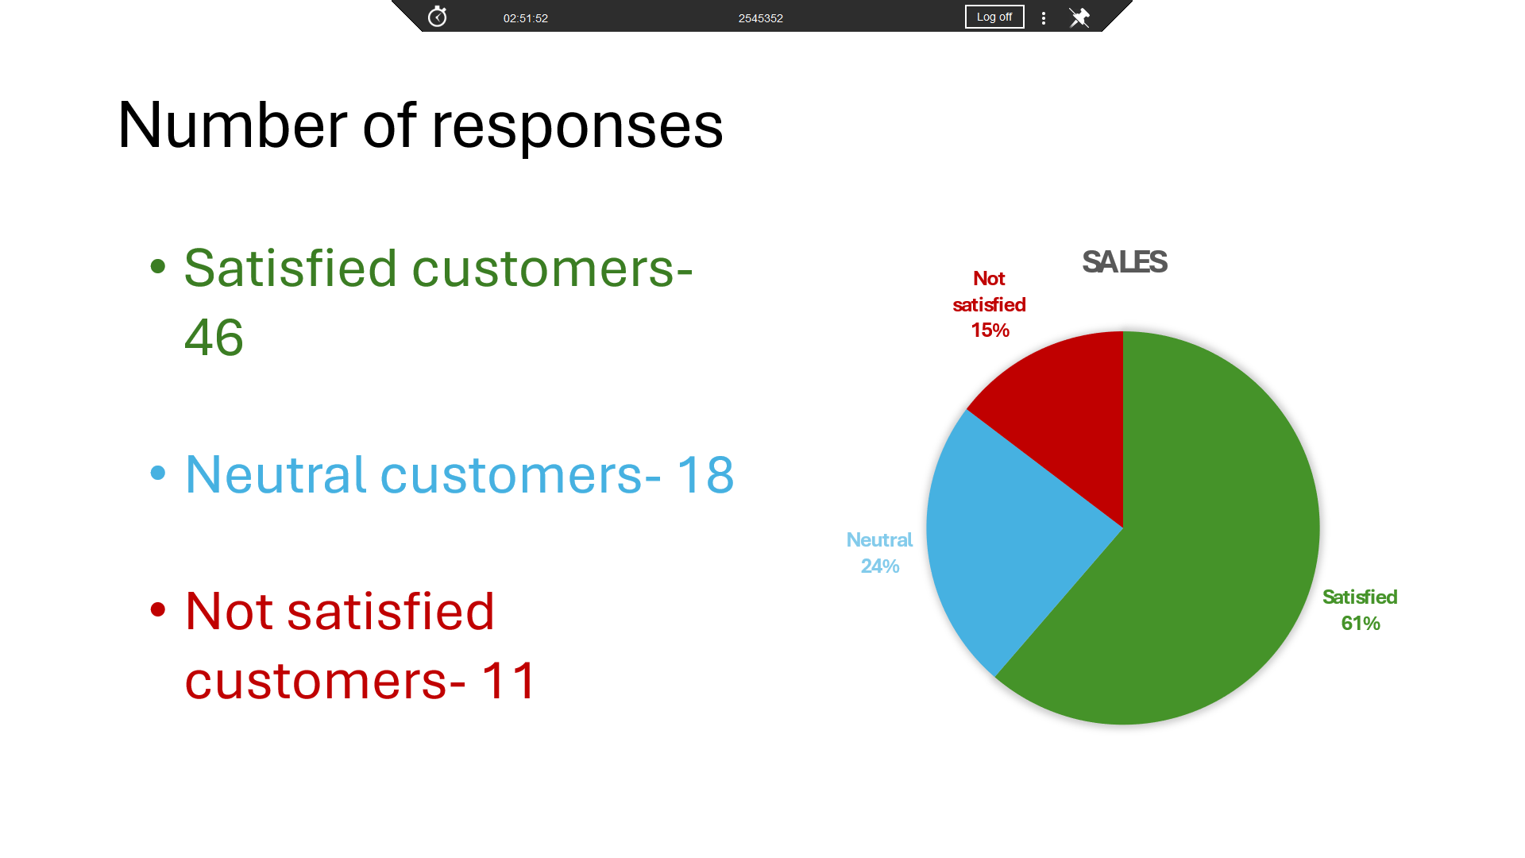
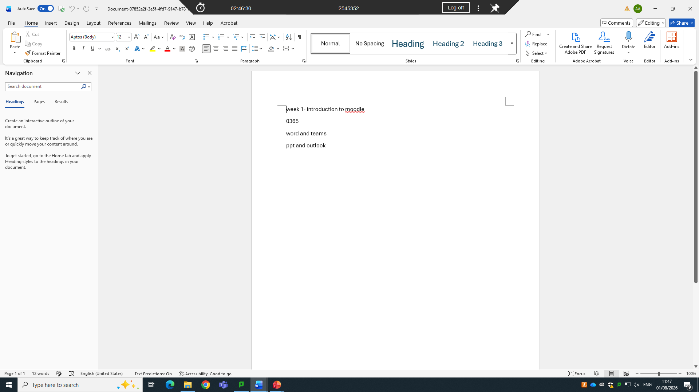

ITRODUCTION
During term 1 in digital skills for business, I gained more confidence using PowerPoint, Word and Excel for business skills. While using digital tools I learned that it can make it easier to stay organized and get things done more efficiently. The practical skills that I learned in Word, PowerPoint and Excel are important tools that I will need for my upcoming assignments.


