

An analysis of social media and its impact on esports course funding at FE college level.

Leah Griffiths

Swansea Business School

University of Wales Trinity St David

Dissertation submitted as part of the requirements for the award BA(Hons) Digital Marketing

Submitted: 12th April 2022

Declaration and Acknowledgements

Throughout the writing of this dissertation there has a been support and assistance provided by the University of Wales Trinity Saint David and the Further Education institutes that collaborated on this study.

The first thank you goes to Dr G Hughes who has been the supervisor of this research study, offering expertise in formatting the research topics and additional chapters.

The other acknowledgements are for all the colleges and further education institutes that were able to participate in the interviewing process of this dissertation. All the institutes were able to support the finding of this study and offer new perspectives and insights, which broadened the outlook.

Abstract

This undergraduate dissertation focuses on esports and how it has become a growing industry, recently been recognised by the educational sector in the United Kingdom. Research has showed that the esports industry has become established across other countries with the Business and Technology Education Council, known as BTEC formulating an esports course that was introduced internationally in 2020. This study aims to analyse how social media can impact the esports course and qualification funding at Further Education or FE college level. This is a new concept that will require literature to be examined surrounding the three-core subject that have been evaluated throughout this research study.

This review is based on literature associated with the esports industry, esports in education and social media. Fifteen structured interviews were conducted with Further Education colleges within the United Kingdom that deliver the esports BTEC qualification. Based on the participants responses, the results indicated that social media has positively impacted funding at the FE college level for both the esports course and students that compete regularly against each other at competitive levels, known as esports teams. It has been recommended that by establishing the esports BTEC course as part of the existing curriculum, dedicated esports teams are created to enhance the learner’s experience. Further research is required to identify how the esports industry will develop and grow in the future.

Contents
Chapter 1 – Introduction 1
Chapter 2 – Literature Review 3
2.0 Marketing 3
2.1.1 Building Customer Relationships 3
2.1.2 Traditional Marketing Methods combined with Digital Marketing 4
2.1.3 Social Media Marketing in Business within the Education Sector 4
2.2 Esports 5
2.2.1 Marketing in Esports 6
2.2.2 Social Media Marketing in Esports 7
2.2.3 Esports in Education 7
2.3 Identified gap in the literature 8
Chapter 3 – Methodology 9
3.1 Philosophy and approaches 10
3.1.1 Pragmatism 10
3.1.2 Other considerations 11
3.2 Inductive research 11
3.3 Research strategy 11
3.4 Choices 12
3.5 Time horizons 12
3.6 Data collection methods 13
3.7 Ethical Considerations 13
3.8 Limitations 14
Chapter 4 – Conducted Research 15
4.1 Objective one 15
4.2 Objective two 17
4.3 Objective three 19
Chapter 5 - Conclusion 21
5.1 Achievements of Aims and Objectives 21
5.1.1 To analyse how the esports course has grown and developed in general 22
5.1.2 To critically evaluate the role social media has played in the development of the esports course 23
5.1.3 The impact social media has had on funding for the esports course and esports team 24
5.1.4 Provide recommendations for the colleges on how to utilise social media to provide further funding for an esports team 24
5.1.5 To analyse how social media can impact esports funding at the FE college level 26
5.2 Recommendations for Future Study 26
5.2.1 Limitations of the study 26
5.2.2 Building on the findings 27
5.2.3 Research Study in a new context 27
5.2.4 Expanding on the theory and frameworks 28
6.0 Appendices 29

7.0 References 50

Chapter 1 – Introduction

This research topic will investigate how social media has impacted education with a focus on the esport industry. Esports was recognised by the United Kingdom as being a “sport in 2010” (British Esports Association, 2016). In 2020, esports was perceived as needing to be taught at a higher education level. The British Esports Association partnered with Pearson to create an esport BTEC Course (British Esports Association, 2020). The BTEC course is taught at an FE college level across the United Kingdom and other parts of the World.

Colleges will use social media to reach potential students as “88% of individuals aged 16-24” (Baron, 2020), have a social media account. Educational institutions including colleges have started using social media platforms to promote esports teams. Social media has positively affected esports by increasing the number of followers the esports teams have, drawing attention to teams' wins and increasing college recognition. This is important as it sways potential students’ attention to the winning esports team and the associated college. This has an impact on student enrolment figures. Promoting the college esports team using social media provides opportunities for sponsorship and funding (Kumar and Nanda, 2019).

This research topic needs to be investigated as esports is a growing industry in the United Kingdom and has been introduced into further education (British Esports Association, 2020). This study will research how developing industries such as social media can positively impact the marketing of a new industry like esports. Social media has become an advertising platform for FE colleges (Kumar and Nanda, 2019). However, this platform can also be used to increase funding and sponsorship deals for the esports college teams.

This research study will investigate and analyse the impact social media has on esport course funding at the FE college level as a gap has been identified in the literature which has led to the need for this study to be recognised. Due to social media and the esports industry being new, academics are trying to establish what these are before investigating the effects on other developed industries.

To investigate these new industries an aim and objectives have been implemented to break down the research topic. These are as follows:

The aim of this research is - To analyse how social media can impact esports course funding at the FE college level.
The objectives are:
- To analyse how the esports course has grown and developed in general
- To critically evaluate the role social media has played in the development of the esports course
- To demonstrate the impact social media has had on funding the esports course and esports team
- To provide recommendations for colleges on how to utilise social media to provide further funding for an esports team
Objective one will be achieved by conducting primary research in further educational institutes specifically focusing on how many already host the BTEC esports course. In addition to this, an evaluation will be carried out to investigate how the esports industry is predicted to grow and develop in the future.

Objective two is going to be accomplished by analysing the social media platforms used in further education, and how these platforms have contributed to the development of the esports course centring the research around the age of social media users.

Objective 3 will be encompassing how social media directly contributes to the funding of the BTEC esports course and the college esports teams. By understanding how social media is used in educational institutes, a conclusion can be made as to the impact social media has on the funding of an esports course.

Objective 4 is going to combine objectives one to three, in which recommendations will be made that will relate directly to the esports course and social media issues raised in the data collection process.

Chapter 2 – Literature Review

An investigation into how social media has impacted businesses with a focus on the esports industry will be reviewed using a wide range of literature. The literature that will be reviewed will involve important themes and trends being identified. The primary themes and trends recognised in both the marketing and esports industry include building customer relationships, traditional marketing methods combined with digital marketing, social media marketing in business specifically the education sector, marketing in esports, social media marketing in esports and esports in education.

Although the literature reviewed in this investigation has evaluated the key topics in depth there are gaps in the literature specifically when facing the esports aspect. This is because esports is an unfamiliar concept within the United Kingdom and has very recently been identified in the education sector.

2.0 Marketing

2.1.1 Building Customer Relationships

Marketing has been defined by academics as

“the activity, set of institutions, and processes for creating, communicating, delivering, and exchanging offerings that have value for customers, clients, partners, and society at large” (American Marketing Association, 2017.)

This idea of marketing implies that organisations can communicate with the customer by creating and delivering an interesting and specific message that will value the customer and help the organisation to grow.

This description of marketing has directed to themes being developed within the marketing community; these themes include customer value and customer importance in any organisation (Foreman, 2003., pp10). These themes have become widely recognised by academics involved in the marketing community. Evaluating customer relationships and customer loyalty has become a critical part of every marketing campaign (Armstrong, et al, 2009., pp 15-16)

Customer relationships and customer loyalty are critically important to marketing campaigns that academics wrote a book called “Successful customer relationship marketing” (Foss and Stone, 2001., 139-144); within the book, insights are offered into how organisations can build better customer relationships and keep customer loyalty (Foss and Stone, 2001., pp 139-144) One method was using customer databases, which can collect and hold data including “customer profiles, demographics, products purchased and other items of interest” (IBID.) Other academics have agreed that using databases to collect and store customer data is an excellent method. There have been many case studies surrounding loyalty cards in supermarkets and retail, in which it was concluded that the customers should receive discounts and perks in exchange for the data (Smith and Potter, 2009.)

2.1.2 Traditional Marketing Methods combined with Digital Marketing

Digital marketing was recognised as a new marketing concept in the “1990s” (Kingnorth, 2019, pp 65-72), and is defined by academics as “any marketing method conducted through electronic devices which utilise some form of a computer” (American Marketing Association, 2021.) However, digital marketing campaigns will often require some form of traditional marketing methods, this is because both marketing techniques are working together to achieve an end goal set by the organisation. Many academics find this concept interesting as Chaffey and Ellis-Chadwick have discussed the idea of digital marketing working “alongside traditional marketing techniques, to get closer to audiences than before” (Chaffey and Ellis-Chadwick, 2019.pp 82-86) This concept of digital marketing refers to customers being able to easily contact the company directly through digital marketing techniques.

Other academics believe that digital marketing is taking over and replacing traditional marketing techniques, and the concept of combined marketing methods is ineffective due to the lack of data and measuring collected from traditional marketing techniques (Ryan, 2019.)

2.1.3 Social Media Marketing in Business within the Education Sector

One of the crucial digital marketing methods being implemented by many organisations is social media marketing. Social media marketing is defined as “the practice of using social media channels to promote business products or services” (American Marketing Association, 2021.) However, academics believe this is an ineffective way of using social media networks. This is due to consumers being overwhelmed with the constant pushing of products and services online. Therefore, social media marketing can also be defined as “activities, practices and behaviours among communities of people who gather online to share information, knowledge and opinions using conversational media” (Safko and Brake, 2009. P6) This is a better interpretation of social media marketing as organisations are given the chance to connect with the customer on a more personable level which helps the organisation to gain the customer's trust and allow the customers to become connected to “larger trusted networks” (IBID., pp 7)

Social media is used specifically by educational sectors as a survey was conducted in the United States of America where it was discovered that 97% of social media users are aged between 13-17 (Pruthi and Bower, 2021) this is also a similar age group of those interested in studying at college and university. Therefore, educational institutes have started using social media marketing to promote the institute and courses available to potential students. Social media marketing is being implemented in higher education institutions as “the potential of these tools to reach and attract future students” (Constantinides and Stagno, 2011,pp 1-3) is being recognised. The marketing teams within these institutions need to be aware of the role social media marketing plays in a student’s decision-making process of choosing a specific course, college, or university.

A study was conducted on the “Potential of the social media as instruments of higher education marketing: a segmentation study” (Constantinides and Stagno, 2011, pp 1-3) and one of the major findings of the study is that “compared to traditional communication channels social media still plays a secondary role in the students’ choice” (IBID.) However, educational institutes needed to be aware that the more content posted on social media and the more engaged students are with the content, then this could impact where the student decides to study.

2.2 Esports

Esports was recognised as a sport in “2010” (British Esports Association, 2021,) by the United Kingdom. Due to this being a new concept in the United Kingdom, there is a lack of academic literature surrounding this specific topic. Therefore, some of the academic research discussed within this section will have been conducted in other countries including Korea, Poland, and America, as it has grown and developed in these countries.

According to the Oxford Dictionary, Esports is described as “a multiplayer video game played competitively for spectators, typically by professionals” (Oxford English Dictionary, 2021). Academics agree with this definition as Scholz described esports as “completive gaming.” Esports involves “coordination, communication, and cohesion” (Scholz, 2019, pp 17-20). Therefore, esports is being forced to be recognised as its competitive nature has led to many large competitions. One esports competition was held in Katowice, Poland in 2013, in which “tens of thousands of young people visited to watch people play video games” (Scholz, 2019., pp 17-20). This is also the case worldwide as “there were Esports events in Korea that are similar to crowded stadiums for the National Football league” (Kane and Spradley, 2011). This emphasises the growth and impact esports is having internationally.

2.2.1 Marketing in Esports

Marketing is an important factor in the esports industry as many well-known companies including “Red-Bull, Coca-Cola and Mercedes” (Singer and Chi, 2019., pp 1-6), have been known to host and sponsor esports events in the United States of America. In an academic paper researching “The keys to esports marketing” (IBID). it was discovered that these well-known companies have helped the industry grow by 34% in 2019 (Singer and Chi, 2019.,pp 1-6). A book that researched “The esports and esports sponsoring” (Heinz and Stroh, 2021 pp 13-15), discovered that organisations from relevant industries including computing and gaming, sponsoring esports to present and promote products are the most important “financial pillars and key drivers” (Heinz and Stroh, 2021, pp 13-15), of the industry.

The academic research also discovered that in the United States of America there are “21 million esports fans” (Singer and Chi, 2019., pp 1-6). These esports fans often watch a streaming platform known as Twitch. Twitch is growing strongly as a streaming platform and has gained an academic understanding as one academic described the platform as allowing its users to “broadcast their screen whilst playing games” (Taylor, 2018.) Many popular gamers and esports teams will use Twitch to stream tournaments. These specific streaming platforms allow the use of adverts, therefore, marketing an esports team or sponsorship deals through Twitch will gain a lot of attention. There are many marketing opportunities available through this platform including the use of adverts.

Academics and professionals involved in the esports industry have recognised the need for and the importance of marketing. Many esports teams need sponsorship deals to get the latest technology to keep competing.

2.2.2 Social Media Marketing in Esports

Social media marketing allows esports teams to grow by offering a free-to-use platform that can reach many potential fans. Esports teams will often use a range of social media platforms to promote the team, these platforms include, Instagram, Facebook, Twitter, TikTok, and Discord (Alanko and Laaksonen, 2019.) One case study found that to use social media effectively within an esports team “good, authentic, quality content” (Alanko and Laaksonen, 2019,) needed to be created. Social media works by measuring specific algorithms. These algorithms work by sorting posts in a user’s social media feed by, relevancy not by publish publishing time (Alanko and Laaksonen, 2019.) Therefore, to effectively gain a large social media following organic and paid adverts may need to be implemented.

Streaming services like Twitch have helped to increase team exposure which has led to a rise in esports teams promoting themselves through social media platforms. These social media platforms have allowed international team teams to connect and battle against each other in recognised competitions.

2.2.3 Esports in Education

Esports has recently implemented an esports qualification in the United Kingdom at a higher educational level (British Esports Association, 2021.) Due to how recent the industry has been recognised there is a gap in the academic research.

However, academic research has already been carried out on esports in education in American colleges and universities. Professors have commented on esports in education and have noted how the skills used in esports have led to other industries benefiting (Kim, 2019.) Some of the industries that are involved within the esports industry include business specifically the need for business models and marketing, broadcasting and videography, and psychology along with many more (Stomski, 2018.) By recognising the growing industry, courses have been developed to enrich the skills required that are required to be a part of this industry.

Esports in education has also helped introverted students become a part of the community, one academic wrote “esports can provide an outlet for introverts” (Rogers, 2019.) This has positively affected the colleges and universities in America as extroverted students who have an interest in esports have helped introverted students become a part of the student community (IBID.)

2.3 Identified gap in the literature

The overarching themes investigated in this literature review include marketing and esports. There is a lack of literature regarding the Esports section. The use of social media and esports in the United Kingdom education system has been identified however, can be researched further. An inquest into how social media can impact esports course funding at the FE college level needs to be researched as knowledge and understanding can be gained on the importance of these new and developing industries and how together these can complement each other.

The analysis of the marketing aspect of this review has focused primarily on digital marketing specifically social media. Targeting how social media is being used to promote educational institutes is a positive way to promote the institute as the users of these platforms are aged 16-24 which is the age individuals start college. Therefore, knowing social media is being used by the target audience for a college education is one of the core reasons these platforms are being analysed.

The other category being investigated is the esports industry relating to esports in education. This is a growing and developing industry and is becoming recognised by many colleges across the United Kingdom. This industry has already been established in the American education system.

Therefore, establishing the importance of how social media can impact esports course funding at the FE college level has identified a gap in the literature as themes such as funding an Esports FE college team have not been discussed by academics due to Esports being such a new concept, there is a lack of understanding as to what is required to have an active team in this industry.

Before any research can be conducted or collected, the philosophies and approaches need to be understood and why these methods have been chosen. Understanding these will lead to an in-depth conclusion being made.

Chapter 3 – Methodology

To conduct this research study and gain an appropriate perspective, objectives have been developed to ensure the research study is always observed. These objectives include:

- To analyse how the esports course has grown and developed in general
- To critically evaluate the role social media has played in the development of the esports course
- The impact social media has had on funding the esports course and esports team
- To provide recommendations for colleges on how to utilise social media to provide further funding for an esports team
The methodology section will be structured around the research onion model developed by Saunders, Lewis, and Thornhill in 2009. This framework is conducted of six layers, each discussing the different aspects of which research methods will be used.

The methodology surrounding this study will involve a pragmatic, inductive approach with the use of primary qualitative data.


(Saunders, Lewis, and Thornhill 2009)

3.1 Philosophy and approaches

The first few layers of the research onion are the philosophies and approaches. The philosophy of this research study will define the interpretation of the research that will take place. The interpretation of the philosophical viewpoint will include an understanding of the ontology and epistemology of each philosophy evaluated. The ontology is the study of reality or being (Marsh, Ercan, and Furlong, 2018 pp 4). This attributes to the nature of existence, specifically focusing on what something is and how things are classified. Ontology offers a foundational understanding of what someone’s reality is. Compared to epistemology which is the study of knowledge. This focuses on what is known and how knowledge can be gained (Marsh, Ercan, and Furlong, 2018 pp 4).

The philosophy that will be used in this research study will be a pragmatic approach. This approach was decided upon after an evaluation of pragmatism, positivism, and constructivism.

3.1.1 Pragmatism

Pragmatism is the belief in interacting with reality and gaining a true perception of what reality is through experimentation and research states (Stanford Encyclopaedia of Philosophy, 2020). This research hypothesis is best suited to a pragmatic approach as it allows future outcomes of similar hypotheses to develop and grow from this research.

The ontology of pragmatism relies on actions and experiences which can be justified through research and experimentation (Paul, 2005). The research hypothesis will lead to researching a variety of qualitative data from a range of colleges, which will result in a conclusion being made.

The Epistemology of pragmatism is acting as the knowledge is understood, built, and modified through interactions with individuals. Pragmatism focuses on results (Paul, 2005). Therefore, combining knowledge from colleges that actively have an esports team and social media page can help to justify these results that have been tried and tested. Therefore, this is the best philosophical approach for this research.

3.1.2 Other considerations

Before pragmatism was decided as to where the research would sit, other considerations were made to positivism and constructivism. Positivism relates to the research using scientific methods and is best used for quantitative data. Due to the research topic discussing themes including social media and esports there will be no financial data to analyse, therefore, this philosophy will be not discussed.

Another philosophy that was considered was constructivism. This is the belief in bringing reality and knowledge into being (Crotty, 1998). This philosophy focuses on the journey of discovery which is again not suitable for this research topic as the outcome is far greater than the understanding of the research and which methods will be used to interpret the data.

3.2 Inductive research

The research hypothesis will be evaluated using an inductive approach. An inductive approach allows for a new theory to be tested using new research methods and collecting new data (Russell, 2015). Whereas deductive research analyses an existing hypothesis to check its relevance and update any research changes (Russell, 2015). Based on the modern concept of social media and the recent introduction of esports in the United Kingdom this research is inductive.

3.3 Research strategy

Many research strategies can be related to a variety of research hypotheses. However, the research strategy used in this research study will be qualitative surveys. Qualitative surveys allow for important data to be collected focusing on a specific study area (Seixas, Smith, and Mitton, 2018). The surveys that will be produced for this research study will specifically relate to the objectives. This will allow for a conclusion to be drawn on all the growth and development of the esports course because of social media, and the impact social media has on course funding.

Another research strategy that was considered for this research study was developing a case study. The development of a case study would have allowed in-depth knowledge that specifically relates to a real-world subject (Perry, 1998). A case study was considered for this research as this could be based in an FE college focusing on the esports team and social media. However, this is a new concept and with larger sample size, a better understanding can be gained of the exact impact social media has on esports teams. Therefore, qualitative surveys will be used.

3.4 Choices

There are three choices of methods that can be used when conducting research. These three methods include mono methods, mixed methods, and multi-methods. For this research hypothesis, mono-methods will be used. This is because mono-methods are associated with the use of one type of research approach (Lopez-Robles, et al, 2020). For example, this research study will involve the use of qualitative data only.

Whereas mixed methods involve the collaboration of both qualitative and quantitative data (Fielding, 2010). Combining these data methods can lead to an in-depth analysis of the study, however different aims and objectives will be required with the use of larger data collection (Fielding, 2010). This would be inappropriate within this research study due to the limited number of FE college esports teams in the United Kingdom.

Multi methods are different from mixed methods as multi-methods involve the use of two or more qualitative data collections and two or more quantitative data collections within one research study (Anguera, et al, 2018). However, due to the limited research available within this research study multi-methods would be unsuitable.

3.5 Time horizons

There are two types of time horizons, however, only one is suitable for this research study. The two types of time horizons consist of longitudinal and cross-sectional. This study will acknowledge the time horizon cross-sectional. This is because a cross-sectional study is a short-term study and involves the collection of data at a specific point in time (Rindfleisch, et al, 2008). This is most suited to this research study and will not need to be repeated.

Data collected that involve a longitudinal approach consists of evaluating research over an extended period, this can stem from a few weeks to a few years (Rindfleisch, et al, 2008).
This research study will not need to be repeated and the results will not need to be re-evaluated, therefore this study will use the cross-sectional time horizon approach.

3.6 Data collection methods

The data collection methods for this research study will consist of qualitative primary research. Qualitative data is non-numerical and focuses on categorical data and can be observed and recorded (Levitt, et al, 2018). The data collection methods used for qualitative data will involve virtual online meetings being conducted over Teams. The interview participants will include college lectures that teach the esports BTEC course and host an esports team. The colleges that are involved with esports in education are based across the United Kingdom. Therefore, virtual meetings must be conducted to allow as many colleges as possible to be included in the sample.

To ensure that the information collected from the interviews stays the same and is relevant to the research topic, a list of questions will be asked that directly relate to objectives one, two and three. Objective one is to analyse how the esports course has grown and developed in general and objective two is to critically evaluate the role social media has played in the development of the esports course and objective three analyses the impact social media has had on funding the esports course and esports team. To analyse the data collected all answers will be submitted into a Google Forms document where the answers will be evaluated. The practicality of this evaluation to be conducted via Google Forms is the ability this system must create graphs and charts from specific data and trends within the collected data. Google form is an appropriate tool to use to analyse the data as it constructs a visual representation of the data and offers a breakdown of each question and the answers which can be viewed easily.

There were ethical issues that needed to be considered before any research could begin including each college being made aware that the lecturers and institutions' names would be kept anonymous throughout the data collection and publication of the analysis.

3.7 Ethical Considerations

This undergraduate study has had ethical considerations (Appendix 6.1), specifically relating to the primary data that will be collected in the form of interviews. Before any information is collected, all adults over the age of eighteen will have to provide written consent to participate in the research study. The participants will also be informed that in the write up of the study all statistics and quotes used will be kept anonymous, giving the participant full confidentiality.

3.8 Limitations

The core limitations of this research study involve the lack of academic research relating to the esports industry. This industry is developing in the United Kingdom, however, is yet to be fully investigated by academic literature. This has resulted in a bigger gap in the research than first predicted.

Another limitation is the limited number of further educational institutes in the United Kingdom that offer the esports BTEC qualification. This study has combined institutes from Wales, England, and Scotland that have this qualification as part of the curriculum, which has led to a smaller sample size being collected.

A pragmatic, inductive approach will be conducted with the use of primary, qualitative data. The collection of this data and a breakdown of results will be evaluated and analysed in
Chapter 4 – Data Collection.

Chapter 4 – Conducted Research

To collect the data required, a wide range of colleges that either currently delivers the esports BTEC course or host an esports team were contacted. Due to esports being a new concept in the United Kingdom, only fifteen colleges participated in the study.

The interviews were conducted using a series of pre-determined questions that were asked in structed format with the same order being used each time (Appendix 6.2). This method is known as structured interviews. This interviewing technique is being used to ensure that there is continuity in the research which will allow themes and trends to be identified. To analyse these trends Google Forms will be used. Google Forms allows the questions to be viewed individually with the corresponding responses. This analysis tool also constructs graphs and charts from the relevant data. Google forms has been used by academics to conduct research as Bethea-Hampton and others agreed that this analytics platform includes “helpful tools” (Beathea-Hampton et al, 2020 pp1657-1661), that provide new perspectives and insights into the understanding of the data collected.

The questions asked in the interviews relate to one of the three objectives. This allowed the interview to stay structured and on topic. As part of this process, the responses have been entered into Google Forms for further analysis to be conducted.

The overall aim of the research is to analyse how social media can impact esports course funding at the FE college level. This research topic has four objectives overall. However, objective four will be investigated in Chapter 5. Therefore, three objectives have been met during the data collection process. The objectives are:

- Objective one – To analyse how the esports course has grown and developed in general
- Objective two – To critically evaluate the role social media has played in the development of the esports course
- Objective three – The impact social media has had on funding the esports course and esports team

4.1 Objective one

To understand how the esports course has grown and developed in general, all questions relating to this objective are centred around the esports BTEC FE college course and the college esports teams (Pearson BTEC Level 3 Esports). Out of the twenty-eight questions asked during each interview, questions one to five and question twenty-three are all dedicated to answering this objective.

Out of the fifteen responses gathered during the interview process, fourteen colleges answered “yes” to teaching the esports BTEC course (Appendix 6.3). However, on further inspection, the Google forms analysis tool showed that Participant Thirteen does not currently teach the esports BTEC course but is implementing it in “September 2022” (Appendix 6.4). Therefore, all participants agreed that esports is a growing and developing industry. The idea of esports being a growing industry has been confirmed by academic Adams, Billing, and others as esport has continued to grow internationally and has been recognised as a “global phenomenon” (Adams, Billing, et al, 2019, pp 1). Other academic research in the literature review have referred to esport competitions gathering crowds like the “National Football League” (Kane and Spradley, 2011).

Participant Twelve also agreed that esports is a growing industry and stated that the esports BTEC course has given them the “chance to be part of a rapidly growing industry” (Appendix 6.5). Participant Fourteen added that esports is an “ever-growing industry” (Appendix 6.6). This was a common theme identified by Google forms with Participant Fifteen having confidence in the industry as there is “growth in the esports area” (Appendix 6.7). Academics are continuously agreeing that esports is a growing and developing industry with a lot of potential and must be taken more seriously (Hollist, 2015 pp1).

Apart from esports being a growing and developing industry, it also allows for new skills to be learnt. Participant Two added the esports industry “supports new skills” (Appendix 6.8). This was another theme identified as Participant Four added, “learners can engage with topics such as business and marketing” (Appendix 6.9). Therefore, the esports BTEC course teaches valuable skills from other college courses which enhances the esports course. Academic Stomski in 2018 praised esports for its interchangeability with other industries like business, marketing, videography, and more. Academics believe that esports should become “integrated in the curriculum” (Lee, et al, 2020), due to endless industries that are involved in the development of the industry.

Even though not all colleges teach the course, 100% of participants answered “yes” to having a college esports team (Appendix 6.10). Having an esports competitive team is an important aspect of the course. The FE college BTEC course includes modules which directly relate to an esports team, therefore, having the ability to write assignments around a college team that students know of enhances the course by allowing the students to have experience and relatable content to write about. As well as this student can develop new skills including, strategy in gameplay, marketing of an esports team and coaching techniques. Therefore, having an active esports team is an integral part of the FE BTEC esports course. Research has been conducted in Canada, which has surrounded the need for college esport to be taken seriously. As students that leave college with the BTEC esports qualification are more likely to have relevant experience in the industry (Kauweloa and Winter, 2019 pp 35-50). It is also recognised by all participants that the esport teams provide health and well-being opportunities for all learners involved (Monteiro et al, 2022 pp 1-22).

4.2 Objective two

Objective two critically evaluates the role social media has in the development of the esports course. To conduct this analysis, questions six to fourteen, eighteen to twenty-two and questions twenty-six to twenty-seven are all about the impact social media has on the course and esports team.

Social media tools are used to promote both the course and the teams. Therefore, by using a range of social platforms colleges can reach the target audience. Out of the fifteen interviews conducted fourteen colleges have a social media presence. After analysing the trends within the use of social media it was discovered that Participant Eleven has only recently set up an esports team and is “focused on getting systems right, before pushing social media” (Appendix 6.11). Therefore, social media has been strongly considered by all colleges. Participant Four commented “It promotes the team and creates more connections for learners when going into the industry” (Appendix 6.12), this theme was similar throughout as Participant Two added social media “advertises the team’s success and continues its growth” (Appendix 6.13). Participant Thirteen also mentioned the community that social media builds by quoting it “builds relationships in the community” (Appendix 6.14) Which reinforces the point that students use social media and by following other teams a “community,” can be developed which strengthens the growth and development of social media and the esports industry. Academics support the need for social media in esports as it can influence a wider fans base to support teams (Sjoblom, Hassen, et al, 2018, pp 160-167).

To understand how social media is used an investigation was conducted into which social media platforms were most popular. Seven colleges use Twitter and Instagram, making these the most popular platforms used by the college institutions. Five colleges use YouTube whereas three colleges use TikTok, LinkedIn, and Facebook. One college uses Twitch (Appendix 6.15). A survey conducted by Statista in 2019 found that TikTok was one of the fastest growing platforms amongst young adults aged 15-25, while platforms like Facebook were experiencing less new users signing up to the platform.

Analysing why these platforms are being used by these colleges is an important aspect of this research as it considers the different ways in which social media can be used. For example, some colleges recognised that it is used by the target audience as Participant Nine said “most current students of 16+ are using social media” (Appendix 6.16). While Participant Eleven added, “These are the social media platforms with the maximum reach” (Appendix 6.17). Statistics gathered by Statista, 2019 discovered that 97% of social media users are aged between 17-20. Therefore, using these platforms to target to college students is expected.
However, the other trend identified that these platforms are best used to promote esports as Participant Eight agreed “it gives us a wide area of showing the team off. Clips for YouTube and TikTok” (Appendix 6.18). While Participant Ten simply added its “best for gaming” (Appendix 6.19). As well as this, academic also believe that having the ability to watch experienced players in esport competitions helps to improve personal gameplay (Deral, 2022 pp 159-182). The more the esports team is followed, liked, and shared on social media the better exposure (Bajpai et al, 2012., pp214-223), it is for the college. The college esports teams are often named with either the college initials or the college name. This is a clever way to market the esports team as it incorporates the college branding which helps the identity of the esports team.

Out of the fourteen live social media accounts seven post daily, six post weekly and one post monthly (Appendix 6.20). Out of the fifteen colleges interviewed thirteen replied “yes and one responded “no” to seeing a growth in following since the start of the social media accounts (Appendix 6.21).

Posting consistently on social media can impact how effective the platform can be for a college. One interview respondent believes that because the content isn’t posted regularly enough it is negatively impacting the effectiveness of the social media platform. Academics agree that posting consistently on social media has positive affects (Akram and Kumar, 2017., pp 351-354). Participant Two quoted “not posting consistent enough” (Appendix 6.22), to have witnessed a growth in following since starting the social media accounts.
However, the thirteen colleges that have sustained growth in following since starting the social media accounts all agreed it benefits current and potential students. As Participant Fifteen stated, “our main target audience is young people 16+, the more these individuals learn about the team, the more interested and awareness can be spread” (Appendix 6.23). Academics agree that the age in which individuals are being exposed to social media is decreasing each year (Auxier and Anderson, 2021., pp 1-4).

The main college esports teams also tend to follow each other on social media as it creates a wider community for learners and lecturers. This concept was first adopted by small business owners as to support one another, this has evolved over time and has become an integral part of the esports college team’s social media platforms (Bandyopadhyay, 2016 pp 4). Participant Seven confirmed this by saying “other colleges are following our team” As well as this Participant Thirteen added that the growth of social media has created a “friendly esports community presence”

When investigating the effect social media has had on the esports BTEC course, out of the fourteen colleges that have live social media accounts twelve answered “yes” to there being a benefit whereas two answered “no” (Appendix 6.24). Those colleges that responded positively to this question also added that “there are units specifically based around social media and branding involved in the course.” This benefits students as learners can actively participate in competitions which will “become part of the syllabus” (Yuzyk and Seidner, 2022., pp 615-648).

Social media supports the promotion of the esports course by raising awareness of the team. The more competitions a team enters and wins the larger the following becomes (Funk, Pizzo and Baker, 2018., pp 7-13). Current and potential students often use social media as a search engine and having a college social media platform that is not related strictly to academia becomes a unique selling point.

4.3 Objective three

Social media can also positively affect college esports teams by impacting the funding of the esports course and the esports team, which is why objective three is centred around funding and sponsorship. In the interview questions, sixteen to eighteen, twenty-four and twenty-five all related to funding and sponsorship.

Currently, seven esports teams receive funding out of the fifteen interviews conducted. Sponsorship and funding are external sources for the esports course and team. Therefore, is a process that takes time to develop. However, out of the seven that receive sponsorship and funding, five esport college teams have received sponsorships and funding through social media platforms. Therefore, having a social media platform with a relatively large following that posts often will positively impact the esports course and team. Many major esports events are sponsored by well-known brands including “Red-Bull, Coca-Cola and Mercedes” (Singer and Chi, 2019), proving that funding and sponsorship are important to the esports industry.

As well as having social media as a source to attract sponsorship and funding deals, many colleges have developed esports arenas to professionally host gaming competitions. Creating and building arenas to host esports competitions is on rise due to the popularity of the industry (Jenny, Seth et al, 2018 pp1). Out of the fifteen interviews conducted five answered “yes” to using these facilities other than for college purposes (Appendix 6.25). Participant Six stated that the esports facilities were used to host “boot camps and parties” (Appendix 6.26). Whereas Participant Ten allows the room to be booked by other courses that “need high spec PC’s” (Appendix 6.27). These types of facilities have become a necessary platform for colleges to invest in. Colleges that do not currently have esports facilities are either in the process of creating and installing or in the process of researching it.

When asked if these colleges would recommend social media to promote and fund the esports course all responded “yes” (Appendix 6.28), as having an esports team opens opportunities like funding and sponsorship to become an option. Often this will lead to the team being sent the latest technology including keyboards and headsets. Large companies like Hyper-X, GT-Omega, Stone Computers, YoYo Tech, Corsair and Asus are just a few that have seen the opportunity to provide kits to colleges in return for positive social media postings. This free kit benefits the Colleges and in turn, provides financial efficiencies for college budgets.

After identifying the core themes and trends, a conclusion can be conducted as to whether the aim and objectives have been achieved. This final analysis will conclude on the research topic.

Chapter 5 - Conclusion

The conclusion chapter will base results on the research conducted from an inductive, pragmatic, primary, and qualitative approach (Miller, Chan and Farmer, 2018 pp 240-254). A judgement of the success of the research can be composed of the research question, aim and objectives. Along with considerations being constructed regarding the limitations of the research study, recommendations will also be comprised for future studies conducted in the esports industry.

The overarching research question for this study is an analysis of social media and its impact on esports course funding at the FE college level. To answer the question posed an aim was set to analyse how social media can impact esports course funding at an FE college level. This aim was divided into four objectives, which become the focal point of the data collection chapter. These aims were:

- To analyse how the esports course has grown and developed in general
- To critically evaluate the role social media has played in the development of the esports course
- The impact social media has had on funding the esports course and esports team
- To provide recommendations for colleges on how to utilise social media to provide further funding for an esports team
Each objective will be discussed and assessed to address the levels of achievements. Once the assessment of the objectives has been conducted, an overall impression can be formed to measure the performance of the aim. During this chapter limitations of the research and recommendations for future study will be established. Objective four will be discussed within this chapter only because this objective is to provide recommendations for the colleges on how to utilise social media to provide further funding for an esports team.

5.1 Achievements of Aims and Objectives

This research study was constructed on a variety of literature being evaluated and the use of an inductive, pragmatic approach. To gain further knowledge in the study of social media and esports, fifteen colleges participated in an interview process which allowed vital questions to be answered. Every question followed a structed pattern (Wright, et al, 1989., pp191-199), asked during the interviews was related to one of the core three objectives. Objective four will be analysed during the summary of the research topic.

These interviews offered insights into the functions and processes required when teaching the esports BTEC course as well as an understanding of why an esports team is an important aspect and enhances the course and learning experience. Having expert opinions on this topic has enriched this study by allowing knowledge to be addressed in ways which have not been considered before (Helmer, 1967., pp 2-5).

Using these professional judgements, a conclusion can be summarised as to whether the objectives have been met with a clear understanding of how and why.

5.1.1 To analyse how the esports course has grown and developed in general

The data collected during the interview process established that fourteen out of the fifteen colleges have implemented the FE BTEC esports course into the curriculum. After further analysis of the data, it was discovered that Participant Thirteen will be running the BTEC course in “September 2022.” This proves that esports is a growing and developing industry as in “2020, British esports teamed up with Pearson to develop the first BTEC qualification of its kind” (British Esports Association, 2022). Two years later, the esports BTEC course is well established across the United Kingdom, with new colleges implementing the esports BTEC course every term showing the growth and development in the industry (Block and Haack, 2021).

Throughout the interview and data collection processes, the fifteen colleges all concluded that esports is a growing and developing industry as Participant Fifteen quoted that there is “growth in the esports industry.” The development of the esports BTEC course has also encouraged students to learn new skills in coaching an esports team and strategy in gameplay. While Participant four added that the BTEC esports course gives students the chance to engage with other subjects including “business and marketing.” Combining other subject topics into esports again shows the development opportunities within the esports industry (Lehnert, Walz et al, 2020 pp122-128).

Based on the interviews conducted and the answers discussed by the experts in this field a conclusion has been obtained that there are growth and development opportunities in a general sense in the esports industry.

5.1.2 To critically evaluate the role social media has played in the development of the esports course

Within the interviews, questions were also asked regarding the role social media has played a role in the development of the esports course. Social media has become a marketing platform for many industries (Saravanakumar, 2012 pp 4444-4451) including education and esports. Furthermore, being able to understand how this new industry is being marketed can positively impact future colleges that may want to offer the esports BTEC course.

In the interviews conducted, a range of answers was given about how social media has impacted the development of the esports BTEC course. Many colleges believe the impact of social media has been positive as Participant Four quoted

“esports is massively about networking and developing relationships between people. Twitter and other social media platforms are the main source of communication and having those networks will help the learners get roles within the industry.”

Fourteen out of the fifteen interviews conducted have social media accounts for college run, esports teams. Based on this data analysis, conclusions could be established based on the most popular social media platforms, including Twitter and Instagram. Participant Eleven commented, “these social media platforms have the maximum reach.” Currently, seven colleges use Twitter and Instagram to promote esports teams and the college.

Social media has a specific target audience (Gharis et al, 2014 pp 1-11), which includes individuals aged sixteen and over which is also the core age demographic for students who will be thinking about college courses. Many college institutions are aware that social media platforms are being used by their target audience as Participant Nine added “most current students of 16+ are using social media platforms.”

Even though the social media platforms are being used to promote the esports team, colleges are witnessing a rise of learners interested in joining the esports BTEC college course. This is because twelve out of fifteen colleges have students aware of the esports social media pages before they start the course. Often potential students are made aware of the social media pages on open days, taster and transition days, and during the college interview process. However, Participant Eight added, “Our website provides links, but more can be done.” This suggests that social media is having a positive impact on the course overall, but it can be enhanced to have more engagement.

From this analysis of research, it can be concluded that social media does play a role in the development of the esports course. However, colleges can do more regarding the reach of potential students (Martin, 2011 pp15-18). Furthermore, social media is a new concept in education and is a learning curve for many. Therefore, developing an understanding of how social media can improve the team and create content to have an established page with a large following (Casey and Worden, 2016, pp 1).

5.1.3 The impact social media has had on funding for the esports course and esports team

An important aspect of the esports course and esports team is funding and sponsorship. Seven out of the fifteen colleges interviewed currently receive funding or sponsorship from external sources. Analysis of how these colleges obtained funding and sponsorship deals became part of the interview questions where it was discovered that five out of the seven colleges received sponsorship through social media. Having sponsorship and funding allows colleges to secure new equipment donated by external technology companies. For example, some of the colleges that have acquired funding and sponsorship deals have had technology including headsets and keyboards donated to them.

As well as having funding and sponsorship deals, five out of the fifteen interviewed have dedicated esports facilities. These facilities are often used as a method to enhance the funding of the esports course. This is because many colleges will let out their esports facilities for non-college related activities. Participant Six commented that their esports facilities are used for “boot camps and parties.”

From this investigation, it has been concluded that social media has had an impact on the funding for the esports course and esports teams. As some colleges have used these social media platforms to network and communicate with funding opportunities.

5.1.4 Provide recommendations for the colleges on how to utilise social media to provide further funding for an esports team

To utilise social media to further fund an esports team, the introduction of new methods could be introduced. These methods could include the introduction of new social media platforms, including social media platforms designed for networking such as LinkedIn, paid social media adverts, the use of influencers and specific content (Davis et al., 2020 pp 103396).

Social media is a new industry that is forming, which is causing new platforms to be created. Colleges need to be aware of the trends happening within social media as platforms like Facebook are seeing a decrease in users (Jung, 2018 pp 590-592), whereas new platforms such as TikTok are having an increase in users (Xu et al, 2019 pp 1). TikTok is a free video-sharing platform that allows individuals to voice opinions and create funny content within a three-minute timeframe (Support.TikTok, 2022). Furthermore, this platform could positively impact the esports industry as it would allow colleges to share short videos of gameplay showcasing their team skills. Ensuring that platforms like these are being used allows the core demographic to be targeted.

In addition to this, lecturers and students should be encouraged to use platforms like LinkedIn. LinkedIn is a networking social media platform which allows individuals to connect with professionals in the desired field. By connecting and following these influential individuals’ students will be able to analyse how esports works as a career and the types of jobs available in this industry. This platform allows lecturers to connect with fellow professionals and companies for funding opportunities in addition to career prospects for their students.

However, the content posted by the college is integral to the social media presence. Therefore, posting about the team every week should be a top priority for all college esports teams. The content posted on social media should include a schedule of matchdays and the fixtures, wins, losses and ties for these competitions. Any new equipment in which should always be tagged by the sponsor with relevant hashtags. By dedicating a specific day in the week in which competitions take place, followers can become aware of the routine and will be able to follow the team and not miss out. Once a timetable has been established and hashtags are added to every post the social media following for the team should increase.

Promoting the esports team via social media is the main reason to have these accounts. However, there is still a stigma around this new industry. Therefore, colleges should consider posting about job prospects that are available in the esports industry to educate potential students and parents about the wide range of job opportunities available. By posting about these careers, companies may be more likely to employ students who have relevant knowledge in this field of study.

5.1.5 To analyse how social media can impact esports funding at the FE college level

Social media has impacted the esports course funding at the FE college level. Out of the seven teams that currently receive funding, five had had contact through social media. 100% of participants answered “yes” to recommend social media to promote and fund the esports course because Participant Four quoted

“there are so many benefits to social media as it develops players, creates networks, and allows students to see how to use social media correctly, it allows other learners to notice the team and want to get involved.”

While Participant Seven added “social media will advertise the course to students and sponsors. Social media will grow the course and help get free or reduced merchandise from companies.”

5.2 Recommendations for Future Study

5.2.1 Limitations of the study

Within the literature review, some limitations within this study were identified including a lack of academic research regarding the esports industry and esports in education. Due to esports being a new industry this was expected. However, esports has become established in counties including Korea, Poland, and America. Therefore, for this research study, academic literature conducted in the countries could be assessed and used. This was a limitation as this research study is based in the United Kingdom.

Another limitation that was identified in the literature review is that digital marketing and social media have been explored by academics. However, not within the educational sector. This was also a limitation for the esports industry due to esports being a new and developing industry. As well this, the esports BTEC course was launched in 2020 (British esports Association, 2022). To combat this limitation, interviews were conducted with questions referring to this course and how social media is used by FE colleges.

Other limitations that were articulated throughout this study included the lack of understanding amongst parents which was identified during the collection of data for this study. It was identified that parents view this industry as “playing games.” However, Participant Five commented that “the nature of competitive esports allows for global interaction, due to its international reach.” Many the United Kingdom-based college esports team follow and connect with global teams to create an international network.

5.2.2 Building on the findings

The research study has three core segments including the esports industry, esports in FE college education and social media. The esports industry has an international “compound annual growth rate of 24.4% from 2020 to 2027” (Geyser, 2022). Therefore, conducting this research study in three to five years will have allowed the industry to become established in the United Kingdom. Many of the limitations that have affected this study have formed the lack of literature and research surrounding this study topic, for this reason re-evaluating this study in three to five years will allow for the limitations to be eliminated.

When conducting this research in the future, the social media platforms will need to be re-determined. Social media is a relatively new concept. However, unlike esports, social media has been recognised in academic research. There are often trends in social media which lead to a change in popularity year-on-year. Therefore, the platforms that were popular during this study are likely not going to be popular in three to five years. By having awareness of these trends, further analysis can be conducted as to which platforms are best to promote the esports industry and the esports college teams.

5.2.3 Research Study in a new context

This research study could be conducted in a new context which would involve the study being investigated in another country where esports is already established. Esports has grown and developed in countries including America, Korea, and Poland. Analysing the esports industry and the methods used in which funding and sponsorship are received, could lead to new insights. As the United Kingdom are yet to fully develop this industry and is relying on external forces from social media platforms to fund the esports course and team. It would be interesting to evaluate the other methods used to fund and sponsor a college esports team.

5.2.4 Expanding on the theory and frameworks

Throughout this study, many theories and frameworks have been addressed. However, due to the limitations of this study, many of the frameworks have not directly related to the esports industry, esports in education, or social media. Therefore, if this research was to be conducted in the future, stronger references should be made to these frameworks. The issue that this study has was it was researching a new industry that is yet to be investigated by academics. So, the frameworks that might be used in this study in the future have yet to be created.

6.0 Appendices

6.1 Ethics Form

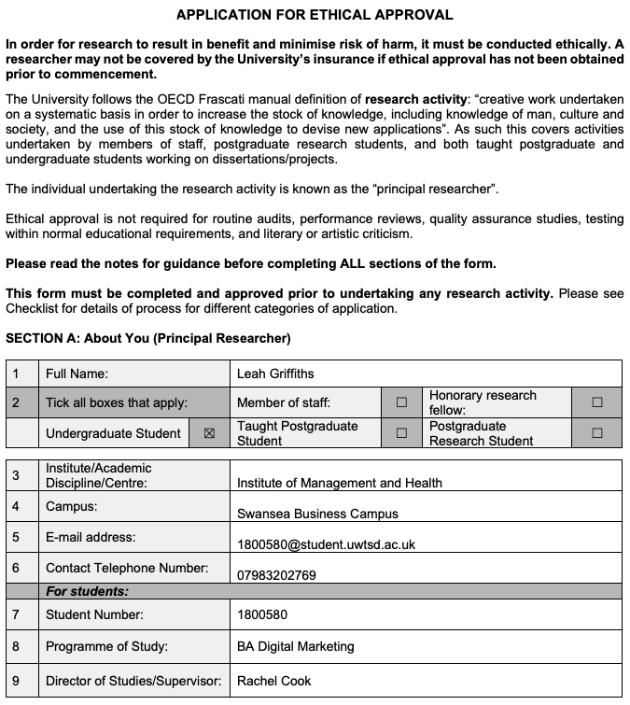

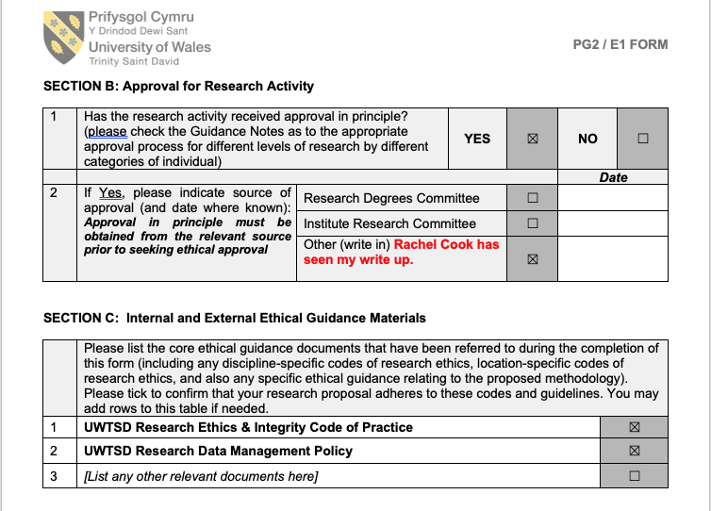
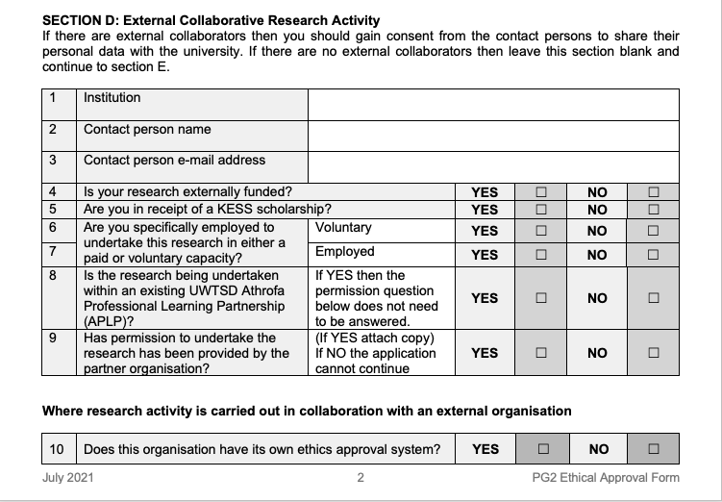
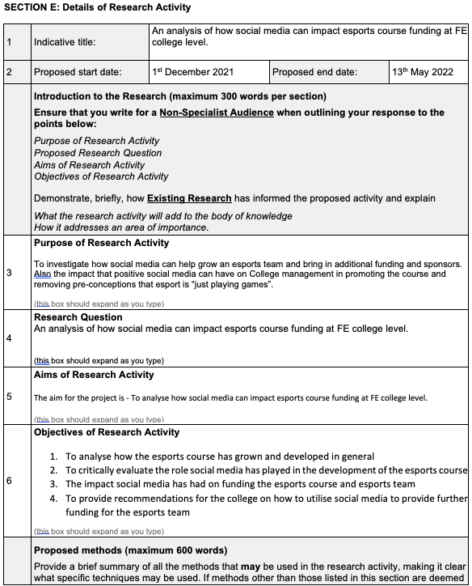

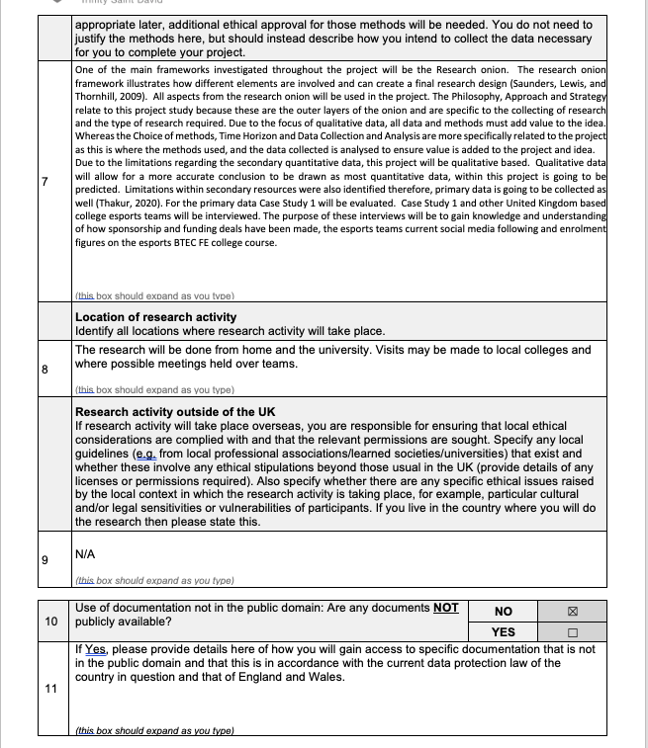
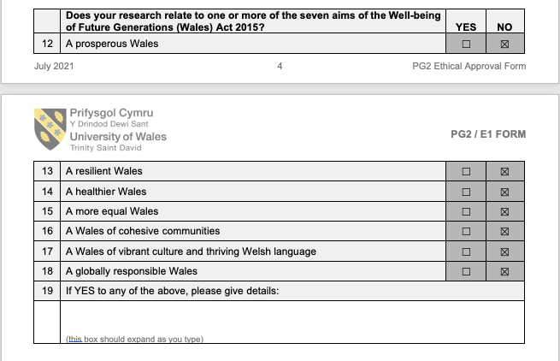

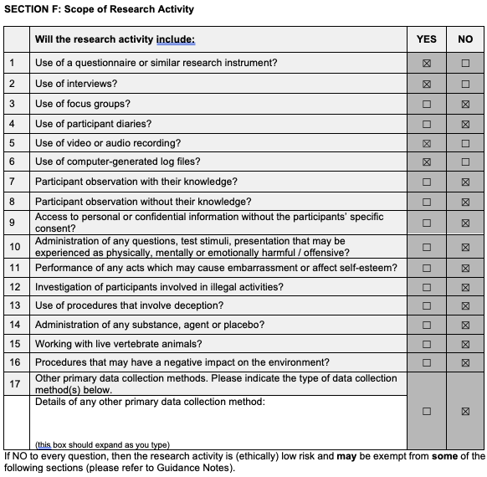

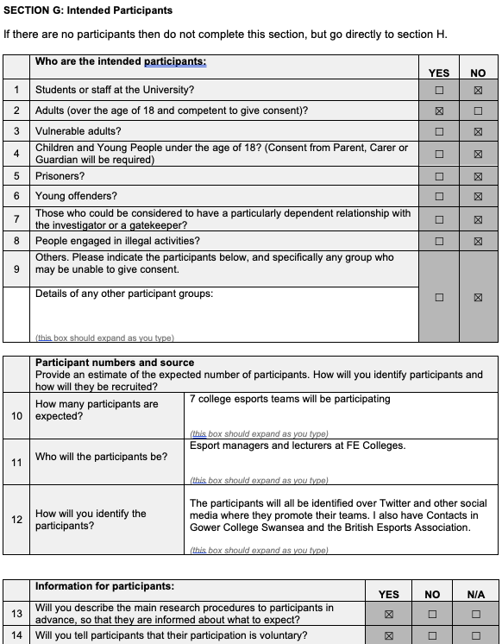

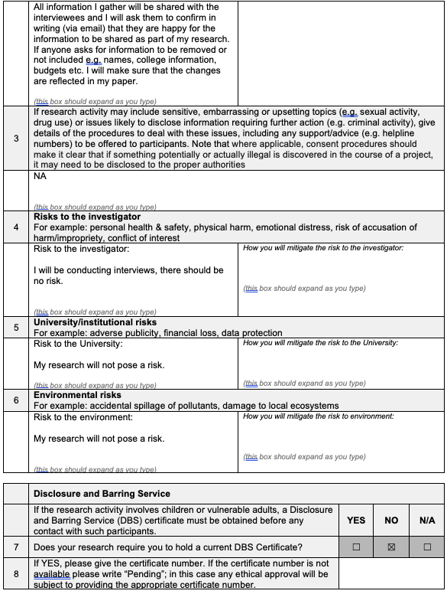

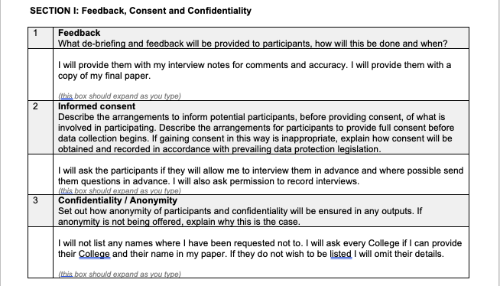
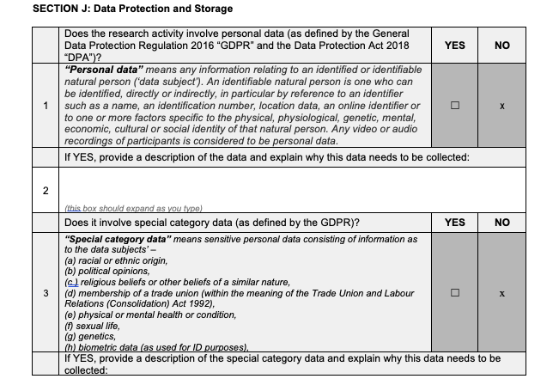

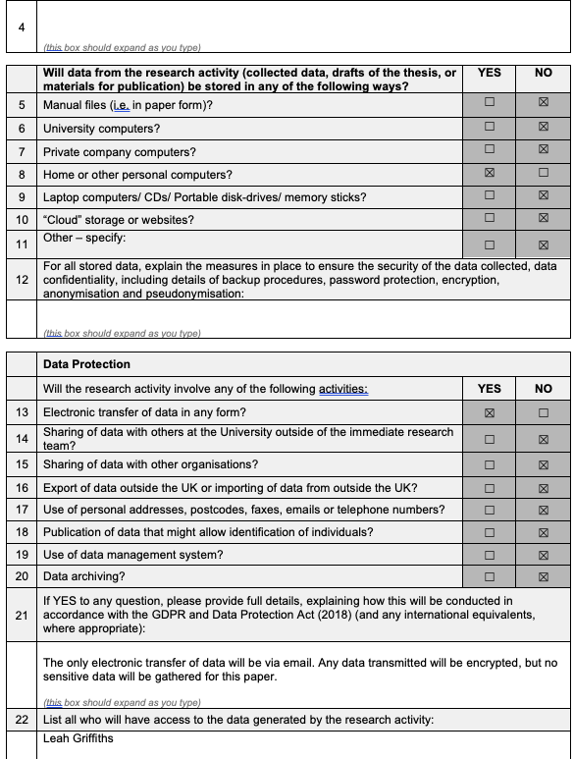

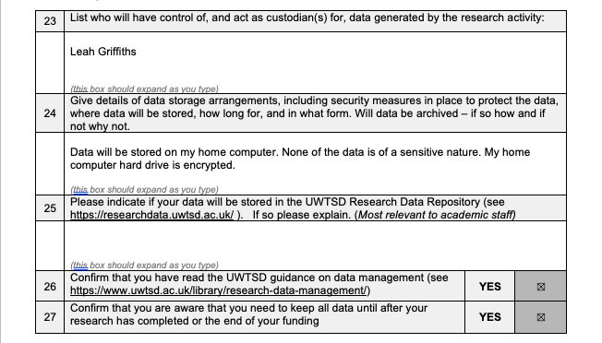
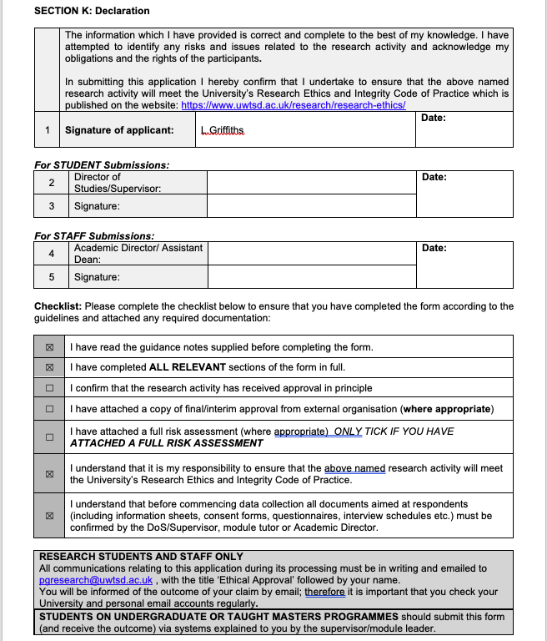

6.2 Interview Questions in Google Forms
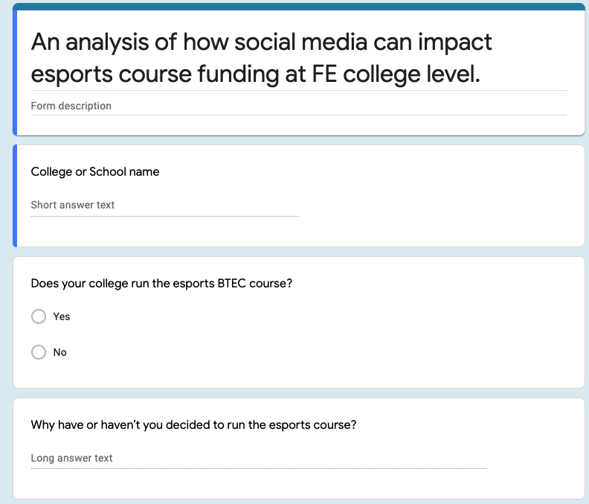

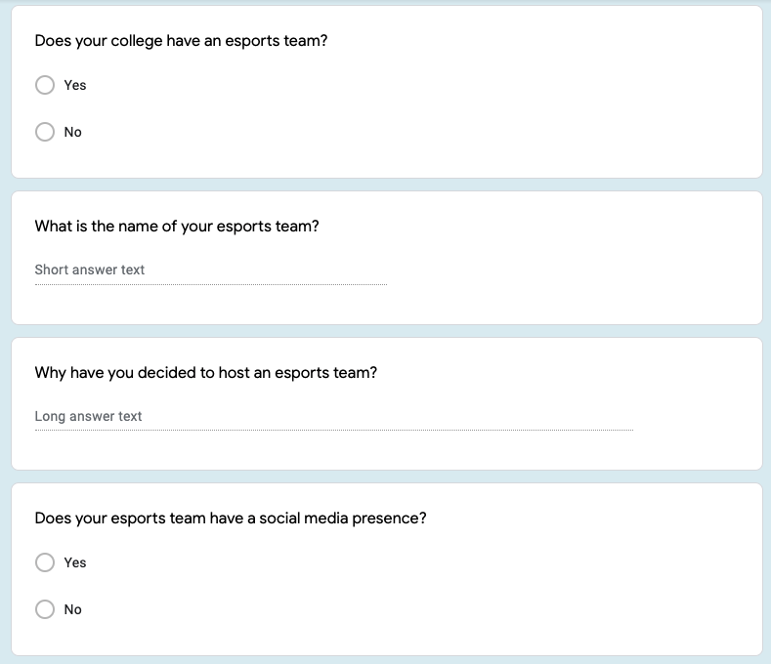

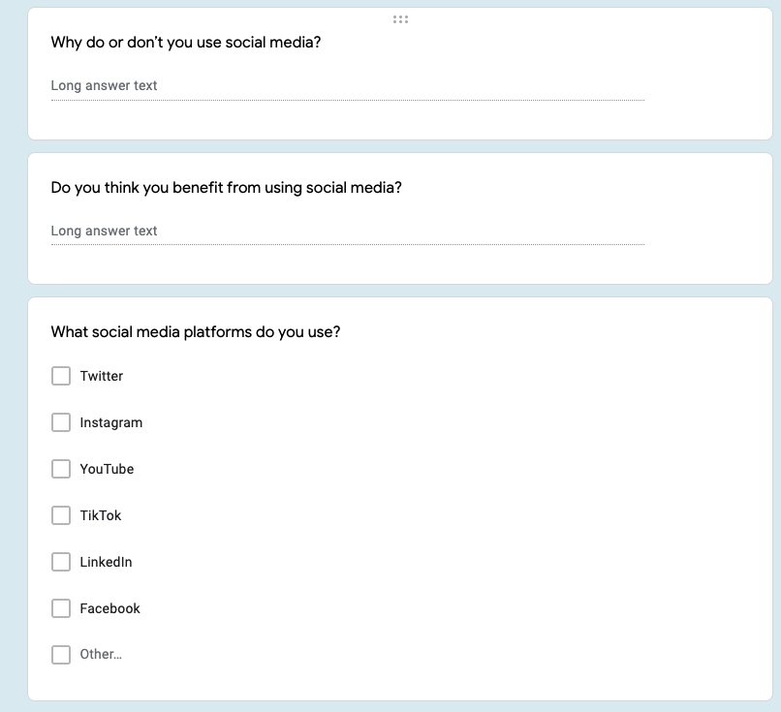
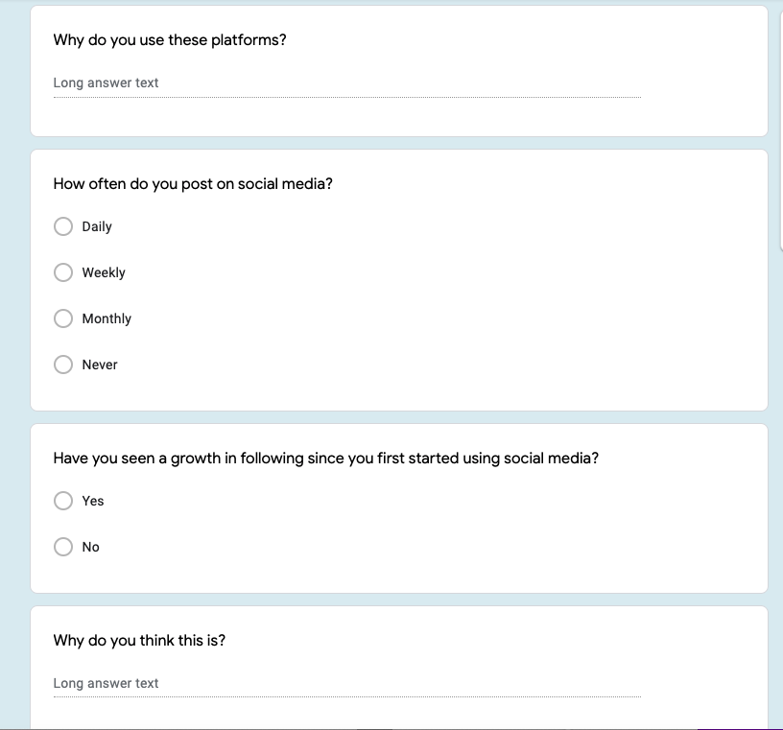
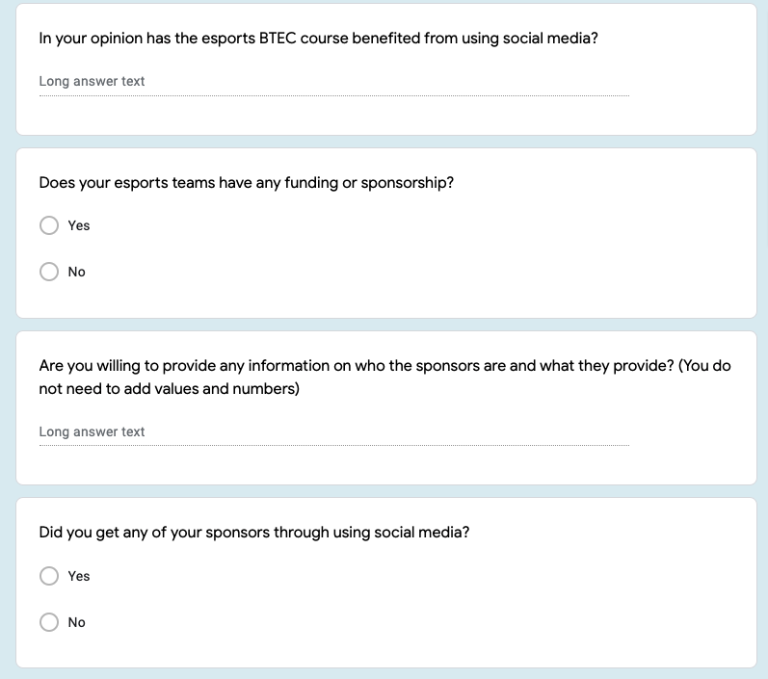
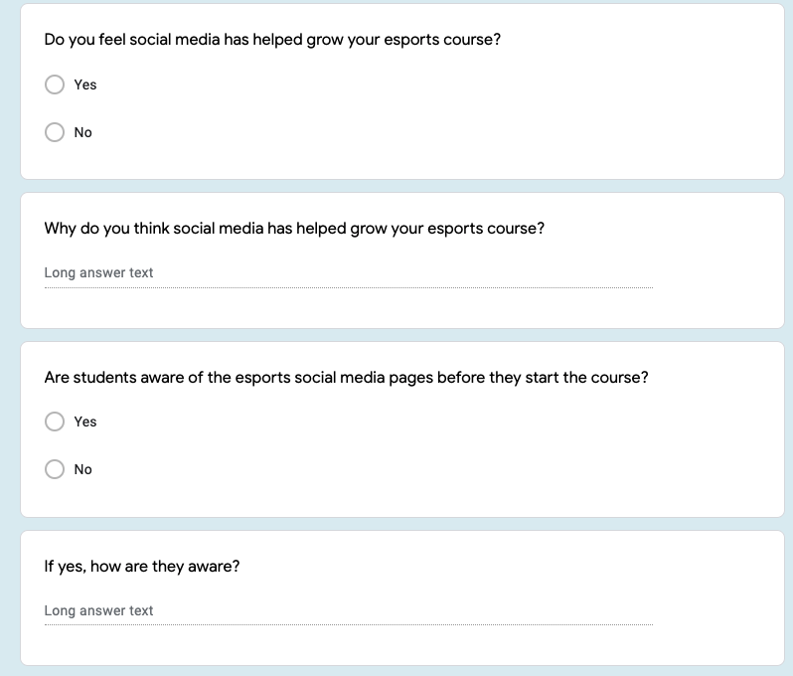

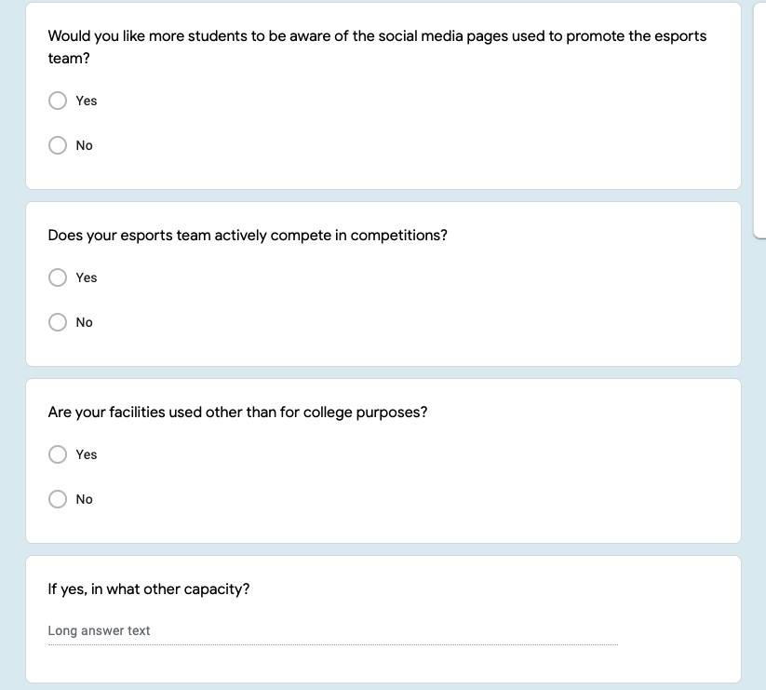
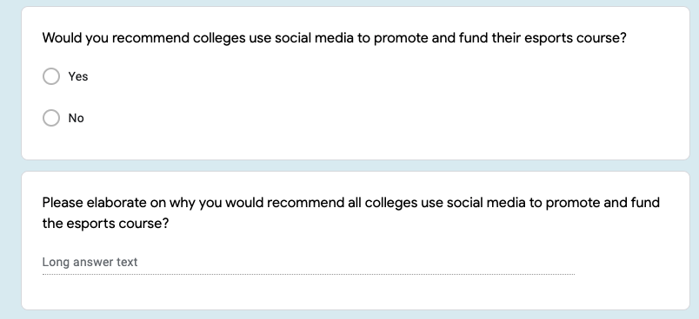

6.3 “Does your college run an esports BTEC course” Pie Chart
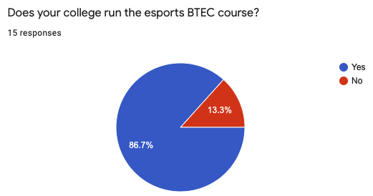

6.4 Response submitted into form

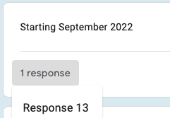

6.5 Response submitted into form

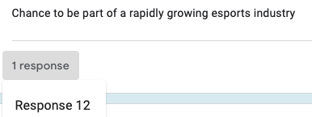

6.6 Response submitted into form
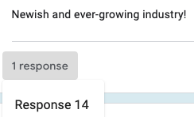

6.7 Response submitted into form
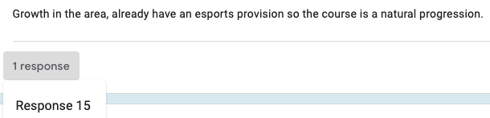

6.8 Response submitted into form
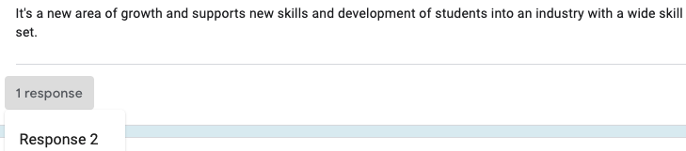

6.9 Response submitted into form
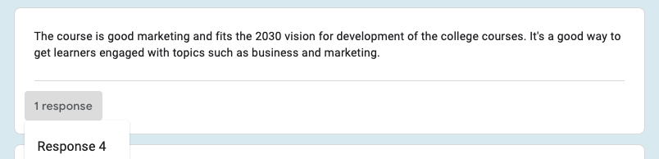

6.10 “Does your college have an esports team?” Pie Chart
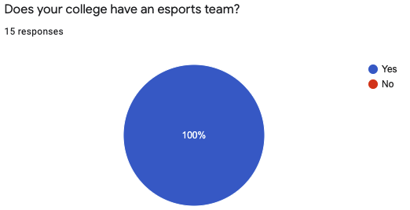

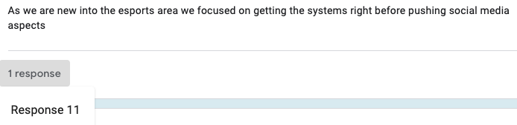
6.11 Response submitted into form

6.12 Response submitted into form
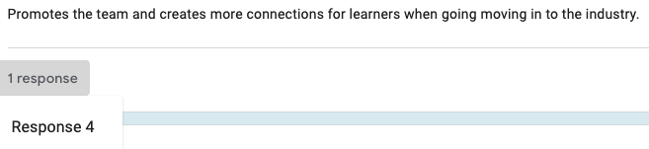

6.13 Response submitted into form
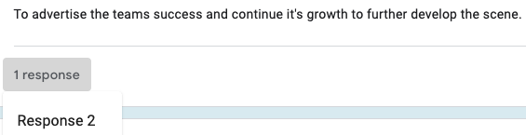

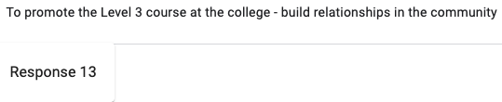
6.14 Response submitted into form

6.15 “What social media platforms do you use?” Bar Graph
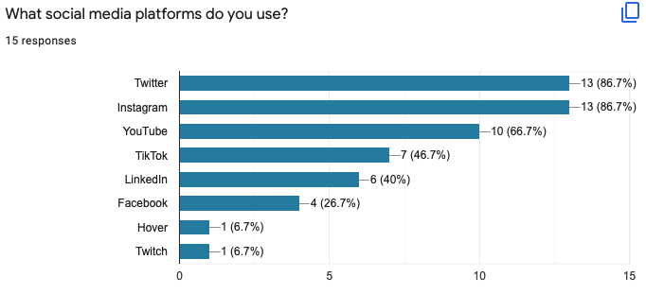

6.16 Response submitted into form
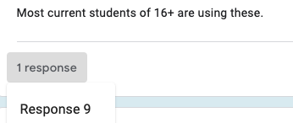

6.17 Response submitted into form
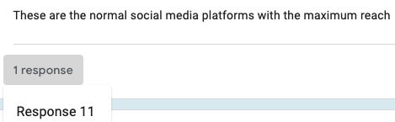

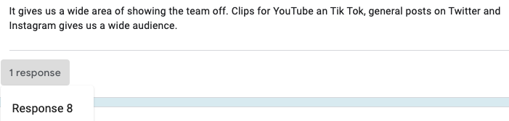
6.18 Response submitted into form

6.19 Response submitted into form
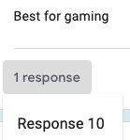

6.20 “How often do you post on social media?” Pie Chart
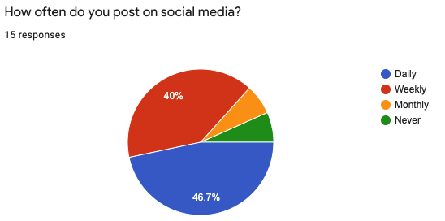

6.21 “have you seen a growth in social media since you first started using social media?” Pie Chart
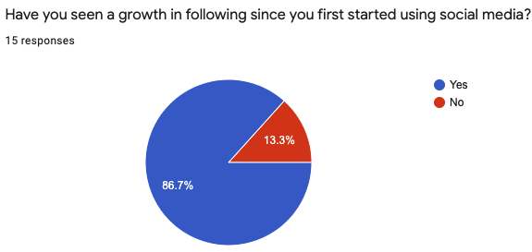

6.22 Response submitted into form
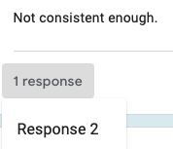

6.23 Response submitted into form
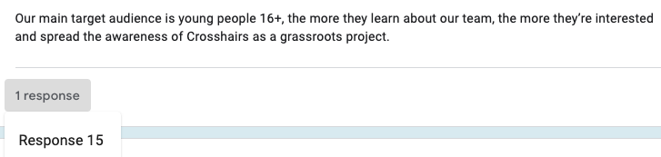

6.24 “Do you feel social media has helped grow your esports course” Pie Chart
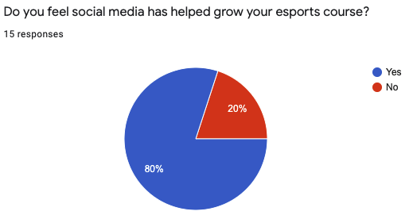

6.25 “have you seen a growth in social media since you first started using social media?” Pie Chart
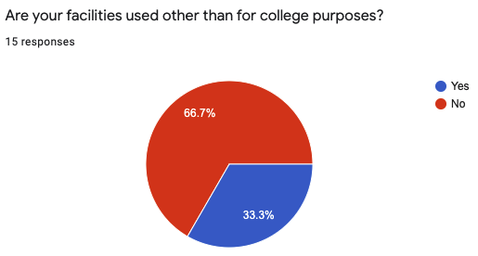

7.0 References

Acatrinei, C. and Puiu, T., (2012). The Loyalty Card: Issues in Evaluating Loyalty Program Effectiveness. International Journal of Economic Practices and Theories, 2(3), p.154.

Adams, K.L., Billings, A.C., Bowman, N., Coble, J., Cranmer, G.A., Devia-Allen, G., Rodgers, E.B.D., Einstein, C., Farquhar, L.K., George IV, J. and Grabowski, M., (2019). Understanding esports: An introduction to the global phenomenon. Rowman & Littlefield.

Akram, W. and Kumar, R., (2017). A study on positive and negative effects of social media on society. International Journal of Computer Sciences and Engineering, 5(10), pp.351-354.

Alanko, J. and Laaksonen, E., (2020). Social Media Marketing and Growth Study For An Esports And Gaming Business. LAB University of Applied Science LTD, pp.3-16.

American Marketing Association. (2021). What is Digital Marketing?. [online] https://www.ama.org/pages/what-is-digital-marketing/

American Marketing Association. (2021). What is Marketing? — The Definition of Marketing — AMA. [online] https://www.ama.org/the-definition-of-marketing-what-is-marketing/

Anguera, M.T., Blanco-Villasenor, A., Losada, J.L., Sánchez-Algarra, P. and Onwuegbuzie, A.J., (2018). Revisiting the difference between mixed methods and multimethods: Is it all in the name?. Quality & Quantity, 52(6), pp.2757-2770.

Armstrong, G., Kotler, P., Harker, M. and Brennan, R., (2012). Marketing: An Introduction. 2nd ed. Pearson Education Limited, pp.15-16.
Auxier, B. and Anderson, M., (2021). Social media use in 2021. Pew Research Center, 1, pp.1-4.

Bajpai, V., Pandey, S. and Shriwas, S., (2012). Social media marketing: Strategies & its impact. International Journal of Social Science & Interdisciplinary Research, 1(7), pp.214-223.

Bandyopadhyay, S., (2016). How a cost-effective social media plan can make a difference for small businesses. Journal of the Indiana Academy of the Social Sciences, 19(1), p.4.

Baron, C., (2020). Social network profile ownership by age UK 2015-2020 | Statista. https://www.statista.com/statistics/271879/social-network-profile-creation-in-the-uk-by-age

Bethea-Hampton, T. and Johnson-Holder, A., (2020), April. Google and Other Applications to Support the Dissertation Process. In Society for Information Technology & Teacher Education International Conference (pp. 1657-1661). Association for the Advancement of Computing in Education (AACE).

Block, S. and Haack, F., (2021). eSports: a new industry. In SHS Web of Conferences (Vol. 92). EDP Sciences pp 4.

British Esports Association. (2016). A brief history of esports and video games - British Esports Association.https://britishesports.org/general-esports-info/a-brief-history-of-esports-and-video-games

British Esports Association. (2020). Education - British Esports Association. https://britishesports.org/esports-and-education

British Esports Association. (2020). Education and esports: Which colleges and universities are offering courses? – British Esports Association. https://britishesports.org/news/education-and-esports-which-colleges-and-universities-are-offering-courses

Casey, K. and Worden, L., (2016). Making Social Media Worth It. Marketing and Outreach for the Academic Library: New Approaches and Initiatives, 7, p.1.

Chaffey, D. and Ellis-Chadwick, F., (2012). Digital marketing: strategy.

Chaffey, D. and Ellis-Chadwick, F., (2019). Digital marketing: strategy, implementation, and practices. 7th ed. Pearson, pp.82-86.

David Marsh, Selen a. Ercan and Paul Furlong. (2002)

Davis, J., Wolff, H.G., Forret, M.L. and Sullivan, S.E., (2020). Networking via LinkedIn: An examination of usage and career benefits. Journal of Vocational Behavior, 118, p.103396.

Deng, J., Cuadrado, F., Tyson, G. and Uhlig, S., (2016). Behind the game: Exploring the twitch streaming platform. IEEE, p.1.

Derval, D., (2022). Sense of Motion, eSports, and the Future of Entertainment. In The Right Sensory Mix (pp. 159-182). Springer, Berlin, Heidelberg.

Fielding, N., (2010). Mixed methods research in the real world. International Journal of Social Research Methodology, 13(2), pp.127-138.

Foreman, S., (2003). Marketing. SAGE Journal, [online] 15(1), p.10.
Funk, D.C., Pizzo, A.D. and Baker, B.J., (2018). eSport management: Embracing eSport education and research opportunities. Sport Management Review, 21(1), pp.7-13.

Geyser, W., (2022). The Incredible Growth of eSports [+ eSports Statistics]. Influencer Marketing Hub. https://influencermarketinghub.com/esports-stats/

Gharis, L.W., Bardon, R.E., Evans, J.L., Hubbard, W.G. and Taylor, E., (2014). Expanding the reach of Extension through social media. Journal of Extension, 52(3), pp.1-11

Heinz, J. and Stroh, A., (2021). The esports marketing and esports sponsoring. 1st ed. tectum verlag, pp.13-15.

Helmer, O., (1967). Systematic use of expert opinions. RAND CORP SANTA MONICA CA. pp 2-5

Hollist, K.E., (2015). Time to be grown-ups about video gaming: the rising eSports industry and the need for regulation. Ariz. L. Rev., 57, p.823.

Jenny, Seth E., Margaret C. Keiper, Blake J. Taylor, Dylan P. Williams, Joey Gawrysiak, R. Douglas Manning, and Patrick M. Tutka. "eSports venues: A new sport business opportunity." Journal of Applied Sport Management 10, no. 1 (2018): pp .

John, (2021). Esports Organizations in Korea - A Complete Overview for 2021. [online]

Jung, E.H., (2018), December. Age differences in using Facebook: younger adults vs. older adults. In Proceedings of the 30th Australian Conference on Computer-Human Interaction (pp. 590-592).

Seoulz. https://seoulz.com/esports-organizations-in-korea-a-complete-overview-for-2021/
Kane, D. and Spradley, B., (2017). Recognizing esports as a Sport. The Sports Journal, 1, pp.1-2.

Kauweloa, N.S. and Winter, J.S., (2019). Taking college esports seriously. Loading: The Journal of the Canadian Game Studies Association, 12(20), pp.35-50.

Kingsnorth, S., (2019). Digital Marketing Strategy: An Integrated Approach to Online Marketing. 2nd ed. Kogan Pages, pp.65-72.

Kingston., (2019). Digital marketing strategy: an integrated approach to online marketing. Kogan Page Publishers.

Kotler, P., (2012). Kotler on marketing. Simon & Schuster UK, Page, pp 1 - 3.

Kotler, P., Kartajaya, H. and Setiawan, I., (2021). Marketing 5.0: Technology for humanity. John Wiley & Sons.

Kumar, V. and Nanda, P., (2019). Social media in higher education: A framework for continuous engagement. International Journal of Information and Communication Technology Education (IJICTE), 15(1), pp.97-108.

Lee, J.S., Wu, M., Lee, D., Fleming, L., Ruben, L., Turner, T., Brown, K. and Steinkuehler, C., (2020). Designing an interest-based integrated curriculum around esports. International Journal of Designs for Learning, 11(3), pp.78-95.

Levitt, H.M., Bamberg, M., Creswell, J.W., Frost, D.M., Josselson, R. and Suárez-Orozco, C., (2018). Journal article reporting standards for qualitative primary, qualitative meta-analytic, and mixed methods research in psychology: The APA Publications and Communications Board task force report. American Psychologist, 73(1), p.26.

Lehnert, K., Walz, A. and Christianson, R., (2020). The booming eSports market: a field day for fans. Journal of Business Strategy pp122-128.

Marsh, D. Selen., A Ercan and Furlong.,P (2018). Theory and Methods in Political Science. 4th ed. p.179.

Martin, G., 2011. The importance of marketing segmentation. American Journal of Business Education (AJBE), 4(6), pp.15-18.

Melnikovas, A., (2018). Towards an explicit research methodology: Adapting research onion model for futures studies. Journal of Futures Studies, 23(2), pp.29-44

Miller, R.M., Chan, C.D. and Farmer, L.B., (2018). Interpretative phenomenological analysis: A contemporary qualitative approach. Counselor Education and Supervision, 57(4), pp.240-254.

Monteiro Pereira, A., Costa, J.A., Verhagen, E., Figueiredo, P. and Brito, J., (2022). Associations Between Esports Participation and Health: A Scoping Review. Sports Medicine, pp.1-22.

Perry, C., (1998). Processes of a case study methodology for postgraduate research in marketing. European journal of marketing.

Pruthi, S. and Bower, J., (2021). How to help your teen navigate social media. [online] Mayo Clinic. https://www.mayoclinic.org/healthy-lifestyle/tween-and-teen-health/in-depth/teens-and-social-media-use/art-20474437

Rindfleisch, A., Malter, A.J., Ganesan, S. and Moorman, C., (2008). Cross-sectional versus longitudinal survey research: Concepts, findings, and guidelines. Journal of marketing research, 45(3), pp.261-279.

Roch, J. and Mosconi, E., (2016). The use of social media tools in the product life cycle phases: A systematic literature review. In 2016 49th Hawaii International Conference on System Sciences (HICSS) (pp. 1830-1839). IEEE.

Safko, L. and Brake, D., (2022). The social media Bible: Tactics, Tools and Strategies for business success. 1st ed. Hoboken, New Jersey: John Wiley & Sons, pp.6-7.

Saravanakumar, M. and SuganthaLakshmi, T., (2012). Social media marketing. Life science journal, 9(4), pp.4444-4451.

Scholz, T., 2019. Esports in Business Management in the world of competitive gaming. 1st ed. Palgrave Pivot, pp.17-20.

Seixas, B.V., Smith, N. and Mitton, C., (2018). The qualitative descriptive approach in international comparative studies: using online qualitative surveys. International Journal of Health Policy and Management, 7(9), p.778.

Singer, D. and Chi, J., (2019). The keys to esports marketing: Don’t get ‘ganked’. McKinsey and Company, pp.1-6.

Sjöblom, M., Hassan, L., Macey, J., Törhönen, M. and Hamari, J., (2018), July. Liking the game: How can spectating motivations influence social media usage at live esports events?. In Proceedings of the 9th international conference on social media and society (pp. 160-167).

Stagno, M. and Constantinides, E., 2011. Journal of Marketing for Higher Education, 21(1), pp.1-3.

Statista. (2019). U.S. teens: most popular social media apps 2020 | Statista. [online] https://www.statista.com/statistics/199242/social-media-and-networking-sites-used-by-us-teenagers/#:~:text=Despite%20Snapchat's%20dominance%2C%20Facebook%20con

Stone, M. and Foss, B., (2001). Successful Customer Relationship Marketing. 1st ed. London: Kogan Page, pp.139 - 144.

Tang, W., (2018). Understanding Esports from the Perspective of Team Dynamics. The Sports Journal, 1 (1), pp1

Target Internet. (2021). Top 9 Digital Marketing Books That Every Marketer Should Read | Target Internet. https://www.targetinternet.com/top-9-digital-marketing-books-that-every-marketer-should-read/

Taylor, (2018). Watch me Play: Twitch and the rise of Game Live Steaming. New Jersey: Princeton University Press, pp 2-4.

Thakur, S., (2020). How to establish the validity and reliability of qualitative research?. Project Guru.https://www.projectguru.in/how-to-establish-the-validity-and-reliability-of-qualitative-research
Support.tiktok.com. (2022). [online] https://support.tiktok.com/en/getting-started

Vien, C., 2015. The future of marketing: Thriving in a digital world. ProQuest, 219(5), p.50.

Vizcarguenaga-Aguirre, I. and López-Robles, J.R., (2020). Mono, mixed or multiple strategies approaches a descriptive study of the latest published articles in the International Journal of Project Management.

Williams, D., Jenny, S., Gawrysiak, J. and Burton, R., (2020). Using Esports Efficiently to Enhance and Extend Brand Perceptions pp10-12.

Xu, L., Yan, X. and Zhang, Z., 2019. Research on the causes of the “TikTok” app becoming popular and the existing problems. Journal of advanced management science, 7(2) pp1

Yuzyk, M. and Seidner, P., (2022). E-Sports Development. In Developments in Information & Knowledge Management for Business Applications (pp. 615-648). Springer, Cham.

Zumstein, D. and Hundertmark, S., (2017). Chatbots – An interactive technology for personalized communication, transactions, and services. Research Gate, 15

