

Daniela Veselinova Vasileva
2235335
BABM
LCBB5001, Entrepreneurship
Amer Kareem

Business plan
HealthyLife

Table of Contents
Business description and market opportunity 2
Industry analysis 5
Operation and management team plan 7
Marketing plan and strategy 8
Financial plan 9
Summary 10
References 11

Business description and market opportunity
According to Hayes (2023) business plan is a detailed plan of your company’s objectives and how to achieve goals in it. Followed his guides, here below is the business plan for HealthyLife:

Business overview
HealthyLife is an innovative online nutritionist service that provides personalised, science-based nutritional advice via user-friendly software. Our mission is to use technology to give accessible, effective, and personalised nutrition solutions to health-conscious people.
Who we are?
HealthyLife is a digital platform that bridges the gap between professional nutritional guidance and modern technology, and clients. Our staff includes qualified nutritionists, dietitians, and health specialists that bring extensive expertise and experience to our clients. We are committed to helping our clients achieve optimal health and well-being through personalized nutrition plans tailored to their specific needs.
HealthyLife is more than simply an online nutritionist service; it is a comprehensive platform dedicated to improve people's health and well-being by providing personalised, science-based nutritional advice and creative digital solutions. Join us on the journey to a healthy lifestyle, one personalised plan at a time.

Mission statement
Our objective is to help people live healthier lifestyles by providing personalised nutritional advice and assistance using modern digital platforms and professional knowledge. We’ll achieve this by combining cutting-edge digital platforms with the knowledge of our professional team. We try to make healthy living accessible, intuitive, and tailored to each individual's specific needs by combining modern technology and a thorough understanding of nutritional science.
Our mission is to inspire and encourage people to embrace healthier lifestyles by providing personalised nutritional advice and support. We are committed to providing personalised treatment that fits smoothly into our clients' lifestyles by using innovative digital tools and the comprehensive expertise of our nutrition professionals. Our goal is to positively impact health and wellness by providing:
1.Personalized Nutritional Plans: Developing dietary guidelines based on each client's personal health goals, preferences, and needs.
2.Innovative Digital Solutions: Using modern technology to provide accessible and convenient nutritional coaching, clients may track their progress and stay inspired.
3.Expert Knowledge: We ensure that our guidance is based on the most recent scientific research and offered by trained nutritionists and dietitians.
4.Holistic Support: This includes not only food needs but also lifestyle elements including physical activity, stress management, and overall well-being.
5.Community Engagement: Creating a supportive community in which people can share their experiences, seek encouragement, and access resources that promote a healthy lifestyle.
By focussing on these basic concepts, we hope to change people's views towards health and nutrition, encouraging long-term wellness behaviours. Our mission is to be a trusted partner in each client's journey to improved health, offering the tools, knowledge, and support they require to succeed.

Description of service
HealthyLife provides a broad range of nutrition services, such as personalised meal plans, nutritional consultations, and wellness tracking. Our unique selling point is our personalised, science-based approach paired with a user-friendly digital interface that makes it simple for users to access and profit from our services.

Ownership structure
HealthyLife is a privately owned business constituted as a limited liability company (LLC), which allows for management flexibility and protects the owners from personal liability.
Legal requirements
The company will follow all applicable healthcare standards, data protection laws (such as GDPR for personal health information), and professional certification criteria for nutritionists.

Intellectual property considerations
HealthyLife's intellectual property portfolio comprises unique algorithms for personalised dietary regimens, a trademarked brand name, and copyrighted software and teaching resources. These assets give us a competitive advantage while also protecting our innovative solutions from imitation.

Market opportunity and needs
A growing number of lifestyle-related health conditions, as well as increased awareness of the importance of nutrition, creates a large need for personalised, accessible, and cost-effective nutrition services.

Target market
Our target market comprises of people aged 21 to 65 who want to enhance their health via improved eating. This group is known for its willingness to invest in health and wellness services, as well as its preference for digital health solutions. Our priority is to answer the specific requirements and challenges of each group within that wide age range.
Detailed demographic breakdown:
Young Adults (21-35)
This sector includes college students, recent graduates, and early-career professionals who are proficient with technology and health-conscious.
Needs - Quick and easy meal plans, advice on stress management through diet, and assistance with fitness objectives.
Preferences include mobile-friendly platforms, app-based tracking, and interaction with fitness equipment.

Middle-aged adults (36-50)
Frequently preoccupied with professions and family commitments, this group wants convenient and effective solutions to preserve their health.
Needs - Balanced diets that fit around busy schedules, family meal planning advice, and weight management strategies.
Preferences include flexible plans, access to expert advice, and educational information about long-term health.

Older Adults (51–65)
This group of people who are going to retire or have already retired, with a focus on maintaining health and vitality.
Nutritional guidance suited to age-related health concerns, such as chronic disease management, bone health, and energy levels.
Preferences include personalised consultations, simple dietary advice, and encouragement to keep an active lifestyle.

Urban and suburban areas - the primary focus is on people who live in cities and suburbs, where there is a higher concentration of health-conscious people and more access to technology.

Market size
The digital health sector, particularly the nutrition section, is growing rapidly. According to recent forecasts, the global digital health market is expected to grow to USD 509.2 billion by 2025, with the nutrition segment playing a prominent role (MarketLine, 2024).

Competitive advantage
HealthyLife differentiates itself in the market with its personalised, science-based approach, user-friendly software, and complete service offerings. Our unique combination of technology and professional expertise delivers high levels of customer satisfaction and loyalty.

Industry analysis

Size and Growth Rate.
The digital health industry is quickly developing, owing to technical developments and higher consumer health awareness. The nutrition industry, in particular, is likely to expand significantly as more consumers seek personalised health solutions.

Sales projections
Positive growth patterns in the digital health market are being supported by technological innovations and increased consumer health awareness, suggesting HealthyLife's robust sales estimates (MarketLine, 2024).

VRIO analysis:
Value - The high demand for personalised nutrition advice demonstrates the significance of HealthyLife's services.
Rarity - Our customised algorithms and comprehensive service bundle provide a unique combination in the marketplace.
Imitability - HealthyLife's unique technology and highly skilled people make it impossible to replicate.
Organisation - Efficient operational processes and solid digital platforms ensure that services are delivered effectively.

valuable | rare | imitability | organized
yes |  |  |  | Competitive disadvantage
yes | yes | yes |  | Competitive parity
yes | yes | yes | yes | Temporary competitive advantage
yes | no | no | no | Unused competitive advantage
yes | yes | yes | yes | Sustainable competitive advantage
(Lucidity, 2022)
Porter’s five forces analysis:
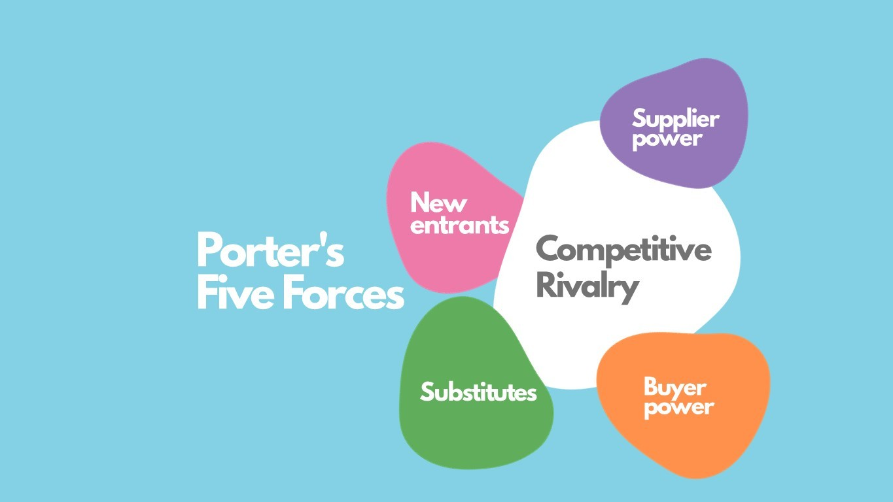
(Mishra, 2020)
• The threat of new entrants is moderate due to low entry barriers in digital health, but significant for patented technologies.
• Suppliers have low, as digital platforms and nutritionists are widely available.
• Buyers have strong bargaining power due to several options available. High, as consumers have many choices.
• Substitute threat: Moderate, with both traditional in-person consultations and free internet alternatives.
• Industry competition is high, with multiple established online nutrition providers.
(Gratton, 2024)

Competitor Analysis
Our biggest competitors are:
1. ”EatingWell”, which provides healthy meals and nutrition guidance. (EatingWell, 2024)
2. ”HelloFresh” offers meal kit delivery services that promote healthy eating. (Hello Fresh, 2019)
3. ”Jane Plan” provides personalised diet plans and meals delivering to customers' homes. (Michell, 2021)

These competitors differ from HealthyLife in that they concentrate on meal delivery or generic nutrition guidance, whereas HealthyLife provides a more personalised and comprehensive digital solution.

Operation and management team plan
Operations and management
HealthyLife's operations include creation of personalized meal plans by nutritionist, blood tests and contact to endocrinologist, suggesting original and healthy meals (according to the meal plan) and providing customer support during the plan.
• Partnerships with certified doctors and laboratories, nutritionists, chefs and providing high-quality support.
• Product Development: Chefs and nutritionists collaborate to create meals according to customers meal plan.
• Efficient distribution ensures timely delivery direct to customers.
• Dedicated customer service team for enquiries and feedback.
HealthyLife intends generating money through direct sales (both online and offline), subscription meal plans, and collaborations with doctors and chefs. Upselling premium meal plans and health consultation services might generate additional money.
Revenue will be earned through subscription plans. Monthly plans start at £20, £50 for three months, and £120 for six months.

Management team
- Daniela Vasileva, CEO, holds a BMBA, with 20 years of industry experience.
- Marketing Director: Master’s degree in marketing and 10 years of expertise in digital health marketing.
- CFO: CPA, MBA, with 15 years of financial management expertise.
- Head Nutritionist: PhD in Nutrition with 12 years of clinical nutrition experience.

These team members will contribute a lot of knowledge and experience, showcasing their capacity to guide HealthyLife to success.
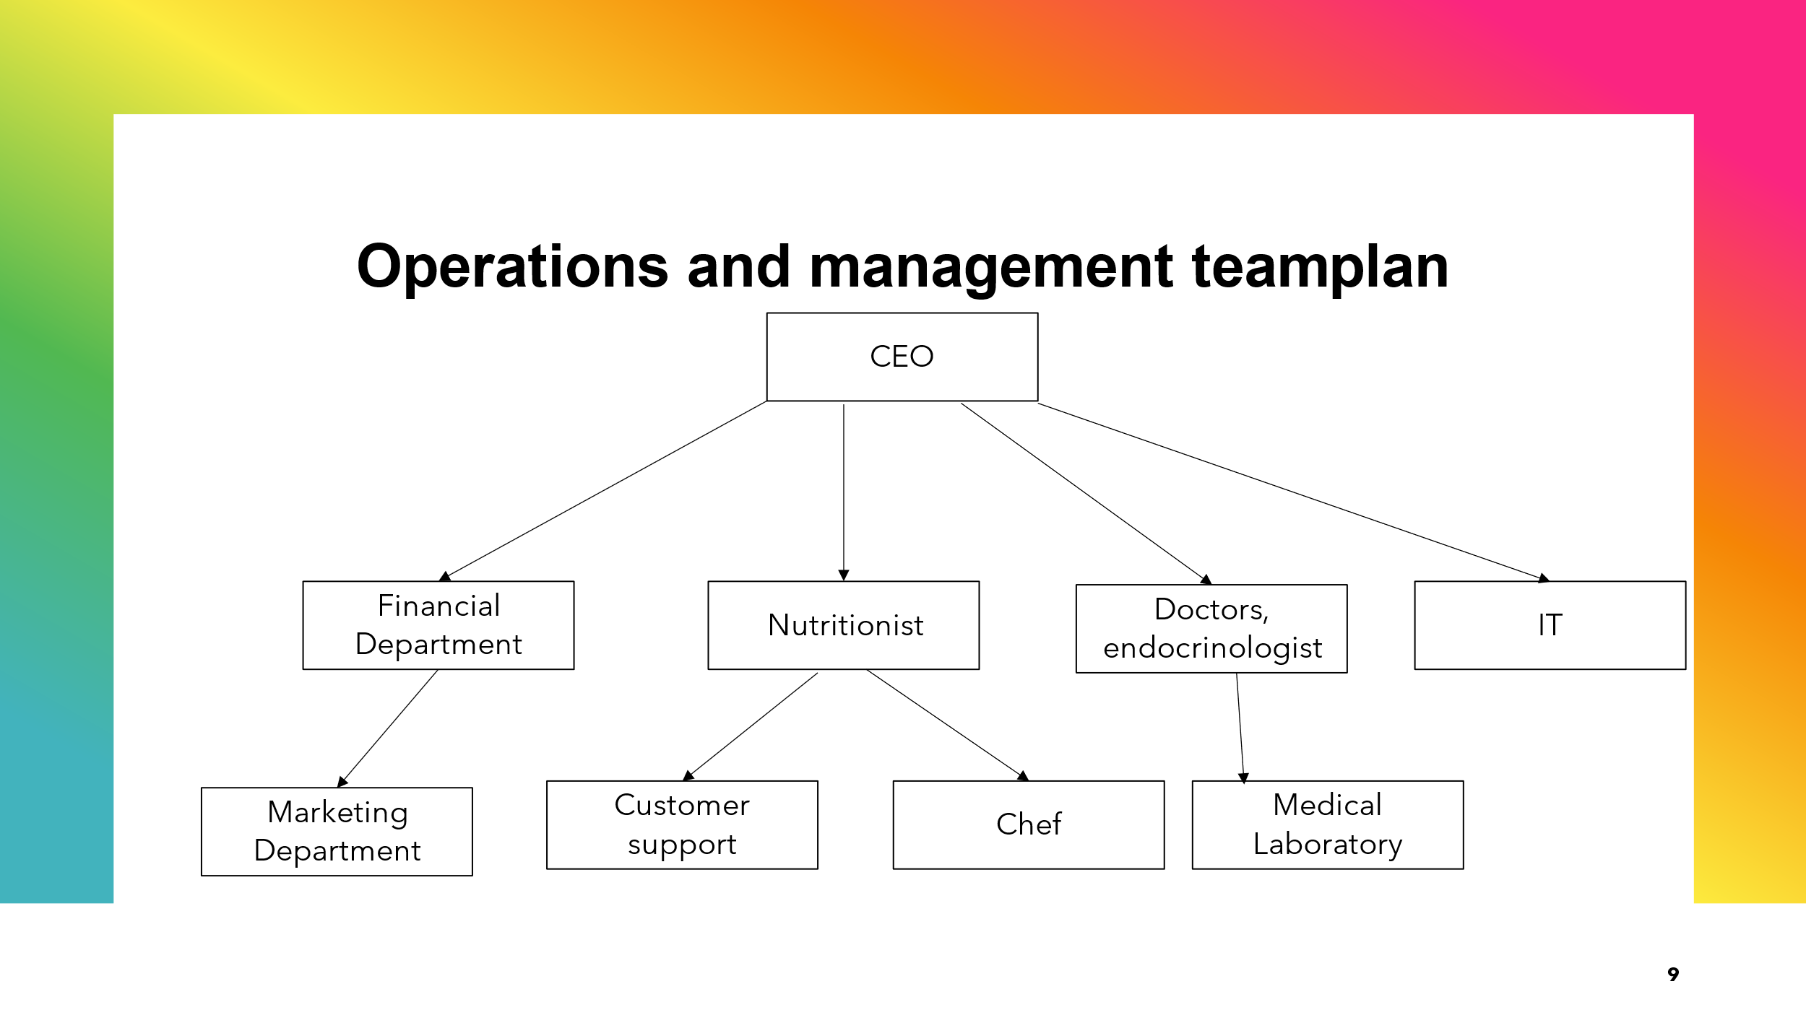

Marketing plan and strategy

HealthyLife’s marketing approach focusses on differentiation via personalised, science-based nutrition services and a user-friendly digital platform.

Positioning and Differentiation
We found ourselves as the leading provider of personalised nutrition solutions, integrating technology to deliver simple and efficient services. Our differentiating points include:
• Personalized plans tailored to individual needs.
• Comprehensive service offering food planning, consultations, and wellness tracking.
• User-friendly software: easy to use and accessible from any device.

Marketing Plan and Strategy
HealthyLife's marketing strategy focusses on increasing brand awareness, focussing product benefits, and building consumer loyalty.
Positioning: As a premium brand, we provide high-quality customer support, well known nutritionist and doctors services, and convenient food preparation for health-conscious consumers.
Our unique selling points include personalized meal plan, based on customer needs and health condition.
(Kotler et al., 2020; Whittington et al., 2020)

Marketing Mix (Four Ps):
• Product: Personalised meal plan.
• Premium pricing strategy corresponds to product quantity, quality, and benefits.
• Promotion strategies include digital marketing campaigns, influencer partnerships, content marketing, and participation in health and wellness events.
• Available via e-platform and subscription-based product.
(Kotler et al., 2020)

Market Entry and Sales Process:
• Launch Campaign: social media, partnerships with health influencers, initial offers, gyms.
• Sales channels include only our e-platform and our website, partnerships with organic food stores.
(Whittington et al., 2020)

Financial plan
Start-up Costs:
- Personal savings: £10,000.
- Technology development, marketing, operational expenses, and legal fees: £250,000.
Financing Options:
- Debt financing: Seeking £250,000 from Dragon’s Den, banks, and other financial institutions.
- Grants: Applying for health tech innovation grants (approximately £50,000).
Costs Breakdown (Yearly):
- Creation of an online platform for nutritionist consultations, customer app, IT support: £100,000.
- Marketing: £50,000.
- Nutritionist and doctor (will be paid per meal plan): £30,000.
- Chef (will be paid per recipe): £30,000.
- Rent for kitchen is £30,000.
- Legal fees are £10,000.

6-Month Cash Budget Forecast

Month | Income (£) | Expenses (£) | Net Cash Flow (£)
January | 50,000 | 40,000 | 10,000
February | 60,000 | 45,000 | 15,000
March | 70,000 | 50,000 | 20,000
April | 80,000 | 55,000 | 25,000
May | 90,000 | 60,000 | 30,000
June | 100,000 | 65,000 | 35,000

HealthyLife intends to achieve financial sustainability by the end of its first year through strategic investments and effective cost management.

Summary
HealthyLife is well positioned to capitalise on the growing demand for preparing of personal meal plans, providing nutritionist, doctors and customer support care. HealthyLife is well-positioned to become a leader in the health and wellness business, thanks to its excellent management team, clear market difference, and solid financial plan.
Investors should expect a profitable business with significant growth potential in a fast-expanding market.
HealthyLife will exceed and exceed consumer expectations by employing new product offerings, efficient operations, and effective marketing, ensuring long-term success and sustainability.
References:
- EatingWell (2024). Healthy Recipes, Healthy Eating. EatingWell. Available at: https://www.eatingwell.com [Accessed 6 Jul. 2024].
- Gratton, P. (2024). Porter’s 5 Forces Explained and How to Use the Model. Investopedia. Available at: https://www.investopedia.com/terms/p/porter.asp [Accessed 1 Jul. 2024].
- Hayes, A. (2023). Business Plan: What It Is, What’s Included, and How to Write One. Investopedia. Available at: https://www.investopedia.com/terms/b/business-plan.asp [Accessed 10 Jul. 2024].
- Hello Fresh (2019). HelloFresh: #1 Recipe Box Delivery Service | Dinner is Solved. @HelloFreshUK. Available at: https://www.hellofresh.co.uk [Accessed 1 Jul. 2024].
- Kenton, W. (2024a). Marketing Mix: The 4 Ps of Marketing and How to Use Them. Investopedia. Available at: https://www.investopedia.com/terms/m/marketing-mix.asp [Accessed 7 Jul. 2024].
- Kotler, P., Armstrong, G., Harris, L.C. and He, H. (2020). Principles of Marketing. Eight European Edition ed. Pearson UK.
- Lucidity (2022). Introduction to the VRIO Framework | Resources | Get Lucidity. getlucidity.com. Available at: https://getlucidity.com/strategy-resources/introduction-to-the-vrio-framework/ [Accessed 4 Aug. 2024].
- MarketLine (2024). Country Analysis Report: United Kingdom, In-depth PESTLE Insights. Uwtsd.ac.uk. Available at: https://advantage-marketline-com.ezproxy.uwtsd.ac.uk/Analysis/details/country-analysis-report-united-kingdom-in-depth-pestle-insights-25880 [Accessed 6 Jul. 2024].
- Michell, J. (2021). Jane Plan. Available at: https://www.janeplan.com/how-it-works [Accessed 7 Jul. 2024].
- NHS Digital (2022). Overweight and Obesity in Adults. NHS digital. Available at: https://digital.nhs.uk/data-and-information/publications/statistical/health-survey-for-england/2021/overweight-and-obesity-in-adults [Accessed 26 Jun. 2024].
- Trainerize (2012). Trainerize | #1 Software for Fitness Professionals. Trainerize.com. Available at: https://www.trainerize.com/ [Accessed 1 Jul. 2024].
- Whittington, R., Regner, P., Angwin, D., Johnson, G. and Scholes, K. (2020). Exploring Strategy. 12th ed. Hoboken: Pearson.

