Module Name: Financial Management for the Hotel Industry
Module Code: BMIH5007
Report Case Study: The City Hotel
Assessment 2
Student Number: 2008329

Table of Contents
Introduction 3
1. An applied formulation of the financial position initiative for The City Hotel 3
2. Identification of fundamental reasons regarding contemporary declined profit in The City Hotel 6
3. Influential presence of turnaround strategies for business development 9
Conclusions 10
References 11

Introduction
An application of financial analysis is essential and attributable to every individual business that provides some specified guidance for the business objective completion. Along with the financial, some of the non-financial measurements are equally influential which represents a contemporary positioning opportunity in relation to the business progress and stability. A proper collaboration of both the financial and non-financial presence provide some accountability growth and an influential approach which is relevant for the expansion of business earnings and operating stability in a proper manner (Salehi and Arianpoor, 2021).
The organisation “The City Hotel” is engaged in providing restaurant, bar and event facilities and currently operates in an urban landscape. However, due to certain uncertainty related to the trade initiative the revenue position, occupancy rates including the level of customer satisfaction significantly declined which represents a certain level of challenging approach for the business. In this report mainly, the evaluations of financial position including the reasons behind such financial consequences and application of turnaround strategies are formulated in association with the marketing consequences.

An applied formulation of the financial position initiative for The City Hotel
An applied initiative of financial performance analysis for every business is necessary that provides a basic understanding including the formulation support of business growth. As per the general recognition, the application of proper financial ratio analysis provides the operating development including the standardised support mainly that is processable for the general accountability and other growth initiatives (Milasinovic et al., 2021). Under the present circumstances, for the evaluation of the current financial position related to The City Hotel, the following measurements are provided that include the revenues, expenditures, profitability, solvency, and liquidity initiative of the business over the provided period. Such details are provided.
Revenue: The engagement of business revenue is considered a relevant approach that represents the financial earning position including the operating stability initiatives that manage the progressive support regarding business values (Alrawadieh et al., 2021). In relation to the present operating position, the revenue structure of The City Hotel indicates a progressive growth initiative as during 2022 the value of business revenue level was 5307480 from the level of 5248290 in 2021. On the other hand, the current year (2023) level of the business indicates the declined level of 2325440 that occurred due to the general market insufficiencies including the demand position reasons that are unable to formulate the earning structure in a proper manner.
Expenses: The application of business expenses generally represents the level of charges that have been initiated for the processing of a business operating position in an effective order. It is formulated for general progress including the compatibility reasons that formulate the general earning statutory initiatives on a proper basis (Alvarez et al., 2021). It can be identified that for this City Hotel, the level of expenditure is mainly expanded up to 4632750 in 2022 from the level of 4584130 in 2021. While the present level of expanses in 2023 expanded to 1106590 in proportion to the present sales position this indicates the expanded level of operating expenditure approach over the business performances.
Profitability: The formulation of a business profit initiative is formulated for the recognition of earning structure on a developing basis that brings the general understanding support of business revenue potential. For the identification of business profitability initiatives, the application support of ratio analysis is mainly considered so that the overall trending initiative level related to this measurement can be evaluated on a more fruitful basis (Panno, 2020). Such ratios for the business are provided:
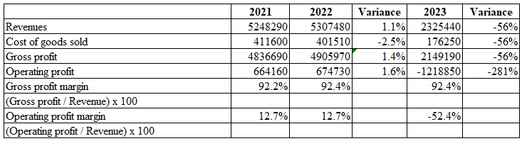
As per the above analysis, it can be recognised that the gross profit margin in the context of ratio analysis represents the same proportionate results compared to the previous year's financial level. However, in the present period of 2023 due to the expanded level of operating charges, the level of earnings declined to the negative position in this business representing the decreasing position initiative in this business mainly. For such, it can be recognised that the operating probability declined from 12.7% to the standard of (52.4%) in 2023. Even the proportionate volume of operating profit declined up to (281%) in the current year while the gross profit declined up to (-56%).
Liquidity: Applications of this measurement are mainly structured for realising the ultimate position of business liquidity or the cash inflow formulations in a specific order that is relevant for the maintenance of business payback initiatives or short-term investment support (Lima Santos et al., 2021). The formulation structure of this analysis for this hotel business is provided with ratios support and trending position bases.
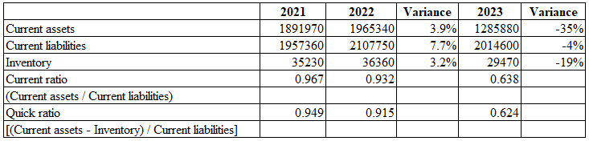
The formulated level of this analysis indicates the general level of declining liquidity approach from 0.96 times development to the standard of 0.93 times, which declined to 0.63 times during the period of 2023. The same proportion is also noticed related to the quick ratio as well from 0.94 times standard to 0.91 times and ultimately up to 0.62 times initiative in the current 2023. The variance analysis on the other hand represents the current assets declining from 3.9% of positive standard to the level of (35%) negative level, while the current liability declined only from 7.7% to (4%) in 2023. A general expanded level of current liability consequences imposes this type of negative impact over the liquidity formulations which is unable for the standardisation of business values. It can be identified that this declining approach mainly occurred due to the reasons of decreasing level of revenue standard as well.

Solvency: It refers to the applicability of an organisation's ability to make the long-term financial obligations and debt approach that ultimately initiated for the measurement support of financial health position and stability growth with indicating capability of debt payment (Akbulaev et al., 2020). The formulation of such analysis for the business is provided in the form of ratio analysis.
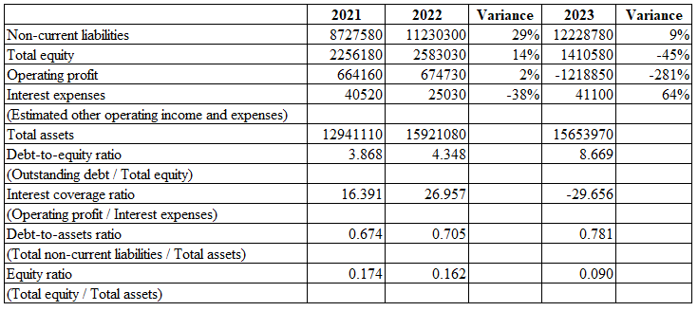
The formulated application of this measurement in relation to the Debt-to-equity ratio indicates are general expanded level from 3.86 times to the standard of 4.34 times, which is expanded up to the level of 8.66 times mainly represents a general dependency approach over the debt capital instead of equity. Additionally, the interest coverage ratio level of the business presently declined up to the standard of (29.655) times initiating a general declined positioning engagement due to the general pressure of the operating cost approach. The primary level related to the standard of equity ratio of the business also represents a certain declining approach which mainly imposes the general reasons for declining revenue and liquidity structure the dependency value of the business over the debt capital is expanded ultimately imposing the Outsourcing financial risk engagement in this business.

Identification of fundamental reasons regarding contemporary declined profit in The City Hotel
As per the identifications the following reasons and mainly noticed in relation to the declined profitability approach over this particular business with the consideration of declined revenue position as well. The general reasons regarding such declined value include.

Geopolitics and world events: In the present positions due to reasons of the Russia-Ukrainian War, primary level of marketing positions including supply chain engagement are significantly declined which initiates a general level of operation challenges for individual hospitality businesses. Due to such reasons with the supply chain disruption, the volume of business revenue in The City Hotel has declined. Additionally, the overall inflation level in the UK is around 2.2% which imposes the expansion approach in relation to the product or service price consequences. The expansion of such an overprice mainly declined the level of business earnings in the current year. The present level of interest charges in the UK is expanded to the level of 5.25% by the BOE which imposes certain difficulties related to the maintenance of borrowing capital engagement in the hospitality business which ultimately imposes the consequences of financial source crisis (Peachey, 2023).
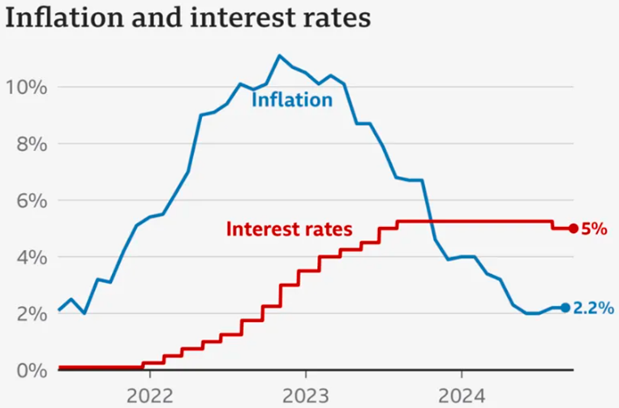
Global warming: As per the primary engagement the temperature anomaly level in the UK currently reached the level of +0.83°C with the GHG emission level in the UK 417.1 MtCO₂e. On the other hand, the annual temperature departure constantly represents a positive volume which currently indicates the level of 1.19 degrees Celsius in the UK imposes a certain volume of negative consequences of Global Warming (Salas, 2023). Due to this excessive level of temperature enhancing approach compared to the previous value currently the volume of tourist engagement is declining imposing a negative impact on the hospitality business and the same consequences is also imposed a negative impact on The City Hotel as well.
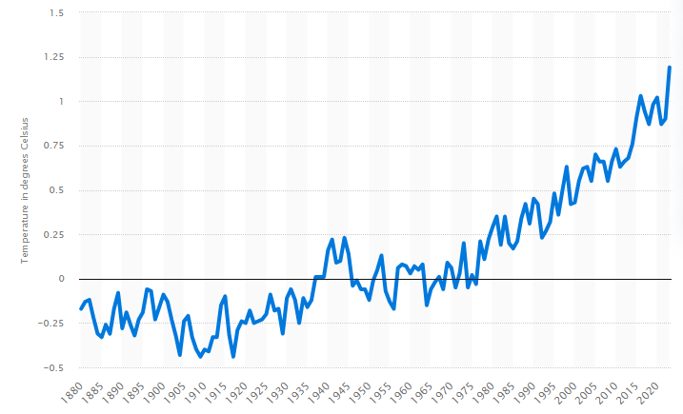
Rise of virtual meetings: In the present scenario, with expansions of the technical advancement support the applicability of Zoom and other video conferencing technology is rapidly rising and as a result, one of the most profitable segmentations for the hotel industry related to the meetings and events are dwindled. As per the analysis during the period of 2021, the overall volume of more than 300 million daily meeting participants on a worldwide basis is noticed via Zoom video Communications which represents a proper level of dependencies approach regarding virtual communication engagement in the present period (correspondent, 2020). As these expansions have progressed, overall engagement in office meeting-related activities within the hospitality industry has decreased, leading to a similar impact at The City Hotel, through declining the revenue position of the business.
Rising labour costs and hotel staff shortages: Currently, the unemployment rate in the UK has decreased to 4.2%, down from a previous high of 8.04%. Despite this overall decline in employment opportunities, the impacts of the ongoing war have created pressures on the labour market. Approximately 9.3 million people are economically inactive, representing around 21.9% of the population. In contrast, average wages have risen by 1.9% over the last three months, accompanied by an increase in bonus requirements of 3% (Powell et al., 2023). In the present position the expansions of labour costs mainly expand the level of operating charges in the business of The City Hotel and as a result, the level of business earnings are also declined.

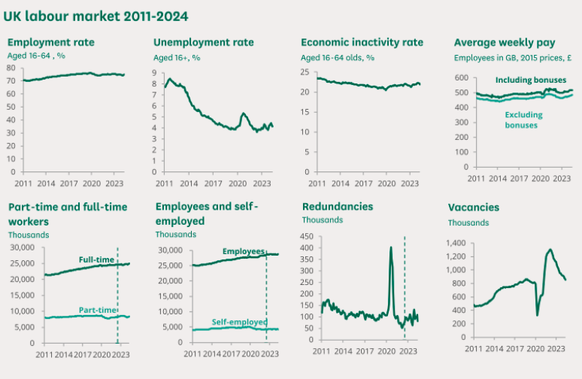
Poor pricing strategies: According to the general initiative the overall price per night of hotels in the United Kingdom is rapidly expanding depending on the economic scenario however the general declined demand and the standard of living decreasing approach mainly impose and negative impact (Thornhill, 2024). As per the basic identification, the average price in a hotel in London is around 158 GBP, while the per week earning level in the UK for an average person is £689 gross (Statista, 2024). This declined standard of living consequences mainly impose a certain level of market insufficiencies that impose and negative impact on the revenue formulations in the hospitality business including in The City Hotel.

Influential presence of turnaround strategies for business development
The applicability of proper strategic attributes with respect to the revenue formulations is supportive of the expansions of business profitability. Depending on the present market scenario and operating consequences the applications of a value-based pricing approach including the availability of a discounting facility will be a sustainable approach for this hotel business for expanding the level of customer retention. To successfully execute the business turnaround plan for The City Hotel, implementing effective strategic attributes is essential for enhancing revenue and driving profitability. Given the current market conditions, a value-based pricing strategy—coupled with flexible discounting options—will be vital for improving customer retention and attracting new guests (Christen et al., 2022). Additionally, fostering a culture of diversity in the workplace will play a crucial role in the turnaround efforts. Emphasizing inclusivity not only supports positive employee engagement but also aids in retaining top talent, which is critical for maintaining high service standards. By cultivating a diverse workforce, we can enhance service quality and innovate our offerings, thereby contributing to sustainable revenue growth (Reidhead, 2020). As part of The City Hotel's business turnaround plan, leveraging artificial intelligence (AI) for customer engagement and booking processes is essential. The integration of AI technologies will enhance operational efficiency and stability, enabling us to attract and retain customers in a competitive urban market, especially against rural hotels (Doborjeh et al., 2022). Depending on the present market initiative, the primary significance of social media engagement is influential for maintaining some promotional attribute for every individual business which will be an accountable standard for the maintenance of stability growth and Business expansion processing. As the primary volume of business debt capital dependency for this particular business is expanded even the level of interest charges are also expanded on a simultaneous basis, a primary focus on the equity capital and internal source of finance development approach will be a supportive attribute for the business standardisations in the upcoming (Awaliyah et al., 2021). The applicability of this type of initiative will be a sustainable approach for this particular business to expand the revenue formulations appropriately and in a standardized order which will be a sufficient attribute for maintaining a competitive involvement with the others.

Conclusion
A general identification of proper accounting approach including the revenue formulation influences the profit initiative structure mainly with the consideration of marketing values. The presence of price elasticity of demand generally represents a proper progressive approach including the value formulation initiatives mainly that provide a progressive attribute regarding business values. General engagement of standard of living initiates sustainable development progress for every business including The City Hotel with the processing of demand structure that is relevant for the maintenance support of revenue initiative in the individual business. The present marketing demand, level of expanded inflation, market uncertainty, operating expansion expansions and other reasons mainly impose a significant level of challenging approach for the City Hotel that brings the general declined profit initiative in this business.
References
Akbulaev, N., Guliyeva, N. and Aslanova, G., 2020. Economic analysis of tourism enterprise solvency and the possibility of bankruptcy: The case of the Thomas cook group. African Journal of Hospitality, Tourism and Leisure, 9(2), pp.1-12.
Alrawadieh, Z., Alrawadieh, Z. and Cetin, G., 2021. Digital transformation and revenue management: Evidence from the hotel industry. Tourism Economics, 27(2), pp.328-345.
Alvarez, T., Sensini, L., Bello, C. and Vazquez, M., 2021. Management accounting practices and performance of SMEs in the Hotel industry: Evidence from an emerging economy. International Journal of Business and Social Science, 12(2), pp.24-35.
Awaliyah, S., Negoro, D.A., Syah, T.Y.R. and Bertuah, E., 2021. Impact of empiris profitability, growth, size firm, tangibility on capital structure of the hotel industry.
Christen, T., Hess, M., Grichnik, D. and Wincent, J., 2022. Value-based pricing in digital platforms: A machine learning approach to signaling beyond core product attributes in cross-platform settings. Journal of Business Research, 152, pp.82-92.
correspondent, R.N.W. (2020). Zoom booms as demand for video-conferencing tech grows. The Guardian. [online] 31 Mar. Available at: https://www.theguardian.com/technology/2020/mar/31/zoom-booms-as-demand-for-video-conferencing-tech-grows-in-coronavirus-outbreak.
Doborjeh, Z., Hemmington, N., Doborjeh, M. and Kasabov, N., 2022. Artificial intelligence: a systematic review of methods and applications in hospitality and tourism. International Journal of Contemporary Hospitality Management, 34(3), pp.1154-1176.
Johnson, M. E., & Wang, S. (2022) ‘Sustainable growth strategies for urban hotels in a post-pandemic world’, International Journal of Hospitality Management, 100, pp. 200-215. doi:10.1016/j.ijhm.2022.102028.
Lee, T. H., & Kim, J. Y. (2021) ‘The role of social media in enhancing customer engagement in the hospitality sector’, Tourism Management, 82, pp. 104-112. doi:10.1016/j.tourman.2020.104112.
Lima Santos, L., Gomes, C., Malheiros, C. and Lucas, A., 2021. Impact factors on Portuguese hotels’ liquidity. Journal of Risk and Financial Management, 14(4), p.144.
Milasinovic, M., Mitrović, A. and Milojević, S., 2020. Financial performance measuring of a hotel company-case study. Challenges of Tourism and Business Logistics in the 21st Century, 3(1), pp.228-234.
Panno, A., 2020. Performance measurement and management in small companies of the service sector; evidence from a sample of Italian hotels. Measuring business excellence, 24(2), pp.133-160.
Peachey, K. (2023). Bank of England: What are interest rates? BBC News. [online] 5 Aug. Available at: https://www.bbc.com/news/business-57764601.
Powell, A., Francis-Devine, B. and Clark, H. (2023). UK Labour Market Statistics. commonslibrary.parliament.uk, [online] 9366(9366). Available at: https://commonslibrary.parliament.uk/research-briefings/cbp-9366/.
Reidhead, C., 2020. Impact of organizational culture on employee satisfaction: A case of Hilton hotel, United Kingdom. Journal of Economics and Business, 3(1).
Salas, E. (2023). Land and ocean temperature anomalies worldwide 2020. [online] Statista. Available at: https://www.statista.com/statistics/224893/land-and-ocean-temperature-anomalies-based-on-temperature-departure/.
Salehi, M. and Arianpoor, A., 2021. The relationship among financial and non-financial aspects of business sustainability performance: evidence from Iranian panel data. The TQM Journal, 33(6), pp.1447-1468.
Smith, J. A., & Taylor, R. L. (2023) ‘Leveraging technology for competitive advantage in the hospitality industry’, Journal of Business Research, 145, pp. 12-25. doi:10.1016/j.jbusres.2023.02.007.
Statista. (2024). Average price per night of hotels in big cities UK 2022. [online] Available at: https://www.statista.com/statistics/1371742/average-price-per-night-hotels-in-big-cities-uk/.
Thornhill, J. (2024). Average UK Salary By Age In 2024. [online] Forbes Advisor UK. Available at: https://www.forbes.com/uk/advisor/business/average-uk-salary-by-age/.

