Dietary Development Values in the UK
All these questions do not have a one size fits all answer, but some guidance is needed. Especially when collecting data in terms of this of this as there are potential pitfalls can occur. Within the book composition by foods (McCance and Widdowson’s, 2015, p. 21) it states that errors will arise if foods are classified incorrectly and it is important to ensure that sufficient detail about each food is available to allow the best match to be selected.
Factors that should be considered:
- Are there different versions of food? For example, the type of milk (whole semi-skimmed, 1% fat, skimmed) will affect the content of fat, fatty acids, energy and fat soluble vitamins.
- Is the food raw or cooked, and if cooked, which cooking method was used?
- Is the food known by alternative names or are there local variations in the food name? For example, in Scotland, swede is sometimes referred to as turnip.
- Which part of food was consumed? For example, a chicken breast could be consumed with or without the skin.
Source: (McCance and Widdowson’s, 2015, p. 21)
In the UK we have set a set of dietary and nutritional requirements for distinct groups of healthy people in the UK population. These are not recommendations or goals for individuals. These were set by the committee on Medical Aspects of Food and Nutrition Policy (COMA) in 1991. COMA has since been disbanded and replaced by the Scientific Advisory Committee on Nutrition (SACN) they are responsible for advising the government on diet and health.
DRV’s are divided into several groups based on age, sex and body compositions' I will be specifically looking at the DRVS for male teenagers category(adolescents).

Dietary Reference Values:
There are four categories of DVRS, I have provided a brief description of these below as per the article(British National Foundation,2019).

- EAR (Estimated Average Requirements)
The EAR is an estimate of the average requirement of energy or a nutrient needed by a group of people (i.e. approximately 50% of people will require less, and 50% will require more.
- Reference Nutrient Intakes (RNIs)

The RNI is the amount of a nutrient that is enough to ensure that the needs of nearly all of a group (97.5%) are being met.

- Lower Reference Nutrient Intakes (LRNIs)

The LRNI is the amount of a nutrient that is enough for only a small number of people in a group who have low requirements (2.5%) i.e. the majority need more.

- Safe Intake

The Safe intake is used where there is insufficient evidence to set an EAR, RNI or LRNI. The safe intake is the amount judged to be enough for almost everyone, but below a level that could have undesirable effects.

Figure 1- Nutritional requirements at different life stages
Table 1: Nutritional Requirements at Different Life-Stages
infants | First 4-6 months of life (period of rapid growth and development) breast milk (or infant formula) contains all the nutrients required.  Between 6-12 months - requirements for iron, protein, thiamin, niacin, vitamin B6, vitamin B12, magnesium, zinc, sodium and chloride increase.  Department of Health advice recommends exclusive breastfeeding until 6 months of age with weaning introduced at 6 months.
1-3 years | Energy requirements increase (children are active and growing rapidly). Protein requirements increase slightly. Vitamins requirements increase (except vitamin D). Mineral requirements decrease for calcium, phosphorus and iron and  increase for the remaining minerals (except for Zinc).
4-6 years | Requirements for energy, protein, all the vitamins and minerals increase except C and D and iron.
7-10 years | Requirements for energy, protein, all vitamins and minerals increase except thiamin, vitamin C and A.
11-14 years | Requirements for energy continue to increase and protein requirements increase by approximately 50%.  By the age of 11, the vitamin and mineral requirements for boys and girls start to differ.  Boys: increased requirement for all the vitamins and minerals.  Girls: no change in the requirement for thiamin, niacin, vitamin B6, but there is an increased requirement for all the minerals. Girls have a much higher iron requirement than boys (once menstruation starts).
15-18 years | Boys: requirements for energy and protein continue to increase as do the requirements for a number of vitamins and minerals (thiamin, riboflavin, niacin, vitamins B6, B12, C and A, magnesium,  potassium, zinc, copper, selenium and iodine). Calcium requirements remain high as skeletal development is rapid.  Girls: requirements for energy, protein, thiamin, niacin, vitamins B6, B12 and C, phosphorus, magnesium, potassium, copper, selenium and iodine all increase.  Boys and girls have the same requirement for vitamin B12, folate, vitamin C, magnesium, sodium, potassium, chloride and copper. Girls have a higher requirement than boys for iron (due to menstrual losses) but a lower requirement  for zinc and calcium.

Source: (Pheasant, 2008)

Figure 2- Relationship between various reference values (1991)
According to the Department of Health, (1991) this figure shows the relationship between various reference values of nutrient requirements.
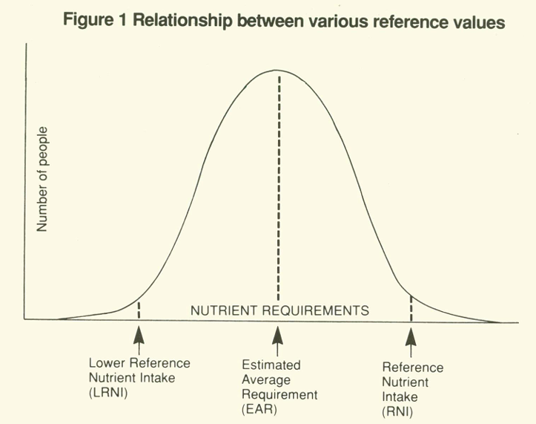

The Lower Reference Nutrient Intake is enough for only a small number of people (about 3% of the population who have low needs). It is not enough for most people. The Estimated Average Requirement for energy or a nutrient is the amount which any stated group of people will, on average, need. The Reference Nutrient Intake is the amount of a nutrient which is enough for at least 97% of the population.
The amount of each nutrient needed differs between individuals and at different life stages. Individual requirements of each nutrient are related to a person’s age, gender, level of physical activity and health status.
The changes in estimated nutritional requirements at different life-stages are outlined in table 1 below: Faculty of Public Health (2010).

According to Lean and Combet (2017, p.148) that teenage athletes energy needs may be 50% greater than those for an average teenager. For someone eating 2,000 calories a day this will be around 225g to 335g of carbohydrates per day. Also within the book barasi’s human nutrition it is said that carbohydrates are an important source of energy for the body, providing glucose for immediate use and glycogen reserves (Lean and Combet (2017, p. 228). Also according to Lean and Combet (2017, p. 228) it is said that even though glucose can be produced from non-carbohydrate sources, the processes are inefficient and potentially harmful and indicate a specific need for carbohydrate in the diet to supply energy.
Within the book it states that intakes in Great Britain, estimated from the dietary and Nutritional Survey of British Adults, were 11.7 g/d of n-6 fatty acids and 1.6 g/d of n-3 fatty acids (Department of Health, 1991, p.39. For a person consuming 2,000 calories a day saturated fat should be less than 10% of daily calories. It is important to limit the level of saturated fats consumed, these can lead to an increased risk of heart disease later in life.
The recommended daily allowance for protein per day for a teenage male is 52 grams per day, protein is needed to ensure the recovery of muscles after physical activity, upping the amount of protein intake can increase muscle mass. According to Department of Health (1991, p. 78) that this evidence suggested that there was relatively little change with age requirements for protein maintenance, values falling from 120mg N/kg/d at one year to 96mg N/kg/d in adults. Within the book also it states that teenagers that are 11-14 years old average weight would be around 43.0kg and the estimated protein requirement is 33.8 g/d (Department of health,1991, p. 79). According to Department of health (1991, p. 79) teenagers 15-18 years old weight would be around 64.5kg and estimated requirement of protein is 46.1 g/d.
During the teenage years bodies rapidly change and develop, the bodies Nutrional needs change and it is more important than ever to consume a varied diet in a bid to meet all the vitamin and mineral needs required to fuel the body. Calcium -helps to ensure teens have strong bones, Vitamin D- helps with strong nones and prevents rickets ,Iron- Helps with growth and muscle development, Zinc-increases the immune system and helps with wound healing, Vitamin B12 Helps make red blood cells and keep nerves working well, Vitamin C –Helps to fight infections, keeping teeth and gums healthy and finally omega 3 contributes to brain development.
The Eat well guide was launched in March 2016 this replaced the previous initiative of the eat well plate launched in 1994 which was revised a 2007 the amendments have been made mainly due to the change of recommendations, dietary requirements and to be easier to understand. The guide is a really good visual guide of food and drinks and in the proportions that they should be consumed. This makes it much easier for male teenagers to have a visual of the foods' they should be eating and the portion sizes they should be consuming to ensure their dietary requirements are meet on a daily basis. This simple format makes it a quick and easy reference to ensure a balanced diet.

The initial initiative worked well but it was thought that further information about diet and nutrition should be made available, especially as recommendations has changed over time.
The revision of segment sizes includes the increase in size Fruit/Vegetables and starchy carbohydrates . The dairy and fats segments have reduced in size, The History of the Eat Well Guide , (2016).

There has also been a change to the visuals the pictures of real food have been replaced with illustrations these looks more refreshing and up to date feel, this is therefore the first official dietary guide that does not use real food in the UK.

In addition to these changes, sugary, fatty and salty foods were removed from the purple “Fats” segment of the plate and placed on the outside, with a reminder that these foods (illustrated with chocolate, biscuits, crisps, ice cream and various condiments such as tomato ketchup) should be eaten less often and only in small amounts.
This was supposed to demonstrate that these foods aren’t essential to our diet – but that they could still be eaten as occasional treats.

Figure 3- The Eat Well Guide (2016)

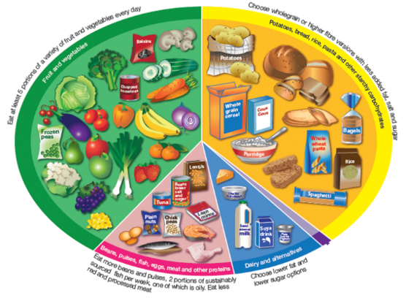

Source: (Henderson,2023)
The conclusion of my assignment has highlighted to me how important DRVS are and how they differ dependant on the specific groups. There is no one size fits all and people can follow the guidelines that have been produced to make it easier to understands. The eat well guide is a really simple visual which means teens can easily refer to this to help them ensure they eating a well-balanced diet and treats are not banned just need to minimise to try to avoid further medical complications. In today's society there are many other aids that help us to understand food and their nutrient value this includes food labelling; this shows a breakdown of the food along with a traffic light system indicating Nutrional value at a very quick glance. This again will appeal to teenagers who often want to make a quick decision regarding foods they will consume.

Reference list
British Nutrition Foundation (2021). Nutrition Requirements. [online] British Nutrition Foundation. Available at: https://www.nutrition.org.uk/media/nmmewdug/nutrition-requirements.pdf.
Department Of Health (1991). Dietary reference values for food energy and nutrients for the United Kingdom : report of the panel of dietery reference values of the committee on mediical aspects of food policy. Hmso.
Department of Health (1991). Dietary Reference Values a Guide. [online] Available at: https://assets.publishing.service.gov.uk/media/5bab995240f0b607130bd49d/Dietary_Reference_Values_-_A_Guide__1991_.pdf.
Faculty Of Public Health (2010). Dietary Reference Values (DRVs), current dietary goals, recommendations, guidelines and the evidence for them. [online] Health Knowledge. Available at: https://www.healthknowledge.org.uk/public-health-textbook/disease-causation-diagnostic/2e-health-social-behaviour/drvs.
Henderson, L. (2023). The History of the Eatwell Guide | Diet & Weight Loss Advice. [online] myBMI. Available at: https://my-bmi.co.uk/education/the-history-of-the-eatwell-guide/.
Lean, M.E.J. (2017). BARASI’S HUMAN NUTRITION : a health perspective, third edition. Taylor & Francis Group.
Mccance, R.A., Widdowson, E.M., Institute Of Food Research (Great Britain, Public Health England and Society, R. (2015). McCance and Widdowson’s the composition of foods. Cambridge: Royal Society Of Chemistry.

Nyle Grahame- 2401415 – March 2025 -Word Count 1991(including reference list)

