MOCK EXAM - Marking KEY

ANSWER ALL THE QUESTIONS

Question 1 [25 Marks]
- A power supply requires 25W of input power and produces an output power of 20W. Calculate its efficiency in percentage and the total power loss. [5 Marks]
Answer:
Efficiency =$\frac{P_{OUT}}{P_{IN}}= \frac{20}{20}=0.8$ [2 Marks]
% Efficiency =$0.8×100=80\%$ [1 Mark]
Total Power Loss $P_{Loss}=P_{IN}-P_{OUT}=25-20=5W$ [2 Marks]
- A solar yard light has a solar collector that can provide 1.0W of power for charging the 3.0V batteries. What is the maximum charging current the solar collector could supply to the fully discharged 3.0V batteries? [4 Marks]
Answer:
$I=\frac{P}{V}=\frac{1}{3}$ [2 Marks]
$I=0.33A$ [2 Marks]
- For the circuit shown in fig.1, calculate the following.
- Equivalent Resistance, [6 Marks]
- Current flowing through $20Ω$ Resistor [3 Marks]
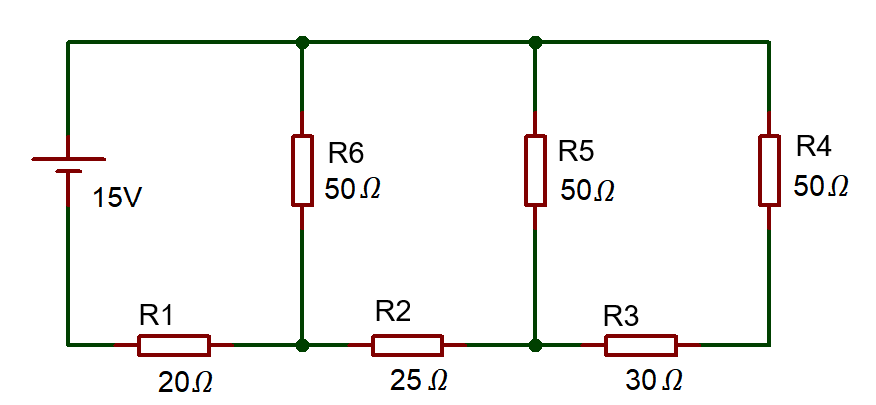
Fig:1
Answer:
- Equivalent Resistance
$\left(R_{4}+R_{3}\right)$ in parallel with $R_{5}$
$R_{eq1}=\frac{{(R}_{3}+R_{4})×R_{5}}{R_{3}+R_{4}+R_{5}}=\frac{\left(30+50\right)×50}{30+50+50}=30.369Ω$ [2 Marks]
$\left(R_{eq1}+R_{2}\right)$ in parallel with $R_{6}$
$R_{eq2}=\frac{{(R}_{eq1}+R_{2})×R_{6}}{R_{eq1}+R_{2}+R_{6}}=\frac{\left(30.369+25\right)×50}{30.369+25+50}=26.274Ω$ [2 Marks]
$R_{eq2}$is series with $R_{1}$
$R_{eq}=R_{1}+R_{eq2}=20+26.264=46.264Ω$ [2 Marks]
- Current flowing through $20Ω$ Resistor
$I=\frac{V}{R_{eq}}=\frac{15}{46.264}=0.324A$ [3 Marks]

- Define Kirchoff’s Current Law. [3 Marks]
Answer:
At any node or junction in an electrical circuit, the sum of currents flowing into that node is equal to the sum of currents flowing out of that node. [3 Marks]

- Define the following terms
- Impedance [2 Marks]
- Peak inverse Voltage [2 Marks]
Answer:
- Impedance
Vector sum of resistance and reactance – Describes total opposition to current – AC and DC circuit property. [2 Marks]
- Peak inverse voltage
The maximum reverse voltage a diode can withstand without breaking down. Exceeding the PIV can cause permanent damage to the diode. [2 Marks]
Question 2 [25 Marks]
- Determine the current across each resistor in the circuit shown in fig.2, using mesh analysis (Kirchhoff’s Voltage Law) [16 Marks]
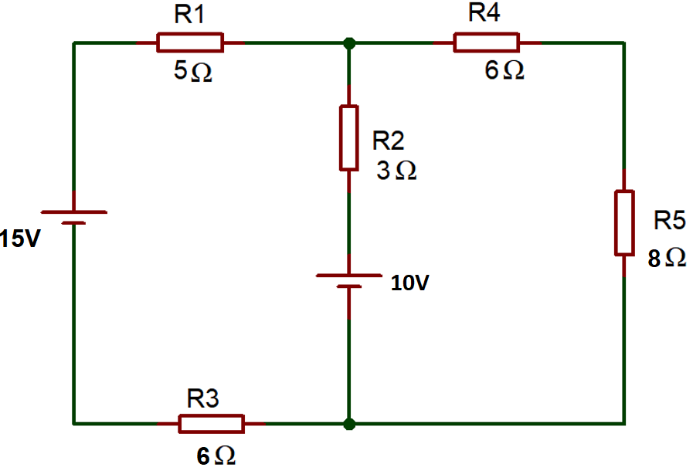
Fig.2
Answer:
Apply KVL in ABEFA
$-5I_{1}-3\left(I_{1}-I_{2}\right)-10-6I_{1}+15=0$ [3 Marks]
$-14I_{1}+3I_{2}=-5$ …………(1) [2 Marks]
Apply KVL in BCDEB
$-6I_{2}-8I_{2}+10+3\left(I_{1}-I_{2}\right)=0$ [3 Marks]
$+3I_{1}-17I_{2}=-10$ …………(2) [2 Marks]
Simplifying Equation (1) and (2)
$I_{2}=0.677A$ [3 Marks]
Substitute, $I_{2}$ in equation (1)
$-14I_{1}+3\left(0.677\right)=-5$
$I_{1}=\frac{7.031}{14}$=0.5022A [2 Marks]
Current across branch BE
$I_{1}-I_{2}=0.5022-0.677=-0.1678A$ [1 Mark]
Current Across $R_{1}and R_{3}=I_{1}=0.5022A$
Current Across $R_{2}=I_{1}-I_{2}=-0.1678A$
Current Across $R_{4} R_{5}=I_{2}=0.677A$
- For the circuit shown in fig 3, determine the following
- Total impedance [5 Marks]
- Circuit current [2 Marks]
- Phase angle [2 Marks]
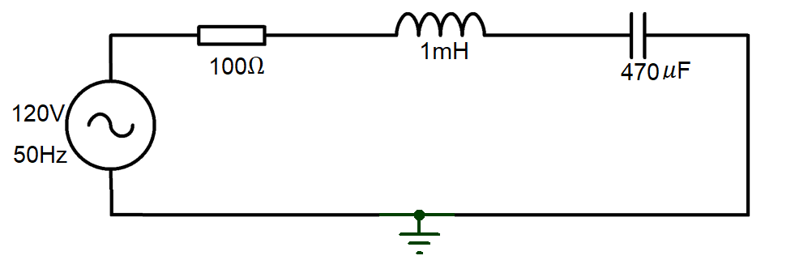
Fig.3
Answer:
- Total impedance
$X_{L}=2πfL=2×π×50×1 mH=0.3142 Ω$ [2 Marks] $X_{C}=\frac{1}{2πfC}=\frac{1}{2×π×50×470 μF}=6.773 Ω$ [2 Marks]
$\left|Z\right|=\sqrt{R^{2}+{\left(X_{L}-X_{C}\right)}^{2}}=\sqrt{{100}^{2}+{\left(0.3142-6.773\right)}^{2}}=100.208 Ω$ [1 Mark]

- Circuit Current
$I=\frac{V}{Z}=\frac{120}{100.208}=1.198 A$ [2 Marks]
- Phase Angle
$φ=\tan^{-1}{\frac{X_{T}}{R}}=\tan^{-1}{\frac{\left(0.3142-6.773\right)}{100}=}-3.695°$ [2 Marks]
Question 3 [25 Marks]
- A 12 V Battery has an internal Resistance of 12Ω, Calculate the power dissipated by various load resistances given in the below table and complete the table. [10 Marks]
Load Resistance (Ω) | Load power (W)
4
8
12
16
20
Answer:
Load Resistance (Ω) | Load power (W)
4 | 2.25
8 | 2.88
12 | 3
16 | 2.938
20 | 2.813
[2 marks for each, maximum of 10 marks]
- A sine wave is observed on a oscilloscope as shown in fig 4. The time setting is 10ms/div and voltage is 3V / div. Estimate the following.
- Peak Voltage [2 Marks]
- Peak to peak voltage [2 Marks]
- Time period of the waveform [2 Marks]
- Frequency [2 Marks]
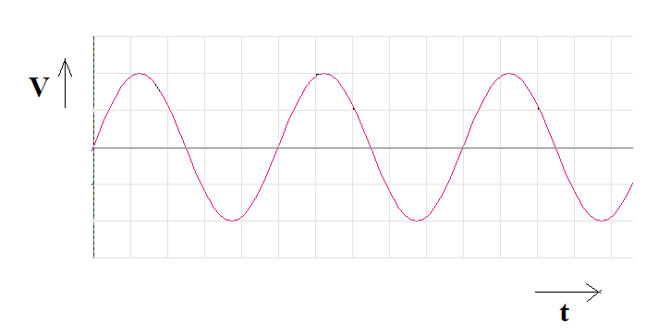
Fig.4
Answer:
- Peak voltage
$Peak voltage=3×2div=6V$ [2 Marks]
- peak-peak voltage
$V_{pk-pk}=4 div ×3 V=12 V$ [2 Marks]
- time period of the waveform.
$Period=5 div ×10 ms=50 ms$ [2 Marks]
- Frequency.
$f=\frac{1}{t}$
$f= \frac{1}{50 ms}=20 Hz$ [2 Marks]

- A transformer steps up voltage from 110 V to 440 V. If the primary coil has 50 turns, how many turns does the secondary coil have? [5 Marks]
Answer:
$\frac{V_{S}}{V_{P}}=\frac{N_{S}}{N_{P}}=\frac{440}{110}=\frac{N_{S}}{50}$ [2 Marks]
$4=\frac{N_{S}}{50}$ [2 Marks]
$N_{S}=200$turns [1 Mark]
- List any two applications of Transistor. [2 Marks]
Answer:
- Transistor as an amplifier [1 Mark]
- Transistor as switch [1 Mark]
Question 4 [25 Marks]
- For the circuit shown in fig5, Calculate the following
- Total resistance in the circuit [6 Marks]
- Total current in the circuit. [2 Marks]
- Current across each resistor [10 Marks]
- the voltage across $R_{7}$ resistor [2 Marks]
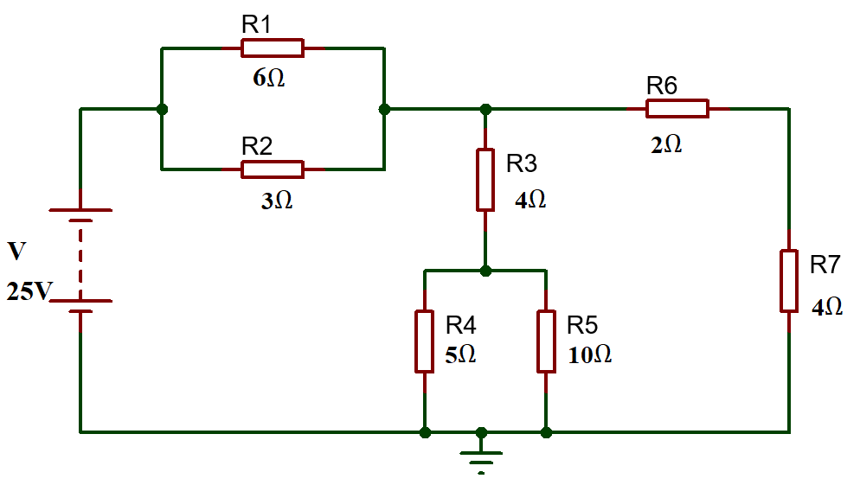
Fig: 5
Answer:
- Total Resistance in the circuit
$R_{1} and R_{2}$ are in parallel
$R_{eq1}=\frac{1}{\frac{1}{R_{1}}+\frac{1}{R_{2}}}=\frac{1}{\frac{1}{6}+\frac{1}{3}}=\frac{1}{0.5}=2Ω$ [1 Mark]
$R_{4} and R_{5}$ are in parallel
$R_{eq2}=\frac{1}{\frac{1}{R_{4}}+\frac{1}{R_{5}}}=\frac{1}{\frac{1}{5}+\frac{1}{10}}=\frac{1}{0.3}=3.33Ω$ [1 Mark]
$R_{eq2} and R_{3}$ are in series
$R_{eq3}=R_{eq2}+R_{3}=4+3.33=7.33Ω$ [1 Mark]
$\left(R_{6}+R_{7}\right)$ in parallel with $R_{eq3}$
$R_{eq4}=\frac{{(R}_{6}+R_{7})×R_{eq3}}{R_{6}+R_{7}+R_{eq3}}=\frac{\left(2+4\right)×7.33}{2+4+7.33}=3.3Ω$ [2 Marks]
$R_{eq4} and R_{eq1}$ are in series
$R_{t}=R_{eq4}+R_{eq1}=3.3+2=5.3Ω$ [1 Mark]
- Total current in the circuit
$I=\frac{V}{R_{t}}=\frac{25}{5.3}$ [1 Mark]
$I=4.71A$ [1 Mark]
- Current across each resistor
Current across $R_{1}$
$I_{1}=\frac{IR_{2}}{R_{1}{+R}_{2}}= \frac{4.7×3}{6+3}=1.57A$ [1 Mark]
Current across $R_{2}$
$I_{2}=\frac{IR_{1}}{R_{1}{+R}_{2}}= \frac{4.7×6}{6+3}=3.14A$ [1 Mark]
Current across $R_{3}$
$I_{3}=\frac{I(R_{6}+R_{7})}{R_{6}+R_{7}+R_{eq3}}= \frac{4.7×(2+4)}{2+4+7.33}=2.1A$ [2 Marks]
Current across $R_{4}$
$I_{4}=\frac{I_{3}R_{5}}{R_{4}+R_{5}}= \frac{2.1×10}{5+10}=1.4A$ [2 Marks]
Current across $R_{5}$
$I_{5}=\frac{I_{3}R_{4}}{R_{4}+R_{5}}= \frac{2.1×5}{5+10}=0.7A$ [2 Marks]
Current across $R_{6}$ and $R_{7}$
$I_{6}=\frac{IR_{eq3}}{R_{6}+R_{7}+R_{eq3}}= \frac{4.7×7.33}{2+4+7.33}=2.55A$ [2 Marks]
- Calculate the current across $R_{7}$ Resistor
$V_{7}=I_{6}R_{7}=2.44×4=10.2V$ [2 Marks]

- What happens when a PN junction diode is forward biased? [5 Marks]
Answers:

- Depletion region narrows, allowing charge carriers to move across the junction.
- Barrier potential reduces, making it easier for electrons and holes to cross.
- Current flows through the diode due to the movement of majority charge carriers. Voltage drop occurs around 0.7V for silicon diodes. [Each 2 marks, maximum of 5 Marks]
Diwedd/End

