

Course: HND in Electrical & Electronic Engineering
Course Code: BL1132FT1
Module: PLCS
Name: Tomos Day
Student ID: DAY15823602
Assignment:
Name of Lecture: Linton Cook
Assignment number: 2
Date due:
Date Submitted:
Submitted via: email

Contents
Introduction 3
Task 1 3
a)Explain the principles of PID control in a PLC system. Your explanation should include a description of the relative effects of each of the three terms (Proportional Integral Differential) 3
B) Provide a detailed description of two tuning methods for PID control. You should give examples of where each method could be applied. Also explain any limitations of the techniques. 4
Ziegler-Nichols step response method 4
Chien-Hrones-Reswick method 5
c) Using the Zeigler Nichols oscillation method, determine the PID control parameters for a plant with an open loop transfer function given by:- (2−𝑠)(𝑠+3)2 5
Task 2 6
Task 3 7
a) Explain the concept of root locus analysis 7
b) Draw by hand a root locus diagram for the systems represented below. In doing so determine the value of K that will cause the system to be unstable. 8
i 8
ii 9
Task 4 10
a) Explain the concept of State Space modelling 10
b) 11
c) Determine the transfer function for a system represented by the following state space 13
conclusion 14
references 15

Introduction
In this assignment it will go over the principles of PID control within a plc system also explaining about relative effects of each of the three terms (proportional integral differential) It will then go onto describing two methods of tuning a PID control.
Next the assignment will show you a way of using Ziegler Nichols oscillation method to determine the PID control parameters for a plant with an open loop transfer function
Going onto task 2 I will look at a system block diagram that will then be used to produce a signal flow diagram that corresponds with the system block , then also showing how to apply the mason gain formula to derive a transfer function for the system.
Task 3 I will explain the concept of root locus analysis explaining all the key components, secondly I will draw by hand a root locus diagram for the systems represented in the assignment brief I will also then determine the value of k that will cause the system to be unstable.
Task 4 will then be explain about state space and what it is used for stating advantages and disadvantages then using what I’ve learnt to then give an example a go , and then finally determine the transfer function of a state space.

Task 1

a)Explain the principles of PID control in a PLC system. Your explanation should include a description of the relative effects of each of the three terms (Proportional Integral Differential)
First off PID stand for Proportional, integral and derivative control. This is a closed loop system. It compares the process variable (feedback variable) with the set point and it generates an error signal and according to that it adjusts the output of system.
PID controllers are an instrument used in industrial control applications to regulate temperature, flow, pressure, speed and loads of other process variables and are to be known to be the most accurate and stable controller.
(eurotherm, 2017)
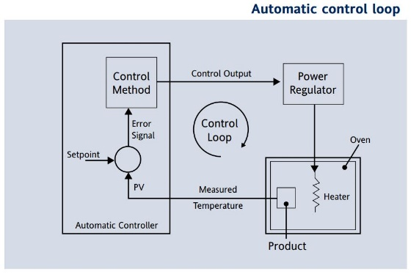
The image is an example of a PID in a heating element.
So, for an example the proportional band is 10 degrees and error signal of 3 degrees will produce an output of 30%. Proportional only controllers will not in general control precisely at setpoint, but with an offset corresponding to the output power equals the heat loss from the system.
The integral term removes

B) Provide a detailed description of two tuning methods for PID control. You should give examples of where each method could be applied. Also explain any limitations of the techniques.

Ziegler-Nichols step response method
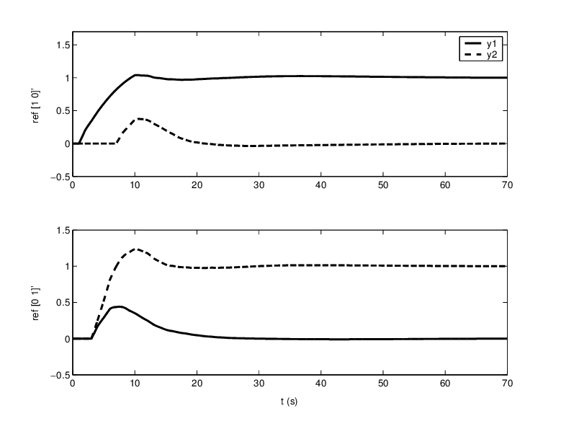
https://www.researchgate.net/figure/Step-response-of-the-system-with-PID-tuned-using-Ziegler-Nichols-formulae-and-ultimate_fig5_224700401

this method conducted numerous experiments and proposed rules for determining values for Kp , Ki and Kd based on the transient step response
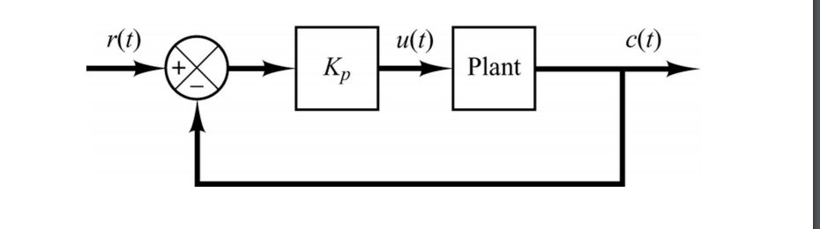
This method seems the standard for PID control. To tune using this method the steps should be like
Remove the integral actions from the controller by setting it to either 0 if it is in units of reset, if in units of integral set it to be very large/ in some controllers that use integral, setting to 0 also removes the integral action.

Next you set the controller derivative to 0 increase the gain of the controller until the loop is continuously cycling in the shape of a sine wave. When cycling, the controller should not be hitting limits after each gain increase, you may need to make a setpoint change to see if the loop oscillates. Record the gain where the loop is continuously cycling as ku. Record the period (time between peaks) of this oscillation as Pu.

Chien-Hrones-Reswick method
Chein hrones reswick method focuses more on the set point response and disturbance response. This method provides formulas for 0% and 20% overshoot. This is also known as a modified version of the Ziegler Nichols method. it was developed in 1952, which provides a better way to select a compensator for process control applications. In industry, controller parameters are often tuned according to CHR recommendation.
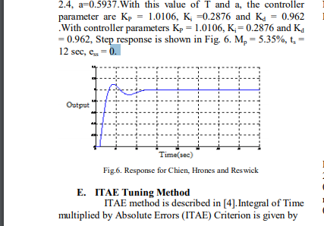
(Raut, 2016)
They proposed that this is the most efficient at 0 % overshoot or 20%

c) Using the Zeigler Nichols oscillation method, determine the PID control parameters for a plant with an open loop transfer function given by:- (2−𝑠)(𝑠+3)2
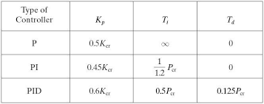

Task 2
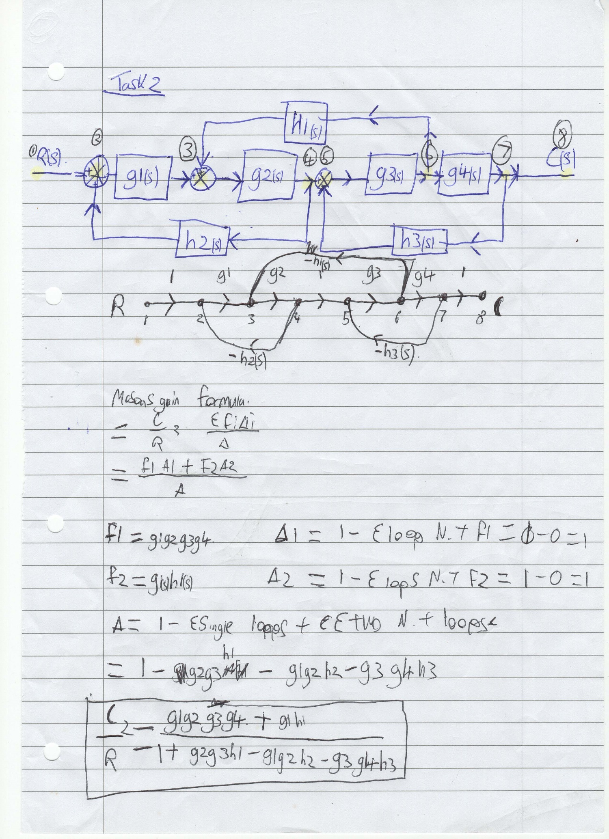

Task 3

Explain the concept of root locus analysis
(UniS, n.d.)

In control theory and stability theory, root locus analysis is a graphical method for examining how the roots of a system change with variation of a certain system parameter, commonly a gain within a feedback system.

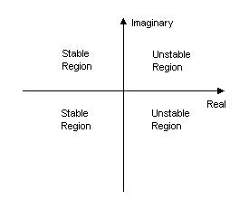
Basically, root locus is a method of many methods that allows to modify our poles (denominator values) the root locus method allows to determine a gain for the transfer function in a open loop system and example of a system is a SISO.

(gutz, 2017)according to this link:

It states that root locus is going out of favour as a practical tool because It gets really complicated by digital sampling models.

When you introduce feedback to a system the solution of the differential equations of motion becomes a transfer function with a characteristic equation in the denominator. The locus of poles and zeros on the phase-plane plot that correspond to the solutions (roots) of the characteristic equation for various feedback gains are the Root Locus. Get it: ‘locus.’ ‘Roots’. When gain is zero the system is open loop and the open loop poles and zeros make the start of the locus. As gain is increased the feedback effects become stronger and different natural responses result.

Draw by hand a root locus diagram for the systems represented below. In doing so determine the value of K that will cause the system to be unstable.

i
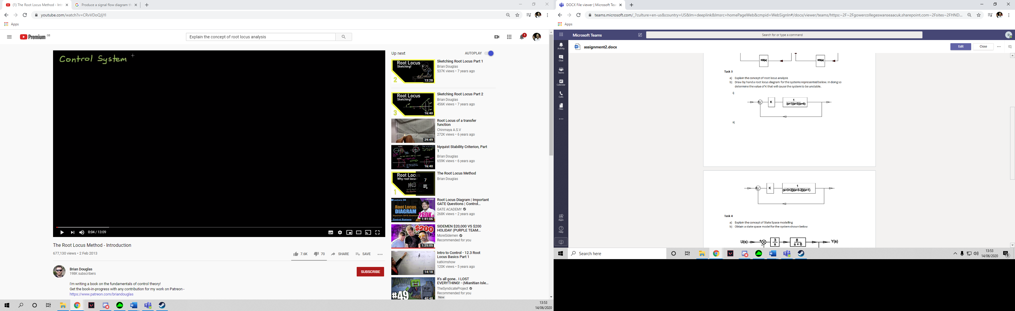
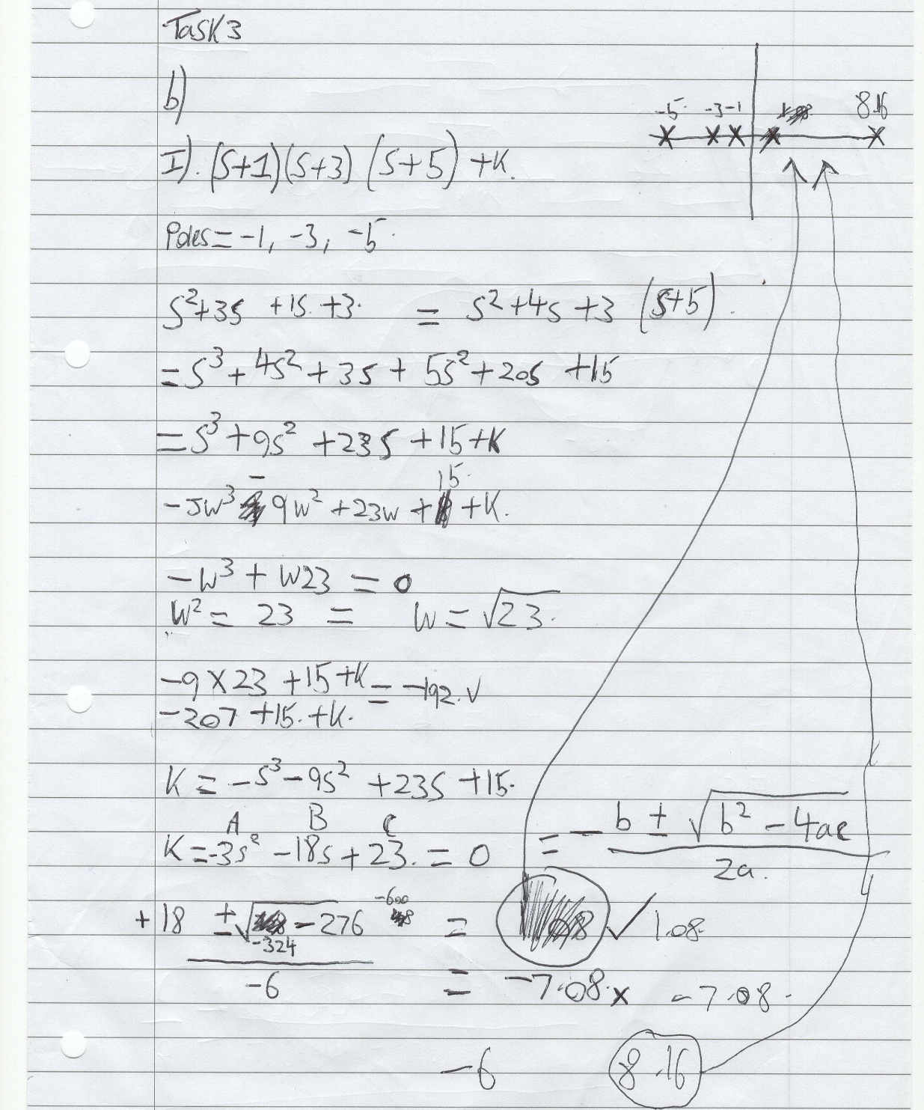

ii


Task 4

Explain the concept of State Space modelling

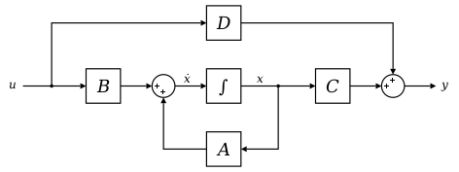
A state space representation is a mathematical model of a physical system as a set of input, output and state variables related by first order. It is a popular technique for forecasting and smoothing series data there are two main components which make up state space models, and observed data and unobserved states, the observed data are conditionally independent given the states.
(oehm, 2018)
The transition probabilities of the states are defined as implying the Markov property of the probability of moving to the next state is only dependent on the previous state for all. The probability of observing at time is given by implying the observed data is conditional on the current state.
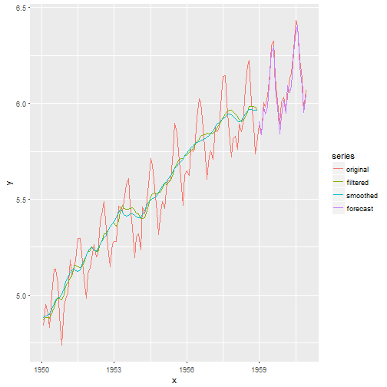
definition from matlab (matlab, present)
State-space models are models that use state variables to describe a system by a set of first-order differential or difference equations, rather than by one or more nth-order differential or difference equations. State variables x(t) can be reconstructed from the measured input-output data but are not themselves measured during an experiment.
The state-space model structure is a good choice for quick estimation because it requires you to specify only one input, the model order, n. The model order is an integer equal to the dimension of x(t) and relates to, but is not necessarily equal to, the number of delayed inputs and outputs used in the corresponding linear difference equation.

b)
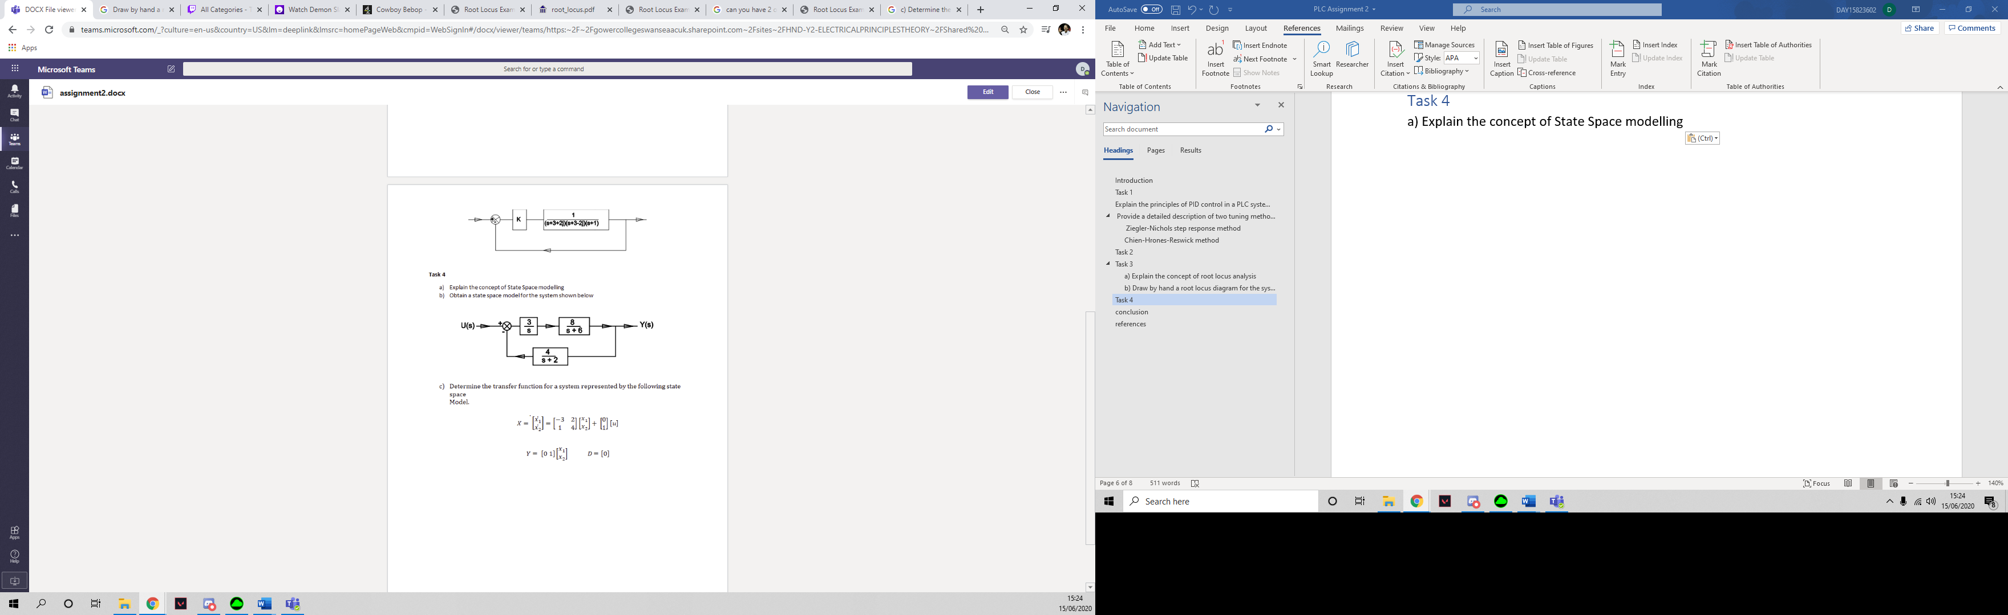
X1
X2
X3
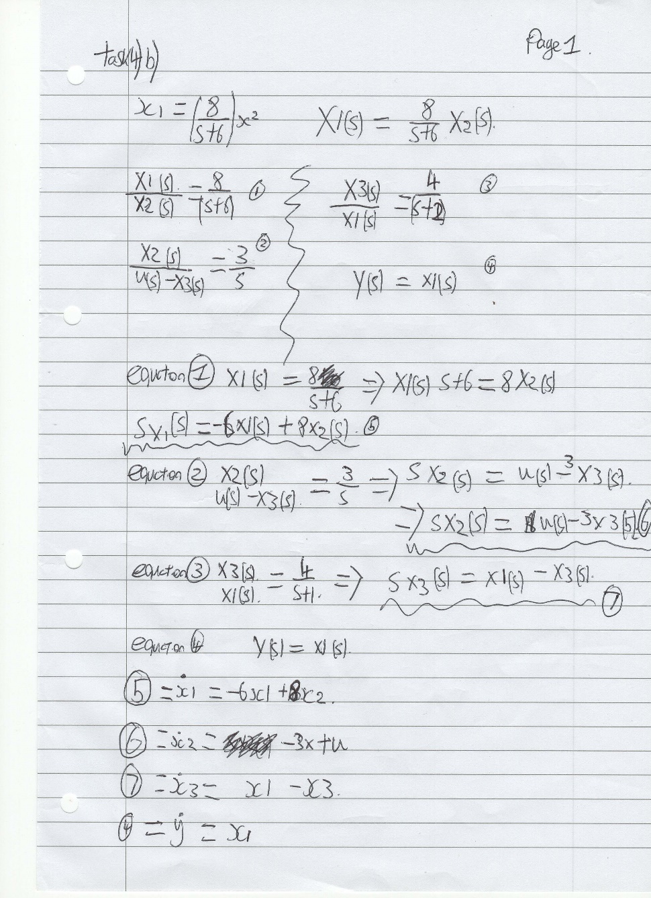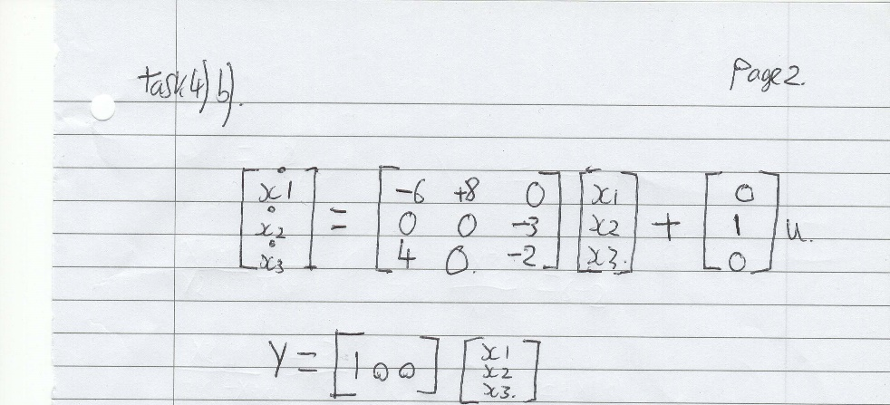

c) Determine the transfer function for a system represented by the following state space
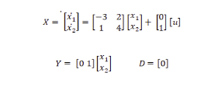
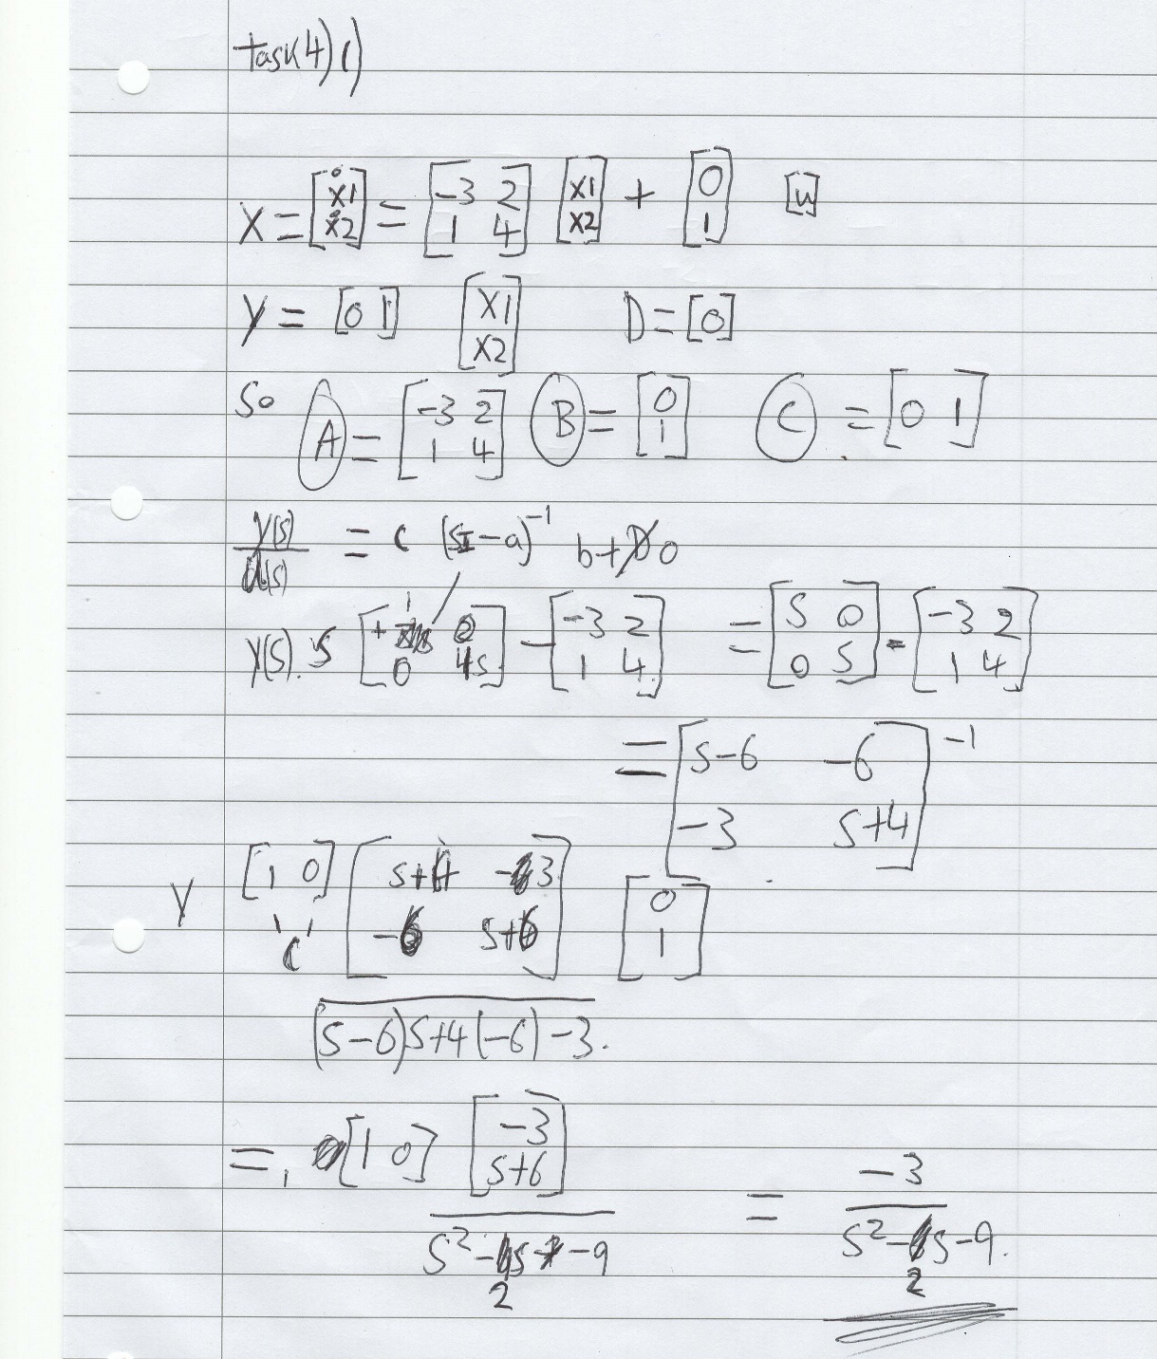

Conclusion
To conclude on the assignment I was able to explain the principles of PID control within plc systems, giving 2 descriptions of two tuning methods being Ziegler Nichols method and chein hrones rewick method , coming to the conclusion that Ziegler felt like a better method ,
Next, we went onto task 2 which was about the mason gain formula given the values you were given we had to work out what the masons gain formula was
next we explained the concept of root locus and explained how over the years different methods are coming out but this one still seems to be the main use even though other practises are slowly becoming the norm over root locus , we next went onto drawing the root locus to understand it a bit better.
Lastly task 4 I explained the concept of state space modelling explain that different methods are being used over as it’s a lot more difficult than other methods next onto using a the state space method and then determining the state space model for a transfer system.
To conclude I was able to reference all the key components I thought that helped me through the assignment.

References
eurotherm. (2017). Retrieved from https://www.eurotherm.com/en/temperature-control-en/principles-of-pid-control-and-tuning/
gutz, d. (2017, 12 29). Retrieved from https://www.quora.com/What-is-the-real-world-application-of-the-root-locus
matlab. (present). Retrieved from https://www.mathworks.com/help/ident/ug/what-are-state-space-models.html
oehm, d. (2018, 5 8). Retrieved from http://gradientdescending.com/state-space-models-for-time-series-analysis-and-the-dlm-package/
Raut, K. H. (2016). Retrieved from file:///C:/Users/tomos/Downloads/1_new_paper_for_international-libre.pdf
UniS. (n.d.). Retrieved from http://www.ee.surrey.ac.uk/Projects/CAL/control/stability.htm

Bibliography
eurotherm. (2017). Retrieved from https://www.eurotherm.com/en/temperature-control-en/principles-of-pid-control-and-tuning/
gutz, d. (2017, 12 29). Retrieved from https://www.quora.com/What-is-the-real-world-application-of-the-root-locus
matlab. (present). Retrieved from https://www.mathworks.com/help/ident/ug/what-are-state-space-models.html
oehm, d. (2018, 5 8). Retrieved from http://gradientdescending.com/state-space-models-for-time-series-analysis-and-the-dlm-package/
Raut, K. H. (2016). Retrieved from file:///C:/Users/tomos/Downloads/1_new_paper_for_international-libre.pdf
UniS. (n.d.). Retrieved from http://www.ee.surrey.ac.uk/Projects/CAL/control/stability.htm

