Name: Safa Ahmed
Student ID: 2124319
Modul Name: Introduction to physiology
Modul code: BMHP5003_LON
Lecturer Name: Olusegun Awolaran
Assessment: 2
Topic: Atherosclerotic disease

1. Introduction
In the normal human body, the blood is transported through arteries, which are organic tubes. To ensure blood flow through these tubes to exchanges from and to the heart and to prevent leaks, they must be in good condition. For the most part, our bodies will keep these tubes maintained. These tubes can be damaged by wear and tear that cannot be repaired with simple maintenance. The inside of these tubes can accumulate particles in some cases, which can lead to problems and blood cannot flow through them easily then it became atherosclerosis disease. Atherosclerosis is a condition in which your arteries narrow, and it is serious disease that affects 50% of people over the age of 40 who are in good health. This risk increases with age. Most people over 60 have some atherosclerosis, but often have no noticeable symptoms. In the UK, there are 3.7 million women and 4 million men who are currently coping with a cardiac or circulatory condition. Aim of this report will be about a health condition of patient (A) how is diagnosed with Atherosclerosis disease. (HRI, 2023)

The Stage of Atherosclerosis Disease
1. The initial stage of a “fatty streak” manifest as a yellow stripe running down the main arteries and can affect children as young as 10 to 14. In the streak you can see cholesterol-filled smooth muscle cells, as well as macrophages, a type of white blood taken from the bloodstream to consume foreign substances. (NHR, 2020)
2. The Fibrous Plaque Stage: Over time, the fatty stripe may develop into a cholesterol-filled fibrous plaque made up of many cell types. The plague develops in the artery's inner layer, and as it grows, it causes the artery's interior, where the blood is flowing, to become narrower. (NHR, 2020)
3. The final stage of atherosclerosis, known as the complicated lesion stage, happens when the fibrous plaque cracks up to reveal the connective tissue and cholesterol beneath. This results in a blood clotting reaction, creating a complex lesion, which is a combination of fibrous plaque and a blood clot. (NHR, 2020)
2. Anatomy and Physiology of Heart
In the human body, the heart pumps blood via the vessels of the circulatory system, providing oxygen and nutrients to the tissues and removing waste products. Blood is carried away from our hearts by our arteries. Various sizes are available, and the walls of these arteries are strong and flexible at the same time. As a result of this flexibility, blood pressure is adjusted and regulated. It is critical that our arteries remain healthy. The body's tissues need constant nutrition to function. The heart's role is to supply blood to organs and tissues. The human heart is in the centre of the chest, slightly to the left of the sternum. A double-walled sac encases it between your lungs and is called pericardium. (Dutfield and Lewis, 2022)
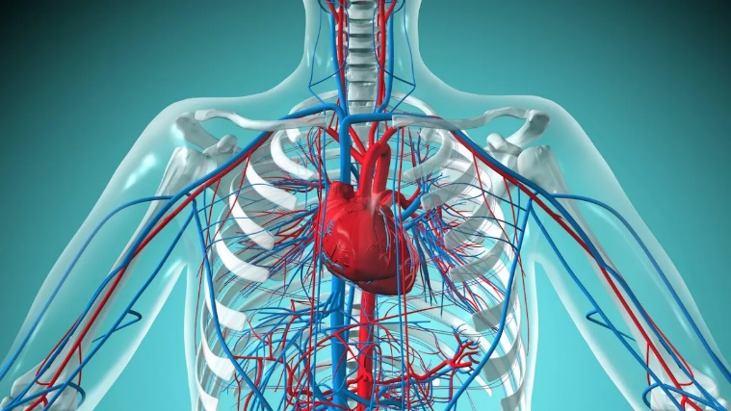
Dutfield and Lewis (2022)
Blood supplied to your heart is oxygen-rich by your body's coronary arteries. When the coronary arteries narrow or harden, atherosclerosis occurs. Better known as coronary artery disease, this type of heart disease is affected by atherosclerosis. Atherosclerosis is where fatty deposits build up on the inside walls of the blood vessels carrying blood away from the heart (arteries). These deposits are called plaques or atheroma’s. In this condition, the artery walls thicken due to plaque build-up. As a result of fatty material and other substances accumulating around the walls of the arteries, they narrow and become hard. The coronary arteries become narrower as they become narrower, making it harder for them to supply blood to the heart. This causes chest pain and other symptoms and ultimately leads to a heart attack. (CVC,2021)
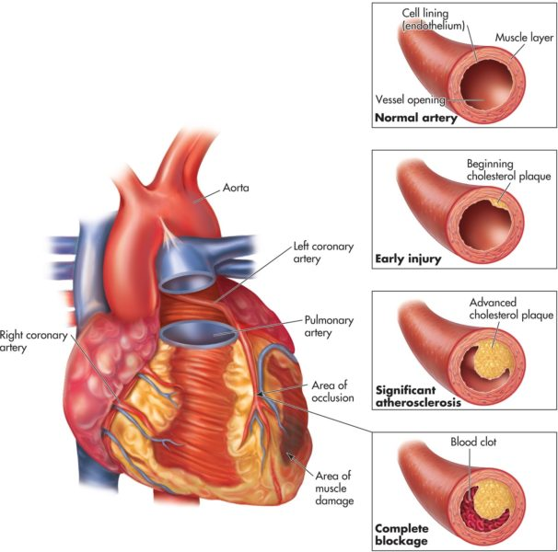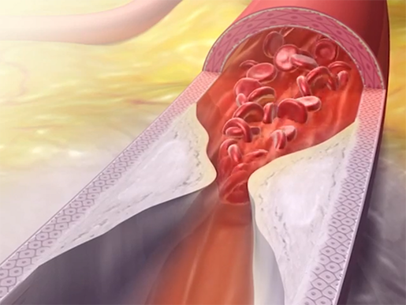
(CVC, 2021) ( visiblebody, 2018)

3. Health and Lifestyle routine measures
Patient A is 50 years old and has been smoking 8-10 cigarettes since being diagnosed with atherosclerosis and he was drinking alcohol one’s a week. He is of black African ethnicity. Also, he has a family history of heart disease. His full-time job is as a manager. The foods he ate were unhealthy, such as high-fat foods and fast food. Sometimes he eats cakes and sweets and adds sugar to his coffee. Usually, he used to walk 30 minute to work every day, but he was not do any exercise. This damage can be caused by a variety of factors, such as high cholesterol, smoking, diabetes, inflammation, and a high heart rate. (NHS)
Health Risks
The process of atherosclerosis often begins as a childhood disease and progresses as we age. Atherosclerosis begins when the inner layer of an artery is damaged or injured. Although the exact cause is unknown, damage to the inner layer can lead to atherosclerosis. There are certain risk factors associated with a CVD diagnosis, such as family history and advancing age. These risk factors can also be managed or changed by individuals with a higher risk. (BHF, 2022)
Several factors contribute to ASCVD's etiologic. The most frequent risk factors are high LDL cholesterol, hypertension, and diabetes mellitus. As Patient A smokes and is 55 years old, A smoker's actions harm nearly every organ in the body, including the heart, blood vessels, lungs, respiratory system, immune system, reproductive organs, digestive organs, bones and more this can increase his health risk and he have a significant family history of heart attacks. He was not eating any health food and he was not exercising. There is evidence that high-density lipoprotein (HDL) cholesterol contributes to ASCVD risks, but pharmacological treatment has produced worse outcomes, raising questions about how HDL cholesterol contributes to the condition. (NHS, 2022)
4. Health and Social Care practice
As part of the National Health Service and British Government's efforts to combat atherosclerosis, they are working hard to advise people about healthy lifestyles and advise them on changes in lifestyle for the future. According to NHS (2020) The government is working to build a new NHS. faster, fairer, more convenient for the patient. A medical system that can respond to the challenges of the new era. Millennium. We have a radical and far-reaching program to transform the NHS But stay true to its value based on need rather than ability to pay.
The changes we are making will tamper with the old NHS over time. Completed a 10-year modernization program. For too long, the treatment and care provided by the NHS was considered superior. In some parts of the country there are more, but not more than others. we are determined. In the future, we will enable people from all regions of our country to come out on top. The quality and treatment and care they need is provided by a local doctor or local government services, general district hospitals, or regional specialty centres. The National Services Framework establishes plans based on evidence of what works. It is best to ensure that these standards of care are available to all in the future. (NHS, 2020)
Also, the public has easy access to consistent, precise, and unambiguous information on how they may contribute to prevention and control. Everyone is actively involved in education, even medical professionals. Must be a member of the public and assist in information dissemination.
Aims to bring the best cholesterol-lowering medication to the UK and make it accessible in a novel and ground-breaking way to a sizable number of vulnerable NHS patients. Unusual partnership to investigate large-scale primary prevention study utilising NHS infrastructure and digital capabilities, speeding up and improving patient accessibility. (GOV, 2020)
The United Kingdom is regarded as a world leader in the creation of similar cutting-edge treatments for the rest of the world. The government of the United Kingdom has stated that it intends to pursue an innovative new collaboration with the pharmaceutical company Novartis with the goal of addressing the major global health issue of cardiovascular disease and attracting significant investment to the world-class life sciences sector in the United Kingdom. The Medicines Company negotiated and signed the current Memorandum of Understanding (MOU), which serve as the proposal's foundation, prior to Novartis' acquisition of the company. Cardiovascular sickness is the world's greatest executioner, as well as the second greatest reason for death in the UK with north of 3,000,000 individuals experiencing atherosclerotic cardiovascular illness. (GOV, 2020)
A regulatory submission to the European Medicines Agency (EMA) is anticipated for the experimental medication incisura for secondary prevention patients in Q1 2020. The intention is to deliver incisura through a population-level agreement following approval and NICE review. By making incisura available to this high-risk group of people, the NHS may be able to fulfil its long-term goal of averting 150,000 cardiovascular deaths over a ten-year period. In the world's first extensive NHS clinical study investigating a novel strategy to treat such a patient group and lower the risk of heart disease in the general population, incisura will be given to primary prevention patients. (GOV, 2020)

5. Recommendations
One of the best strategies to both prevent and improve the signs of atherosclerosis is to make good adjustments to Patient A way of life. The same factors that lower Patient A risk of getting other heart and circulation conditions also lower the risk of developing atherosclerosis, such as: Patient A eating healthier foods, including vegetarian and vegan diets. Eat at least 5 portions of fruit and vegetables every day. Eat some beans, pulses, fish, eggs, meat, and other high-protein foods. Drink plenty of water. Water is healthy for quenching thirst. Plain tea, fruit tea and coffee (without added sugar) are healthy. Even if it's just light exercise, try to be physically active every day. It is recommended that Patient A exercises on at least two days per week to improve strength, balance, and flexibility. Reduce time spent sitting or lying down and break up long periods of not moving with some activity Maintaining an active lifestyle, which enhances heart health, increases energy, and improves sleep. Maintaining a healthy weight will improve your overall health and protect your heart from having to work too hard. limiting your alcohol consumption (to no more than the weekly maximum of 14 units). Giving up tobacco use in general and smoking. Taking medicine, as directed by your doctor, to treat conditions including diabetes, high blood pressure, and high cholesterol. (NHS, 2022)
Also, the UK health guidelines recommend that: Patient A should eat no more than 30g of saturated fat a day. Compare food labels when shopping to choose lower fat foods. It is recommended that he choose dairy products or dairy alternatives that are low in fat or reduced in fat. Food can be grilled, baked, poached, or steamed rather than fried or roasted. You can use an oil spray or measure the amount with a teaspoon. (NHS, 2023)

6. Conclusion
In conclusion Atherosclerosis is very serious health condition it is when your arteries narrow, preventing blood from flowing freely. Heart attacks and strokes are increased by it. It is possible to prevent atherosclerosis from getting worse by modifying one's lifestyle, such as quitting smoking, eating healthier and exercising regularly. There are Stage of Atherosclerosis disease. In this report we have Patient A who diagnosed with Atherosclerosis and changing in his lifestyle can help him to balance the risk of his disease and unhealth lifestyle can be danger for him.

References
1. British Heart Foundation (2022) Am I at risk of getting atherosclerosis? [Online] Available at: https://www.bhf.org.uk/informationsupport/conditions/atherosclerosis#How%20Do%20I%20Prevent%20Atherosclerosis? (Accessed: 15 April 2023).
2. Cardiovascular Consultants (2021) What Is Atherosclerotic Heart Disease? [Online] Available at: https://www.cardiovascularconsultantspc.com/services-specialties/tests-and-procedures/atherosclerotic-heart-disease/ (Accessed:21 April 2023).
3. Dutfield, S and Lewis, T. (2022) Human heart: Anatomy, function & facts [Online] Available at: https://www.livescience.com/34655-human-heart.html (Accessed: 22 April 2023).
4. GOV.UK (2020) UK Government tackles heart disease with new partnership [Online] Available at: https://www.gov.uk/government/news/uk-government-tackles-heart-disease-with-new-partnership (Accessed: 24 April 2023).
5. HRI (2023) The impact of atherosclerosis. [Online] Available at:https://www.hriuk.org/health/learn/cardiovascular-disease/atherosclerosis (Accessed: 10 April 2023).
6. National Health Service (2023) Things you can do to help with atherosclerosis. [Online] Available at: https://www.nhs.uk/conditions/atherosclerosis/?dom=prime&src=syn (Accessed: 18 April 2023).
7. National Health Service (2022) Eating a balanced diet. [Online] Available at: https://www.nhs.uk/live-well/eat-well/how-to-eat-a-balanced-diet/eating-a-balanced-diet/ (Accessed: 26 April 2023).
8. National Health Service (2020) National Service Framework
for coronary heart disease. [Online] Available at: https://assets.publishing.service.gov.uk/government/uploads/system/uploads/attachment_data/file/198931/National_Service_Framework_for_Coronary_Heart_Disease.pdf (Accessed: 27 April 2023).
9. National Health Remedies (2020) What is Atherosclerosis - Stages of Atherosclerosis [Online] Available at: https://www.natural-health-remedies-4u.com/what-is-atherosclerosis.html#:~:text=What%20is%20Atherosclerosis%20-%20Stages%20of%20Atherosclerosis%201,Stage%3A%20This%20last%20stage%20of%20atherosclerosis%20occurs%20when (Accessed: 25 April 2023).
10. Roma Pahwa, R and Jialal, I. (2022) Pathophysiology [Online] Available at: https://www.ncbi.nlm.nih.gov/books/NBK507799/ (Accessed: 25 April 2023).

