

DWSCNN Online Signature Verification Algorithm

by
Ziyao Chen

Supervisor: Dr. Nitheesh Murugan Kaliyamurthy
Second Marker:

Project submitted as part of the requirements for the award of MSc Software Engineering and Artificial Intelligence

September 2023

DECLARATION

I, Ziyao Chen declare that I am the sole author of this Project; that all references cited have been consulted; that I have conducted all work of which this is a record, and that the finished work lies within the prescribed word limits.

This work has not previously been accepted as part of any other degree submission.
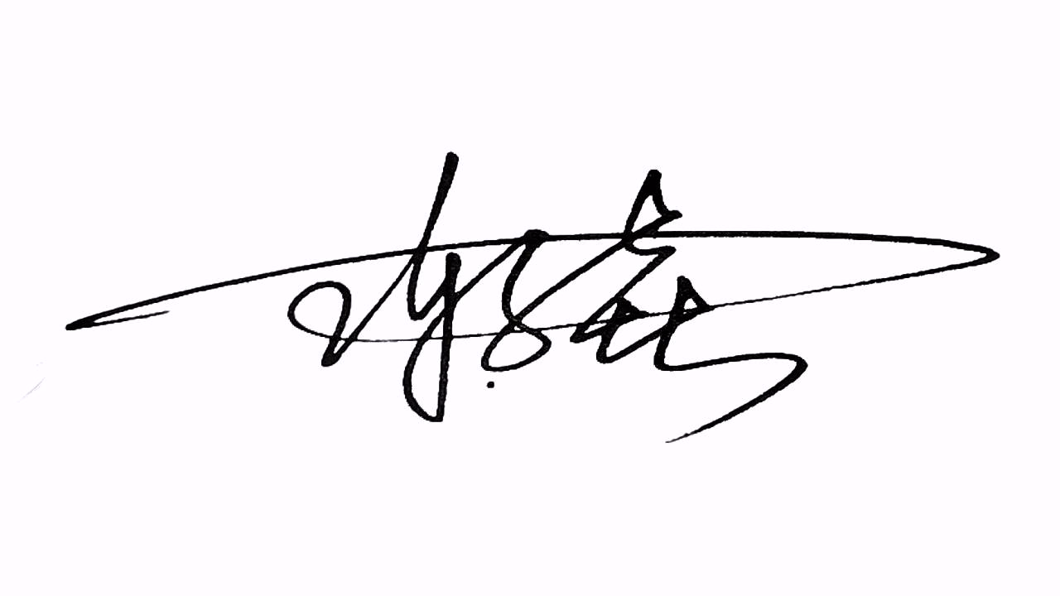
Signed :

Date : September 8, 2023

FORM OF CONSENT

I, Ziyao Chen hereby consent that my Project, submitted in candidature for the M.Sc. Software Engineering and Artificial Intelligence degree, if successful, may be made available for inter-library loan or photocopying (subject to the law of copyright), and that the title and abstract may be made available to outside organisations.

Signed :

Date : September 8, 2023

Abstract
In recent years, the field of signature verification has witnessed notable advancements thanks to the rapid progress in deep learning technologies, particularly deep neural networks. These advancements have significantly enhanced the accuracy of signature verification systems. However, several challenges still hinder their practical implementation. These challenges include difficulties in extracting meaningful features from signatures, long computation times required by deep neural networks, and high resource consumption.
In this paper, we introduce an algorithm for online handwritten signature verification. Our approach utilizes a Depth-wise Separable Convolutional Neural Network (DWSCNN) based on Depth-wise separable convolution for classifying and verifying signature feature sets. Compared to traditional Convolutional Neural Networks (CNNs), the DWSCNN offers a substantial reduction in the number of neural network parameters while maintaining similar classification performance. This reduction leads to significantly shorter processing times and lower resource utilization.
We conducted extensive experiments on two widely recognized signature databases, MCYT-100 and SVC-2004, to evaluate the proposed algorithm. The results demonstrate that our approach improves accuracy and reduces both the False Acceptance Rate (FAR) and False Rejection Rate (FRR). On average, our algorithm achieves an impressive verification accuracy of 96.92%, surpassing the performance of mainstream online signature verification frameworks. This underscores the effectiveness and efficiency of our proposed framework.

Keywords: Online Signature Verification, Deep Learning, Depth-Wise Separable Convolution Neural Network, pattern recognition

Contents
1 Introduction 1
2 Related work 3
3 Construction of signature feature set 10
3.1 Public dataset used in the proposed algorithm 10
3.2 Feature selection based on Model Verification 10
4 Depth-wise Separable Convolutional Neural Network (DWSCNN) 14
4.1 Depth-wise Separable Convolution (DWS convolution) 14
4.2 DWS convolution V.S. standard convolution 16
4.3 The DWSCNN used in this algorithm 17
4.3.1 The original feature dimension of online handwritten signature 17
4.3.2 DWSCNN parameter discussion 18
4.3.3 Depth-wise Separable Convolution Layer 19
4.3.4 Fully connected layer 21
5 Experimentation 24
5.1 Experimental Setup 24
5.2 Experimental Results and Comparisons 25
5.2.1 Results and Analysis of Experiments 25
5.2.2 Results comparison and analysis 27
6. Conclusion 31
Reference 32

1 Introduction
Biometric recognition plays a crucial role in personal authentication within many financial institutions, with signatures being the most widely used method. Handwritten signatures, as one of the biometric features, are employed in various applications to verify an individual's identity, thereby enhancing security and privacy. Compared to other biometric authentication measures, signature verification is highly prevalent in everyday life, making it of immense potential value in legal, financial, and administrative domains[1]. To date, a substantial body of research has been dedicated to signature verification. Although signatures are gradually developed through learned behaviors and possess a degree of variability, signature writing is a skill honed by individuals over prolonged practice, representing the collaborative result of the human consciousness perception system and the neuromuscular motor system in physiology. Therefore, research in the field of signature verification remains highly active and relevant to this day[2].
Signature verification methods can be categorized into Writer-Independent (WI) and Writer-Dependent (WD) based on different training strategies. As the names suggest, WI methods require training a single model for all signers to determine whether a signature is genuine or forged. In other words, WI methods aim to obtain a verification model that is as universally applicable as possible, necessitating a large number of training samples. In contrast, WD methods involve training separate models for different signature authors.
Based on the collection method, handwritten signatures can also be categorized into offline signatures and online signatures. Online signatures refer to signatures collected by special devices (such as dedicated digitizing tablets) that capture the trajectory information of the writing process (such as pressure, positional coordinates, velocity, etc.) and store it in the form of a time series. Offline signatures, on the other hand, are signatures that are written and then captured or scanned, and stored in image form. Online signatures provide a richer representation of the writing process, preserving dynamic information, whereas offline signatures only retain static information about the end result, losing nearly all dynamic aspects of the writing process. In comparison, online signatures contain more dynamic information, have stronger personal styles, and are more difficult to forge. This places higher demands on verification algorithms for online signatures, and thus this article mainly focuses on online handwritten signature verification.
Based on the degree of imitation from shallow to deep, forged signatures can be classified into random forgery, simple forgery, and skilled forgery. Random and simple forgery samples are generated by impersonators without knowledge of the signer and their signature. Skilled forgery is generated by individuals who attempt to mimic the original signature and have undergone extensive training. In other words, random forgery involves genuine signatures written by different signers, while simple forgery is created by individuals who are different from the original signer and write the signature without any practice or prior knowledge of the signature. In fact, compared to simple and random forgery, the problem of signature verification considering skilled forgery is more challenging, as such cases are often difficult to distinguish by the naked eye or simple tools, as shown in Figure.1, where (a) and (c) are genuine signatures, while (b) and (d) are skilled forged signatures.
In recent years, deep learning techniques, notably convolutional neural networks, have gained widespread popularity and are extensively applied across various domains[3]. They have proven to be particularly effective in addressing classic problems like image classification, image segmentation, and object detection when compared to traditional pattern recognition methods. This showcases the significant advancements in machine learning technology, especially in well-established problem areas .
However, it's worth noting that deep learning still faces certain challenges. For instance, the methods used for feature extraction can sometimes produce coarse or insufficiently representative features, making it challenging to capture the unique characteristics of individual data samples. Deep learning models also tend to demand a substantial volume of training data to effectively learn and recognize features, which can be resource-intensive. Additionally, the intricate structure of neural networks, coupled with a large number of parameters, often results in extended training times and high computational resource requirements.
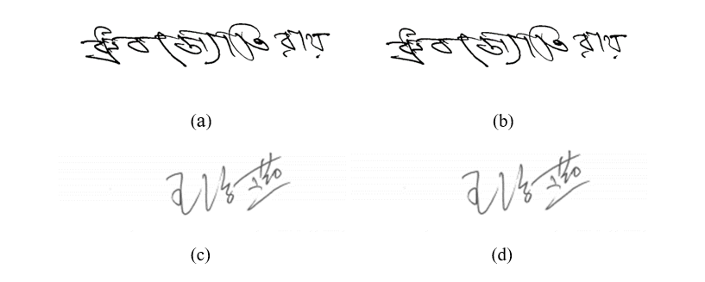
Fig. 1 Samples of authentic and skilled forged signatures in Hindi and Chinese
This paper proposes a DWSCNN-based online signature verification algorithm. The algorithm's overall flowchart is shown in Fig.2. For each online signature data, the algorithm first extracts 100-dimensional initial features from a public dataset, selecting the top 45 dimensions out of the 100-dimensional feature set as the new signature data feature set, which is then sent to the DWSCNN for classification. Finally, based on the set threshold, the algorithm compares the classification probabilities and outputs the final conclusion of whether the signature is genuine or forged.
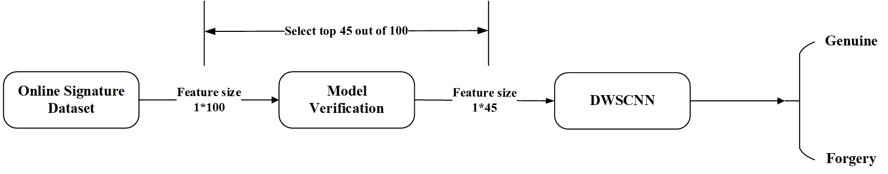
Fig.2 Overall system framework

2 Related work
Research on computer signature verification began in the 1980s. Scholars both domestically and internationally have investigated methods for online signature verification. Using electronic devices such as digitizing tablets, electronic pens, mobile phones, or pads, it is possible to record the signature trajectory of a writer, typically including two-dimensional X and Y coordinates and timestamps. In addition, signature trajectory capture devices can also collect dynamic signals such as pen-tip pressure and pen tilt angle during the writing process.
One very common method involves using distance metrics to calculate signature differences and using this information for signature authentication. Mohit et al. conducted signature authentication using three different distance scales: Mahalanobis distance, Chebyshev distance, and Euclidean distance, comparing them on the SVC2004 signature authentication database.
Apart from statistical classification methods, methods based on segmentation and curve matching are commonly used in signature authentication. Jing and Liu studied signature authentication as an elastic matching problem for spatial curves by incorporating pressure information. Luan Fangjun and colleagues defined signature curve segments as different states and validated the effectiveness of Hidden Markov Models (HMM) for Chinese handwriting recognition.
He et al. [4]approximated feature trajectories as spatial curves, associating curvature and flexion features with Hausdorff distance measurement for signature authentication. Zheng Jianbin and others introduced discrete Fréchet distance for signature curve matching, effectively using fewer feature details for signature verification.
Luan Fangjun employed pen-form curves of handwritten signatures, using Dynamic Time Warping (DTW) for signature curve matching and similarity discrimination. Zhang Yong and his team used a sliding aggregation mean approximation method for sequence segmentation and dimensionality reduction, calculating distances between segments using DTW for signature trajectory sequence distance computation.
Sharma and Sundaram[5] proposed an online signature verification system based on Enhanced DTW using code vectors generated by Vector Quantization (VQ) strategies. Razzak and Alhaqbani[6] applied segment-based VQ to signature authentication. Sharma and Sundaram combined Gaussian Mixture Models (GMM) and DTW after computing centroid-adjusted DTW distances as the basis for signature authentication.
Zheng Jianbin and others used EC (Euclidean Curvature) to calculate X and Y curve matches for signature verification. By dynamically searching for and matching segments of the test signature with sample curves, they achieved adaptive dynamic segmentation and matching with reference signature segments. This algorithm autonomously finds the optimal solution for the signature verification problem, with low rejection and acceptance errors, although it involves a relatively high number of iterations.
In recent years, signature authentication has primarily addressed the issue of signature instability, leading to the development of new methods and techniques.
Chaoqun and colleagues introduced a novel deep Convolutional Neural Network (CNN) architecture that utilizes manifold regularized convolutional layers (MRDL). These layers generate a low-rank manifold space and produce a regularized deep feature vector[7].
Jun and colleagues developed a novel Convolutional Neural Network (CNN) architecture called VeckerNet, which replaces a conventional f×f kernel convolutional layer with two separate convolutional layers using f×1 and 1×f kernels[8]. This alteration helps to decrease the number of parameters in the CNN, while maintaining its recognition accuracy.
Shyam and colleagues introduced a hybrid learning algorithm that combines two different techniques for training a multilayer neural network. Specifically, the inner layer parameters are trained via the stochastic weight perturbation algorithm, while the output layer is trained using the incremental rule[9]. Compared to traditional models based on backpropagation, this model eliminates the backpropagation operation and has better performance.
Chaoqun and colleagues developed an innovative 3D pose reconstruction network that employs multimodal learning to combine multiple feature sets. The features are first extracted and fed into a Multimodal Deep Autoencoder (MDA) and a denoising autoencoder. This approach helps to effectively represent the features in 3D for accurate pose reconstruction[10].
Serdouk et al. discussed and proposed a novel offline signature verification algorithm based on artificial immune systems. Two types of features emphasized in this algorithm are Longest Run Feature (LRF) and Gradient Local Binary Patterns (GLBP), which complement each other. LRF features aim to represent the topology of signatures by analyzing distant sets of text pixels. GLBP is an optimized texture feature extraction method based on LBP. The algorithm also introduced the use of K-Nearest Neighbor (KNN) for signature feature verification.
Sharif et al. introduced an optimal signature verification method based on feature selection. This verification method comprises two important components: Artificial Neural Networks (ANN) and Genetic Algorithms (GA). These are employed for selecting the best offline signature features, which are then utilized with SVM classification models. The method is based on extracting local and global features from signature images using horizontal and vertical points and geometric information. In the feature selection phase, an adaptive function based on Mean Square Error Rate (MSER) is used for genetic algorithm execution. The signature verification experiments were conducted on GPDS, MCYT, and CEDAR datasets, demonstrating the algorithm's significant performance.
Kumar and Puhan proposed a unique theoretical string moment for offline signature verification. The theory involves central moments (such as variance, skewness, and kurtosis) and the first moment (mean), calculated using chord lengths and angle sets of each envelope reference point. The advantage of string moments lies in their ability to fully quantify spatial relationships between upper and lower envelope points. These features are integrated into the SVM model training for signature verification. String-based methods significantly reduce the dimensionality of highly detailed chord sets, demonstrating robustness against nonlinear variations in signature images through experimental comparisons.
Das and Roy[11] introduced a feature extraction and rough set-based verification technique for offline signature verification using Gabor filters. They employed Gabor filter technology to extract statistical and topological features from offline signatures. In the feature selection phase, rough set theory was used to select significant features suitable for signature verification. The advantage of this approach is the reduction in feature vector dimensionality by retaining relevant and effective features, leading to reduced verification system processing time. Extensive comparative experiments demonstrated the effectiveness of Das et al.'s technique in reducing signature verification error rates.
Hafemann et al.[12] proposed an efficient offline signature verification system based on static signature samples. Signature samples were normalized in size, and spatial pyramid pooling was employed to assess system performance for high and low-resolution signature samples. The study explored the impact of different image resolutions on system performance during classifier training, as well as the effects of various operational conditions (different acquisition protocols such as writing tools and scanning resolutions) on signature verification accuracy and efficiency. In comparative experiments, Hafemann et al. primarily used the GPDS dataset, achieving high accuracy compared to existing methods and demonstrating superior performance in distinguishing skilled forgeries at high resolutions.
Maergner et al. proposed an offline signature verification system based on Depth Neural Networks (DNN) and Graph Editing Distance (GED). They used a combination of DNN and GED models to extract key offline signature features. In comparative experiments, Maergner et al. evaluated the system primarily on the MCYT and GPDS datasets, demonstrating its effectiveness. The high accuracy of signature verification indicated that the combined structural and statistical models significantly improved offline signature verification performance, with complementary effects.
Yilmaz et al.[13] presented a system utilizing a complementary classifier based on multiple local feature types. These local features include oriented gradient histograms, Local Binary Patterns, and Scale-Invariant Feature Transform descriptors. The system combines results from complementary classifiers with score-level fusion, where each classifier uses feature-level fusion to comprehensively represent various local features. For WD signature verification systems, user-specific classifiers and global classifiers were employed. User-specific classifiers were individually trained for each signer to distinguish genuine and forged signatures. In WI signature verification systems, global classifiers were trained using information from all signers in the training set along with their corresponding difference vectors, assigning different weights to different types of differences.
Alaei et al.[14] introduced an efficient offline signature verification algorithm primarily based on fuzzy similarity measurement and interval symbol representation. In the feature extraction step, a set of texture features is computed from both the signature image and its down sampled bitmap. These features are derived from Local Binary Patterns (LBP). Texture features obtained from each signature class are transformed into corresponding interval symbol value data. Each offline signature of a signer is represented by a set of interval value symbols. A method based on fuzzy similarity measurement is proposed to evaluate the similarity between sample signature images in the test set and their corresponding interval value symbol models. Comparative experiments on open-source databases demonstrated the effectiveness of the proposed algorithm.
Shariatmadari et al.[15] proposed an algorithm based on wavelet subbands, treating offline signature images as waveforms. Signature images are decomposed into a series of wavelet subbands at specific levels. The required waveforms are obtained by extending the wavelet subbands. Two non-linear dynamical tools, Probabilistic Finite State Automata (PFSA) and Multi-Resolution Box-Counting (MRBC) fractal dimension algorithms, quantize the waveforms to generate feature vectors. During the training and verification phases, a Gaussian Process (GP) prior is used for the WI offline signature verification system. Experimental results show certain advantages over other techniques.
Zhao Yan[16] proposed a preprocessing scheme based on image mask cropping and a Partial-Uniform LBP (PULBP) feature based on stroke regions. The former aims to retain as much useful information from offline signature images as possible, while the latter enhances feature extraction capabilities.
Ren et al.[17] introduced a Two-Channel and Two-Stream Transformer Approach (2C2S) to improve the efficiency of signature verification. The 2C2S method combines both the original and central flows. The original flow receives original signature pairs as input, while the central flow receives signature pairs generated by cropping the centers of the original pairs as output. By applying excitations and squeezes between two standard transformer modules, correlations between feature channels are established. An upsampling enhancement module is proposed to guide the model's focus directly.
Ferrer et al. introduced a template matching algorithm based on signature envelopes. Morphological dilation operations are used during the computation of signature envelopes to ensure uniform contours in offline signatures, reducing variability in signature images. They also employ filling operations to simplify the extraction of signature contours, improving algorithm efficiency.
Fotak et al. proposed an efficient signature verification method based on graph theory concepts. They construct a graph by calculating the minimum spanning tree for offline signature images, using Euler and Hamiltonian paths and graph connectivity to classify acquired signature images. Fotak et al. avoid the concept of sets as conditions for measuring similarity and distance between signatures, which is a combinatorial necessary and sufficient condition for cluster consensus.
Zois et al. introduced a grid-based template matching approach for offline signature verification. Based on signature grid templates, they encode the geometric structure of signature images effectively by partitioning signature images into subsets. They employ a grid-shaped detection structure formed by reshaping a binary mask over a 5×5-pixel window to generate an efficient feature representation, detecting transitions effectively. Zois et al. conducted extensive comparative experiments on four different signature databases, characterizing quality in terms of stability, complexity, and overall complexity for distinguishing real or forged signatures.
Guerbai et al. proposed a technique based on One-Class SVM (OC-SVM) applied to WI offline verification systems. The technology is suitable for processing a large number of signature samples to be verified. However, OC-SVM may exhibit performance deficiencies and lower verification accuracy in some cases. These issues can be mitigated by merging different distance functions used in the OC-SVM kernel and modifying the composition of the decision function to improve the optimal threshold. Extensive verification experiments on GPDS and CEDAR handwritten signature datasets demonstrated system robustness.
Miskhat et al.[18] described an efficient offline signature verification system based on ANN and Gaussian Support Vector Machine (GSVM). In the signature verification stage, classifiers are based on point density, slice feature sets, and gradient histograms. The designed system achieved a 96.5% verification accuracy on a self-created signature database, demonstrating improvements over similar technologies.
Gyimah et al. proposed an offline signature verification system based on improved feature extraction vectors, combining Gray-Level Co-Occurrence Matrices with region-based methods. Feature vectors obtained are trained and validated using Support Vector Machines with different kernel functions, and both Least Squares and Sequential Minimal Optimization were employed. The results indicate that combining Sequential Minimal Optimization with Radial Basis Function is the most suitable SVM kernel function for offline signature verification, yielding high verification accuracy.
Arab et al.[13] proposed applying a data augmentation scheme to features, which proves to be more effective than applying it to offline signature images. The feature generator is based on three major mechanisms of artificial immune systems: cloning, resource competition, and mutation. For the first descriptor, Arab et al. introduced local difference features oriented in multiple directions. The second descriptor is a template histogram used for comparison purposes, as it demonstrates satisfactory performance in representing offline signatures.
Hafemann et al.[19] introduced a feature extraction method using Convolutional Neural Networks (CNNs), consisting of four fully connected layers, three max-pooling layers, and five convolutional layers. This method efficiently distinguishes between forged and genuine signatures. The model includes an important feature processing technique known as batch normalization.
Ooi et al. presented a hybrid framework for efficient offline signature verification, consisting of three main components: Discrete Radon Transform (DRT), Principal Component Analysis (PCA), and Probabilistic Neural Network (PNN). Extensive experiments on a self-created signature database achieved promising results, with Equal Error Rates (EER) of 13.07% for skilled forgeries and 1.51% for random forgeries. In the MYCT feature database, the proposed framework achieved an EER of 9.87%.
Bhattacharya et al. designed an offline verification system that incorporates pixel matching techniques. This technique verifies signatures by processing signatures stored in a directory. They conducted a comparative performance analysis of the proposed algorithm using ANN backpropagation techniques and SVM.
Liu et al. proposed a region-based deep convolutional Siamese network using metric learning techniques for both WI and WD scenarios. To capture subtle differences between genuine and forged signatures, Liu et al. designed a Mutual Signature Density Network (MSDN). It focuses on extracting key feature information from local regions rather than the entire signature image and is capable of learning similarity metrics. The proposed Siamese network compares local regions of offline signature images, and the similarity scores from multiple regions are fused to verify test set signature images.
Ruiz et al.[20] presented a twin neural network-based approach for WI offline signature verification. They focused on three types of synthetic data: synthetic signature generation samples from shape primitives, GPSS synthetic data, and enhanced data samples from the GAVAB dataset. These synthetic data types increased the volume of offline signature samples, meeting the requirements for training deep neural networks. The first and third methods serve as "on-demand" generators, allowing the generation of any desired number of synthetic signatures during model training. Different combinations of GAVAB dataset signatures and synthetic data were emphasized during the training of the Siamese neural network, resulting in higher signature verification accuracy.
Xamxidin et al.[21] addressed offline signature verification for mixed single- and multi-language scenarios using an Improved Verification Network (IDN). The designed network consists of four components, all of which are neural network flows with shared weights. Two flows receive original signature images and are called the discrimination flows, while the other two receive grayscale-inverted images, known as reverse flows. An enhanced spatial attention model is used for message propagation, connecting reverse and discrimination flows. Comparative experiments demonstrated superiority over other techniques.
Tsourounis et al.[22] proposed an efficient offline signature verification system based on CNNs and contrastive loss functions. After preprocessing, offline signature image data are incorporated into CNNs for pretraining in signature verification. The mapping metric learning phase primarily employs contrastive loss functions to learn mappings of extracted offline signature texture features to a latent space suitable for offline signature verification tasks.
Naz et al. studied and compared various CNN architectures, including AlexNet, GoogleNet, ResNet, MobileNet, and DenseNet. They also proposed an efficient transfer learning-based algorithm for handling offline signature verification problems. Comparative experiments demonstrated the algorithm's effectiveness.
Zhu Yecheng introduced a Fractional Max Pooling (FMP) network method that effectively preserves details such as curves and line segments, a characteristic of signature images. Validation experiments on CEDAR and MCYT75 showed the effectiveness of the proposed signature verification system.
Wang Haoshuang designed a data collection process and system for creating a large-capacity offline Chinese signature dataset. They also proposed a dual-channel CNN model to enhance feature extraction capabilities of verification model.
Lu et al.[23] proposed an offline handwritten signature verification system based on a twin neural network using a hybrid mode. The system employs Residual Neural Networks (ResNet) to build a powerful feature extraction model for efficient learning of offline signature features. The designed system is for WD offline signature verification, and a single-layer twin neural network (NN) forms a classifier while minimizing storage space. By incorporating the reference signature as one of the inputs into the Siamese neural network, the influence of high intra-class differences in signatures is reduced, and the learning efficiency of the twin network is improved. A modified contrastive loss function is used to enhance accuracy.

3 Construction of signature feature set

3.1 Public dataset used in the proposed algorithm
- MCYT-100
The MCYT-100 database is a large multimodal biometric database, collected and published by the BiDA laboratory at Universidad Autónoma de Madrid. This database contains two modalities of biometric features: fingerprints and signatures. In this paper, MCYT-100 specifically refers to the online signature data portion, which includes 100 users, each with 25 genuine online signature samples and 25 skilled forgery signature samples[24]. The entire MCYT-100 database was created during the same period and data collection was not conducted across different time periods. During the signature collection process, an electromagnetic induction WACOM tablet with a sampling frequency of 100 Hz was used to record information, including:
- The horizontal and vertical coordinates X and Y of the online signature;
- The pen tip pressure P during the signature;
- The azimuth angle of the pen tip during the signature.
The values of X and Y coordinates range from 0 to 12700 and 0 to 9700, respectively. The pressure P ranges from 0 to 1024, while the horizontal and vertical angles in the azimuth angle range from 0 to 3600 and 300 to 900, respectively.
- SVC-2004
This paper focuses on the SVC-2004 database, which was created for the International Signature Verification Competition and includes two tasks. This paper specifically focuses on Task 2 of the database, which provides the following information:
- The horizontal and vertical coordinates X and Y of the online signature;
- The timestamp of the signature;
- The pen-up and pen-down states during the signature process;
- The azimuth angle and altitude angle of the pen tilt during the signature;
- The pen-tip pressure P during the signature.
Each task contains 40 users, including 20 genuine signatures and 20 skilled forgeries, where the forgeries are composed of 4 skilled forgeries from each of 5 random users. The database includes Chinese and English signatures, and the appearance of Chinese and English signatures alternates randomly, which is more in line with the signing habits of Chinese people. In addition, due to the long time spent by signature forgers practicing forgery, and the mixture of Chinese and English signature data, this database has the highest verification difficulty among existing publicly available signature databases.

3.2 Feature selection based on Model Verification
Model verification are essential aspects of the machine learning workflow, and various methods and algorithms are used for these purposes.
Model verification are crucial steps in the machine learning process, ensuring that the trained models perform well, generalize to unseen data, and meet the desired criteria. In this comprehensive explanation, we will delve into various model verification and evaluation techniques, their importance, and how they contribute to building robust and effective machine learning models.
Model verification are vital because they help us assess a model's performance, reliability, and suitability for its intended purpose. These processes are essential for identifying and addressing issues such as overfitting, underfitting, and bias in machine learning models.
Cross-verification stands as a stalwart technique in the realm of model verification, particularly when confronted with the challenges of working with limited data. It provides a resilient framework for assessing the performance of machine learning models and is especially valuable in scenarios where data scarcity poses a significant hurdle. At its core, cross-verification hinges on the principle of data partitioning. It commences by segmenting the available dataset into multiple subsets or folds, essentially dividing the data into manageable portions. Each of these folds plays a crucial role in the verification process.
The process unfolds as follows: The machine learning model is first trained on a portion of the dataset, typically one of the folds, and then evaluated on the remaining folds. This sequence of training and evaluation is performed iteratively, with each fold taking on the role of the verification set in turn. The outcomes of these iterations are then aggregated and averaged, resulting in a consolidated assessment of the model's performance.
This approach yields several notable advantages. Firstly, it ensures that every data point in the dataset is used for both training and verification, minimizing the risk of overfitting and providing a more holistic evaluation of the model's generalization capabilities. Secondly, it allows for the robust estimation of key performance metrics, such as accuracy, precision, recall, and F1 score, by averaging the results across multiple verification sets. This averaging process helps mitigate the influence of random variability that can occur when dealing with limited data.
Cross-verification excels in scenarios where data is scarce or expensive to acquire, such as in medical diagnostics, rare event prediction, or when working with small datasets in research domains. It enables data scientists and machine learning practitioners to make the most of the available information while ensuring the reliability and stability of their model evaluations.
Its ability to provide robust estimates of model performance makes it an indispensable tool in the toolkit of anyone working with machine learning and predictive analytics. Whether it's optimizing model hyperparameters, selecting the best algorithm, or ensuring the model's generalization ability, cross-verification remains a cornerstone of effective model evaluation.
K-fold cross-verification stands as a widely embraced technique in the realm of data analysis and machine learning. Its fundamental premise revolves around the division of a dataset into 'k' distinct subsets or folds. This approach offers a robust and systematic means to ensure that every single data point contributes to both the training and verification phases of model evaluation. The process begins by partitioning the dataset into 'k' equally sized folds, with each fold serving a unique purpose in the cross-verification procedure. During each iteration, one of these folds is earmarked as the verification set, while the remaining 'k-1' folds amalgamate into the training dataset. This sequential rotation of verification and training sets unfolds until every fold has had its turn as the verification set. In essence, each fold enjoys the dual role of being a part of the training dataset multiple times and serving as the exclusive verification dataset once. The beauty of K-fold cross-verification lies in its inherent fairness and comprehensiveness. By ensuring that every data point experiences both training and verification, it minimizes the risk of bias and overfitting that can arise when working with limited datasets. This systematic rotation of subsets guarantees that the model encounters diverse data scenarios, enabling a more thorough evaluation of its performance. Once all 'k' iterations are completed, the results are aggregated and summarized, often by computing metrics like accuracy, precision, recall, F1 score, or others. This consolidation of outcomes provides a holistic view of the model's overall performance, smoothing out fluctuations and random variability that can emerge in smaller datasets.
K-fold cross-verification is a pivotal technique employed in a multitude of applications, ranging from machine learning model development to statistical hypothesis testing. It offers data scientists and analysts a dependable means to assess model generalization and identify potential weaknesses or areas for improvement. K-fold cross-verification is a robust and widely embraced method that ensures rigorous model evaluation by systematically leveraging all available data points for both training and verification. Its versatility and effectiveness have made it an indispensable tool for those seeking to develop, fine-tune, or validate machine learning models and data-driven insights. Whether in research, industry, or academia, K-fold cross-verification continues to play a pivotal role in the quest for reliable and robust data analysis.
Machine learning models are assessed using various evaluation metrics depending on the type of problem. The choice depends on the problem and the importance of different aspects of model performance.
Model verification is closely tied to hyperparameter tuning. It involves adjusting the model's hyperparameters (e.g., learning rate, depth of a decision tree) to optimize performance.
In some cases, multiple models are evaluated and compared to determine which one performs best on the verification data. This comparison helps in selecting the most suitable model for the task.
In real-world applications, external verification on completely unseen data is crucial to ensure the model's generalization. This is especially important when deploying machine learning models in production.
In summary, model verification and evaluation are integral components of the machine learning workflow, playing a vital role in assessing model performance, mitigating issues like overfitting, and ensuring the model's suitability for its intended task. A combination of techniques such as train-test splitting, cross-verification, evaluation metrics, hyperparameter tuning, and external verification is employed to build robust and effective machine learning models.
In the realm of machine learning, the Model Verification (MV) algorithm stands as a pivotal component in the evaluation and testing of machine learning models. Its primary mission revolves around the critical task of ascertaining how effectively a model can extend its predictive capabilities to unseen, novel data. This essentially involves scrutinizing the model's ability to maintain accuracy when confronted with data it has never encountered before, thus assessing its generalization performance.
In the context of our innovative online signature verification algorithm, our primary objective was to discern the optimal feature dimensionality from the initial 100-dimensional feature set. To achieve this, we meticulously conducted a systematic analysis characterized by a deliberate exploration of feature sets with varying dimensions. To gauge the performance of these different feature sets, we employed a metric known as the Equal Error Rate (EER), which provides a balanced measure of the system's False Acceptance Rate (FAR) and False Rejection Rate (FRR).
The graphical representation of our model verification endeavors is prominently displayed in Figure 3. Our journey began by systematically reducing the feature dimensionality in a linear fashion, taking strides of 20 dimensions at a time. The goal was to identify the range within which the optimal feature dimensionality resided. The results of these initial experiments unequivocally pointed to a sweet spot lying between 40 to 60 dimensions, where the model exhibited the highest level of performance.
To further fine-tune our feature selection process, we ventured into a more granular exploration, reducing the dimensionality by 5 at a time. This meticulous exploration allowed us to pinpoint with precision that the system achieved its most exceptional performance when the feature dimensionality was trimmed down to a mere 45 dimensions. This level of granularity helped us unlock the true potential of our signature verification algorithm, delivering an outstanding level of accuracy.
In summary, our holistic system framework commenced its journey with a 100-dimensional feature set, meticulously extracted from the original signature dataset. However, we did not stop at this point; instead, we embarked on a journey of feature selection, deploying advanced techniques to weed out redundant features and noise. The result was a refined feature set with a dimensionality of 45, carefully curated to represent the unique characteristics of each signature. These 45-dimensional feature vectors were subsequently fed into our neural network, forming the bedrock of our classification process[25].
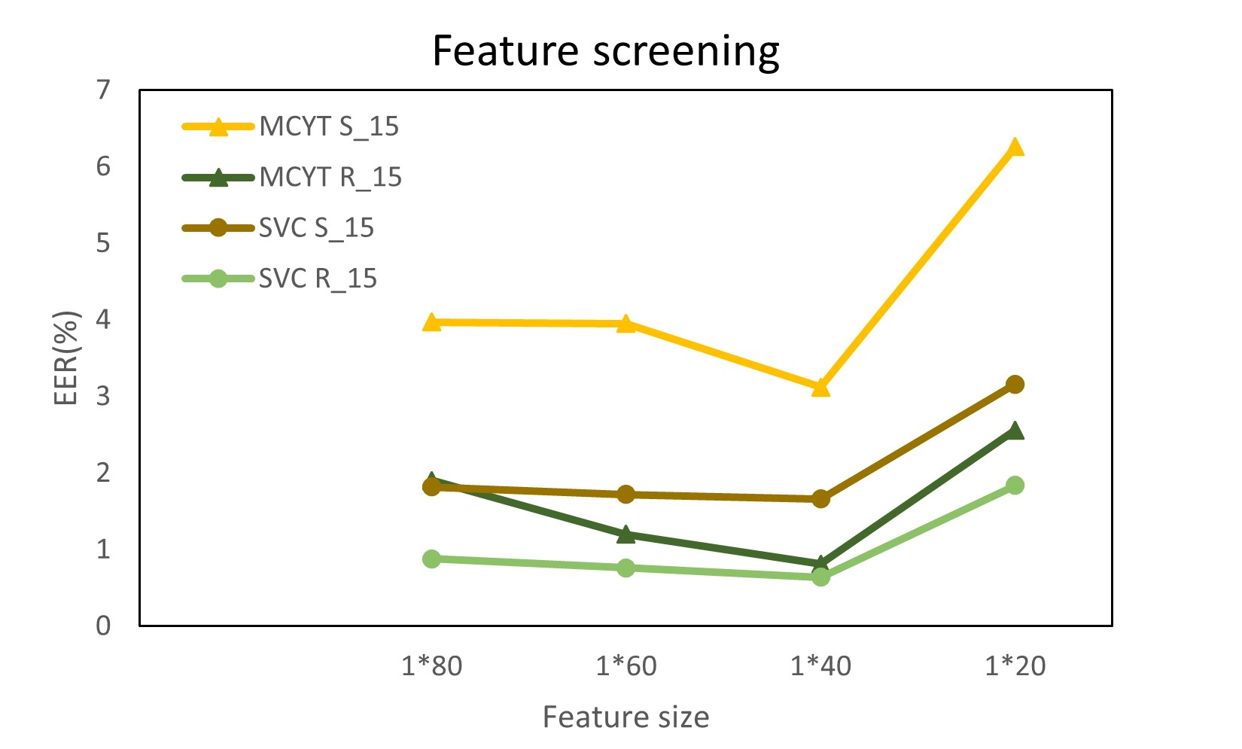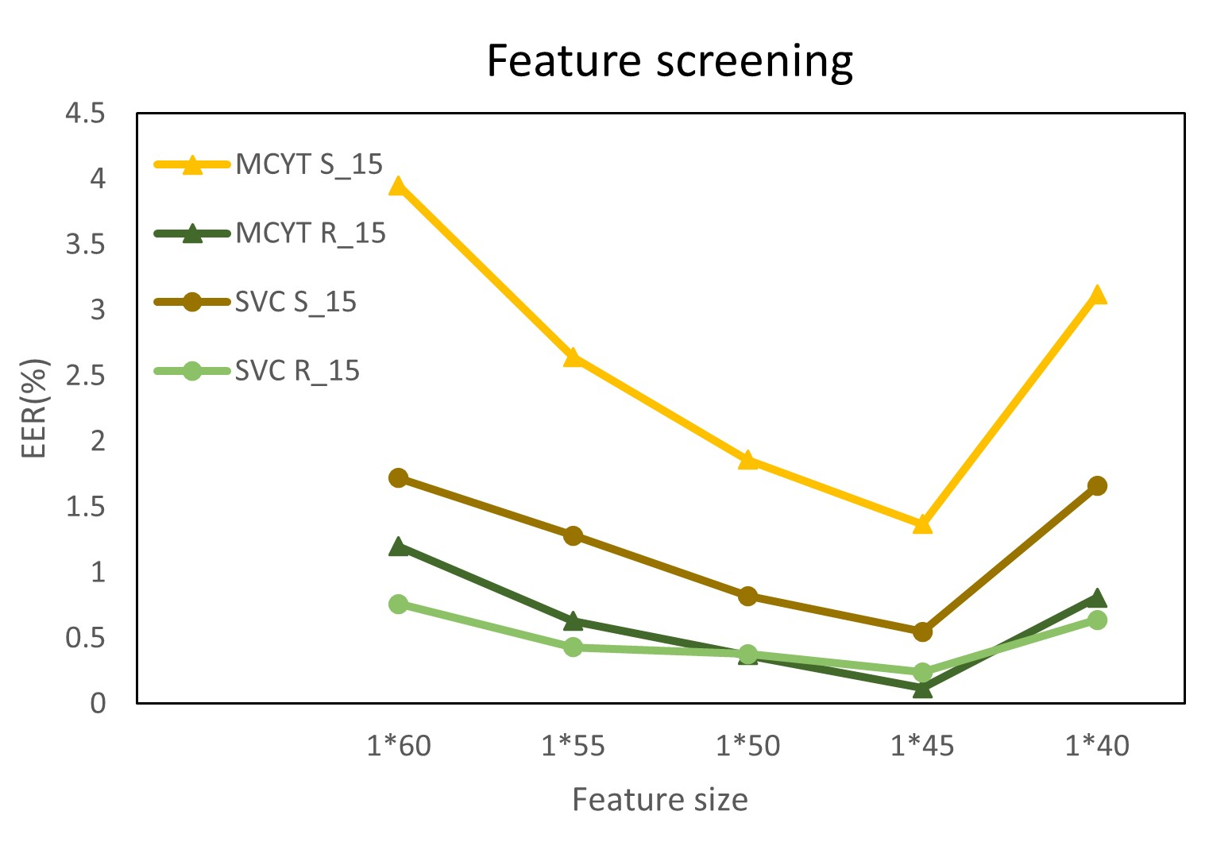
Fig.3 Feature screening of different feature sizes

4 Depth-wise Separable Convolutional Neural Network (DWSCNN)

4.1 Depth-wise Separable Convolution (DWS convolution)
The convolution operation is a fundamental concept in signal processing, mathematics, and particularly in the field of deep learning, where it plays a central role in Convolutional Neural Networks (CNNs).
In the context of CNNs, convolution is used to extract relevant features from input data, such as images or sequences, by applying a filter (also known as a kernel) to the input.
To perform a 1D convolution, we slide the filter along the input, element-wise multiply the filter and the input values at each position, and sum the results. This produces a new output signal that captures local patterns or features in the data.
The most common use of convolution in deep learning is in 2D, where it's applied to two-dimensional data, such as images. In this case, both the input and the filter are matrices. We slide the filter across the input image, performing element-wise multiplications and summing the results to produce an output matrix. This process is often illustrated as "sliding a window" over the input.
The convolution operation has several key parameters:
- Filter Size: The dimensions of the filter, such as 3×3 or 5×5, dictate the receptive field, which is the region of the input that the filter considers at each step.
- Stride: The stride determines how much the filter is moved during each step of the convolution.
- Padding: Padding helps to control the output size and preserves information at the edges of the input.
Convolution is used in deep learning primarily for feature extraction. When applied to images, for instance, filters can detect edges, corners, textures, and other low-level features. As we move deeper into a neural network, filters learn to detect increasingly complex and abstract features.
A significant advantage of convolution is weight sharing. In traditional fully connected layers, each connection has its weight, leading to a vast number of parameters. In convolution, the same filter is applied across the entire input, allowing for parameter sharing and reducing the number of learnable weights. This makes convolution computationally efficient.
Convolution introduces a degree of translation invariance. This means that a filter can recognize a particular pattern, like a diagonal edge, regardless of its position in the input data.
Convolutional layers in deep neural networks are often stacked. As data passes through these layers, they learn to recognize increasingly complex and hierarchical features. Low-level layers detect basic features, while higher-level layers capture more abstract and informative patterns.
Convolution operations are widely used in various domains:
- Computer Vision;
- Natural Language Processing;
- Speech and Audio Processing: In speech recognition and audio signal processing;
- Signal Processing: For tasks like noise reduction, image filtering, and feature extraction.
The convolution operation is a fundamental concept in mathematics and deep learning. It is a versatile tool for feature extraction, weight sharing, achieving translation invariance, and learning hierarchical features. Convolution is a key ingredient in the success of Convolutional Neural Networks, making them powerful tools in various fields.
The concept of Depth-wise Separable Convolution (DWS convolution) represents a significant advancement in the field of convolutional neural networks (CNNs). This innovative approach was first introduced by Laurent Sifre in his doctoral thesis titled "Rigid-motion scattering for image classification," which was submitted to the prestigious Ecole Polytechnique in Paris back in 2014. DWS convolution has garnered attention and acclaim due to its distinctive ability to process data in both spatial and depth dimensions, setting it apart as a game-changer in the realm of convolution operations.
To gain a deeper understanding of DWS convolution, let's delve into its core components and workings. This convolutional operation can be dissected into two fundamental steps: depth-wise convolution and point-wise convolution, both of which employ a compact 1×1 kernel size, as visually represented in Figure 4.
The first step in the DWS convolution process involves what is known as depth-wise convolution. Here, each channel of the input feature map undergoes a dedicated convolution operation using its specific convolution kernel. These individual convolution operations result in a set of output feature maps, one for each input channel. These output feature maps are then ingeniously concatenated to form the final output. The outcome of this step is a collection of N feature maps, each composed of just one channel, mirroring the N input channels. This separation of convolution operations based on input channels is at the heart of the "depth-wise" aspect of DWS convolution.
The second pivotal step in DWS convolution is point-wise convolution, which employs a 1×1 convolution kernel. This seemingly simple operation carries out two crucial functions. Firstly, it provides the flexibility for depth separable convolution to modify the number of output channels. This adaptability in altering the channel count proves to be highly valuable in shaping the architecture of neural networks. Secondly, and perhaps more importantly, point-wise convolution conducts channel fusion on the output feature map generated by the preceding depth-wise convolution. In simpler terms, it combines and blends information from different channels, enriching the model's ability to discern complex patterns, features, and relationships within the data. This fusion of channels enhances the network's capacity for representation learning, making it a formidable tool in the deep learning arsenal.
In essence, depth-wise separable convolution stands as a formidable innovation in the world of convolutional neural networks. It is not just a reduction in computational complexity; it is a clever and efficient way to process multi-channel input data. By segregating spatial and depth components into distinct operations, DWS convolution not only boosts the performance of neural networks but also does so with an eye on computational efficiency. This breakthrough has become a cornerstone in the development of modern deep learning models, enabling them to handle increasingly complex tasks and datasets while keeping computational resources in check. The impact of DWS convolution reverberates throughout the field, showcasing the power of innovation in advancing machine learning technology.
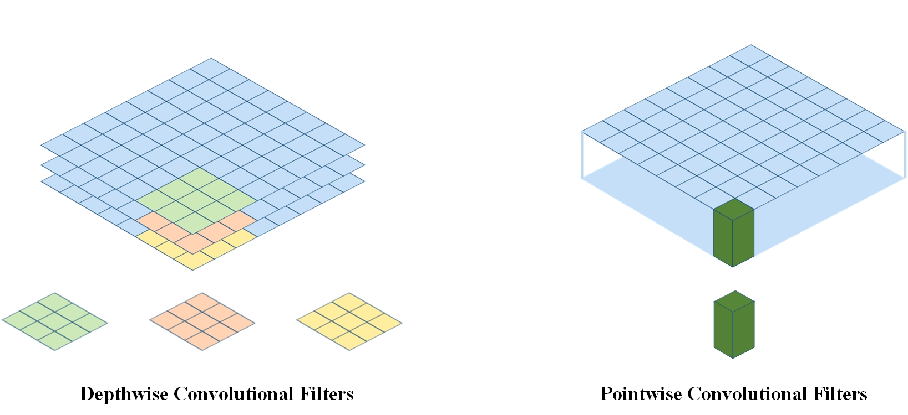
Fig.4 Depth-Wise Separable convolution structure

4.2 DWS convolution V.S. standard convolution
In contrast to the conventional standard convolution operation, DWS convolution introduces a novel and highly efficient approach by employing separate convolution kernels for each input channel. This fundamental departure from the traditional single-kernel approach, illustrated in Figure 5, offers a remarkable advantage. It allows DWS convolution to achieve substantial reductions in both computational cost and parameter size within neural networks while preserving the essence of the convolution operation.
To grasp the significance of this innovation, let's delve deeper into how DWS convolution operates. In standard convolution, a single convolution kernel is applied uniformly to all input channels. This means that regardless of the unique characteristics or features within each channel, the same kernel is utilized. This can result in redundancy and inefficiency as the kernel attempts to capture diverse information.
DWS convolution, on the other hand, takes a more sophisticated approach. It recognizes the distinct nature of each input channel and tailors the convolution operation accordingly. Specifically, it convolves each input channel with its dedicated convolution kernel. This targeted convolution process results in the creation of output channels, each representing a specific aspect of the input data. These output channels, though reduced in dimensionality compared to the original input, hold valuable information extracted through channel-specific kernels.
Once these individual convolutions are complete, the output channels are skillfully concatenated to form the final output feature map. This fusion of channels retains the essential information while effectively reducing the overall computational burden and network parameters. The net result is a network architecture that is streamlined and more computationally efficient, making it well-suited for a wide range of applications.
It's worth emphasizing that this innovative approach has found widespread adoption across various convolutional neural network architectures. Its ability to boost efficiency without compromising the core convolutional operation's effectiveness has made it a cornerstone in modern deep learning practices.
In summary, DWS convolution's unique feature of employing separate convolution kernels for each input channel is a transformative advancement in the realm of deep learning. It efficiently harnesses the distinct characteristics of each channel, reducing computational costs and parameters while maintaining the convolution operation's integrity.
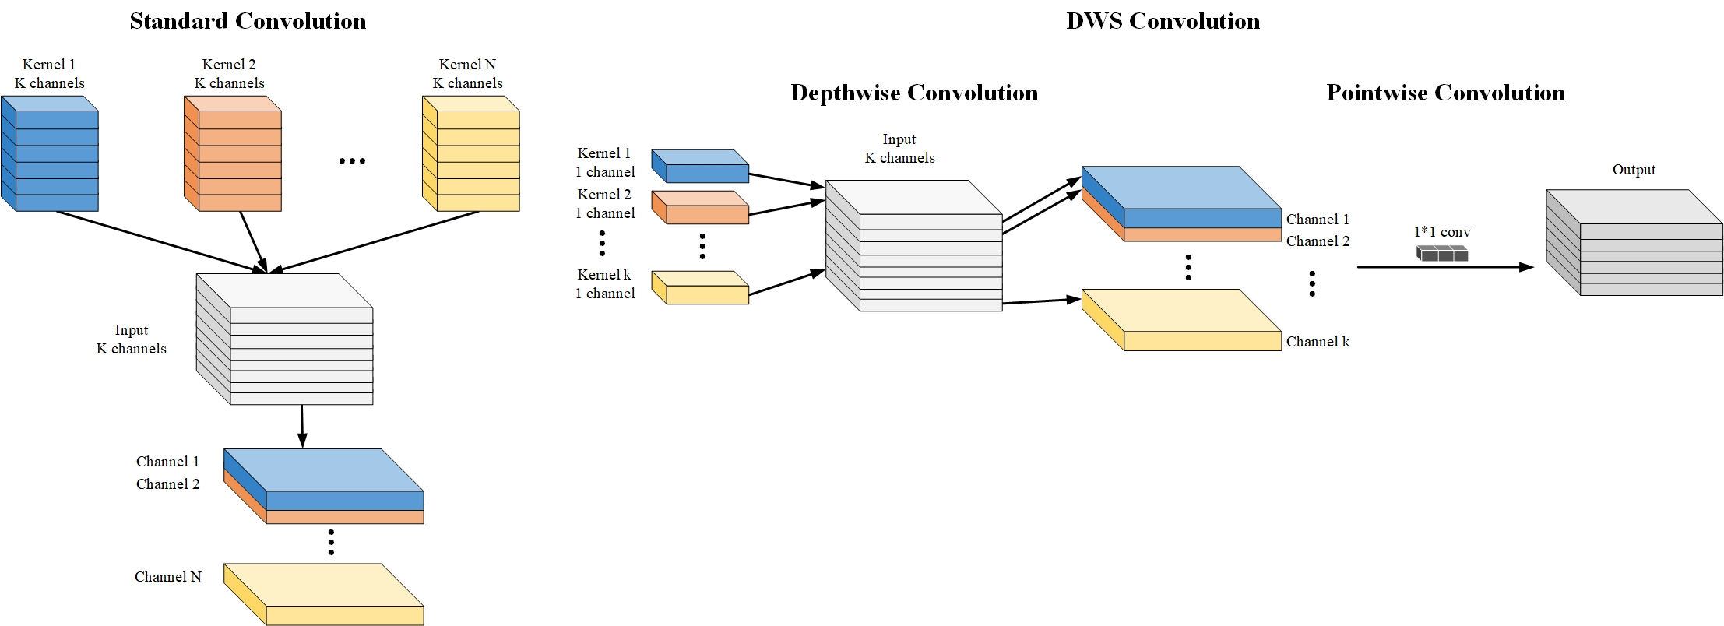
Fig.5 Contrast of DWS convolution with standard convolution operations
If we take convolutional images as an example, the computational complexity is shown in Table 1.
According to Table 1, the total computational cost of standard convolution and DWS convolution for convolutional images is shown. The ratio of the computational cost of DWS convolution to standard convolution can be obtained by comparing the two, which is denoted by . Since represents the number of filters, it is usually large. If the convolutional kernel size used for image convolution is 3×3, then DWS convolution can reduce the computational cost by approximately 9 times. Moreover, as the network deepens, the advantages of such convolution computation will become more apparent. Therefore, DWS convolution can achieve an improvement in computational efficiency without reducing the performance of a specific type and significantly reduce the resource consumption.

4.3 The DWSCNN used in this algorithm

4.3.1 The original feature dimension of online handwritten signature
This algorithm relies on the power of neural networks to handle online signature feature datasets and perform classification tasks. Online signatures, depending on the specific public signature databases used, are represented as one-dimensional feature vectors of varying lengths. This representation method encapsulates essential signature characteristics within these feature vectors. For instance, in the case of the MCYT-100 dataset, each signature is condensed into a 1×100-dimensional feature vector. On the other hand, the SVC-2004 dataset represents signatures as 1×47-dimensional feature vectors. These dimensions, 100 and 47 respectively, signify the number of global features extracted from each online signature.
These global features encompass a wide array of signature characteristics that are crucial for the classification process. They include parameters such as the overall duration of the signature, the standard deviation of y-axis acceleration, the standard deviation of x-axis acceleration, and the ratio of the total speed of the signature to the maximum speed achieved during the signature capture[26-29]. These features provide a holistic representation of the signature, capturing both its temporal and spatial characteristics.
Table 1 Comparison of standard convolution and DWS convolution computation for an image
Picture size： Convolution kernel size: Convolution kernel quantity:
standard convolution |  |  |  | DWS convolution
single convolution |  |  |  | depth-wise convolution
 |  |  |  | point-wise convolution
total |  |  |  | total
Once these raw features are extracted from the public datasets, such as MCYT-100 and SVC-2004, they undergo further processing within the algorithm. This processing entails utilizing neural networks to analyze and classify the signatures effectively.
In essence, this algorithm takes advantage of neural networks to interpret the unique characteristics of online signatures, represented as one-dimensional feature vectors. These feature vectors encapsulate vital information about the signatures' temporal and spatial properties, ultimately enabling the algorithm to perform accurate classification tasks on different public signature databases. The integration of neural networks and these feature representations enhances the algorithm's capability to recognize and verify signatures across diverse datasets, making it a powerful tool in the realm of online signature verification.

4.3.2 DWSCNN parameter discussion
In the realm of convolutional neural networks (CNNs), the process of feature extraction heavily relies on the settings and parameters of its convolutional layers, which are applied sequentially, layer by layer. The primary objective of this article is to embark on an empirical journey, conducting thorough comparative analyses and engaging in in-depth discussions concerning two critical factors: the number of separable convolution layers (referred to as SL) and the number of convolution kernels (referred to as K). The ultimate aim is to identify and determine the optimal combination of these factors that would yield the most effective feature extraction within the CNN.
To facilitate this investigation and ensure rigorous experimentation, we've employed a systematic approach that involves controlling variables. This method is essential for precisely assessing the impact of altering the number of SL and K on the performance of our CNN. The experiments have been meticulously conducted and meticulously validated using the MCYT-100 skilled-01 dataset, a reliable benchmark for our evaluations.
Figures 6 and 7 serve as visual aids to elucidate the experimental process and results. These figures provide a clear overview of the controlled variables and the outcomes of varying the number of SL and K within our convolutional neural network.
In essence, the heart of our research lies in exploring the optimal configuration of CNN parameters, particularly SL and K, which play pivotal roles in feature extraction. By rigorously conducting experiments and leveraging the method of controlling variables, we aim to unlock insights that will guide us towards a CNN architecture that excels in extracting and harnessing features from data, with real-world applications spanning various domains.
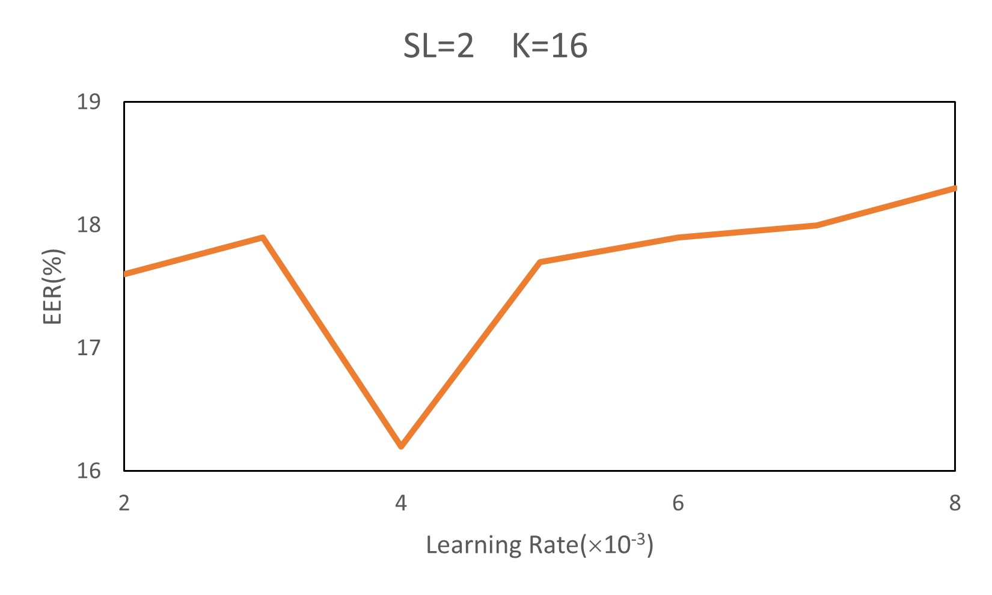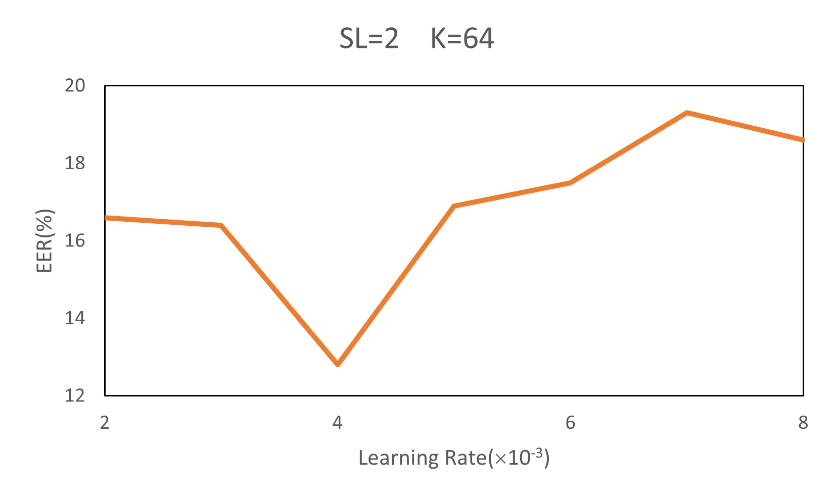
Fig.6 EER results for fixing the number of separable convolution layers = 2 and changing the number of convolution kernels
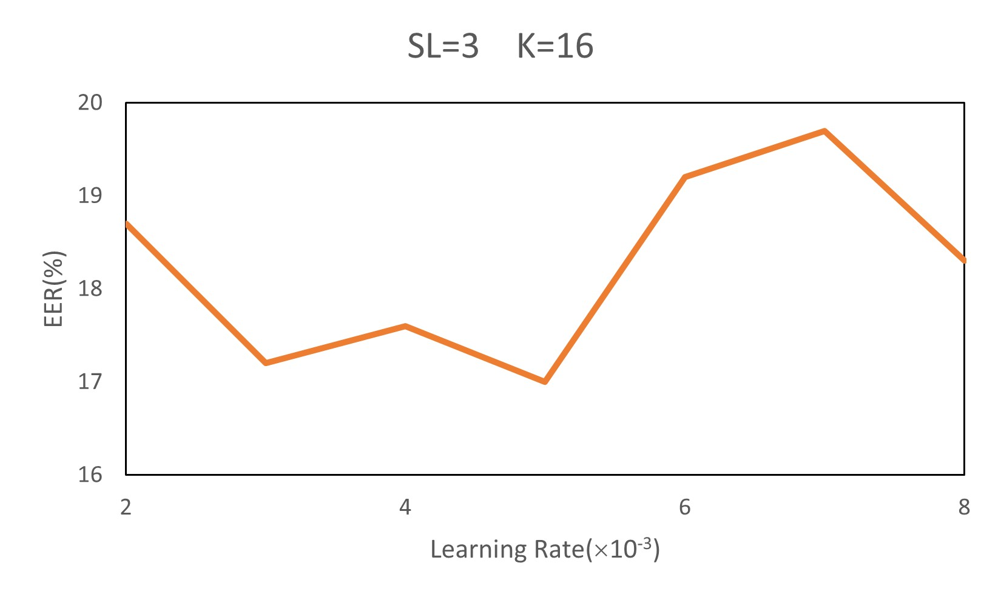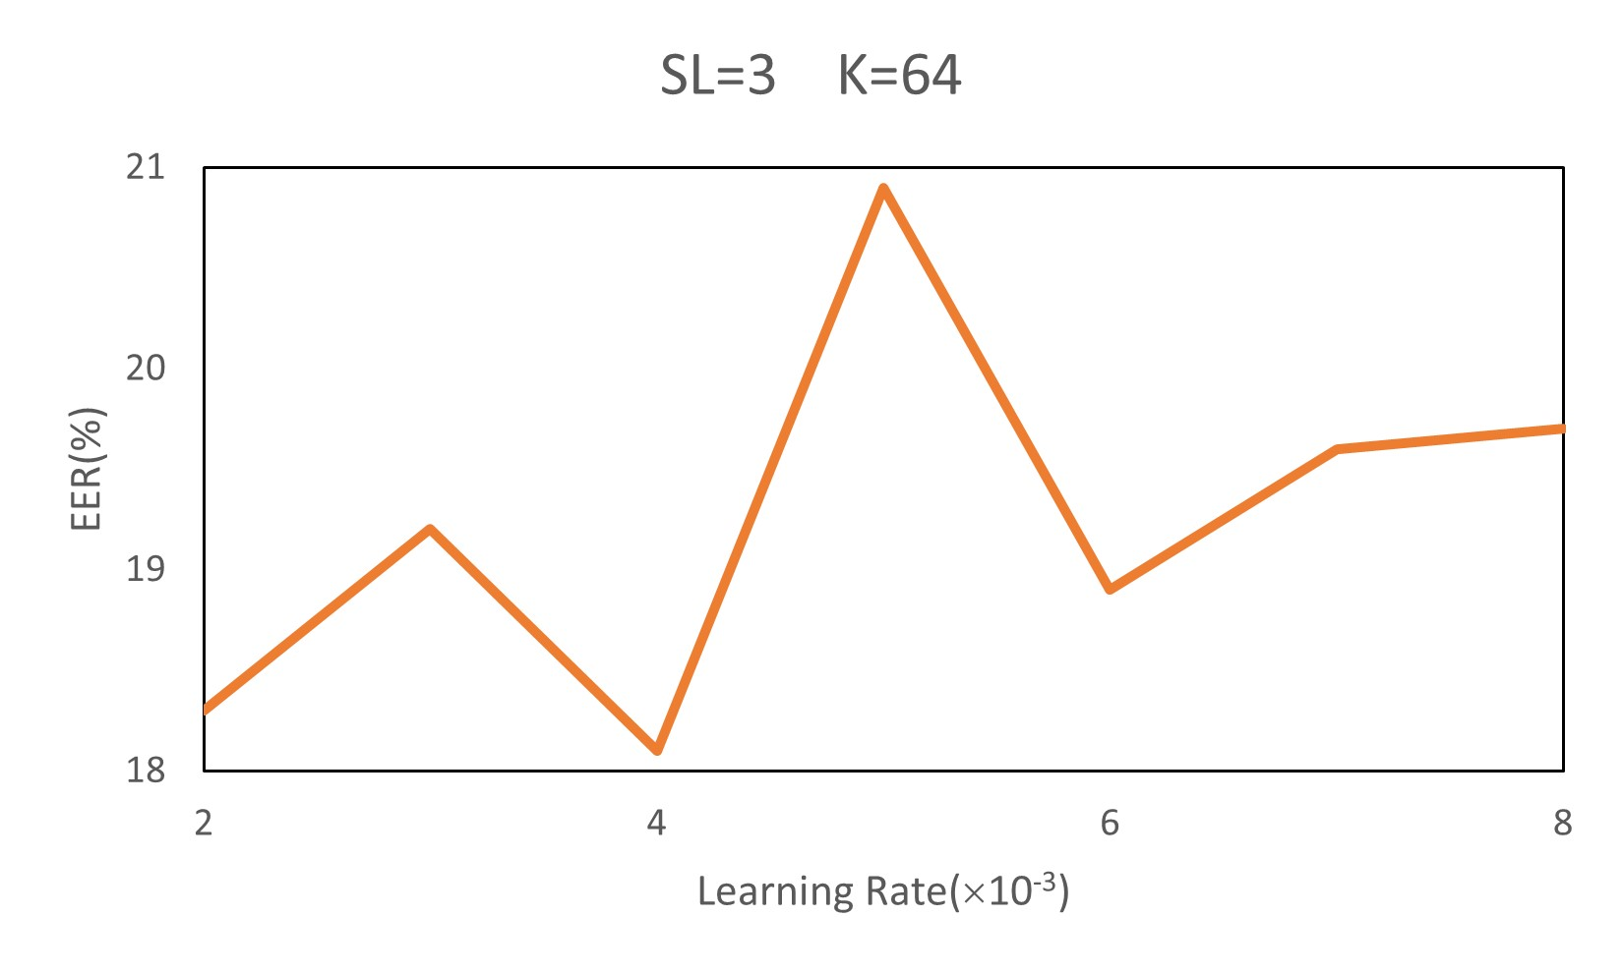
Fig.7 EER results for fixing the number of separable convolution layers = 3 and changing the number of convolution kernels
From the analysis of the curve, the lowest EER value of the system occurs in Fig.8, where SL=2, K=64, and Learning Rate=4×10⁻³, with the lowest EER value of 12.8%. Following an exhaustive experimental analysis of the MCYT-100 skilled-01 dataset, this algorithm successfully identified the optimal neural network configuration parameters. These parameters were then meticulously employed as the cornerstone for all subsequent experimental procedures detailed in this paper. In essence, the entire spectrum of experiments conducted herein was executed under the controlled and well-defined conditions set by these variable parameters, ensuring a consistent and comprehensive evaluation of the proposed algorithm's performance and capabilities.
So far, the parameters of the convolution layer are basically determined.

4.3.3 Depth-wise Separable Convolution Layer
The convolutional layer is a fundamental building block within Convolutional Neural Networks (CNNs), and its role is central to the network's ability to extract meaningful features from input data.
The primary function of the convolutional layer is to extract relevant features from the input data. This process captures patterns, edges, textures, and other low-level features present in the data.
Convolutional layers employ local receptive fields. This locality enables the layer to focus on capturing features while maintaining spatial hierarchies, which is crucial for understanding the structure of the data.
One of the key innovations of convolutional layers is weight sharing. Each filter is used at multiple spatial positions across the input.
Convolutional layers are typically stacked in multiple levels within a CNN. As data flows through these layers, they learn to recognize increasingly complex and abstract features. Low-level layers detect basic features like edges and corners, while higher-level layers recognize more complex patterns and object parts.
Convolutional layers provide a degree of translation invariance. This means that the network can recognize a particular feature, like a diagonal edge, regardless of its position in the input image.
Convolutional layers maintain a spatial hierarchy of features. As you progress through the layers, neurons have access to a wider receptive field, allowing them to capture larger and more abstract features. This hierarchy facilitates the network's ability to recognize objects and their relationships in the input data.
Alongside feature extraction, convolutional layers often include pooling operations (e.g., max pooling) that reduce the spatial dimensions.
Convolutional layers enable feature visualization by showcasing the learned filters and feature maps. This visualization helps researchers and practitioners gain insights into what features the network has learned and how it processes information.
Convolutional layers have been pre-trained on large datasets can be transferred to other tasks. This transfer learning allows the features learned by convolutional layers to be leveraged for various applications, saving both time and computational resources.
The convolutional layer is a cornerstone of CNNs, responsible for feature extraction, local receptive fields, weight sharing, hierarchical feature learning, translation invariance, spatial hierarchy, dimensionality reduction, feature visualization, and transfer learning.
The architecture of the DWSCNN utilized in this framework is illustrated in Figure 8. This DWSCNN network is structured with a total of 5 layers, and it operates on input data that comprises n online signature features, each with dimensions of 1×45. Let's delve into a detailed breakdown of this network structure, using an online signature data example for clarity.
In the first layer of the DWSCNN network, we employ a depth-wise separable convolutional layer. This layer is equipped with 64 convolutional kernels, each having dimensions of 1×3. When applied to the input, it generates 3 feature maps, each with dimensions of 1×45. Subsequently, point convolution with a kernel size of 1×1 is applied to these feature maps, resulting in the creation of 64 feature maps, each now containing 45×1 features.
The second layer of depth-wise separable convolution mirrors the operations of the first layer, further enhancing the network's ability to extract relevant features from the input data. After the convolutional operations within each layer, steps are taken to ensure the output data remains stable and optimal. Batch normalization and judiciously applied dropout techniques are employed to enhance data stability, minimize the risk of data fluctuations, and mitigate overfitting.
As the data progresses through two consecutive layers of depth-wise separable convolution, it undergoes a transformation, resulting in an output data size of 45×64. To facilitate downstream processing and analysis, this data is passed through a flattening layer. This flattening layer serves to expand the data into a linear vector, which now possesses dimensions of 1×2880.
The DWSCNN architecture is thoughtfully designed to process online signature features effectively. It applies a series of depth-wise separable convolutional layers, each contributing to the extraction of crucial features from the input data. The subsequent application of batch normalization, dropout, and flattening transforms the data into a format that is amenable to further analysis and classification.
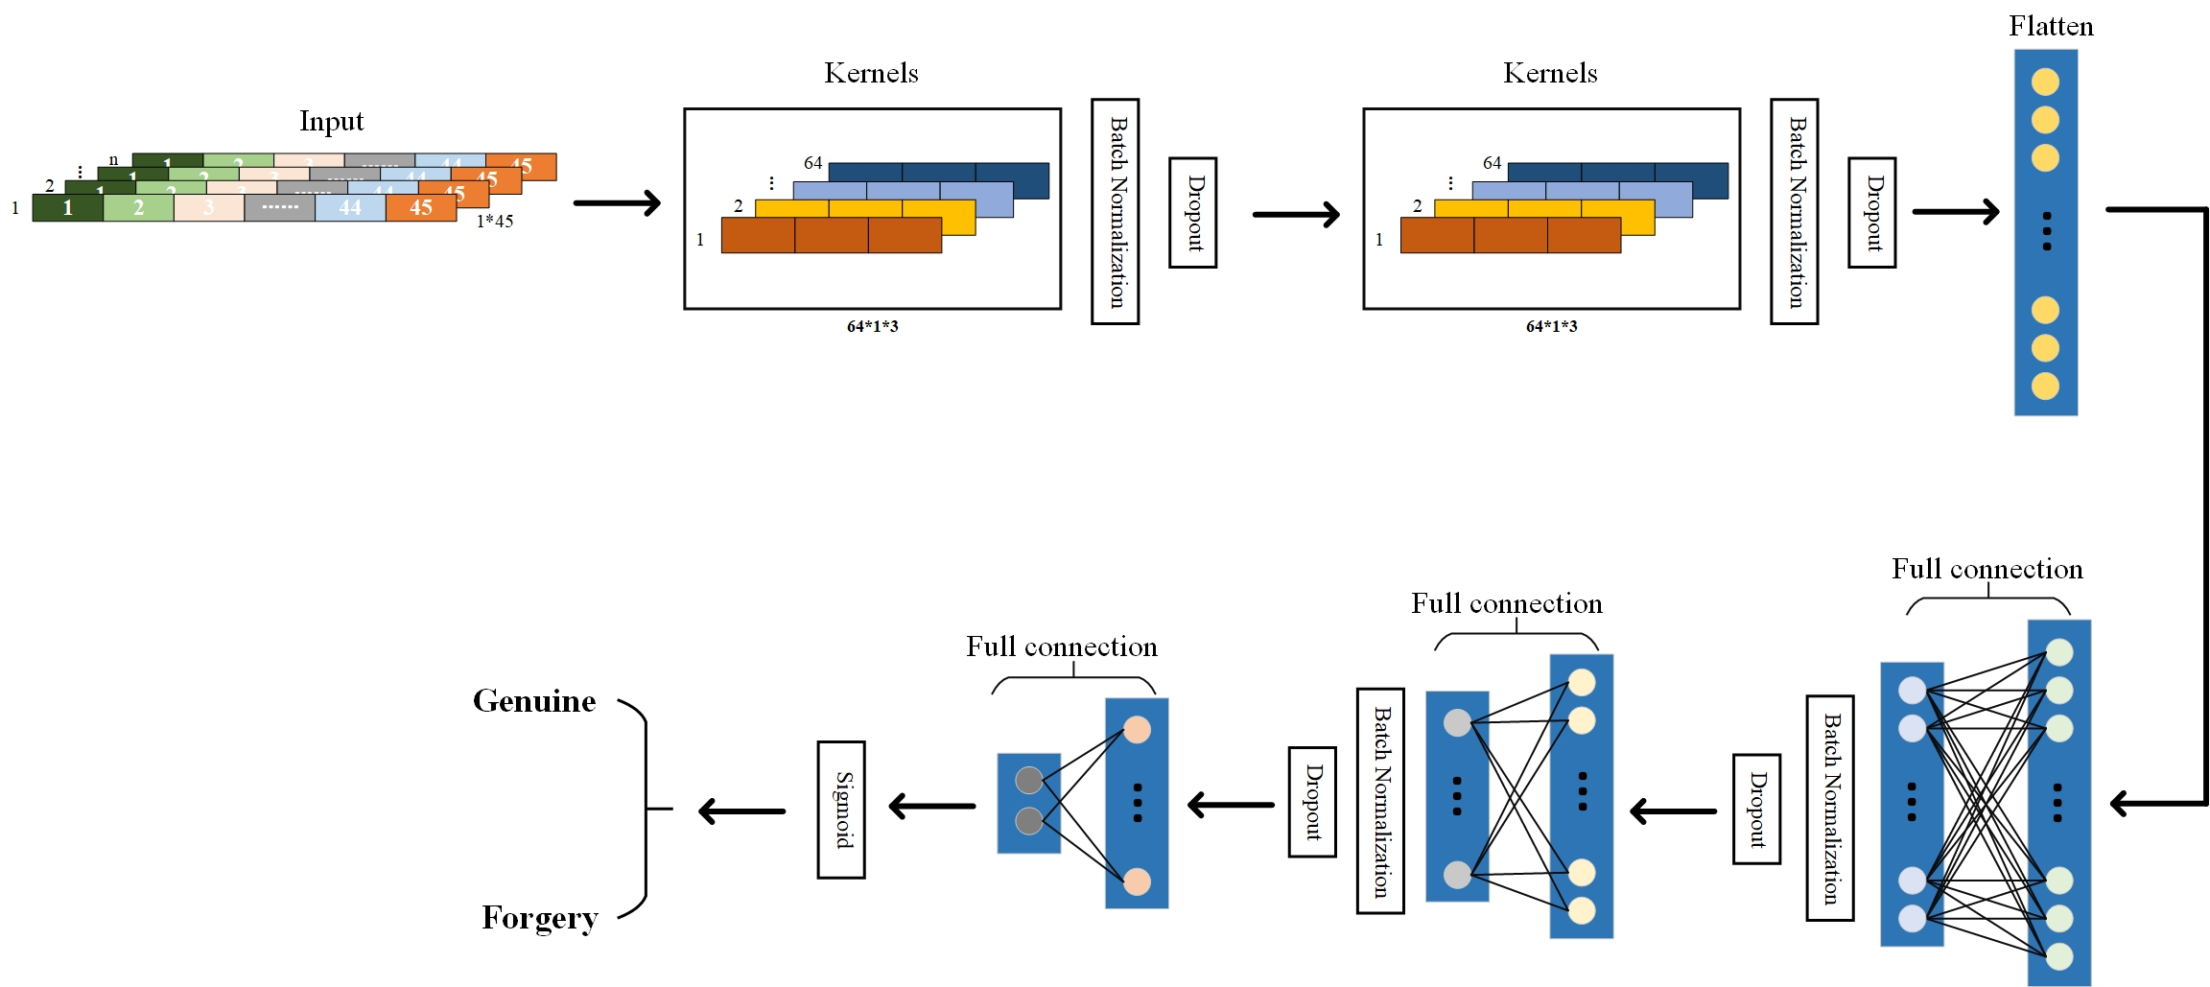
Fig.8 The overall structure of DWSCNN

4.3.4 Fully connected layer
The full connection layer, also known as the fully connected layer or dense layer, is a crucial component within convolutional neural networks (CNNs). Its role is pivotal in extracting and processing essential information from the feature maps generated by convolutional and pooling layers.
In convolutional and pooling layers, CNNs learn local features such as edges, textures, and basic patterns. However, these features are fragmented across different channels and locations within the feature maps. The full connection layer comes into play by connecting all neurons to each other, facilitating the fusion of these local features into a global representation. This enables the network to comprehend the holistic semantics and context of the input data.
The primary function of the full connection layer is often seen in classification tasks, where each neuron corresponds to a specific class or label. By converting the extracted features from previous layers into a probability distribution matching the number of classes, the full connection layer enables the network to make predictions. Additionally, it is also employed in regression tasks, such as facial key point detection, where each neuron corresponds to a key point's coordinates.
These weights are learned during the training process, allowing the full connection layer to adapt to different data distributions, thereby improving the network's generalization capability.
In CNNs, convolutional and pooling layers often produce a multitude of high-dimensional feature maps. The full connection layer serves to transform these high-dimensional feature maps into lower-dimensional representations. This reduction in dimensionality not only reduces the model's parameter count and computational cost but also helps prevent overfitting.
The presence of the full connection layer enables the network to learn hierarchical representations, progressively moving from lower-level features to higher-level semantic features. This aids the network in constructing abstract interpretations of the input data.
The full connection layer allows for easy visualization of the intermediate representations within the network. This visualization can assist in understanding the crucial features and decision pathways during the inference process, enhancing the model's interpretability.
The full connection layer plays a pivotal role in convolutional neural networks by aggregating local features into a global context, enabling classification and regression tasks, introducing non-linearity, connecting parameters, reducing dimensionality, facilitating hierarchical representation learning, and aiding in model visualization and interpretability.
Following the extraction of feature vectors by the initial two layers of depth-wise separable convolutional layers, these features are channeled into fully connected layers for the crucial classification stage. In this process, the features, once activated, are amalgamated by establishing connections between neurons in the fully connected layers and nodes in the preceding layer. This interconnectedness allows for the comprehensive integration of extracted features, a pivotal step in the classification journey.
To ensure the stability of the output data, mitigate the potential for erratic fluctuations, and counteract overfitting, we have judiciously incorporated batch normalization and applied dropout techniques after the first two fully connected layers. These measures play a pivotal role in enhancing the robustness and generalization capabilities of our model.
As the task at hand is signature verification, which falls under the domain of binary classification, the output layer of the fully connected layers is designed with 2 neurons. These neurons represent the two classes involved in the binary classification problem: genuine signatures, labeled as 1, and forged signatures, labeled as 0. The final classification decision hinges on the output of these neurons.
To bridge the output from the fully connected layers to the desired range of values, we employ the Sigmoid activation function. This function efficiently maps the neural network's output to the interval (0,1), allowing us to interpret the results with ease and precision. Figure 9 visually represents this final step in our framework.
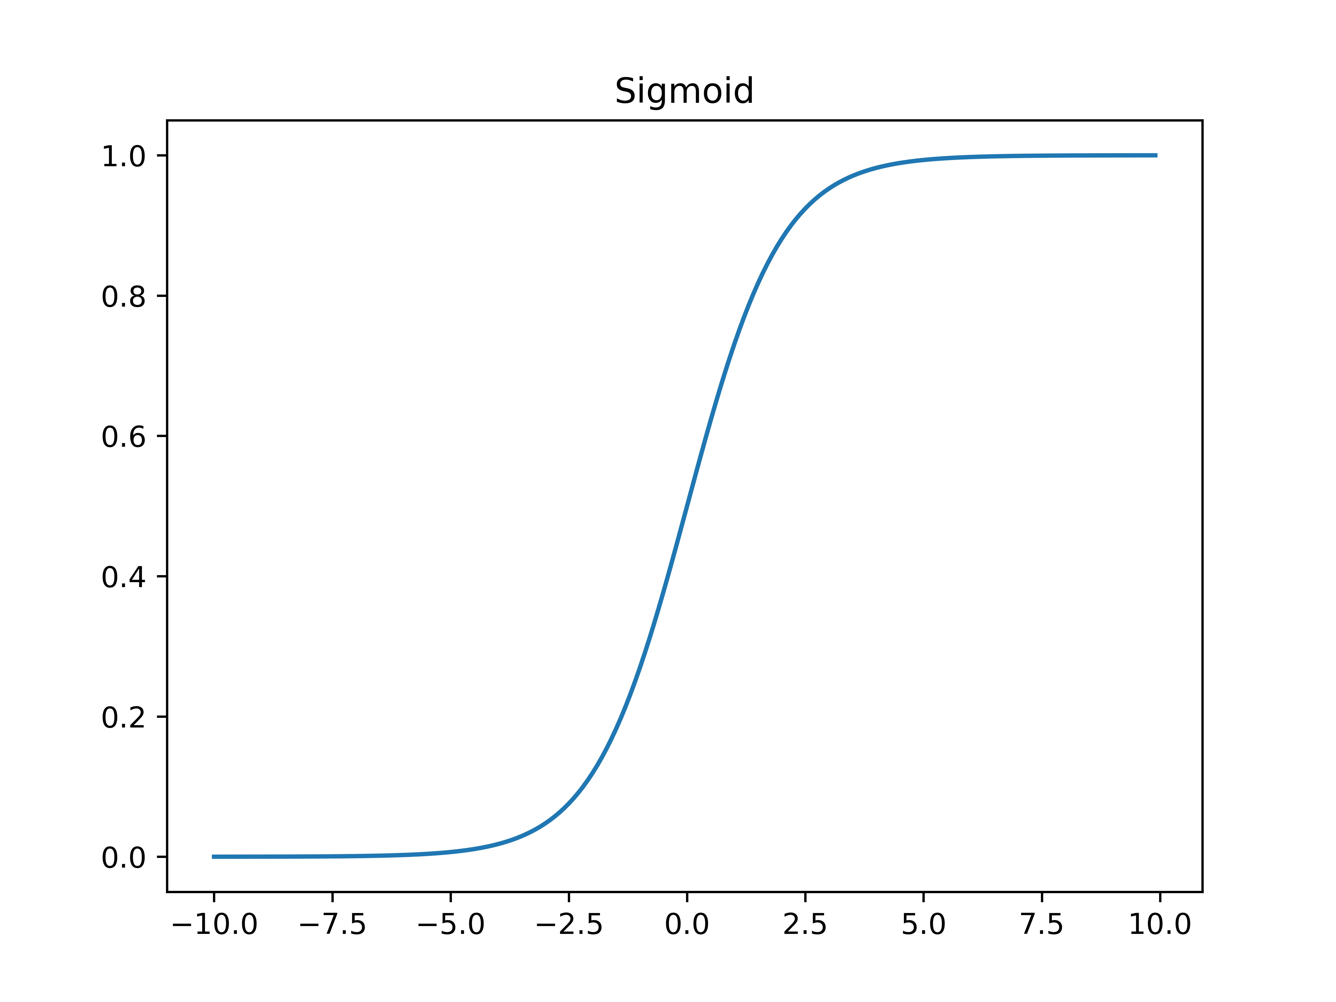
Fig.9 The Sigmoid function
During the training phase, we employ the Cross-Entropy Loss function. This loss function is instrumental in our supervised learning approach, serving as a guide to minimize the disparity between the model's predictions and the actual ground truth values. Through this optimization process, our model learns to make accurate distinctions between genuine and forged signatures.
The framework employs a meticulously designed neural network architecture that seamlessly integrates feature extraction, classification, and decision-making. The incorporation of fully connected layers, along with careful consideration of data stability and overfitting, ensures that our model is well-equipped to handle the nuances of signature verification—a quintessential binary classification problem. This comprehensive approach, coupled with the Cross-Entropy Loss function, forms the bedrock of our successful supervised learning methodology.

5 Experimentation

5.1 Experimental Setup
To ensure the robustness and applicability of our proposed algorithm, we meticulously selected two widely recognized online signature databases, allowing for meaningful comparisons with other state-of-the-art signature verification methods. These databases, outlined in Table 2, constitute a critical part of our experimental framework.
In our pursuit of rigorous experimentation and thorough evaluation, we conducted a series of experiments using a powerful NVIDIA GeForce RTX 3060 Laptop GPU equipped with 6GB of memory.
To comprehensively evaluate the capabilities of our framework, we organized our experiments into three distinct categories for each type of forgery, encompassing skilled forgery and random forgery. Specifically, we examined Skilled_05 (S_05), Skilled_10 (S_10), and Skilled_15 (S_15) within the skilled forgery category, as well as Random_05 (R_05), Random_10 (R_10), and Random_15 (R_15) within the random forgery category.
For a detailed breakdown of the training and testing data distribution within each category, please refer to Table 3. Each dataset within these categories consists of n individual users, with each user contributing both genuine signature samples (G) and forgery signature samples (F) for analysis.
The experiment design and dataset selection were carefully crafted to ensure that our proposed algorithm underwent thorough testing and validation under diverse conditions and forgery scenarios. This meticulous approach allows us to draw robust conclusions regarding its effectiveness and suitability for real-world online signature verification tasks.
Table 2 The particulars of dataset used in the experimentation of the proposed algorithm
Dataset | MCYT-100 | SVC-2004
Total number of writers | 100 | 40
Set of features for each signature | 100 | 47
Number of genuine signatures for each writers | 25 | 20
Number of forgery signatures for each writers | 25 | 20
Quantity of genuine signatures | 2500 | 800
Quantity of forgery signatures | 2500 | 800
Table 3 Details of the Training and Testing Signatures
Training/Testing  samples details | Skilled_05 | Skilled_10 | Skilled_15 | Random_05 | Random_10 | Random_15
No. of training  signatures | 100×5=500(G) | 100×10=1000(G) | 100×15=1500(G) | 100×5=500(G) | 100×10=1000(G) | 100×15=1500(G)
No. of testing  signatures | 100×20=2000(G)  +100×25=2500(F) | 100×15=1500(G)  +100×25=2500(F) | 100×5=500(G)  +100×25=2500(F) | 100×20=2000(G)  +100×99=9900(i) | 100×15=1500(G)  +100×99=9900(i) | 100×5=500(G)  +100×99=9900(i)
In this paper, FAR, FRR, EER and Accuracy (Acc) are chosen as evaluation metrics for the online signature verification algorithm. All tests are repeated 10 times, and the mean value of the evaluation metrics is taken as the final performance evaluation of the algorithm. All experimental results are reported with two significant figures.
For an online signature verification algorithm to be deemed effective for practical use, it must fulfill two crucial criteria that underscore its reliability and robustness:
- Scaling with Training Samples: The algorithm should exhibit a consistent trend wherein increasing the number of training samples leads to a noticeable reduction in the error rate across the entire system framework. This phenomenon should result in a tangible improvement in accuracy. Essentially, as the algorithm learns from an expanded dataset, it should progressively enhance its ability to correctly classify and verify signatures, thus yielding higher accuracy levels. This characteristic reflects the algorithm's adaptability and capacity to generalize from diverse training data.
- Distinguishing Skill Levels: During the testing phase of the system framework, a fundamental hallmark of an effective algorithm is its consistent ability to differentiate between various types of forgery. Specifically, the error rate associated with randomly forged samples should consistently remain lower, while the accuracy rate should consistently remain higher when compared to the error rates and accuracy rates concerning skilled forged samples. This discernment between skilled and random forgeries is pivotal, as it underscores the algorithm's capability to detect and thwart more sophisticated forgery attempts, a key requirement in real-world applications.
In a word, an effective signature verification algorithm should demonstrate not only the capacity to improve with an increased volume of training data but also the proficiency to consistently outperform in distinguishing between skilled and random forgery attempts during the testing phase. These two critical characteristics ensure the algorithm's practical utility and its readiness to address the complex and evolving challenges posed by signature verification in real-world scenarios.

5.2 Experimental Results and Comparisons

5.2.1 Results and Analysis of Experiments
Table 4 shows the performance of algorithm on the two databases and three categories. As shown in the Table 4, the EER value of the entire system decreases significantly with an increase in the number of samples, and the EER value of random forgery samples is much lower than that of skilled forgery samples. This indicates that the neural network in the signature verification system has learned the features of the samples and efficiently performs classification work.
In the context of the online signature system, which prioritizes user-centric performance, the evaluation metrics of paramount importance are the True Acceptance Rate (TAR) and False Acceptance Rate (FAR). These metrics serve as pivotal benchmarks for gauging the overall effectiveness and efficiency of the system framework.
Figures 10 and 11 provide graphical representations of the TAR and FAR curves, respectively, across various datasets. These curves offer a visual depiction of the system's performance in terms of accepting genuine signatures (TAR) and the potential for erroneously accepting fraudulent signatures (FAR). Analyzing these curves allows us to comprehensively assess how well the system distinguishes between legitimate user signatures and fraudulent attempts.
In a word, the TAR and FAR metrics, as illustrated in these figures, serve as critical indicators of the system's reliability and security. A high TAR signifies that genuine users are correctly authenticated, while a low FAR reflects the system's robustness in rejecting forged or unauthorized signatures. These metrics are central to the assessment of the system's overall efficiency and its ability to meet the stringent requirements of online signature verification.
Table 4 EER values with various signature samples
Dataset | MCYT-100 |  |  | SVC-2004
No. of signature samples | Skilled | Random |  | Skilled | Random
05 | 3.11 | 0.49 |  | 3.98 | 0.42
10 | 1.92 | 0.22 |  | 3.03 | 0.20
15 | 1.36 | 0.12 |  | 0.62 | 0.26
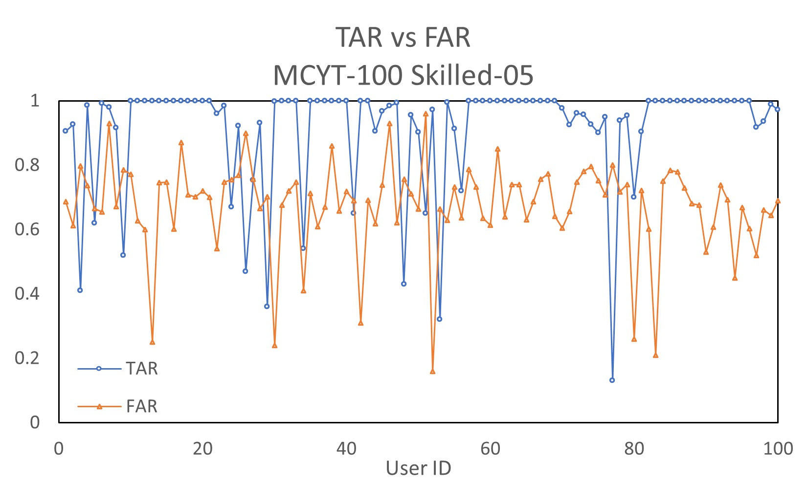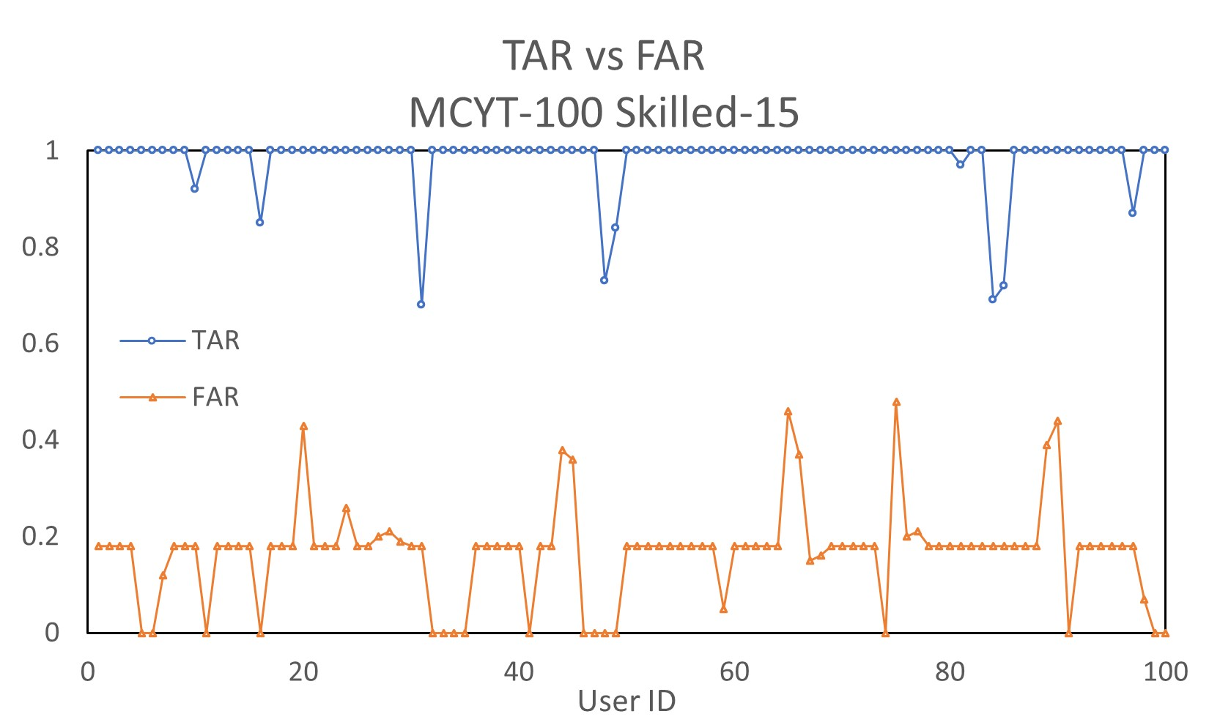
Fig.10 TAR vs FAR on MCYT-100
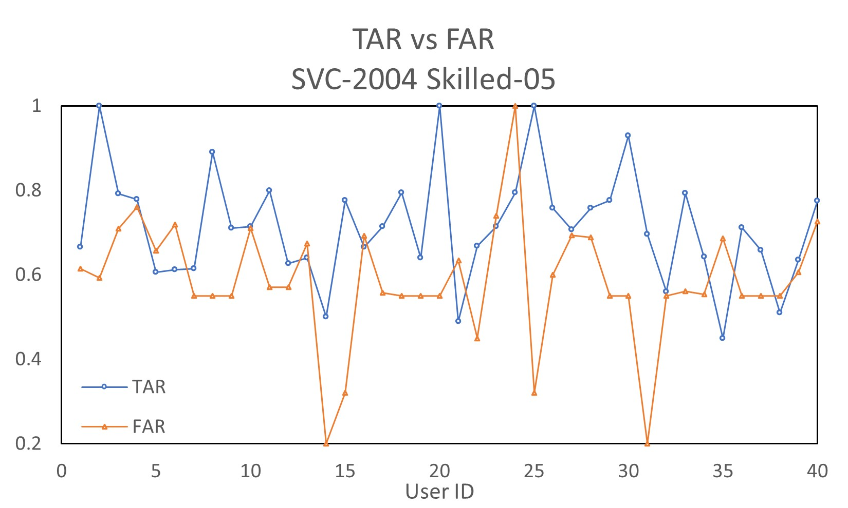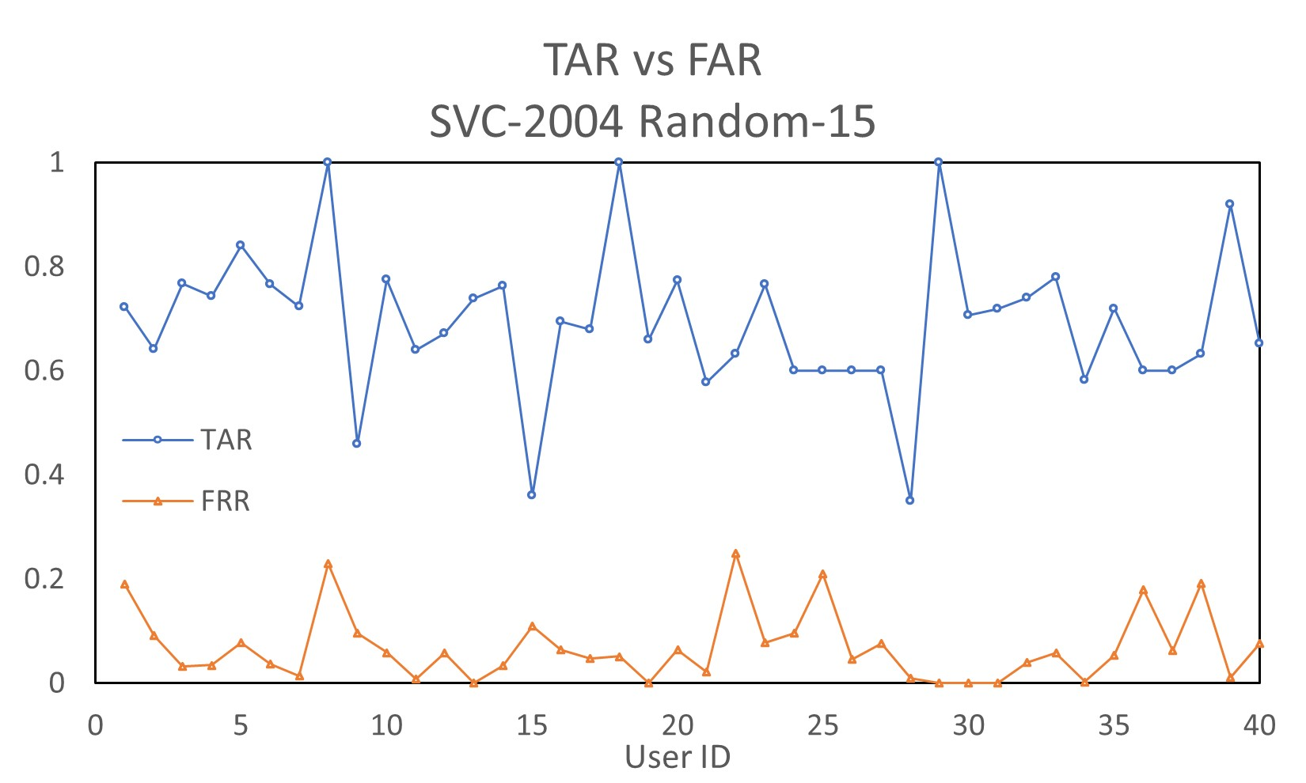
Fig.11 TAR vs FAR on SVC-2004
Analyzing Figure 10 reveals intriguing insights into the performance of our system framework, particularly in the context of the MCYT-100 dataset. When we initiated training with just 5 skilled forgery samples, the True Acceptance Rate (TAR) exhibited remarkable outcomes. For the majority of users, TAR values soared to near perfection, either reaching or closely approaching 1. This signified that the system demonstrated exceptional proficiency in recognizing the genuine signatures of most users. However, a few users exhibited noteworthy fluctuations in their TAR values, warranting further investigation.
In parallel, the False Acceptance Rate (FAR) values remained impressively stable, consistently hovering within the 0.6 to 0.8 range. Nevertheless, it's important to note that the two curves, TAR and FAR, did overlap under these conditions, suggesting a degree of overlap between the genuine and fraudulent signature recognition.
However, the dynamics changed significantly when the training dataset expanded to 15 samples. In this scenario, TAR values for over 90% of users surged to a perfect 100%, indicating impeccable recognition of their genuine signatures. Meanwhile, the FAR exhibited a slight average fluctuation, settling at around 0.18. This remarkable stability suggests that the system framework excelled in classifying signatures within the MCYT-100 dataset under these conditions, demonstrating its robustness and effectiveness.
Turning our attention to Figure 11, we observe a parallel narrative within the SVC-2004 dataset. With a mere 5 skilled forgery training samples, the average TAR values oscillated within the range of 0.6 to 0.8. Similarly, FAR values clustered around 0.58 for most users, with the two curves overlapping significantly. This indicated that, with limited training data, the system maintained respectable performance but experienced some overlap between genuine and fraudulent recognition.
However, when the training samples expanded to 15 randomly forged signatures, a remarkable transformation occurred. The average TAR values exhibited a noticeable improvement, fluctuating between 0.65 and 0.85, showcasing the system's adaptability in learning data characteristics even with minimal training samples. Meanwhile, FAR values underwent a significant shift, fluctuating between 0 and 0.2, reflecting the robustness of the framework in distinguishing genuine from random forgeries.
In summary, our findings suggest that the system framework is capable of delivering impressive classification results even with limited training samples. However, it's important to note that under such conditions, there may be some data oscillation, and the TAR and FAR curves could overlap. As the training dataset expands, the system exhibits enhanced performance, yielding more stable and discernible results, with a growing distinction between TAR and FAR curves.
Furthermore, it's worth highlighting the superior performance in handling random forgery compared to skilled forgery. The larger gap between TAR and FAR curves in the case of random forgery signifies the system's efficacy in meeting the proposed verification standards. This reinforces the framework's efficiency and effectiveness in real-world signature verification scenarios, underlining its potential for practical use.

5.2.2 Results comparison and analysis
In both Table 5 and Table 6, we provide a comprehensive comparison of the Equal Error Rate (EER) achieved by our proposed online signature verification algorithm alongside several other state-of-the-art algorithms. These algorithms have undergone rigorous evaluation on datasets that closely resemble the characteristics of our own signature datasets.
Within these tables, the most outstanding results achieved by our algorithm for each specific class within the dataset are highlighted in bold.
These tables serve as a testament to the effectiveness and competence of our proposed online signature verification algorithm. They offer a clear and concise summary of how our algorithm fares in comparison to other established approaches, affirming its status as a noteworthy contender in the realm of online signature verification algorithms.
As we delve into the results presented in both Table 5 and Table 6, a clear pattern of excellence emerges for our proposed algorithm, especially in specific categories within the MCYT-100 and SVC-2004 datasets. Notably, our algorithm outperforms its counterparts in the S_10, S_15, R_10, and R_15 categories of the MCYT-100 database, as well as in the S_15, R_10, and R_15 categories of the SVC-2004 dataset. These achievements underscore the advanced capabilities and effectiveness of our proposed algorithm.
A striking trend discernible from the data in these tables is the significant reduction in Equal Error Rate (EER) values as the number of training samples increases. This trend reaffirms the algorithm's adaptability and learning capacity when exposed to more extensive training datasets. Essentially, as it learns from a larger volume of data, it becomes increasingly adept at distinguishing genuine from forged signatures, leading to lower EER values and improved accuracy.
Table.5 Comparative analysis between the model in this paper and other models in MCYT database. "-" indicates that the corresponding framework was not evaluated in that particular experimental category
Method | S_05 | S_10 | S_15 | R_05 | R_10 | R_15
Stability Modulated DTW(F13)[30] | 13.56 | - | - | 4.31 | - | -
DTW-Normalization[30] | 8.36 | - | - | 6.25 | - | -
Deep Learning +DTW[31] | 2.40 | - | - | - | - | -
GMM +DTW with Fusion[32] | 3.05 | - | - | - | - | -
VQ +DTW[5] | 1.55 | - | - | - | - | -
Curvature feature[4] | 10.22 | 8.25 | 6.38 | 4.12 | 3.33 | 2.58
Torsion Feature[4] | 9.22 | 7.04 | 5.12 | 3.42 | 2.25 | 1.90
Curvature + Torsion Feature[4] | 6.05 | 4.23 | 3.10 | 2.95 | 1.81 | 1.20
WP +BL DTW[33] | 2.76 | - | - | - | - | -
Histogram +Manhattan[34] | 4.02 | - | - | 1.15 | - | -
Cosine similarities from 1-D CNNs trained with synthesized signatures[35] | 0.93 | - | - | - | - | -
Probabilistic-DTW(case 1)[36] | - | - | - | 0.0118 | - | -
Probabilistic-DTW(case 2)[36] | - | - | - | 0.0187 | - | -
Proposed Model | 3.11 | 1.92 | 1.36 | 0.49 | 0.22 | 0.12
Table.6 Comparative analysis between the model in this paper and other models in SVC database. "-" indicates that the corresponding framework was not evaluated in that particular experimental category
Method | S_05 | S_10 | S_15 | R_05 | R_10 | R_15
DTW based[33] | - | 7.80 | - | - | - | -
Curvature + Torsion Feature[4] | 9.83 | 6.61 | 3.10 | 3.54 | 1.24 | 1.81
SPW +mRMR +SVM[37] | - | 1.00 | - | - | - | -
PCA[38] | - | 7.05 | - | - | - | -
LCSS(User Threhold)[39] | - | 5.33 | - | - | - | -
Cosine similarities from 1-D CNNs trained with synthesized signatures[35] | 2.63 | - | - | - | - | -
Probabilistic-DTW(case 1)[36] | - | - | - | 0.0025 | - | -
Probabilistic-DTW(case 2)[36] | - | - | - | 0.0175 | - | -
Proposed Model | 3.98 | 3.03 | 0.62 | 0.42 | 0.20 | 0.26
Furthermore, it's noteworthy that the EER values for random forgeries consistently remain substantially lower than those for skilled forgeries. This consistent pattern validates the robustness of our algorithm in handling more complex and sophisticated forgery attempts, often encountered in real-world scenarios. The notable gap between EER values for skilled and random forgeries reinforces the algorithm's effectiveness in discerning between genuine and fraudulent signatures.
However, it's crucial to acknowledge and address the outliers present in these tables—values that deviate from the expected trend. These anomalies can be attributed to the inherent variability introduced during the neural network training process, driven by the random initialization of weights and biases. Despite these occasional outliers, the overall trends clearly highlight the algorithm's proficiency and robustness, setting it apart as a promising solution for practical online signature verification.
The results in Table 5 and Table 6 illuminate our algorithm's exceptional performance across various categories within the MCYT-100 and SVC-2004 datasets. The trend of diminishing EER values with increased training samples, coupled with the consistently superior performance in handling random forgeries, substantiates the algorithm's effectiveness. While some outliers may arise due to training variability, the overarching message is clear: our proposed algorithm is a formidable contender in the realm of online signature verification, capable of meeting the stringent demands of real-world applications.
Within the MCYT-100 dataset, it's worth noting that references [35, 36] managed to attain more favorable Equal Error Rate (EER) values in the S_05 and R_05 categories, respectively. Similarly, when examining the SVC-2004 dataset, references [35-37] demonstrated superior EER values in the S_05, S_10, and R_05 categories. These accomplishments signify the strengths of traditional machine learning approaches employed in these references.
However, it's essential to consider a critical trade-off associated with these approaches. While references [35-37] showcase commendable EER results, they do so at the cost of extended training times and heightened computational requirements. This aspect of their methodologies, while effective in achieving low EER values, often disregards the practical realities of real-world application scenarios.
In contrast, our approach places a strong emphasis on practicality. We recognize that the true value of an online signature verification system lies not only in achieving the lowest EER values but also in doing so within the shortest possible training time and with minimal computational demands. This perspective aligns with the needs of real-world applications, where efficiency, speed, and resource optimization are pivotal considerations.
The approach strikes a balance between achieving competitive EER values and ensuring that the system remains practical and feasible for deployment in real-world settings. By prioritizing efficiency alongside accuracy, we aim to deliver a solution that is not only effective but also readily applicable to the demands of contemporary online signature verification scenarios. This focus on practicality underscores our commitment to delivering a solution that can truly make a difference in the field.
While our online signature verification algorithm has exhibited promising results, it's essential to acknowledge certain inherent limitations associated with online signatures. These challenges encompass issues like inadequate preprocessing, susceptibility to sample noise interference, and the underutilization of sample space information. In light of these shortcomings, we recognize the need for ongoing improvement to enhance the algorithm's overall performance.
Looking ahead to our future research endeavors, we are committed to addressing these challenges and further elevating the algorithm's capabilities. One avenue we intend to explore involves the integration of offline signatures into our algorithm. By incorporating offline signatures, we aim to mitigate the deficiencies associated with online signatures and enhance the algorithm's accuracy, robustness, and reliability.
Our overarching objective remains steadfast: to develop an online signature verification algorithm that not only excels in its current state but also continually evolves to meet the evolving demands of signature verification tasks. We understand that the journey toward building an accurate and reliable signature verification algorithm is an ongoing process, and we are dedicated to pushing the boundaries of what is possible in this field.
In conclusion, our commitment to research and innovation drives us to continually refine and enhance our algorithm, with the ultimate goal of delivering a solution that sets new standards in online signature verification accuracy and reliability.

6. Conclusion
In this paper, we introduce an online signature verification algorithm meticulously crafted to overcome longstanding challenges in the field. These challenges encompass issues like suboptimal feature extraction, noise interference, and redundant feature usage, all of which have posed significant hurdles in achieving accurate and efficient signature verification.
Our algorithm introduces a groundbreaking approach by harnessing the power of Depth-wise Separable Convolutional Neural Networks (DWSCNN) based on Depth-wise Separable (DWS) convolution. This innovation serves as the cornerstone of our solution, and it ingeniously addresses several critical issues that have plagued previous signature verification methods.
One of the standout achievements of our algorithm lies in its ability to dramatically reduce the number of neural network parameters. This architectural efficiency not only diminishes the need for an extensive collection of training samples but also significantly truncates the computational time required for signature verification. This represents a paradigm shift in contrast to many existing techniques, which often impose substantial computational overhead.
A hallmark feature of our algorithm is its remarkable effectiveness with minimal training data requirements. With a minimum threshold of just 5 training samples, it demonstrates a level of adaptability rarely seen in the field. This scalability expands the practical utility of our algorithm, making it highly applicable to scenarios where acquiring a vast training dataset may be impractical or infeasible.
To substantiate the capabilities of our algorithm, we conducted extensive validation using two widely recognized signature verification databases. The results were nothing short of outstanding, with an average verification accuracy of 96.92%. These results not only affirm the algorithm's prowess but also position it as a leader in the field, consistently outperforming many existing methodologies across various categories.
In summary, our algorithm represents a robust and efficient framework for online signature verification. Its exceptional classification performance, coupled with its minimal computational demands and rapid processing times, render it highly suitable for deployment in a wide array of practical applications. As such, it stands as a testament to the ongoing advancements in signature verification technology, offering a promising solution that holds the potential to make a substantial impact in real-world settings. Whether in financial institutions, legal offices, or other everyday applications, our algorithm stands ready to elevate the accuracy and efficiency of online signature verification, ushering in a new era of reliability and security.

Reference
[1] K. Bibi, S. Naz, and A. Rehman, "Biometric signature authentication using machine learning techniques: Current trends, challenges and opportunities," Multimedia Tools and Applications, vol. 79, no. 1-2, pp. 289-340, 2019.
[2] M. Diaz, M. A. Ferrer, D. Impedovo, M. I. Malik, G. Pirlo, and R. Plamondon, "A Perspective Analysis of Handwritten Signature Technology," ACM Computing Surveys, vol. 51, no. 6, pp. 1-39, 2019.
[3] C. S. Vorugunti, V. Pulabaigari, R. K. S. S. Gorthi, and P. Mukherjee, "OSVFuseNet: Online Signature Verification by feature fusion and depth-wise separable convolution based deep learning," Neurocomputing, vol. 409, pp. 157-172, 2020.
[4] L. He, H. Tan, and Z.-C. Huang, "Online handwritten signature verification based on association of curvature and torsion feature with Hausdorff distance," Multimedia Tools and Applications, vol. 78, no. 14, pp. 19253-19278, 2019.
[5] A. Sharma and S. Sundaram, "An enhanced contextual DTW based system for online signature verification using Vector Quantization," Pattern Recognition Letters, vol. 84, pp. 22-28, 2016.
[6] M. I. Razzak and B. Alhaqbani, "Multilevel fusion for fast online signature recognition using multi-section VQ and time modelling," Neural Computing and Applications, vol. 26, no. 5, pp. 1117-1127, 2014.
[7] C. Hong, J. Yu, J. Zhang, X. Jin, and K.-H. Lee, "Multimodal Face-Pose Estimation With Multitask Manifold Deep Learning," IEEE Transactions on Industrial Informatics, vol. 15, no. 7, pp. 3952-3961, 2019.
[8] J. Ou and Y. Li, "Vector-kernel convolutional neural networks," Neurocomputing, vol. 330, pp. 253-258, 2019.
[9] A. P. C. Y. S. K. S. M. K. Hyongsuk, "Hybrid No-Propagation Learning for Multilayer Neural Networks," Neurocomputing, pp. 28-35, 2018.
[10] C. Hong, J. Yu, J. Wan, D. Tao, and M. Wang, "Multimodal Deep Autoencoder for Human Pose Recovery," IEEE Trans Image Process, vol. 24, no. 12, pp. 5659-70, Dec 2015.
[11] E. N. Zois, L. Alewijnse, and G. Economou, "Offline signature verification and quality characterization using poset-oriented grid features," Pattern Recognition, vol. 54, pp. 162-177, 2016.
[12] Y. Guerbai, Y. Chibani, and B. Hadjadji, "The effective use of the one-class SVM classifier for handwritten signature verification based on writer-independent parameters," Pattern Recognition, vol. 48, no. 1, pp. 103-113, 2015.
[13] N. Arab, H. Nemmour, and Y. Chibani, "A new synthetic feature generation scheme based on artificial immune systems for robust offline signature verification," Expert Systems with Applications, vol. 213, 2023.
[14] L. G. Hafemann, R. Sabourin, and L. S. Oliveira, "Learning features for offline handwritten signature verification using deep convolutional neural networks," Pattern Recognition, vol. 70, pp. 163-176, 2017.
[15] S. Y. Ooi, A. B. J. Teoh, Y. H. Pang, and B. Y. Hiew, "Image-based handwritten signature verification using hybrid methods of discrete Radon transform, principal component analysis and probabilistic neural network," Applied Soft Computing, vol. 40, pp. 274-282, 2016.
[16] I. Bhattacharya, P. Ghosh, and S. Biswas, "Offline Signature Verification Using Pixel Matching Technique," Procedia Technology, vol. 10, pp. 970-977, 2013.
[17] L. Liu, L. Huang, F. Yin, and Y. Chen, "Offline signature verification using a region based deep metric learning network," Pattern Recognition, vol. 118, 2021.
[18] W. Bouamra, C. Djeddi, B. Nini, M. Diaz, and I. Siddiqi, "Towards the design of an offline signature verifier based on a small number of genuine samples for training," Expert Systems with Applications, vol. 107, pp. 182-195, 2018.
[19] M. Sharif, M. A. Khan, M. Faisal, M. Yasmin, and S. L. Fernandes, "A framework for offline signature verification system: Best features selection approach," Pattern Recognition Letters, vol. 139, pp. 50-59, 2020.
[20] P. Maergner et al., "Combining graph edit distance and triplet networks for offline signature verification," Pattern Recognition Letters, vol. 125, pp. 527-533, 2019.
[21] M. Okawa, "Synergy of foreground–background images for feature extraction: Offline signature verification using Fisher vector with fused KAZE features," Pattern Recognition, vol. 79, pp. 480-489, 2018.
[22] M. B. Yılmaz and B. Yanıkoğlu, "Score level fusion of classifiers in off-line signature verification," Information Fusion, vol. 32, pp. 109-119, 2016.
[23] J.-X. Ren, Y.-J. Xiong, H. Zhan, and B. Huang, "2C2S: A two-channel and two-stream transformer based framework for offline signature verification," Engineering Applications of Artificial Intelligence, vol. 118, 2023.
[24] M. Okawa, "Time-series averaging and local stability-weighted dynamic time warping for online signature verification," Pattern Recognition, vol. 112, 2021.
[25] R. Su, T. Liu, C. Sun, Q. Jin, R. Jennane, and L. Wei, "Fusing convolutional neural network features with hand-crafted features for osteoporosis diagnoses," Neurocomputing, vol. 385, pp. 300-309, 2020.
[26] L. N. Julian Fierrez-Aguilar, Jaime Lopez-Pealba, Javier Ortega-Garcia; Davide Maltoni, " An On-Line Signature Verification System Based on Fusion of Local and Global Information," Lecture Notes in Computer Science, vol. Vol.3546, p. 523, 2005.
[27] M. H. S. Mohsen Fayyaz, Mohammad Sabokrou, M. Hoseini, M. Fathy, "Online Signature Verification Based on Feature Representation," 2015 International Symposium on Artificial Intelligence and Signal Processing (AISP), pp. 211-216, 2015.
[28] W. K. Nelson, E., "Use of dynamic features for signature verification," Conference Proceedings 1991 IEEE International Conference on Systems, Man, and Cybernetics, pp. 201-205, 1991.
[29] W. T. Nelson, W.; Hastie, T., "STATISTICAL METHODS FOR ON-LINE SIGNATURE VERIFICATION," International Journal of Pattern Recognition and Artificial Intelligence, vol. Vol.8, pp. 749-770, 1994.
[30] R. Doroz, P. Kudlacik, and P. Porwik, "Online signature verification modeled by stability oriented reference signatures," Information Sciences, vol. 460-461, pp. 151-171, 2018.
[31] X. Wu, A. Kimura, B. K. Iwana, S. Uchida, and K. Kashino, "Deep Dynamic Time Warping: End-to-End Local Representation Learning for Online Signature Verification," presented at the 2019 International Conference on Document Analysis and Recognition (ICDAR), 2019.
[32] J. Galbally, J. Fierrez, M. Martinez-Diaz, and J. Ortega-Garcia, "Improving the Enrollment in Dynamic Signature Verfication with Synthetic Samples," presented at the 2009 10th International Conference on Document Analysis and Recognition, 2009.
[33] A. Sharma and S. Sundaram, "On the Exploration of Information From the DTW Cost Matrix for Online Signature Verification," IEEE Trans Cybern, vol. 48, no. 2, pp. 611-624, Feb 2018.
[34] S.-B. Napa and N. Memon, "Online Signature Verification on Mobile Devices," IEEE Transactions on Information Forensics and Security, vol. 9, no. 6, pp. 933-947, 2014.
[35] S. L. L. J. L. Lin, "SynSig2Vec: Learning Representations from Synthetic Dynamic Signatures for Real-world Verification," The Thirty-Fourth AAAI Conference on Artificial Intelligence, pp. 735-742, 2020.
[36] R. Al-Hmouz, W. Pedrycz, K. Daqrouq, A. Morfeq, and A. Al-Hmouz, "Quantifying dynamic time warping distance using probabilistic model in verification of dynamic signatures," Soft Computing, vol. 23, no. 2, pp. 407-418, 2017.
[37] B. Kar, A. Mukherjee, and P. K. Dutta, "Stroke Point Warping-Based Reference Selection and Verification of Online Signature," IEEE Transactions on Instrumentation and Measurement, vol. 67, no. 1, pp. 2-11, 2018.
[38] L. Yang, Y. Cheng, X. Wang, and Q. Liu, "Online handwritten signature verification using feature weighting algorithm relief," Soft Computing, vol. 22, no. 23, pp. 7811-7823, 2018.
[39] K. Barkoula, G. Economou, and S. Fotopoulos, "Online signature verification based on signatures turning angle representation using longest common subsequence matching," International Journal on Document Analysis and Recognition (IJDAR), vol. 16, no. 3, pp. 261-272, 2012.

