HTML & CSS
Web Development
  - Name: Sarann Elizabeth Strange

Student No: 1701763

Email: 1701763@student.uwtsd.ac.uk

Course: BSC (Hons) Software Engineering

Module Name: Introduction to Web Development

Module Code: ACCA4003

Lecturer: Kemi Ademoye

Assignment Number:

Table of Content
Table of Contents
1. Introduction 1
2. Requirements 1
2.1 Introduction to the website 1
2.2 Site Map 2
2.2.1 Navigation Bar 4
2.2.2 Footer Navigation 5
2.2.3 Home Page Navigation 6
2.2.4 Gallery Page Navigation 7
2.3 Wireframe 8
2.3.1 Design elements & Contents section of website 9
3 Implementation 11
3.1 HTML Pages 11
3.1.1 Index Page / Home Page 11
3.1.2 Gallery page 12
3.1.3 About Page 13
3.1.4 Equipment 14
3.1.5 Contact Page 15
3.2 Validation 16
3.2.1 HTML Validation 16
3.2.2 CSS Validation & Prefixing 17
4 Evaluation 19
4.1 Navigation & Footer Bar 19
4.2 Headings 19
4.3 Images & Other Media Content 19
4.4 Colours of the Website 20
4.5 Information Structure 20
4.6 Evaluation of Tools 21
4.6.1 Contrast Checker 21
4.6.2 WAVE Evaluation Tool 22
4.6.3 Visual Studio 23
5 Recommendations for Future Improvements 24
6 Conclusion 25
7 References 26

Introduction
This report covers the requirements and considerations that must be made when designing a website; such as the business that the website is for, the audience that its trying to attract, and the use of images and text. The layout and navigation are discussed, along with tools that were used in the creation and evaluation of the accessibility of the finished website.
Potential improvements are suggested along with an evaluation on how successful the finished design of the website. A further evaluation is made on the strengths and weaknesses of the website.

Requirements
Before a website can be created it is advisable for the requirements and needs of the business or individual that is requesting the website to be identified. Once the requirements have been identified a design for the website can be developed. The purpose of identifying the requirements is to ensure that the overall design and navigation attract the specific audience that the business or individual wishes to reach.

Introduction to the website
The overall purpose of the website is to provide a platform for the photographer, Mr. Nobody, to display his previous work to generate interest and new clientele. The website describes Mr. Nobody allowing individuals an insight on who he is, his work history and passions. When individuals visit the website, they have access of previous photos that Mr. Nobody took, and the ability to contact Mr. Nobody directly and provide their own contact E-mail. Individuals who visit the website will build a rounded idea on Mr. Nobody personality and may wish to hire him.
The target audience of the website is aimed at individuals who require the services of a professional photographer for a range of events. The website design uses soft colours that are appealing to both a male and female audience.

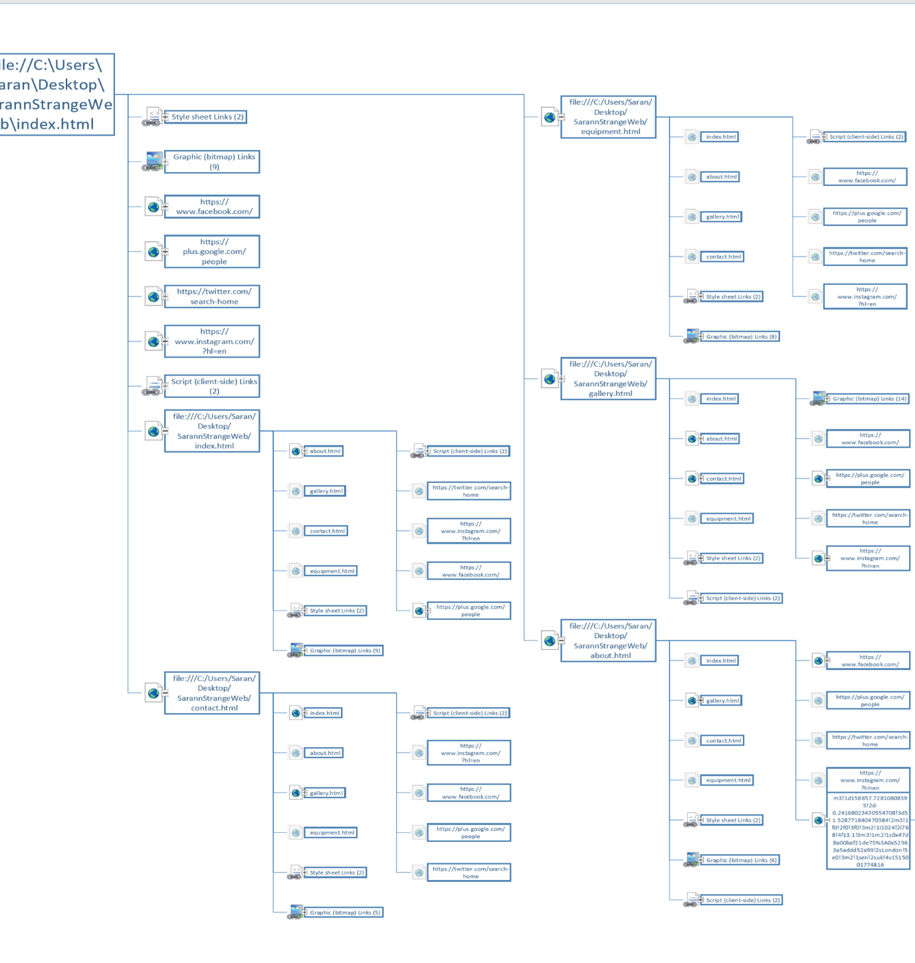
Site Map
Figure 1 Navigation links of the website how they link to one another

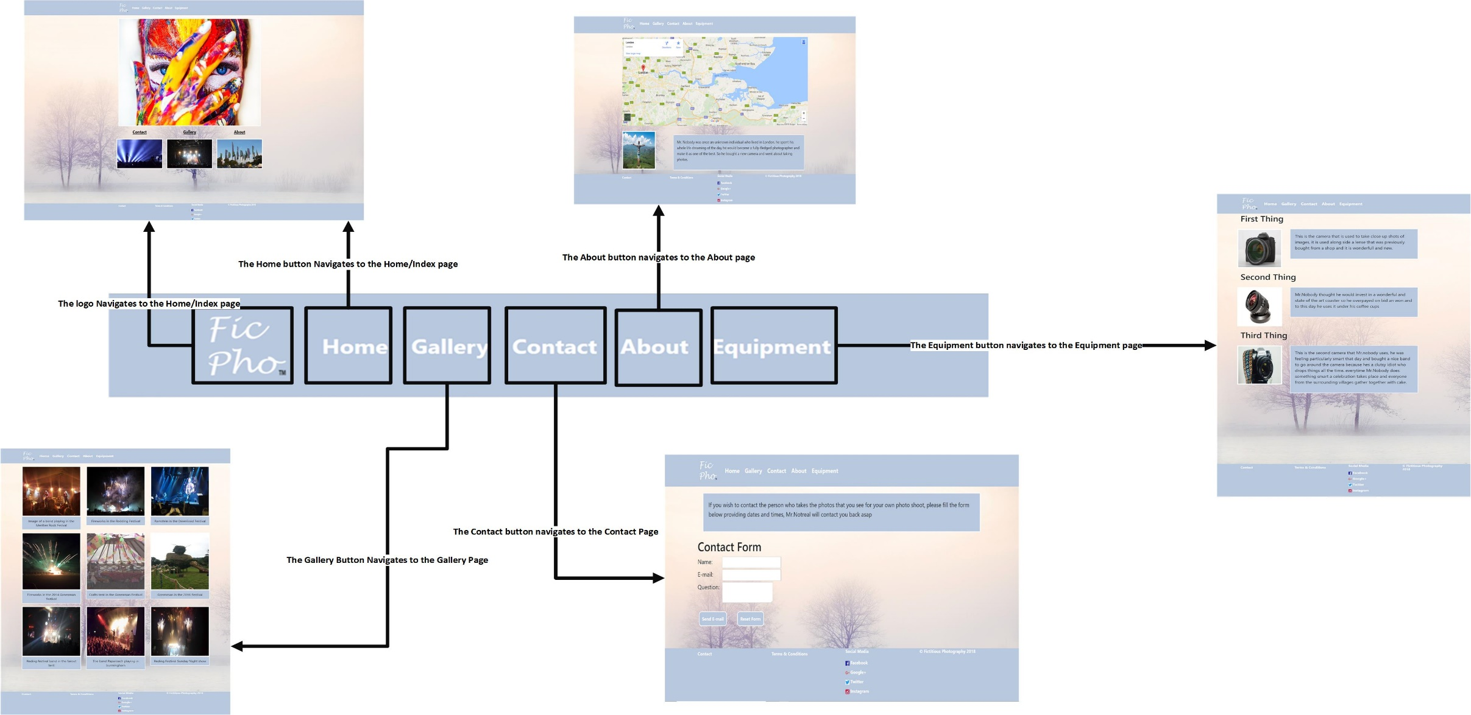
2.2.1 Navigation Bar
Figure 2The Navigation menu on all webpages

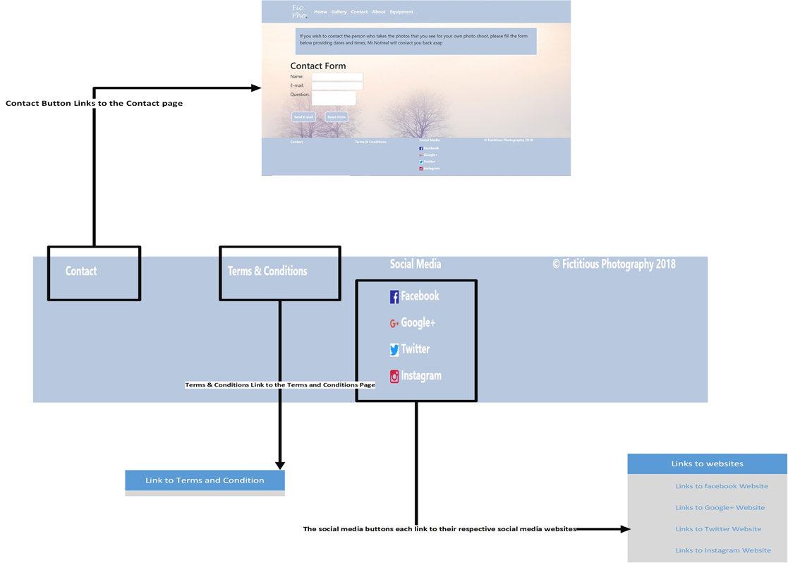
2.2.2 Footer Navigation

Figure 3 The footer navigation on all pages

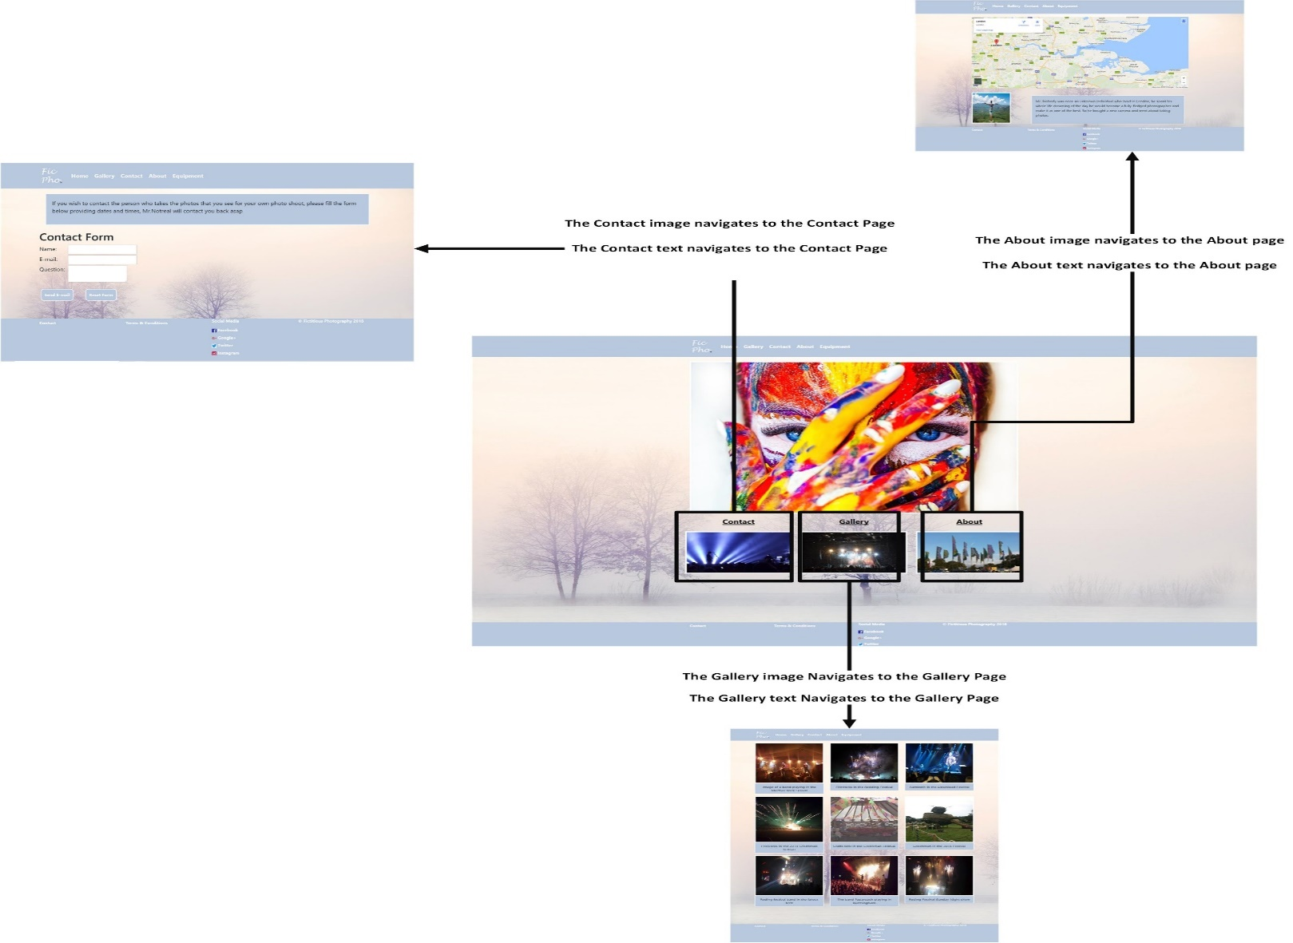
2.2.3 Home Page Navigation
Figure 4 Index page of website

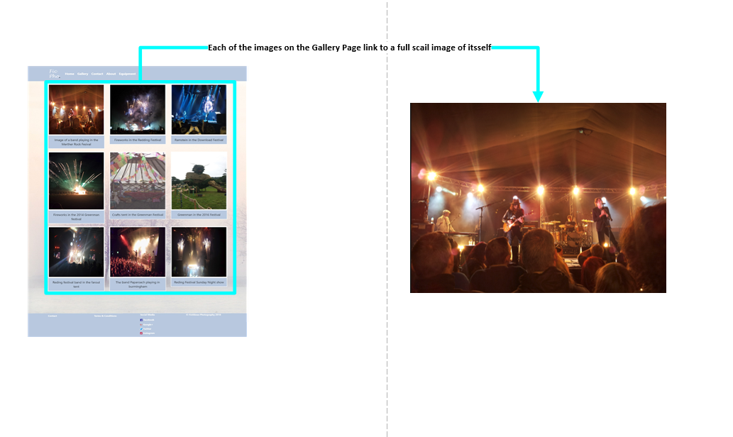
2.2.4 Gallery Page Navigation
Figure 5 The gallery page of the website

Wireframe
The Navigation bar consists of 1 container, which holds all of the links.
When the browser window reaches a certain threshold all the links are held within a hamburger icon.
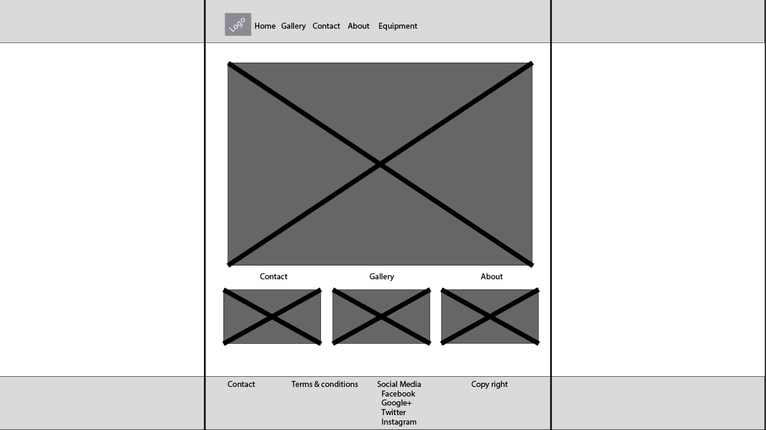
This section of the webpage uses 1 container, with 2 row, with 3 equal columns of 4 each.
The main image that is found in the body. It consists of 1 container, with 1 row, with 1 column of 12
The Footer bar consists of 1 container, with 1 row with 4 equal columns. With a responsive design where col-12, col-sm-6, col-lg-3.

Design elements & Contents section of website
The background colour of the website was chosen as it is not distracting, allowing the audience to appreciate the images. The website’s simplicity and plain design replicates an art gallery, and the white background reinforces expectations that individuals are viewing art in turn encouraging them to make a purchase [1].
The static navigation bar placed at the top of the webpage has been well established and has become the standard amongst websites. As this is an established convention, it was implemented to reduce confusion to ensure users feel that they have access to the important content at all times [2].
The footer contains links to other webpages that are not as highly required to the user as the links within the navigation bar, but are of importance. Similar to the navigation bar it has become standard form for it to be located at the bottom of the webpages, and to aid user’s expectations the website adheres to that standard. [3]
There were many hover-over effects used on the website such as the opacity changes on images and colour change of text. They were used to improve accessibility as users have a visual indication of what can be clicked or used on each of the webpages.
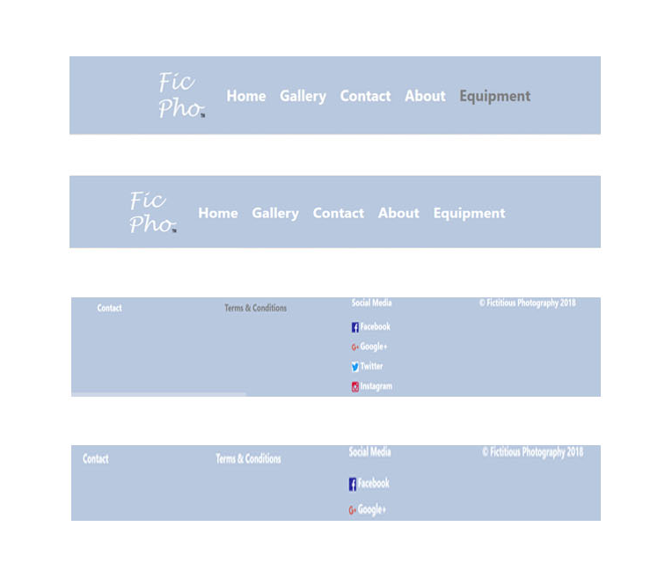
Figure 6 navigation & footer bar hover over colour change

The logo of the website is placed within the navigation bar, which functions as a clickable link. The logo redirects the user back to the home page. This has become another established convention for websites and is an expectation of the users.
There are specific images and text that direct users to other pages, those links have been used to indicate other pages of interest to the user to encourage them to continue to explore the website.
Bootstrap was used to enhance the layout of the website as it provides a grid layout with rows and columns which allows for proper alignment of the content of the website keeping it visually appealing.

Implementation
Once the requirements had been identified and the design stage had been fully completed the implementation of the design was coded into HTML and CSS.

HTML Pages

Index Page / Home Page
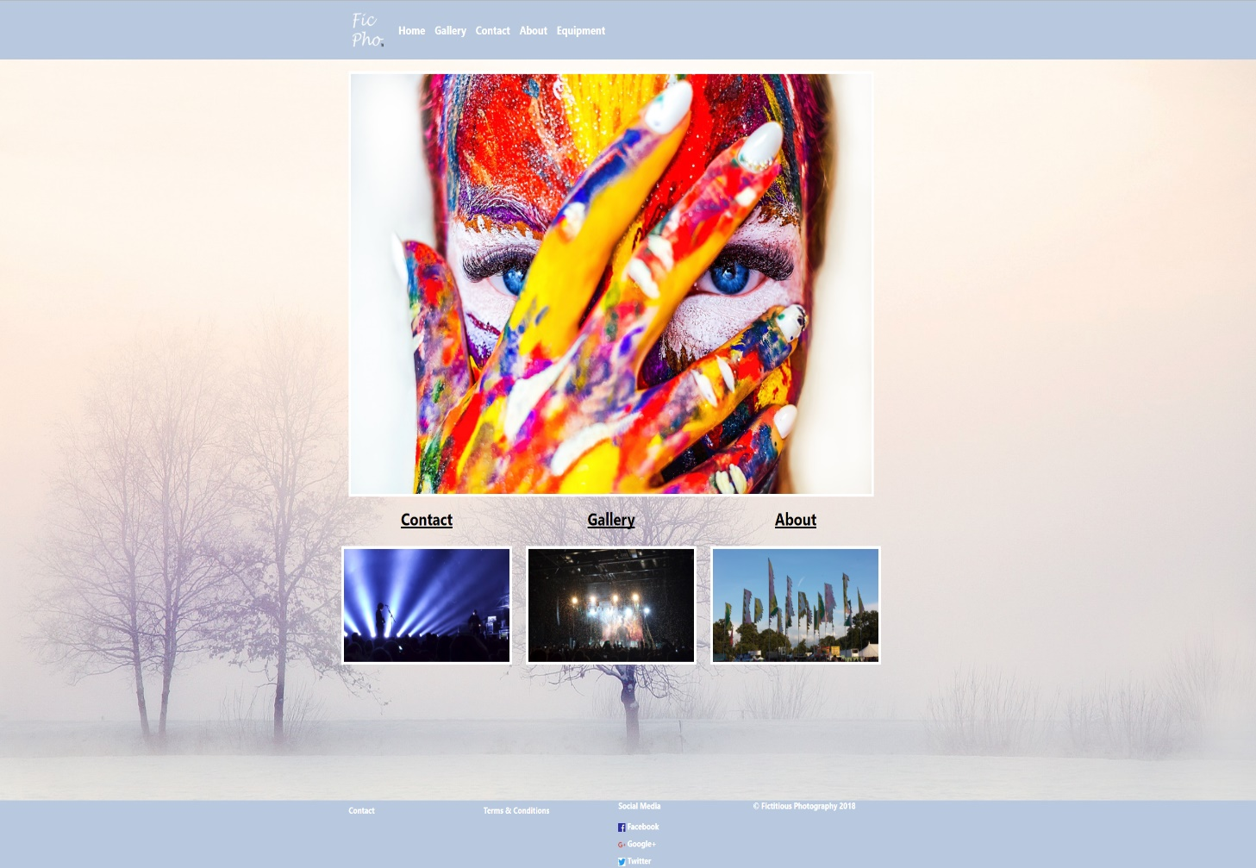
The Index/Home page of the website is used as a greeting page it contains minimal information and images not to overwhelm the visitor of the website.

Gallery page
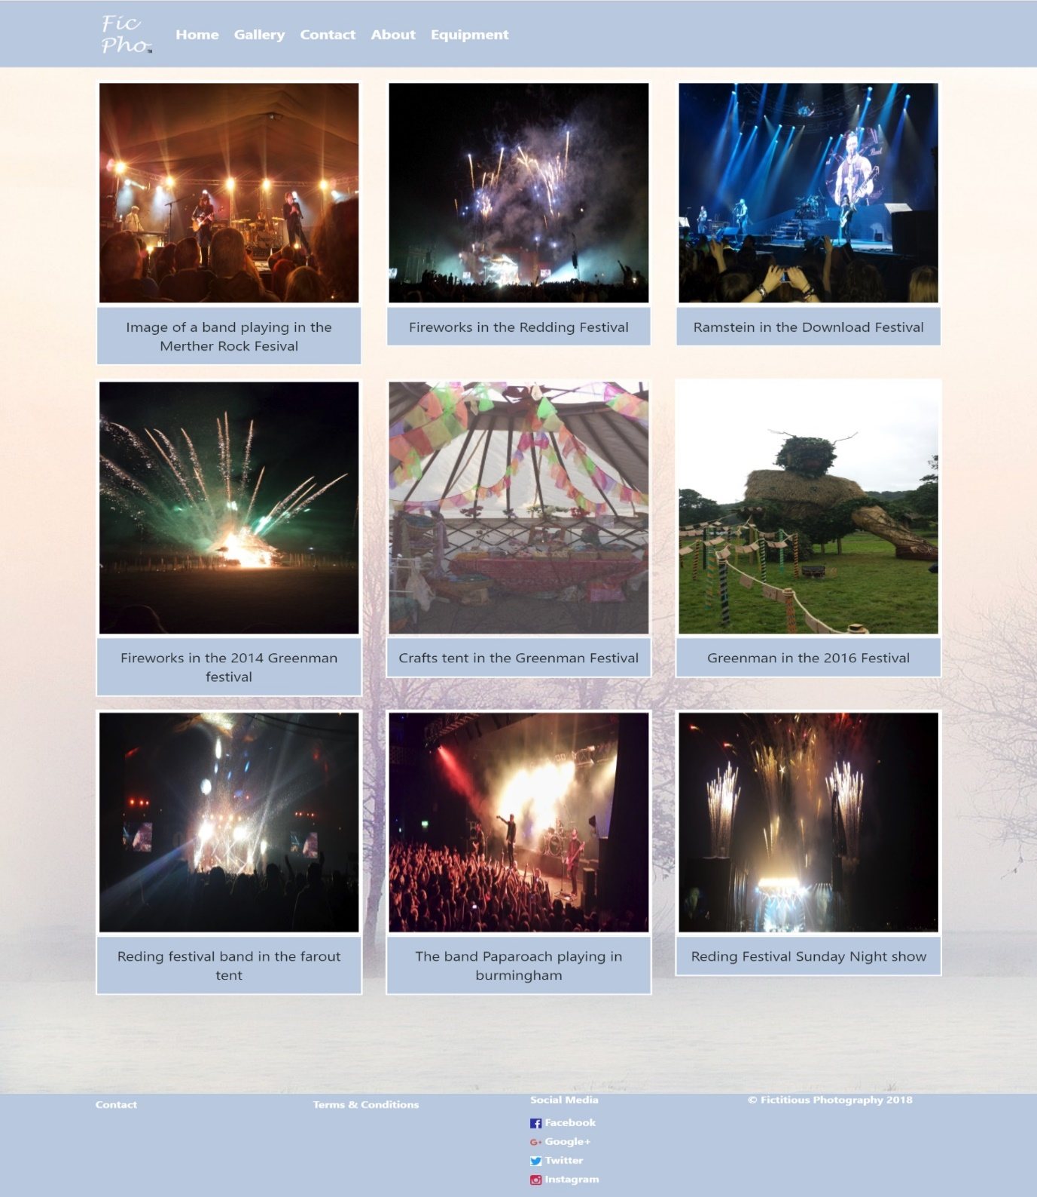
The gallery page of the website contains images that the photographer had taken during previous employment. It also contains a description of the image being shown, and allows for the user of the website to click on the images to view an enlarged version of the photo.

About Page
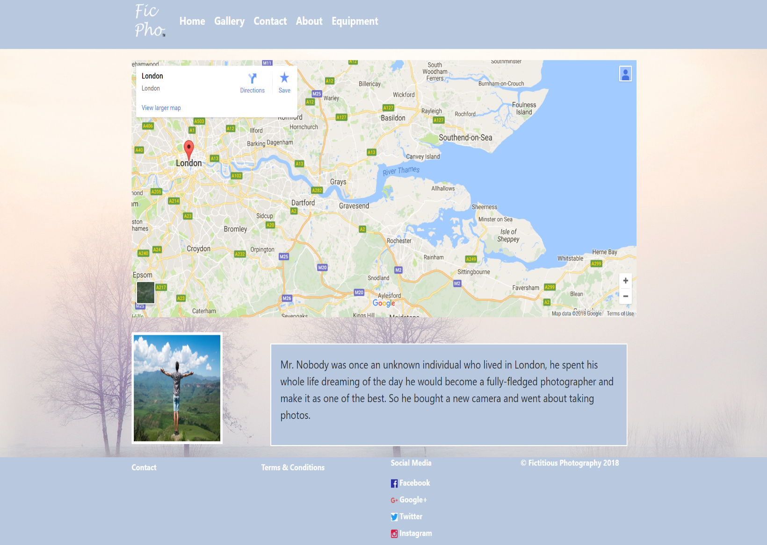
The about page provides an image of the photographer Mr. Nobody, along with a short description and map of the location of Mr. Nobody’s shop.

Equipment
This page displays the equipment of that is used to take the photographs along with a short description.
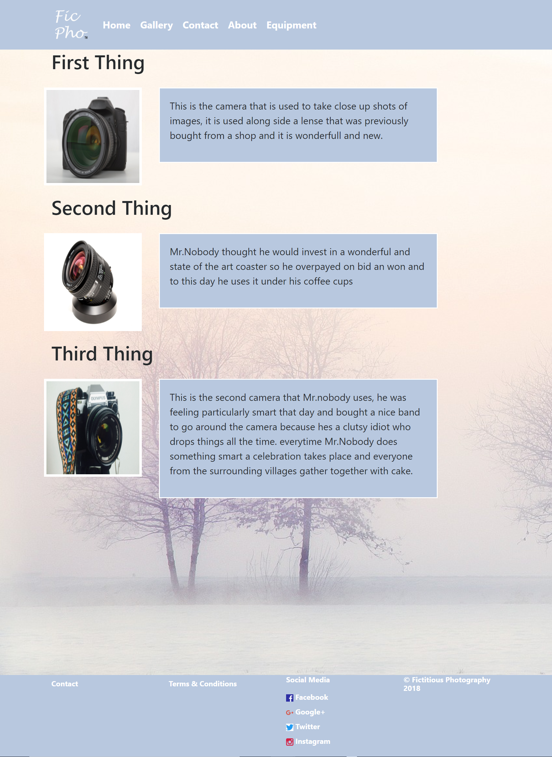

Contact Page
The contact page allows potential clients to send e-mails to Mr. Nobody directly along with their own contact e-mail and a question.
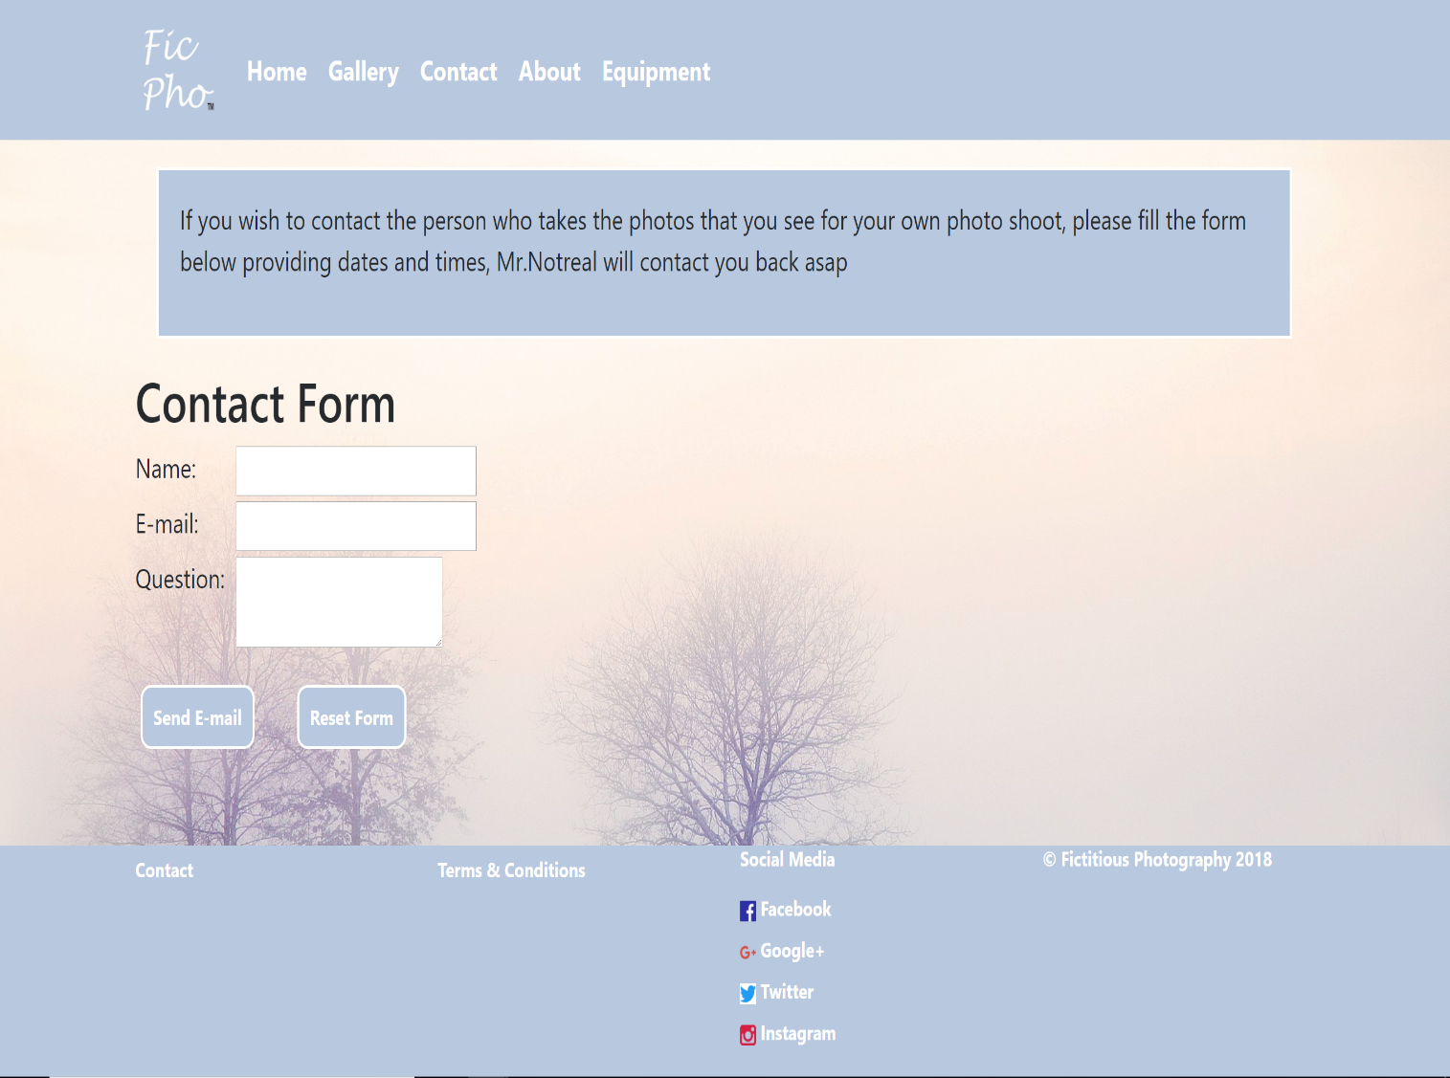

Validation
After completion of the website the code for the HTML was uploaded to http://validator.w3.org/ and CSS was uploaded to http://jigsaw.w3.org/css-validator/. To validate and displays errors within the code.

HTML Validation
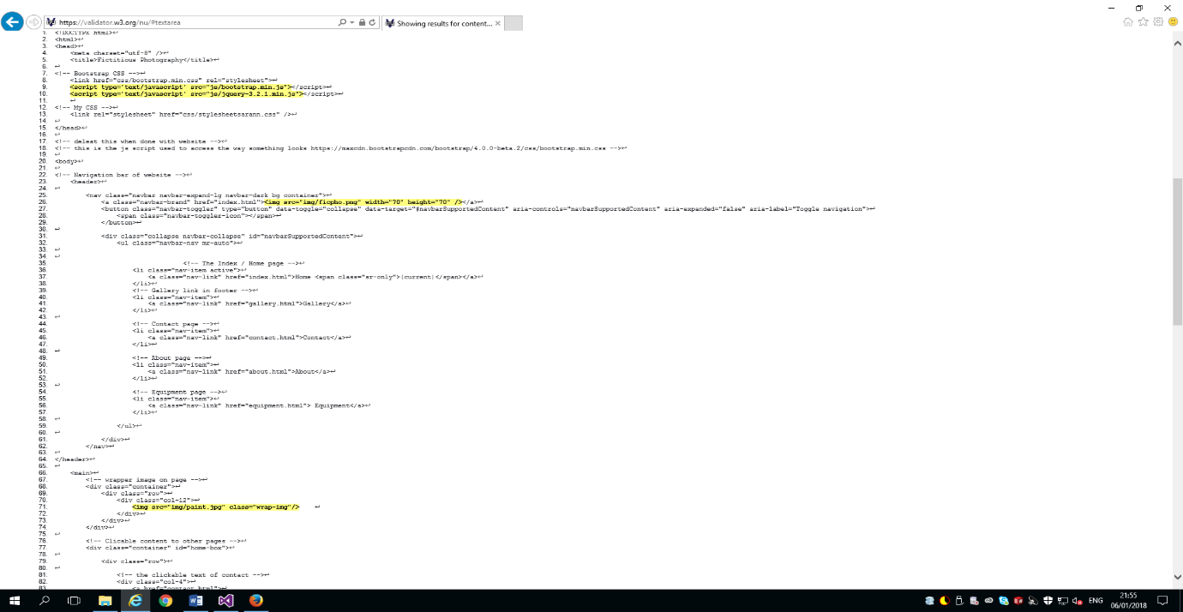
The errors include missing alt attributes within the image tags on line 71 and 26 to amend this error alt attributes should be input, which contain descriptive text on the image being displayed . The type attribute within the script tag is not required to use the JavaScript to amend this error the type attribute needs to be removed [4].
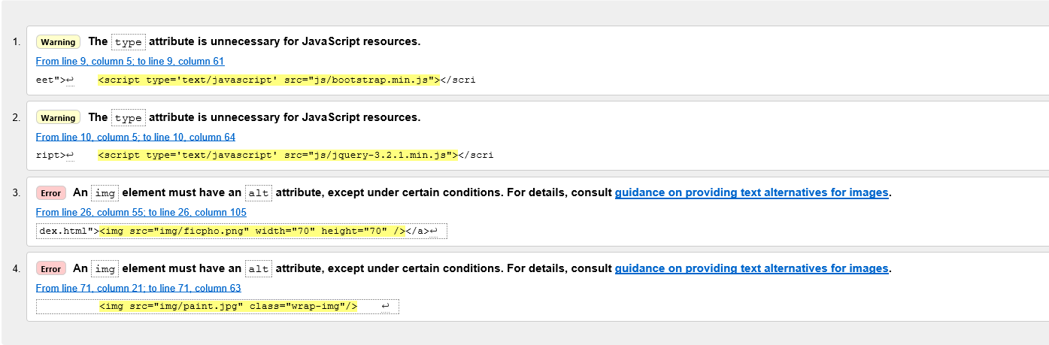
Figure 7 The index page of the website after validation
Figure 8 The errors explained and displayed

CSS Validation & Prefixing
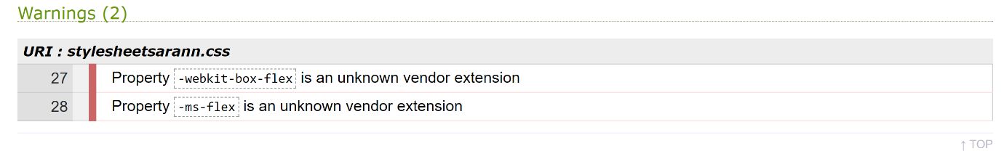
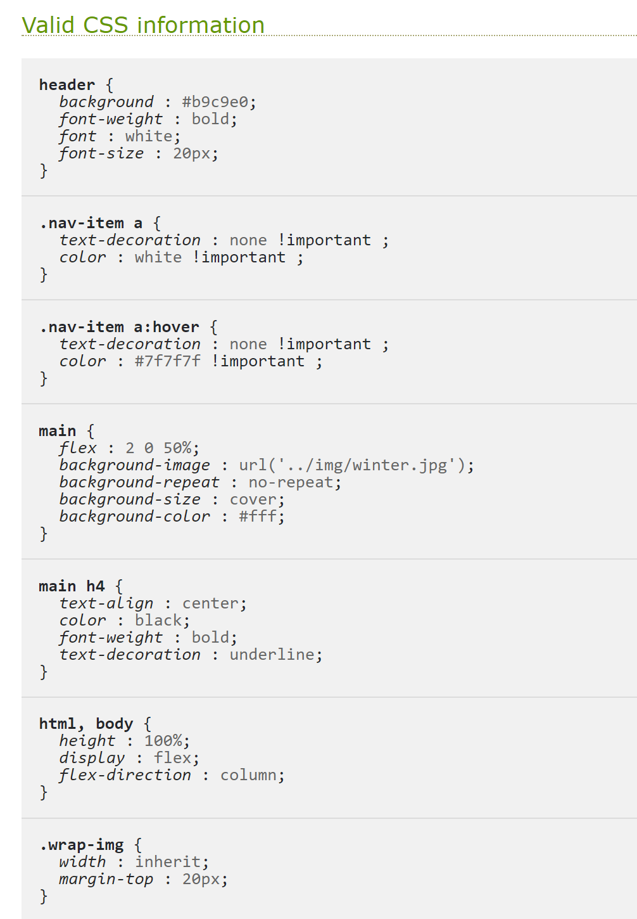
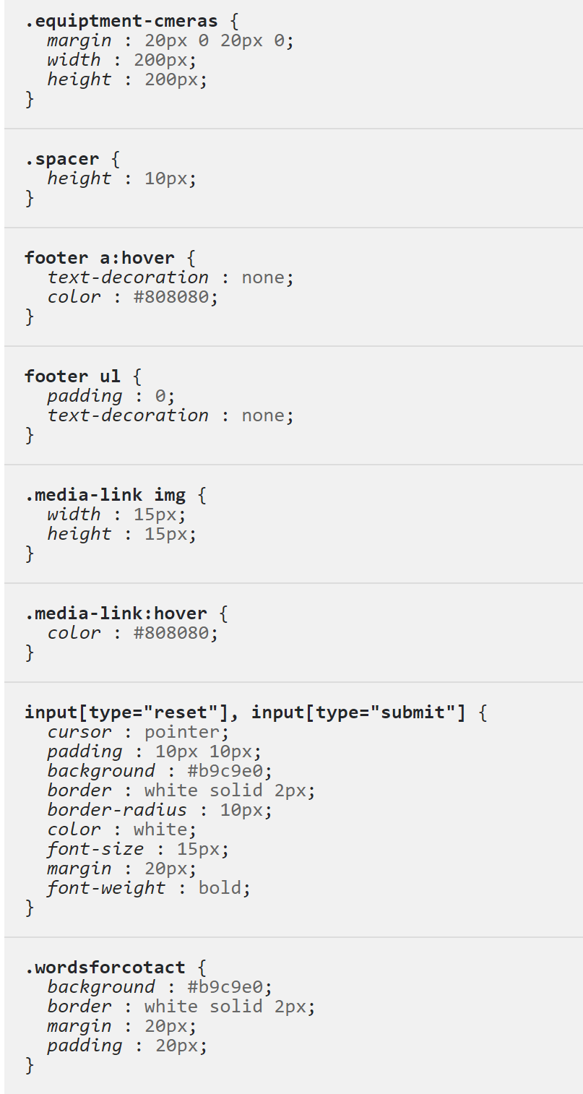
While preforming a validation check of the code the student found that errors where showing for selectors that where displayed within the JavaScript bootstrap. As they are not errors no action was required to amend the CSS. [5]

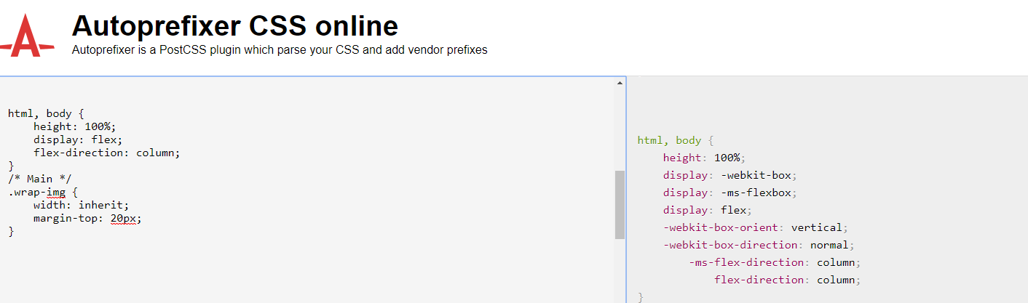
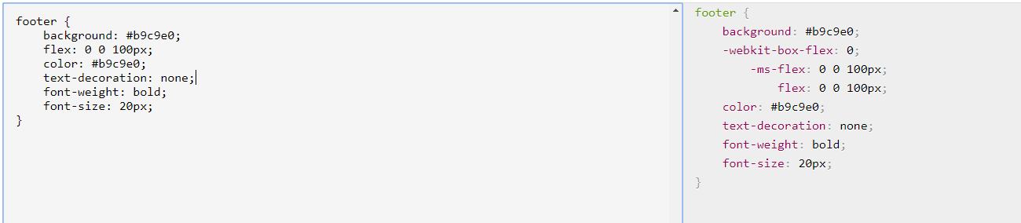
The images below display the prefix for the website. The CSS of the website was uploaded to the Autoprefixer website which goes through the CSS and provides sections of code to include within a website to allow it to run on different browsers. Two sections had alterations made, the html body and the footer. [6]
Figure 9 Autoprefixer of html, body
Figure 10 Autoprefix of the Footer

Evaluation
The website meets the requests of the company to encourage individuals to explore and become clients of Mr. Nobody. The website’s design also meets the varying needs of users following accessibility standards of WCAG 2.0.
According to the WCAG 2.0, it is a human right to have access to different webpages on the internet and a disability should not prevent a user from using or accessing a webpage. WCAG provides guidance on methods to create a more accessible website for numerous disabilities such as visual impairment, dyslexia or hearing impairment [7][8][3]

Navigation & Footer Bar
The navigation and footer follow a consistent design between all pages, due to the static nature of both the navigation and footer bar and its consistency between pages it allows for better access between pages as they are established and easily identifiable. The clickable area of the navigation links covers the text and the surrounding area of the text, because of the larger click area of the navigation buttons, this makes it easier for individuals with disabilities to click the links [9].

Headings
The headings that are set to black and bold provide a clear indication of sections that are displayed on pages of the website. The location of the headings above images and blocks of text provide relevant information for users on where sections begin and end and where the images link to.

Images & Other Media Content
The images and other media content are relevant to the website and Mr. Nobodys’s business, and they improve the website as they provide insight in Mr. Nobodys’s previous work and the type of images that individuals can expect. The addition of the google map within the about page improves the website as individuals have an idea on the location of Mr. Nobodys business. It meets the needs of individuals with disabilities as the map is scalable and accessible via touchscreen.

Colours of the Website
The colours chosen for the website meet the needs of individuals with varying disabilities, the background is off-white in colour contains no flashing imagery which takes into consideration individuals with epilepsy.
The headings and bodies of text aid individuals with dyslexia as the format remains consistent between pages of the website. The font of all text is Arial and are contained within a light blue container to prevent reading fatigue.
The colours that have been chosen also aid individuals with colour-blindness as the background colour of the website is white with a blue navigation bar and footer combined with white text all of which are not changed drastically for colour-blind individuals.

Information Structure
The information on each webpage is contained within a box with a border, this ensures that users of the website recognise that sections of information belong to specific photographs.

Evaluation of Tools

Contrast Checker
The contrast checker allowed the text colour and the background colour that it would be displayed on to be checked for the contrast ratio between them. The checker compares both colours and checks if there is enough of a contrast between the colours to be successfully displayed on a black and white monitor and if it is viewable by some individuals with colour deficits.
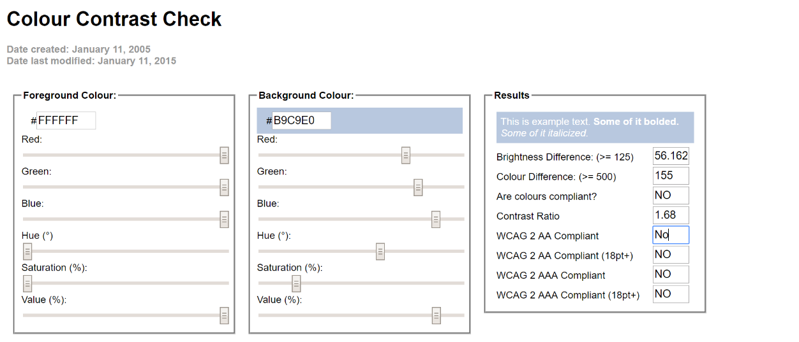
It was identified that the colours chosen for the navigation and footer bar fail the test and are there for unacceptable choices for the website.

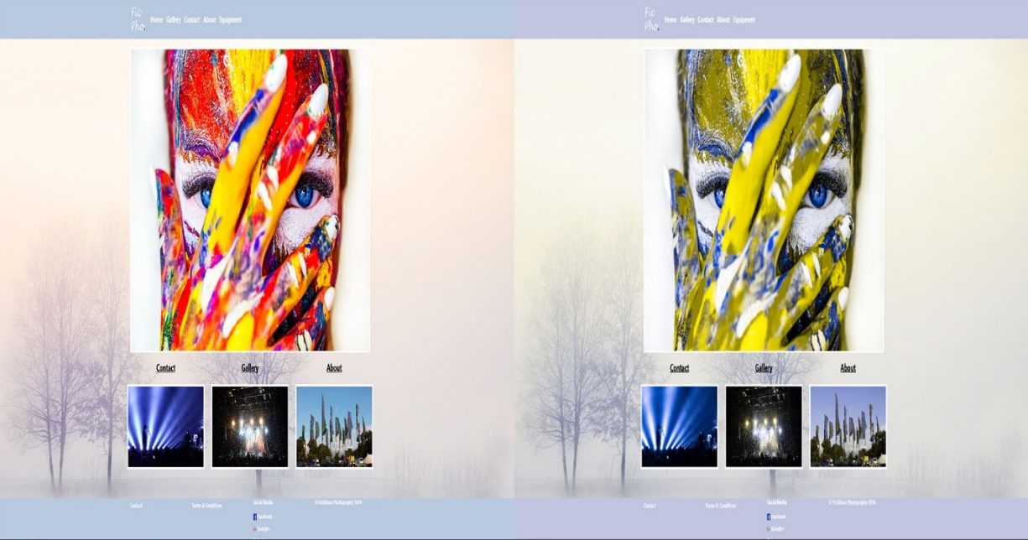

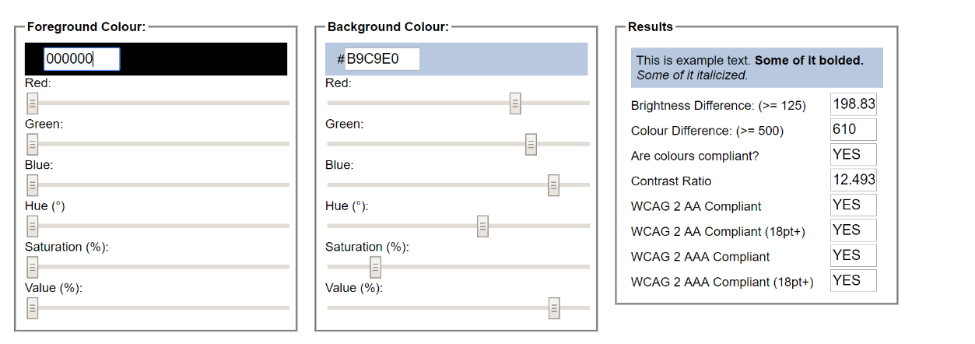
The colours for the bodies of text within the website where also checked the results display that the colour of the text is an acceptable match for the background colour of the boxes.

WAVE Evaluation Tool
The wave evaluation tool was used to notify the learner of potential errors and accessibility issues. The wave tool represents the issues visually through colour coordination of errors being displayed within red for errors, yellow for alerts, green for features and grey for contrast errors. It also provides a report containing an explanation on the total errors and potential errors that had been discovered. [10]
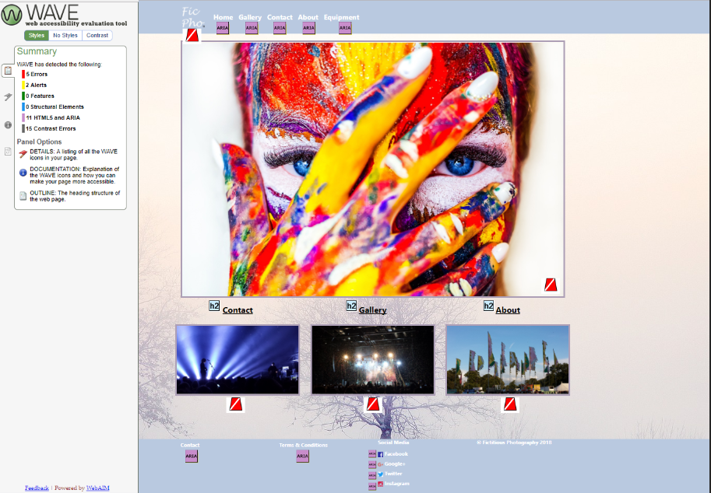

Visual Studio
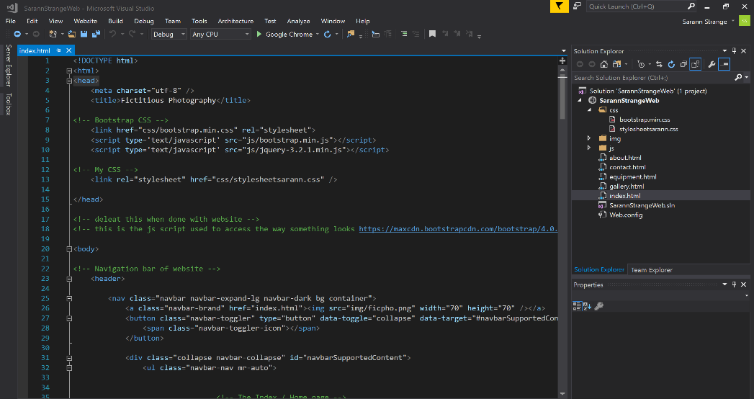
Visual studio is a software suite that is used for coding and it provides standard support for multiple programming languages including HTML and CSS. It has inbuilt functions which allow the user to write code and check for discrepancies, and it contains a library of keywords and tags used within HTMLVisual studio was used to create and organise the webpages and used the syntax of visual studio to display the code within a readable format.

Recommendations for Future Improvements
The inclusion of ALT text attribute to all images across the website would be an improvement made to the website as it enables accessibility of information of images for individuals with visual impairment. ALT text is used by screen readers to provide a description of an image that is otherwise inaccessible [11].
The active navbar link for each active page that is being displayed to the user could be improved with a colour alteration to show the same colour as the hover-over effect. This would allow users of the website to have a better visual understanding on the page they are currently on.
The logo could have a colour alteration when a user hovers over it, to provide user feedback and a visual display on a clickable link.
The footer links could be improved by increasing the size of the clickable area of the links, by enlarging the click area of those links and it would improve the websites usability for members of the public with poor dexterity as they would not require pinpoint accuracy to access the footer links.
Due to the results of the contrast checker, an alteration that can be made would be the colours of both the navigation and footer bar, using the results a possible improvement would be a darker colour for the text and links.
The contact page could be better structured with the contact form section aligned and centred in the page, as this would show a better constructed form. A drop down selection of dates and time for the users to select times and dates that they wish to hire Mr. Nobody would also be a better addition to this page. Within the contact page a separate dropdown to indicate the type of photoshoot that they wish Mr. Nobody to preform would also be useful.

Conclusion
During the development of the website, the creator was required to design and create a website that abided by the standards proposed by the W3C and WCAG 2.0. The requirements of the website were to provide an attractive and enticing platform for an individual to advertise and sell his skills in photography. The website was first designed using a wireframe that indicated the location of main elements within the website along with text and images. The code of the website was created within Visual Studio, and once the website had been created, aspects of the website were validated using different tools such as WAVE and contrast checker.
Discoveries where made in the validation section of the report, faults were highlighted which allowed for the conception of alterations that needed to be implemented to abide by the WCAG 2.0 standard.

References
[1] Brian O’Doherty, “The Ideology of the Gallery Space Annandale-on-Hudson, NY,” Artforum Mag. , pp. 74–89, 1999.
[2] Jake Rocheleau, “Fixed Headers and Navigation Bars Used in Web Design - Treehouse Blog,” 2013. [Online]. Available: http://blog.teamtreehouse.com/fixed-headers-and-navigation-bars-used-in-web-design. [Accessed: 07-Jan-2018].
[3] Anna M. Michalska, Cindy X. You, Ariana M. Nicolini, Vincent J. Ippolito, and Wolfgang Fink, “Accessible Web Page Design for the Visually Impaired: A Case Study.: EBSCOhost,” Intl. J. Human–Computer Interact., 2014.
[4] “Ready to check - Nu Html Checker,” 2017. [Online]. Available: https://validator.w3.org/nu/#textarea. [Accessed: 08-Jan-2018].
[5] “The W3C CSS Validation Service,” 2009. [Online]. Available: https://jigsaw.w3.org/css-validator/#validate_by_uri. [Accessed: 08-Jan-2018].
[6] “Autoprefixer CSS online,” 2017. [Online]. Available: https://autoprefixer.github.io/. [Accessed: 08-Jan-2018].
[7] W. Chisholm and M. May, Universal design for Web applications : for web applications. O’Reilly Media Inc, 2009.
[8] J. B. Shadi Abou-Zahra, “Accessibility Principles - How People with Disabilities Use the Web | Web Accessibility Initiative (WAI) | W3C,” 2017. [Online]. Available: https://www.w3.org/WAI/intro/people-use-web/principles. [Accessed: 07-Jan-2018].
[9] Gian Wild, “Links and accessibility - AccessibilityOz,” 2017. [Online]. Available: https://www.accessibilityoz.com/2014/02/links-and-accessibility/. [Accessed: 07-Jan-2018].
[10] I. Elkabani, L. Hamandi, R. Zantout, and S. Mansi, “Toward better web accessibility,” in 2015 5th International Conference on Information & Communication Technology and Accessibility (ICTA), 2015, pp. 1–6.
[11] M. Kirchner, “Evaluation, repair, and transformation of Web pages for Web content accessibility. Review of some available tools,” in Proceedings. Fourth International Workshop on Web Site Evolution, pp. 65–72.
[12] “Black Camera Lens · Free Stock Photo.” [Online]. Available: https://www.pexels.com/photo/black-camera-lens-615302/. [Accessed: 08-Jan-2018].
[13] “Free photo: Paint, Makeup, Cracky, Girl - Free Image on Pixabay - 2985569.” [Online]. Available: https://pixabay.com/en/paint-makeup-cracky-girl-cosmetics-2985569/. [Accessed: 08-Jan-2018].
[14] “Free stock photo of camera, canon, digital.” [Online]. Available: https://www.pexels.com/photo/camera-photography-technology-lens-42066/. [Accessed: 08-Jan-2018].
[15] “Black and Gray Olympus Dslr Camera White Orange Blue and White Strap · Free Stock Photo.” [Online]. Available: https://www.pexels.com/photo/camera-photography-lens-color-93875/. [Accessed: 08-Jan-2018].
[16] “Man Wearing Grey Shirt Standing on Elevated Surface · Free Stock Photo.” [Online]. Available: https://www.pexels.com/photo/landscape-nature-africa-boy-103123/. [Accessed: 08-Jan-2018].
[17] “Instagram logo Icons | Free Download.” [Online]. Available: https://www.freepik.com/free-icon/instagram-logo_732145.htm. [Accessed: 08-Jan-2018].
[18] “Twitter Logo transparent PNG - StickPNG.” [Online]. Available: http://www.stickpng.com/img/icons-logos-emojis/tech-companies/twitter-logo. [Accessed: 08-Jan-2018].
[19] “Google+ | Brands of the WorldTM | Download vector logos and logotypes.” [Online]. Available: http://www.brandsoftheworld.com/logo/google-7. [Accessed: 08-Jan-2018].
[20] “Facebook logos in vector format (EPS, AI, CDR, SVG) free download.” [Online]. Available: https://www.seeklogo.net/tag/facebook/. [Accessed: 08-Jan-2018].
[12][13][14][15][16][17][18][19][20]

marking criteria and Student FEEDBACK

This section details the assessment criteria. The extent to which these are demonstrated by you determines your mark. The marks available for each criterion are shown. Lecturers will use the space provided to comment on the achievement of the task(s), including those areas in which you have performed well and areas that would benefit from development/improvement.

Common Assessment Criteria Applied (Assignment 1) | Marks available | Marks  awarded
1. Research-informed Literature
Extent of research and/or own reading, selection of credible sources, application of appropriate referencing conventions.
Demonstrates an excellent level of research. An extensive list of references has been provided and it is evident they have been consulted to inform the implemented work and write-up. See comment below as regards no reference to the WCAG guidelines. (Grade mark: 80.00%) | 5 | 4
2. Knowledge and Understanding of Subject
Extent of knowledge and understanding of concepts and underlying principles associated with the discipline.
Demonstrates a very good understanding of the standards used to design and implement a website. Just a few things to note. Avoid using the !important shortcut to enforce CSS styles and try using more specific selectors, as this is recommended and there are only a few instances when important is necessary. Use more descriptive alternative text descriptions for your images and be careful to ensure you have enough contrast between all text content and the background. See your report for the correct way to use the textarea input field and other comments. (Grade mark: 75.00%) | 20 | 15
3. Analysis
Analysis, evaluation and synthesis; logic, argument and judgement; analytical reflection; organisation of ideas and evidence
Although you have provided a very good accessibility evaluation of the website and how this has been achieved in your website, you have made no reference to the WCAG guidelines. Relevant and well-thought-out recommendations have also been provided. (Grade mark: 77.50%) | 20 | 15.5
4. Practical Application and Deployment
Deployment of methods, materials, tools and techniques; application of concepts; formulation of innovative and creative solutions to solve problems.
An excellent attempt featuring a well-thought-out website. Well done. See your report for additional comments. (Grade mark: 77.00%) | 50 | 38.5
5. Skills for Professional Practice
Attributes in professional practice: individual and collaborative working; deployment of appropriate media; presentation and organisation.
The report is of a good standard, but pay attention to the structure of your sentences. See suggestions for additional improvements in your report. (Grade mark: 60.00%) | 5 | 3

Assignment Mark (Assessment marks are subject to ratification at the Exam Board. These comments and marks are to give feedback on module work and are for guidance only until they are confirmed. ) | Late Submission Penalties (tick if appropriate) |  | 76%
 | Up to one week late |  | 76%
 | 1st/2nd/3rd attempt? |  | 76%

