

To what extent does a domestic abuse victim’s perceptions of the Police affect their willingness to engage with the Police, or make a complaint against the offender?

Student: Hannah Brown
Student Number: 1815767
Word Count: 7494

Degree: BSc (Hons) Professional Policing Practice
UWTSD 2021

Acknowledgements
I would like to thank my Supervisor, Adrian Osbourne, for all his guidance, support and time given throughout the process of this dissertation.

I would also like to thank my family, my partner and my friends for their support and assistance throughout. They have offered me the motivation I needed not only to complete my dissertation but during my entire university experience and I simply could not have completed, what has been an extremely challenging three years, without them.

Declaration
This work has not previously been accepted in substance for any degree and is not being concurrently submitted in candidature for any degree.
Signed: H.G.Brown
Date: 25/11/2021

STATEMENT 1
This dissertation is being submitted in partial fulfilment of the requirements for the degree of BA.
Signed: H.G.Brown
Date: 25/11/2021

STATEMENT 2
This dissertation is the result of my own independent work/investigation, except where otherwise stated.
Other sources are acknowledged by footnotes giving explicit references. A bibliography is appended.
Signed: H.G.Brown
Date: 25/11/2021

STATEMENT 3
I hereby give consent for my dissertation, if accepted, to be available for photocopying and for interlibrary loan, and for the title and summary to be made available to outside organisations.
Signed: H.G.Brown
Date: 25/11/2021

STATEMENT 4
I hereby give consent for my dissertation, if accepted, to be available on the university’s IT system to those who have consent to use the system.
Signed: H.G.Brown
Date: 25/11/2021

Abstract

The aim of this study was to investigate whether a domestic abuse victim’s perceptions of the Police affect their willingness to engage with the Police, or make a formal complaint against the offender. Critical analysis of relevant, existing literature surrounding the topic of domestic abuse was carried out. In order to understand domestic abuse victim’s perceptions of the Police, a survey was created and was promoted on popular social media platforms in order to reach the largest number of respondents. The questions within the survey were underpinned by research found within the literature review, in terms of identifying areas of importance. The findings of this study support a substantial amount of existing literature, which was analysed in chapter two. A number of trends were identified during this study, the main one being that victims’ of domestic abuse are more likely to engage with the Police and the investigatory process if they receive the appropriate support from the Police and referrals to partner agencies. The study achieved its objectives by answering the following questions: what are domestic abuse victim’s perceptions of the Police? And what makes victims less likely to engage with the Police, or make a complaint against the offender? The answer to the research question aligned with these objectives and existing academic research.

Table of Contents

Chapter 1: Introduction ……………………………………………………………………….7
1.1: Introduction …………………………………………………………………………….7
1.2: Background and Rationale …………………………………………………………......7
1.3: Aims and Objectives …………………………………………………………………...8
1.4: Conclusion ……………………………………………………………………………...8
Chapter 2: Literature Review …………………………………………………………………9
2.1 Introduction ……………………………………………………………………………..9
2.2 Domestic Abuse ………………………………………………………………………...9
2.3: Domestic Abuse and the Police ……………………………………………………….10
2.4: Why victims may struggle to come forward ………………………………………….11
2.5: How a domestic abuse victim’s perceptions of the Police affect disclosure ………….12
2.6: Conclusion …………………………………………………………………………….13
Chapter 3: Methodology ……………………………………………………………………..15
3.1: Introduction …………………………………………………………………………...15
3.2: Aims and Objectives ……………………………………………………………….....15
3.3: Research Methods and Methodology …………………………………………………15
3.4: Limitations …………………………………………………………………………....17
3.5: Conclusion …………………………………………………………………………….18
Chapter 4: Analysis of Results ………………………………………………………………19
4.1: Introduction …………………………………………………………………………...19
4.2: Data Analysis ………………………………………………………………………....19
4.3: Types of Domestic Abuse and reasons for not reporting ……………………………..20
4.4: Gender of attending officer(s) and help and support offered ………………………....21
4.5: Perceptions of the Police ……………………………………………………………...22
4.6: Conclusion …………………………………………………………………………….23
Chapter 5: Conclusion and Recommendations ……………………………………………...25
5.1: Findings ……………………………………………………………………………….25
5.2: Conclusion …………………………………………………………………………….26
5.3: Limitations ……………………………………………………………………………27
5.4: Recommendations …………………………………………………………………….27
Chapter 6: Bibliography ……………………………………………………………………..29
Chapter 7: Appendices ……………………………………………………………………....34
7.1: Survey ………………………………………………………………………………...34
7.2: Results …………………………………………………………………………….......40

Chapter 1: Introduction

1.1 Introduction
This chapter aims to deliver a background to the topic of domestic abuse victim’s perceptions of the Police, and provide a rationale for the study. It will outline and explain the research question and objectives of the study.

This research aims to understand a domestic abuse victim’s perceptions of the Police, and whether these perceptions affect the victim’s willingness to engage with the Police, or make a complaint against the offender. Firstly, it is important to understand what domestic abuse is, and how it affects people differently.

1.2 Background and Rationale
Domestic abuse has been highlighted as and continues to be a priority for all Police forces in the UK. It is outlined in the Policing Vision 2025, that officers and forces dealing with domestic abuse are subject to high levels of scrutiny and the importance of dealing with these crimes is outlined (National Police Chiefs Council, 2016). Domestic abuse is defined in the UK as “any incident or pattern of incidents of controlling, coercive or threatening behaviour, violence or abuse between those aged 16 or over who are or have been intimate partners or family members regardless of gender or sexuality” (Home Office, 2012). This abuse can involve a number of acts, including emotional abuse, physical abuse and sexual abuse.

Recent research indicates that an estimated 2.3 million adults experienced domestic abuse between March 2019 and March 2020 (Office for National Statistics, 2020). 758,941 individuals reported domestic abuse to Police between that time and 79,965 of those cases that were referred to the Crown Prosecution Service (CPS). The amount of persons charged for such offences referred to the CPS was 73%, which was a decrease on the two years previous (Office for National Statistics, 2020). This decrease could be due to a number of factors, including lack of evidence, victim complaint withdrawals or victims failing to provide an initial complaint against the perpetrator.

There are a number of barriers which victims may face when coming forward to report domestic abuse. Once they have come forward, the investigation itself can be daunting and can be another reason a victim may choose to stay silent. Some of these barriers have been highlighted by Felson et al. (2002) as fear of reprisal, privacy concerns, sympathy for the perpetrator and Police leniency. There might be a number of reasons why victims of domestic abuse fail to report an incident to Police including the fear of whether they will be believed, the fear of the court process, social issues such as housing and their family dynamics.

1.3 Aims and Objectives
Although several studies have found a link between why victims do not report domestic violence issues to the Police and barriers to them first reporting, there is limited information as to whether the victim’s perceptions of the Police influence this decision. This poses the question as to whether their personal perceptions of the Police may influence their decision to make a formal complaint to Police. Due to this gap in the research, a further study is required to investigate this area, not only to expand on knowledge but to also expand on existing findings. The objective of this research is to investigate how victims of domestic abuse perceive the Police, whether this is due to previous dealings with the Police, or their preconceived ideas of the Police if they have never come in to contact with Police before. The purpose of the research is to attempt to answer the following question:

- To what extent does a domestic abuse victim’s perceptions of the Police affect their willingness to engage with the Police, or make a complaint against the offender?

The research objectives that derive from this question are: what are domestic abuse victim’s perceptions of the Police? And what makes victims less likely to engage with the Police, or make a complaint against the offender?

1.4 Conclusion
This chapter introduced the research topic, identified the research question and objectives and has identified why the research is required, which is to understand domestic abuse in more detail. The next chapter will present a literature review, and it will bring more depth to the issues discussed in this chapter.

Chapter 2: Literature Review

2.1 Introduction
The purpose of this chapter is to conduct a literature review of studies regarding victims of domestic abuse. The review is essential in order to position this study in relation to the existing literature and also to identify any gaps in current research. A substantial amount of research has been conducted on victims of domestic abuse in general, but it is important to understand that a sizeable and concerning amount of domestic abuse is still unreported. There are a number of reasons why victims may or may not have reported incidents to the Police, which will be examined during the course of the review. The main purpose of this review is to consider the reasons why some incidents of domestic abuse are not reported and to what extent the victim’s perceptions of the Police are a contributing factor.

Most specifically, the review will detail any studies that note the victim’s perceptions of the Police, and how that may impact their decision to engage with the Police and the investigative process, or make a complaint against the offender in a domestic abuse incident. The review will seek to establish if there are any gaps in current research, with the focal point of identifying where there are areas for improvement by the Police in terms of engagement with victims of domestic abuse.

2.2 Domestic Abuse
Some of the most serious of crimes committed are those that surround domestic abuse. Due to this, police, charities and other key stakeholders have made substantial efforts to increase awareness and the better recording of crimes (Bland and Ariel, 2020). As defined by The Home Office (2012), domestic abuse is “any incident or pattern of incidents of controlling, coercive or threatening behaviour, violence or abuse between those aged 16 or over who are or have been intimate partners or family members, regardless of gender or sexuality”. Between March 2019 and March 2020, it was estimated that 2.3 million adults, aged between 16 and 74 experienced domestic abuse with 1.6 million of those victims being women and the remaining 757,000 men (Office for National Statistics, 2020). It is important to understand that domestic abuse is not just physical abuse, but also encompasses: coercive control; psychological and/or emotional abuse; physical or sexual abuse; financial or economic abuse; harassment and stalking; and online or digital abuse (Women’s Aid, n.d.). Domestic abuse can have a long-lasting effect on the victim both physically and mentally. Research has identified that vulnerable victims of domestic abuse are at an increased risk of substance misuse, mental health issues, such as depression and post-traumatic stress disorder (PTSD), and suicide (Kilpatrick et al., 1997; Hossain et al., 2010; Ullman and Brecklin, 2002, as cited in Spruin et al., 2015).

During the COVID-19 pandemic it became a worry that domestic abuse was going to increase, due to victims being limited to their homes, during lockdown with perpetrators. Phumzile Mlambo-Ngcuka, the Executive Director of UN Women, stated that confinement would foster an increased tension and strain created by health and money worries for women isolated with violent partners and she described the COVID-19 situation as being ‘a perfect storm for controlling, violent behaviour behind closed doors’ (UN Women, 2020). It was reported by Refuge (2020), that during the initial week of lockdown in March 2020 there was a 25% increase in calls to their helpline, while the number of visitors to the national domestic abuse helpline website increased by 150%. This shows that domestic abuse continues to be a major issue, and many people may be suffering, without knowing who to turn to for help. Although domestic abuse victims can be male or female, women are predominantly the victims. In the incidents of domestic abuse reported to the Police in England and Wales between March 2019 and March 2020, 74% of victims were women (Office for National Statistics, 2020).

2.3 Domestic Abuse and the Police
Domestic abuse continues to be a priority within Policing, as agreed in a recent statement released by the domestic abuse lead of the National Police Chief’s Council (NPCC), which reaffirmed that tackling domestic abuse continues to be a Policing priority (NPCC, 2020). Although asserted as a priority for policing, an earlier review conducted by Her Majesty’s Inspectorate of Constabulary (HMIC), found this was not always reflected in practice, and it outlined that there was room for improvement by Police when dealing with such cases (HMIC, 2015). The issues outlined included a lack of support and the desensitisation of abuse by Police (HMIC, 2015). Police officers attend a large number of dometic abuse incidents, many of which the victim does not engage which can leave the officers feeling frustrated and desensitised, therefore not providing the appropriate help and support to the victim. Richards (et al., (2021), found that while Police officers expressed sympathy and a desire to help victims, they also conveyed frustration which was exacerbated when they felt they were unable to fulfil their role because victims did not disclose injuries, and refused their assistance.
As statistics show, there are numerous victims of domestic abuse and they are just the victims who were able to come forward. In order to encourage victims to continue reporting, and for officers to continue tackling the ever-growing issue, it is more important than ever that attending officers deal with domestic abuse in the right way (NPCC, 2016). When a Police officer attends a domestic abuse incident, there are many crimes that may have occurred, such as assault, rape, coercive and controlling behaviour, and harassment. A study by Robinson et al. (2018), found that physical injury and escalation were at the forefront of officers minds when attending an incident, and other risk factors were often over-looked, suggesting that violence-related risk factors are influential in police interpretations of risk.

In the UK there is a “positive action policy”, surrounding incidents of domestic abuse, meaning that officers must consider the information they have been given, and arrest if necessary, in order to protect a vulnerable person, prevent injury or harm, and to allow a prompt and effective investigation (National Policing Improvement Agency, 2008). This is regardless of victim’s wishes, as the necessity to safeguard the victim is of upmost importance. The first officer on scene must then complete a Domestic Abuse, Stalking and Harassment or honour-based violence (DASH) risk assessment, which grades the victim and perpetrator as either standard, medium or high risk, and this will subsequently be shared with partner agencies, such as social services, schools and doctor surgeries in order to manage that risk (Norfolk County Council, n.d.). DASH is a common tool used by Police and non-Police, allowing all parties involved to be working from the same guidelines. Those who are deemed to be high risk, are likely to be referred to a Multi-Agency Risk Assessment Conference (MARAC). In 2014 a review was carried out to investigate the ways in which risk-led Policing in England and Wales is carried out (Robinson et al., 2016). This review found that the DASH risk assessment may be better suited to specially trained domestic abuse officers, rather than the attending officers, as they might be able to build a better rapport with the victim (Robinson et al., 2016).

2.4 Why victims may struggle to come forward
A victim of crime includes anybody who has been harmed, either physically, financially or emotionally, injured or killed as a result of a crime, accident or other event or action (Cambridgeshire Constabulary, n.d.). There are many reasons why a victim of domestic abuse may fail to contact Police, these can range from fear of reprisal, privacy concerns and sympathy for the perpetrator and Police leniency (Felson et al., 2002). For a number of years it has been estimated that victims of domestic abuse will suffer approximately 35 incidents of domestic abuse before reporting it to the Police. A study conducted by Strang et al., (2014) showed that many victims suffer from years of abuse prior to reporting to Police; however, they argue that the figure of 35 has little basis in fact and came from old, unreliable research. It is important to realise that even if a victim did come forward and report an incident to police, it is likely that they may find themselves to be a victim again in the future. This was supported by Felson et al. (2002), who found in their study that the victim may fear reprisal. A study conducted by Hester et al. (2006) confirmed this and found that 50% of a sample of 356 men convicted of domestic violence reoffended within three years and that 80% of these incidents were against the same partner. Victims who leave the perpetrator may even find themselves at greater risk. Wallace, (1986) conducted a study that found that 98 of 217 (45%) women who were murdered by their partner in Australia had left their killers or were in the process of leaving.

Victims of domestic abuse are not just women, but include men as well. In a study conducted by Mirrlees-Black (1999), it was estimated that one in seven men were the victim of domestic abuse. It is also important to remember that domestic abuse can also be from the same gender. There is an enduring stigma around males reporting domestic abuse, as it can be deemed as not masculine; however, it still occurs, and this reluctance can place males at particular risk of recurring domestic abuse. As stated by Goldberg (1979), “male socialisation diminishes the likelihood of reaching out for help”, due to the accusations of this behaviour not being “manly”. It has been found that males would not always consider domestic violence as being a crime, and in a study conducted by Stets and Straus (2017), it was found that less than 1% of men who claimed they had been assaulted by their wife reported the incident to Police. This is a very concerning figure, and the lack of under reporting will have a wider impact on the understanding of how many male victims of domestic violence there are. Within the same study Stets and Straus (2017), found that 2% of men would contact a family member or friend to ask for help instead of contacting Police. Due to the nature of domestic abuse, and the reasons mentioned above, victims may struggle to come forward to report the abuse, regardless of their perceptions or preconceived ideas of the Police.

2.5 How a domestic abuse victim’s perceptions of the Police affect disclosure
When an incident is reported to Police, this may or may not be the first time that the victim has come in to contact with the Police. Due to this the victim might have perceptions of the Police from their previous contact with them, or if they have not had contact, they might have preconceived ideas of Police. Perceptions of the Police can relate to the perceived quality of the actions an officer took during the investigation process (Murphy, 2009). Obviously when a person contacts the Police, they are in need of assistance from them. It is therefore absolutely essential that Police build a rapport with a victim in order to safeguard them, and to gather best evidence. In a study conducted by Johnson (2007), it was found that victims wanted Police officers to listen and understand their situation as well as provide information on support services and additional legal protections. When a victim feels as though they have been treated unfairly by a Police officer, it may cause them to refuse future cooperation, or assistance with the investigation (Koster et al., 2016). This is agreed by Hickman and Simpson (2003), who stated that if a victim perceives a Police Officer to be hostile or blaming, they may be less likely to contact Police again in the future, whereas if a victim perceives that Police are caring, supportive and concerned, they are more likely to contact them again.

Whether a victim perceives their contact with the Police to be either positive or negative depends largely on how a police officer interacts with them during an incident and then during the subsequent investigation (Symonds, 1975). Sometimes Police are the only agency a victim of domestic abuse will come in to contact with. For this reason, if Police officers are able to facilitate positive experiences during encounters with domestic abuse victims, it may encourage victim cooperation, thus encouraging safeguarding (Koster et al., 2016). In a study conducted by Apsler, et al. (2003), it was found that positive reactions towards the police from victims are consistent with the Police’s efforts to support victims. It was also found that a victim’s willingness to call the Police in the future is consistent with the victim finding the Police helpful during the current incident (Apsler et al., 2003). This supports the concept that how a victim perceives the Police, will affect their willingness to engage.

2.6 Conclusion
The understanding generated from this review of the literature on domestic violence and victims’ perceptions of the police shows that how a Police officer interacts with the victim affects their willingness to engage. Prior to the implementation of risk-led policing, domestic violence incidents might not have been dealt with in the most appropriate manner. Since the implementation of DASH this has allowed the Police to risk assess victims in a more uniform manner, while giving victims the appropriate safeguarding and support they need. Within these studies there is evidence that a positive experience with the police encourages the victim to contact the Police again in the future, and if the appropriate support is offered, this encourages the victim to continue through the investigatory process. Research into victims’ perceptions of the Police is limited with Apsler et al., (2003) and Koster et al., (2016) being two of the few studies to do so. Further research is needed in order to explore domestic abuse victims’ perceptions of the Police, in order to maximise Police responses to domestic violence incidents. This research can then be used to understand victims’ perceptions, and for forces across the UK to implement changes if necessary.

Chapter 3: Research Methodology and Planning

3.1 Introduction
In the previous chapter it was demonstrated that a limited amount of research has been conducted in to a domestic violence victim’s perceptions of the Police. In order to further progress this study, and to gain a better understanding, a discussion is required of the research methods and research methodology to be used. This chapter will detail the reason the research took place and the methods which were used in order to address the gap in research which has already been identified.

3.2 Aims and Objectives
In the research proposal two aims and objectives were outlined, and the purpose of the research study was to answer these. The aims and objectives were; what are a domestic abuse victims perceptions of the Police; and what makes a victim less likely to engage with the Police, or make a complaint? In order to answer both the research aims and objectives and the research title, a questionnaire has been designed in order to obtain the thoughts and feelings of domestic abuse victims regarding the Police and, in turn, whether this effects their overall willingness to engage with the Police and the investigative process. This will, therefore, be primary research. By receiving data from respondents it will then be possible to understand how the Police service can improve, in order to provide victims with the appropriate advice and guidance, and ultimately safeguard more victims.

3.3 Research Methods and Methodology
The study was initially approved by the University of Wales Trinity Saint David Ethics Committee, on completion of the ethics form. As stated above, this is a primary research study which has been completed by the author. Primary data is data which has been collected for a specific research problem, using procedures that fit that research problem best (Hox and Boeije, 2005). It had been hoped that participants could be recruited from local domestic abuse charities; however, due to the obvious risk involved, this was not possible. Therefore, participants will be sought via social media channels such as Facebook and Twitter. Participants will be either a current domestic abuse victim or a domestic abuse survivor, having been a victim in the past. Participants will be victims of all types of abuse, including: physical, psychological or financial abuse, coercive controlling behaviour, harassment and stalking and online or digital abuse (Women’s Aid, n.d.). The study includes both male and female victims of domestic abuse, therefore encouraging a full insight to victim’s perceptions of the Police, and ascertaining whether there are any trends relating to the gender of both the victim and the Police officer dealing with them.

As stated by Queirós et al. (2017), research methods are used for the development of scientific studies, which allows specific analysis according to the methodology used by the researcher. Within the same study, it was found that one of the most commonly used forms of quantitative analysis was the use of surveys/questionnaires. However, it was noted that the correct method should be chosen according to the type of study it is, and from that choice the appropriate specificities and the general nature of the research should be considered. This study is a quantitative study, whereby the data has been collected using a carefully designed questionnaire. The key characteristics of quantitative research are broad but can include the following; if data can be measured; if the data aims to be objective; findings can be evaluated using statistical analysis; and results can be summarised, compared, or generalised using statistics (Goertzen, 2017). A survey or questionnaire is carried out when the researcher is interested in collecting data on the observations, attitudes, feelings and experiences or opinions of the population.

It is hoped that the study will receive between 50-80 participants in order to obtain enough data to identify any common trends. The respondents will be from the general population, which will give an oversight of domestic abuse victims’ perceptions of the Police. Once the study is approved by the ethics committee, the questionnaire can be designed using a popular survey creating website, and it can then be released via social media channels, in order to seek participants. Questionnaires are thought to be a valid and dependable method for collecting data, as they provide a large amount of data outlining views of the participants (Akinci and Saunders, 2015).

At the forefront of the questionnaire will be a briefing to participants outlining what the study is, and exactly what they were going to be participating in. If participants agree to this, and wish to be part of the study, they will then be asked to carefully read and sign a consent form. Within this briefing and consent form, it will be made clear to participants that any information they provide would be anonymous, and it would not be possible to identify them from the information they provide. The questionnaire will consist of purely closed questions in order for it to remain a quantitative study. A number of options will be offered to participants on each question, hopefully in order to gain a full insight in to how the victims felt.

Once all the data has been received from participants, it will then be analysed in order to draw conclusions from the results. The analysis technique which will be used is statistical analysis. Statistical analysis means collecting data, analysing it and subsequently uncovering patterns and trends (Statistics How To, n.d.). Parametric analyses, such as T-tests and analysis of variance (ANOVA) were considered, but due this research producing a single data-set, from the questionnaire, these would not be appropriate.

3.4 Limitations
Due to the nature of the information that is required, many people may feel as though they cannot come forward. It has been made very clear that the information required will be confidential, and anonymity will be maintained throughout the process. This will hopefully ease the minds of participants, in order for them to provide true and accurate information about their incident. This will in turn allow for the best possible data to be received and to avoid any validity concerns. In order to avoid the validity being threatened, the questionnaire has been carefully constructed, so that it is quick and easy for the participant to complete. All ethical principles and preventative measures have been followed in accordance with the Data Protection Act (2018), and the University of Wales Trinity Saint David (UWTSD) ethical code of practice (UWTSD, 2017-2020).

The author understands that due to the nature of the study, and the potential difficulty in seeking participants, it is not likely that the results will reflect every domestic abuse victim’s thoughts and feelings about the Police. It is also noted that due to the questionnaire being shared via social media channels, it is likely that victims will be residing within different Police force areas, who might have different procedures when dealing with domestic abuse cases.

Due to the reasoning the research is being conducted, in order for an undergraduate dissertation to be completed, the time constraint of a few months may be an issue. Due to this time constraint the questionnaire will only be active for approximately 4 weeks, therefore possibly limiting the participant numbers.

In terms of the data that is being collected, as explained above this study is of a quantitative nature. With that in mind, there are limitations which have been addressed. Such limitations include: the data not providing evidence for why victim’s may think, feel or act in certain ways; specific groups, such as domestic violence victims in this case, being difficult to reach; and studies can be time consuming and require data collection over long periods of time (Goertzen, 2017). These points have been considered throughout. However, it was decided that the advantages of a quantitative study outweigh the negatives. This is because by conducting a quantitative study, the results will be clear, concise, and trends will be easily identifiable, in order to answer the research title.

3.5 Conclusion
This chapter has identified the most suitable and appropriate form of methodology to be used for this research study, as well as for achieving both objectives of the project. The following chapter of the dissertation will present the analysis of results of the data that was collected during the course of the research project.

Chapter 4: Analysis of results

4.1: Introduction
The previous chapter explained the methods employed to gather the data, namely the use of a survey. In this chapter, the aim is to analyse the data gathered through the primary data source. An online survey was created, which attracted 53 respondents, allowing an insight into whether a domestic abuse victim’s perceptions of the Police affects their willingness to engage or make a complaint. The objective of this chapter is to provide analysis of the project following the collection of such primary data.

4.2: Data Analysis
Data analysis can be described as the requirement to collect and transform data in order to understand whether any patterns will emerge, and to provide supportive visual representations in order to compare such patterns (Bryman and Hardy, 2009). They survey was completed through Survey Legend, a survey creating website (www.surveylegend.com). The survey was promoted on social media website such as Facebook and Instagram, in order to reach the largest number of respondents. There are a number of advantages in gathering data in this way; as outlined by Wright (2005), these can include: access to unique populations, the ability to reach a large amount of people in a short amount of time and financial outlays can be avoided. Parametric analysis, such as the T-test and analysis of variance (ANOVA) were considered; however, due to there being a single data set, these would not be relevant for this study.

Participants would have located the survey of their own accord via social media platforms and completed it voluntarily. All participants were asked to read a consent form and agree to their answers being included in the dissertation, before being able to progress through the survey. 53 participants completed the survey and of those, 17 were male, and 36 were female. Asking the participant’s gender was relevant, as it was significant to investigate whether gender was a factor when looking at participants perceptions of the Police. Participants were also asked to provide their age range, as this could also have identified any trends with between certain age groups. Of the 53 respondents the majority (57%) were between the ages of 25-34, as can be seen below in Figure 1.

.

Figure 1

4.3: Types of domestic abuse and reasons for not reporting
The survey was split in to two parts as the aim was to encompass views of those persons who contacted the Police in relation to their domestic abuse, and those who did not. When analysing the data, it was clear that the outcome was fairly even, with 26 participants contacting the Police, while 27 participants did not. The participants were victims of all types of abuse; however, the most prevalent abuse was coercive and controlling behaviour, concerning 43% of all participants. The number of persons per age range, experiencing the different types of abuse, can be seen below in Figure 2. The fact that over half the participants admitted they had not contacted the Police, despite stating they have experienced one of the seven types of domestic abuse, indicated that a sizeable amount of domestic abuse is still going unreported within force areas.

The participants who did not involve the Police were then asked why this was the case, and were given a number of options including: “did not feel the matter was important enough to involve the Police, felt embarrassed, scared of repercussions, did not want anyone to know, did not want the offender to get in to trouble and other”. Of the options given, the most common response was because the participants didn’t feel the matter was important enough to involve the Police, of the 27 participants, 30% selected this, followed by embarrassment (22%), and the victim not wanting anyone to know (15%). Just 4% of participants stated that it was due to negative perceptions of the Police.

Figure 2

4.4: Gender of attending officer(s) and help and support offered
The remaining 26 participants who did involve the Police were asked the gender of the attending officer(s), and whether the gender of the attending officer(s) effected their decision to make a complaint against the offender. 5 of the participants (19%), 3 male and 2 female, stated that the gender of the Police officer had a negative impact on their decision to make a complaint against the offender or engage with the Police. The gender of the officer(s) involved in those incidents was either a single male officer, or a male and female officer together. 7 participants (27%) stated that the gender of the attending officer(s) had a positive impact on their decision to make a complaint, all of whom were female participants. The attending officer(s) varied between single female, single male and a female and male officer together. Those participants that involved Police were asked whether they feel they were satisfied with the help and support offered by the Police, and what support they were offered. Of the 26 participants who involved the Police, 15 participants (56%) agreed, somewhat agreed, or strongly agreed that they were satisfied with the support offered. Of those participants, 100% were offered support from the Domestic Abuse Unit (DAU), an Independent Domestic Abuse Adviser (IDVA), or were referred to partner agencies such as Victim Focus or Live Fear Free. 7 participants (27%) either disagreed or strongly disagreed that they were satisfied with the support, and the remaining 4 (15%) were neutral. Of the 11 participants who were not dissatisfied with the support offered or were neutral, 4 (36%) stated they were not offered any support by Police.

4.5: Perceptions of the Police
The participants who involved the Police were asked whether they had been in contact with Police prior to this incident. Of the 26 participants in this category, it was observed that 7 (27%) had previously been a victim, 6 (23%) had no previous involvement with Police, 5 (19%) had been an offender, 4 (15%) had been a witness, and 4 (15%) had friends or family who had been involved with the Police. The 26 participants who involved the Police were then asked what their perceptions of the Police, prior to this incident were. Over half of the 26 participants (58%), reported either positive or very positive perceptions of the Police prior to this incident. The 26 participants were then asked whether their perceptions of the Police had changed since this incident. Interestingly, as seen in Table 1 below, 5 (19%) participants indicated that their perceptions had changed positively, and those 5 participants either agreed or somewhat agreed that they were satisfied with the help and support offered by Police.

Previous Perceptions | Changed Perceptions | Satisfied with Help Offered | Status of Complaint
Positive | Yes Positive | Somewhat Agree | Offender Charged
Positive | Yes Positive | Somewhat Agree | Offender Not Guilty
Somewhat Negative | Yes Positive | Agree | Offender Found Guilty
Somewhat Negative | Yes Positive | Agree | No Statement Provided
Very Positive | Yes Positive | Strongly Agree | Offender Found Guilty

Table 1

The results in Table 2 show the opposite side of the spectrum. They reveal that 5 participants (19%) had been involved with Police before as an offender. 80% of the 5 participants stated that their previous perceptions of the Police were either negative or somewhat negative. 4 of those 5 participants said that their perceptions had not changed since this incident and 1 participant acknowledged that their perceptions had changed negatively. Interestingly, 80% of the 5 participants who had been involved with the Police as an offender, outlined that they either disagreed or strongly disagreed with the help and support offered by the Police. 60% of these 5 participants admitted that their perceptions of the Police influenced their willingness to engage with the Police or make a complaint against the offender.

Involved with Police Prior | Previous Perceptions | Changed Perceptions | Satisfied with Help Offered | Perceptions Influenced Willingness to Engage
Offender | Negative | No Change | Disagree | No
Offender | Negative | No Change | Neutral | Yes Negative
Offender | Negative | No Change | Strongly Disagree | Yes Negative
Offender | Somewhat Positive | No Change | Strongly Disagree | No
Offender | Somewhat Negative | Yes Negative | Strongly Disagree | Yes Negative
Table 2

4.6: Conclusion
This chapter has helped to answer the two research objectives, which were:

- What are a domestic abuse victim’s perceptions of the Police?
- What makes a victim less likely to engage with the Police, or make a complaint against the offender?

The present study has attempted to understand whether there is a link between a domestic abuse victims perceptions of the Police, and if this affects their willingness to engage. It has been found that a number of domestic abuse victims, are still failing to report such incidents to the Police. This ranges from not only physical violence, but psychological abuse and harassment as well. Only a small number of those victims stated that the reason they didn’t report the matter to Police was due to negative perceptions of the Police. The majority of the victims who did not report the matter to Police did so because they didn’t feel the matter was important enough to involve the Police. This data partially supports that found in the literature review, such as Felson et al. (2002) who recognised a number of reasons for not reporting abuse to Police, such as privacy concerns. This data also agrees with Strang et al. (2014), who identified that domestic abuse victims are likely to be subjected to years of abuse prior to the matter being reported to the Police.

Of the victims who did report the matter to the Police, a number of interesting trends have been identified. It can be established that the gender of the Police officer in attendance can have a negative impact to some people. There could be a number of reasons for this including embarrassment in front of the same/opposite sex of Police Officer. The majority of participants who reported that gender had a negative impact on them were men when the attending officer was also male. As identified in the literature review, Goldberg (1979) argued that males are less likely to reach out for help, due to the impression that such behaviour was not “masculine”. In order to better understand this trend, more research would be required to gather more data, with a view to addressing this problem. What the data has predominantly identified is that the help and support offered by the Police has a huge impact on a victim’s perceptions. It has been identified that when the victim has not been satisfied with the help and support they were offered during the incident their negative perceptions have either not changed at all, or they have changed in a negative way. On the opposing side, when a victim was satisfied with the help and support offered it was found that their perceptions changed positively. This data supports that found by Johnson (2007) and Hickman and Simpson (2003), where victims wanted Police to provide information on support services, and they are more likely to re-contact Police if they receive this.

To conclude, this chapter has successfully analysed the data and discovered the views of the Police by domestic abuse victims. The data from this survey has largely agreed with research found in the literature review and has also identified room for new research to be conducted.

Chapter 5: Findings and Conclusion

5.1: Findings
This dissertation has sought to answer the research question of “To what extent does a domestic abuse victim’s perceptions of the Police affect their willingness to engage with the Police, or make a complaint against the offender?” During the literature review, gaps in the research were identified in relation to a domestic abuse victims’ perceptions of the Police, with Apsler et al., (2003) and Koster et al., (2016), being two of the few studies to have been conducted in this area. It was identified that this area could be further investigated in order to better understand domestic abuse victims’ perceptions of the Police, in order to optimise Police responses to such incidents.

In the previous chapter the results of this study’s survey were analysed, and a number of trends were identified. It was observed that many domestic abuse victims fail to report the matter to Police, and of those participants who did not report the matter to the Police the majority stated it was because they did not feel the matter was important enough, while the second most popular answer was embarrassment. This partially supports research carried out by Felson et al. (2002), which identified privacy concerns as a reason for victims not reporting incidents to the Police.

From the literature review the importance of the attending officer’s demeanor was identified on having an impact on the victim’s participation with the investigation, and this, therefore, affected their perceptions. Johnson (2007) supports this as his study found that victims wanted Police officers to listen to them and to understand their situation, while providing information on support services and legal protections. This was also agreed by Koster et al., (2016), who found that if victims felt like they had been treated unfairly by a Police officer this could affect their cooperation during the investigation. The results of this dissertation have confirmed previous research by finding that when support such as referrals to partner agencies or an independent domestic abuse adviser was offered by the attending officer, the victim was more satisfied with the service from the Police. The opposite was also shown as those victims who were not offered support were subsequently dissatisfied with the support offered from Police. This, in turn, could affect their perceptions of the Police. The results from this dissertation demonstrate that domestic abuse victims’ perceptions of the Police change in a positive way if they are offered help and support following an incident.

Interestingly, the results showed that if the victim had been in contact with the Police as an offender, and previously had negative perceptions of the Police, after a domestic abuse incident their perceptions either had not changed or had changed negatively. Concerningly, the majority of these participants admitted they were not offered the appropriate help and support by Police and subsequently this effected their willingness to engage with the Police or make a complaint against the offender. This could potentially show that the victim may be less likely to contact the Police in the future, as their perceptions of the Police had changed negatively. This reaffirms the research conducted by Apsler, et al. (2003), which found that a victim’s willingness to call the Police in the future is connected to the victim’s finding the Police helpful during the current incident. If a victim does not find the Police helpful, they are less likely to contact the Police in the future. Apsler et al. (2003) also indicated that positive reactions towards the Police from victims are consistent with the Police’s efforts to support them. Although the data gathered and analysed in this dissertation focused on domestic abuse rather than criminal offences in general, it confirms previous research that positive support from the Police encourages victims to engage with the investigatory process.

5.2: Conclusion
This dissertation has identified that both positive and negative experiences with the Police influence a victim’s perceptions of the Police and subsequently their willingness to engage with the Police and make a complaint against the offender, thereby confirming this study’s primary research question. The research objectives were ‘What are victims of domestic abuses perceptions of the Police? And what makes victims less likely to engage with the Police, or make a complaint?’ From the data collected and analysed, it appears that a victim’s perceptions of the Police have an impact on how they proceed with an investigation. Although, as has also been outlined, there are other reasons why victims do not engage, including not wanting to get the perpetrator in to trouble, and privacy concerns.

This chapter has successfully summarised the findings from the survey, and the experiences of the general public who responded.

5.3: Limitations
As Ross and Zaidi (2019) state, it is the responsibility of the researcher(s) to provide complete and honest limitations of a presented study. It was intended that the survey would be shared with victims who attended specific local domestic abuse charities, which would have exposed the survey to a larger number of participants. However despite contacting charity representatives, a response was not received. This avenue may have provided additional data from a wider group of persons, in order to add value to the data collected. However, due to the short time scale of the data collection, this information could not be collected, which subsequently limited the data obtained.

5.4: Recommendations
From the results, and conclusions discussed in previous chapters, a number of recommendations can be made in order to improve the Police response to domestic abuse. It has been found that acknowledging what victims want from Police will provide them with a better service, and, as a consequence, victims will be more likely to contact Police in future. However, this study shows a number of issues that need to be addressed. By addressing these issues, the acknowledgement and resolution of problems can improve engagement and provide more positive outcomes (Rice, 2019).

A recommendation is improving the support offered to domestic abuse victims by Police, such as referrals to partner agencies and charities. This study has shown that a victim’s positive interactions with the Police will improve their perceptions, and therefore increase the likelihood of the victim to engaging in the investigative process and making a complaint against the offender. If the Police provide a victim with the appropriate help and support, it will encourage victims to engage. It is recommended that it becomes mandatory for Police to offer certain support services to victims, to ensure the relevant assistance is in place once they have made a report to Police.

A second recommendation would be for the government and Police chiefs to engage in more public discussion of domestic abuse, in order to increase awareness of the typical signs of domestic abuse. Although there has been an increased focus on domestic abuse over the last few years, further attention could be drawn to it to ultimately safeguard more victims. By doing this, and highlighting the issue of domestic abuse as a whole, it should encourage victims to recognise the signs of domestic abuse and report it at an earlier stage. As this research has shown, a concerning number of victims still think domestic abuse is too trivial to report to the Police.

Chapter 6: Bibliography

Akinci, C. and Saunders, M.N., (2015) Using questionnaire surveys for within-organisation HRD research. Handbook of research methods on human resource development. Cheltenham: Edward Elgar Publishing

Apsler, R., Cummins, M.R. and Carl, S. (2003) ‘Perceptions of the police by female victims of domestic partner violence’, Violence against women, 9(11), 1318-1335.

Bland, M.P. and Ariel, B. (2020) Targeting domestic abuse with police data. Switzerland: Springer International Publishing.

Bryman, A. and Hardy, M. (2009) Handbook of Data Analysis. London: Sage Publications.

Cambridgeshire Constabulary (n.d.) Information for Victims. Available at: https://www.cambs.police.uk/information-and-services/Victims-and-Witnesses/Victim-information (Accessed: 29 June 2021)

Data Protection Act 2018. Available at: https://www.legislation.gov.uk/ukpga/2018/12/contents/enacted (Accessed: 12 May 2021).

Felson, R.B., Messner, S.F., Hoskin, A.W. and Deane, G. (2002) Reasons for reporting and not reporting domestic violence to the police. Criminology, 40(3), 617-648.

Goertzen, M.J., 2017. Introduction to quantitative research and data. Library Technology Reports, 53(4), pp.12-18.

Goldberg, H. (1979) The new male: From self-destruction to self care. New York: William Morrow.

Hester, M., Westmarland, N., Gangoli, G., Wilkinson, M., O’Kelly, C., Kent, A. and Diamond, A. (2006) Domestic violence perpetrators: identifying needs to inform early intervention. Newcastle: Northern Rock Foundation.
Her Majesty’s Inspectorate of Constabulary (2015) Increasingly everyone’s business: A progress report on the Police response to domestic abuse. Available at: https://www.justiceinspectorates.gov.uk/hmicfrs/wp-content/uploads/increasingly-everyones-business-domestic-abuse-progress-report.pdf (Accessed: 22 July 2021).

Hickman, L.J and Simpson, S. S. (2003) ‘Fair Treatment or Preferred Outcome? The Impact of Police Behaviour on Victim Reports of Domestic Violence Incidents’, Law & society review, 37(3), pp.607–634.

Home Office (2012) New definition of domestic violence and abuse to include 16 and 17 year olds. Available at: https://www.gov.uk/government/news/new-definition-of-domestic-violence-and-abuse-to-include-16-and-17-year-olds (Accessed: 28 June 2021).

Home Office (2012) The definition of Domestic Violence. Available at: https://www.gov.uk/government/news/new-definition-of-domestic-violence (Accessed: 29 April 2021).

Hox, J.J. and Boeije, H.R., 2005. Data collection, primary versus secondary. Available at: file://swp.police.int/data/home/swp6434/Downloads/hox_05_data+collection,primary+versus+secondary.pdf (Accessed: 27 August 2021).

Johnson, I.M. (2007) ‘Victims' perceptions of police response to domestic violence incidents’, Journal of criminal justice, 35(5), 498–510.

Kilpatrick, D.G., Acierno, R., Resnick, H.S., Saunders, B.E. and Best, C.L. (1997), ‘A 2-year longitudinal analysis of the relationships between violent assault and substance use in women’, Journal of consulting and clinical psychology, 65(5), 834.

Koster, N.S.N., Kuijpers, K.F., Kunst, M.J. and Van der Leun, J.P. (2016), ‘Crime victims’ perceptions of police behaviour, legitimacy, and cooperation: A review of the literature’, Victims & Offenders, 11(3), 392-435.

Mirrlees-Black, C. (1999) Domestic Violence: Findings from a new British Crime Survey self-completion questionnaire. London: Home Office.
Murphy, K. (2009) ‘Public satisfaction with police: The importance of procedural justice and police performance in police-citizen encounters’, Australian & New Zealand Journal of Criminology, 42(2), 159–178.

National Police Chief’s Council (2016) Policing Vision 2025. Available at: https://www.npcc.police.uk/documents/Policing%20Vision.pdf (Accessed on: 25 July 2021)

National Police Chief’s Council (2020) Domestic Abuse victims urged to keep seeking help during Coronavirus outbreak. Available at: https://news.npcc.police.uk/releases/domestic-abuse-victims-urged-to-keep-seeking-help-during-coronavirus-outbreak (Accessed: 28 June 2021).

National Policing Improvement Agency (2008) Guidance on Domestic Abuse. Available at: https://library.college.police.uk/docs/npia/Domestic_Abuse_2008.pdf (Accessed: 29 June 2021).

Norfolk County Council (no date) Risk Assessment. Available at: https://www.norfolk.gov.uk/safety/domestic-abuse/information-for-professionals/risk-assessment (Accessed: 29 June 2021).

Office for National Statistics (2020) Domestic Abuse in England and Wales overview: November 2020. Available at: https://www.ons.gov.uk/peoplepopulationandcommunity/crimeandjustice/bulletins/domesticabuseinenglandandwalesoverview/november2020#:~:text=According%20to%20the%20Crime%20Survey,last%20year%20(Figure%201).&text=The%20remaining%2059%25%20(758%2C941),as%20domestic%20abuse%2Drelated%20crimes. (Accessed: 29 April 2021).

Queirós, A., Faria, D. and Almeida, F., 2017. Strengths and limitations of qualitative and quantitative research methods. European Journal of Education Studies. Available at: file://swp.police.int/data/home/swp6434/Downloads/1017-3969-1-PB.pdf (Accessed: 26 August 2021).

Refuge (2020) 25% Increase in calls to the National Domestic Abuse Helpline since lockdown measures began. Available at: https://www.refuge.org.uk/25-increase-in-calls-to-national-domestic-abuse-helpline-since-lockdown-measures-began/ (Accessed 28 June 2021).

Richards, J., Smithson, J., Moberly, N.J. and Smith, A., (2021) “If It Goes Horribly Wrong the Whole World Descends on You”: The Influence of Fear, Vulnerability, and Powerlessness on Police Officers’ Response to Victims of Head Injury in Domestic Violence. International journal of environmental research and public health, 18(13), 7070.

Robinson, A.L., Myhill, A., Wire, J., Roberts, J. and Tilley, N. (2016) ‘Risk-led policing of domestic abuse and the DASH risk model’, What Works: Crime Reduction Research, Cardiff & London: Cardiff University, College of Policing and UCL Department of Security and Crime Science.

Robinson, A.L., Pinchevsky, G.M. and Guthrie, J.A. (2018) ‘A small constellation: risk factors informing police perceptions of domestic abuse’ Policing and society, 28(2), 189-204.

Ross, P. and Zaidi, N. (2019) ‘Limited by our limitations’, Prospect Medical Educational, 8(4), pp. 261-264.

Spruin, E., Alleyne, E. and Papadaki, I. (2015), ‘Domestic abuse victims’ perceptions of abuse and support: a narrative study’, Journal of Criminological Research, Policy and Practice.

Stets, J.E. and Straus, M.A. (2017) ‘Gender differences in reporting marital violence and its medical and psychological consequences’, Physical violence in American families, (pp. 151-166).

Strang, H., Neyroud, P. and Sherman, L. (2014) ‘Tracking the evidence for a ‘mythical number’: Do UK domestic abuse victims suffer an average of 35 assaults before someone calls the police?’, Policing: A Journal of Policy and Practice, 8(2), 222-228.

Statistics How To (n.d.) Statistical Analysis: Definitions and Examples. Available at: https://www.statisticshowto.com/statistical-analysis/ (Accessed: 23 November 2021).

Symonds, M. (1975), ’Victims of violence: Psychological effects and aftereffects’, The American Journal of Psychoanalysis, 35(1), 19–26.

Ullman, S.E. and Brecklin, L.R. (2002) ‘Sexual assault history and suicidal behaviour in a national sample of women’, Suicide and Life-Threatening Behaviour, 32(2), 117-130.

UN Women, (2020) Violence against women and girls: the shadow pandemic. Available at: https://www.unwomen.org/en/news/stories/2020/4/statement-ed-phumzile-violence-against-women-during-pandemic (Accessed: 23 November 2021).

UWTSD (2017-2020) Research Ethics and Integrity Code of Ethics. Available at: https://www.uwtsd.ac.uk/media/uwtsd-website/content-assets/documents/research/research-ethics-integrity-code-practice.pdf (Accessed: 12 May 2021).

Wallace, A. (1986). Homicide: The social reality. Sydney: Bureau of Crime Statistics and Research and Attorney General's Department.

Women’s Aid (n.d.) What is domestic abuse? Available at: https://www.womensaid.org.uk/information-support/what-is-domestic-abuse/ (Accessed: 28 June 2021).

Women’s Aid (no date) Types of Domestic Abuse. Available at: https://www.womensaid.org.uk/information-support/what-is-domestic-abuse/ (Accessed: 9 May 2021).

Wright, K.B., (2005) ‘Researching Internet-based populations: Advantages and disadvantages of online survey research, online questionnaire authoring software packages, and web survey services’, Journal of computer-mediated communication, 10(3).

Chapter 7: Appendices

7.1: Appendix 1 – Survey
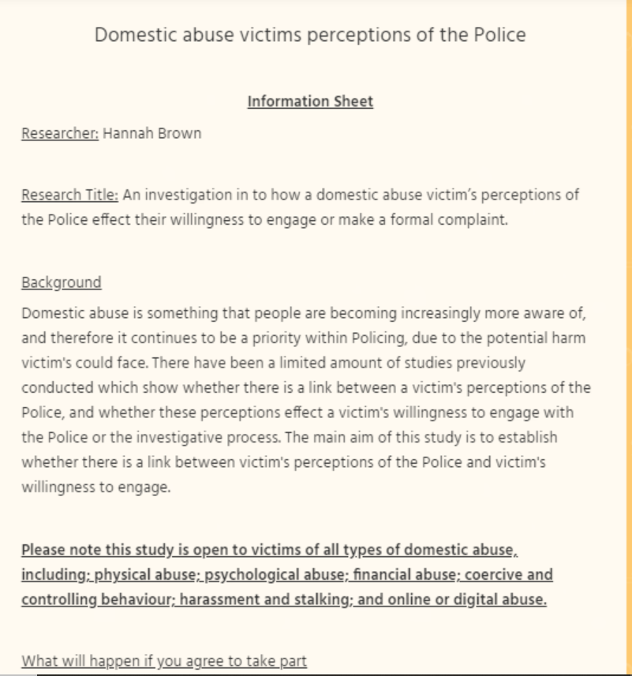

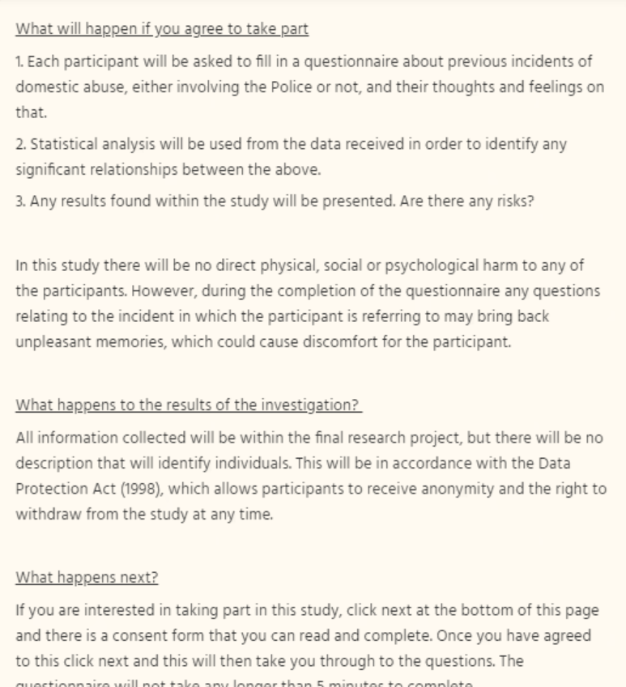

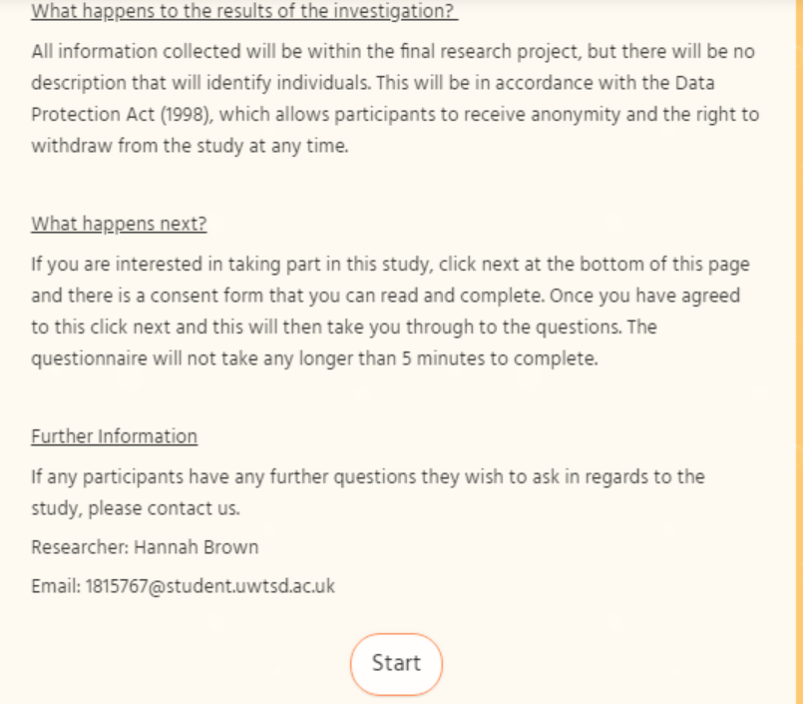

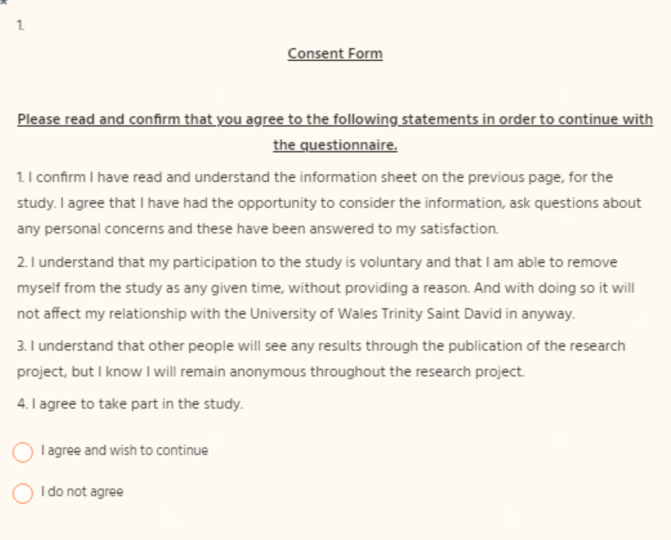

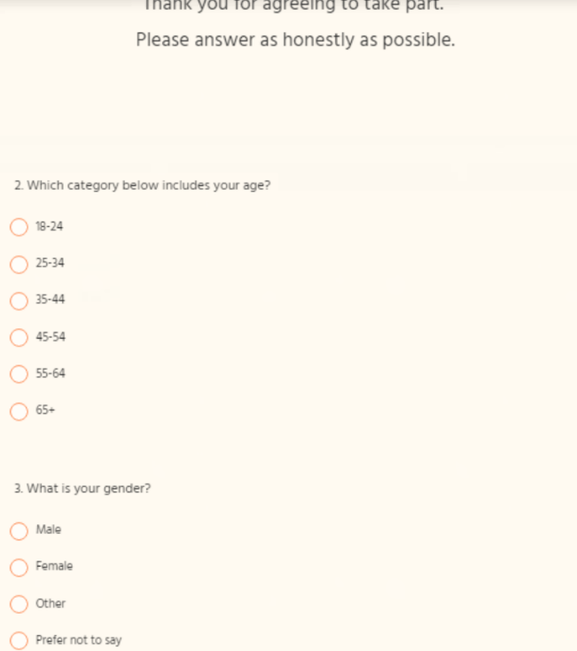

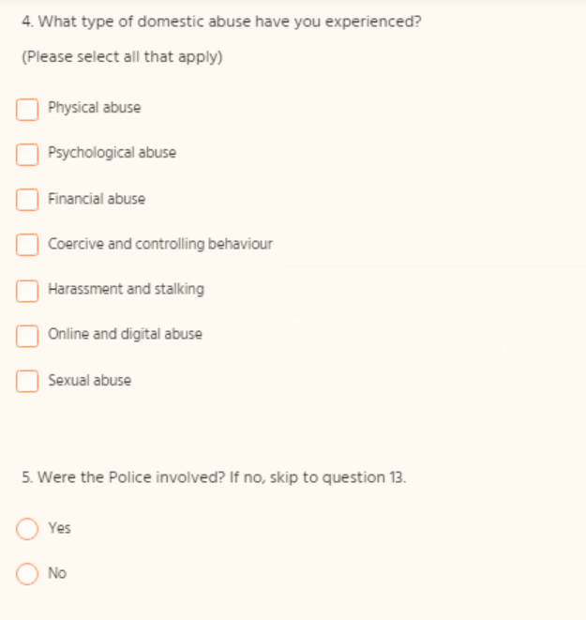

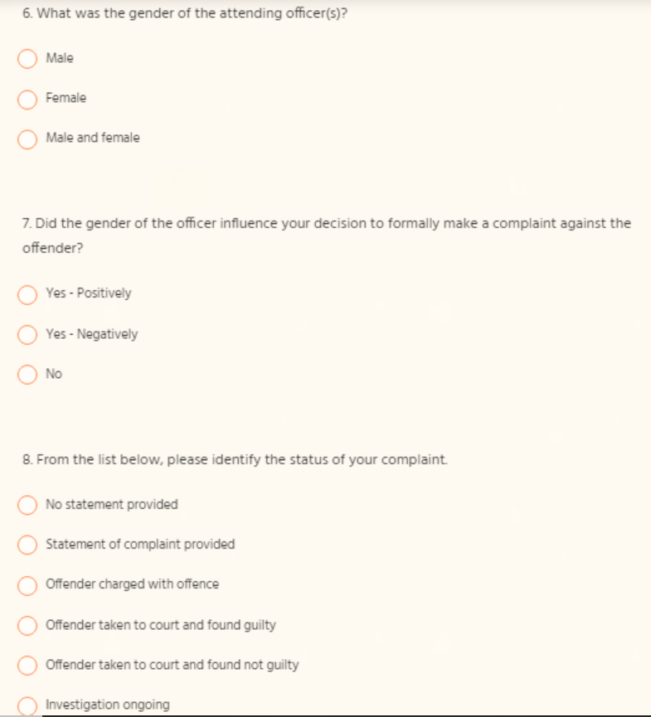

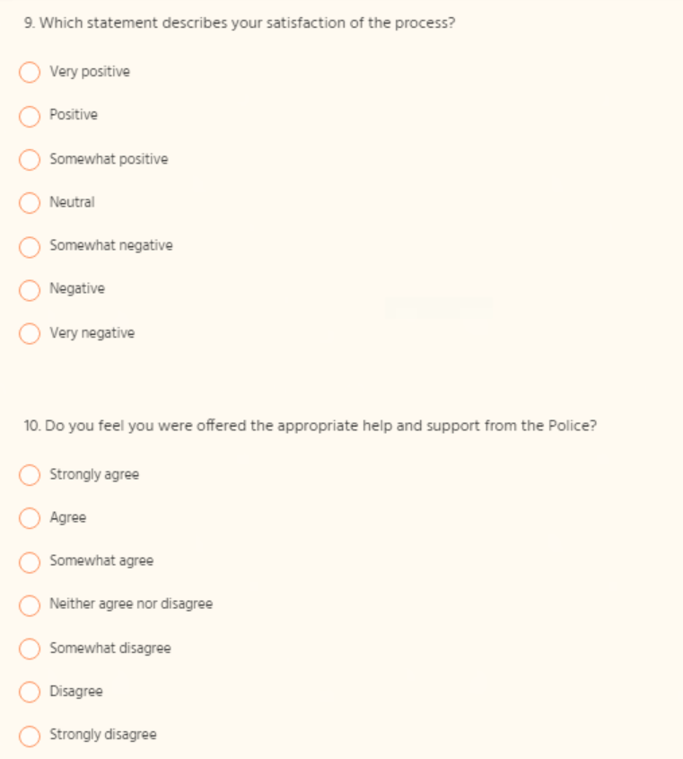

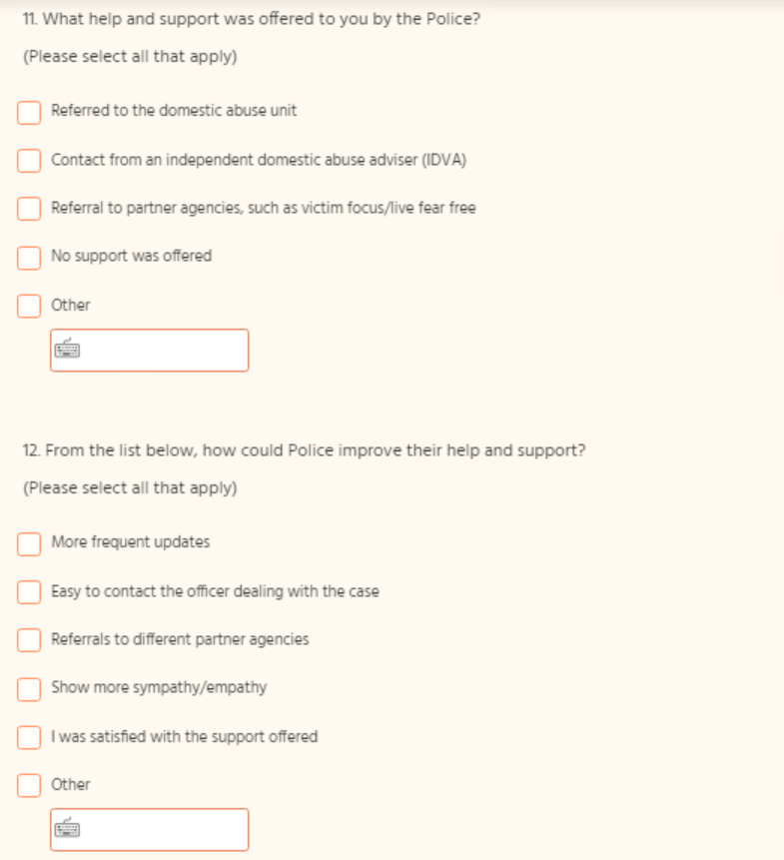

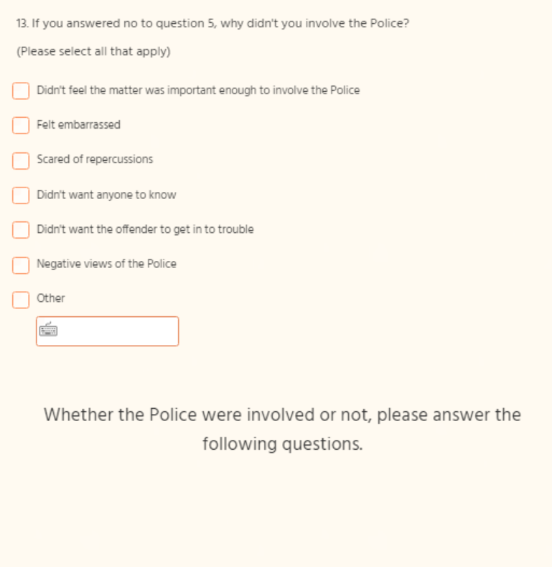

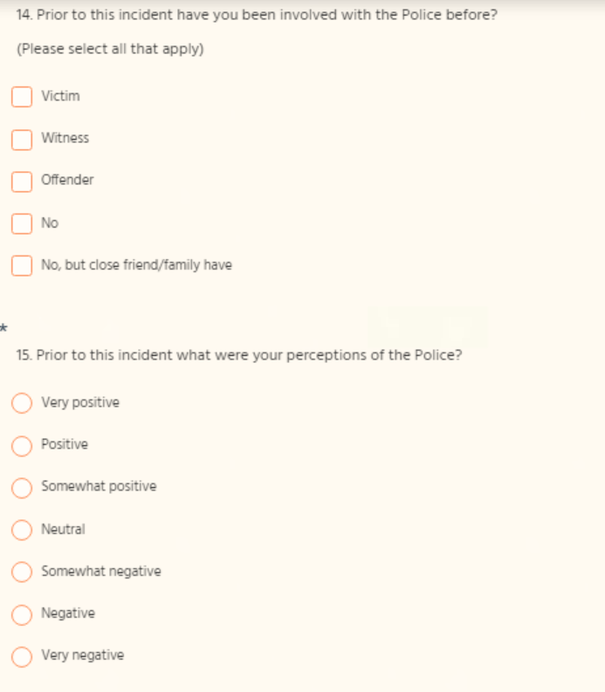
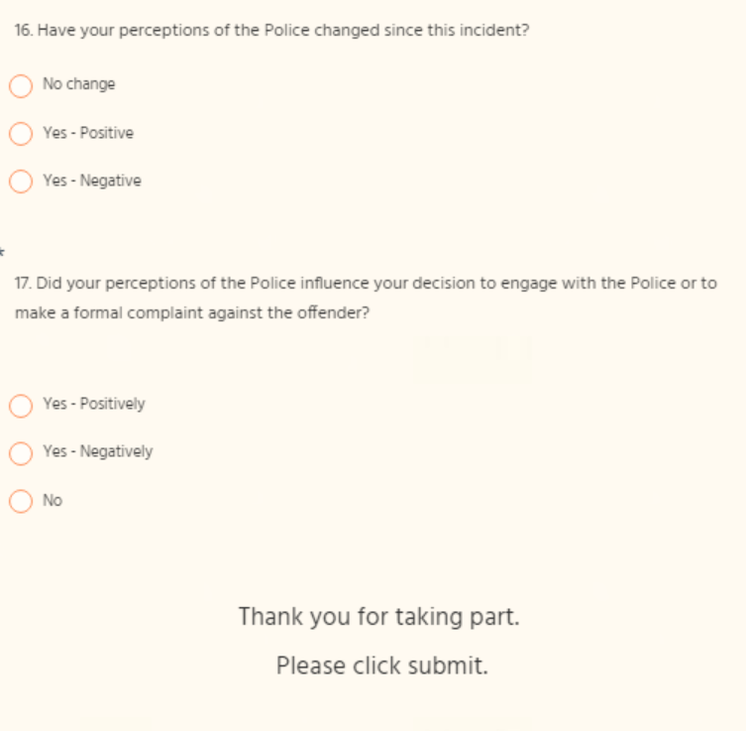

7.2: Appendix 2 – Results

Answers from participants 1-28 for questions 2-9.

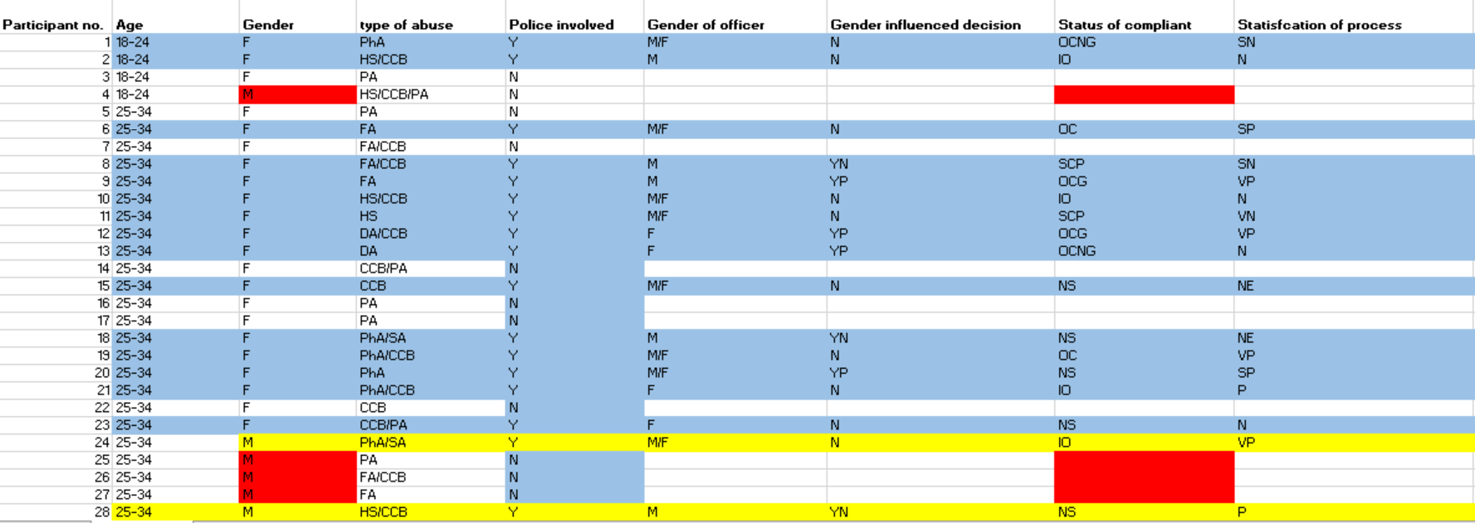

Answers from participants 1-28 for questions 10-17.
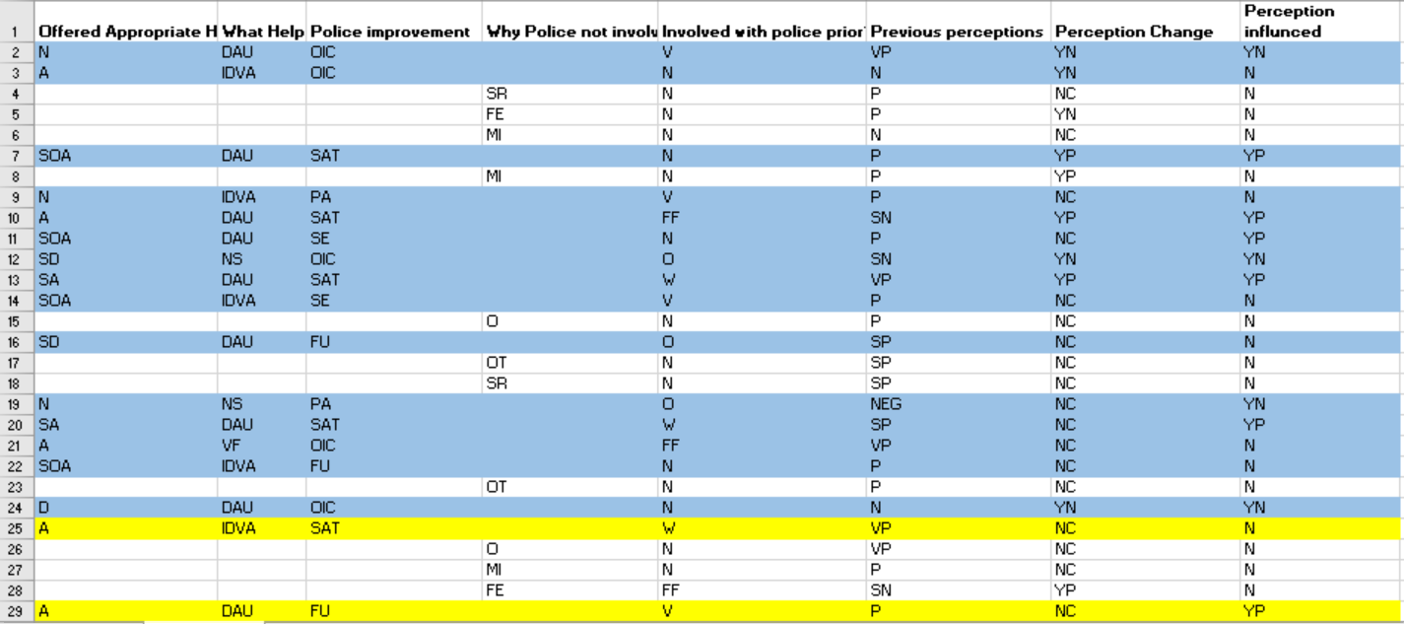

Answers from Participants 29-53 for questions 2- 9.

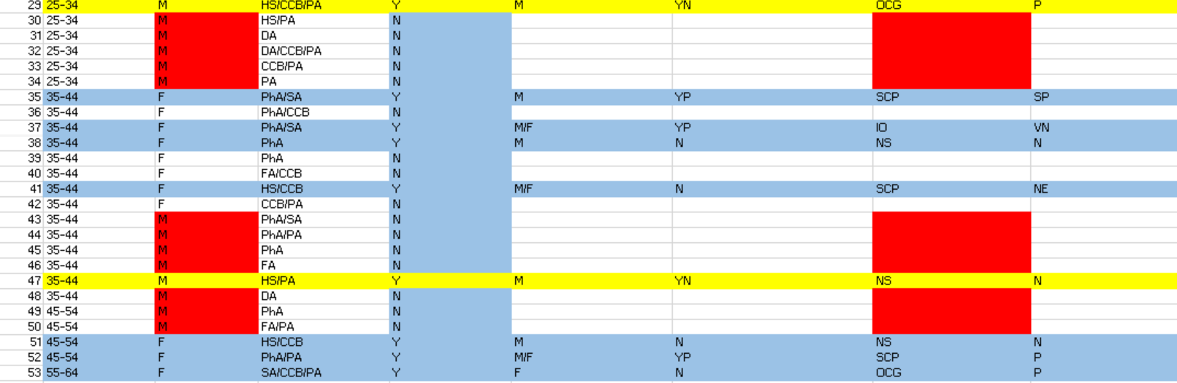

Answers from Participants 29-53 for questions 10-17.



Key for questions 3-9.

Key for questions 10 – 17.

