 | Student No: | 2227016
 | Module Title: | Operating Hotel Facilities
 | Module Code: | BMIH4006
 | Lecturer: | Muhammad Cassamo
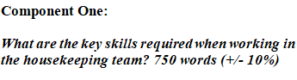
Hospitality is very important factor in the hotel business and housekeeping team plays a big role in this sector. I started my career as a housekeeper in the Premier Inn Faversham hotel and I have seen how the team work is done and their responsibilities. We have to ensure the required functioning and standard to make the customers happy. Gibbs’ reflective approach describes the most about the skills required in housekeeping team. In this paper, I will discuss the real housekeeping job based on theoretical approach with the help of my experience and expert of doing this business (Tan & Fawzi, 2017).

Discovering the Skills Critical to Premier Inn Hotel's Housekeeping Team
A housekeeper needs some quality skills to ensure his job permanently in this sector. It is followed here based on the analysis on my skills.
Accuracy
Premier Inn Faversham hotel gives importance on the accuracy of the work of its employees. The accuracy on cleanness and displaying the view of the inner side of the hotel is important to attract the customers. The authority arranges regular inspection to maintain the standard (Neighbour, 2015).
Efficiency-Premier Inn faces a huge pressure of room booking in the hot season especially in summer and spring. Basically the people of the country and all over the world come to spend their holiday time. Without efficiency I would be difficult to maintain this busy schedule (Kowalski, 2013).
Flexibility
I have many difficult situations in the Premier Inn. As a worker, I have to face such embarrassing situation but I have handled that with the need of the customers. Though I am housekeeper, I have to work in other duties if it is required. The flexibility of the work is the quality that ensures the capability of the employee in adapting (Laerdal et al., 2021).
Communication
As housekeeping in Premier Inn I have to communicate with the visitors about their requirements and general housekeeping service. English and French is the most common language to make communication. Confident and fluency make the communication effective (Yeh, 2012).
Teamwork
Housekeeping is as teamwork that needs team dynamics within the employees. Cooperative nature and supportive mind helps to create bonding among the employees (Leung, 2019).

Reflecting on the Housekeeping Experience Utilizing Gibbs Model
The factors of reflecting on experience of housekeeping based on Gibbs’ model is described below following my job in Premier Inn Faversham hotel.
Description
There are lots of responsibilities in the housekeeping service. Every morning I have to go for my routine work like sweeping, cleaning, changing daily kits, ensuring the full facilities of the visitors etc. I always ask the visitors whether they need any particular thing or not (Tan & Fawzi, 2017).
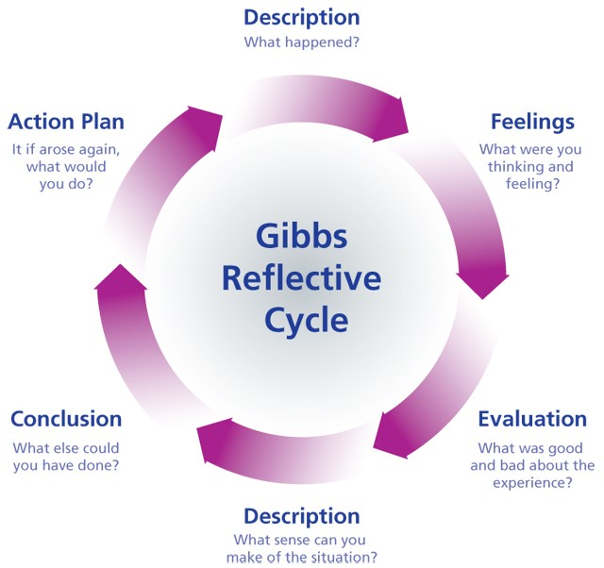
Figure 1: Gibbs’ reflective model (Kowalski, 2013)
Feelings
There are lots of feelings in this service I have faced in Premier Inn. Sometimes the feeling is very warming and sometimes it’s embarrassing. When I get good complement and tips from the visitors about my service to them, I feel that being professionally well. Sometimes I have to face unexpected behavior which I tried to handle with care (Tarasiuk et al., 2020).
Evaluation
There is an evaluation system in the Premier Inn for the housekeeping team. As the profession is based on the service giving, the evaluation mostly follows the customers’ feedback. Without this, the company reviews its employee in its other process (Laerdal et al., 2021).
Analysis
Collaboration, integration, efficiency etc. are the qualities that help to uphold the prestige of Premier Inn. These qualities have made me take my position permanent in the hotel. The recruiting team ensures the patience within its employees (Yeh, 2012). I have many difficult situations in the Premier Inn. As a worker, I have to face such embarrassing situation but I have handled that with the need of the customers. Though I am housekeeper, I have to work in other duties if it is required. The flexibility of the work is the quality that ensures the capability of the employee in adapting (Laerdal et al., 2021).

Conclusion
In my professional career I am eager to develop my skills. I am trying to learn several languages so that I can make more communication with the foreign people. Premier Inn is giving me the scope for finding my lacking and providing me training from experienced seniors. Skills are always mandatory for doing success in the professional life. This paper will highlight the basic skills and reason of competence in the market (Leung, 2019).

Component Two: Housekeeping cleaning checklist
Contribution to Overall Module Assessment: 25%
Housekeeping Cleaning Checklist
Name: Mr X ----------------------- Location: Premiere Inn --------------------- Start Date: 03-11-2023
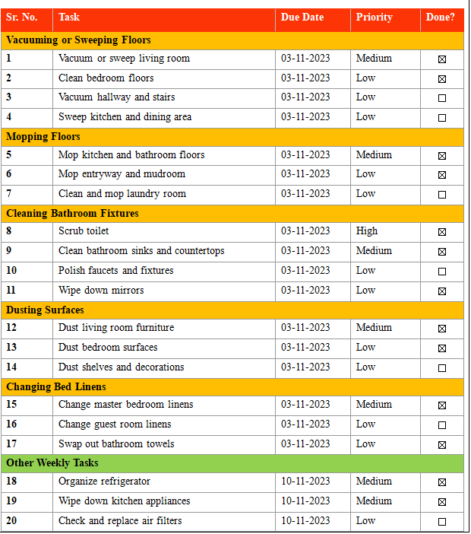

Based on your completed checklist you will need to write 500 words in essay format discussing the following:

How will you guarantee that the rooms are cleaned in accordance with brand guidelines?
Routine is not only the way to bringing consistency in Premier Inn but also the right application of the routine is to be ensured. Premier Inn provides the latest equipment to make the clean of the hotel. The numbers of room will be divided among the employees (Leung, 2019). I will ensure the cleanness of room in brand standard by taking the feedback of the guests and the housekeepers themselves. Incentives and penalty will be imposed to ensure the strictness of the routine. The housekeeper will report to the supervisor within a fixed time about completing their duty (Neighbour, 2015). Consistency helps to keep the whole process way in a decorated way. Without consistency the employees have habit to avoid responsibility and there is personal liability in this case. A daily routine of work is required to maintain all the rooms and services are fully provided. Consistency brings discipline among the employees.
How would you implement these changes to increase team effectiveness?
Team effectiveness is built through the team bonding and the company’s thinking regarding the employees. Premier Inn ensures the salary, bonus and overtime payment on time to its employees. The other facilities life insurance, pension policy etc. impact positively on the team effectiveness (Laerdal et al., 2021). I will make sure about the bonus and overtime time to the employees. The employees will be provided their festival vacation and vacation in case of emergency. The company will also provide the 100 percent cost of education for their first child and 50 percent cost for second child. Strong monitoring will also bring effectiveness (Neighbour, 2015). Premier Inn is facing some difficulties in consistency especially in room cleanness. Several guests have complained about the issue. The hotel committee has found out this and given me task so there is a working balance within the company. The routine has the following benefits (Tan & Fawzi, 2017).
Why do you believe your list to be the most useful?
I am working for quite a long time in premier Inn. So I know about maximum ways and possibilities. I have ensured that no employee is missing in the checklist firstly. I have divided and shuffle the distribution of work according to the types of work. I have taken opinion from all the employees so it can be a democratic decision. In the routine, the rooms of the hotel will be cleaned within 10 AM. The authority has permitted the routine to be applied (Yeh, 2012). So with the daily monitoring the checklist can be applied. There are different parts of cleaning the room which are described in the routine. The employees have to fulfil all the tasks in routine.

Hospitality is very important factor in the hotel business and housekeeping team plays a big role in this sector. I started my career as a housekeeper in the Premier Inn Faversham hotel and I have seen how the team work is done and their responsibilities. We have to ensure the required functioning and standard to make the customers happy. The accuracy on cleanness and displaying the view of the inner side of the hotel is important to attract the customers. The authority arranges regular inspection to maintain the standard (Neighbour, 2015).

References
Ambardar, A., & Raheja, K. (2017). Occupational Safety and Health of Hotel Housekeeping Employees: A Comparative Study. International Journal of Hospitality & Tourism Systems, 10(2).
Grobelna, A., & Tokarz-Kocik, A. (2017). Relationships between job characteristics and organizational commitment: the example of hotel housekeeping employees. Economic and Social Development: Book of Proceedings, 491-500.
Joshi, S. (2016). To study the relationship between Ergonomics and Efficiency of the Housekeeping Employees at Workplace. Atithya: journal of Hospitality, 2(1), 37-42.
Kotian, D. R., Yadav, S., & Panakkal, N. (2021). Knowledge of magnetic resonance safety measures among nursing and housekeeping staff in a tertiary care hospital. Turkish Online Journal of Qualitative Inquiry, 12(9).
Kowalski, Z. (2013). Commercial hospitality as a business model in the independent hotel company. Managerial Economics, (14), 99. Rakib_Ariful
Laerdal, K. M., Palmer, C., & Lester, J.-A. (2021). Constructing and performing hotel hospitality culture. Hospitality & Society, 00(00), 1–24.
Leung, R. (2019). Smart hospitality: Taiwan hotel stakeholder perspectives. Tourism Review, 74(1), 50–62.
Lloyd, H. (2023). Quantifying Housekeeping Challenge and Conservation Need. Heritage, 6(4), 3757-3776.
Neighbour, R. (2015). Housekeeping revisited. Education for Primary Care, 26(6), 426–427.
Pawar, A. (2018). A study on analysis of supportable employee engagement model in McDonald. International Journal of Information, Business and Management, 10(1), 172-181.
Tan, L. M., & Fawzi, L. (2017). Withdrawn: Employability Skills Required of Accountants. SHS Web of Conferences, 34, 06001.

Tarasiuk, H., Chagaida, A., & Sokolovska, I. (2020). PROSPECTIVE DIRECTIONS OF HOTEL BUSINESS DEVELOPMENT FOR ENSURING FINANCIAL STABILITY OF UKRAINIAN HOSPITALITY INDUSTRY. Black Sea Economic Studies, (55).
Tra, T. (2020). Action plan for training new Housekeeping Employee: case: Hotel Indigo Helsinki.
Yeh, R. (2012). Hotel General Managers’ Perceptions of Business Ethics Education: Implications for Hospitality Educators, Professionals, and Students. Journal of Human Resources in Hospitality & Tourism, 11(1), 72–86.
Zemke, D. M. V., Neal, J., Shoemaker, S., & Kirsch, K. (2015). Hotel cleanliness: will guests pay for enhanced disinfection?. International Journal of Contemporary Hospitality Management, 27(4), 690-710.
Zreiqat, M., Marin, L. S., & Minnick, W. (2018). Ergonomic Assessment of Cleaning Spray Bottles for Hotel Housekeeping Use.

