
Services & Energy Performance of buildings
Module Code: M7X01813

Hand in date: 16th March 2020
Student Name: Mr. paul Hill
Lecturer: Mr. Paul Manley

Table of Contents
Preface 2
Introduction Cardiff Business School 3
1.0 Building Engineering Services 3
1.0.1 Heating 3
1.0.2 Ventilation & air conditioning 5
1.0.3 Lighting and lighting control 7
1.0.4 Building Management System (BMS) 8
1.0.5 Small Power & Photovoltaic 8
8
1.0.6 Water 8
1.0.7 Conclusion 9
2.0 Maintenance Strategy Business Case 10
2.0.1 Topic 10
2.0.2 Background Research 10
2.0.3 Problem 11
2.0.4 Discussion 12
2.0.5 Conclusion 14
3.0 Energy Audit & Recommendations 15
3.0.1 Utility Consumption and Costs 15
3.0.2 Building Controls 16
3.0.3 Degree Days 17
3.0.4 Recommendations 19
3.0.5 Conclusion 21
References 23
Appendix 24
Appendix 1 – Degree Days 24
Appendix 2 – Display Energy Certificate 25
Appendix 3 – Energy Performance Certificate 26
Appendix 4 – Energy Management Matrix 27

Preface
This aim of this assignment is to understand the issues of operationally managing engineering services within a case study building, namely the Cardiff Business School Postgraduate Teaching Centre. Part one of this assignment will identify the major items of engineering plant within the building and describe how the engineering services are delivered. Part two will recommend an appropriate maintenance strategy for the University in the form of a business case. And finally, part three will investigate how the building currently performs and provide investment grade recommendations for energy improvements.

Introduction Cardiff Business School
The Cardiff Business School (CARBS) is a state-of-the-art Postgraduate Teaching Centre located in Cardiff on Colum Drive. The four storey building was constructed under a Joint Contracts Tribunal (JCT) 2011 design and build contract at the cost of £13.5m. It has a floor area of 5044 m2, took 73 weeks to build and was completed in September 2014. The architects on the project were Boyes Rees and the main contractor was ISG (ISG, 2020).

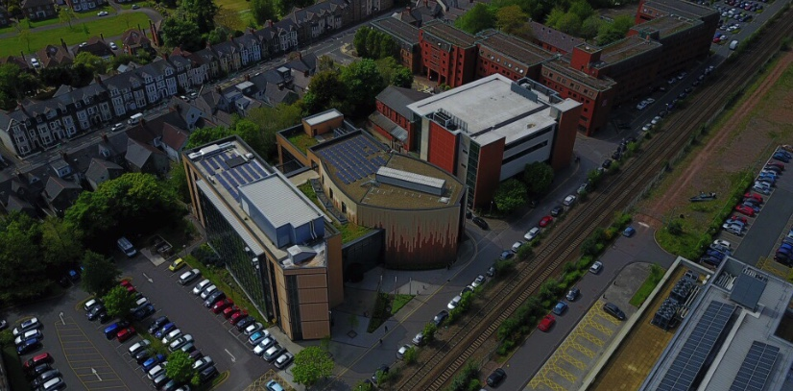
Internally, the building boasts a large central atrium, two lecture theatres, twelve flexible teaching rooms, two post graduate common rooms, and a 56-seat trading room, which is the largest in Wales. Externally the building is constructed from buff brick and curtain walling, has a five colour terracotta rainscreen cladding, flat roofs, and powder coated aluminium doors and windows. In terms of sustainable design, the building has a south facing twin skin façade, which
(www.googlemaps.co.uk)
provides acoustic screening and allows natural ventilation; a green roof to aid biodiversity; and photovoltaic panels (Cardiff University, 2014). The buildings operating hours are Monday - Friday (08:00 – 21:00) and Saturday – Sunday (09:00 – 16:00) with a view of extending in the near future.

1.0 Building Engineering Services

1.0.1 Heating
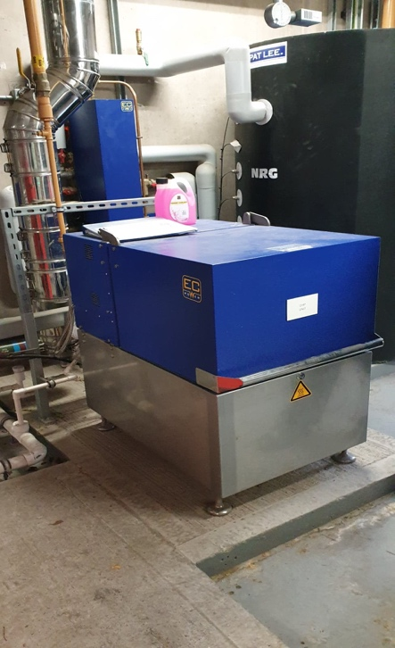
The main source of heating in the building is provided via a gas fired combined heat and power (CHP) engine. The unit has a heat output of 14-20 KW and a three-phase electrical output of 4-9 KW. This mini CHP unit boasts service intervals of 10,000 operating hours and an efficiency rating of 93% (EC Power, 2016). The CHP runs all year and acts as the lead boiler, it’s fully automated and switches off once the heating demand is satisfied.
Image 1 - CHP (3/2/20)

During colder months the heating system is supplemented by three Remeha gas 210 Eco Pro boilers. These high efficiency industrial condensing boilers have a gross calorific value (GCV) of 95.2% and are particularly suited to the underfloor heating circuit in the central atrium (Remeha, 2020).
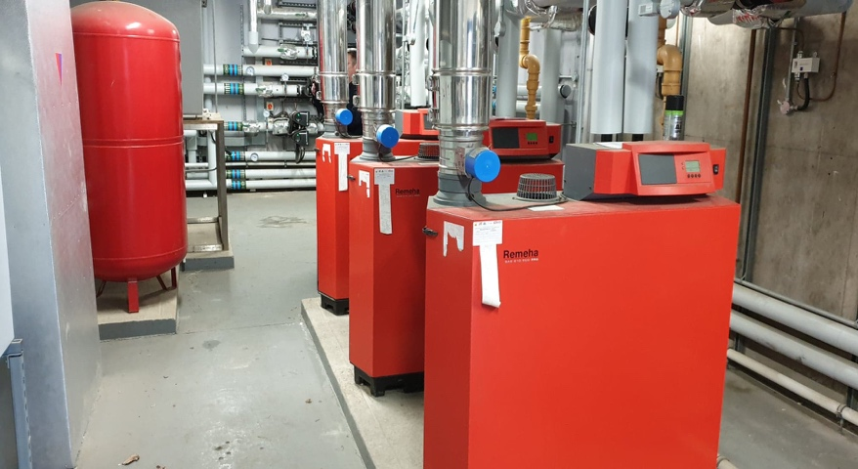
Image 2 – Gas Boilers (3/2/20)

1.0.2 Ventilation & air conditioning
The CARBS building features a variety of systems to ventilate and cool the building; these include air handling units (AHU), a twin skin façade, displacement ventilation, a chilled beam, and automated windows.

The building has eleven AHUs in total, which serve the offices on all floors, seminar rooms, lecture theatres, common rooms, servery, and toilets. The AHUs are manufactured by Weger air solutions and are controlled via Trend VSD2H variable speed drives for optimum control and efficiency. One AHU incorporated a thermal wheel to reduce energy and carbon emissions. The medium for heat transfer is heated water from the boilers for heating, and refrigerant from a roof mounted chiller for cooling. 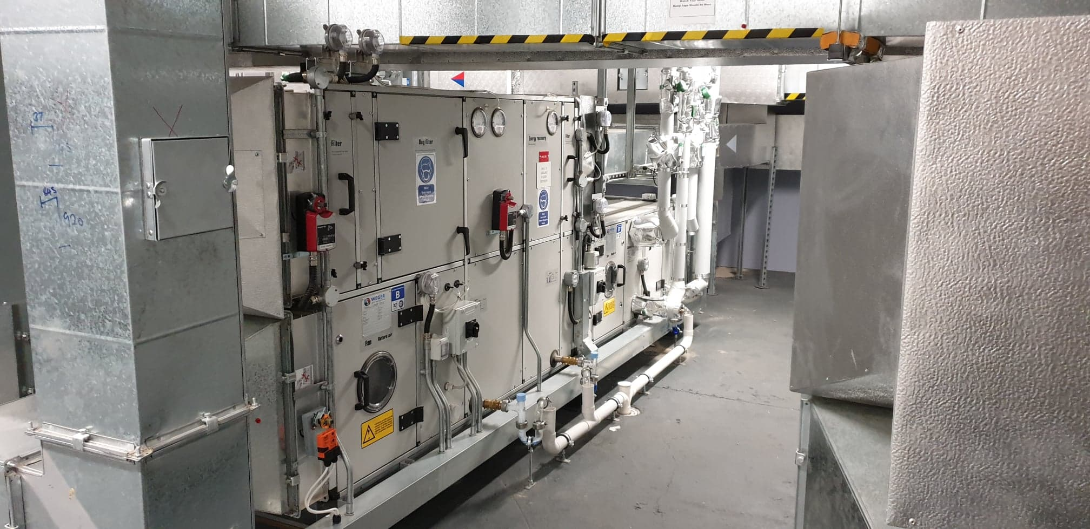
Image 3 – Air Handling Unit (3/2/20)

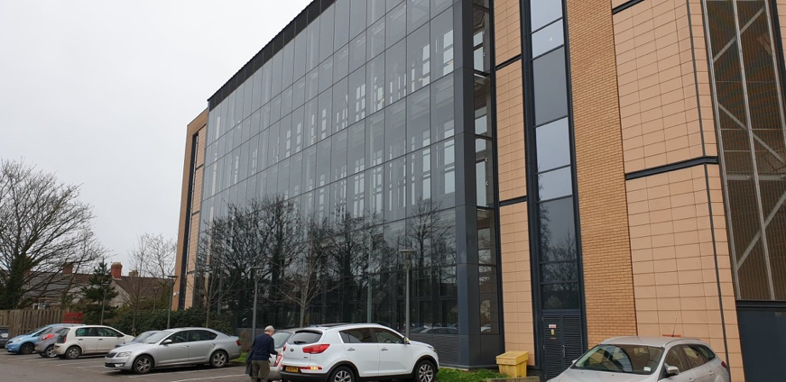
A double skin façade is provided to the south elevation of the research offices and provides natural ventilation and is principally an acoustic device to shield opening windows from train noise. There is no BMS control to the façade louvres. This is referred to as the stack effect and works by
Image 4 – Twin skin façade natural ventilation (3/2/20)

drawing cold outside air into the building at low level; as the air warms it becomes less dense and therefore more buoyant, then rises and exits through high level ventilation grilles. During the site visit some of the rooms felt warm which raises concern as to how effectively the natural ventilation system is working. Warm and uncomfortable environments can result in increased reliance on mechanical cooling systems, the issue could however be due to user error and this is something the University should investigate.

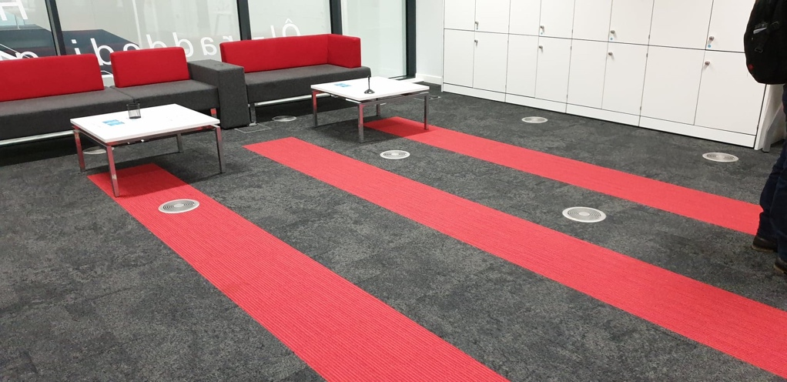
The building also features displacement ventilation in some office spaces. This ventilation strategy supplies conditioned outside air through low level induction air diffusers located in the floor and is extracted through high level grilles. The rooms which feature this system were warm and somewhat uncomfortable during the visit. It was noted that these rooms had openable windows which when opened would have an effect on the performance of the displacement ventilation system.
Image 5 – Displacement ventilation (3/2/20)

The ground floor trading room and flexible area are cooled via a chilled beam which is essentially a fan coil unit without the fan. Because of this, chilled beams are quieter, use less energy, and can provide greater thermal comfort due to air distribution (Buildings, 2018).
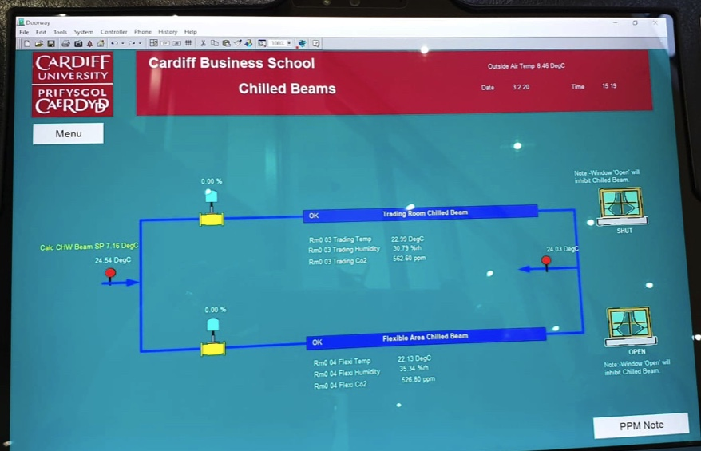
Image 6 – BMS Chilled beam (3/2/20)

Automated windows open/close based on the average room temperature and Co2 measured by multiple temperature and Co2 sensors throughout the building. The windows provide nighttime ‘purge’ ventilation, which is controlled in order to reduce the temperature of the exposed concrete soffits to the areas overnight, assisting in reducing peak gains during occupied periods. When external conditions prevent natural ventilation from effectively maintaining the internal air quality the mechanical displacement ventilation system is enabled and all automatically controlled windows are closed. Should the external temperature be too cold to be of use, the automated windows are inhibited using an adjustable hold off set-point. A rain detector ensures the windows close when rain is detected. The windows close at the end of occupancy.
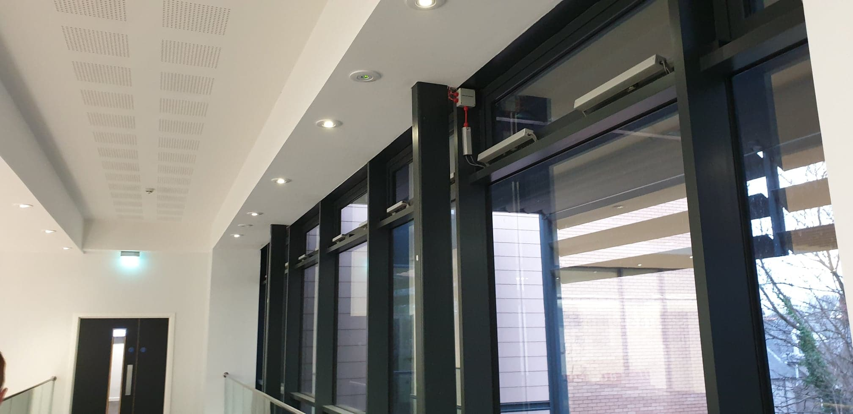
Image 7 – Automated windows (3/2/20)

1.0.3 Lighting and lighting control
The building has been designed to incorporate natural light in the majority of areas which reduces the reliance on artificial lighting. The lighting system is Light Emitting Diode (LED) throughout the building and is automatically controlled by ceiling mounted PIR occupancy sensors. The lighting system is very efficient; however, it could be improved if photoelectric dimming light fittings were installed. These automatically dim based on the amount of natural light entering the room therefore reducing consumption.

1.0.4 Building Management System (BMS)
The building has a Trend BMS system which is used to monitor and control the boilers, AHUs, cooling, chilled beams, windows, underfloor heating, and metering throughout the building. The University is currently using Trend IQ3 and plan to upgrade to Trend Vision in the near future. The energy management team at the university is very small and as a result monitoring the BMS system performance is limited. Thus, it may be beneficial for the university to explore the possibility of increasing their staff to monitor energy efficiency more frequently.

1.0.5 Small Power & Photovoltaic
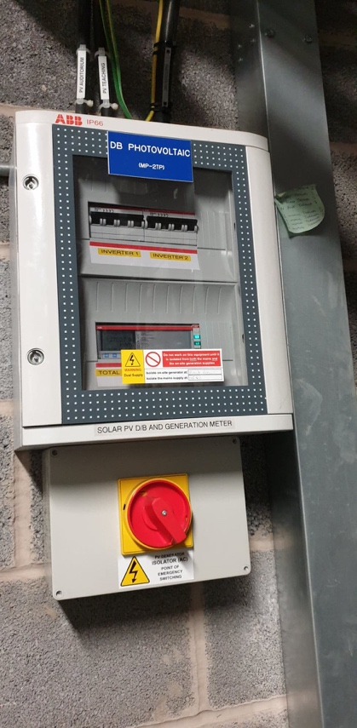
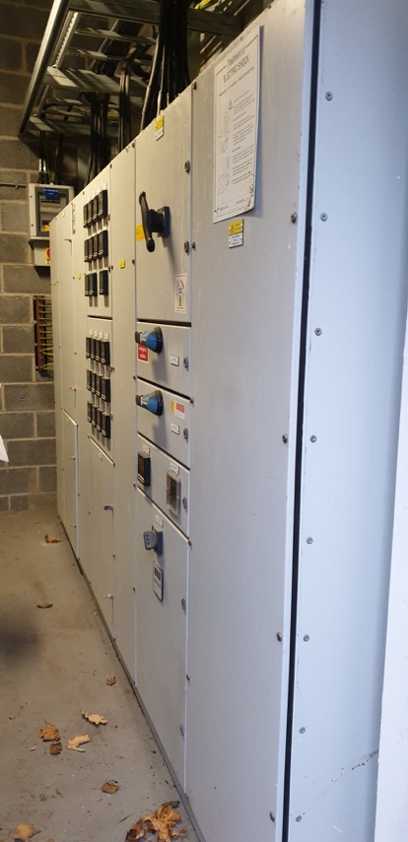
The main LV panel board is located in the external ground floor plantroom and is fed via an 800KVA transformer located in the Aberconway substation. The panel board has digital meters for each outgoing circuit and has incoming generation circuit breakers from the CHP and the 30.5 KWP dual photovoltaic system on the roof.

Image 8 & 9 – LV Main Panel Board
and PV Fuse Board (3/2/20)

1.0.6 Water
It is unsure if the building incorporates a rainwater harvesting system, information available on the internet suggests yes however during the site visit I was unable to locate this. The University toilets utilise a Propel air system which uses 1.5 litres per flush compared to approximately 9 litres in conventional flushing systems, which can account for around 84% less water usage therefore saving money and reducing the carbon footprint (Propelair, 2020).

1.0.7 Conclusion
The CARBS building has been designed with energy efficiency in mind which is evident from its EPC ‘A’ rating. In order to ensure the building engineering services operate efficiently and effectively the university must adopt an appropriate maintenance strategy which will be discussed in the next section of this assignment.

2.0 Maintenance Strategy Business Case

2.0.1 Topic
Cardiff University has an evolving estate disseminated over a fairly large area of Cardiff. The challenge facing the University is choosing an appropriate maintenance strategy to meet the changing needs of the organisation. This section of the assignment will look at previous and current research, identify the problems, and give recommendations on how best to deliver maintenance at the University.

2.0.2 Background Research
Many organisations today overlook the importance of maintenance and fail to consider it as a core function of the business. Facilities management (FM) arguably has a key role to play with regards to maintenance; Kurdi et al (2011) suggest that FM can help encourage returns on investment by increasing output from the facility in order to reduce life cycle costs and increase profits. This is further supported by Atkin & Brooks (2015) who suggest that FM is a technique which can improve quality, add value, and reduce risk whilst providing a safe and dependable service.

If the University is to preserve their assets and uphold their persona, they must implement the appropriate level of maintenance; this can be delivered via in-house direct labour operatives (DLO), by outsourcing or out-tasking to specialist contractors, or a mixture of both (mixed method). Organisations have differing needs and thus the problem lies in selecting the best approach. Maintenance can therefore be delivered in a number of different ways, for example, small organisations may opt to only undertake basic statutory maintenance whilst operating a run to fail approach and call upon external resources when required. This approach is favored by small organisations as the cost of employing DLO cannot be justified. However, in larger organisations maintenance might be delivered by combining DLO with specialist subcontractors in order to inspect and maintain the complex engineering services (CIBSE Guide M, 2014). The advantages and disadvantages of in-house versus outsourcing are highlighted in table 1 below.

Table 1 - Comparison between contract and directly employed service provision
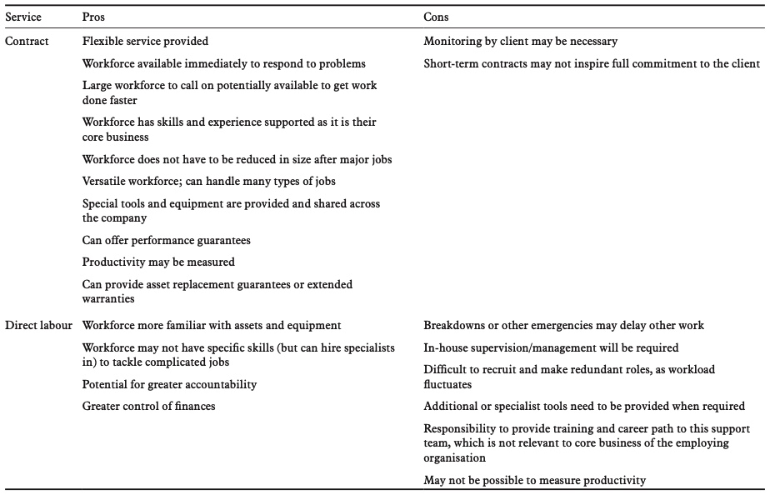
CIBSE Guide M Maintenance Engineering and Management

When exploring the various options managers should be aspiring to identify the right skills for the job as appose to focusing on achieving short term cost savings (Sullivan, 2005).

2.0.3 Problem
Cardiff University is ranked a respectable 26 out of 131 in the UK University league table 2020, has a student population of more than 25,000, employs more than 6600 staff and is the only Welsh University to be a member of the Russell group (Cardiff University, 2020). The University has a high reputation to uphold with world class research studies which have been running for many years; coupled with this is their geographical location in a busy city centre, reliance on specialist engineering services/equipment, and a large property portfolio. It is therefore essential that the University adopt appropriate maintenance techniques to maintain their engineering services and preserve the life expectancy of their assets.

Cardiff University currently employ an in-house DLO team of approximately 25 staff ranging from electricians, mechanical tradesmen, and plant attendants who are essentially maintenance assistants. The workforce is based in the school of social sciences Glamorgan Building in the basement, which acts as the central hub for the portfolio of properties. The in-house team are responsible for some statutory maintenance, not all, such as weekly fire alarm testing, emergency lighting testing, and filter replacements on AHUs to name a few. The remainder of statutory maintenance is outsourced to specialist contractors, for example boiler servicing is undertaken by Gibson who are gas safe registered. Adopting this approach saves the University money as training in-house staff to be gas safe is costly. Fixed wire testing and PATs testing are another example of the University outsourcing statutory maintenance along with lift maintenance. Additionally, the University do not undertake any planned preventative maintenance (PPM), hence the main function of the in-house team is reactive maintenance.

2.0.4 Discussion
Having identified the various maintenance options available and explored how maintenance is presently delivered at the University, I will now detail how I would organise maintenance of the engineering services. During the site visit observations suggested that the level of maintenance in the CARBS building was average/good. Housekeeping in all plantrooms was good and all engineering plants were running with no faults. The building appeared to be in a good state of repair with no glaringly obvious issues. However following discussions with Mr. Mark Durdin (energy manager, one could argue that the University could be doing more with regards to maintaining their assets.

An example is that the University does not currently have any life cycle plans in place, do not have planned maintenance strategies and operate a run to fail system; whilst this seems to have worked so far for the University, I don’t think it’s best suited for maintaining the value of the assets and does not offer an acceptable level of resilience for their high profile studies and clinical trials which collect vast amounts of longitudinal data. This observation was further supported during the site visit during a conversation with a University employee where a comment was made that ’capital cost is king, life cycle is not’. The engineering services and plant in the building are not very old which is possible why the University have this attitude towards maintenance and future planning. Historically managing directors have the attitude that new buildings require less maintenance, however this interpretation is quite the opposite as new buildings usually contain more complicated equipment and systems. Regardless of plant and building age the University should maintain all engineering services in line with manufacturers guidelines; this will prolong the service life of the equipment, reduce breakdown costs and disruptions, and reduce the future backlog maintenance for the organisation.

In my opinion the University is already implementing the most suitable maintenance strategy for their needs via the mixed method approach of in-house DLO and maintenance contracts with specialist contractors. I suggest that this same approach is followed; in-house DLO will be responsible for reactive day-to-day breakdowns such as faulty lights, damaged sockets, minor works, blocked toilets etc. DLO will also be responsible for undertaking some statutory maintenance such as weekly fire alarm testing (MCPs only), emergency lighting, water temperature checks to name a few. Finally, DLO will be responsible for undertaking some preventative planned maintenance such as filter replacements on AHUs. The specialist contractors will be responsible for undertaking the remainder of the statutory maintenance and the PPM; which will include maintaining the boilers, CHP, annual fire alarm testing, fixed wire testing, PATs, BMS, ACUs, chiller, lightning protection system, PV, and lifts. Each service contract will stipulate the number of visits required per year along with contracted response times to site in an emergency. For example, the lift contract will specify two maintenance visits per year per lift, attendance to site within 4hrs for breakdowns and 1hr for entrapments. Each contract will be closely monitored, and regular service level agreement meetings will be held with each contractor. Contractors will provide risk assessments and method statements prior to attending site and will provide the University with training certificates for their employees. All contractors must be inducted by the University and follow the sign in/out procedure when attending site in line with the Universities control of contractor’s policy.

In-house teams offer the advantage of being able to react to breakdowns in a timely manner and generally hold greater site knowledge and awareness which is essential for rectifying problems quickly. Outsourcing offers the advantage of being able to call upon specialist engineers who can usually offer a higher quality of workmanship on specialist items of plant. Furthermore, the contractor is responsible for sick pay, holidays, and pension which alleviates the workload for the University.

2.0.5 Conclusion
The University already implements a suitable maintenance strategy; however, I feel it could be enhanced by adopting the suggestions discussed above by introducing planned preventative maintenance in line with manufacturers guidelines and investing in life cycle plans for the future. These changes will help safeguard the value of the Universities assets in years to come and help maintain their reputation as one of the leading Universities in Wales.

3.0 Energy Audit & Recommendations

3.0.1 Utility Consumption and Costs

Table 2 below denotes the annual consumption figures, cost, and carbon emissions for electricity and gas in the CARBS building from Jan-Dec 2019. The total KWh have been collated from the Excel data set from Mr. Mark Durdin.

Table 2 – Annual Electricity and Gas Data (Jan – Dec 2019)

Table 3 shows the total KWh from the Display Energy Certificate (DEC) for the same period. As can be seen there are discrepancies with the electricity and gas totals between the University data and DEC data. Having analysed the data provided from the University it is clear that some data is missing, incomplete, and many meters have reset back to zero. It is therefore difficult to provide an accurate proposal of the energy consumption based on the metered data. Therefore, the data will need to be interpreted with caution.

Table 3 – DEC Annual Electricity and Gas

According to the University data the PV system has generated 25,239 KWh over 12 months. Each KWp should generate between 800 – 850 kwh per year if unshaded, so a 30.50 KWp system should generate 24,400 KWh, which indicates that the PV system at the University has slightly over performed.

Table 4 – PV annual generated KWh

Unfortunately, CHP data was not provided from the University therefore no business case can be made with regards to increasing the size of the CHP or installing an additional unit. Likewise, the chiller consumption data was not available either, this would have been useful to calculate if the chillers were running in the winter, and to establish if the heating and cooling systems are interlocked.

3.0.2 Building Controls
Graph 1 shows the gas consumption on Christmas Day and Boxing Day 2019. Over the period of 48hrs the KWh remained at 1711.5 indicating that the boilers and CHP were not running. Although the building was closed for the Christmas period, I would have expected to see some gas usage over this time period to maintain some background heat in the building. If the University intentionally turn them off over Christmas, then the controls are clearly working correctly. However, if the boilers are left on then the data is clearly incorrect.

Graph 1 – Gas Consumption Christmas and Boxing Day 2019.
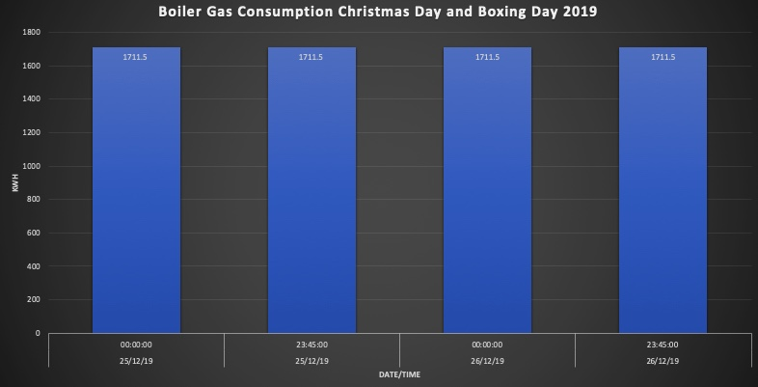

Graph 2 shows the electricity consumption on Christmas Day and Boxing Day 2019. The building used 43 KWh per day which at 12p/KWh equates to £5.16 per day. Again, these figures appear small for a building of this size and it’s interesting how both days are identical, I would therefore question if the data is accurate.

Graph 2 – Electricity Consumption Christmas and Boxing Day 2019.
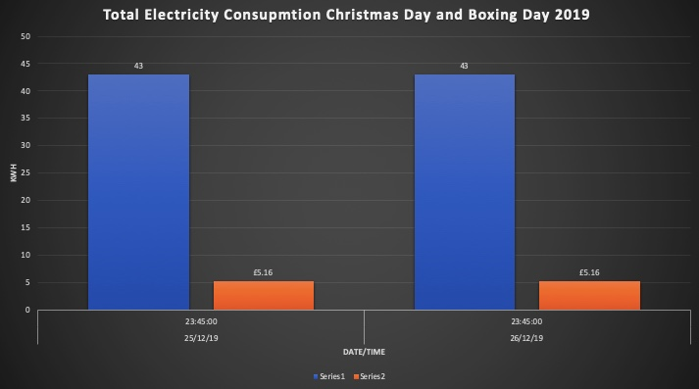

3.0.3 Degree Days
In order to monitor, manage, and reduce energy consumption in the CARBS building I have developed Graph 3 which compares gas consumption (KWh) against degree days over 12 months. Buildings require more heating when the weather is colder and more cooling when hotter, therefore degree days is a useful tool to analyse if the building is being over heated or over cooled. Degree days information was obtained from www.degreedays.net, the relevant Cardiff weather station was selected, and plotted on the line graph below. The bar graph highlights that the University gas consumption data is questionable and does not appear to follow the degree day profile as one would expect throughout the year.

Graph 3 – Gas Consumption V Degree Days (Jan - Dec 2019).
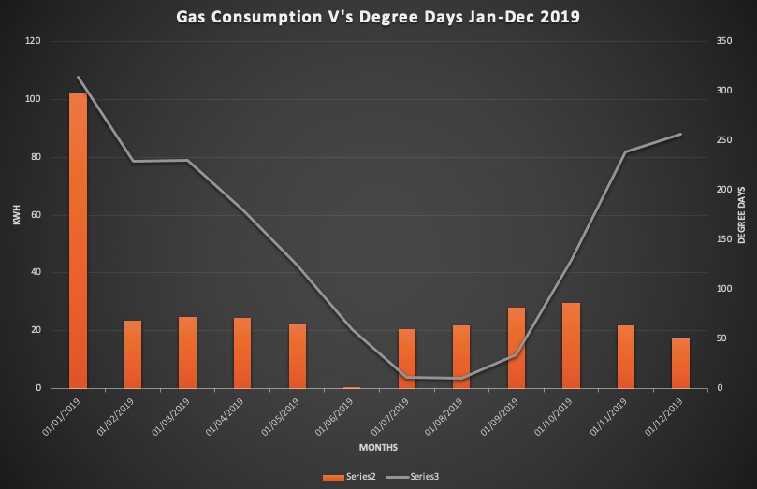

The Universities annual gas consumption data was then run a second time, this time on the last day of each month (Graph 4), and the results showed that the meter consumption did not change for the whole year. Unfortunately, due to the inaccuracies in the data it’s not possible to provide an accurate comparison between gas consumption and degree days. A second site visit would be required to further investigate. This is unfortunate as the degree days analysis would have identified if the boilers are running during the summer, or if the heating is being left on.

Graph 4 – Gas Consumption Last day of each month (Jan - Dec 2019).
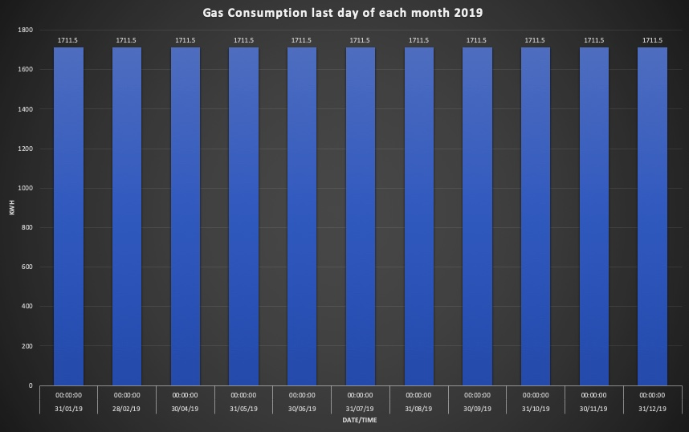

3.0.4 Recommendations
From analysing and reviewing the data provided by the university it is difficult to draw any concrete conclusions as it appears to be inconsistent and inaccurate. Consequently, drawing valid results in order to make calculated recommendations along with paybacks has been very difficult and challenging. However, the following section will attempt to identify recommendations with short, medium, and long paybacks.

Short Payback Recommendations (Less than 3 years)
- The University should consider engaging with members of staff and students in order to reduce equipment energy consumption. Building users should receive awareness training with regards to saving energy, this could include switching off lights and computers, or even wearing an extra layer of clothing when cold. The University could offer incentives by awarding individuals for their achievements and showing users how well targets are being met. The management should introduce posters and notice boards informing users on how they can save energy and the benefits of doing so. This recommendation is very low cost and has potential low impact.

- The energy team at Cardiff University is very small consisting of two people. The University should consider improving their energy management techniques by increasing the size of their team or allocating the responsibility to one individual such as an energy champion. Money saved on energy goes straight back into the bottom line as profit. This recommendation is low cost with medium impact.

- The PV meter readings must be recorded and aligned with the DEC dates to ensure they are correct on future DECs. Low cost low impact

- The CHP meter readings must be recorded and aligned with the DEC dates to ensure they are correct on future DECs. Low cost low impact.

- Investigations should be carried out to determine if the heating and cooling systems are interlocked. Low cost, low impact.

Medium Payback Recommendations (Between 3 and 7 years)
- The University should review the building fabric in order to establish the air tightness of the building, this should be undertaken by specialists who will carry out a building pressure test. Further testing could include thermography testing to prove the insulation properties. Although the building is only 6 years old it may have been constructed to meet the minimum building standards at that time. This is medium cost, low impact.

- The BMS system only covers approximately 95% of the portfolio. The University should introduce regular checks on the BMS system to review time settings, occupancy hours, and weather compensation control. This is Low cost, medium impact.

- The University should engage experts to assess the possibility of load shedding. Historic data should be reviewed to determine the buildings peak demand e.g. if the University are paying for 300KW and only require 200KW then savings can be made here. This is low cost, medium impact.

Long Payback Recommendations (More than 7 years)
- The University should engage experts to assess the possibility of increasing the size of the CHP or installing a second unit. Providing the building has the ability to utilise the heat then this would be a viable option. Alternatively, a larger CHP could service more than just the CARBS building as the University has other buildings in close proximity. This is high cost, high impact.

- If a second CHP is not viable the University should consider installing a building mounted solar water heater, this is high cost, high impact.

3.0.5 Conclusion
This assignment has aimed to provide an overview of the engineering services in the CARBS building combined with a description of how each service is delivered. It also explored the various options available for maintaining the building and provided a recommendation of the most appropriate maintenance strategy to suit the needs of the University. Regrettably the energy data provided by the University appears to be inconsistent and therefore unreliable; this has made it very difficult to determine the exact energy consumption of the building, and therefore establishing investment grade recommendations has not been possible. If the energy consumption data were reliable, I would have been able to accurately measure the energy baseload of the building which could then be compared against various days throughout the year to establish how well the building controls are functioning.

If CHP gas consumption data were available this would have allowed me to establish how often the three gas boilers are running to supplement the heating demand. If the boilers were identified as running frequently then clearly there would have been an opportunity to investigate the possibility of either increasing the size of the existing CHP or possibly installing a second unit. This coupled with the dubious gas consumption data for the building has left me unable to draw a valid recommendation. Unfortunately, energy consumption data for the chiller was also missing from the excel spreadsheet. If this information were available, I would have been able to establish if the chiller is being controlled correctly, whether the heating and cooling are interlocked, and if the chiller runs throughout the winter.

Although the data has presented challenges it should be noted that the CARBS building is certainly an energy efficient building as identified by the display energy certificate (Appendix 2). The operational rating for the building in year 2018 was 67 and in year 2019 the score decreased to 48; giving the building a rating of ‘B’. The energy performance certificate has awarded the building a performance rating ‘A’ and a score of 25, making this building very energy efficient (Appendix 3). This rating is significantly lower than the benchmarked score of 33 when compared against other newly built similar buildings. Furthermore, Appendix 4 presents the energy management matrix for the University; this evaluation tool is a way of determining how effectively the organisation accomplishes energy management. The matrix distinctly shows that the University is committed to energy management and this is reinforced by the improved score on the DEC from year 2018-2019.

If the University are to continue toward lowering their energy consumption and making their buildings more energy efficient it is vital that energy audits are not used in isolation. The information identified from energy audits should be used to link with condition surveys, planned refurbishment works, and backlog maintenance. Any energy savings can help offset some backlog maintenance costs in a business case. One final observation is that any changes to the building fabric or system changes should be considered with caution as they have the ability to impact on building regulations. For example, if installing extra cooling to particular rooms or adding extra lighting these changes may result in consequential improvements as identified in approved document L2B.

References

Buildings Smarter Facility Management. (2018) Explore HVAC chilled beam systems. Available at: https://www.buildings.com/article-details/articleid/6087/title/chilled-beam-system (Accessed: 3rd February 2020).

Cardiff University. (2020) League Table Ranking. Available at: https://www.thecompleteuniversityguide.co.uk/cardiff (Accessed: 2nd March 2020).

Cardiff University Campus Developments. (2014) Postgraduate teaching centre. Available at: https://www.cardiff.ac.uk/campus-developments/projects/postgraduate-teaching-centre (Accessed: 8th February 2020).

CIBSE Guide M. (2014) Maintenance engineering and management. Lavenham Press Ltd. London.

EC Power. (2016) Product range. Available at: https://www.ecpower.eu/en/product-range.html (Accessed: 4th February 2020).

ISG. (2020) Case study – Cardiff Business School (CARBS) Cardiff, UK. Available at: https://www.isgplc.com/en/our-experience/government-public-sector-and-education/higher-education/case-study/cardiff-business-school-cardiff-construction (Accessed: 4th February 2020).

Kurdi, M, K., Abdul-Tharim, A, H., Jaffar, N., Azli, M, S., Shuib, M, N., Ab-Wahid, A, M. (2011) ‘Outsourcing in facilities management – A literature review’, Elsevier, 20, pp. 445-457.

Propelair. (2020) The commercial toilet of choice. Available at: https://propelair.com/propelair-toilet/ (Accessed: 5th February 2020).

Remeha. (2020) Gas 210 ECO PRO. Available at: https://www.remeha.co.uk/Products/Floor-Standing-Range/Gas-210-Eco-Pro (Accessed: 5th February 2020).

Sullivan, E (2005) Building operating management, pp. 27-30.

Appendix

Appendix 1 – Degree Days
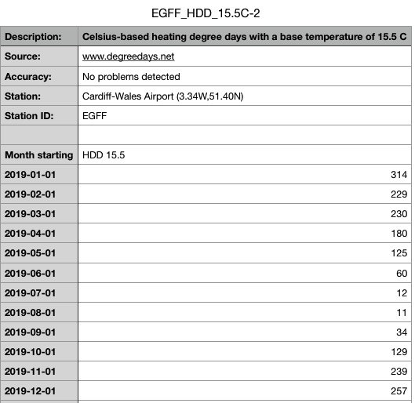
https://www.degreedays.net/#generate

Appendix 2 – Display Energy Certificate
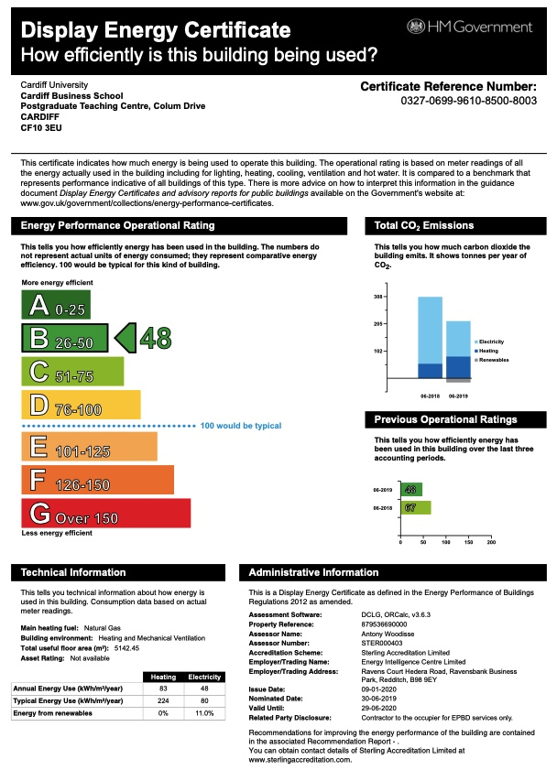

Appendix 3 – Energy Performance Certificate
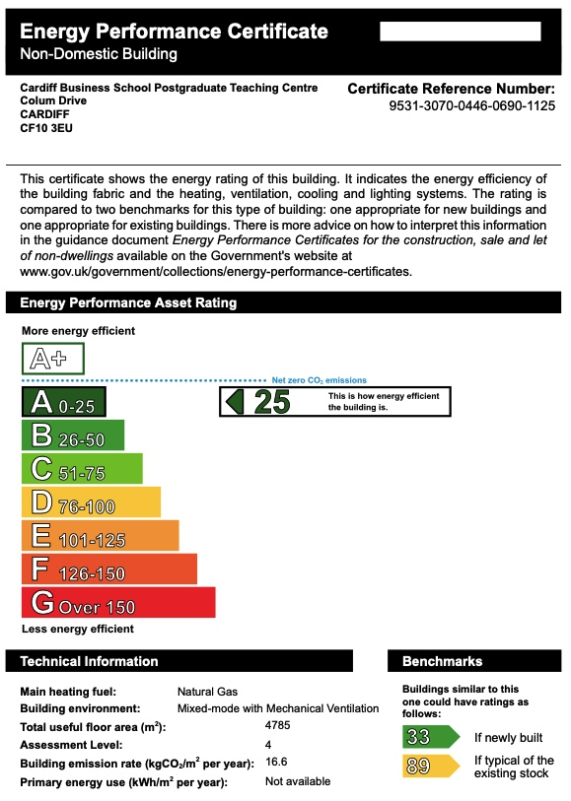

Appendix 4 – Energy Management Matrix


