BMSW4004
Problem Solving and Decision Making
Assessment 1
Task 2
Georgi Paskalev
Gasso Muwaluseke

Table of Contents
Introduction 3
H&M: Company Introduction 4
Supply Chain Problems of H&M 4
Implementation of Problem Solving Tools 5
SWOT Analysis 5
PESTLE Analysis 5
ADKAR Model of Change Management 6
Solution to The Problem 7
Alternate Solution 7
Evaluation of Best Alternative 8
Implementation 8
Monitoring and Control 9
Communicate to the Stakeholders 9
Recommendation and Conclusion 10
Reference 11

Introduction
In both life and business or workplace, problem-solving ability and decision-making capacity are essential tools to see the light of success. It is often the case that the problem-solving methods include the process of decision making as both are correlated. Especially decision making is necessary and crucial for leadership and management (Adair, 2019). And in the field of business or workplace or even in life, there are some methods and tools that can help in improving the problem-solving situation and can generate a suitable decision.

H&M: Company Introduction
H&M or Hennes & Maurtiz is a fashion retail brand that is one of the largest around the world. They are known for their ‘fast-fashion’ approach. They operate in 62 countries and have 4500 retail stores around the world. Just behind Inditex, they are the second-largest brand in the fashion retail industry. They hold 31st position in the Forbes brand value list along with Apple and Coca-Cola (H&M Group at a glance - H&M Group, 2021).
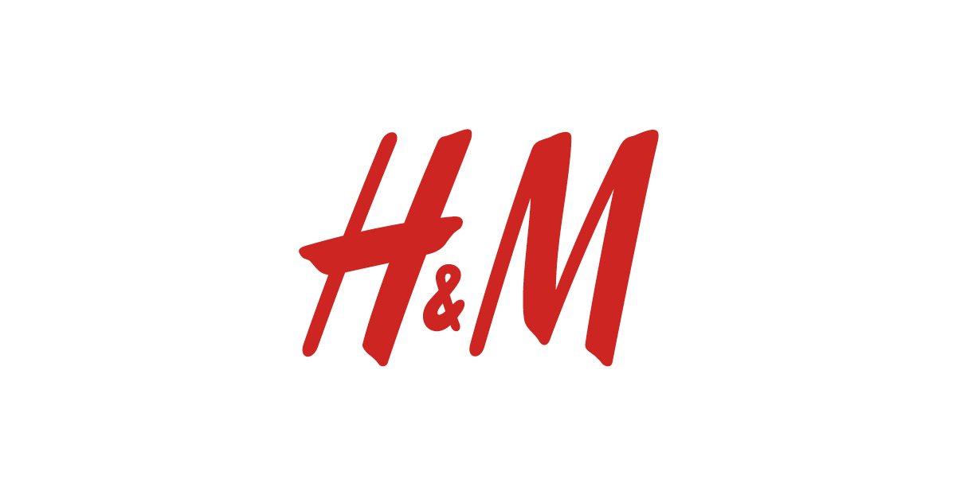

Figure 1: Hennes & Maurtiz AB (Leonard, 2007)

Supply Chain Problems of H&M
Although H&M has a pretty strong supply chain management, recently they had some problems in their logistics departments and the company saw a drop of 22 per cent in net profit in 2018 as the huge reduction in the sales and production flow. These problems in logistics cost them 34 million euros and so the sales dropped also by 8% over the year. This happened when they introduce a new logistics system and with which the company had trouble adjusting (Hicks, 2013). They introduced the new logistics system to speed up the supply chain but, in the end, they have failed to show promise in the department. Another thing is that there seems to be some transportation error in their logistics system which saw a huge fall in sales as the products were not delivered in time. As a result, their online sales were pressurised in the Nordic countries and they were forced in selling the products at a low price which was another blow as the logistics division failed.

Implementation of Problem-Solving Tools

SWOT Analysis
Strength: H&M is the second-largest fashion retailer in the world for a reason. They have a next-generation supply chain that is highly effective and efficient.
Weakness: H&M do not own any factories and outsources their products to 900 independent suppliers around Asia and Europe (Haastrecht and Scheepbouwer, 2012). As a result, their logistics systems are dependent on the suppliers.
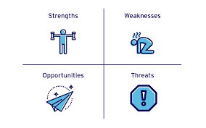
Figure 2: SWOT analysis framework (Haastrecht and Scheepbouwer, 2012)
Opportunity: With their next-generation supply chain. H&M has really some promising opportunity to better their logistics operation in future.
Threat: After Brexit, H&M has some serious problem in the logistics operation in and out of the UK. And also, the increase in labour and operation cost are new threats (Drummond and Hodgson, 2011).

PESTLE Analysis
Political Factors: As a global fashion brand, H&M often faces political phases in various regions. Like Brexit did a lot of harm with new and restricted logistics rule. Countries like Egypt, Lebanon where H&M operates are also the stimuli of political instability and the logistics of H&M gets damaged.
Economic Factors: During the COVID-19 situation, H&M suffered much as the logistics were not able to operate and as a result, the supply chain was severely affected.
Socio-Cultural Factors: As a global brand, H&M has to deal with various regional society and cultures (Pokras, 2010). In the logistics department, the social and cultural norms are applied and in various regions, the logistics apply to the local employees.
Technological Factors: H&M have always been keen on using technology in their supply chain and as a result, they have opened up a new high-tech centre of logistics in the UK which paid off very much despite some fall (Koller, 2019).
Legal Factors: As a global fashion brand H&M had to obey the governmental rules and regulations of different countries. And this affects the smoothness in the logistics department as laws like Brexit are restrictive in the free flow of products globally.
Environmental Factors: H&M always operated according to the environmental situation of different regions. But as climate change is now a real visible thing, they have a hard time coping with the different environmental state of regions and so their logistics suffer in the storage and transportation of products.

ADKAR Model of Change Management
Awareness: H&M were aware of the need for change in their logistics department and that’s why they brought new logistics systems into their supply chain.
Desire: As a global brand, H&M have a particular desire to participate in the logistics department with force and thus they should have the means to support the change (Beach, 2014).
Knowledge: H&M have a particular research division to help out in the logistics problem and they should thus know how to change the system for the better.
Ability: Although after the pandemic, they suffered huge losses, they should have the resources to implement the new change in the logistics operations.
Reinforcement: As changes come, there have to be reinforcements to sustain and keep the change (Rasche and Rehder, 2018). H&M should have the reinforcements to support their new logistics change as they are the second-largest fashion brand in the world.

Solution to The Problem
As H&M introduced a new system for their logistics department which is ‘intensive work’ has cost them gravely as the sales dropped hugely. They introduced the new system to speed up the logistics systems but instead the fixing problem has led to extra outlay and the sales dropped by 8 per cent. This new system was for their speed of supply chain for USA, France, Belgium and Italy.
Now, these problems have to be solved in order to get back in the game as H&M have fallen behind their main rival Zara. The solutions can be found in the rearranging of the new system so that the process can breathe with a little bit of past system and generating reinforcements to support the new system so as to ensure the effectiveness (Haastrecht and Scheepbouwer, 2012). The intensive work is supposed to speed up the supply chain and this is what can be done, to make room for the new change to take place not without but alongside the previous system.

Alternate Solution
1. An alternate solution can be to stick with the previous logistics system. H&M is a world-renowned fashion brand and they are a pioneer in their industry with the fast-fashion concept. They have a tremendous amount of production and sales rate. And all of this they achieved with an effective and efficient supply chain and logistics system (Koller, 2019). They rank the second-largest fashion retailer which is based on annual sales with their previous logistics systems and the turnover is 232 billion euros. This is a huge feat that they gained with the effective logistics system they had. They can add some modification to it.
2. Another alternate solution can be found in the redistribution of some part of the supply chain to the independent retailers and some can be retained in their own systems. H&M does not own any factories and is dependent on 900 independent suppliers around the world. This affects the logistics systems as the whole operation is at the mercy of these suppliers (Adair, 2019). So they should own some factories and perform the logistics from there. From that, they can profit and like the rest of the portion is into their own systems so they can perform as effectively as they fit to see.

Evaluation of Best Alternative
It seems that the best possible solution is to stick with the previous supply chain system with some modification as it helps in the best way for H&M. The evaluation of this alternative with the PMI technique is given below.
Plus, Point: The plus point of this alternative is that the supply chain and logistics system are the same with some modifications as the changes are in demand (Koller, 2019). And so, although there are some changes the system as good as before so the workforce will easily be able to operate with much ease rather than the completely new ‘intensive work’ system.
Minus Point: The minus point is that the ‘intensive work’ logistics system could have speed up things more than the previous system. And in the previous logistics system, there were several transportation problems which is another thing that could have been avoided by a new strategy.
Interesting Point: The interesting thing is that the previous system with modification will actually steer towards the newly adjusted ‘intensive work’ logistics system as the modifications will guide the way for the new changes which caused problems and loss previously as the sales and turnover dropped with the sudden arrival of the new strategy (Rasche and Rehder, 2018).

Implementation
For the solution to take place in effect for the supply chain of H&M, there should be slight changes with the previous system. The changes started from the very modification of the transportation system. Previously there was some transportation error that put the delivery process in jeopardy. So, there are now new transports with constant checking of the functionality (Hicks, 2013). As Brexit approached in the business field with new strict regulations, the huge market of the UK is now somewhat limited for the in and out the function of the logistics of H&M. So, there had to be changed like employing the British nationals for UK operations and keep them mostly there with enough skill development training.
Now, the previous supply chain system dealt with 900 independent suppliers. Now it is shorter with the newly owned factory as the modification took place. So, there are new factories to be distributed with reinforcements and new recruitment to implement the new modification of the supply chain system. This could be a little hard as there never were any factories and so, maintaining these new factories will be difficult. Other than just these, there can be new policies regarding a rise in wage as it will keep the labour in their head.

Monitoring and Control
Monitoring and control are very important for the whole operations management systems. Especially in supply chain management and factors like logistics, monitoring and control can save H&M from huge error or losses. And so, there has to be enough monitoring of the new changes and modification. And to guide the logistics process to be in shape, the controlling procedures must be followed with observant decisiveness. H&M have to monitor and control n how to outsource the production as it’s hard to control the quality of the product in the supply dependability. And so, the handlings with the independent suppliers are to be monitored carefully and controlled if necessary (Leonard, 2007). To help in the increase in lead times, H&M inspects the time on the completed goods with extra care of monitoring which is needed for the safety of the product and delivery. Also, there is the problem of transportation error. And so, H&M doubles their monitoring on transporting system and the gadgets needed. This thing should be under observation and control. For a company to retain success, logistics and supply chain should be flexible and efficient and so H&M is performing as best they should in this regard.

Communicate to the Stakeholders
Communication is the heart of any human dealing from every activity of life to business. Especially in business, there should be effective communication or there can be some difficulties with the whole operations. In the supply chain, communication is too much important. Therefore, H&M communicates with the stakeholders for the betterment of the organisational performance as the stakeholders are the skeleton of the business. Stakeholders include starting from shareholders, CEOs, managers, employees, customers etc. In other words, every person related directly or indirectly to the business are the stakeholders of H&M (Beach, 2014). And, so H&M deals with the managers as well as the employees and customers. In the operations management of H&M, it is ensured that the flow of information is accurate among all the personals involved with the corporation. Therefore, the new changes in logistics systems were first announced to the stakeholders of the company to gain feedback on the matter. Thus H&M approached with the ‘intensive work’ strategy to speed up the process. Although there were some huge losses for the new strategy, given a little time, this can grow up with effective and productive communication among the stakeholders.

Recommendation and Conclusion
H&M should be more careful about their new approaches toward the supply chain as it is the heart of operations management which have a huge impact on the performance of the whole corporation. They can think of pursuing the ‘downstream vertical integration’ for more output. As the intensive work failed to bring about the profit it was mainly because of the stressed-out approach to make more time and speed. They should ease up the over-pressure on the production flow and rate so that logistics can perform with much ease. After all, the logistics are the reason behind the sales of the products. So, they need to make sure there is no transportation error.

Reference
ADAIR, J., 2019. DECISION MAKING AND PROBLEM SOLVING. 2nd ed. [Place of publication not identified]: KOGAN PAGE.
Beach, L., 2014. Decision making in the workplace. 3rd ed. New York: Psychology Press.
Drummond, H. and Hodgson, J., 2011. Escalation in decision-making. 4th ed. Farnham: Gower.
Fernandes, T., 2009. Strategic leadership and decision making 2. 5th ed. Chandni Chowk, Delhi [India]: Global Media.
H&M Group. 2021. H&M Group at a glance - H&M Group. [online] Available at: <https://hmgroup.com/about-us/h-m-group-at-a-glance/> [Accessed 13 May 2021].
Haastrecht, R. and Scheepbouwer, M., 2012. Thinking backwards. 6th ed. Singapore: Marshall Cavendish Business.
HICKS, M., 2013. Problem Solving in Business and Management. 4th ed. New York, NY: Springer.
Koller, G., 2019. Risk Assessment and Decision Making in Business and Industry. 2nd ed. CRC Press LLC.
Leonard, B., 2007. Multidimensional decision making. 5th ed. [Bradford, England]: Emerald.
Pokras, S., 2010. Problem solving for teams. 5th ed. [Rochester, N.Y.]: Axzo Press.
Rasche, C. and Rehder, S., 2018. Change management. 3rd ed. Stuttgart: Kohlhammer Verlag.

