Rebecca Rees
Employment Relationship
Management

Word Count: 4070

(AC 1.1)

The CIPD (n.d.) maintains that effective employee voice is individual dialogue and collective representation. These practices give employees the autonomy to express ideas and increase engagement but can also improve organisational performance by valuing different views and opinions. Two key approaches to employee voice are employee involvement and employee participation, which, though related, are distinct in nature and function.
Employee involvement is the interaction between managers and employees, allowing staff to contribute to decisions that affect their roles. Armstrong and Taylor (2023) describe this as the ‘direct voice’, whereby voice can be used with suggestion boxes or ‘quality circles.’ By doing this an organisation is allowing for two-way communication and collaboration, which will make employees feel like they are being listened to. Employee participation is more formal and refers to employees having a say in decisions, by using union or staff forums. Armstrong and Taylor (2023) describe this as the ‘indirect voice’. It guarantees that the employee’s opinions are considered, particularly in unionised public sector settings. Ayling and Suff (2024) emphasise that both direct and collective voice, create a positive environment, helping employees feel valued and heard.
Evidence from the Involvement and Participation Association (IPA, n.d.) shows that employee involvement and employee participation positively support productivity and morale. For example, the 1924 Hawthorne studies showed that involving workers in decisions, led to improved engagement. The CIPD (2021) Nottinghamshire NHS case study also showed that increasing employee voice through strategies like Just Culture and Freedom to Speak Up Guardians helped rebuild trust, together with improved decision making and strengthening relationships between leadership and staff. Although, the challenge remains around slow cultural progress, poor survey results and low engagement.
According to Armstrong and Taylor (2023) employment relations focuses on managing the working relationship between employers and employees. Theoretical perspectives further explain the significance of these approaches. The unitarist view promotes shared goals between managers and employees (Walton, 1985), whereas the pluralist perspective recognises deep-rooted tensions, (Dundon et al., 2017; Edwards, 1986).
Employee involvement and employee participation are distinct but have complementary approaches. Involvement provides immediacy and empowerment through direct input, while participation offers structure and fairness through representation. Both approaches are essential to building positive employment relationships, particularly during organisational change, where trust, collaboration, and mutual understanding are key during a merger.

(AC 1.2)

Following the recent merger in your Trust, it is important to understand the differences between union and non-union employee representation, to support harmony and effective workforce engagement. The CIPD (2024b) maintains that employees have a legal right to be accompanied. This could include, for example, grievance meetings and/or formal disciplinary meetings and it could also be with a colleague instead of a trade union representative.
In relation to non-union representation, ACAS (2021), maintains that roughly half of UK workplace representatives are non-union, and these representatives often function in employee forums, works councils, or consultation bodies and are established voluntarily by employers. ACAS (2021) acknowledges that they may not have the same powers as union reps, however, they are important in collective consultations involving redundancy or TUPE. ACAS (2021) recognises that non-union representatives are entitled to paid time off, access to facilities, and training when involved in these processes.
However, as Luckhurst (n.d.) suggests that the effectiveness of non-union forums can differ. Various non-union representatives contribute to strategic decisions, but others can struggle because of poor communication and a focus on individual grievances. Armstrong and Taylor (2023) argue that some employers use generous pay and communication practices to avoid unionisation, while others rely on informal consultation, particularly in smaller firms. The CIPD (2022) NatWest case study provides a strong example of integrating union and non-union representation. While the organisation has recognised unions (Unite and Financial Services Union) for most staff, it also establishes Employee Consultative Bodies (EBCs) for senior managers not covered by collective agreements. All representatives receive training, and mentoring is provided by experienced union reps. One main advantage of this is it allows employee voice to be a part of the organisations strategic planning.
In relation to trade union representation, they have legal rights under the Trade Union and Labour Relations (Consolidation) Act 1992 (TULR(C)A). ACAS (2021a) explains that some of these legal rights include paid time off, protection from dismissal or detriment, and access to training. ACAS (2021a) also acknowledged that Union Learning Representatives and Health and Safety Representatives have other rights under the relevant legislation.
Taylor and Woodhams (2022) maintain that it is unlawful to discriminate against employees based on union membership. This includes blacklisting or disadvantaging individuals during recruitment. One of the protections union members have, provided they comply with the balloting and notice requirements; is that they will benefit from protection when organising lawful industrial action. The Employment Relations Act 1999 also supports union rights around recognition and consultation. Trade union representatives and non-union representatives vary in power, and legal protections. ACAS (n.d) advises on the benefits that Union members have, which include, statutory recognition, collective bargaining rights, and legal protection, including the ability to head industrial action. Whilst for non-union representatives, operations are often formed by internal policies or ICE regulations. They do not have the power to engage in formal negotiations or collective disputes. Fundamentally, union representation carries greater influence and legal status in protecting the interest of the worker, however both union and non-union representation promote employee voice.

(AC 1.3)

According to the CIPD (n.d) employee voice is when employees’ express opinions, influence decision making, and contribute to discussions. Organisational performance looks at areas such as efficiency, innovation, staff retention, and employee wellbeing, (CIPD, 2024). This evaluation considers how employee voice can influence organisational performance, drawing on case studies and academic evidence.
The CIPD (n.d.) highlights two central purposes of employee voice: safeguarding employee rights and enhancing organisational performance. When employee voice is encouraged, they are more likely to feel valued, resulting in greater engagement and productivity. This was demonstrated in the CIPD (2021a) case study of Faircroft College, the evidence suggested that by empowering staff, silos were broken down, trust and communication improved, which then allowed leaders to have the capacity to focus on strategic aims. These conditions meant improved collaboration and morale, which had a positive influence on performance. Gifford, (2024) examines a review of a study of German firms, who found that employee representation supports long term productivity gains, showing that voice is a main contributor to performance, particularly through works councils.
The IPA (n.d.a) reinforces the link between voice and performance and uses the examples, of Mid Staffordshire NHS and Deepwater Horizon incidents, where lack of voice contributed to catastrophic failures. These cases demonstrate how early warnings from staff, if acknowledged, could improve safety and learning, which IPA maintain are core elements of high performing organisations. The IPA acknowledge the importance on following up on employee voice, to avoid an environment of potential distrust and disengagement.
However, Armstrong & Taylor (2023) refer to the CIPD (2019) findings and established that employee voice did not automatically result in improved performance. Only 25% of employees felt able to express themselves at work, with low rates in the public sector. Similarly, Luckhurst (n.d.) found that some forums created under the ICE Regulations, lacked influence due to poor communication and a focus on individual issues rather than planned input.
There is clear evidence that effective employee voice can have a positive impact on organisational performance, particularly through increased engagement, improved trust, and better decision making. However, the relationship relies on the quality of leadership, the environment whereby employees feel safe to use their voice can use their voice, and whether employee input is genuinely valued and acted upon. In your newly merged public sector organisation, creating both formal and informal voice channels, underpinned by visible leadership, will play a key role in enhancing organisational outcomes.

(AC 1.4)

The CIPD (2024) defines better working lives as creating inclusive, fair, and supportive workplaces. This will allow employees to grow and prosper and will benefit both the organisation and wider society. The CIPD Good Work Index is a yearly survey which is evidence-based and measures job quality across the UK. It explores how individuals experience their work and how they feel about it. The data looks at what defines ‘good work’. These include:
- Salary and employee benefits
- Terms of employment and job security
- Work-life balance
- Job structure and content
- Workplace relationships
- Opportunities to be heard / workplace voice
- Support for health and wellbeing (CIPD, Good Work Index, 2024)
The CIPD (2024) explains that better working lives are focused on environments where employees are engaged and supported. The Good Work Index (2024) found that while workplace conflict has slightly decreased, it still affects those with protected characteristics. Additionally, there is a risk of declining motivation and productivity due to some workers viewing their jobs as purely transactional. This highlights the need for organisations to reduce conflict and strengthen employee voice as part of designing better working lives, CIPD (2024).
The Index also emphasises that people professionals must get the basics right while tackling new challenges that shape how and where work is done. They maintain that organisations must address negative experiences, promote fairness, and tailor job quality to ensure that ‘good work’ is accessible to all, (The Good Work Index, 2024). The CIPD Podcast 209 (2024a) recognises obstacles to good work, with research showing that 25% of workers experience conflict. They maintain that to achieve ‘good work,’ there must be open communication with trained managers with strong leadership skills, who support employee voice. They maintain that employee engagement improves when organisations foster collaboration, providing opportunities for feedback and further development.
This view is further supported by Dobbin and Kalev (2022) who believe that better working lives is achieved through inclusive, supportive, and flexible work environments. They stress the importance of clear communication and fair policies, such as family leave, which contributes to job satisfaction, productivity, and retention. The Taylor Review (2017) complements these views by offering a framework for better working lives by advocating for effective people management, and a strong focus on employee wellbeing.
To design better working lives, organisations should implement inclusive policies (Dobbin & Kalev, 2022), train managers in conflict resolution (CIPD, 2024a), and promote flexibility and autonomy (CIPD, 2024).

(AC 2.1)

Following the recent merger, there is the potential for both organisational conflict and misbehaviour. It is important to differentiate between them, as they both require different management responses to maintain organisational continuity and performance.
Conflict
Conflict arises from differing interests or goals, values, or expectations between individuals or groups, (CIPD, 2020). Conflict during an organisational merger can stem from clashes between merging employees and management styles and the uncertainty around any new roles. Armstrong and Taylor (2023) note that conflict is inevitable within organisations and often develops during periods of change, especially when the changes are perceived as threats, or frustration. However, they argue that when addressed early, conflict can lead to innovation and positive transformation.
The CIPD (2020) report on managing conflict in the modern workplace and identifies common causes of conflict, including:
- Poor communication
- Lack of trust and respect
- Unclear expectations
- Bullying or harassment
CIPD (2020)

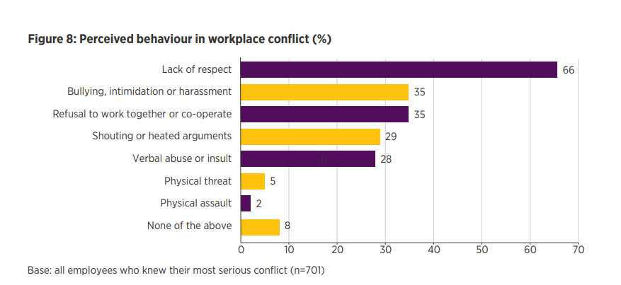
CIPD (2020)

ACAS (2022), maintains that Conflict does not necessarily breach organisational rules or warrant disciplinary action. It can be a natural consequence of organisational dynamics and can frequently be resolved through informal channels such as open discussion or mediation. The CIPD (2020) emphasises that early intervention is critical to prevent escalation into formal grievances.
Misbehaviour
In contrast, the CIPD (2022) refers to misbehaviour as deliberate actions that breach organisational rules or norms. It may include:
- Breach of contract
- Persistent bullying or harassment
- Discriminatory behaviour
- Violations of formal policies
While conflict may involve differing perspectives, misbehaviour constitutes misconduct and typically requires a formal disciplinary response, CIPD (2020).
The CIPD (2020) also highlights that public sector organisations are more likely to apply both informal and formal methods to manage conflict. In the public sector, 56% of employers, train managers in handling difficult conversations, compared to 32% in the private sector. Likewise, 56% use grievance procedures compared to 38% in the private sector. This may reflect the higher number of union representation and membership in the public sector compared to the private sector or an increased emphasis on procedural fairness. Ultimately, distinguishing between conflict and misbehaviour allows for proportionate and appropriate intervention, helping preserve trust, morale, and effective communication, which is especially critical during a merger.

(AC 2.2)

Following the merger and the appointment of new managers from private sector backgrounds, it is essential to understand how conflict and industrial sanctions display themselves differently in public sector employment relations.
Union membership in the UK has dropped from ‘13 million in 1979 to 6.4 million’, with membership now concentrated in the public sector (Luckhurst, n.d.). This is because employees may address their concerns to their line manager instead of a union representative. However, in the Labour Market Outlook (Cominetti, Hamdan & Slaughter, 2023) reveals a renewal of industrial conflict, with “3.9 million working days lost to strike action in the 12 months to May 2023,” the highest since 1989. Strikes were concentrated in health, education, public administration, and transport, whilst further data showed that 96% of strike days and 69% of union members are found in these public sectors.

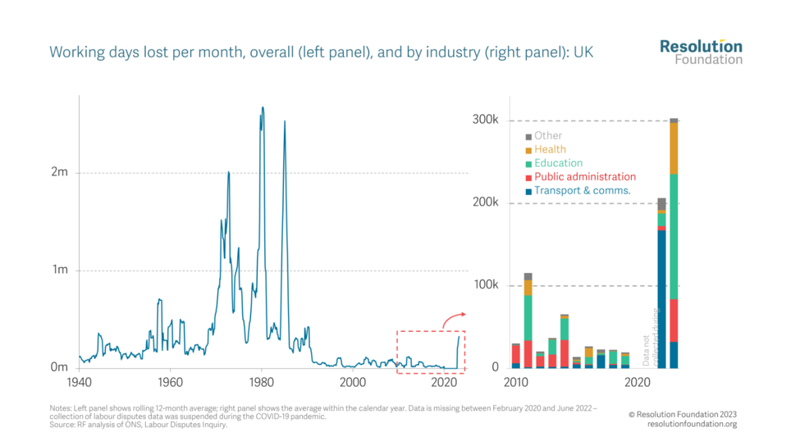
Cominetti, Hamdan & Slaughter (2023)

Pay is a significant driver of this conflict. The data shows that the public sector workers experienced a real pay fall of 9.2% between May 2021 and May 2023, compared to 2.9% in the private sector, and this was combined with increased workloads and vacancy freezes, which contributed to greater stress in public sector roles (Cominetti et al., 2023).
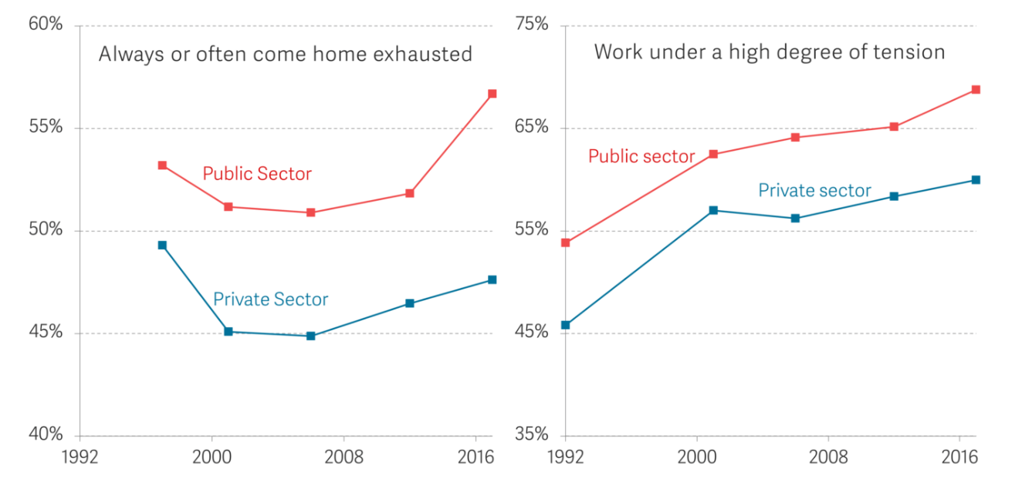
Cominetti, Hamdan & Slaughter (2023)
According to Taylor & Woodhams (2022) recent strike action may be viewed as collective unrest, but it is unlikely to revert to the levels seen in 1979, due to legal, financial and public support. Conflict has increasingly shifted to individual forms, such as sickness absence, tribunals, and grievances, which also significantly affect organisational performance. Strikes today are shorter (in comparison to the Miners’ strike of 1984, which lasted a year (BBC News 2024) and are now strategically planned for a bigger impact. The ONS (2023) reports that sixteen individual NHS strike days between December 2022 and February 2023 had disrupted 154 organisations and led to the postponement of over 93,000 outpatient appointments. This is an examples how shorter strikes have a big impact on organisations.
The CIPD Podcast (Episode 160) highlights that when managed well, conflict can be constructive, when it is usually viewed as a negative. Gallo, Lewis, and Suff (CIPD Podcast Episode 160) argue that poor management and lack of training can worsen disputes. With skilled intervention, however, conflict can foster innovation and strengthen workplace relationships. In summary, public-sector conflict is increasingly shaped by both economic pressure and organisational dynamics and remains more unionised and subject to collective action.

(AC 2.3)
Conciliation
Daniels (2022) explains that early conciliation was introduced in 2014 and is a free and mandatory process before someone can lodge a claim with an Employment Tribunal. Either the claimant or employer can start it, and it begins by contacting ACAS, and informing them with the basic case details. The next stage involves a conciliation officer, who then works with both parties to reach a resolution, usually within six weeks. If conciliation fails to achieve a resolution, a certificate is issued, allowing the claimant to proceed with a tribunal claim. Daniels (2022) explains that during conciliation, the time limit for submitting a tribunal claim is paused, ensuring at least one month remains once conciliation ends. ACAS (2024) outlines the benefits of conciliation, including privacy, no cost, and is less complex than tribunals, in conciliation, participation is optional.
Mediation
ACAS (2022) describes the aim of mediation as repairing working relationships, whilst remaining confidential and voluntary. The mediator is a neutral person, and helps find an agreeable solution, that satisfies both parties. ACAS (2022) supports this through external mediators, staff training, and advice on mediation policies. Mediation is particularly effective in interpersonal disputes such as bullying, harassment, or communication breakdowns. It often results in improved workplace communication, reduced stress, and fewer formal disputes. Outcomes are flexible and agreed jointly, such as changes in behaviour or job duties. However, ACAS (2022) notes, the outcomes of mediation are not legally binding and is not suitable for certain disputes, including disciplinary matters.
Arbitration
ACAS (2022b) explains that Arbitration is a more formal process out of the three. An arbitrator is a neutral third party, who hears evidence from both sides and presents a legally binding decision. ACAS (2022b) offers arbitration for both individual and collective cases and decisions are made within 14 to 21 days depending on the case type. Similar to mediation and conciliation, arbitration is voluntary and impartial, however, it is the only method among the three that results in a binding outcome. While conciliators facilitate negotiation and may suggest solutions, mediators simply guide discussion. In contrast, arbitrators assess both sides and make the final decision.

(AC.3.1)

Daniels (2022) states that under UK employment law, dismissal is considered potentially fair if it falls under one of the five reasons in Section 98 of the Employment Rights Act 1996. Two key reasons are capability and conduct (misconduct). In both cases, employers must ensure the dismissal is fair, justified, and in line with legislation and best practice.
Capability
Brione (2024) explains that under Section 10 of the Employment Rights Act 1996, employees with at least two years’ service have the right not to be unfairly dismissed. Employers must show a fair reason for dismissal, such as capability, and demonstrate that they acted reasonably and followed a fair procedure. Under Section 98(2)(a) of ERA 1996, an employee may be dismissed fairly if they are unable to carry out their duties due to lack of capability or qualifications.
Daniels (2022) defines capability as an employee’s skills, health, or qualifications to perform their job and explains that before dismissal, employers should clarify job expectations, provide training, and explain the consequences of underperformance. If the issue is health-related, they must assess the nature of the illness and the impact on the role, obtain medical advice, and consider reasonable adjustments under the Equality Act 2010 (Employment Statutory Code of Practice, 2015). In DB Schenker Rail (UK) Ltd v Doolan (2011) UKEAT/0053/09 170, dismissal was deemed unfair because the employer failed to get the medical evidence required. Daniels, (2022) maintains that employers must show they provided support, considered adjustments, and had clear justification for dismissal based on capability.
Misconduct
ACAS (2024a) states that when handling misconduct, you must follow the ACAS Code of Practice. Misconduct involves behaviour that is considered to be inappropriate or unacceptable, such as breach of the rules. Daniels (2022) outlines two types of misconduct. Firstly, gross misconduct, which is a serious offence justifying immediate dismissal without notice (e.g., theft or violence), and secondly, general misconduct, which typically requires warnings through formal disciplinary procedures. Daniels (2022) emphasises that tribunals assess “whether the employer acted fairly, considered the evidence, and made a decision that falls within the ‘range of reasonable responses” (Daniels, 2022, p. 172).
The Burchell Test (BHS v Burchell [1980] IRLR 379) is used to determine fairness:
- That the employer reasonably believes that the misconduct happened
- That there was sufficient evidence to support the belief
- That a suitable investigation took place (Daniels, 2022).
Ultimately, dismissals based on capability or misconduct must follow fair procedures, with clear justification and comply with legal standards to avoid claims of unfair dismissal. It is fundamental to have fair decision making with thorough investigations to ensure compliance.

(AC 3.2)

It is important for your organisation to be aware of potential employee grievances following the recent merger, particularly as the new leadership team may be less familiar with public sector employee practices. ACAS (2024), explains a grievance procedure to be a formal process that permits an employee to raise a concern or a complaint with their employer.

Bullying and Harassment
The CIPD’s report on Managing Conflict in the Modern Workplace (2020) recognises bullying and harassment as considerable causes of grievances, particularly in the public sector, where 21% of employees reported bullying and 12% reported harassment. This is notably more than in any other sector. From the data the evidence shows that these behaviours range from physical intimidation to subtle acts of bullying and harassment. Wilkinson, in Taylor and Woodhams (2022), explain that harassment in relation to protected characteristics is unlawful under the Equality Act 2010 and can significantly affect employee well-being.

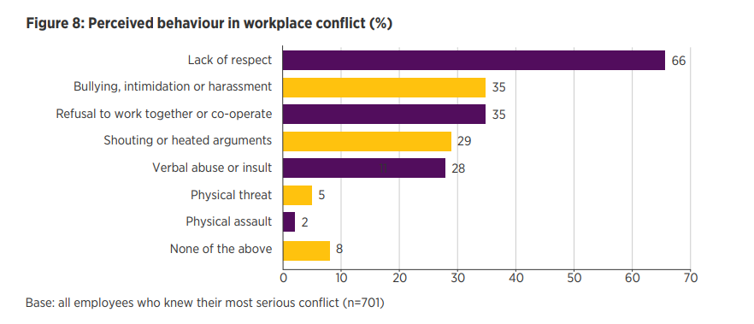
The CIPD (2020)

Poor Management Capability
The CIPD (2020) report also recognises poor management capability as a reason for grievances. The data showed that only 40% of line managers reported having formal training in people management, and 32% of employees involved in conflict stated that their manager had made the situation worse. In your organisation, new managers from private sector backgrounds may lack insight into public sector values and employment relationships. This skills gap can lead to inconsistent handling of issues, damaging trust and prompting grievances. Engaged for Success (n.d.) stresses that employee engagement is embedded in trust, communication, and fairness, and without these, perceptions of injustice or unfairness are likely to increase.

Perceived Inequality and Unfair Treatment
A third common cause is inequality and unfair treatment. Wilkinson (2022) in Taylor and Woodhams (2022), explains that unfair treatment, including exclusion from opportunities or being persistently undermined, can create tensions and formal complaints. The CIPD (2018) draws on Zerkowitz’s work, which links perceptions of unfairness in pay, with recognition to lower levels of motivation and trust. When employees see large discrepancies in rewards, resentment can potentially build and may lead to workplace conflict and formal grievances. Fundamentally, addressing these root causes through fair policies and manager training, is essential to maintain a healthy and productive post-merger culture.

(AC 3.3)

According to the CIPD (2024b), disciplinary and grievance procedures play a fundamental role in helping people professionals manage complaints or misconduct and in making sure it is dealt with fairly, ensuring legal compliance. Effectively managing grievances is important for organisations and is important during a merger as there is the potential for cultural, leadership changes, and restructuring, which may increase employee anxieties and wellbeing. The Employment Rights Act 1996 (s.3) legally requires employers to have clear grievance and disciplinary procedures. Furthermore, by adhering to the ACAS Code of Practice, organisations are reducing the risk of legal claims and tribunal penalties. The CIPD (2024b) acknowledges that adhering to well-structured processes ensures fairness and can also avoid claims of unfair and constructive dismissal. For example, observing the right to be accompanied at formal meetings and ensuring the undertaking of impartial investigations are examples of procedural fairness.
The CIPD (2024b) explains that grievances should not create a "combative culture," but should offer employees a constructive way to raise concerns, making the resolution the forefront of the outcome. Fair grievance procedures promote trust and positive organisational culture. When policies are consistently applied, employees are more likely to feel that their voice is heard and respected. This is important with a merger, where uncertainty and shifting responsibilities can fuel tensions. Armstrong and Taylor (2023) argue that conflict is inevitable in any organisation, however it can lead to positive outcomes when managed constructively.
Employee well-being and morale is another important reason as to why grievances should be handled effectively. As noted by the CIPD (2024b), HR managers should ensure that support is available to all parties involved and is part of their ‘duty of care’. The CIPD (2024b) address how mediation supports early, informal intervention and is encouraged where possible to minimise stress and potentially resolve conflict. Taylor & Woodhams (2022) highlight that good grievance management protects employment relationships and can reveal general issues that, if addressed, improve the working environment. They acknowledge that handling grievances effectively can also support organisational performance. When employees trust that concerns are addressed fairly, it enhances engagement, motivation, and retention. However, they also warn that risk-averse cultures and lack of training can hinder resolution. In conclusion, effective grievance management safeguards legal compliance, builds trust, protects wellbeing, and enhances organisational performance, making it a vital component of people practice, especially during periods of organisational change. The CIPD’s professional map (2018a) in Taylor & Woodhams (2022) encourages HR professional to move away from a risk adverse mindset and instead prioritise people – focused practices, using principles- led and evidence-based methods to handle conflict effectively.

Bibliography

ACAS (n.d) Acas guides on trade union and employee representation https://www.acas.org.uk/acas-guides-on-trade-union-and-employee-representation (08/04/2025)

ACAS (2021) Non-Union Representation in the Workplace
https://www.acas.org.uk/sites/default/files/2021-03/non-union-representation-in-the-workplace.pdf (Accessed 08/04/2025)

ACAS (2021a) Trade Union Representation in the Workplace
https://www.acas.org.uk/sites/default/files/2021-03/trade-union-representation-in-the-workplace.pdf (Accessed 08/04/2025)

ACAS (2022) What mediation is and how it can help – Mediation at work https://www.acas.org.uk/mediation (Accessed 30/04/2025)

ACAS (2022b) Arbitration
https://www.acas.org.uk/arbitration (Accessed 30/04/2025)

ACAS (2024) If you want to make a claim - Early Conciliation.
https://www.acas.org.uk/early-conciliation (Accesses 30/04/2025)

ACAS (2024a) Unfair Dismissal
https://www.acas.org.uk/dismissals/unfair-dismissal (Accessed 05/05/2024)

Armstrong, M & Taylor, S. (2023) Amstrong’s Handbook of Human Resource Management Practic.16th Edition London: Kogan page.

Ayling, L and Suff, R (2024) CIPD, Employee Relations: an introduction.
https://www.cipd.org/uk/knowledge/factsheets/relations-employees-factsheet/#Whatis
(Accessed 07/04/2025)

BBC News (2024) Miners’ Strike 1984: Why UK miners walked out and how it ended. https://www.bbc.co.uk/news/uk-england-68244762 (Accessed 01/05/2025)

Boxall, P F & Purcell, J (2016) Strategy and Human Resource Management, 4th ed, Basingstoke, Palgrave Macmillan

Brione, P (2024) Key Employment Rights. House of Commons Library
https://researchbriefings.files.parliament.uk/documents/CBP-7245/CBP-7245.pdf (Accessed 04/05/2025)

CIPD (n.d.) Employee Voice
https://www.cipd.org/uk/views-and-insights/cipd-viewpoint/employee-voice/
(Accessed 07/04/2025)

CIPD (2018) The impact of inequality – why fairness pays https://www.cipd.org/uk/knowledge/bitesize-research/inequality-fairness-pays/
(Accessed 02/05/2025)

CIPD (2018a) Profession Map, https://peopleprofession.cipd.org/profession-map (archived at: https://perma.cc/9HCH-JNWU?type=standard (Accessed 05/05/2025)

CIPD (2020) Managing Conflict in the modern workplace https://www.cipd.org/uk/knowledge/reports/managing-workplace-conflict-report/ (Accessed 22/04/2025)

CIPD Podcast 160: (2020) Shifting the perception of workplace https://www.cipd.org/uk/knowledge/podcasts/shifting-perception-conflict/ (Accessed 28/04/2025)

CIPD (2021) Talking about voice: Nottinghamshire Healthcare NHS Trust
https://www.cipd.org/uk/knowledge/case-studies/nottingham-healthcare-trust/
(Accessed 08/04/2025)

CIPD (2021a) Talking about Voice: Faircroft College https://www.cipd.org/uk/knowledge/case-studies/fircroft-college/ (Accessed 20/04/2025)

CIPD (2022) Collective Employee Voice: Recommendations for working with employee representatives for mutual gain: Case Studies.
https://www.cipd.org/globalassets/media/knowledge/knowledge-hub/reports/collective-employee-voice-case-studies-july22_tcm18-110239.pdf (Accessed 10/04/2025)

CIPD (2024) Good Work Index
https://www.cipd.org/uk/knowledge/reports/goodwork/ (Accessed 20/04/2025)

CIPD Podcast 209: (2024a) What’s hampering ‘good work’? https://www.cipd.org/uk/knowledge/podcasts/whats-hampering-good-work/ (Accessed 20/04/2025)

CIPD (2024b) Disciplinary and grievance procedure: Guide for people professionals
https://www.cipd.org/uk/knowledge/guides/discipline-and-grievance/#:~:text=This%20guide%20helps%20you%20handle%20such%20cases%20in,may%20arise%20as%20part%20of%20the%20working%20relationship (Accessed 05/05/2025)

Cominetti, N. Hamdam, N & Slaughter, H (2023) Resolution Foundation, Labour Market Outlook Q2 2023
https://www.resolutionfoundation.org/publications/labour-market-outlook-q2-2023/
(Accessed 27/04/2025)

Daniels, K. (2022) Introduction to Employment Law
Kogan Page: London

Dundon, T, Cullinane, N and Wilkinson, A (2017) A Very Short, Fairly Interesting and Reasonably Cheap Book About Employment Relations, London: Sage.

Dobbin, F & Kalev, A. Harvard Business Review (2022) The Surprising Benefits of Work/Life Support
https://hbr.org/2022/09/the-surprising-benefits-of-work-life-support (Accessed 22/04/2025)

Edwards, P K (1986) Conflict at Work, Oxford, Blackwell.

Engage for Success (n.d.) What is Employee Engagement
https://engageforsuccess.org/what-is-employee-engagement/
(Accessed 01/05/2025)

Employment: Code of Practice (2015) EHRC
https://view.officeapps.live.com/op/view.aspx?src=https%3A%2F%2Fwww.equalityhumanrights.com%2Fsites%2Fdefault%2Ffiles%2F2021%2Femployment-code-of-practice.docx&wdOrigin=BROWSELINK (Accessed 01/05/2025)

Gifford, J (2024) Employee Voice boosts outcomes of management practices: CIPD https://www.cipd.org/uk/knowledge/bitesize-research/employee-representation/ Accessed 24/04/2025)

Involvement & Participation Association – IPA (n.d.) How Workplace Participation Increases Productivity: Behavioural Evidence & Participation Association.
https://www.ipa-involve.com/News/how-workplace-participation-increases-productivity-behavioural-evidence (Accessed 07/04/2025)

Involvement & Participation Association – IPA (n.d.a) What is Employee Voice?
https://www.ipa-involve.com/employee-voice (Accessed 15/04/2025)

Luckhurst, D. (n.d.) Involvement & Participation Association (IPA) Workplace Representation – What next for Trade Unions and Staff Forums?
https://www.ipa-involve.com/News/workplace-representation-what-next-for-trade-s-and-staff-forums (Accessed 08/04/2025)

ONS (2022) Labour Market Statistics Time Series.
London: Office for National Statistics

ONS (2023) The impact of strikes in the UK.
https://www.ons.gov.uk/employmentandlabourmarket/peopleinwork/workplacedisputesandworkingconditions/articles/theimpactofstrikesintheuk/june2022tofebruary2023 (Accessed 28/04/2025)

Taylor, S & Woodhams, C (2022) Studying Human Resource Management. 3RD Ed. Kogan Page: London

The Taylor Review (2017) Good Work: The Taylor Review of Modern Working Practices.
https://assets.publishing.service.gov.uk/media/5a82dcdce5274a2e87dc35a4/good-work-taylor-review-modern-working-practices-rg.pdf (Accessed 21/04/2025)

Walton, R E (1985) From Control to Commitment in the Workplace, Harvard Business Review, March-April, pp 77-84.

Zerkowitz, A (CIPD 2018) How inequality changes the way we work and perform
World at Work Journal. Jan-March 2018, Vol 27, No 1.

