
Masters of Business Administration: Human Recourse Management
Module Assignment Submission
Student Name: | Yoana Georgieva
Student Number: | 1714886
Module No: | LCMB7001
Module Title: | Marketing Management
Lecturer: | Tushara Balendran

Statement of Confirmation of Authenticity
By the act of making this submission, the student declares that this is the work of the student named above. The work has not, in whole or in part, been knowingly presented elsewhere for assessment, or where an assessment has been built on a previous assessment, this has been identified. Where materials have been used from other sources, it has been properly acknowledged. If this statement is untrue, the student acknowledges that an assessment offence has been committed.
Attention is drawn to the plagiarism and unfair practice policies of both the University and of ILM.

Introduction 3
PESTLE analysis 3
Political factor (unfavourable) 4
Economical factor (unfavourable): 4
Social/cultural (unfavourable): 4
Technological factor (favourable): 4
Environmental factor (favourable): 5
Legal factor (favourable): 5
Porter's 5 Forces 5
Entry of competitors 6
Threat of substitutes 6
Bargaining power of supplier 6
Bargaining power of buyers 7
Rivalry among existing competitors 7
SWOT analysis 7
Advantages and Disadvantages of the SWOT analysis 8
Strength 8
Weakness 8
Opportunity 9
Threat 9
Segmentation, targeting, and positioning 9
Segmentation 10
Targeting 11
Positioning 11
Marketing mix strategies of Cadbury 11
Product 11
Price 11
Place 12
Promotion 12
Ansoff Matrix 12
Recommendations for future marketing strategies 14
Conclusion 14
List of Figures 15
References 15

Introduction

The main purpose of this report is to conduct an environmental marketing analysis of one of the world’s chocolate leaders- Cadbury. This will be done by considering the key external factors and the way they influence the productivity of the company by providing PESTLE and Porter 5 Forces analysis. Furthermore, the report will also focus on the internal environmental factors through SWOT analysis, as well as the role that the marketing plays in the organisation. The report will conclude with recommendations for future marketing strategies for the company.
Cadbury is a worldwide sweets manufacturer based in the United Kingdom that has been owned by Mondelez International since 2010. It is the world's second largest chocolate company with Mars being its biggest competitor. Cadbury is headquartered in Uxbridge, West London, and operates in over 50 countries around the world. Cadbury was founded in 1824 by John Cadbury, who started off by selling tea, coffee, and drinking chocolate. He founded the business in partnership with his brother Benjamin, and later passed over to his sons Richard and George (Cadbury, 2022). In 2021, the company achieved $7.24 billion in net revenue, with a $515 million rise in gross profit. Cadbury is worth £1,682.1 million in 2020, according to Nielson data (Selwood,2020).

PESTLE analysis

The PESTLE analysis consists of six categories of macroeconomic variables (Political, Economic, Social, Technological, Legal, Environmental) which can be individually monitored by managers. This is to help them analyse the developments of the business by considering those macroeconomic variables and establishing the factors which have bad influence on the business. The model can then begin to conceptualise various scenarios based on these uncertain variables to better predict the future and make the best decisions today in the interest of the better future (Cadle, Paul and Turner, 2010).
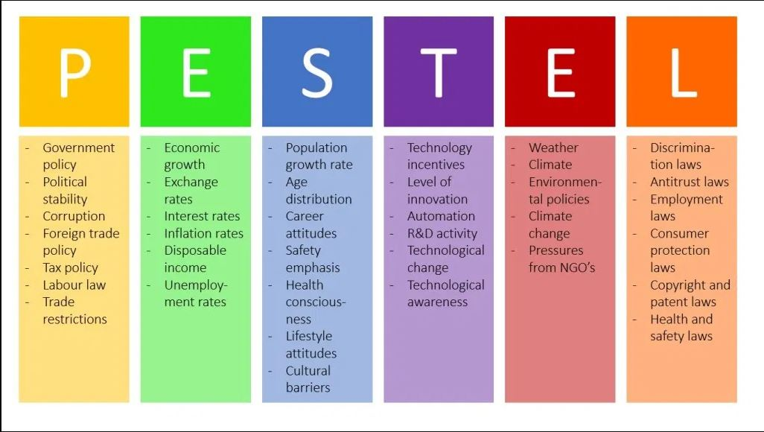
Figure 1: Pestle Analysis in Sum (De Bruin, 2016)

Political factor (unfavourable):
Following Kraft’s hostile takeover of Cadburys, potential political reactions to economic activities were also offered (Morris, 2014). What is more, Cadbury has undertaken “shrinkflation” approach in which the size of the chocolate bar is reduced, however, the price remains the same (Ruddick,2017).

Economical factor (unfavourable):
In 2010 due to the weak pound, Kraft managed to purchase Cadbury cheaper that its actual value, as well as allowing the company to complete the sale by acquiring a £7 million loan from a British bank (Morris, 2014). Wallop (2016), also adds that Kraft was considered as being more concerned with the profit Cadbury would bring rather than the influence of the brand itself which is why they moved the manufacturing to Poland which is cheaper (Wallop, 2016). Lewis (2016) further adds that Mondelez's cost conscious approach has resulted in recipe changes and product reductions in sizes to manage growing production and ingredient prices (Lewis, 2016). With this year's increase in the inflation rates, however, the company will face even more difficulties and challenges with the production and price of ingredients.
Social/cultural (unfavourable):
According to the latest obesity statistics, 28% of adults in England are obese and a further 36% are overweight. As per experts in the UK, by 2025, one in three deaths will be weight related if our eating and exercise habits does not change (Baker, 2022). Due to those to statistics, chocolate products are considered high in calories and unhealthy choice because the public is being more conscious in their choices and being more interested in high in fibre and protein products.
Technological factor (favourable):
Cadbury uses technology to promote their products and to keep their customers up to date. The company uses various social media platforms where they can not only engage with their clients but also gather feedback and reflections for future marketing campaigns. However, when it comes to diversification, Cadbury is still a step behind its competitors because of the lack of cereal-making machines and baby food technology.
Environmental factor (favourable):
The factor includes the amount of packaging used by the company as well as the carbon footprint created by their supply chain, including manufacturing and distribution. To comply with that factor, in 2007 Cadbury launched environmental strategy “Purple Goes Green” which includes in cutting the excess packaging and managing out the water use. Significantly, in its 2020 report, the company has declared that it has attained a more than 20% reduction of carbon dioxide from manufacturing. In addition, it has also achieved more than 30% reduction in priority water usage.

Legal factor (favourable):

Cadbury is affected by legal difficulties, such as the necessity to publish ingredients and calorie information to help consumers make decisions based on fat content. Other legal concerns that Cadbury may have facilitated for future commercial actions may develop because of Kraft’s aggressive takeover (Morris, 2014).

Porter's 5 Forces

Porter’s Five Forces is another framework used to consider the external environmental factors and the way they influence the development of the business. This method concentrates on the industry within a company or business operates and identifies the business pressure that could be brought upon that company or business the five categories in the model are: industry competitors, new entrants, substitutes, buyers, and suppliers. Analysis to each of these category help to identify the factors within the industry of business domain that might have either positive or negative impact on the organisation (Porter, 1980).
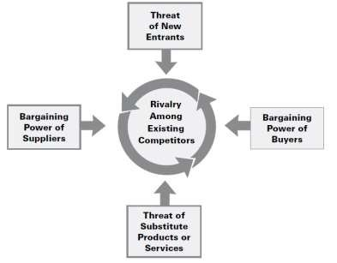
Figure 2: Porter's Five Forces Model (Michael E. Porter 2008)

Entry of competitors- Low effect on Cadbury
The chocolate confectionary market is already dominated by well established brands such as Cadbury, Nestle, Ferrero Rocher and others. It would be extremely challenging and difficult for the new companies to win a place in the market. However, with the growing problem of population overweight and obesity, the of offer of new healthy and low on sugar dessert products could be a potential winning product. Still, however, it will be difficult for new entry companies to compete with businesses that have already established strong brand names, distribution channels and high capital investment.
Threat of substitutes- Moderate to High effect on Cadbury
As mentioned above, obesity has become a major health problem world-wide. According to the World Health Organization, in 2016 more than 1,9 billion adults aged 18 or over were overweight of which 650 million were obese. Another scaring statistic shows that in 2020 39 million children under the age of 5 were overweight or obese. It is also claimed that the obesity is preventable and can be reduced by limiting the sugar intake, increasing the consumption of fruits, vegetables, whole grains, and nuts, and engaging in regular physical activities (WHO, 2021). Therefore, consumers are becoming increasingly aware of the healthy eating and start changing their snacking habits by choosing fruit bars, cereal bars, and protein bars. All those substitute products are a great threat to the chocolate confectionary industry which is why the chocolate companies should offer new healthy products to the market (Scully, 2006). Currently, Cadbury has few healthy snack options on the marker, such as the Brunch Bar ad Cadbury Nuttier which also come in few tastes' options.
Bargaining power of supplier- Moderate to high effect on Cadbury
The main products that Cadbury uses for the productions of chocolate are cocoa, milk, and sugar. The company imports the cocoa beans and cocoa butter from West Africa, Ecuador, and Venezuela. Most of the sugar is purchased at prices set by the European Union and a small portion is bought at fluctuating prices. This factor has a moderate to high effect on the company due to the changing prices of the products, regulations, imports, and taxes.
Bargaining power of buyers- High effect on Cadbury
Cadbury's products are available all around the world and customers can buy them in all kinds of shops, vending machines, petrol stations and cafes. Although the company is one of the largest chocolate producers in the world and has millions of loyal customers, this customer loyalty can be altered by a range of factors. One influencing factor on customers loyalty is the price of the product. Example is the recent decision of Cadbury to slash the size of Dairy Milk bark by 10% but keep the price the same. Although Cadbury reasons their decision due to the growing inflation in the UK, their loyal customers had been left unhappy, commenting in the social media, and naming this whole move “shrinkflation” (The Guardian, 2022).
Rivalry among existing competitors- High effect on Cadbury
Cadbury's main existing competitors are Nestle, Mars & Wrigley, Ferrero Rocher and Hershey. The competition among these brands is strong as they all offer products similar in quality, taste, and price. Although, Cadbury has won 11% of the global market share though actively introducing new products and taste, and extensively advertising and promoting, the fight for a bigger share will be always ongoing.

SWOT analysis
SWOT analysis is a vital framework used by managers to evaluate the company's current market position, as well as to determine the strengths and weaknesses of their products. Moreover, the SWOT analysis help managers to develop effective plan for the future of the company, seizing marketing opportunities, and avoiding potential risks and problems.
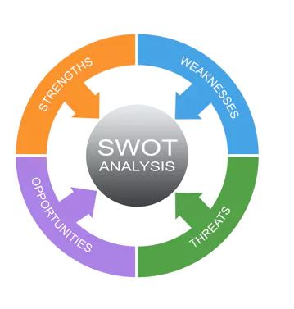
Figure 3: SWOT Analysis (Haughey, 2021).

Advantages and Disadvantages of the SWOT analysis
The advantages of doing SWOT analysis are that it does not require a lot of time to be conducted, as well as any costs or materials. The framework allows businesses to establish a realistic idea of their current position on the market and produces current ideas to help them take advantage of the company’s strengths. Parallel with that, it also illustrates the potential threat and defends against them. This furthermore allow companies to create and prepare plans for dealing with the difficulties (Haughey, 2021).

Strength
- Strong brand
Cadbury has built an extremely strong and powerful brand over the years by becoming one of the world's leading confectionery companies. The brand has also built strong loyalty with its target market and is associated with taste, quality, and value for money. Furthermore, Cadbury product line also features products that have established their own brands, for example Oreo.
- Global Presence
Another strength of the company is its well-established operation in over 50 countries all over the world. This global presence is not only an additional revenue for the giant but also acts as an insurance policy for the organisation in terms of unfavourable regulation changes which might come into force in some countries.

Weakness
- Product Recalls
A weakness of the brand is that on numerous occasions it has battled with product recalls. In 2019 Cadbury Dairy Milk Little Robins Daim chocolate was recalled for being wrongly packaged and containing nuts, meaning it was a health risk for people with nut allergy (Mohan-Hickson, 2019). Another case is dating back to 2006, when the company had to recall more than one million of its chocolate bars due to salmonella contamination, leaving the company with a loss of £20 million (Walsh,2006).
- Lack of US rights
Another weakness of the company is that they lack the rights to sell UK produced products in USA. Since 2015, Hershey holds the rights to manufacture Cadbury chocolate in the United States and there is a ban on imports of British made Cadbury chocolate from that year as well. However, although Hershey claims to be using the exact same recipe and ingredients in producing the well known and loved chocolate, British expats assert that the US made Cadbury chocolate tastes differently than the homemade British one (Hanbury, 2018).

Opportunity
- Emerging Markets
One of the main opportunities of Cadbury is that the company can reduce its costs by moving its production and manufacturing functions to other countries with cheaper labour costs than those in the UK. In addition, emerging markets provide wonderful opportunity for growth and increase in the revenue streams.
- Product Range Expansion
Another opportunity for the company would be expanding its product range. Nowadays, increased number people are monitoring their health and are trying to lead healthy lifestyle. This is by regular physical activities, and healthy eating. Therefore, Cadbury could use that as an opportunity to create healthier, gym-lover’s products, apart from the protein bars, such as protein shakes and drinks.

Threat
- Health Consciousness
As already mentioned, more and more people are becoming health conscious and would prefer to consume less chocolate and sugar. This is the main threat of the company as chocolate is their base product and this would therefore lead to serious decline in revenue.
- Pressure by competitors and threat by substitutes
Another threat for category is the pressure by competitors who offer comparable products for cheaper price. Although Cadbury has proved its value for money with the nowadays inflation and struggle in living costs, more and more people would rather choose the cheaper options on the market.

Segmentation, targeting, and positioning
The main goal of the STP marketing model is to identify profitable opportunities and serve the market accordingly. Marketers and businesses use the STP marketing technique to determine the potential market for their products and services.
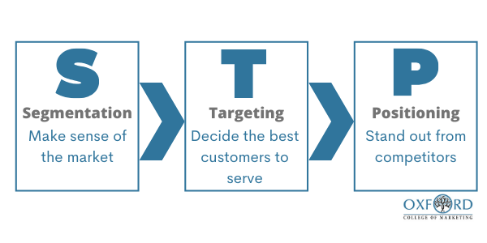
Figure 4: Segmentation: Make Sense of The Market (Oxford College of Marketing Blog, 2020).

Segmentation
The segmentation of Cadbury is based on a mix of four different variables- demographic, geographic, behavioural, and psychographic.
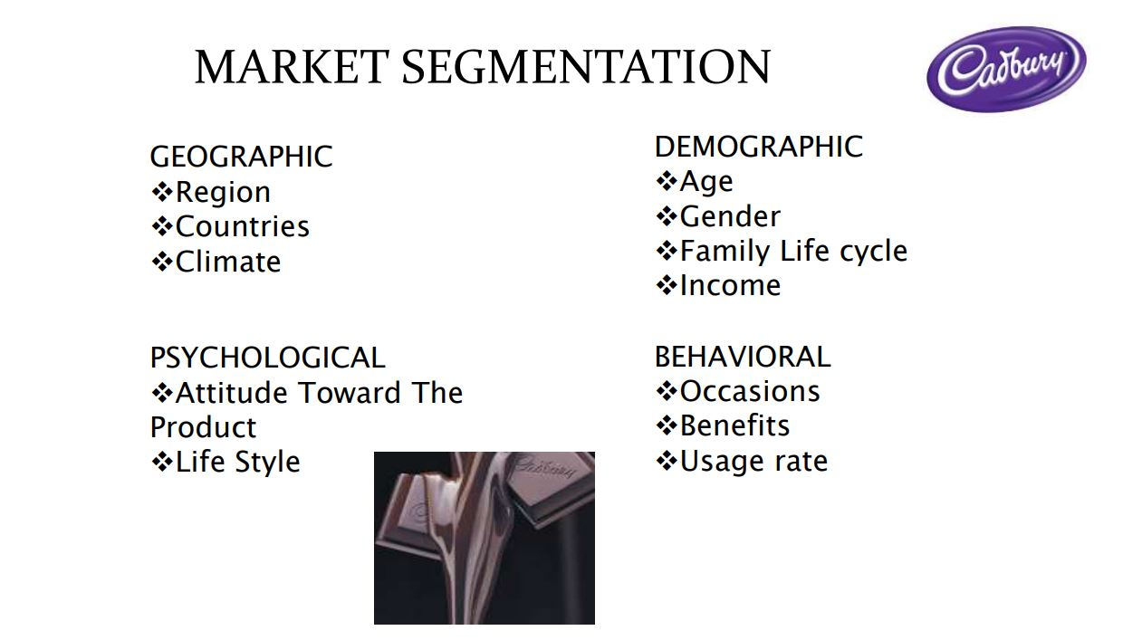
Figure 5: Cadbury market segmentation

The demographic segment combines all the age, gender, nationality, and religion factors. Cadbury does not have a distinct segmentation based on the above factors and in relation to age, the company is targeting both the younger and older population. In relation to price, Cadbury’s products are highly affordable even for people with smaller income.
Geographically, Cadbury offers its product all around the world in urban, semi-urban and rural regions. The increasing disposable income and e-commerce has helped rural segment demand for premium chocolates as well.
Behavioural- Cadbury uses various strategies to target more people. The company focuses on the impulse purchasing of customers and has its products stocked everywhere. furthermore, the company offers gift options, hampers, and baskets suitable for birthday parties, presents, or other special occasions. In some demographic regions, such as India the company also offers dessert options which are extremely popular.
Psychographic- the company offers its products taking into account the social class, lifestyle, and personality of its customers. Cadbury’s products are highly affordable and offered in assorted sizes. The brand also focuses on the lifestyle and personality of its customers by offering wider range of products.

Targeting
Cadbury uses undifferentiated mass marketing strategy for its targeting. They are targeting broadly, customers of all ages and focus on what is common rather than what is different.
The company also uses differentiated marketing as it targets several different market segments and designs separate offers for each. The goal of this targeting strategy is to achieve more sales, stronger market position, and more awareness of the company.

Positioning
What the customer believes, not what the provider wants them to believe, is what is referred to as positioning. Due to countermeasures taken by the competition, positioning may change. Knowing our customer and understanding our competition is necessary for managing our product positioning Hutt and Spech, 2004). Cadbury uses attribute positioning strategy where the company depends on its brand performance, brand durability, and benefits desired by the customers. Cadbury’s chocolates are tasty, they have a vast range of choices, and the price is affordable. Another strategy which the company uses is positioning by competitor. This strategy uses competitor’s image as a reference point and allows comparison in the price, quality, and product range. Head-to-head positioning strategy is also a strategy of similar kind where the brands compete with its main competitors directly (Hooley et at., 2005). Cadbury’s biggest competitors are Nestle and Mars and using those strategies allows the company to differentiate its products from the competitor’s ones, as well as address important customer buying criteria to improve its service and brand.

Marketing mix strategies of Cadbury

Product
Cadbury is the second world chocolate leader with a very solid reputation and strong product portfolio. The company’s entire global portfolio consists of 57 sub-brands in the confectionary category, more than 11 types of desserts, 7 diverse types of beverages, 3 biscuit kinds, 4 kinds of cooking products, and at least 20 other assorted chocolate sub-brands (Cadbury, 2020). Undoubtedly, the company is a massive umbrella brand with a hugely varied product range that leverages its brand equity.

Price
A few conditions must be met before the pricing strategy can be implemented: competition, demand, and packages. The price of Cadbury’s products has been set so that it meets all those requirements which means that customers have been receiving excellent value for money. However, due to the increase in the inflation and the “shrinkflation” move of Cadbury now customers will be getting less product for the same price, which has provoked a lot of negative comments and dissatisfaction. For its various products, the company uses various pricing strategy. For example, for Bournville, Cadbury uses price skimming strategy by selling the product at a higher price. For festive seasons the company sells products in bundles where customers can purchase a multiple number of products for a lower price than when buying them each individually. This is a discount price strategy. Another pricing strategy is the one used for the Cadbury Dairy Milk which comes in different sizes and therefore in different prices (Shastri, 2021).

Place
Cadbury is so successful and well-known not only because of its wide product range but also because of its availability and distribution and being available all around the world which is a great strategy to targeting a huge mass of people. Furthermore, the company is making its products available in not only urban but also rural areas. The company uses both direct and indirect channels of distribution, as well as a combination of “push and pull” method to create the demand. this means that the company pushes the brand through the multi-channel network of 2,100 distributors, and 450,000 wholesalers and retailers, and creates the consumer pull with mass-media advertising, television ads, and social events pressure. The company also uses intense distribution strategy.

Promotion
When it comes to promotion, there are many strategies that can be used in order to increase the product awareness, such as advertising, sales promotion, and direct marketing. Cadbury has used every feasible way of promotion, from television and radio to newspapers and posters. The company uses mainly social media platforms for communication and engagement with the customers. Furthermore, Cadbury also launches various kinds of campaigns that have proved to have an extremely high rate among people and increase the sales. Such campaigns are the famous gorilla playing the drums, the AR advent calendar, and the Easter Egg Hunt.

Ansoff Matrix
According to Ansoff (1957), it is essential for businesses to always find ways for improvement and growth in order to increase their profit. Which is why he creates a framework that focuses on planning and is used for deliberate judgement about company’s growth through product and market extension networks. The vectors he presents in the matrix are market penetration, market development, product development, and diversification (Ansoff, 1957). The matrix is used by companies that seek to create competitive advantage and grow in market (Hall and Lobina, 2007).

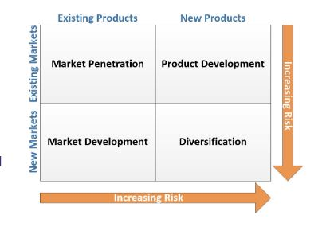
Figure 6: Ansoff Matrix model (Reiling, 2021)

  - Market penetration
This strategy focuses on increasing the sales of the existing product to an existing market. For it to be successful, companies can decrease the price of the product to attract new customers or increase the promotion and distribution efforts (Eagle and Brennan, 2003).
  - Product development
This strategy is used when the company has a strong understanding of the current market and can not only satisfy the customers' needs and expectations, but also provide innovative and exciting new products. For this strategy to be successful, the company needs to focus on extensive research and development.
Market development
The strategy is used when companies want to enter new markets with their existing products. The new marker can be geographic region, new customer segment, etc. For this strategy to work, the company need to assure that the customers behaviour in the new markets does not differ too much from that of customers in the existing markets. Furthermore, the company needs to own proprietary technology that it can leverage into new markets.
Diversification
In this strategy the company uses a new product to enter a new market. The strategy is the riskiest one as it relates to penetrating new unknown markets. For this strategy to work out, companies need to have a clear assessment of the risks involved and have an unobstructed vision of what the strategy is expected to gain (Martin and Sayrak, 2003). There are related and unrelated diversification strategies. In related diversification the business remains in the same industry in which it is familiar with. In unrelated diversification, however, there is usually o previous industry relation or market experience.

Recommendations for future marketing strategies

In order for Cadbury to keep its competitive advantage and also increase the revenue, there are few future marketing strategies that it could undertake. The company can concentrate on a product development strategy by improving its existing range, specifically the healthy bars and options. More and more people nowadays are choosing to have healthy eating lifestyle and try to limit the sugar and chocolate intake. This is why it would be beneficial and a winning strategy for Cadbury to increase the number and choices of nut bars they offer.
Another strategy the company could focus on is diversification and the use of brand new products offered to new target market. Currently, the company offers a wide range of chocolate products and drinking chocolate and has a very broad target market with people from all ages, gender, religion, financial background, etc. However, to build a stronger competitive advantage Cadbury could explore the option of creating baby food products and getting into the baby market as well with baby purees, chocolate puddings, and drinks. In this sense, when it comes to children and the younger target market, Cadbury can also expand by considering the cereal breakfast options, such as Kellogg’s, which is a very well-liked product by many children. Additionally to that, the company can also explore the “gym market” and create protein drinks and bars.

Conclusion
To sum up, the report provided analysis of the current market position of Cadbury through PESTLE and SWOT analysis. The strengths and weaknesses of the company were discussed and recommendations for future improvements were provided. Furthermore, the report also considered the external environmental factors and the way they influence the development of the business by using the Porter’s 5 Forces. Additionally, the report focused on the STP marketing model and 4ps analysis of the company and the strategies it implements in order to keep its competitive advantage on the market. A definition and analysis of Ansoff matrix is also included and recommendations for future marketing strategies in order to improve the competitive advantage and revenue are provided are the end of the report.

List of Figures

Figure 1: Pestle Analysis in Sum (De Bruin, 2016) 3
Figure 2: Porter's Five Forces Model (Michael E. Porter 2008) 5
Figure 3: SWOT Analysis (Haughey, 2021). 7
Figure 4: Segmentation: Make Sense of The Market (Oxford College of Marketing Blog, 2020). 9
Figure 5: Cadbury market segmentation 9
Figure 6: Ansoff Matrix model (Reiling, 2021) 12

References

Ansoff, H., (1957). Strategies for Diversification. Harvard Business Review. 35, pp.113-24.
Baker, C., (2022). Obesity Statistics. [online] Available at: https://commonslibrary.parliament.uk/research-briefings/sn03336/ [Accessed 12 April 2022].
Cadbury (2020). Our Products. [online] Available at: https://www.cadbury.co.uk/products [Accessed 18 April 2022].
Cadle, J., Paul, D. and Turner, P., (2010). BUSINESS ANALYSIS TECHNIQUES. Swindon, UK: British Informatics Society Limited (BISL).
De Bruin, L., (2016). PESTEL Analysis (PEST Analysis) EXPLAINED with EXAMPLES | B2U. [online] Available at: https://www.business-to-you.com/scanning-the-environment-pestel-analysis [Accessed 22 April 2022].
Eagle, L., and Brennan, R., (2007). Beyond advertising: in-home promotion of “fast food”. Young Consumers, 8(4), pp.278-288.
Hall, D., and Lobina, E., (2007). Profitability and the poor: Corporate strategies, innovation and sustainability. Geoforum. 38, 772-785.
Hanbury, M., (2018). We compared the UK's favorite chocolate to the version that's sold in the US — and we were surprised by what we found. [online] Available at: https://www.businessinsider.com/cadbury-chocolate-different-in-us-vs-uk-evidence-2018-5?r=US&IR=T [Accessed 12 April 2022].
Haughey, D., (2021). SWOT Analysis. [online] Available at: https://www.projectsmart.co.uk/tools/swot-analysis.php [Accessed 22 April 2022].
Hooley, G., Saunders, J., and Piercy, N., (2005). “Marketing strategy and competitive positioning”, Prentice Hall.
Hutt, D. and Spech, W., (2004). “Business Marketing Management”, Prentice Hall.
Lewis, K., (2016). 'Cadbury's Creme Eggs sales and satisfaction falls after controversial recipe change' Independent, March 24 [online] Available at http://www.independent.co.uk/news/uk/home-news/creme-egg-easter-cadbury-mondelez-recipe-sales-a6950221.html [Accessed 22 April 2022].
Martin, D., and Sayrak, A., (2003). Corporate diversification and shareholder value: A survey of recent literature. Journal of Corporate Finance, pp. 37-57.
Mohan-Hickson, M., (2019). Cadbury is urgently recalling these chocolate products over fears they could be a health risk. [online]Available at: https://www.portsmouth.co.uk/health/cadbury-is-urgently-recalling-these-chocolate-products-over-fears-they-could-be-a-health-risk-997240 [Accessed 12 April 2022].
Morris, B., (2014). 'The Cadbury deal: How it changed takeovers' BBC Business News, May 2 [online] Available at http://www.bbc.co.uk/news/business-27258143 [Accessed 22 April 2022].
Oxford College of Marketing Blog., (2020). Finding The Right Customers With The STP Model. [online] Available at: https://blog.oxfordcollegeofmarketing.com/2020/06/24/finding-the-right-customers-with-stp-model [Accessed 22 April 2022].
Porter, M., (1980). Competitive Strategy – Techniques for Analyzing Industries and Competitors. New York: The Free Press.
Porter, M., (2008). The Five Competitive Forces That Shape Strategy. Harvard Business Review.
Reiling, J., (2021). Ansoff Matrix Model: Explanation, Advantages, and Disadvantages | The Strategic Project Manager. [online] Available at: https://bethestrategicpm.com/ansoff-matrix-model-explanation-advantages-and-disadvantages/ [Accessed 22 April 2022].
Ruddick, G., (2017). 'Cadbury says chocolate could get smaller after Brexit' Guardian, March 24 [online] Available at https://www.theguardian.com/business/2017/mar/24/cadbury-warns-chocolate-could-get-smaller-after-brexit [Accessed 22 April 2022].
Selwood, D., (2020). Cadbury is Britain’s fastest-growing grocery brand as chocolate sales soar. [online] Available at: https://www.thegrocer.co.uk/britains-biggest-brands/cadbury-is-britains-fastest-growing-grocery-brand-as-chocolate-sales-soar/603365.article [Accessed 12 April 2022].
Shastri, A., (2021). Comprehensive Marketing Mix of Cadbury - 4Ps Included. [online] Available at: https://iide.co/case-studies/marketing-mix-of-cadbury/#:~:text=The%20Marketing%20Mix%20of%20Cadbury%20includes%204Ps%20(Product%2C%20Price%2C [Accessed 18 April 2022].
The Guardian (2022). Cadbury family-size Dairy Milk bars get 10% smaller but price stays the same. [online] Available at: https://www.theguardian.com/business/2022/mar/28/cadbury-family-size-dairy-milk-bars-get-10-smaller-but-price-stays-the-same [Accessed 7 Apr. 2022].
Wallop, H., (2016). 'The many ways Cadbury is losing it magic' Telegraph, March 21, [online] Available at http://www.telegraph.co.uk/food-and-drink/features/the-many-ways-cadbury-is-losing-its-magic/ [Accessed 22 April 2022].
Walsh, F., (2006). Product recall costs Cadbury £20m. [online]Available at: https://www.theguardian.com/business/2006/aug/02/food.foodanddrink [Accessed 12 April 2022].
World Health Organization (2021). Obesity and overweight. [online] Available at: https://www.who.int/news-room/fact-sheets/detail/obesity-and-overweight [Accessed 7 Apr. 2022].

‌

