

M6X01294- Asset Tracking Technology
Ged Edwards
Elliot Allsop

- Introduction
This report aims to explain what asset tracking is, what it consists of and how far it has come since the first barcode was produced (Bar Code Direct, 2018). To do that within the report there will be an introduction to assert tracking and its history or asset management as it was more commonly known until recently. The benefits and downfalls of asset tracking. Asset tracking is as vital as any function within a business this is because, locaters will need to know where items are to be able to provide customers with expected arrival dates. Likewise,
when (Pontius, 2018) says asset tracking is as important as managing inventory” due to the fact it’s very useful and sensitive information when knowing where products are, so that people can plan and prepare around the expected delivery date, or in basic terms can track their products. Additionally, if products can not be tracked or even found then a certain individual (responsible for tracking) will have a lot of questions to answer regarding misplaced or lost items. In addition to this the consequences do really rack up once an item is misplaced and cannot be found. As you can see in the image below (Clearspider.com, 2018), there are a lot of repercussions that follow as a result of an error in the workplace which leads to an item becoming lost.
The rest of the report will focus on a SWOT analysis of having visibility in transport, The Strengths, weaknesses, opportunities and threats (Academy, 2018). As well as the critical evaluation of having asset tracking technologies in transport such as RFID and GPS as well as featuring a case study of asset tracking will also be documented throughout the report. Evidence will also be sourced for advantages and disadvantages to illustrate how useful asset tracking can be and how costly it also is.

1.1 What is Asset Tracking
According to (Pontius, 2018), asset tracking is “the method you use to track your physical assets, whether you scan barcode labels…or use GPS/ RFID tags” essentially placing a tracker on your items that may be in the process of being distributed and knowing precisely where they are or at last very close to the last checkpoint reached to where they are in the distribution process. Whether it is just being shipped or ready to be delivered via a fulfilment centre. Asset tracking really became popular when an individual decided to attach WIFI tags to products in a means to track their location. (Conti, 2018). It advanced warehouse practices especially with its local networks. The tags also “came with a hefty price” but this was no surprise as this technology was just being developed. “The tags chirped every few seconds” this was in order to aid determining their location and the relevant information would be entered into a database.

1.2 History
It is not a surprise to see that when researching that asset tracking has come far and was used a lot by our predecessors, albeit less advanced and less sophisticated. From the days off the hunter gatherers era where they required a systematic approach whilst hunting and colleting food. Then When these hunter gatherers advanced into more civilised populations, they began to transport food and other items and so had to recollect all the items they were taking and trading or selling. (SkyBitz, 2018) “Eventually companies realised they needed a way to track and manage their goods” when storing and transporting, as imagining being in a scenario there would be no way to recite all the items produced and sold without any manual evidence, the individual would either forget, duplicate or double count, therefore voiding their analysis.

1.3 1960’s The Barcode was born
That’s right not too long ago respectively, the barcode was created by “a group of retailers whom came together” they produced the modern barcode in order to track inventory (Bar Code Direct, 2018). They made their lives a lot easier by scanning items and then comparing this to inventory levels where the items sold would be deducted automatously from the database. So where would the world be without it today, given all its technological advancements that the barcode has seen today, they really did pave the way, the predecessors really made everyone lives easier by speeding up productivity really as well as processing speeds (Barcode.ro, 2018). However, RFID technology has now outpaced the basic barcode and has seriously quicker processing speeds (Pidding,2018).

2 Visibility in Transport SWOT
Strengths | Weakness | Opportunities | Threats
Location convenience (consumer) | Perishable goods | Divert for emergency
It gets delivered | Costs More | Expand market (based on competence)
Prevents waste | Hard to manage/ Training Issue | Competitive advantage
RFID- Inventory control
Drivers management of Delivery
Allows contingency plans

2.1 Analysis of Asset Tracking
As it can be seen above there are a lot of elements that come to mind when analysing visibility in transport in terms of tracking technology. Such as RFID, GPS and local IT networks. Firstly, having some sort of RFID tracking tag not only benefits the business but it is also a great tool/ service for the consumers as they will also pay extra for this, as for an extra fee they will know exactly or close enough where their product or asset is (Transporeon.com, 2018). Yes, there is that little downside that the consumer will have to pay a little extra or tracking however the number of benefits outweigh the cost and so make it more worthwhile as it can eb seen above when comparing the four elements of the SWOT analysis. Additionally (Pidding, 2018) shows how the benefits of RFID tags or likewise will benefit the business more in comparison to their cost, just by looking at image 2, the benefits are simply cleared up. As you can see in the hierarchy it simply sums up the most important needs for when using RFID tags or similar asset tracking technology.

3 Importance of Asset Tracking
It is also no alarm that if a business cannot locate their assets, then they could potentially fail or lose out on a lot of money and demand thus having an adverse effect on their reputation. Likewise, when (IGM Services, 2018) says “In some industries, even hours without equipment or transportation can have near catastrophic financial results”. This just goes to show how vital assets can be to some business especially if they are heavily invested capital throughout their business. Hence the genuine and necessity for asset tracking for businesses heavily reliant. In addition to the above statement, it also depends on how much capital the business has invested, and sensibly the higher the amount the more important the tracking of the assets will as well as the number of assets to track.
So, the importance of asset tracking is quite vital really and clear to see. Let’s suppose you have lost your assets, or they are stolen, then asset tracking within your business can rectify this problem. It will allow the business owners/ managers to look at the last location that RFID tag checked
through and so they can delve further into this area and find the problem and produce a long-lasting solution to ensure it never happens again (Management, 2018). They also go on to say the more effectively assets are tracked them this will account for hiccups or errors in the inventory management side of things and so the business will be as efficient as possible really and “yield higher profitability for any company” this will be because the company will be able to account for all its assets successfully even those that are written off, that is if they are recorded correctly.

3.2 Consequences of lost Items
As opposing as it sounds there still may be a time where one worker makes an error to which results in a tracked item being misplaced and not being able to be tracked or found. With that being said if this scenario were to happen then this can have costly chain like problems for the business (Clearspider.com, 2018). As you can see in the below image there are a lot of expensive step to step complications which will add up if the problem is not rectified initially.
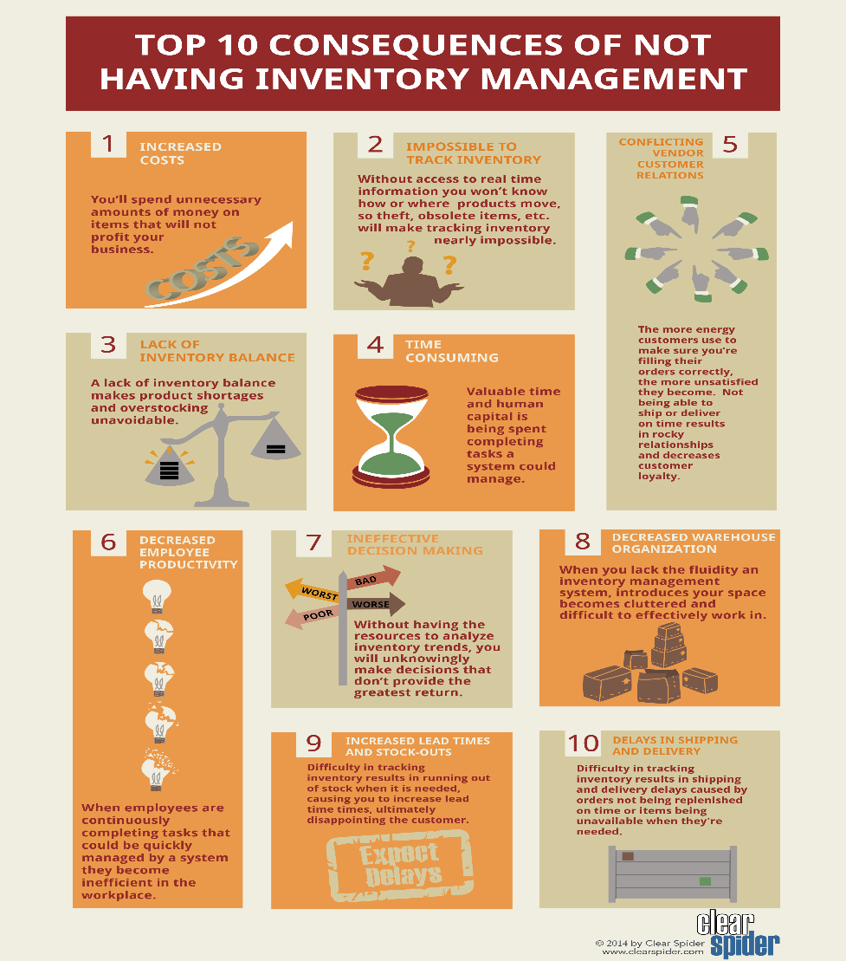

Image 1 (Clearspider.com, 2018)


3.3 Advantages of Asset Tracking
Image2 (Pidding,2018)
Again, as it can be seen by the above image there are many more features that come naturally or are heavily supported when it comes to using asset tracking technology. Such as when it comes for searching for missing items, this is where asset tracking is at its most useful and helps its intended function. Additionally, it can also ease stock taking and suitable ensure it is completed correctly by using the inventory database.
The (Inventory, 2018) pretty much states the relevance of using asset tracking to aid overall stock counts due to the simpler nature of the job when taking advantage of the asset tracking. Why make work harder when it can be so simple so quick. However, when using asset tracking technology items that are missing, damaged etc need to be accounted for, otherwise the overall stock count will be invalid. So, workers will need to know strongly that all items are accounted for “Shrinkage, theft & loss control” when the workers care about the nature of their jobs then the business can have piece of mind until then fully use tracking to its full potential as it is very beneficial as this report has seen so far.

3.4 Cost Saving

Image 3 (Pidding,2018)
Another element which show how asset tracking technology comes out on top compared to having just a basic barcode vs RFID tracking. looking at image three it can be that there are vast savings to be made when acquiring the asset tracking technology instead of the barcode. For an asset se of “100,000 the saving is more than $150,000” quite a substantial saving really and this can be reinvested elsewhere to further improve the asset tracking and potentially increase future savings using development.

3.5 Inventory Processing Times

Image 4 (Pidding,2018)

Again, RFID comes out on top with much quicker processing times when performing asset inventories compared to barcode scanning. That much so that it saves over 90%, a very respectable yield. Also, where there is saved time there are always saved costs, so again more reinvestment or potentially savings.

Additionally (Ray, 2018) makes a great analysis as to whether the asset tracking will be useful for your business or the lower more cost-effective types within asset tracking. There will be some sort of tracking for whatever type of business you are. It totally depends on a lot of factors suitably. Such as whether “staff spend lots of time locating items” if so then asset tracking is for the business since the labour paid in having your employees find assets could be justified by paying for lower end Bluetooth RFID tags which will simplify your asset tracking. Therefore, for a little price it will save a lot of manhours and time as well as being more convenient to the business.
Again (Ray, 2018) also has a good point that correlates with necessity of contingency plans which having RFID tags will allow your business to do if required. For example, if you have an important shipping “contract with the government” them this will be a high priority to keep track of and hive the business does sustain an error of some sort then suitable contingencies will be in place ready for the right moment. Such as holding buffer stocks at nearby distribution centres to rectify similar problems. On the other hand, this will cost the business a bit more however it could be the difference between keeping or losing a high-end contract and potential losing a lot of custom.

4 Disadvantages of Asset Tracking
As with any element of the business that all seems all to great there will always be a downside, downfall or disadvantage that will cost the business and so here are some of the downsides of asset tracking to a business.
Asset tracking can be expensive and time consuming however if done correctly or a enough method is adopted then it can be rather effective to the business and will ensure the smoother operation of the company. According to (Pontius, 2018) there specific types of asset tracking which offer themselves as cheaper and swifter in terms of saving finance on money invested as well as employing the individuals who conduct the work. Logically with any advanced feature of option within the workplace there will always be increased cost so irrespective of its cost, asset tracking really begs the question; is the item worth being tracked?
Respectively states that “asset tracking refers to unique items of value” so however unique or sensitive or even expensive the item then the more it will cost to track as well as the more expensive the asset tracking will be based on it (RedBeam, 2018).

4.1 Confusion of exact location
Depending on the type of asset tracking purchased or implemented, difficulties can reveal themselves such as confusion as to where the products are, especially when passing through tracking points (Wireless Innovation Ltd, 2018). Additionally, it is also very difficult to transfer cellular carriers when changing territories as (Wireless Innovation Ltd, 2018) states. This can also be costly as most carriers simply don’t have enough coverage. So visually this could lead to interrupted tracking or even no tracking for an unspecified amount of time which when paying or investing so much money into a service is rather disappointing, however this cannot be helped sometimes. The only way to solve this situation would be to offer multiple carriers however respectively the cost may go up or extra costs incurred.

5 Conclusion
So respectively it is very clear to see that asset tracking or asset management as it was used to be known as, has been around for quite some time now. Even going back to the simplest of era’s when our predecessors, the hunter gatherers used to recollect their hunting tools and their animals or pickings (SkyBitz, 2018). In respect to todays forms of asset tracking are so much more sophisticated and effective as data is everything in todays society especially when tracking items (Pobonline.com, 2018), as data is an integral part of today’s society in every day aspects too.
As with everything that brings a lot of benefits there comes a price and with asset tracking that is especially the case as you certainly get your money’s worth. Yes, asset tracking can be very costly and equally time consuming according to (Pontius, 2018) however if it is done correctly and efficiently it can only be a developing process and yield higher results each time. In today’s forever changing society asset tracking aspects can only get better and better with more investment and so will continue to overwhelm.
Again, asset tracking is somewhat expensive however if done correctly and accurately then the results and the speed will outweigh the costs incurred and so will be written off, this can be seen when reflecting on the processing speeds of RFID technology compared with the basic barcode (Pidding,2018). Lastly the only two aspects that bring asset tracking down are the costs, which cannot be helped as there is a cost with everything and dependent upon how unique or expensive the item is then the tracking will always be an expensive overhead (RedBeam, 2018). Also, that there can be difficulties faced when trying to precisely track the item. Overall with asset tracking technology the benefits really do outweigh the disadvantages.

References
Academy, P. (2018). Marketing Theories - SWOT Analysis. [online] Professionalacademy.com. Available at: https://www.professionalacademy.com/blogs-and-advice/marketing-theories---swot-analysis [Accessed 13 Nov. 2018].
Bar Code Direct. (2018). The History of Inventory Management. [online] Available at: https://www.barcodedirect.com/the-evolution-of-inventory-management/ [Accessed 9 Nov. 2018].
Barcode.ro. (2018). Rosistem Barcode - Barcode Education. [online] Available at: https://www.barcode.ro/tutorials/barcodes/history.html [Accessed 9 Nov. 2018].
Blue Tower, G. (2018). [ebook] Available at: https://www.gs1hk.org/sites/default/files/media_plus/event-and-news/publications/industry-collaterals/gs1_achieving_visibility_in_transport_logistics_2013.pdf [Accessed 9 Nov. 2018].
Clearspider.com. (2018). Consequences of Poor Inventory Management -. [online] Available at: https://www.clearspider.com/inventory-management-infographics-consequences/ [Accessed 19 Nov. 2018].
Conti, A. (2018). The Evolution of Equipment Tracking - Tenna. [online] Tenna. Available at: https://www.tenna.com/evolution-equipment-tracking/ [Accessed 19 Nov. 2018].
Eagle Blog. (2018). Amazon Go & RFID - The Automation Dilemma | EAGLE | Blog. [online] Available at: https://www.autodesk.com/products/eagle/blog/amazon-go-rfid-automation-dilemma/ [Accessed 13 Nov. 2018].
Inventory, C. (2018). Tips on Performing Inventory Counts - Clearly Inventory. [online] Clearlyinventory.com. Available at: https://www.clearlyinventory.com/inventory-basics/tips-on-performing-inventory-counts [Accessed 19 Nov. 2018].
IoT For All. (2018). How IoT is Revolutionizing Supply Chain Management | IoT For All. [online] Available at: https://www.iotforall.com/supply-chain-management/ [Accessed 9 Nov. 2018].
IoT For All. (2018). Time-Based vs. Proximity-Based Asset Tracking | IoT For All. [online] Available at: https://www.iotforall.com/time-based-vs-proximity-based-asset-tracking/?fbclid=IwAR2t8QdxXrg06S_87dulSuPH13qGh05zkvC7Pv1u5IWKWssat8DAOVcgXGM [Accessed 9 Nov. 2018].
Management, 1. (2018). When a business fails with Asset Management - AB&R (American Barcode and RFID). [online] AB&R. Available at: https://www.abr.com/business-fails-asset-management/ [Accessed 14 Nov. 2018].
Pidding, S. (2018). COST‐BENEFIT ANALYSIS OF AN RFID ASSET TRACKING SYSTEm. [ebook] Available at: https://www.danbygroup.com/docs/Cost-Benefit-Analysis_of_RFID_Asset_Tracking_Danby.pdf [Accessed 19 Nov. 2018].
Pidding, S. (2018). COST‐BENEFIT ANALYSIS OF AN RFID ASSET TRACKING SYSTEm. [ebook] Available at: https://www.danbygroup.com/docs/Cost-Benefit-Analysis_of_RFID_Asset_Tracking_Danby.pdf [Accessed 19 Nov. 2018].
Pobonline.com. (2018). [online] Available at: https://www.pobonline.com/articles/100227-the-role-of-data-in-an-asset-management-system [Accessed 20 Nov. 2018].
Pontius, N. (2018). What is Asset Tracking? - Asset Tag & UID Label Blog. [online] Asset Tag & UID Label Blog. Available at: https://www.camcode.com/asset-tags/what-is-asset-tracking/ [Accessed 9 Nov. 2018].
Ray, B. (2018). Will You Benefit From Asset Tracking & Asset Location Technology?. [online] Airfinder.com. Available at: https://www.airfinder.com/blog/asset-tracking [Accessed 14 Nov. 2018].
RedBeam. (2018). The Difference Between Asset Tracking and Inventory Tracking. [online] Available at: http://www.redbeam.com/the-difference-between-asset-tracking-and-inventory-tracking/ [Accessed 20 Nov. 2018].
Ro.uow.edu.au. (2018). [online] Available at: https://ro.uow.edu.au/cgi/viewcontent.cgi?referer=https%3A%2F%2Fwww.google.co.uk%2F&httpsredir=1&article=1009&context=thesesinfo&fbclid=IwAR2Hh3JNDYjuxtjyOxUtAFKL1vjAEgRVrA9mu20LBJj38yHTS68Q3CS8ox8 [Accessed 19 Nov. 2018].
Services, I. (2018). The evolution of Asset Management. [ebook] USA: IBM Business Consulting Services, p.1. Available at: http://In some industries, even hours without equipment or transportation can have near catastrophic financial results [Accessed 14 Nov. 2018].
SkyBitz. (2018). The History of Asset Tracking | SkyBitz. [online] Available at: https://info.skybitz.com/history-asset-tracking/ [Accessed 9 Nov. 2018].
Team, I. (2018). 5 Areas Where The IoT Is Having The Most Business Impact. [online] Forbes. Available at: https://www.forbes.com/sites/insights-hitachi/2017/12/18/5-areas-where-the-iot-is-having-the-most-business-impact/#5f59523d4396 [Accessed 9 Nov. 2018].
Transporeon.com. (2018). Transport Visibility. [online] Available at: https://www.transporeon.com/en/products/products-for-shippers/transport-visibility/ [Accessed 9 Nov. 2018].
Wireless Innovation Ltd. (2018). The Challenge of Asset Tracking - Wireless Innovation Ltd. [online] Available at: https://www.wireless-innovation.co.uk/case-studies/the-challenge-of-asset-tracking/ [Accessed 20 Nov. 2018].

