
Component 1: Design and Implementation of a Relational Database System

Prepared by:
Student Name: Mame Diara Dieng
Student ID: 2437938
The program: CertHE Computing Skills for the Workplace
Module Name: Introduction to Web and Database Concepts
Module code : ACCA4023
Lecturer’s Name : Sadhana Jha


November 1, 2025
UNIVERSITY OF WALES TRINITY SAINT DAVID

Contents
Scenario Analysis 2
Entity Relationship Diagram (ERD) 3
1. List of attributes and their descriptions 3
2. List of relationships and their meaning. 4
3. ER diagram: 4
Normalization 5
Sample Data Population 7
8
Query Development 8
Testing and Validation 11
Design Decisions and Future Work 11
1. Design Decisions: 11
1. Future Work: 12
References: 12

Scenario Analysis
The CEO of a growing community pharmacy called MediLink Pharmacy has approached me with the design and implementation of a relational database system using Microsoft Access to take the place of the pharmacy’s existing manual processes. Currently, the pharmacy manually oversees medicine inventory, customer information, prescriptions, and sales transactions, leading to inefficiencies, inaccurate inventory management, and limited reporting capabilities. The CEO seeks a system that will enhance stock management, improve sales tracking, and facilitate better management reporting.

Database Making Explanation
To meet this requirement, I have identified four primary entities that form the core of the database: Supplier, Medicine, Customer, and Sales Transaction.
The Supplier entity holds information about the companies that supply medicines to the pharmacy. Its attributes include SupplierID (Primary Key), Supplier Name, Phone Number, Email, and Address. Each supplier can offer multiple medicines, creating a one-to-many relationship between Supplier and Medicine.
The Medicine entity contains information on pharmaceutical products available for sale. Its attributes include MedicineID (Primary Key), MedicineName, Category, Unit Price, QuantityInStock, ExpiryDate, and SupplierID (Foreign Key). The relationship between Supplier and Medicine ensures that every medicine is associated with a specific supplier. This structure enables the system to track inventory levels and identify medicines that require reordering, directly addressing the CEO’s concern about stock management.
The Customer entity holds details about customers, including CustomerID (Primary Key), First Name, Last Name, DOB, Phone Number, and Address. This will allow the pharmacy to keep accurate customer records and monitor purchasing history.
The Sales Transaction entity captures all sales transactions that occur within the pharmacy. Its attributes consist of Transaction ID (Primary Key), Transaction Date, Quantity Sold, Total Amount, Payment Method, CustomerID (Foreign Key), and MedicineID (Foreign Key). This entity connects customers to the medicines they purchase, establishing a one-to-many relationship between Customer and Sales Transaction, as well as a one-to-many relationship between Medicine and Sales Transaction.
By defining these four entities and creating suitable relationships among them, I will develop a simple yet functional relational model that aids in stock management, customer tracking, and sales reporting. This database design will directly respond to the CEO’s need for enhanced accuracy and improved operational efficiency.

Entity Relationship Diagram (ERD)

List of attributes and their descriptions

Supplier: Stores supplier information to manage medicine sourcing and maintain supplier relationships.
PK
Attribute | Description
SupplierID | Unique identifier for each supplier
SupplierName | Name of the supplier company
Contact Person | Main contact person at the supplier
PhoneNumber | Suppliers' contact phone number
Email | Suppliers' contact email address
Address | Supplier’s address

Medicine: Tracks stock, pricing, supplier relationships, and expiry to ensure accurate inventory management.
FK
PK
Attribute | Description
MedicineID | Unique identifier for each medicine
MedicineName | Name of the medicine
UnitPrice | Price per unit
Category | Type/category of medicine (e.g., Painkiller, Antibiotic)
QuantityInStock | Current Stock level
ExpiryDate | Expiration date of the medicine
SupplierID | The supplier that provides this medicine

Sales Transaction: Records all sales, links customers to medicines purchased, updates stock and supports reporting.
FK
PK
Attribute | Description
SaleID | Unique identifier for each sales transaction
SaleDate | Date when the sale occurred
QuantitySold | Number of units of medicine sold
TotalPrice | Total amount for the sale
CustomerID | The customer who made the purchase
MedicineID | Medicine that was sold

Customer: Tracks customer information and purchase history, enabling targeted reporting.
Attribute | Description
CustomerID | Unique identifier for each customer
Title | Customers’ title
FirstName | Customer’s first name
LastName | Customer’s last name
DOB | Customer’s date of birth
PhoneNumber | Customer’s contact phone number
Address | Customer’s residential or delivery address
PK

List of relationships and their meaning.
Suppliers to Medicines: This is a one-to-many (1:M) relationship in which each supplier can supply multiple medicines, but each medicine is supplied by only one supplier. Medicines' participation in this relationship is total, meaning every medicine must have a supplier, whereas supplier participation is partial, as a supplier may or may not currently supply medicines.
Customers to Sales Transactions: This one-to-many (1:M) relationship indicates that each customer can have multiple sales transactions (including prescriptions), but each sales transaction is linked to only one customer. SalesTransactions participation is total, as every transaction must be associated with a customer, whereas customer participation is partial since some customers may not have made any transactions yet.
Medicines to Sales Transactions: This one-to-many (1:M) relationship shows that each medicine can be part of many sales transactions, but each sales transaction involves only one medicine. SalesTransactions participation is total, since every transaction must involve a medicine, whereas the medicine participation is partial since some medicines may not have been sold yet.

ER diagram:
The ER diagram is below
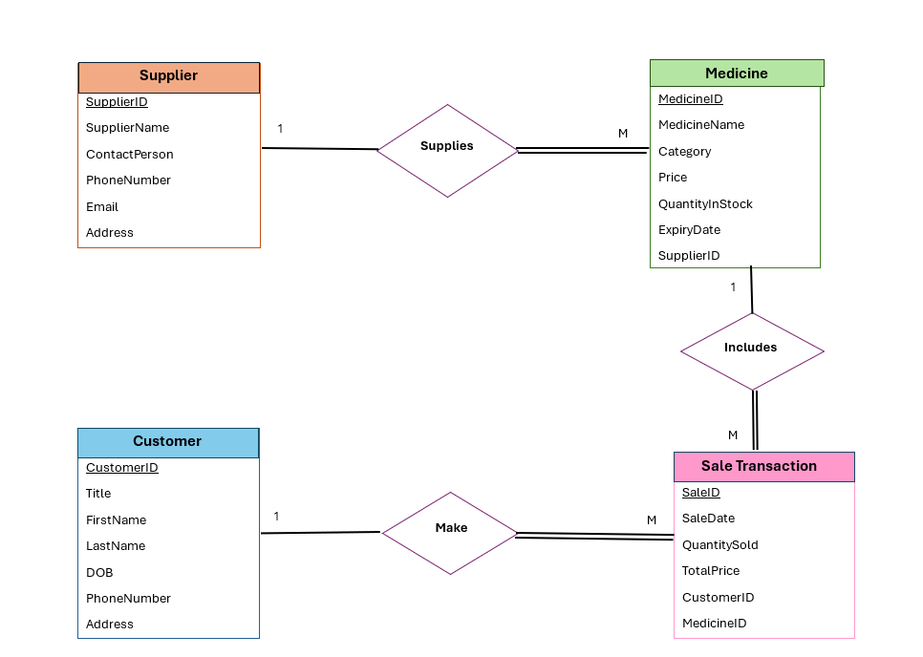
Figure 1: Entity Relationship Diagram for MediLink Pharmacy

In my designed database system, several foreign keys are used to establish relationships between entities and maintain referential integrity.
In the Medicine entity, the SupplierID attribute serves as a foreign key. This foreign key references the SupplierID in the Supplier entity, which is the primary key.
The Sale Transaction entity contains two foreign keys. The CustomerID attribute serves as a foreign key referencing the CustomerID column in the Customer entity, which is that entity's primary key.
Finally, the MedicineID attribute in the Sale Transaction entity acts as a foreign key that references the MedicineID in the Medicine entity, which serves as the primary key.

Normalization
Supplier(SupplierID, SupplierName, ContactPerson, PhoneNumber, Email, Address)
Medicine(MedicineID, MedicineName, Category, UnitPrice, QuantityInStock, ExpiryDate, SupplierID)
Customer(CustomerID, Title, FirstName, LastName, DOB, PhoneNumber, Address)
Sale Transaction(SaleID, SaleDate, QuantitySold, TotalPrice, CustomerID, MedicineID)
(Underline indicates the Primary keys)
The foreign key relationships I implemented are:
Medicine.SupplierID references Supplier.SupplierID
SaleTransaction.CustomerID references Customer.CustomerID
SaleTransaction.MedicineID references Medicine.MedicineID

To ensure data integrity and minimise redundancy, the database design was normalised to Third Normal Form (3NF). The normalisation process was conducted step by step to verify that the relational schema meets the criteria for First Normal Form (1NF), Second Normal Form (2NF), and Third Normal Form (3NF).
Normal Form | Description | Application to MediLink Pharmacy Schema
First Normal Form (1NF) | Eliminate repeating groups; ensure attribute atomicity. | All tables have atomic attributes, no multi-valued fields. For example, Supplier contacts are single values, and Medicine details are atomic.
Second Normal Form (2NF) | Remove partial dependencies; all non-key attributes depend on the whole primary key. | To ensure that all non-key attributes are fully dependent on the entire primary key. Since all tables have single-attribute primary keys, 2NF is inherently satisfied. For example, in SaleTransaction, attributes such as SaleDate and QuantitySold depend entirely on SaleID.
Third Normal Form (3NF) | Remove transitive dependencies; non-key attributes depend only on the primary key. | No transitive dependencies exist, and non-key attributes depend only on the primary key. For example, in Medicine, SupplierID is a foreign key, and Supplier details are stored separately in the Supplier table, avoiding redundancy.

Sample Data Population
I populated the database tables with sample records for suppliers, medicines, customers, and sales transactions to simulate the pharmacy’s operations. This allowed me to test relationships between tables and ensure foreign key constraints maintained referential integrity. The sample data also helped verify that validation features such as drop-down lists and input masks worked correctly.
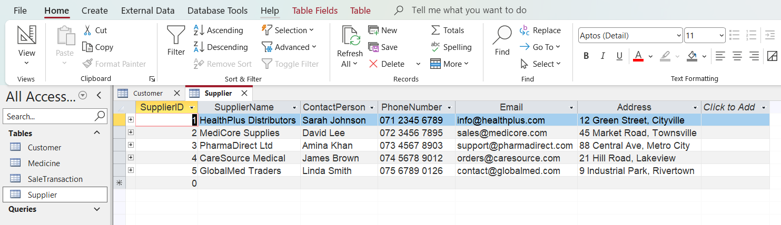
Supplier table
Medicine Table
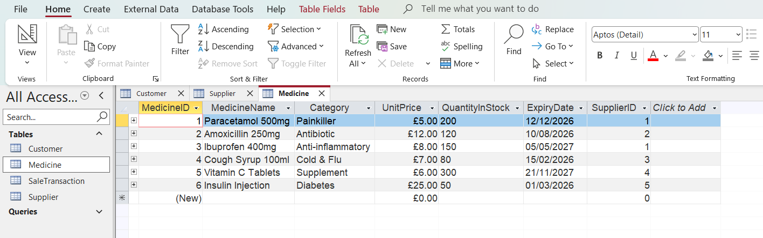
Customer Table
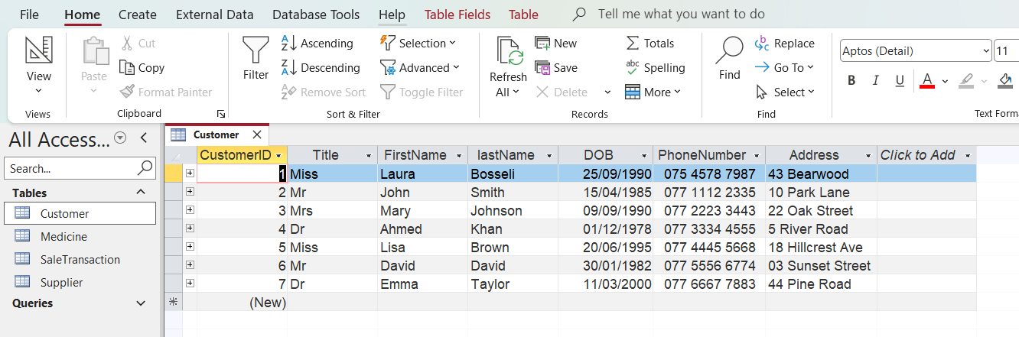

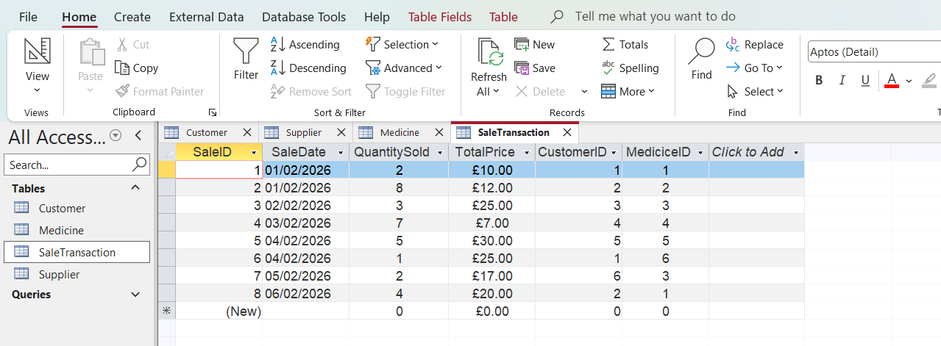
SaleTransaction Table

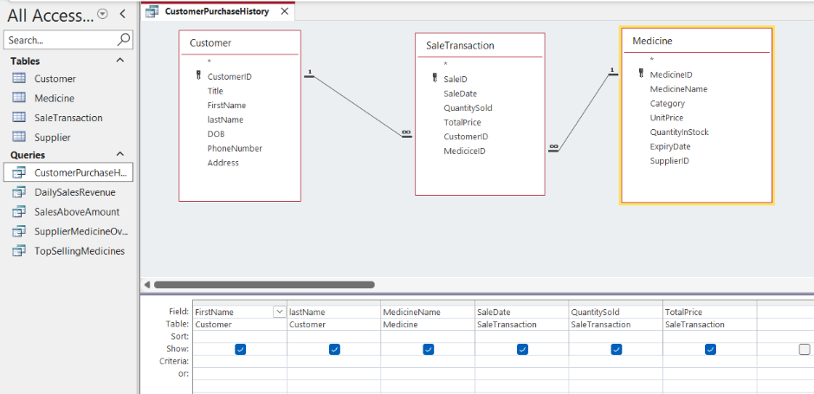
Query Development

I made the CustomerPurchaseHistory query to view detailed information about each customer's purchases. This query combines customer details with sales and medicine information, allowing me to see the medicine name, quantity sold, sale date, and total amount
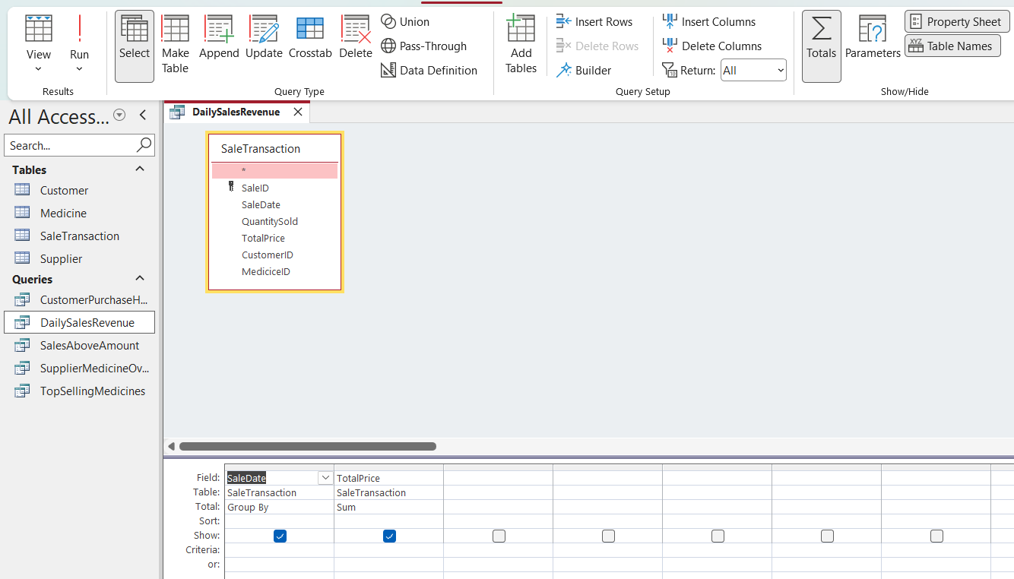
The DailySalesRevenue query is to calculate the total revenue generated each day. By grouping sales by date and summing the total amounts.

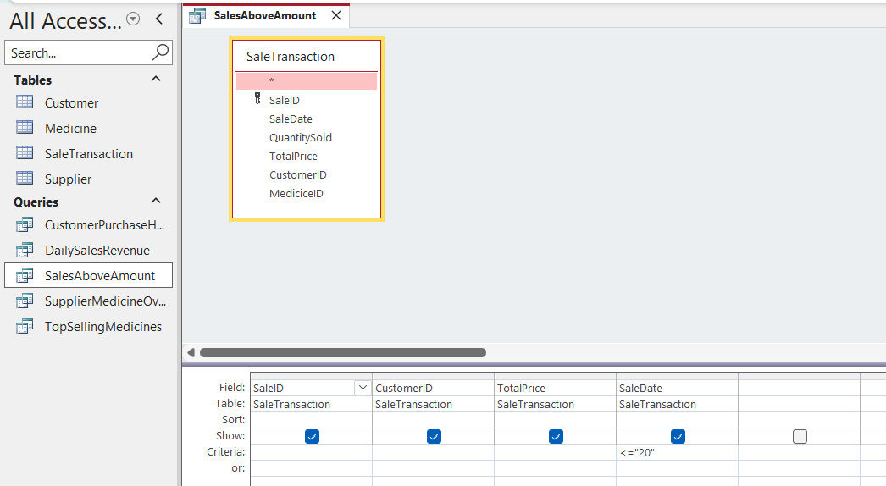

I created the SalesAboveAmount query to filter and display high-value transactions based on specific criteria.
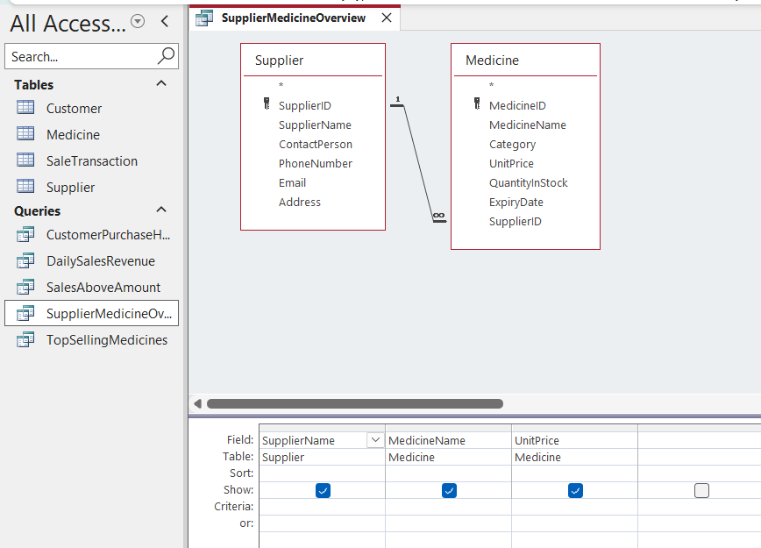

The SupplierMedicineOverview query was created to display which supplier provides each medicine, along with related details. This allows the pharmacy to manage supplier relationships effectively and track product sourcing for better procurement decisions.
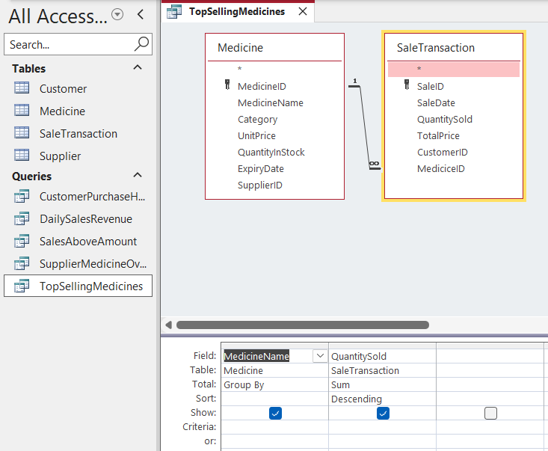

I created the TopSellingMedicines query to identify the medicines with the highest quantity sold. By grouping and sorting the data, I can identify the most popular products, which will help the pharmacy with inventory planning and ensure that high-demand medicines remain in stock.

Testing and Validation
After implementing the MediLink Pharmacy database, I conducted several tests to ensure the system met functional and data integrity requirements.
First, I verified that primary keys were unique and that all fields had the correct data types. I tested required fields to ensure that null values were not accepted where they were inappropriate.
I enabled referential integrity between related tables and tested this by attempting to enter invalid CustomerID and MedicineID values in the SaleTransaction table. The system rejected these entries, confirming that foreign key constraints were working correctly and preventing orphan records.
To improve data accuracy, I implemented a drop-down list for the Title field in the Customer table using the Lookup Wizard. This restricts users to predefined values such as Mr, Mrs, Miss, and Dr, ensuring consistent data entry. I tested this feature to ensure that only valid titles could be selected.
Additionally, I applied an Input mask to the PhoneNumber field (000\ 0000\ 0000) to enforce a standard phone number format. I tested this by entering incorrectly formatted numbers, and the system successfully prevented invalid input. This feature reduces data entry errors and improves overall data consistency.

Design Decisions and Future Work
- Design Decisions:
In designing the MediLink Pharmacy database, I focused on creating a streamlined and efficient system by limiting the model to four core entities: Suppliers, Medicines, Customers, and SalesTransactions, which are relational database. This approach was chosen to balance simplicity with the need to capture all essential data, including prescription details integrated within sales transactions. By doing so, I avoided unnecessary complexity that could arise from additional entities, which aligns with best practices in healthcare database design to reduce errors and improve usability.
A key design decision was to enforce total participation across the many sides of relationships to maintain data integrity[1]. For example, every medicine must have a supplier, and every sales transaction must be linked to a customer and a medicine. This ensures data completeness and consistency, which is critical to pharmacy operations.
One challenge I encountered was balancing normalisation with practical usability. While normalisation to Third Normal Form (3NF) reduces redundancy and dependency issues, it can sometimes complicate query performance[2]. To address this, I carefully structured foreign keys and relationships to facilitate efficient data retrieval without sacrificing data integrity[3].
Including prescription details directly in the SalesTransactions entity rather than creating a separate Prescription entity simplified the schema and reflected the pharmacy’s operational workflow, where prescriptions are closely tied to sales. This design choice supports streamlined data entry and reporting.
- Future Work:
In the future, I plan to enhance the system by integrating electronic health records (EHR) capabilities to provide a more comprehensive view of patient medication histories, thereby improving privacy. Secure and scalable EHR integration has been shown to improve healthcare data management and regulatory compliance [4]. Implementing automated reorder alerts based on stock levels and expiry dates could optimise inventory management and reduce waste, a feature increasingly important in modern pharmacy management.
Additionally, implementing automated stock monitoring and reorder alerts based on quantity thresholds and expiry dates would improve inventory management efficiency. Incorporating AI-driven analytics tools could further support decision-making and trend analysis in pharmacy operations, aligning with recent advancements in healthcare information systems [5]. Expanding the system to support multi-branch pharmacy operations with centralised data management would also facilitate scalability as MediLink Pharmacy grows.

References:
[1]Addy, P. L. Hang, C. Z. Hei, L. T. Hua, and N. U. Amin, “Design and Implementation of a Relational Database System for Efficient Facility and Booking Management,” Mar. 2025, doi: https://doi.org/10.20944/preprints202503.0070.v1.
‌[2]T. Taipalus, “The effects of database complexity on SQL query formulation,” Journal of Systems and Software, vol. 165, p. 110576, Jul. 2020, doi: https://doi.org/10.1016/j.jss.2020.110576.
‌[3]M. Hardini, V. Agarwal, D. Apriani, I. A. Widjaya, E. Setiawaty, and N. Nurasiah, “Application of Database Normalisation in Increasing Data Storage Efficiency,” International Transactions on Artificial Intelligence (ITALIC), vol. 3, no. 2, pp. 201–211, May 2025, doi: https://doi.org/10.33050/italic.v3i2.799.
‌[4]K. Pampattiwar and P. Chavan, “A secure and scalable blockchain-based model for electronic health record management,” Scientific Reports, vol. 15, no. 1, Apr. 2025, doi: https://doi.org/10.1038/s41598-025-94339-w.
[5]M. Chinnaiah, “AI-Driven Digital Transformation in Global Healthcare: From Hospital Systems to Pharmacy Benefit Managers,” International Journal Of Scientific Advances, vol. 6, no. 2, 2025, doi: https://doi.org/10.51542/ijscia.v6i2.22.
‌

