
(Robinson & Garton, 2007)

Professional Career Development

MODULE LECTURER´S NAME: Hossein Shokri
STUDENT NAME: Analius Jose Mendoza Silva
STUDENT IDENTITY NUMBER: 1916664

Table of Contents
Introduction 2
2. Lifeline 3
3. Reflection on the Role Play 4
4. Self Evaluation Review 4
5. Personal Development Plan 5
6. SWOT Analysis 5
7. SMART Objectives 6
8. Johari Window 6
9. Conclusion 7
References 8

Introduction

Working at Harrods for the past three years have taught me that to be successful and achieve your goals you must be persistent and to focus on keep on going until achieve goals in short and long term. When I join Harrods one of the most popular retail company around the world, one of the goals I wanted to achieve within one year was to become a brand manager and with the right motivation and my determination to become the brand manager of Rag&bone within my first year I successful achieved the goal. Working in this company have made me realise that I want to become a Human Resources Manager to help other and improve within the business that I could work for. In this report I will discuss my personal development plan and how I will become a Human Resources Manager.

2. Lifeline

The lifeline represents the ups and downs and the keys events that happened in the process of developing and achieving the goals to succes in my proffesional career, the lifeline represents the key moments that have lead me to where I am today and what I want to achieve proffesionally (University, 2020). One way of thinking what is going to be the next step in my career is to think how I motivative myself to achieve those goals. The lifeline is going to help me to identify the personal qualities I present for at work and it can help me to make a decision to include and exclude aspects that I have to improve or the highly the skills that I posses. Since my birth until the present day there have been a few key events that have affect postively to where I am today. I went to high school in Spain and when I finished I moved to London with my brother to improve my english and to gain experience working in a big city, since then I have worked in many places but my goal was to work at Harrods, within two years of experience in retail I applied to Harrods and my interview was succesfull, Harrods have taught me that my passion in life is to help others at the work place that is why I want my next goal is to graduate in HR Management and become the best I can be at my workplace. To represent the key events in my proffesional career I have created a personal lifeline.

Brand Manager at HARRODS
To write in another language
Bullying at the workplace
Lack of work experience
Lack of english
Suffer bullying at primary school
Studying at UWTSD
Birth 10 15 20 21 25
Moving to London
Finishing High School
Studying in Spanish
Low points

3. Reflection on the Role Play

My role play was based in want I want to become once a gradute from HR Management, I based my interview in my past experiences also I tried to reflect my stong points and the ones I have to improve. For the interview I wrote around my proffesional career as an individual making emphasis in my strenghts and the points I have to improve in my professional career. I described myself as an responsible and realible person that can manage time well and enjoy to work with a team and communicate with others, my experience as a brand manager at harrods is reflected in the way I manage people and research in the qualities of a HR manager for my interview that will be consistent because I will treat everyone fairly, also inspirational because I believe I can encourage the team in the working environment, and professional because I will respect the company’s principals and value also to keep the employment role and law regulations at all time. For the areas I need to improve I described an experienced I had while working at Harrods with a colleague and how I manage to communicate effectively, I also mention the area I need to improve and that I have been practicing in, is that is when I have deadlines It can be difficult to communicate others in a way they can understand that the task needs to be done on time and how I learnt from my past experiences to complete the tasks on time and communicate effectively. Whilst doing the interview for a HR manager position i brought the qualities I posses to be a succesfull candidate and I mentioned that in this role I can be the candidate because of my past experince at Harrods and how I am williing to learn new things and improve myself to becoma HR manager also I described the threats HR can face with the current situation with COVID-19 and how it can affect in the way the recruit people and in the changes they can face while working from home.

4. Self Evaluation Review

Self-motivation is the strenght that keeps us going until we achieve our personal or proffesionals goals, is the personal drive to achieve and develop our selfs to keep moving forward, the self-motivations helps you to grow no matter in the situation that you can be and this is why is an essential tool to keep on going to achieve and develop our careers. (team, 2020). My motivation on keep on going everyday and becoming successful in the proffesional area is my family, I was raised with limited sources and my mom was a single parent with five childrens to feed and raise with the best education she could offer, moving to London five years ago was the first step into become a successful proffesional. I would like to become a HR manager because I want to help people in their role in the company and also because I would like for my mother to have a good retirement without any distressed for the the finacial needs she might have. Another aspect of the self-motivation the learning styles I have and how this affects to my proffesional career and the development of this one, I believe my learning styles are visual because I like to learn through the observation, I tend to talk fast and to visualize how works needs to be done such as powepoints presentation or charts at work, also I believe that kinesthetic learning suits the way I learn, i enjoy by resolving problems in reals life also I enjoy reading and writing.

5. Personal Development Plan

Being brand manager for Rag&bone at Harrods I am resposable for the sales and achieving montly targerts, also I make sure the brand fits Harrods standars, I am senior brand manager which means that I have funtions at the tills as the same managers of the shop floors have, and I ensure I communicate with the team and to help them through bring the brand to new customers, my aspirations in the long term at Harrods is to gain more knowledge about the business and learn how to communicate better and networking with my colleagues. My goals for the next three to four years I would like to graduate from HR Management and I will be working fours days a week and I will study three days, in these years I would like to get the knowledge about managing people in order to become a good manager. The skills I need to develop are the essential tools and tecniques of managing people and the understaning of these ones, I want to increase my proffesional profile and develop my writing skills on emails or presentations, I want to learn how the techniques of being a HR manager and bring them to practice at my workplace. In other to fulfil this plan I will follow the next activities, such as doing an apprenticeship in HR at Harrods by 2021 to gain knowledge in the office area and make notes about recruting people and how to keep the employess and company laws and regulations, also to network with HR members at Harrods, reading The HR Answer Book by Shawn A. Smith, Rebecca Mazin 2004, reading is a good way to learn and gain knowledge about a subjetc it is a constructive way of learning and having more understanding in this area.

6. SWOT Analysis
SWOT analysis are often composed of matrices that are divided into the strengths and weaknesses that any individual or organitation can have (Dr. Doug Leigh Ph.D., doctorate, 2009), my personal SWOT analysis is the following one:
Strenght: I am responsable, quick learner, I manage time well also I enjoy being part of team and communicating with others.
Weaknesses: I have lack of knowledge in experience in HR area since I always work in retail for the past few years and to improve that area I want to study and get a certificate to have access to this work enviroment.
Opportunities: Having three years experience as a brand manager at Harrods I have gain knowledge about targets and dealines, I become more resposable and working underpressure have giving me confidence to achieve targerts.
Threats: The current situation with the pandemic can affect the way of study also in the employment areas.

7. SMART Objectives

SMART is the acronym that stands for Specific, Measurable, Achievable, Relevant, Time Bound this SMART goal will helps us setting the achivement we want to make. (Institute, 2015).
Specific: In the next three to four years I would like to graduate from Human Resouces Management, I want to gain the knowledge I need to become succesful in this area.
Measurable: To measure my achievement every year I will complete the assigments and exams requiered at the univerisity, also to gain more knowledge and learn how to manage people and to understand better the HR enviroment, I will make sure that by 2021 I will start an apprenticeship at HR in Harrods for two hours to four hours every week.
Achievable: To achieve this goal I will dedicate hours of reading in HR management books also books about leading people.
Relevant: This goal is realistic and I can achieve it in the next three years my motivations are stong, my family and to have a better work position and to lead people through their career, my comminment and effort to graduate is also a self-motivation that I have plan to achieve in the years to come.
Time Bound: By 2024 I want to be graduated in HR management and become a proffesional in this area.

8. Johari Window

The Johari Window is a model and useful tool to ilustrate and improve self-awareness and mutual understanding with others individuals in the same group. This model was create by the by American psychologists Joseph Luft and Harry Ingham in 1955 (BusinessBalls, 2017). This modele is use to help others to learn and get to know each other to have a better communication at the workplace. To evaluate myself and to learn how others see me and what areas I need to improve I made a Johari Window in which the Area known to other I was bold and knowledgeable, the blind spots were adaptable, helpful, intelligent and organized, in the façade area where is unknown to others the adjectives use were simpathetic, trustworthy, accepting, and wise, in the unknown area decribes the next adjectives, able,brave, calm,caring, cheerful, clever, complex, confident, dependable, dignified, energetic, extroverted, friendly, giving, happy, idealistic, independent, ingenious, introverted, kind, logical, loving, mature, modest, nervous, observant, patient, powerful, proud, quiet, reflective, relaxed, religious, responsive, searching, self-assertive self-conscious, sensible, sentimental, shy, silly, spontaneous, tense,warm,witty.
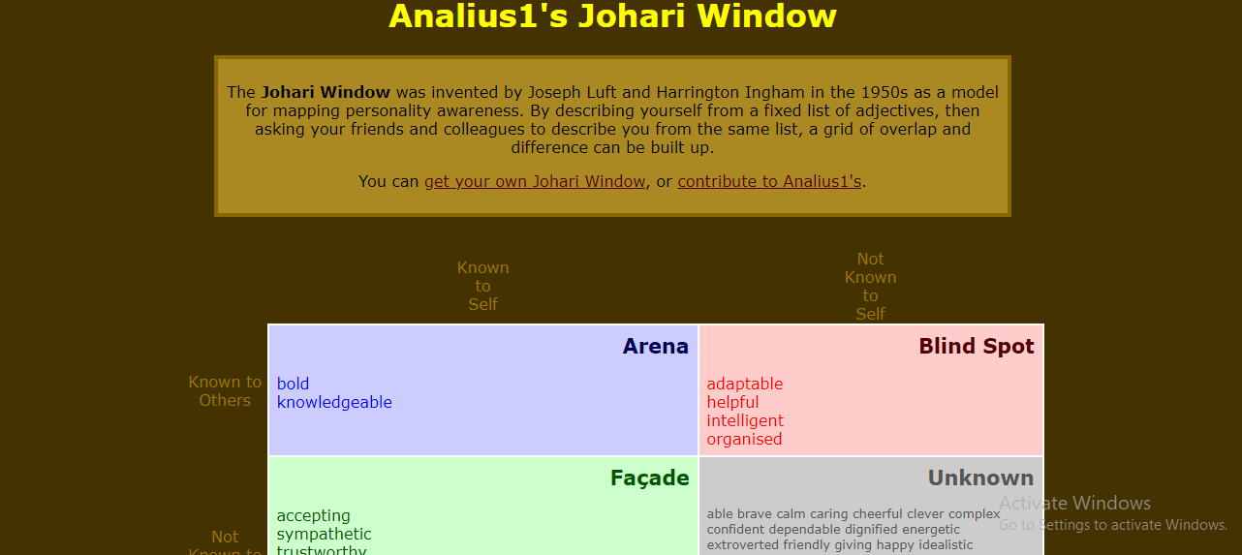
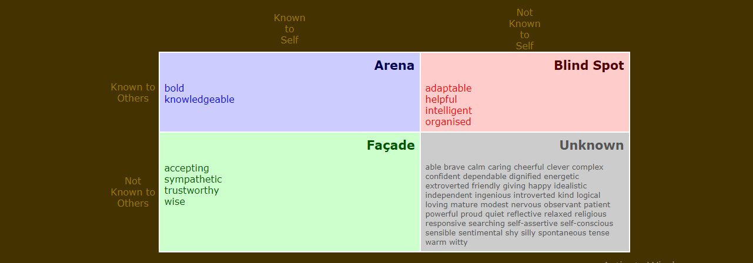
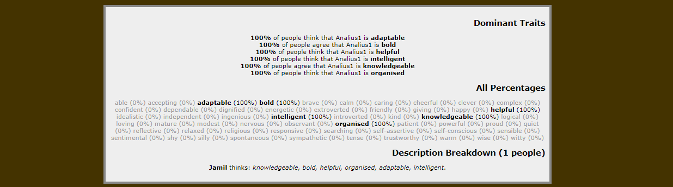

9. Conclusion
Working at Harrods have push me to become better and to achieve the goals I planned for my future, becoming a Human Resouces Manager in the next three years. I want to become a proffesional in this enviroment and to be able to understand the managing techniques that this role requires, also to help and maintain the law and regulations for the company and employers. With the current situation with COVID-19 Human Resouces might have change the employment world in the up coming years the recuirtment for the managers roles at HR can be affected and in consequence it might slow down the recruitment process and that is a motivation I have to gain as much knowledge I can about this role and become the best I can be to be succesful in my future interviews about this role.

References
BusinessBalls, 2017. Businessballs. [Online]
Available at: https://www.businessballs.com/self-awareness/johari-window-model-and-free-diagrams/
[Accessed 4 1 2021].
Dr. Doug Leigh Ph.D., doctorate, 2009. Wiley Online LIbrary. [Online]
Available at: https://onlinelibrary.wiley.com/doi/abs/10.1002/9780470592663.ch24
[Accessed 4 1 2021].
Institute, C. F., 2015. Coporate Finance Institute. [Online]
Available at: https://corporatefinanceinstitute.com/resources/knowledge/other/smart-goal/
[Accessed 4 1 2021].
team, M. t. c., 2020. Mindtools. [Online]
Available at: https://www.mindtools.com/pages/article/newLDR_57.htm
[Accessed 4 1 2021].
University, T. o., 2020. Openlearn. [Online]
Available at: https://www.open.edu/openlearn/ocw/mod/oucontent/view.php?id=28130&section=2.2
[Accessed 4 1 2021].

