Name-Petru Varga 
Student ID-2022595
Lecturer -Dr Ernest Balutie Wavei
BMIH6001
Contemporary Themes in the Hotel and Hospitality Sector

Assignment 01
“Conference Research Paper”
Table of Contents
Introduction 3
Literature Review 4
Application to the Hotel and Hospitality Sector 6
PESTEL Analysis 6
Industry Responses to Sustainability 9
Evaluate Future Policy and Management Options for Sustainability 10
Conclusion 13
References 14

Introduction
Sustainability has become a significant subject in the hotel and hospitality industry due to growing awareness of environmental implications and responsible business practices. Increasing emphasis on sustainable and eco-friendly operations indicates the need to balance economic expansion with ecological responsibility. Climate change, resource scarcity, and waste management are changing customer behaviour and regulatory landscapes, forcing hotels to adopt sustainable operations (Ford.R.C. & Sturman.M.C., 2020). The hotel and hospitality sector contributes to environmental issues by consuming much energy, water, and garbage. Hotels emit much carbon due to their 24/7 energy need for lighting, heating, cooling, and food service. Guest rooms, laundry, and garden water use increase environmental problems. Thus, sustainability initiatives in this industry attempt to reduce operating footprints while ensuring visitor pleasure. Sustainable technologies are popular in the sector due to regulatory demands, changing customer expectations, and economic benefits. Hotels must use renewable energy, reduce trash, and conserve water by tightening environmental restrictions worldwide (Conrady & Buck, 2012). Sustainability is a competitive advantage for businesses as consumers seek ecologically friendly travel options. Economic incentives like energy-efficient technology savings and tax advantages encourage sustainable activities. Sustainability is a current issue that shapes the hotel and hospitality sector, reflecting a broader shift towards responsible tourism.

Literature Review
Introduction to Sustainability in the Hotel Industry
Sustainability has become a significant subject in the hotel and hospitality industry due to environmental awareness and consumer desire for eco-friendly operations. Hotels use sustainable practices to reduce their environmental impact, meet regulations, and improve their brand. These practices emphasise energy efficiency, waste management, water conservation, and renewable energy. Hotel Wrexham illustrates industry sustainability efforts.
Focus Area: Waste Management Strategies
Hospitality waste is a significant issue, including food, packaging, and other throwaway materials. Effective waste reduction can significantly minimise a hotel's environmental impact. Hotel Wrexham recycles and reduces food waste and partners with waste management firms for sustainable disposal.
The Impacts of Waste Management on Hotel Operations
Environmental Impact Reduction: Implementing comprehensive waste management systems in hotels has reduced landfill waste. Filimonau and De Coteau (2019) found that hotels with vital recycling programs may divert 60% of their garbage from landfills. Hotel Wrexham's waste output has decreased due to local recycling organisations. This strategy follows the industry's circular economy trend of reusing resources.

Hotels that reduce waste also reduce greenhouse gas emissions. Landfills produce greenhouse gas methane from organic waste breakdown. Hotels like Wrexham reduce emissions by composting or giving excess food. Pirani and Arafat (2016) found that hotel food waste management can cut greenhouse gas emissions by 50%, making it essential to sustainability.
Economic Benefits: Waste minimisation benefits the economy. Waste reduction and recycling result in lower disposal costs. The Hennchen (2020) case study showed that hotels that reduced food waste might save 40% on waste management. Hotel Wrexham composted food waste to minimise disposal expenses and sell compost to local farmers, generating additional cash. Cost savings can be used for other sustainability projects, boosting a hotel's eco-friendliness.
Challenges and Limitations in Implementing Waste Management
Waste management is complex despite its benefits. The hospitality industry generally lacks recycling and composting infrastructure. Waste reduction projects also need staff training and customer participation. Hotels often struggle to increase recycling participation, depending on communication and disposal facility convenience, according to Jones et al. (2021). Staff and visitors initially resisted Hotel Wrexham's recycling initiative, but training and awareness campaigns helped.
Water Conservation Measures in Hotels
Water conservation is another hospitality sustainability focus. Low-flow fixtures, smart irrigation, and water recycling reduce water usage without affecting the guest experience. Hotel Wrexham uses low-flow showerheads, tap aerators and greywater recycling for landscape watering.
Impacts of Water Conservation on Sustainability
Environmental Impact: Water conservation directly protects local water resources. On average, hotel guests drink 300 litres of water daily (Bohdanowicz & Martinac, 2020). Hotels using water-saving systems can cut water use by 20-30%, relieving local water resources. According to its sustainability reports, low-flow fixtures and smart irrigation have reduced Hotel Wrexham's water consumption by 25%. Water conservation lowers greenhouse gas emissions by reducing water heating energy. Gössling et al. (2018) found that water-saving methods minimise water use and heating carbon emissions by 15%. Energy-efficient water heating systems at Hotel Wrexham have helped the hotel reduce its carbon footprint.
Economic Benefits: Reduced utility bills are a financial benefit of water conservation. Hotels profit from water-saving solutions like greywater recycling. Kolstad and Bull (2019) discovered that hotels with complete water management programs saved 25% on water bills. Greywater irrigation at Hotel Wrexham has reduced landscaping expenditures and saved potable water.
Challenges in Water Conservation Efforts
Water conservation has several benefits, but the upfront expenses of modern water-saving devices are a worry. Intelligent irrigation systems and greywater recycling are expensive for smaller hotels. Radwan et al. (2021) found that smaller hotels struggle to fund such investments. Hotel Wrexham used government grants to finance the implementation of sustainability programs.
Renewable Energy Integration in the Hospitality Sector
Hotels are increasingly using solar panels and geothermal systems. Renewable energy integration supports global carbon reduction and energy independence. Hotels like Hotel Wrexham have installed solar panels and energy-efficient technologies to switch to renewable energy.
Impacts of Renewable Energy on Sustainability Goals
Reduction in Carbon Emissions: Hotels' carbon footprints drop dramatically when they switch to renewable energy. Solar panels can reduce energy costs and emissions by 30%, depending on the project scale (Foster et al., 2017). Solar power provides 35% of Hotel Wrexham's electricity, reducing carbon emissions. This change helps sustainability aims and boosts the hotel's green image.
Cost Efficiency: Renewables save money over time. Despite their high initial cost, solar panels have a five- to ten-year payback (Kumar & Kumar, 2020). Solar panels reduced Hotel Wrexham's electricity costs and gained government subsidies for renewable energy. Savings can be used for other hotel sustainability programs.

Application to the Hotel and Hospitality Sector

PESTEL Analysis
Political Factors
Government Regulations and Policies: Governments worldwide strengthen environmental regulations to minimise carbon emissions, encourage waste management, and enhance renewable energy. Hotels must adopt sustainable solutions to comply with these laws. The UK's Climate Change Act and carbon reporting laws affect Hotel Wrexham's operations (Cooper & Hall, 2019). Hotel Wrexham observes waste management laws and participates in government-funded environmental programs, including solar panel incentives. These programs have encouraged the hotel to invest in green technologies, reducing expenses and environmental impact.
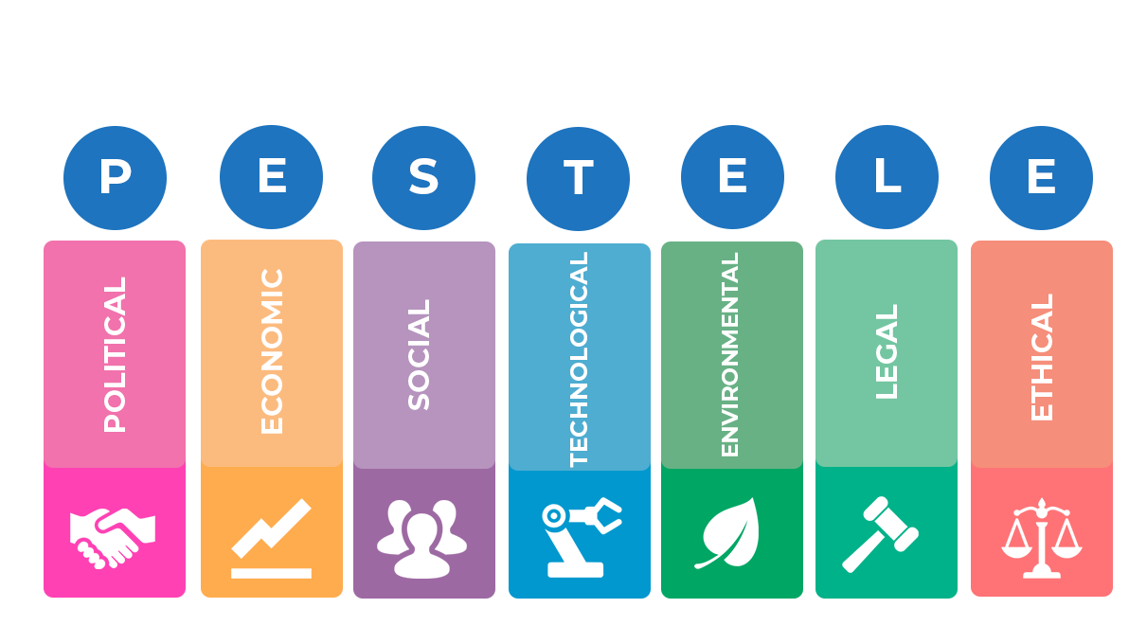
PESTLE analysis model; (Cooper & Hall, 2019)

Industry Standards and Certifications: International standards like Green Key and ISO 14001 are affected by politics. Hotel certifications encourage waste reduction, energy conservation, and water conservation. Hotel Wrexham's Green Key designation affirms its sustainability and reputation. This approach boosts brand reputation and attracts eco-conscious customers. The certification procedure demands ongoing monitoring and reporting, which can be difficult for hotels with limited resources.
Economic Factors
Cost Implications of Sustainable Practices: Hospitality sustainability efforts have expenses and savings. Renewable energy systems, energy-efficient appliances, and waste management initiatives require significant initial investments. Solar panel installation at Hotel Wrexham was expensive. The initial cost may inhibit smaller hotels, but the long-term benefits include lower energy bills and tax rebates (Costa & Costa, 2022). The economic benefits of sustainable practices may vary with market conditions. Renewable energy technology price volatility or government subsidies can affect sustainability investment cost-benefit analyses.
Green Consumerism: Green consumption has affected hospitality's economy. Eco-friendly hotels are gaining popularity, with guests prepared to pay more. Hotel Wrexham has capitalised on this trend by promoting water conservation and renewable energy practices. This technique has helped the hotel attract eco-conscious guests, increasing occupancy and income.
Social Factors
Changing Consumer Preferences: Consumer tastes influence hotel sustainability trends. Green measures are valued by guests, who expect hotels to be environmentally responsible. Hotel Wrexham uses biodegradable toiletries, locally produced cuisine, and energy-efficient lighting to address sustainability (Gowreesunkar, 2021). A rising number of travellers seek sustainable housing options. Social replies boost client loyalty and the hotel's market position. Social sustainability requires personnel training and operational adjustments, making it difficult to achieve.
Corporate Social Responsibility (CSR): CSR has inspired hotels to incorporate sustainability into their social responsibility. Hotel Wrexham partners with local environmental groups and participates in community-based sustainability programs as part of its CSR strategy. Such initiatives boost brand image and community interactions. CSR initiatives may be limited if they are seen as superficial or not incorporated into core business operations.
Technological Factors
Advancements in Green Technology: Technology has helped hotels adopt sustainable practices. Energy-efficient HVAC systems, intelligent lighting, and waste management solutions have helped hotels lessen their environmental effect. A greywater recycling system for landscape irrigation and smart thermostats optimise energy efficiency at Hotel Wrexham. Technology improves sustainability projects, saving money and reducing carbon emissions (S.R., et al., 2021). Hotels may struggle to keep up with technological advances or pay expensive fees to upgrade outdated systems.
Digital Tools for Sustainability Reporting: Digital technologies and software help track and report environmental performance parameters in sustainability reporting. Hotel Wrexham tracks energy, water, and trash with digital platforms. This data-driven strategy helps the hotel improve and be transparent to stakeholders. Technology for sustainability reporting might have drawbacks, such as data accuracy and personnel training.
Environmental Factors
Impact of Climate Change: The hospitality business faces climate change issues like energy use and water availability. Hotels are being pressured to reduce their environmental effect. Hotel Wrexham uses ecological landscaping and solar panels to reduce water and fossil fuel use. These environmental measures help the hotel minimise its carbon footprint and meet global sustainability targets (Brotherton, 2015). While individual hotels can make a difference, systemic reforms are needed to combat climate change.
Resource Scarcity: Environmental factors include water scarcity and non-renewable energy depletion. Hotels use plenty of resources. Thus, resource management is crucial. Hotel Wrexham installed low-flow fixtures and an intelligent watering system to combat water scarcity. These activities help conserve resources, but more dramatic measures are needed in water-scarce areas.
Legal Factors
Compliance with Environmental Regulations: Environmental restrictions require hotels to comply. Therefore, legal concerns drive sustainability measures. Hotels must follow waste, energy, and water-saving laws. Failure to comply can result in fines, legal responsibilities, and reputation damage. Hotel Wrexham follows local and national environmental requirements by separating waste, using energy-efficient building designs, and reporting sustainability (Dawson, et al., 2012). Legal compliance protects the hotel from penalties and boosts its image of responsibility. However, regional laws might be tight, making it difficult for hotel chains to operate in various places. When laws mandate major infrastructure modifications, compliance costs might be significant.
The Role of International Agreements: International agreements like the Paris Agreement affect the law by setting global carbon emission and environmental protection targets. These accords force governments to tighten ecological standards, affecting the hotel business. Being proactive about worldwide environmental goals has helped Hotel Wrexham remain ahead of regulatory changes. However, international agreements might cause regulatory changes to vary, making it difficult for hotels to plan long-term sustainability initiatives.

Industry Responses to Sustainability
Adoption of Sustainable Certifications
Hotels seek eco-friendly certificates as part of their sustainability efforts. Hotel Wrexham's Green Key membership shows its commitment to sustainability. Certification schemes boost credibility, competitiveness, and government incentives (Darcy, et al., 2012). However, certification maintenance resources and "greenwashing," where hotels get certificates without making actual modifications, are constraints.
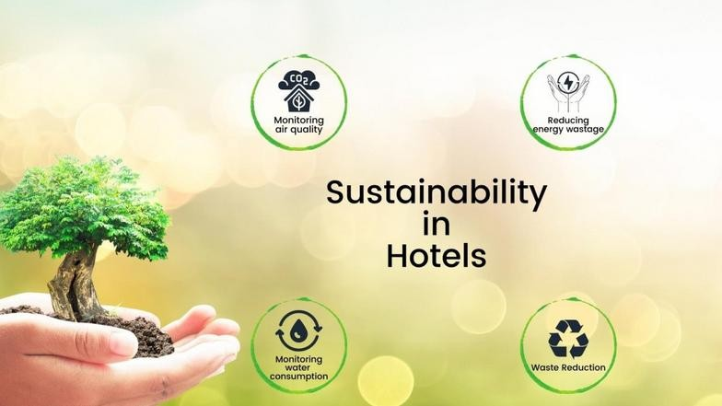
Eco-friendly sustainability; (Darcy, et al., 2012)
Use of Technology for Energy and Water Management
Industry responses to sustainability problems include adopting energy and water management technology. Hotel Wrexham's smart thermostats, solar panels, and greywater recycling demonstrate the sector's technology approach to environmental protection (S. & C., 2005). This approach boosts efficiency, cuts costs, and lowers carbon emissions. However, technology updates are expensive and require continual maintenance and personnel training.
Engagement in Corporate Social Responsibility Initiatives
Sustainability in CSR helps hotels solve environmental and social issues. Hotel Wrexham's CSR efforts include local ecological projects and cooperation with sustainability groups. The benefits of CSR include better community interactions and brand reputation.

Evaluate Future Policy and Management Options for Sustainability
Strengthening Waste Management Policies
Expansion of Circular Economy Practices: Future waste management policies should emphasise circular economy ideas. Reducing waste and recycling or reusing materials are required. Hotel Wrexham might add upcycling to its recycling programmes or work with local businesses to reduce waste. A closed-loop waste management system that composts organic waste and uses it in landscaping would boost sustainability.
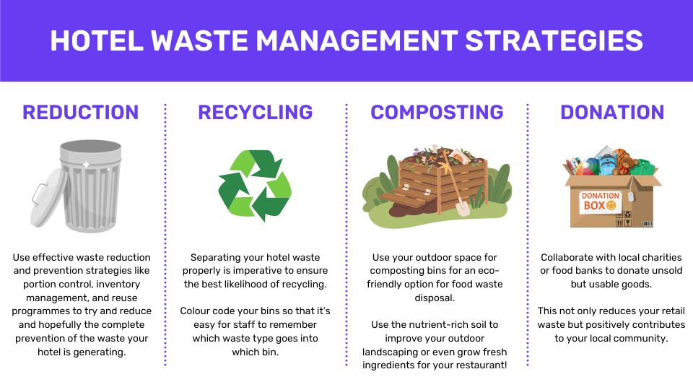
Waste Management; (Faulkner, et al., 2001)
Implementation of Food Waste Tracking Systems: Hospitality struggles with food waste. Innovative food waste tracking systems can detect waste causes and conduct focused reduction initiatives (Faulkner, et al., 2001). Hotel Wrexham might use food waste monitoring technology from preparation to disposal.
Enhancing Water Conservation Measures
Adoption of Smart Water Management Technologies: Intelligent leak detection systems and automated water consumption analytics can boost water conservation. Hotel Wrexham could utilise IoT-enabled equipment to monitor real-time water use and detect leaks and inefficiencies.
Promotion of Onsite Water Recycling Systems: Onsite water recycling solutions can conserve water, like greywater treatment for non-potable usage. Greywater recycling at Hotel Wrexham could include laundry and other high-water-use areas (Ivanov & Webster, 2019). Greywater treatment and recycling for irrigation and toilet flushing would significantly cut municipal water use.
Expanding Renewable Energy Integration
Investment in Emerging Renewable Energy Technologies: Renewable energy sources like solar and wind are essential for carbon reduction. Future policy should invest in energy storage alternatives like batteries to complement solar panel installations. Hotel Wrexham might employ geothermal heating and cooling instead of HVAC equipment to save energy year-round.
Participation in Renewable Energy Programs and Partnerships: Community solar and Power Purchase Agreements (PPAs) with renewable energy providers can improve the environment and finances (Laws, et al., 2007). Hotels in Wrexham could join regional renewable energy cooperatives to get cheap, clean energy and promote local green energy projects.
Improving Policy for Employee Engagement and Training
Development of Comprehensive Sustainability Training Programs: Effective sustainability programs require employee engagement (Santos & Silva, 2019). Staff should get mandated sustainability training on energy reduction, trash management, and eco-friendly guest service. Hotel Wrexham can benefit from role-specific training courses to ensure personnel understand their sustainable impact.
Introduction of Incentive Programs for Sustainable Practices: Sustainable employee incentive programs can encourage personnel to work towards sustainability goals. Hotel Wrexham may measure individual or departmental energy, waste, and water reductions (Mill, 2012). Rewarding staff for their work would promote sustainability and improvement in daily operations.
Strengthening Industry Collaboration and Advocacy
Participation in Industry Sustainability Initiatives: Industry collaboration can accelerate the adoption of best practices. Hotel Wrexham should join sustainability-focused industry groups that advocate for regulatory changes, share innovations, and develop industry standards.
Advocacy for Government Support and Incentives: Advocating for government support and incentives for sustainable practices can boost the industry. Promote tax incentives, subsidies, and low-interest loans for hotels using green technologies. Through industry groups, Hotel Wrexham might advocate for legislation reforms that make sustainable initiatives more accessible, especially for smaller businesses that cannot afford large-scale projects (Robson, 2016).

Conclusion
This paper discusses that sustainability is an acute problem in the hotel and hospitality industry; environmental factors influence it, as well as the growing number of regulations and changing consumer preferences. However, implementing sustainable practices has become critical because of the vast amounts of resources employed and the amount of waste produced by the industry. It operates in different sectors designated as waste and recycling, water, and energy. The various sustainability improvements not only improve the positions of hotels about environmental conservation but also improve general operations. Advanced technologies like intelligent water metering and energy-saving devices save substantial amounts of money in the long run and help win the hearts of people concerned with the environment. Further policies that involve the economy, longevity, and functionality are recommended to focus on more effective waste management, devote comprehensive human resources training, and encourage industrial partnerships for sustainability. The sector can achieve the goal of making green technologies more usable by others by promoting government support and incentives. This paper, therefore, concludes that sustainability forms the basis of the future of the hotel and hospitality industry, hence the need to ensure strict implementation of sustainable practices. Such measures and actions will reduce the environmental effects, improve reputation, and increase customer patronage.

References
Bohdanowicz, P. & Martinac, I., 2020. Determinants and benchmarking of resource consumption in hotels—A case study of Hilton International and Scandic in Europe. Energy and Buildings, Volume 39(1), pp. 82-95.
Brotherton, B., 2015. Researching Hospitality & Tourism. 2 ed. London: Sage.
Conrady, R. & Buck, M., 2012. Trends and Issues in Global Tourism. s.l.:Springer.
Cooper, C. & Hall, M., 2019. Contemporary Tourism: An International Approach. 2 ed. Oxford: Goodfellows.
Costa, V. & Costa, C., 2022. Sustainability and competitiveness in the hospitality industry. Hershey, Pennsylvania: Business Science Reference.
Darcy, S., Ambrose, J. & Bulhalis, D., 2012. Best Practice in Accessible Tourism: Inclusion, Disability, Ageing Population and Tourism. London: Channel View.
Dawson, J., Lemelin, H. & Stewart, E., 2012. Last Chance Tourism: Adapting Tourism Opportunities in a Changing. London: Routledge.
Faulkner, B., Moscardo, G. & Laws, E., 2001. Tourism in 21 Century. Reflections on Experience. London: Continuum.
Filimonau, V. & De Coteau, D., 2019. Food waste management in hospitality operations: A critical review. Tourism Management, Volume 71, pp. 234-245.
Ford.R.C. & Sturman.M.C., 2020. Managing Hospitality. 2nd ed. London: Sage.
Foster, R., Ghassemi, M. & Cota, A., 2017. Solar Energy: Renewable Energy and the Environment. s.l.:CRC Press.
Gössling, S., Hall, C. M. & Peeters, P., 2018. It is time for aviation to reduce its contribution to climate change. Tourism Geographies, Volume 10(1), pp. 01-16.
Gowreesunkar, V., 2021. Tourism destination management in a post-pandemic context : global issues and destination management solution. Bingley, England: Emerald Publishing.
Hennchen, B., 2020. Knowing the kitchen: Applying practice theory to food service sector food waste issues. Journal of Cleaner Production, Volume 225, pp. 1001-1010.
Ivanov, S. & Webster, C., 2019. Robots, artificial intelligence, and service automation in travel, tourism and hospitality. 1 ed. s.l.:Emerald Publishing.
Jones, P., Hillier, D. & Comfort, D., 2021. Sustainability in the global hotel industry. International Journal of Contemporary Hospitality Management, Volume 26(1), pp. 5-17.
Kolstad, C. & Bull, S., 2019. Environmental Economics. Oxford : Oxford University Press.
Kumar, A. & Kumar, N., 2020. Renewable energy for sustainable development in India: Current status, future prospects, challenges, employment, and investment opportunities. Energy, Sustainability and Society, Volume 5(1), pp. 2-8.
Laws, E., Prideaux, B. & Chon, K., 2007. Crisis Management in Tourism. Wallingford: CABI.
Mill, R., 2012. Resorts management and Operations. 3 ed. London: Wiley.
Pirani, S. I. & Arafat, H. A., 2016. Solid waste management in the hospitality industry: A review. Journal of Environmental Management, Volume 146, pp. 320-336..
Radwan, H. R. I., Jones, E. & Minoli, D., 2021. Managing solid waste in small hotels. Journal of Sustainable Tourism, Volume 18(2), pp. 155-170.
Robson, C., 2016. Real World Research. Wiley: Chicheste.
S.R., C., T., S. & .A.L., V., 2021. Project Management: A Value Creation Approach. London: Sage.
S., W. & C., C., 2005. Tourism in the Age of Globalisation. Abingdon: Routledge.
Santos, J. & Silva, Ó., 2019. Digital Marketing Strategies for Tourism, Hospitality, and Airline Industries. 1 ed. Hershey: IGI Global.

