Serena Jonathan (2306363)
[2306363@student.uwtsd.ac.uk]
BSC Computing (Software Engineering)

AdventureWorksCycles’
Database Design &
Implementation

Module: Databases and Application Development

Table of Contents
Adventure Works Cycles 1
Task 1a: Database Design 1
Introduction 1
Entity Relationship Diagram 1
Tables in 3NF (Normalisation Form) 2
1b. Database Implementation: 3
The Rationale Behind ROLLBACK and COMMIT Functions 3
. Performance Tuning Enhancement 6
Conclusion 8
Appendix 8
Bibliography 9

Adventure Works Cycles

Task 1a: Database Design

Introduction
AdventureWorksCycles is a company that specialises in selling bicycles and cycling-related accessories. They offer an extensive range of stock, operating both online and in physical stores to complete customers’ orders. They ensure efficient processing with stock management and supplier correspondence. This report will focus on designing and building a robust database management system. This will include things such as Entity Relationship Diagrams (ERD), check constraints, and rollback and commit operations to assist transactional scenarios.

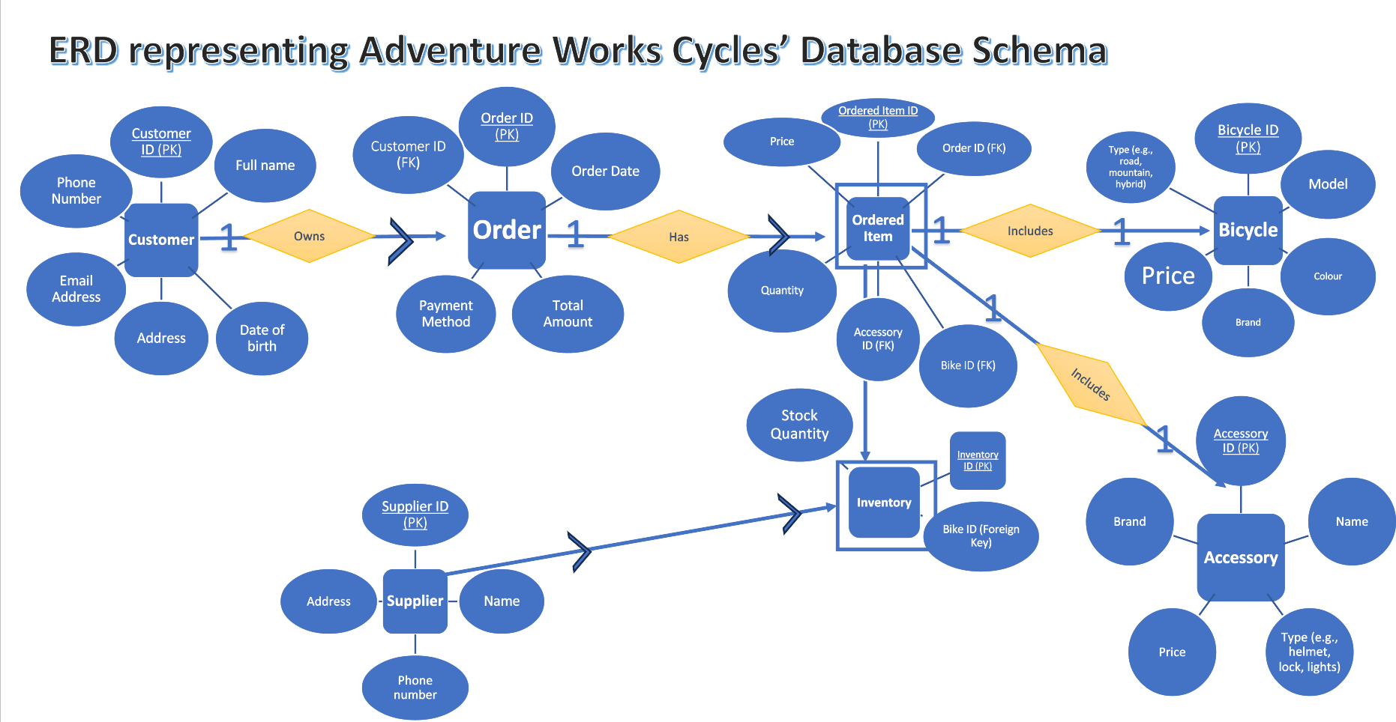
Entity Relationship Diagram

Figure. 1: Entity Relation Diagram Representing Adventure Works Cycles’ Database Schema

The above figure shows an ERD for Adventure Works Cycles. It shows the relationship between entities. It also represents weak entities with square outlines, primary keys with “PK” with underlines and foreign keys with ‘FK.’ The relationship between entities is represented by an arrow or a number one. A ‘1’ and an arrow means that one entity can have many of the entity it relates to. Two ‘1’ means that an entity can have only one of the entities it relates to.

Tables in 3NF (Normalisation Form)
Below are tables made with the process of 3NF normalisation. 3NF normalisation builds on 1NF and 2NF normalization. It reduces redundancy and increases data integrity. It ensures a robust database schema that is efficient and reduces inconsistencies. [1]
The process of 3NF normalisation was a loss-less join. This process was designed to ensure no loss of data. [2] I ensured there was never more than one value in a single cell for efficient readability for those using the database. Relationships between tables are represented by labelling the primary keys (PK) and foreign keys (FK). The design also ensures that each table contains relevant attributes, clearly reflecting the database's structure. It also includes each table having relevant attributes that would easily portray the structure of the database.
For example, within the ‘CUSTOMER’ table, one entity presented is the customer’s details with attributes that include attributes such as ‘CUSTOMER ID’, ‘CUSTOMER NAME’, ‘CUSTOMER DOB’, ‘CUSTOMER PHONE NUMBER’, ‘CUSTOMER EMAIL ADDRESS’ and ‘CUSTOMER ADDRESS’. These attributes are crucial to the way the database is designed as they determine what sort of data is stored and how users can edit it. [3]
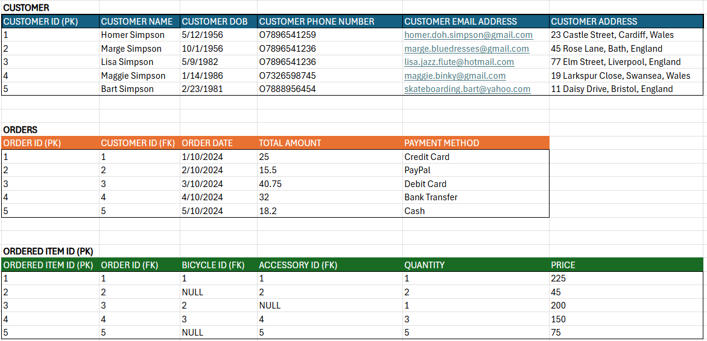
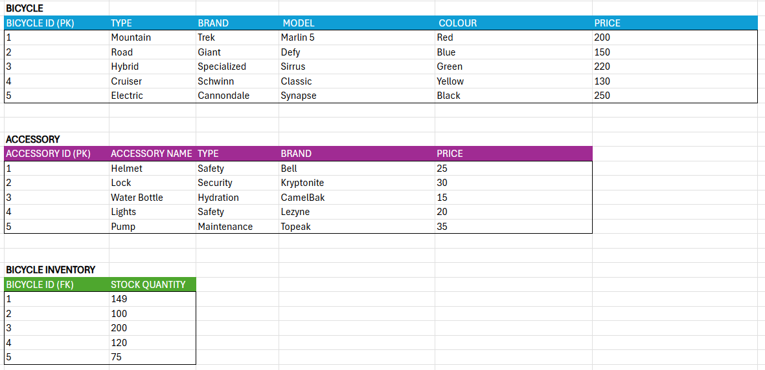
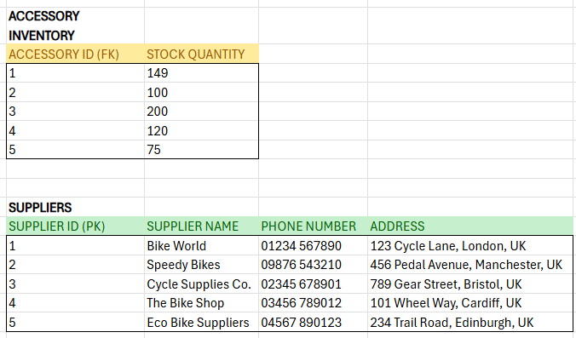

1b. Database Implementation:

The Rationale Behind ROLLBACK and COMMIT Functions
‘ROLLBACK’ and ‘COMMIT’ functions are used with databases during transactions to determine whether the transaction becomes permanent(‘COMMIT’) or not(‘COMMIT’). If it does, changes within the data of tables that are joined will change to accommodate, this is the ‘COMMIT’ function. [4]
When designing code for these ROLLBACK and COMMIT functions, it is crucial to adhere to the ‘ACID’ principles to ensure consistency and accuracy within the AdventureWorksCycles database. ‘ACID’ stands for; Atomicity, Consistency, Isolation and Durability. [5] These four principles are presented in the figure below and are crucial for daily business and transactions that will often be needed by AdventureWorksCycles.
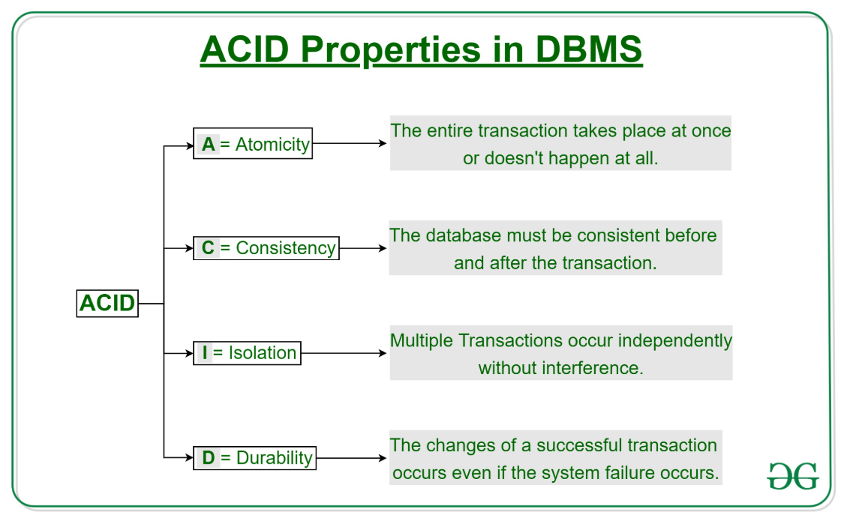
Figure 1: ACID Properties in DBMS [6]

The atomicity principle means that if one check fails and there is a ‘ROLLBACK’, then all transactions will ROLLBACK. The consistency principle refers to the fact that the database should be consistent before and after the transaction. All tables should correlate with one another’s data. [7] Isolation means that multiple transactions can proceed simultaneously without causing database inconsistencies. Each transaction will operate independently. This comes with changes remaining unseen to other transactions until they are committed, and permanent changes are made.
The first transactional scenario where ‘ROLLBACK’ and ‘COMMIT’ functions are used is processing orders. The code ensures that when a customer makes an order, the tables presenting the inventory for bicycles and accessories are adjusted accordingly. This ensures that the data always remains accurate and up to date. It ensures atomicity for the database. [8] This means that all operation during a transaction scenario will either all succeed, or all fail. This prevents partial updates to certain updates which may cause discrepancies.
Additionally, when a new order is made the first step is to update the ‘ODERS’ table, as shown with the code below. It updates the table with details of a new order, before updating the joined tables such as any of the inventory tables or the ‘ORDERED_ITEM’ tables. However, if any of the data inserted is invalid the transaction will ‘ROLLBACK’ and cancel all and any changes to the relevant tables. Thus, data remains consistent.
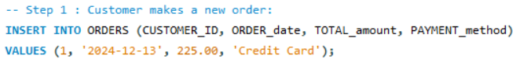
The next step would be to check the ordered items within the made order before updating the ORDERED_ITEM table. Within the code the ORDERS table is joined with the ORDERED_ITEM table. If there is something mismatched within the new order when inserting the items into the ORDERED_ITEM table, the operation will ‘ROLLBACK’ and the data will not be changed. Thus, errors are avoided within the ORDERED_ITEM table. This could include things such as the order including bicycle types that do not exist or accessory brands that the business does not carry.
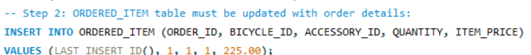
The third and fourth steps are to check for availability within the inventory tables for availability for the items the customer has ordered. Thus, the code shown below checks the BICYCLE_INVENTORY and ACCESSORY_INVENTORY Tables for positive values. If the values are positive, then the transaction will ‘COMMIT’ and the values will decrease accordingly and will adjust the data in all the joined tables. This will be a permanent update. [9]
However, a ‘ROLLBACK’ will take place to cancel the transaction and prevent any changes to the corresponding tables if the stock levels for the ordered items are insufficient to the customer's request. This ensures that AdventureWorksCycles does not process orders they cannot fulfil, helping to prevent customer disappointment. [10]
Therefore, to summarise if the amount of stock for the customer’s item requests is sufficient it will trigger the ‘COMMIT’ operation and update all joining tables accordingly. However, if the stock is not sufficient then a ‘ROLLBACK’ will happen, and the data will not be altered. This automatically ensures that the data remains consistent and accurate while also maintaining atomicity. This reduces human error if the database were to be manually updated and ensures that the database remains a great tool for keeping track of business and carrying out daily operations.
The code is designed so that if some steps have the sufficient values within the data to ‘COMMIT’ the transactional operation, but a further step does not, then all previous ‘COMMIT’ changes will be undone. This means the database will revert to its original state before the transaction trial. This way, data integrity is always maintained as there are no partial updates made to single tables. It is an all or nothing process when validating.
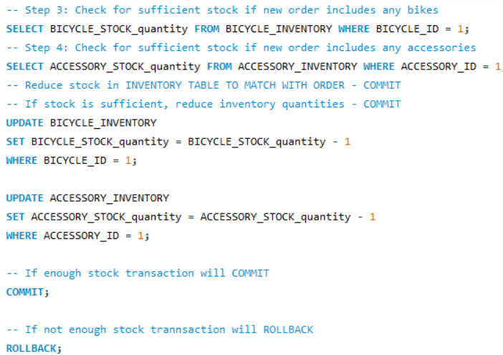
To conclude, the use of the ROLLBACK and COMMIT operations within this transactional scenario ensure the data remains reliable and consistent between updates. It also ensures it adheres to the ACID principles, which are important for a growing business such as AdventureWorksCycles.

Performance Tuning Enhancement
One way to enhance the performance of AdventureWorksCycles’ database would be to improve the way in which queries are executed, especially those which are going to be frequently used. [11] To achieve this, the code focuses on optimising queries that revolve around retrieving data and conducting updates across the various tables. This can include things such as being able to search for data by using personal details or specific attributes such as a customer’s name or a brand of bicycle. This is also known as a secondary index. A secondary index is an efficient way to access data within a database without the necessity to use a primary key to search. Although the primary key will still hold its value and importance. [12] Thus, secondary indexes are used to improve the performance of important data queries.
As an employee will often search for a customer using their name or email address, thus the below code allows this, and when executed, it will present the relevant data. Before a secondary index is completed it is wise to test some search queries, as shown in the code below. The first search query has been executed, which has pulled up ‘Homer’s’ data from the ‘CUSTOMER’ table. It is important to note that there is no need to add secondary indexes to primary keys within the database as they come prefixed with primary indexes due to being a primary key. [13] Secondary indexes, however, are manually instated and can be included at any time. [14]

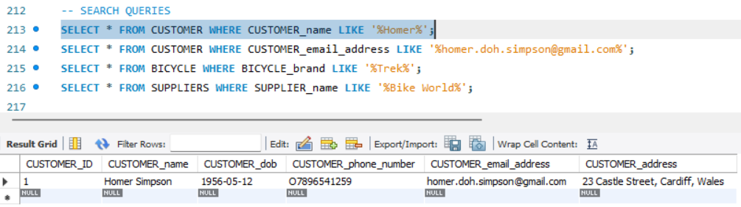

Now, a secondary index is added to the code as shown below to improve performance. There should be a noticeable improvement of efficiency when conducting the search again after implementation of the secondary index.

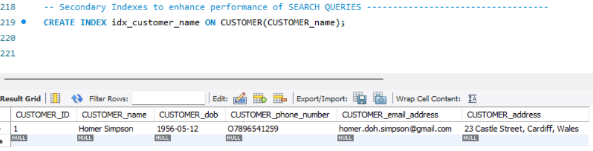

Another common search that AdventureWorksCycles may want to use often is what orders were made by what customers. As some customers may have more than one order, having a query for a customer’s ID or name may be useful when a customer queries about their order. The below search query will carry out this effect.

The below secondary index is added to enhance the performance of this search query and will not pull up the data must quicker.

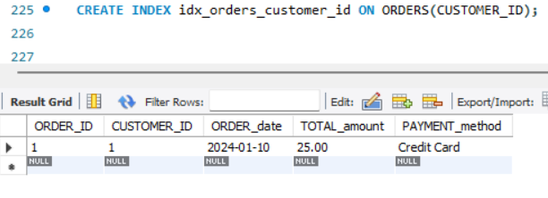

Some employees may enjoy the option of manually checking the ‘INVENTORY’ table even though the ‘COMMIT’ and ‘ROLLBACK’ operations will do this automatically to ensure efficient stock is in place to make orders. Thus, the below search query will allow a manual search of stock for bicycles.

The below secondary index was included to enhance the performance of the above search query.
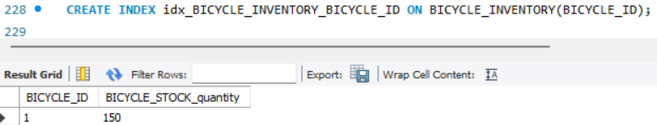

This code is repeated to achieve the same effect with the ACCESSORY_INVENTORY table.

As well as the secondary index to optimise the search:

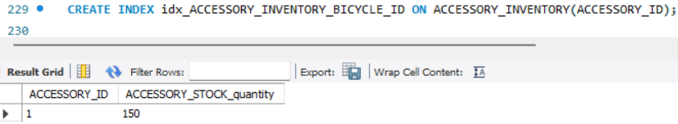

Searching for the date an order was made will also be a common practice. Thus, below is the search query and the secondary index to enhance the time it takes to retrieve the data.

Secondary index:
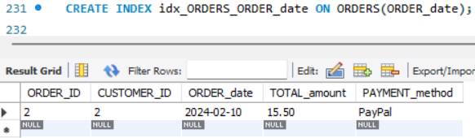

Therefore, secondary indexes are essential for enhancing query speed, especially when filtering data within specific tables.

Conclusion
To conclude, this database design for AdventureWorksCycles will be a useful tool as it uses various techniques such as 3NF normalisation, ACID principles, transactional operations, and secondary indexes. These aspects of the design ensures that the database remains efficient and effective throughout the business’ use. Prioritising data integrity, accuracy and high-speed performance. The database will optimise AdventureWorksCycles operations and support its growth and success.

Appendix
AI Prompts used for assistance within this report:

Prompt: "Review the following SQL code for errors or inefficiencies related to transaction handling with ROLLBACK and COMMIT."

+Prompt: "Generate sample data for the following tables in a bicycle store database: CUSTOMERS, ORDERS, ORDERED_ITEMS, BICYCLE_INVENTORY, ACCESSORY_INVENTORY and SUPPLIER.”

Prompt: "Check the following SQL for syntax errors.”

Prompt: " Why am I receiving an error: CREATE INDEX idx_ BICYCLE_brand ON BICYCLE(BICYCLE_brand);."

Bibliography
[1] M. Upadhyay, “Third Normal Form (3NF) - GeeksforGeeks,” GeeksforGeeks, Jul. 31, 2019. https://www.geeksforgeeks.org/third-normal-form-3nf/ (accessed Dec. 13, 2024).
[2] Venkatesh Gokavarapu, “INTRODUCTION: Lossless decomposition in a database management system (DBMS) is a crucial concept in database design. It involves breaking down a relational schema or table into smaller tables, known as relations, while ensuring that no information is lost during this process.,” Linkedin.com, Sep. 24, 2023. https://www.linkedin.com/pulse/lossless-decomposition-dbms-venkatesh-gokavarapu/ (accessed Dec. 13, 2024).
[3] “What are Attributes in DBMS - An In-Depth Guide!,” Simplilearn.com, Jun. 24, 2024. https://www.simplilearn.com/attributes-in-dbms-article (accessed Dec. 13, 2024).
[4] “MySQL :: MySQL 8.4 Reference Manual :: 17.7.2.2 autocommit, Commit, and Rollback,” Mysql.com, 2024. https://dev.mysql.com/doc/refman/8.4/en/innodb-autocommit-commit-rollback.html (accessed Dec. 15, 2024).
[5] “The Misconception of Relational Database and the ACID Properties | IEEE Conference Publication | IEEE Xplore,” ieeexplore.ieee.org. (accessed Dec. 15, 2024).https://ieeexplore.ieee.org/abstract/document/9826318
‌
[6] A. Kaur, “ACID Properties in DBMS - GeeksforGeeks,” GeeksforGeeks, Jan. 31, 2019. https://www.geeksforgeeks.org/acid-properties-in-dbms/ (accessed Dec. 15, 2024).
[7] L. Frank, “Countermeasures against consistency anomalies in distributed integrated databases with relaxed ACID properties,” Apr. 2011, doi: https://doi.org/10.1109/innovations.2011.5893830. (accessed Dec. 15, 2024).
‌‌[8] N. A. Lynch, “Multilevel atomicity-a new correctness criterion for database concurrency control,” ACM transactions on database systems, vol. 8, no. 4, pp. 484–502, 1983, doi: 10.1145/319996.319999. https://librarysearch.uwtsd.ac.uk/permalink/44WHELF_UWTSD/1ir6fgh/cdi_proquest_miscellaneous_28932859 (accessed Dec. 15, 2024).
[9] barrygolden, “Handling Commit Operations - Windows drivers,” Microsoft.com, Dec. 15, 2021. https://learn.microsoft.com/en-us/windows-hardware/drivers/kernel/handling-commit-operations (accessed Dec. 15, 2024).

[10] M. Sjölinder, “Preventing data loss using rollback-recovery : A proof-of-concept study at Bolagsverket,” DIVA, 2014. https://www.diva-portal.org/smash/record.jsf?pid=diva2%3A682324&dswid=7655 (accessed Dec. 15, 2024).

[11] S. J. Kamatkar, A. Kamble, A. Viloria, L. Hernández-Fernandez, and E. G. Cali, “Database Performance Tuning and Query Optimization,” Springer Link, 2018. https://link.springer.com/chapter/10.1007%2F978-3-319-93803-5_1 (accessed Dec. 16, 2024).

[12] J. Vinish D'silva, R. Ruiz-Carrillo, C. Yu, M. Yousuf, and B. Kemme, “Secondary Indexing Techniques for Key-Value Stores: Two Rings To Rule Them All.” Available: https://ceur-ws.org/Vol-1810/DOLAP_paper_10.pdf (accessed Dec. 16, 2024).

[13] “InfoSphere Optim Data Growth Solution 11.3.0,” Ibm.com, Blog Post. Feb. 16, 2024. https://www.ibm.com/docs/en/iodg/11.3?topic=strategy-analyzing-primary-keys
(accessed Dec. 16, 2024).

[14] “Learn DBMS in 24 Hours,” Google Books, 2022. https://books.google.co.uk/books?hl=en&lr=&id=aPh7EAAAQBAJ&oi=fnd&pg=PT42&dq=WHAT+IS+SECONDARY+INDEXES+DBMS&ots=52LToIrQ1N&sig=kdpyRdS-IvrCQFyIhUum1XUSfgQ&redir_esc=y#v=onepage&q=SECONDARY%20INDEXES&f=false (accessed Dec. 16, 2024).
‌

‌

‌
‌

‌

‌

‌

‌

‌

‌

‌

