Qualification: CIPD Diploma in Applied Human Resources

Module Name: Developing Professional Practice in Human Resources

Activity 2 - Report on CIPD Profession Map

Word Count: 1138

Student Name: Nicola Westcott
Student Number: 1909408
CIPD Membership Number: 55478551

By signing below, I confirm that the work/evidence presented is my own, unaided work. I understand the regulations pertaining to candidate malpractice and the action that may be taken as a result.

Signed: N Westcott
Date: 08/01/2020

Report on CIPD Profession Map

Table of Contents

Content Page

Executive Summary 3

- Introduction 4

- Map design and use 5
2.1 Individuals 5
2.2 Organisations 5

- New CIPD Map 2018 6

- Professional Areas 7
4.1. Core Areas 7
4.1.1 Insights, Strategy and Solutions 7
4.1.2 Leading HR 7

4.2. Functional Areas 7
4.2.1 Organisational design 7
4.2.2 Organisational development 7
4.2.3 Resourcing and talent planning 7
4.2.4 Learning and development 7
4.2.5 Performance and reward 7
4.2.6 Employee engagement 7
4.2.7 Employee relations 7
4.2.8 Service delivery and information 7

- Behaviours 8
5.1 Curious 8
5.2 Decisive thinker 8
5.3 Skilled-influence 8
5.4 Personally credible 8
5.5 Collaborative 8
5.6 Driven to deliver 8
5.7 Courage to challenge 8
5.8 Role model 8

- Bands 9
6.1 Band 1 9
6.2 Band 2 9
6.3 Band 3 9
  - Band 4 9

- Transitions through the bands 9

- Conclusion 10

- Recommendations 10

- Bibliography and Referencing 11

List of Figures

Figure 1: CIPD HRPM 2013 5
Figure 2: CIPD HRPM 2018 6

Executive Summary

The aim of this research report is to explain how the CIPD HRPM professional areas and bands define the HR profession and why the HRPM behaviours are essential to be an effective HR professional.

Being a professional in any career is someone who undertakes their role to a high standard. This can be broken down into four areas or circles. Firstly, to be a professional you must be able to manage your own skills, knowledge and behaviour. To move to the next level of professionalism you must be able to manage groups and teams. The next level is to manage upwards by integrating plans and strategies. The final level is to manage across the organisation, by communicating effectively to influence line managers of the benefit of these strategies.

The 2013 CIPD HRP map is designed and built with these ideas in mind. The CIPD membership levels also reflect this:
Associate Level is consistent performance at Band 1, ready to move to Band 2
Chartered Member is consistent performance at Band 2 ready to move to Band 3
Chartered Fellow is consistent performance at Band 3, ready to move to Band 4.

The majority of HR Professionals in the UK are members of the CIPD, which is the only professional body currently operating in the HR area (Taylor and Woodhams 2016). The CIPD sets out standards of conduct for the HR profession.

The map can be used to improve performance and confidence, by helping individuals make decisions. Assessing and building on team capabilities, which leads to organisational change and improved performance.

The metholodgy used in this report included the gathering of secondary and primary data. Secondary data was captured through literature review of the CIPD map and primary data through undertaking a self-assessment of the map in order to gain insight and understanding of the map, professional areas, behaviours, bands and the transition through the bands.

Following this report recommendations will be made to all HR team members to assess themselves against the CIPD HRPM to identify any development needs in order to put a development plan in place for CPD purposes.

3
1.Introduction

Since its launch in 2013, the CIPD Profession Map has set out standards for HR professionals around the world. Continual research and collaboration have ensured that the map is updated with what is required at each career stage of the most successful HR professionals. The map can be used as a tool by HR Professionals and organisations to build capability, credibility, achievements are recognised through professional qualifications, areas of success or areas requiring improvement are identified, which in turn help to define a great HR.

4
2. Map design and use

The following design principles were used when developing The Profession Map.
The map identifies ten professional areas and eight behaviours, split over four bands of professional competence. It describes what activities you need to do, and knowledge required for each area across the four bands of competence. It describes the behaviours a HR professional needs to carry out their activities. Each behaviour is shown across the four bands of professional competence. The map is relevant to HR professionals at all levels and describes how to transition from one band to another throughout an individual career.

Figure 1 CIPD HRPM, source, (2015)
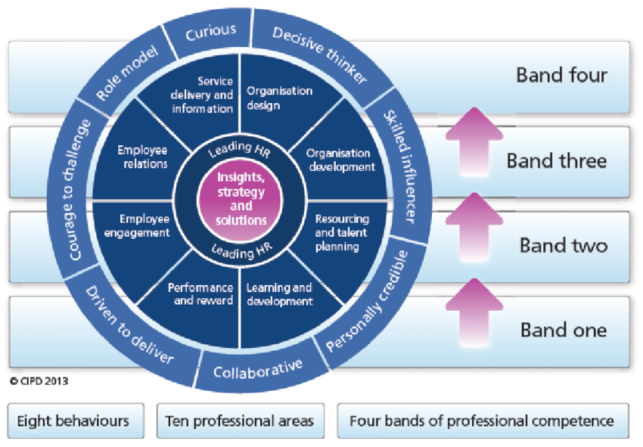

2.1 Individuals

Individuals can benefit from using the map for CPD organisation and planning, appraisal preparation, preparation for CIPD membership, career progression, building a case for development, increase knowledge of the profession and interview preparation.

2.2 Organisations

Organisations can benefit by being able to identify skills required to make change happen, developing career pathways for teams and individuals, identify team’s capabilities and areas for development, focusing on behaviours needed for success, build a competency framework, role profiles, and development programmes.

5
3. New HR Profession Map 2018

In 2018, the CIPD updated its profession map to reflect how the role of the HR professional will change in the future.

Chief executive Peter Cheese said, ‘he wanted the new framework to help build confidence and trust in business and the profession and ultimately enable our wider purpose of championing better work and working lives. The world of work is changing fast. New roles, new skills and ways of working are emerging, along with different, more diverse organisational models – and with them, the role and capabilities of the people profession are changing too’ (Cheese / CIPD (2018).

Figure 2 CIPD HRPM, source, (2018)

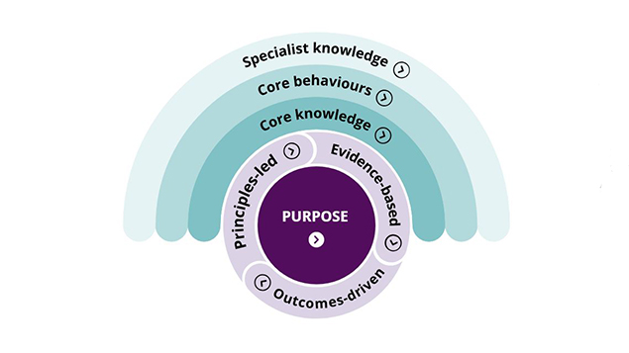

6
4. Professional Areas

There are two core professional areas which sit at the centre of the profession and eight additional professional areas of the CIPD HRPM.

4.1 Core Areas

4.1.1 Insights, strategy and solutions

Understanding the organisation and tailoring strategy and solutions to meet the needs of the organisation.

4.1.2 Leading HR

Support and develop others by acting as a role model to maximise contributions.

4.2 Functional Areas

4.2.1 Organisation design

Ensure organisational design is appropriate to ensure maximum efficiency.

4.2.2 Organisation development

Identify individual and organisational skills to achieve targets, change cultures and behaviours.

4.2.3 Resourcing and talent planning

Ensure correct resourcing, talent to achieve immediate and future goals.

4.2.4 Learning and development

Create a learning culture to meet strategic requirements.

4.2.5 Performance and reward

Recognise employee skills, performance by reward schemes.

4.2.6 Employee engagement

Ensure employees are fulfilled by their work which encourages greater contribution.

4.2.7 Employee Relations

Ensure appropriate management underpinned by relevant law, procedures and culture.

4.2.8 Service delivery and information

Ensure customer focused service and meaningful analytics to improve business.

7
5. Behaviours

Eight behaviours are identified by the HRPM that a HR professional needs to carry out their activities. There are both positive and negative aspects to each behaviour, however all are essential at some point for career development in order to be an effective HR professional

5.1 Curious

Seeks out new improved ways to add value to the organisation, by being open minded and inquisitive e.g. someone who wants seeks new improved ways of completing tasks. However, is focused on present and past, can fail to ask questions, often takes information at face value and rejects ideas without reflection.

5.2 Decisive thinker

Can analyse data/information quickly and use in a structured way in order to make
decisions and recommendations e.g. someone who only focuses on their department. Can have a narrow focus, makes errors in analysing data and looks at symptoms not causes.

5.3 Skilled influencer

Has the ability to influence stakeholders in order to gain support and commitment e.g. researches and presents a new procedure. Does not take views of other into account or understand the impact on others.

5.4 Personally credible

Delivers expertise and professionalism that brings value to the organisation and stakeholders e.g. someone reliable who always ensures deadlines are met. May apply HR knowledge without considering the organisational requirements, does not share expertise with others.

5.5 Collabrative

Brings diversity by including and working with a range of individuals both inside and outside
the organistion e.g. working with different departments to introduce new procedures. However, can withhold information and expertise from others.

5.6 Driven to deliver

Resourceful and determined in order to always deliver the best for the organization e.g. when targets need to be met. Does not always prioritise and finds it difficult to meet changing deadlines.

5.7 Courage to challenge

Prepared to challenge others with confidence e.g. someone who is prepared to challenge management decisions, however can come across as stubborn and blames others if things go wrong.

5.8 Role model

Has integrity, independence and impartial views and leads by example e.g. someone who always considers the impact on others, however can act inconsistently and may not consider impact on others. 8
6. Bands

Four bands of professional competence define what contribution that HR professionals make during their career, by defining where time is spent, what relationship and service they provide and how the contribution they make is measured and skill balance.

6.1 Band 1

Is customer focused, effectively manages data and information and supports the administration process. Contribution measured by efficiency. Skill balance = behavioural 30, technical 70.

6.2 Band 2

Advises/manages individual or team issues by evaluating solutions. Measured by problem solving. Skill balance = behavioural 50, technical 50.

6.3 Band 3

Leads professional areas, addresses challenges by providing ideas, solutions. Measured by being part of leadership team. Skill balance = behavioural 60, technical 40.

6.4 Band 4

Leads the HR function by understanding the organisation and client’s needs and developing plans to suit these. Measured by being highly sought after. Skill balance = behavioural 80, technical 20.

7. Transitions through the bands

During an individual’s career they will progress though the bands, in order to do, so tasks will be relinquished by learning to trust others, focus turns to broader issues, communication skills, influencing skills are improved and relationships are built in wider circles. Understanding the organisation and industry.

9
8. Conclusions

It is evident that the CIPD HRPM map is a useful tool in the career of all HR professionals. The areas, behaviours and bands, the map covers can identify development needs and aids an employee career development plan, enabling them to plan their CPD to become an effective HR Professional.

9. Recommendations

9.1 All members of the HR team undertake a self-assessment on the CIPD Professional Map to identify any personal development needs.

10
10. Bibliography and Referencing

CIPD (2019) CIPD Profession Map. Available at: https://www.cipd.co.uk/learn/career/profession-map (Accessed: 22nd December 2019).

CIPD (2019) 2013 CIPD Profession Map FAQ’s Available at:
https://www.cipd.co.uk/learn/profession-map/2013-profession-map/faqs (Accessed: 22nd December 2019).

CIPD (2019) The CIPD profession map: a guide Contents. [PDF] Available at: https://www.google.co.uk/url?sa=t&rct=j&q=&esrc=s&source=web&cd=1&cad=rja&uact=8&ved=2ahUKEwi8tKfch8nmAhXColwKHQF8D6sQFjAAegQIAhAC&url=https%3A%2F%2Fwww.cipd.co.uk%2FImages%2Fthe-cipd-profession-map-accessible-format_tcm18-(Accessed: 22nd December 2019).

Personnel Today (2018) CIPD unveils new HR profession map at annual conference By Jo Faragher And Ashleigh Webber on 7 Nov 2018. Available at: https://www.personneltoday.com/hr/cipd-unveils-new-hr-profession-map-at-annual-conference (Accessed on 22nd December 2019).

Johns, T. and Perkins, G. (2016) ‘Developing Professional Practice’, in Taylor, S. and Woodhams, C. (ed) Studying Human Resource Management. 2nd ed. London: Chartered Institute of Personnel and Development.

Woodhams, C., Perkins, G. and Wilkinson, K. (2016) ‘Developing the Knowledge and Skill of the HR Professional’, in Taylor, S. and Woodhams, C. (ed) Studying Human Resource Management. 2nd ed. London: Chartered Institute of Personnel and Development.

XpertHR. Taylor, B. (2017) HR careers survey 2017 [Podcast]. 13th October. Available at: https://www.xperthr.co.uk/audio-and-video/podcast-hr-careers/162518/?cmpid=ILC|PROF|HRPIO-2013-110-XHR_free_content_links|ptod_article&sfid=701w0000000uNMa (Accessed: 28th December 2019).

11
Qualification: CIPD Diploma in Applied Human Resources

Module Name: Developing Professional Practice in Human Resources

Activity 4 - Report on Team Dynamics

Word Count: 1133

Student Name: Nicola Westcott
Student Number: 1909408
CIPD Membership Number: 55478551

By signing below, I confirm that the work/evidence presented is my own, unaided work. I understand the regulations pertaining to candidate malpractice and the action that may be taken as a result.

Signed: N Westcott
Date: 08/01/2020

Report on the Concept of Team Dynamics

Table of Contents

Content Page

Executive Summary 3-4

- Introduction 5

- Features of effective teams 6
2.1 Identity 6
2.2 Shared values 6
2.3 Complimentary skills 6
2.4 Complimentary roles 6
2.5 Leadership 6
2.6 Clear roles 6
2.7 Ground rules 6
2.8 Celebrate success 6
- Group Dynamics 7

  - Action orientated roles 7
3.1.1 Shaper 7
3.1.2 Implementer 7
3.1.3 Completer Finisher 7
  - People orientated Roles 7
3.2.1 Co-ordinator 7
3.2.2 Team worker 7
3.2.3 Resource investigator 7

  - Thought orientated roles 7
3.3.1 Plant 7
3.3.2 Monitor evaluator 7
3.3.3 Specialist 7

- Team development 8
- The importance of team building exercises 8

- Key management skills 9

6.1 Influencing 9

6.2 Negotiating 9

6.3. Conflict resolution 9
6.3.1 Competing 9
6.3.2 Accommodating 9
6.3.3 Avoiding 9
6.3.4 Compromising 10
6.3.5 Collaborating 10

- Organisational Politics 11

- Conclusion 12

- Recommendations 13
- Bibliography and Referencing 14

List of Figures

Figure 1: Tuckman’s model 8
Figure 2: Thomas-Kilmann model 9

Executive Summary

The aim of this research report is to explain the concept of team dynamics, political behaviour in organisations and how it can impact on the achievement of organisational objectives.

Teamwork is an essential part of any department or organisation. Being part of a team, employees feel a sense of purpose and working towards a common goal can increase productivity levels. Teams are dependent on individual and group contributions. Ensuring the team consists of the right role profile can aid an organisations recruitment and retention.

People working in an effective team feel the working atmosphere is better due a sense of camaraderie, less pressure as tasks are shared which result in improved morale and increased job satisfaction. A truly strong team welcomes external viewpoints and criticisms, and ensures it stays in touch with its customers, stakeholders and markets, by avoiding complacency.
Engaging with team members, by asking their thoughts and ideas can lead to improved creativity, leading to improved job satisfaction, which in turn can help meet the organisations objectives. It is important that HR professionals are successful at influencing others in order to bring about organisational change. Team building exercises can highlight how taking responsibility and providing responsibility are both critical contributors in team performance.
Although conflicts will arise on occasions, it is important for HR professionals to acquire teamwork skills, be aware of the features of an effective team and how to deal with any conflicts that arise. This will assist in ensuring an effective team is developed, leading to increased organisational performance.
Organisational politics is found in most organisations where individuals seek personal gain by aligning themselves with key individuals and trying to influence decisions. Politics can have a positive effect (collaborative) or a negative effect (destructive and competitive) on the organisation. Negative effects lead to a decrease in productivity due to low morale, increased turnover, increased stress levels. Positive effects can be improved relationships between individuals, decision making can be less formal which can lead to organisational change.

Examples of successful teams are care homes, hospital and surgical teams where it is essential that members work together in order to achieve the best possible outcome. In a surgical team each member has their own responsibilities and must work together collaboratively in order to make effective decisions, to achieve safe surgical care i.e. a win-win situation.

Personally, I feel that I am part of a successful team where our goal each month is to process the payroll accurately and on time. Being responsible for the payment to 1350 employees, involves all three members of the team undertaking their relevant roles, working together, for the BACS to be processed by the tight deadline each month. This involves clear communication, covering any absences, asking for or assisting when necessary, or dealing with any unexpected issues along the way.

I was also recently a member of a project team a few months ago, working on a major system upgrade on the HR/Payroll system that the Service utilises.

3
The metholodgy used in this report included the gathering of secondary and primary data. Secondary data was captured through literature review of team structure and dynamics and
primary data through undertaking a self-assessment as a team-member in order to gain insight and understanding of the team roles.

Following this report recommendations will be made to Heads of Departments and team leaders in the organisation to undertake team role questionnaires to identify roles of team members and identify any gaps which can be filled by putting the appropriate development plan in place.

4

1. Introduction

Teams naturally occur in organisations and are when a set of individuals have complimentary skills and work towards the same goal. (Watson and Reissner 2014).

Professionals in all organisations, including HR professionals must be able to work effectively with colleagues, not only in their own function but individuals across the whole organisation. This is crucial in order to maintain productivity and motivation.

According to Huczynski and Buchanan (2010), teams can include:
- advice teams
- action teams
- project teams
- production teams

Structure and size of teams can vary significantly, and HR professionals may be a member of many different teams working with a range of stakeholders simultaneously.

5
2. Features of effective teams
2.1 Identity
Effective teams have a clear identity, this can include name, uniform, colour scheme, meeting place.
2.2 Shared values
In successful teams, members share similar values and work towards a common goal/task.
2.3 Complementary skills
Each team members skill set is recognised and valued, all members are included and have a sense of responsibility.
2.4 Complementary roles
According to Belbin’s well-known theory, there should be a balance of key roles e.g. completer-finisher, shaper. Too many of the same role, or gaps, will affect the team’s performance.
2.5 Leadership
Effective teams have clear leadership, this does not always mean a clear leader, some teams can be self-managing.
2.6 Roles and responsibilities
Team members accept responsibility for their role/contribution but also have collective responsibility. Knowing who is responsible for what in terms of task completion ensures target are met.
2.7 Ground rules
A set of ground rules provides team discipline. How it deals with internal conflict, decisions, tasks, enables the team to function effectively.
2.8 Celebrate success
A strong team should celebrate its successes, this reaffirms the team’s identity and shows strength and unity to others.

6

3. Group Dynamics

HR professionals need to understand the presence of different individuals to create an effective team. Kurt Lewin noted that ‘group dynamics describes the effects of these roles and behaviours on other group members, and on the group as a whole’ (Mind Tools).

As mentioned earlier, Belbin discovered teams consisting of many people with the same strength do not perform well, therefore a mix of roles helps create an effective team, he grouped these into three orientated roles.
3.1 Action-oriented roles

3.1.1 Shaper
Encourages the team to improve, is goal focused and thrives on pressure, however can offend individuals.

3.1.2 Implementer
Is a doer, turns ideas into action, but can be inflexible and slow to respond to new ideas.

3.1.3 Completer finisher
Conscientious, ensures timely completion, has an eye for detail, however can be reluctant to delegate and is a worrier.

3.2 People-oriented roles

3.2.1 Coordinator
Effectively delegates, is confident, able to identify talent, however can be manipulative.

3.2.2 Team worker
Diplomatic, helps build harmony in a team, co-operative, however avoids confrontation and can be indecisive.

3.2.3 Resource investigator
Outgoing and enthusiastic but can lose interest quickly once the initial enthusiasm has passed.

3.3 Thought-oriented roles

3.3.1 Plant
Presents new ideas and approaches, however can be a poor communicator.

3.3.2 Monitor-evaluator
Are objective and analyses options but lacks ability to inspire others.

3.3.3 Specialist
Provides specialised knowledge and skills but can be narrow minded and too technical.

7
4. Team development

It has been long established that teams go through predictable developmental stages. One of the best-known models of this is Tuckman’s (1965) five stage model of forming, storming, norming, performing and adjourning. This model shows that the path taken is not always a smooth process.

Figure 1 Tuckman’s Model, source, mspguide.org

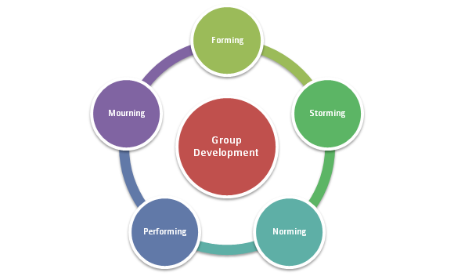

5. The importance of team building exercises
‘Team building can play a huge part in strengthening a corporate culture and a great tool in achieving an efficient organisation. It can balance the five key elements of a productive team: leadership, roles, goals, policies, procedures, and relationships’ (HRM May 2017).

Team building exercises provide invaluable insight into how employees perform together, tasks can be set with organisational objectives in mind. It's an opportunity to engage with employees regarding ideas for improvement. This sense of unity means employees are less likely to leave the organisation. Conflicts that arise on occasions, can be managed through team building activities designed to enhance relationships.

Taking people out of their comfort zone encourages them to work together in different ways, improving problem solving skills which is transferrable to the work environment. Morale can be improved by removing the usual role segregation by bringing together people that may not normally work closely together. Team building exercises can bring fun to the workplace and research has shown that higher productivity can be achieved when fun is involved.

8
6. Key management skills

Aspiring managers must have the necessary skills to facilitate the team’s potential.

6.1 Influencing
According to Yemm (2008) effective influencers should have knowledge, expertise, be empowered, friendly, have vision, and the ability to network/bargain.
6.2 Negotiating
The purpose of negotiation is to reach an agreement on a course of action. A ‘win-win’ outcome is the best result, however there must be a degree of compromise on both levels.
6.3 Conflict Resolution
Conflict is inevitable in teams on occasions, the Thomas-Kilmann model of conflict resolution identifies five options of managing.
Figure 2 Thomas-Kilmann Model, source, Kilmanndiagnostics.com
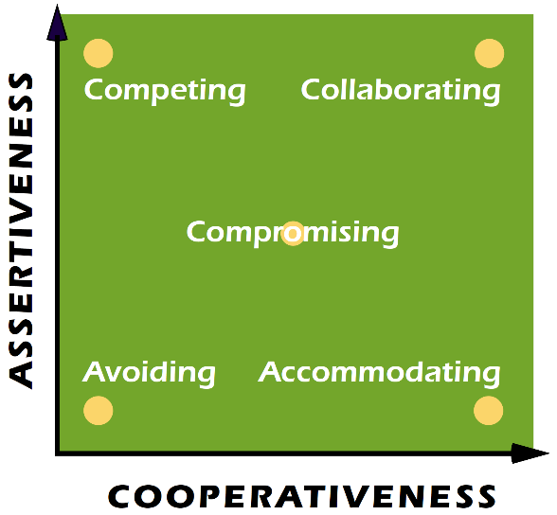
6.3.1 Competing
An assertive and un co-operative approach is taken, defending your position and standing up for your rights.
6.3.2 Accommodating
An unassertive and co-operative approach, selfless generosity or giving in to another’s point of view.
6.3.3 Avoiding
An unassertive and un co-operative approach, possibly sidestepping or postponing an issue, or simply avoiding the situation.
9
6.3.4 Compromising
To some extent both assertive and co-operative by seeking the middle ground.
6.3.5 Collaborating
The belief it is possible for both sides to have a win-win situation, a willingness to listen and being creative in solutions.

10
7. Organisational politics
According to Horn (2009) organisational politics are ‘Taking a particular view or position with the intention of personally gaining from that position’.
Organisational politicians are people who get things done by identifying stakeholders and aligning their image with people with power. By networking and making deals to support others where there is a mutual benefit. Often information is withheld recognising that knowledge is power. Decisions are often made before meetings take place in order to influence weaker people during negotiations.
Elements of organisational politics exist in any organisation, however to keep politics at an acceptable level, organisations should be transparent in its management, ensuring issues are debated fully, differences of opinion dealt with and disagreements depersonalised. Acting politically sensitively by understand how things are done, who makes key decisions, what is going on behind the scenes, are there any hidden agendas.

11
8. Conclusions

Complexity of human interactions means there is still a long way to go to create a consistent, reliable and effective team, however having a team consisting of a diverse range of individuals with different skills, knowledge and life experiences will always be an asset to any organisation. Therefore, understanding team dynamics, identifying any development needs and effectively dealing with conflict is essential in developing professional practice.

12
9. Recommendations

9.1 Recommendation 1

Complete a Belbin team type questionnaire to assess team members roles.

9.2 Recommendation 2

Introduce regular team building exercises.

13
10. Bibliography and Referencing

Belbin, M. (no date) Belbin’s Team Roles. [online] Available at: https://www.belbin.com/ (Accessed 7th January 2020).

CIPD (2014), Lamb, P., Building the best team (04 Nov 2014) [Podcast] Available at:
https://soundcloud.com/cipd/podcast-95-building-the-best-team (Accessed 4th January 2020).

CIPD (2017), Miller, J. Overcommitted? Working across multiple teams. In a Nutshell, issue 70 (21 Sept 2017) [Article review] Available at: https://www.cipd.co.uk/news-views/nutshell/issue-70/multiple-teams (Accessed 08/01/2020).

CIPD (2019), Baczor, L. Workplace politics and employee voice. In a Nutshell, issue 87 (19 May 2019) [Article review] Available at: https://www.cipd.co.uk/news-views/nutshell/issue-70/multiple-teams (Accessed 08/01/2020).

Fletcher, C and Hartley, J (2008) Political skills, People Management

Horn, R. (2009) The Business Skills Handbook. London: Chartered Institute of Personnel and Development.

HRM (2017) The Importance of Team Building in HR Management (12 May 2017)
Available at: http://www.hrmguide.co.uk/relations/team-building.htm (Accessed 4th January 2020).

Huczynski, A. A. and Buchannan, D.A. (2010) Organizational behavior. 7th ed. London: FT/Prentice Hall.

Johns, T. and Perkins, G. (2016) ‘Developing Professional Practice’, in Taylor, S. and Woodhams, C. (ed) Studying Human Resource Management. 2nd ed. London: Chartered Institute of Personnel and Development.

Mind Tools (no date). Improving Group Dynamics: Helping Your Team Work More Effectively. [online] Available at: https://www.mindtools.com/pages/article/improving-group-dynamics.htm. (Accessed 5th January 2020).

Watson, G.and Reissner, S. (2014). Developing Skills for Business Leadership. 2nd ed. London: Chartered Institute of Personnel and Development.

Woodhams, C., Perkins, G. and Wilkinson, K. (2016) ‘Developing the Knowledge and Skill of the HR Professional’, in Taylor, S. and Woodhams, C. (ed) Studying Human Resource Management. 2nd ed. London: Chartered Institute of Personnel and Development.

Yemm, G (2008) Influencing Others – a key skill for all. Manangement Services. Summer. Vol 52 No 2, pp21-4. [pdf] Available at: https://www.ims-productivity.com/user/custom/journal/2008/Summer/MSJ14Summer2008.pdf (Accessed: 7th January 2020).

14

