2/13/2020
Finley Clarke
University of Wales Trinity Saint David
Analysis of System Requirements
INFORMATION ENGINEERING

Table of Contents
SECTION ONE: ASSUMPTIONS MADE 2
SECTION THREE: ENTRY RELATIONSHIP DIAGRAM 3
SECTION FOUR: FLOWCHARTS 4

SECTION ONE: ASSUMPTIONS MADE

The following libraries have been taken to the system’s design. These are:

- A Staff registration list has been designed should the company require it. This list includes full names, company positions, plus their ID number for easier identification.
- A Store menu has been added to the system so that they can be viewed and also altered by staff and managers should it be required.
Clear and easy to read.
No annotation of relationships.
Price to price??
Store menu, ingedients??

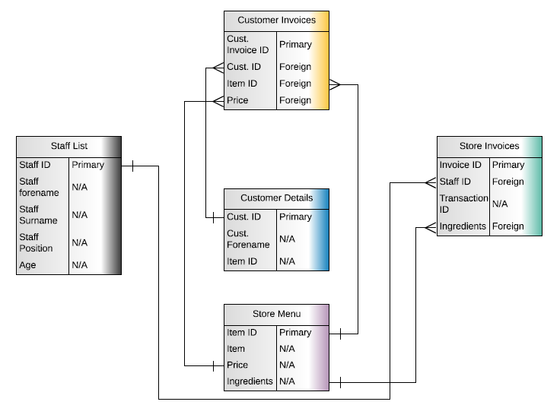
SECTION TWO: ENTRY RELATIONSHIP DIAGRAM

Clear and easy to read.
You have external to external flow and datastore to external.
You are missing a level 0.
Diagram a bit too brief – dataflows missing

SECTION THREE: FLOWCHARTS



