University of Whales Trinity Saint David


Financial Management
Assignment 1

Submitted by
Pavlin Petkov Hristov
(2023214)

MBA 2021/2022
Lecturer: Jiao Miao

Brief History of Experian

Experian plc is an UK-Irish multinational consumer credit reporting company. The company collects and process information of more than one billion people and businesses.
The company is based in Dublin, Ireland and operates in 37 countries. Around 17,000 people are working in the company. Experian reported revenue of $5.18 billion for the fiscal year ended in March 2020. The company is listed on the London Stock Exchange and also listed in the FTSE 100 Index
Experian is a partner in the U.K. government's Verify ID system and USPS Address Validation. It is one of the "Big Three" credit-reporting agencies, alongside TransUnion and Equifax.
Along with its credit services, Experian also sells analytic and marketing assistance to business. The services that consumers can use include access to credit history and products meant to protect from scam and identity theft.
The Fair and Accurate Credit Transactions Act of 2003, signed into law in 2003, amended the FCRA to require the credit reporting companies to provide consumers with one free copy of their credit report per 12-month period. Like its main competitors, TransUnion and Equifax, Experian markets credit reports directly to consumers. Its market segmentation tool, Mosaic, is used by political parties to identify groups of voters. In the British version there are 15 main groups, broken down into 89 hyperspecific categories, from "corporate chieftains" to "golden empty-nesters" which can be taken down to the level of individual postcodes. It was first used by the Labour Party, but then taken up by the Conservatives in the 2015 General Election campaign.

On 1 October 2015 Experian announced that they had discovered a data breach existing between 1 September 2013 and 16 September 2015. As many as 15 million people who used the company's services, among them customers of American cellular company T-Mobile who had applied for Experian credit checks, may have had their private information exposed.

In 2020 it was revealed that Experian had suffered a further data breach, on this occasion in South Africa. Initially, Experian claimed that the incident had been contained but subsequently this was shown to be untrue. Data on 24 million South Africans was leaked, as well as on nearly 800,000 businesses. Of these, 24,838 had financial details leaked.

In January 2021 a new leak was revealed in Brazil, with the source being linked to Experian's Brazilian subsidiary Serasa Experian. The breach resulted in data of 220 million citizens (including some already dead) being sold in the web. This is probably the most severe data breach in history, as it includes names, social security numbers, income tax declaration forms, addresses and other private information on nearly all Brazilian citizens. Experian claims there's no evidence that its systems have been compromised, but this lack of evidence doesn't explain it being the only probable source for the data. According to a Brazilian consumer rights foundation, the company has not been handling the breach appropriately.

Financial analysis of Experian

Group income statement for the FY ended 31 March 2020
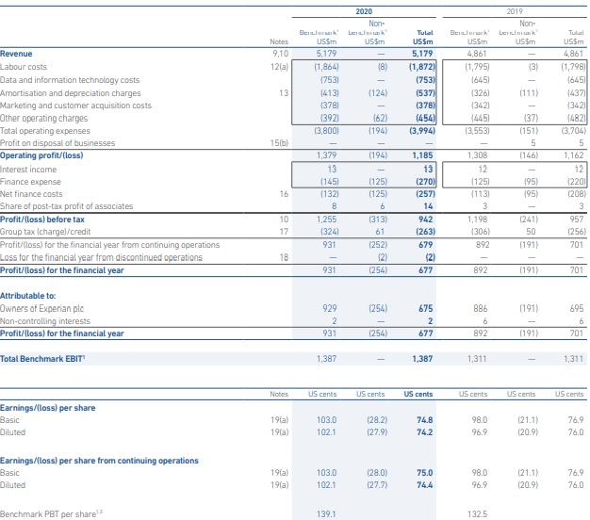
Group statement of comprehensive income for the FY ended on 31 March 2020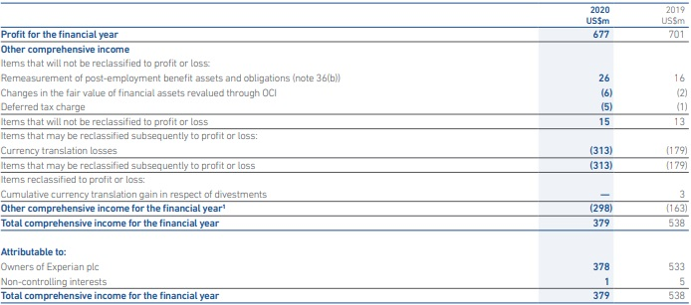
Group Balance Sheet on 31st of March 2020
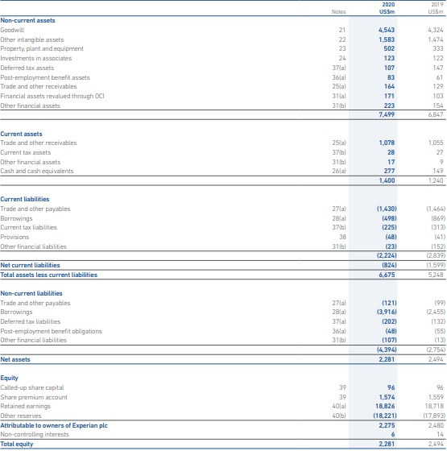

Group cash flow statement for the year ended on 31st March 2020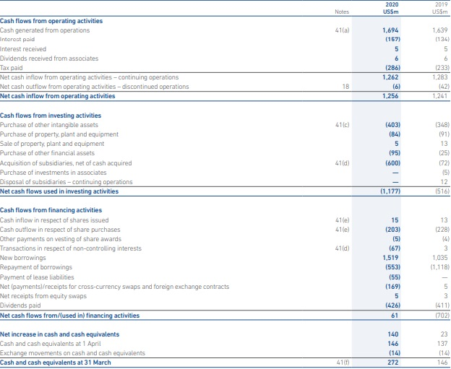

Year | A | B
0 | -80 | -75
1 | 25 | 50
2 | 25 | 20
3 | 20 | 20
4 | 45 | 10

PBP:

Year Project A Cumulative CF
0 (80000000)
1 25,000,000 25,000,000
2 25,000,000 50,000,000
3 20,000,000 70,000,000
4 45,000,000 115,000,000

Payback period for project A: 3,5 years

Year Project B Cumulative CF
0 (75,000,000)
1 50,000,000 50,000,000
2 20,000,000 70,000,000
3 20,000,000 90,000,000
4 10,000,000 100,000,000

Payback period for project B: 2,5 years

ARR:
Calculate the ARR for project A.
 | Cash flow
Year 0 | -80M
Year 1 | 25M
Year 2 | 25M
Year 3 | 20M
Year 4 | 45M
total cash inflows: | 25M+25M+20M+45M=115M
total investment cost: | 80M
total profit: | 115M-80M=35M
average annual profit: | 35M/4=8.750.000
Average capital employed: | (80M+35)/2=57.5M
ARR (ROCE): Approach 1 | 8.750.000/57.500.000=0.15217
Initial capital employed: | 80M
ARR (ROCE): Approach 2 | 8.750.000/80.000.000 = 0.10
 | B
 | Cash flow
Year 0 | -75M
Year 1 | 50M
Year 2 | 20M
Year 3 | 20M
Year 4 | 10M
total cash inflows: | 75M+50M+20M+20M=165M
total investment cost: | 75M
total profit: | 165M-75M=90
average annual profit: | 90/4=22.5M
Average capital employed: | (75M+90M)/2=82.5M
ARR (ROCE): Approach 1 | 22.5M/82.5M = 0.2727
Initial capital employed: | 75M
ARR (ROCE): Approach 2 | 22.5M/75M = 0.3

NPV:
Assume that the company’s cost of capital is currently at 9.75 per cent, and project has a residual value of £10m at year 4 in addition to the cash flow above.

$$PV=\frac{{FV}_{n}}{{\left(1+i\right)}^{n}}$$

Year Project A PV
0 (-80M) (-80M)
1 25M $PV=\frac{{FV}_{n}}{{\left(1+i\right)}^{n}}=\frac{25.000.000}{{\left(1+9.75\%\right)}^{1}}=22779043$
2 25M $PV=\frac{{FV}_{n}}{{\left(1+i\right)}^{n}}=\frac{25.000.000}{{\left(1+9.75\%\right)}^{2}}=20755392$

3 20M $PV=\frac{{FV}_{n}}{{\left(1+i\right)}^{n}}=\frac{20.000.000}{{\left(1+9.75\%\right)}^{3}}=15129215$
4 45M $PV=\frac{{FV}_{n}}{{\left(1+i\right)}^{n}}=\frac{4.500.000}{{\left(1+9.75\%\right)}^{4}}=3101661$

Net Present Value for project A:
-80.000.000+22779043+20755392+15129215+3101661 = -18.234.689

Year Project B PV
0 (-75M) (-75M)
1 50M $PV=\frac{{FV}_{n}}{{\left(1+i\right)}^{n}}=\frac{50.000.000}{{\left(1+9.75\%\right)}^{1}}=45558086$
2 20M $PV=\frac{{FV}_{n}}{{\left(1+i\right)}^{n}}=\frac{20.000.000}{{\left(1+9.75\%\right)}^{2}}=16604314$

3 20M $PV=\frac{{FV}_{n}}{{\left(1+i\right)}^{n}}=\frac{20.000.000}{{\left(1+9.75\%\right)}^{3}}=15129215$
4 10M $PV=\frac{{FV}_{n}}{{\left(1+i\right)}^{n}}=\frac{10.000.000}{{\left(1+9.75\%\right)}^{4}}=6892581$

Net Present Value for project B:
-75.000.000+45558086+16604314+15129215+6892581 = 9184196

