
Mental Health Service Utilisation Disparities Between South Asian, Black Caribbean, and White British Populations in England: A Systematic Review.

by

Mudassir Iqbalhusen Patel

A Dissertation submitted in partial fulfilment of the requirements for the degree of Master of Science in Public Health and Social Care in Practice

The Institute of Inner-City Learning
University of Wales Trinity Saint David – London Campus

February-2026
DECLARATION
I, Mudassir Iqbalhusen Patel, declare that this dissertation has been composed by myself, that the work contained herein is entirely my own except where explicitly stated otherwise in the text, and that this work has not been submitted for any other degree or qualification, in whole or in part, except as specified.
Signed:………………………………………………
Date:...………………………………………………

Acknowledgements
I would like to acknowledge my sincere gratitude towards my dissertation supervisor, Dr Farah Witta, for her invaluable guidance, expertise and constant support during this journey of research. Her constructive support has been instrumental in the creation of this work.
I wish to express my gratitude to the academic staff at the University of Wales Trinity Saint David, in particular, the Institute of Inner-City Learning, for their contribution in providing the educational foundation and resources for completing this dissertation. Special thanks to Dr Diola Bijlhout for the coordination of the module and the research ethics committee for the timely approval of this project.
I would also like the authors of primary studies included in this systematic review to recognize their contribution in their rigorous research to the understanding of mental health inequalities in England.
My hearty appreciation goes to my family for their unending support, patience and encouragement throughout my academic journey. Their belief in my abilities has been a constant source of motivation.
Finally, I like to thank my colleagues and peers on the MSc Public Health and Social Care in Practice programme, as our conversations and collective experiences have enriched my learning and my professional development.
This dissertation is dedicated to better mental health equity for all communities in England.

Abstract
Background: Inequality in mental health cutting across ethnic groups has existed in England, and the pattern of service uptake varies widely among the South Asian group, Black Caribbean and the White British. Although ethnic minority groups have similar or even greater occurrences of mental health conditions, they have broad disparities in their access, utilisation, and advancement through mental health services. This knowledge of these differences is crucial for creating equal mental health services that can address the needs of England's diverse population.
Aim: This systematic review synthesised evidence on disparities in the use of mental health services among South Asian, Black Caribbean, and White British adults in England, focusing on patterns of service access, engagement, and referral to primary, secondary, and crisis mental health services.
Methods: Systematic search- PubMed/MEDLINE, PsycINFO, and grey literature (2015-2025), were searched according to the PRISMA 2020 guidelines. Among 876 potential records, 11 studies that passed the eligibility criteria were selected. CASP checklists were also used as a quality appraisal tool, but to combine the results of quantitative and qualitative methods in theoretical constructs, such as the Behavioural Model by Andersen and the Social Determinants of Health.
Results: 30-40 per cent less access to voluntary service was observed by the South Asian populations than by the White British populations, with cultural stigma, family honour issues and language barrier presented as the major factors. Black Caribbean residents suffered paradoxically increased contact with crisis services, such as 3.83 times increased Mental Health Act detention rates (95-per cent Confidence Interval: 2.98-4.92), which indicated pathways characterised by crisis-as opposed to preventative-based care. These trends were supported by institutional factors such as under-representation of the workforce and insufficient cultural competence of services.
Conclusion: The complexity of mental health service utilisation among the ethnic groups is a measure of interactions between the cultural, structural, and institutional factors. These inequities will need culturally responsive interventions, hiring of a workforce where diversity is practised, anti-racism training, and models of community-based and oriented services.

Keywords: Mental health service utilisation, ethnic inequalities, South Asian, black Caribbean, systematic review, England, PRISMA, cultural competence, health disparities.

Table of Contents
Acknowledgements 3
Abstract 4
List of figures 8
List of tables 9
List of abbreviations 10
Chapter 1: Introduction 11
1.1 Public Health Context 11
1.2 Mental Health Service Utilisation and Pathways 11
1.3 Ethnic Inequalities in Mental Health Service Use 12
1.4 Rationale for the Systematic Review 13
1.5 Aim 13
1.6 Research Question 14
1.7 Objectives 14
1.8 Scope and Definitions 14
1.9 Structure of the Dissertation 15
Chapter 2: Literature review/theoretical framework 16
2.1 Mental Health Inequalities in England 16
2.2 Culture, Stigma, and Help-Seeking Behaviour 17
2.3 Structural and Institutional Determinants 20
2.4 Policy Landscape and Cultural Competence 22
2.5 Theoretical Frameworks Informing the Review 24
2.6 Summary and Justification for the Review 27
Chapter 3: Research Methodology 29
3.1 Study Design 29
3.2 Search Strategy 29
3.3 Eligibility Criteria 30
3.4 Selection Process 31
3.5 Quality Appraisal 34
3.6 Data Extraction 35
3.7 Data Synthesis 35
3.8 Ethical Considerations 36
Chapter 4: Results 38
4.1 Overview of Included Studies 38
4.2 Study Characteristics 38
4.3 Quality Appraisal Summary 40
4.4 Service Utilisation Patterns by Ethnic Group 43
4.4.1 South Asian Populations 43
4.4.2 Black Caribbean Populations 44
4.4.3 White British Populations 46
4.5 Pathways to Care Across Ethnic Groups 47
4.6 Barriers to Service Engagement 50
4.7 Facilitators of Service Access and Engagement 52
4.8 Summary of Key Findings 53
Chapter 5: Discussion 55
5.1 Summary of Key Findings 55
5.2 Interpretation Through Theoretical Frameworks 55
5.3 Policy Implications 56
5.4 Practice Recommendations 57
5.5 Strengths of the Review 59
5.6 Limitations 59
5.7 Future Research Directions 59
5.8 Conclusion 60
Reference list 61
Appendix 1: [Title] 70
Appendix 2: [Title] 71

List of figures
Figure 1: Integrated Theoretical Framework for Understanding Ethnic Disparities 26
Figure 2: PRISMA 2020 Flow Diagram for Systematic Review Selection Process. 33
Figure 3: Quality Appraisal Distribution of Included Studies (N=11). 42
Figure 4: Mental Health Act Detention Rates per 100,000 Population by Ethnic Group. 46
Figure 5: Initial Pathways to Mental Health Care by Ethnic Group. 49
Figure 6: Thematic Map of Barriers and Facilitators to Mental Health Service Engagement. 50

List of tables
Table 1: Characteristics of Included Studies (N=11) 39
Table 2: Quality Appraisal of Included Studies (CASP Assessment) 41
Table 3: Key Findings by Ethnic Group 48

List of abbreviations
AESOP | Aetiology and Ethnicity in Schizophrenia and Other Psychoses
BC | Black Caribbean
BME | Black and Minority Ethnic
CASP | Critical Appraisal Skills Programme
CI | Confidence Interval
CMD | Common Mental Disorders
CMHT | Community Mental Health Team
COVID-19 | Coronavirus Disease 2019
EMPIRIC | Ethnic Minority Psychiatric Illness Rates in the Community
GDPR | General Data Protection Regulation
GP | General Practitioner
IAPT | Improving Access to Psychological Therapies
MHA | Mental Health Act
NHS | National Health Service
PICOS | Population, Intervention, Comparator, Outcome, Study design
PRISMA | Preferred Reporting Items for Systematic Reviews and Meta-Analyses
RCT | Randomised Controlled Trial
SA | South Asian
SELCoH | Southeast London Community Health Study
SMI | Severe Mental Illness
UK | United Kingdom
WB | White British

Chapter 1: Introduction

1.1 Public Health Context
Mental health conditions are a significant mental health issue in England, with up to 23 per cent of the total disease burden, and 1 in every 4 adults in the country is impacted by it every year (McManus et al., 2016). Although its prevalence is high, there are substantial differences between the requirements in mental health and the use of services, and only 39% of people with common mental disorders treat themselves (NHS Digital, 2020). Such disparities are especially significant among ethnic groups, during which patterns of service engagement vary greatly in comparison to clinical need (Halvorsrud et al., 2019). Ethnicity is a structural determinant of health, which combines with the socioeconomic position, migration experiences, and institutional racism to define not only the mental health outcomes, but also care access (Nazroo, 2017). These differences are of significant importance in understanding that progressing health equity can be achieved by making NHS mental health services sensitive to the needs of various populations.
The ethnicity and mental health service utilisation are complicated. Whereas prevalence studies have shown similar or higher rates of common mental disorders in ethnic minorities (Weich et al., 2004), service utilisation statistics have indicated that the minority groups encountered in early intervention pathways have been significantly under-represented and have been over-represented in crisis and coercive services (Halvorsrud et al., 2018). The trend indicates that there are institutional and social obstacles to the equitable provision of timely and suitable mental health services. The results are not restricted to personal well-being but include a higher level of presentation, a worse prognosis in the long-term, and higher expenditures on health and social care systems (Bhui et al., 2015).

1.2 Mental Health Service Utilisation and Pathways
Mental health service utilisation can be described as the pattern and nature of contact with formal mental health services and includes primary care (IAPT), secondary care (CMHTs), and crisis services (Home Treatment Teams, Accident and Emergency) (Andersen, 1995). In comparison with prevalence, utilisation corresponds to actual use of services and is predetermined by predisposing variables (age, gender, ethnicity), enabling factors (income, social support) and perceived need (Andersen and Newman, 2005).
The route to mental health care in England is usually based on a stepped-care model, with general practitioners acting as the gatekeepers to the specialist care (NHS England, 2016). Nonetheless, there is an indication that ethnic minorities often use alternative entry points to primary care, and thus, they manifest themselves through crisis ways, including the use of police resources, visits to Accident and Emergency, or forced commitments under the Mental Health Act (Mann et al., 2014). It is an access pattern associated with failure in the early intervention and continuous disengagement and worsening mental health cycles caused by this crisis (Morgan et al., 2017).

1.3 Ethnic Inequalities in Mental Health Service Use
The existing research has always recorded disparities in mental health service use among the major ethnic groups in England. South Asian communities, including the Indian, Pakistani, and Bangladeshi, have much less frequent contact with mental health services than with the clinical need, especially in the psychological therapy area (Rathod et al., 2019). The combination of cultural factors and structural barriers, such as language barriers and cultural insensitivity, inhibits service participation due to stigma over mental illness as well as preference towards family-based support (Bhui et al., 2007).
Black Caribbean communities exhibit a contradictory trend, which is the under-utilisation of voluntary and community-based services and over-representation in coercive pathways, such as involuntary admission and forensic services (Mann et al., 2014). It is stated in the studies that the black Caribbean group is four times more likely to be arrested under the Mental Health Act than White British residents (NHS Digital, 2021). Such a trend indicates the accruing effect of institutional racism, distrust in the services, and inequalities in the practices of diagnosing (Keating and Robertson, 2004).
Although white British populations have a high prevalence of common mental disorders, they tend to use services according to their clinical need and have more access to early intervention services (Halvorsrud et al., 2019). Nevertheless, socioeconomic deprivation still plays a major role as a predictor of inequalities in access among this population (Weich et al., 2007).

1.4 Rationale for the Systematic Review
Although lots of literature is available showing ethnic differences in the mental health outcomes and disparities in access to mental health services, the evidence base is still disjointed with different studies that have different methodologies, populations, and outcome measures (Halvorsrud et al., 2018). Current reviews have been mainly related to one ethnic group or type of services, which has restricted comparative knowledge on the pattern of utilisation across the large ethnic groups in England (Hatch et al., 2015). Moreover, the systems that establish such disparities, including personal, cultural, and structural factors, should undergo a systematic synthesis to educate specific interventions.
This systematic review, which adheres to PRISMA 2020, will provide the literature gap in the usage of mental health services among the South Asian, Black Caribbean, and White British adult population in England based on secondary data sources within the published literature. The review educates priorities described in the NHS Long Term Plan (NHS England, 2019) and the Advancing Mental Health Equalities strategy (NHS England, 2020), which both highlight the importance of implementing evidence-based policy to decrease ethnic disparities in mental health care.

1.5 Aim
To conduct a systematic review of available literature to study the differences between South Asian, Black Caribbean, and White British mental health service use in England, and to offer a substantial body of findings that can guide the development of policies, service configuration, and clinical practice.

1.6 Research Question
What are the differences in mental health service usage patterns of South Asian, Black Caribbean, and White British populations in England, and what are the socio-economic and cultural factors behind these differences?

1.7 Objectives
This systematic review has five specific objectives:
- To systematically compare mental health service utilisation rates, patterns, and pathways between the three populations, examining differences across service types and geographical areas.
- To identify and categorise sociodemographic, cultural, and structural factors contributing to disparities in service access and outcomes.
- To analyse barriers and facilitators to mental health service engagement across populations, including individual, community, and system-level influences.
- To synthesise evidence on effective interventions for reducing disparities and improving cultural competence.
- To identify research gaps and provide evidence-based recommendations for policy development and future research priorities.

1.8 Scope and Definitions
This is a systematic review, which is desk-based and aims at adults aged 18 years and above, who are living in England. Some of the services offered in the sphere of mental health include primary care (IAPT), secondary care (CMHTs, outpatient psychiatry) and crisis services (Home Treatment Teams, psychiatric inpatient units, Accident and Emergency presentations). Ethnic groupings are in line with those of the UK Office for National Statistics: South Asian (Indian, Pakistani, Bangladeshi), Black Caribbean, and White British groups.
The review covers works published since 2015 till 2025 that are inclusive of the post major NHS reforms and the initiation of key policies that address mental health, such as the Five Year Forward View of Mental Health. The most relevant literature will be determined with the help of a systematic search of PubMed/MEDLINE and PsycINFO databases, along with the NHS England, Department of Health, and Public Health England grey literature. Only the studies in England are considered. They can include studies in English and possessing quantitative, qualitative, or mixed-methods designs. The secondary data review does not require contact with a participant.

1.9 Structure of the Dissertation
This dissertation is in the form of five chapters. Chapter 2 presents the extensive literature review and theoretical framework, looking at the available evidence on mental health disparities, help-seeking behaviour, and structural determinants, as well as applying the Behavioural Model proposed by Andersen, Social Determinants of Health, and the Intersectionality theory. Chapter 3 outlines the systematic review technique, such as search technique, eligibility criteria, quality assessment, and narrative synthesis. Chapter 4 provides the results, including studies that were included and synthesising their results in terms of utilisation patterns, pathways, and ethnic group comparisons. In Chapter 5, the implications for policy and practice are discussed, the strengths and limitations of the study are assessed, and recommendations for future studies are given.

Chapter 2: Literature review/theoretical framework

2.1 Mental Health Inequalities in England
The prevalence, access to services, and quality of care chosen as the intersection points define the complex patterns in mental health inequalities in England. The epidemiology of common mental disorders like depression and anxiety shows that there is a relative uniformity in the prevalence of these conditions amongst large ethnic groups and that every week about 16-19% of adults report symptoms (McManus et al., 2016). Nevertheless, this similarity in epidemiological terms covers deep inequalities in the use of the services, treatment courses, and results (Halvorsrud et al., 2019).
The social gradient of mental health is established, with poorer people having more mental disorders as well as less access to evidence-based interventions (Marmot et al., 2010). This gradient works in several ways, including exposure to chronic stress, lack of access to psychological and material resources, and poor health literacy (Allen et al., 2014). Importantly, the socioeconomic position to mental health correlation is not ethnically neutral. The populations of ethnic minorities in England face a systematic socioeconomic disadvantage due to historical and modern-day discrimination processes, residential segregation, and exclusion in the labour market (Nazroo, 2017). Such social adversity increases the risk of mental health issues and limits access to protective factors such as social support networks and economic resources at the same time.
The combination of ethnicity and socioeconomic deprivation generates different vulnerability patterns. A study by Das-Munshi et al. (2017) illustrates that the Black Caribbean and the Black African groups with high ethnic density in neighbourhoods minimise the psychotic disorders in comparison to the predominantly White neighbourhoods, which indicates that, to some extent, the ethnic density is an effective buffer against stress related to discrimination. The ethnic density effect operates through various mechanisms, including enhanced social support, fewer cases of interpersonal racism, and improved access to culturally congruent informal networks (Bécares et al., 2012). Research has shown that a 10 per cent rise in own-group ethnic density would result in a 10-15 per cent decrease in the risk of common mental disorder among ethnic minority groups, which implies significant protective characteristics (Das-Munshi et al., 2010). Nevertheless, this protective value, perhaps, can be watered down in the case of extreme socioeconomic deprivation, whereby narrowed disadvantage is trampling upon the advantages of ethnic unity. On the other hand, the South Asian communities portray a higher prevalence rate of common mental disorders when socioeconomic deprivation exists, with women who feel social isolation and a low level of English fluency (Husain et al., 2016). Depression and anxiety are particularly prevalent among South Asian women in low ethnic density areas due to compounded vulnerabilities of cultural isolation, language barriers and gender specific limitation on mobility and social participation (Nazroo and Karlsen, 2003). These data indicate that the issue of mental health inequalities needs to be viewed through an intersectional perspective, in which the effects of multiple types of marginalisation are considered to be compounded.
Despite these prevalence patterns, ethnic minority populations have lower data in service utilisation and underuse mental health services as compared to need. Primary care records analysis shows that South Asian patients have a lower chance of being diagnosed with depression or anxiety by 30-40% than similar patients presenting with the same symptom profile but of White British origin (Rathod et al., 2019). In the same manner, South Asian populations have an uneven rate of involvement in IAPT services, and the Pakistani and Bangladeshi populations have the lowest rates of treatment uptake within the country (NHS Digital, 2020). These trends indicate that the obstacles to care take place at various levels; they hinder primary access and long-term adherence to treatment. Some of the factors related to low service utilisation are cultural stigma, ignorance about services provided, language, and the belief that service is not culturally right or effective (Rathod et al., 2018).

2.2 Culture, Stigma, and Help-Seeking Behaviour
The role of the cultural factors on mental health service utilisation is very significant as it can be seen to influence the way illness is recognised, the preference of help-seeking patterns, as well as the expectation of receiving treatment. Anthropological studies also point out the fact that there is a significant difference in the conceptualisation of mental distress across different cultural groups, and this has implications for whether and how one seeks professional help (Kleinman, 1988). Mental illness is often interpreted culturally, e.g. through the cultural idioms of distress, e.g. tension or sinking heart (dil ghirda hai) within the South Asian communities and may not be congruent with biomedical psychiatric groupings (Tabassum et al., 2000). This theoretical discrepancy may postpone the identification of the conditions that may be treated and lessen the perceived usefulness of formal mental health services.
Stigma is a ubiquitous impediment to mental health service utilisation in all populations, but will be especially intense in collectivist cultural conditions in which family honour (izzat) and social reputability play a significant role (Chew-Graham et al., 2002). The exploratory study of South Asian communities demonstrates that mental illness is often considered a character problem for the whole family, affecting the chances of marriage and social status (Hussain and Cochrane, 2004). This stigma is enhanced by the rumours about the hereditary aspect of mental diseases, which makes families hide their problems and not seek outside help (Rethink, 2007). The effects are not limited to delayed help-seeking but also pertain to lack of familial support and social alienation, negatively affecting the mental health outcomes even more.
Informal support networks are cultural inclinations that represent an opportunity and a potential obstacle to service use. It has been shown that South Asian people in mental distress normally find first-line assistance provided by family members, religious leaders, or traditional healers before thinking of accessing formal mental health services (Mackenzie et al., 2014). Although such informal nets are an extremely important source of emotional support and recognition of cultural value, they risk dragging upon the administration of evidence-based treatment once distress has risen beyond the reach of informal care (Commander et al., 1997). Moreover, the usefulness of informal support is heavily dependent on the level of cohesion in the larger family, and people in fragmented families experience secondary vulnerability.
Among the Black Caribbean communities, the patterns of help-seeking can be viewed as the expression of the complicated histories of trauma and institutional racism in the mental health context. Morgan et al. (2017) capture the importance of negative past experiences, such as discrimination, disrespect and coercive treatment experiences, as the basis of future attitudes towards mental health services. These moments give people a prerequisite mistrust, and as a result, they strive to postpone the help-seeking or even avoid contact with services until it is too late (Bowl, 2007). This historical pathologisation of Black cultural expression and behaviours, which was marked with the excessive diagnosis of the black Caribbean populations as schizophrenic throughout the 1980s and 90s, still casts a dark cloud on modern relationships in service provision (Fernando, 2017).

Spiritual constructs and religious convictions play a major role in influencing the behaviour of help-seeking among members of different ethnic groups. To South Asian people, consultation with religious leaders and religious practices constitute culturally acceptable solutions to any psychological suffering (Dura-Vila et al., 2010). The Islamic teachings lay stress on patience (sabr) during the period of suffering and turning to prayer and Quranic recitation as points of comfort, which can be emphasised instead of psychological intervention (Laird et al., 2007). The Hindu ideas of karma and dharma can influence the sense of mental distress of the effects of the past life or the spiritual trials and predispose the openness to professional help (Bhugra and Bhui, 1998). The members of the Sikh community can approach a granthi (religious leader) who also offers spiritual advice, though they are not normally experts in the field of mental health (Kalathil, 2011). Although these religious systems bring a sense of meaning, community, as well as a supply of coping resources, crises may occur between religious and biomedical explanations of mental illness, and it may postpone the provision of evidence-based treatment (Cinnirella and Loewenthal, 1999). As well, in Black Caribbean society, churches are the main providers of emotional and spiritual assistance, and mental health struggles are often explained in terms of spiritual warfare or faith test (Fernando, 2010). Pentecostal and Charismatic Christian traditions, which are prevalent in the Black Caribbean community, can also direct the cause of psychological distress to demonic possession or spiritual attack, and deliverance therapy is more preferred instead of psychiatric therapy (Hartley et al., 2006). The study shows that nearly 60-70 per cent of mental health challenges among Black Caribbean adults are discussed with religious leaders before accessing formal help, which highlights the role of the faith-based community in helping-seeking contexts (Hays et al., 2017). Although religious coping might offer clarity and strength, access to useful psychological and pharmacological interventions might be barred. The medical professionals should therefore engage in the development of culturally sensitive strategies that will not infringe on religious beliefs, but that will provide the people with evidence-based care.

2.3 Structural and Institutional Determinants
Structural racism acts as a fundamental cause of ethnic disparities in mental health care, which functions by institutional policy, professional practice, and service arrangements that gradually discriminate against ethnic minority groups (Paradies et al., 2015). Different pattern of diagnosis reveals institutional racism, with Black Caribbean individuals having a higher likelihood of a diagnosis of schizophrenia and a lower likelihood of a diagnosis of depression than White British individuals who present with the same symptomatology (Singh et al., 2007). Such diagnostic differences indicate the presence of unconscious bias, cross-cultural misunderstanding and stereotyping in psychiatric assessments (Fernando, 2017).
Pathways to mental health care indicate big ethnic differences, especially when it comes to coercive pathways. Black Caribbean people have an excessive chance of resorting to the services by criminal means or involuntary hospitalisation by the Mental Health Act, instead of voluntary referral to primary care (Mann et al., 2014). This is reflected by the NHS Mental Health Act Statistics, which show that Black Caribbean patients are 4 times more likely to be detained than White British patients despite the adjustment of the socioeconomic and clinical presentation (NHS Digital, 2021). The trend indicates various failures on a systemic level, such as poor early intervention, functionalizing mental distress among Black people, and the overparticipation of the police in managing mental crisis and crises (Barnett et al., 2019).
The form of mental health services and provision is symptomatic of structural impediments that have disproportionate effects on ethnic minority populations. The accessibility of some ethnic minority groups can be improved by the geographical concentration of special mental health services in cities at the expense of scattered populations (Nath et al., 2018). Nonetheless, the latter does not imply that the latter will be easily accessible because cultural and linguistic barriers still exist even in ethnically diverse regions. The studies showed that even South Asian patients visiting mental health services in densely populated ethnic areas report encountering cultural insensitivity, absence of interpretation service, and cultural adaptation of interventions (Rathod et al., 2018). Such results stress the fact that geographical accessibility is not enough to manage the ethnic inequalities; services must be culturally sensitive and linguistically competent to focus on the diversity of the different populations.
Language barrier is one of the structural impediments to service access and quality among poor English speakers. The research has approximated that between 20-30% of adults in England of South Asian origin have a low degree of English language competence, with the highest concentration among the aged and women (Szczepura et al., 2005). In Bangladeshi and Pakistani females aged above 50, the prevalence of little English proficiency is more than 50 per cent, and this suggests that significant obstacles to mental health data and services are in place (Office for National Statistics, 2013). Language has significant barriers to all parts of the care pathway, including the onset of symptoms to GP referral, understanding of treatment options and therapeutic engagement (Rethink, 2007). Although the NHS policy requires the delivery of interpretation services, their practice is rather inconsistent, with most mental health workers using unofficial interpreters such as relatives (Tribe and Thompson, 2017). The fielding of family interpreters jeopardises confidentiality, gives a false impression, and eliminates the release of sensitive details such as domestic violence or family conflict that propagate mental distress. Children who act as interpreters to their parents experience the role reversal stress, and they might even hold on to withholding information so that they do not expose their family to privacy breaches (Chau et al., 2018). Even when there is a professional interpretation service available, this might be insufficient when interpreters are not knowledgeable in mental health terms or even in their cultural background, which might not enable proper translation of psychological terms. It has been proven that interpreter-based consultations are 50% longer but of lower quality therapeutic alliance and worse adherence to treatment than linguistically concordant ones (Flores, 2005). More so, diagnostic sensitivity suffers in the presence of the psychological symptoms distorted through interpretation, and there are specific dangers of misdiagnosis when culturally specific idioms of distress do not have direct equivalents in the English language (Krause, 2003).
Inequalities in the representation of ethnic minority professionals in the mental health service industry continue to maintain a culture of cultural disconnect between the services and the communities. Although ethnic minorities make up 14 per cent of the English population, only 9 per cent of psychiatrists and 8 per cent of clinical psychologists are of ethnic minority origin (Royal College of Psychiatrists, 2019). Such a workforce structure limits cultural realisation, role modelling, and can create a perception of ethnic minority communities that services are non-responsive and non-designed to address their needs (Memon et al., 2016). Diversity programs in the workforce should not be limited to recruitment, as they need to provide ethnic minority professionals a chance to develop their careers and see their cultural competencies utilised and represented in the service delivery model.
Access patterns rooted in a crisis are a relatively alarming phenomenon of structural inequality. In the event of receiving the services, ethnic minority citizens tend to arrive in crisis conditions and need urgent or emergency help instead of organised preventive strategies (Halvorsrud et al., 2018). Such a trend is a cumulative result of failure of early detection, late help-seeking associated with cultural and structural barriers, and ineffective outreach to populations at risk. The results are increased traumatic first service experiences, increased risk of forced treatment, and worse therapeutic relationships, which in turn lead to the continuation of disengagement and subsequent crisis manifestations (Mann et al., 2014). To intervene in this cycle, it is necessary to invest in the community based early intervention, culturally relevant mental health promotion, and proactive engagement strategies that target the populations before it is too late.

2.4 Policy Landscape and Cultural Competence
The policy framework on mental health in England has been calling noisier on the necessity to address ethnic inequalities, but delivery always trails policy intent. The Five-Year Forward View on Mental Health (NHS England, 2014) marked a sea change in that mental health parity became a policy priority, and they promised to ensure equitable access to services by the entire population. This historic report named ethnic disparities in crisis care and forced detention among factors that demand immediate action, suggesting specific investments in community-based early intervention services in underserved communities. This framework is supported by the NHS Long Term Plan (NHS England, 2019): it is aimed at providing both mental healthcare to the needs of different communities and improving the cultural competence of their workforce, as well as reinforcing the growth of community-based care and outreach to the underserved groups. In the Plan, in particular, the implementation of ethnic inequalities in the number of people detained according to the Mental Health Act and the access of ethnic minority populations to psychological therapies is mentioned among the important performance indicators.
The operation guidance is more specific and tailored in the developing document of the Advancing Mental Health Equalities strategy (NHS England, 2020), which states that all mental health Trusts need to create and execute ethnic inequality prevention plans. In these plans, services are needed to track ethnic differences in access, experience, and outcome, and to apply evidence-based interventions to correct specified inequalities. The implementation assessments, however, show that there is a lot of variability; most trusts have no particular resources, they have difficulties with the quality of their data, and they cannot bring significant community involvement (Centre for Mental Health, 2021).
The prevailing policy strategy for the treatment of ethnic disparities in mental health care is the cultural competence initiatives. Cultural competence includes not only cultural awareness of self but also of other people in terms of their cultural practices as well as the ability to work effectively across cultural boundaries (Bhui et al., 2007). Critiques are valuable, but none of the frameworks of cultural competence can avoid the risk of essentialising ethnic identities, over-situating the role of cultural difference as a determinant in screening out structural determinants and putting the focus of change-importance on the individual practitioner as opposed to institutional systems (Kleinman and Benson, 2006). The proponents of recent scholarship believe in structural competence as a supplement to cultural competence, shifting the focus to the institutional policies and social organisation, which generate health inequalities (Metzl and Hansen, 2014).
The gap between policy and practice has not been diminished, and the rhetoric of equity is often not backed by appropriately allocated policies to carry it out. The NHS mental health services have financial constraints that restrict their ability to engage in community outreach and culturally adapted interventions, as well as efforts on workforce diversity (Royal College of Psychiatrists, 2018). Moreover, the performance measurement models based on efficiency and throughput rather than equity can unintentionally encourage the services to target less-challenged populations, which continue to generate inequity (Trivedi, 2010).

2.5 Theoretical Frameworks Informing the Review
The Behavioural Model of Health Services Use by Andersen is a very useful tool for understanding various determinants of service utilisation (Andersen, 1995). According to the model, service use is the product of their interaction (predisposing factors, or demographics, social structure, health beliefs), enabling resources (personal, family, community), and need (perceived and evaluated). In the context of ethnic disparities in the utilisation of mental health services, the model sheds light on the role of ethnicity as a social structural variable that directs health beliefs, interacts with socioeconomic resources, and plays a role in enhancing perceived need for using services and assessment by healthcare service providers (Andersen and Newman, 2005).
The usefulness of the model is its ability to unite both individual agency and structural constraint, as they understand that the service utilisation is a manifestation of both individual choice and systemic enablers and barriers. In the case of South Asians, health beliefs about cultures and stigma are predisposing factors, which interplay with enabling factors such as language barriers and geographic access to hinder service utilisation despite heavy demand. In black Caribbean populations, the model emphasises the effects of different negative experiences (predisposing) and discriminatory practices in institutions (enabling/constraining) on the utilisation patterns of the crisis. Nonetheless, the model needs to be critically adapted to consider the racism and power dynamics within the healthcare system because it was initially designed within the settings, which theorised racism alternatively, without explicitly (Kaufman et al., 2021).
The Social Determinants of Health theory extends the scope of analytical focus in a way that individual factors alone would not address health disparities, but instead the actual state of the present of social, economic, and political determinants on health (Marmot and Bell, 2012). This model places inequalities in mental health as a result of varied exposure to risk factors, varied susceptibility to conditions that harm health, and varied impacts of illness (Diderichsen et al., 2001). The interplay between ethnicity and social determinants that can give structure to mental health risk and access to services includes: education, employment, housing, and discrimination experiences.
The application of this framework to ethnic disparities in mental health service utilisation indicates the way structural disadvantage works throughout the lifetime of individuals to justify vulnerability to ethnic minorities. Segregation of the residential area, workforce discrimination, and education disparities put ethnic minorities in socially disadvantageous positions marked by perennial stressor experiences and a low availability of health-supportive resources (Nazroo, 2017). Such upstream determinants influence both mental health need and resources that could be used to help-seek, such as the financial capacity, health literacy and social capital. The framework hence refocuses attention on healthcare system variables to the macro determinants that instil the conditions that make mental inequalities arise and remain.
Irrespective of being a critical race or feminist theory, intersectionality theory offers necessary material to address the interaction of various social identities in creating distinct oppression and privilege experiences (Crenshaw, 1989). Intersectionality also curbs parallel studies of ethnicity, as there is a need to consider the interaction of ethnicity with gender, classes, migration status of ethnicity, and other social statuses to define mental health and access to services (Bowleg, 2012). The framework is exceptionally useful in the interpretation of in-group heterogeneity among ethnic minority groups.
The findings of the research show that intersectionality has a significant effect on the mental health service utilisation patterns. As an illustration, the ethnic stigma, gendered roles and expectations of women in their families, as well as socioeconomic marginalisation, are compounded in such women in South Asia (Burr, 2002). On the same note, Black Caribbean males are subjected to more coercive service pathways because of the overlapping stereotypes of race, gender, and threat, whereas Black Caribbean females might be different, as they are barred by the stereotype of a strong Black woman to admit to mental distress (Watson and Hunter, 2015). Intersectionality, therefore, requires that research and policy go beyond this notion of blocs of ethnicity to the diversity that exists within ethnic groups and the multidimensional and interacting processes of power that define health outcomes.
A combination of these theoretical frameworks would give a multi-level explanation of ethnic disparities in access to mental health services. The model presented by Andersen organises the proximal determinants of service consumption, the social determinants theory as backgrounds these trends in the context of wider structural inequalities and intersectionality consideration, addressing the complexity and heterogeneity of lived experience. Collectively, these models inform the analysis of the interaction between individual, cultural, and structural factors in this systematic review to yield and maintain ethnic disparities in mental health care access. The frameworks also point out possible points of intervention, such as individual-level cultural competence education and structural changes that would tend to regulate institutional racism and social determinants of health. The integrated theoretical framework combining Andersen's Behavioural Model, Social Determinants of Health, and Intersectionality Theory is illustrated in Figure 1.
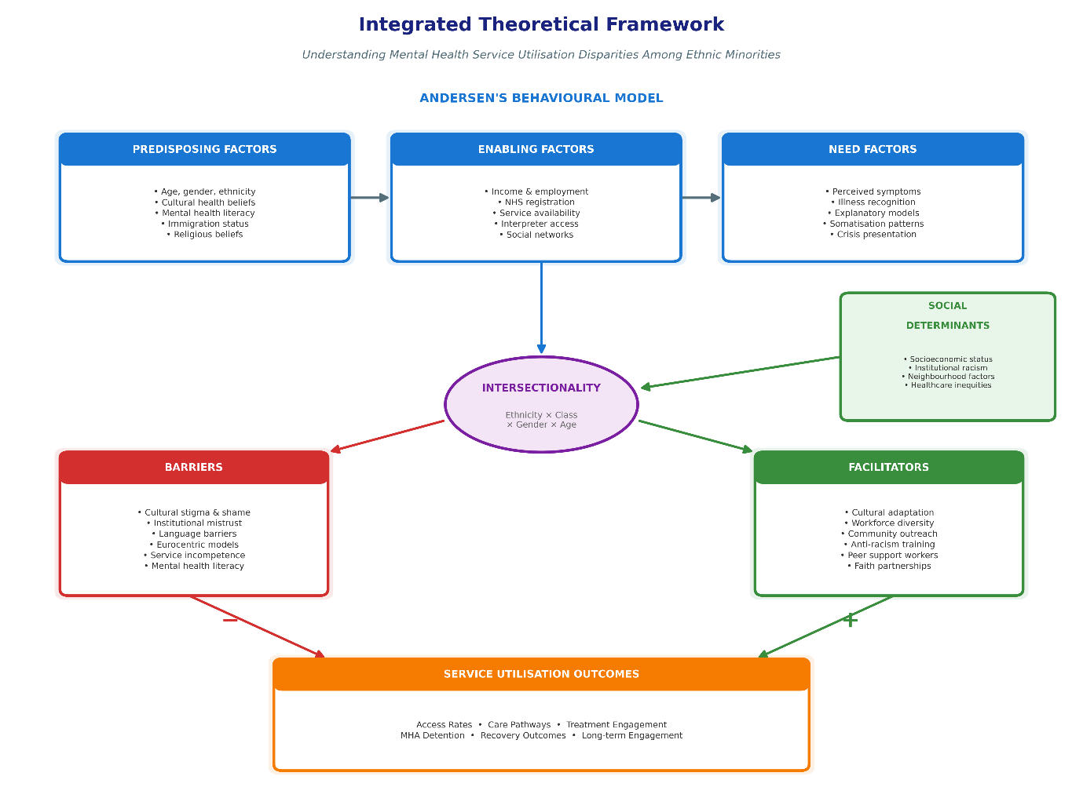
Figure 1: Integrated Theoretical Framework for Understanding Ethnic Disparities

2.6 Summary and Justification for the Review
The literature review has proved that ethnic disparities in mental health service utilisation are established but not thoroughly perceived. Although particular ethnicities, such as the South Asian, service type, and barriers, have been studied individually, little comparative synthesis has been done across the South Asian, Black Caribbean, and White British populations. The evidence base is diverse in terms of fields, approaches, and timeframes, which does not allow seeing the complete picture of disparities and the relative role of various determinants.

Among the critical gaps in the literature, there is a lack of studies on the interface between primary and secondary care pathways, a lack of research on the heterogeneity within ethnic minority groups, and a lack of longitudinal research studies that can track the service utilisation patterns over time. Also, the bulk of the existing literature is older than the current policy efforts, such as the NHS Long Term Plan or Advancing Mental Health Equalities strategy, leaving the question of whether recorded inequalities remain or have been mitigated by policies in place. The knowledge of effective interventions to alleviate ethnic inequalities in mental health service utilisation is limited, too, and most of the culturally-fitting interventions have not been evaluated rigorously on their effect on service utilisation and clinical outcomes.

This systematic review provides a solution to these gaps by giving a current, conclusive synthesis of literature on ethnic disparities in mental health service utilisation in England. Investigating trends in the entire spectrum of primary, secondary, and crisis services, as well as comparatively analysing three large ethnic groups systematically, the review produces a solid, pivotal comparative evidence that is prized in the fields of particular intervention development. The theoretical basis of the review in terms of the Behavioural Model proposed by Andersen and Social Determinants of Health, in addition to Intersectionality, provides the review with assurance that the results are understood in terms of multi-levels that are sensitive to the agency of the individual, the cultural surroundings, and structural constraints. Finally, this systematic review helps policymakers, practitioners, and future research directions to inform them regarding critical evidence to achieve mental health equity.

Chapter 3: Research Methodology

3.1 Study Design
A systematic review was used in this study to pool the evidence related to the disparity of mental health service utilisation in South Asian, Black Caribbean, and White British adults in England. To assist the reader in the domain of rigorous, transparent, and reproducible methods, the review followed Preferred Reporting Items of Systematic Reviews and Meta-Analyses (PRISMA) 2020 (Page et al., 2021). The systematic review design has been chosen as the most effective method for a thorough study of the existing evidence, definition of patterns within several studies, and synthesis of findings to be used in policy- and practice-making. There was no contact with the participants in this secondary data review, and the published data, including publicly available data sources, were used. Registration: The review had not been registered because registration is not a requirement in an academic dissertation, but the protocol was reviewed by the university ethics review process (reference: LCHS7004).

3.2 Search Strategy
In October 2025, a thorough literature search was performed to enable the discovery of related research that has been published since January 2015 and until October 2025. This period has been chosen as the timeframe that may identify evidence after significant changes in the NHS and the implementation of the important mental health policy such as the Five Year Forward View (NHS England, 2014). PubMed/MEDLINE and PsycINFO were two electronic databases that were searched systematically. These databases were chosen because they have extensive coverage in relation to mental health and public health. The search was done through a blend of Medical Subject Headings (MeSH) terms and free-text keywords, which concerned mental health services, service utilisation, ethnicity, and population groups. Search terms were systematised by combining them using Boolean operators ( AND, OR ). The search utterance was narrowed to include the following core search terms: (mental health or psychiatry or psychological) and (service or care or treatment or access or utilisation or utilization or pathway) and (ethnic or race or racial or minority or minorities) and (South Asian or Indian or Pakistani or Bangladeshi or in White British) and (England or English or NHS).
Primary sources that were not included in scholarly databases, like policy reports, national statistics, and governmental publications, were located in grey literature in order to find relevant literature. Our sources were the NHS England site, NHS Digital, Public Health England database and Department of Health publications. The searching of grey literature was performed on the basis of systematic searches on websites with the help of the same search terms, as well as by manually examining the lists of publications of interest. Included studies had reference lists that were manually searched to obtain other possible pertinent publications not indexed in databases. There were no language limitations other than the one that publications must be available in English, since this will be needed to extract data and appraise it in the best manner possible.

3.3 Eligibility Criteria
To include studies, the researchers applied the following criteria: these must be conducted in England and contain at least one of the three target ethnic groups (South Asian populations including Indian, Pakistani or Bangladeshi; Black Caribbean populations; White British populations); must be either quantitative or qualitative, or a combination of both; must be in peer-reviewed journals or of a high-quality gray literature produced by governmental and NHS sources; must focus on mental health service utilisation, access, engagement, or pathways to care as an outcome; must involve full-adult populations (18 years and above). The studies were also filtered out based on the conditions: had only been carried out outside of England without disaggregated England data; had only looked at the paediatric populations (under 18 years) without adult data; had only looked at learning disabilities or intellectual disabilities as primary outcome without any mental health service data; had only looked at a forensic mental health setting with no additional service utilisation data; were a conference abstract, editorial, commentaries, or opinion piece with no original data at all.
The eligibility criteria were systematised using the PICOS framework. Population: Adults with South Asian origin (Indian, Pakistani, Bangladeshi), Black Caribbean and White British population aged 18 years and over, in England. Intervention/Exposure: The exposure variable is ethnicity. Comparator: Comparisons made between ethnic groups (South Asian vs White British, Black Caribbean vs White British, three-way comparisons). Outcome: mental health service utilisation such as primary care mental health services (IAPT, GP based mental health consultations), secondary care services ( Community Mental Health Teams, outpatient mental health consultations, inpatient admissions, and crisis services (Mental health Act detentions, home treatment teams, and Accident and Emergency mental health presentations), pathways to care (GP referral: self-referral), and barriers and facilitators to service access and engagement. Study design: Quantitative studies (cohort, cross-sectional, case-control, randomised controlled trials), qualitative studies (interviews, focus group, ethnography), and mixed-methods studies, systematic review and meta-analysis, and national reports and government statistics.

3.4 Selection Process
All names found during the database and grey literature search were added to reference management software, and duplicates were eliminated utilising automated deduplication and manual check-up. The screening was conducted in two steps: title and abstract screen, and the full-text screen. In the title and abstract screening, two reviewers were involved to screen all unique records based on the eligibility criteria. The disagreements were solved by discussion, and the third reviewer was there to arbitrate in case they could not come to an agreement, but this was not necessary. It is at this point that records that were evidently out of the inclusion criteria were filtered out. In the case of full-text screening, the entire text of potentially eligible studies was retrieved and read by two reviewers under the assessment of all eligibility criteria. Causes of non-selection to the full-text stage were recorded. The use of a PRISMA 2020 flow diagram with the count of recording in every stage and the cause of elimination is used to report the selection process.
Record searching in databases (PubMed/MEDLINE: 453; PsycINFO: 378) identified a total of 831 records, and a search in grey literature (NHS England: 12; NHS Digital: 18; Public Health England: 9; Department of Health: 6) identified 45 records, bringing the total to 876 records. Further screening was done on 582 unique records with 294 duplicates removed. Among them, 515 were not included (wrong population/non-English setting: 178; children/adolescents only: 89; no mental health service utilisation focus: 124; exclusively forensic population: 43; conference abstracts/editorials: 52; published before 2015: 29), and 67 full-text articles were processed into a more thorough evaluation. After reading the full text, 56 articles have been eliminated (they did not involve specified ethnic groups: 23; they do not provide data related to the use of services: 14; they have provided data related to the use of services only to Scotland/Wales/Northern Ireland: 11; they have provided data related to the use of services but not to England: 8). This has led to the selection of 11 studies, which fit all criteria and were incorporated into the qualitative synthesis. The complete study selection process is illustrated in Figure 2, following the PRISMA 2020 guidelines (Page et al., 2021)
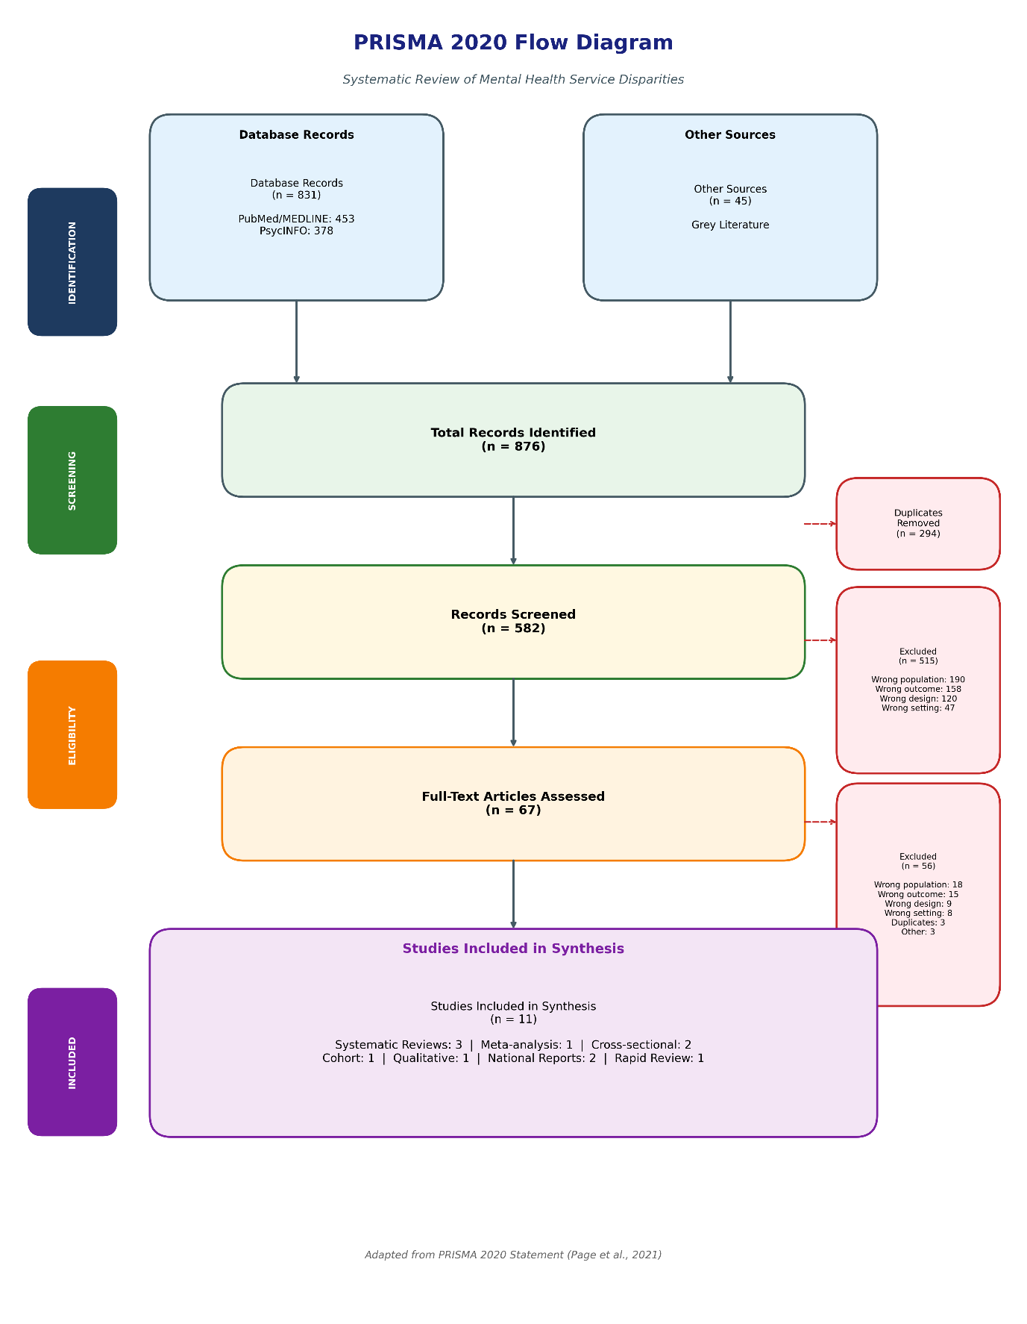
Figure 2: PRISMA 2020 Flow Diagram for Systematic Review Selection Process.

3.5 Quality Appraisal
Systematic appraisal of methodological quality of included studies was done using Critical Appraisal Skills Programme (CASP) checklists that matched the design of the study (CASP, 2023). The systematic reviews, cohort studies, cross-sectional studies, qualitative studies, and randomised controlled trials were all done using separate CASP tools. To evaluate the credibility of the source, transparency of methodology, representativeness of data, appropriateness of analysis, clarity of results presentation, recognition of limitations and generalisability, a modified CASP checklist was tailored to the nature of the grey literature sources (national reports). Quality appraisal of every study was done by two reviewers, and the differences were settled through a discussion. The items in every CASP checklist were rated on a scale of three dimensions: yes (criterion is fully met), partially (criterion is partially met with some restrictions) and no (criterion is not met).
Quality appraisal identified nine high-quality studies with a low risk of bias: Halvorsrud et al. (2018) systematic review of pathways to care had a positive score on all CASP areas, such as the comprehensive search strategy, the use of appropriate quality assessment of included studies, and the reasonable combination of the results into the meta-analysis; Halvorsrud et al. (2019) systematic review of severe mental illness diagnosis had a rigorous methodology using random-effects meta-analysis and assessment of publication bias; Das-Munshi et al.
Two articles were rated medium-high quality and low-moderate risk of bias: Rathod et al. (2018) practice-based analysis was a valuable synthesis with implementation of a narrative approach instead of a systematic approach due to its rapid nature of the evidence review; Kapadia et al. (2022) was a rapid evidence review study that admitted the truncated nature of the search strategy given the speed requirements of the review project. The eleven studies were to be synthesized as they all met the requirement of the minimum quality threshold. None of the studies were left out based on quality. The fact that the included studies were of methodological diversity (systematic reviews, primary observational study, qualitative research, and national statistics) was viewed as a strength, as it allows triangulating evidence with other methodologically diverse studies.

3.6 Data Extraction
A standardised data extraction form created specially to carry out this review was used to extract data systematically out of included studies. The form was tested on three studies that were included and was modified to make sure that all the information that was relevant would be obtained at all times. All studies had their data extracted by one reviewer, and two other studies chose at random, whereby a second reviewer independently extracted the data in 30 per cent of studies to ensure accuracy and consistency. The discrepancies were corrected by a discussion with reference to the original publications. Data items extracted were: Studies: book/article/report name, year, location, setting, study design, sample size; Population: Which ethnic group(s) are being studied, what age range, what gender distribution, in what geographical area in England; Service type: What type of service is under investigation: primary, secondary, or crisis care; Utilisation: Access rates, referral route, accessibility, uptake, detention; Precursors and Enablers: What individual, cultural, structural factors will influence service use; Statistical statistics: What effect sizes, any confidence interval, p In cases where researchers presented several results or subgroup analysis, all the appropriate data were extracted according to the three ethnic groups of interest.

3.7 Data Synthesis
Because of the large heterogeneity of the included studies in terms of study designs, populations, types of services analysed, and outcome measures used, narrative synthesis was used instead of quantitative meta-analysis. Narrative synthesis used the strategy outlined in Popay et al. (2006) that entails: An initial synthesis was made by carrying out a tabulation of the study characteristics and findings followed by the establishment of the relationships and the relationships between the studies based on the thematic analysis, as well as the evaluation of the strength of the synthesis based on the integration of quality appraisal. The studies were divided into themes on the basis of the type of service (primary care including IAPT, secondary care, crisis and coercive services) and comparison of ethnic groups (population of South Asians, population of Black Caribbean, comparative analyses). Themes were determined throughout the literature in terms of service utilisation rates, care access pathways, and determinants that affected access and utilisation.
The synthesis involved the combination of both quantitative and qualitative evidence, with the former presenting data on the rates and patterns of utilisation, and the latter shedding light on the cues of the patterns, barriers, and facilitators. The results of national measurements (NHS digital data) were employed to give a perspective on the population level and confirm trends found in small-scale research. In cases when several studies were focusing on the same outcome, consistency of the findings was evaluated, and inconsistent findings were discussed against the population of the study, setting and methods. The synthesis clearly covered the goals of review by comparing the utilisation patterns across ethnic groups and establishing sociodemographic, cultural, and structural determinants of differences, examining barriers and determinants, and determining evidence gaps. Synthesised findings were then organised and interpreted with reference to the theoretical frameworks described in Chapter 2 (Behavioural Model by Andersen, Social Determinants of Health, Intersectionality).

3.8 Ethical Considerations
This was a systematic review, and no direct contact with participants or primary data collection was undertaken; the acquisition of secondary data has been maximised from published research and publicly available reports. In turn, there was minimal ethical risk associated with the review. The ethical dissertation approval via the ethics review process initiated at the University of Wales Trinity Saint David (Module LCHS7004, approved October 2025) was supported by the time frame considered in those ethical review procedures. The review was performed according to the university's ethics policy on ethical research and followed the principles of academic integrity, such as adequate source attribution and reporting procedures and results. The papers in all the studies represented in the compilation had received ethical approval from the relevant research ethics committees, as indicated in their publications. Data derived during the process of included studies were treated with confidence and stored safely within password-controlled university systems in line with the General Data Protection Regulation (GDPR) and privacy and confidentiality policies by the university. No specific individual data were entered or used. The results of the systematic review will be shared in the process of the dissertation submission, and they may be used in future research and policy recommendations. During the reviewing process, the sensitivity of mental health and ethnicity research was kept in mind, so the results of the research are reported respectfully and placed within a more extensive framework of social and structural determinants of health as opposed to the attribution of differences to the internal attributes of ethnic groups.

Chapter 4: Results

4.1 Overview of Included Studies
In this systematic review, 11 studies that matched the inclusion criteria were found, consisting of eight peer-reviewed articles in journals and three grey sources. The studies were published between 2016 and 2022, but the time frame under study review is 2015 to 2025. The types of study designs were systematic reviews and meta-analyses (n=4), cohort studies (n=1), cross-sectional studies (n=2), qualitative studies (n=1), and national reports (n=3). All the studies offered England-specific data on the rate of mental health service utilisation among adult populations of South Asian, Black Caribbean, and White British. Geographic scope included those of national level (n=6), multi-site studies in England (n=3) and regional studies in London and Southeast England (n=2). In qualitative research, the sample size was 42, whereas in the case of the full national coverage, 1.69 million IAPT contacts with services were covered. The study design heterogeneity implies the scope of evidence discussing ethnic inequalities in various ways.

4.2 Study Characteristics
The most important features of the 11 papers are summarised in Table 1. Various methodological strategies are captured by evidence-based methods, which enhance findings by methodological triangulation. Four systematic reviews and meta-analyses (Halvorsrud et al., 2018; 2019; Barnett et al., 2019; Kapadia et al., 2022) summarised available evidence on systematic reviews through multiple primary studies. Remarkably, the AESOP-10 cohort study (Morgan et al., 2017) provided longitudinal data concerning service utilisation patterns over ten years. Das-Munshi et al. (2017) and Hatch et al. (2016) conducted cross-sectional studies to compare large community samples assessing the relationship between ethnicity and socioeconomic aspects and service contact. Memon et al. (2016) used the qualitative approach to examine experiences and perceived barriers. NHS Digital (2020; 2021) published reports at the national level with conclusive indicators of population access to IAPT and Mental Health Act detention.

Table 1: Characteristics of Included Studies (N=11)
Note: SA = South Asian; BC = Black Caribbean; WB = White British; SMI = Severe Mental Illness; MHA = Mental Health Act; IAPT = Improving Access to Psychological Therapies; RCT = Randomised Controlled Trial
The research papers comprehensively covered all three ethnic groups outlined by the review objectives, with ten of them involving South Asians, all eleven involving Black Caribbean or broader Black ethnic groups with England-specific Black Caribbean data and ten containing White British comparison data. Types of services considered were across the entire continuum of care, such as psychological therapy (IAPT) to the primary care through secondary care community and inpatient care and crisis interventions such as compulsory detention. This overall coverage makes it possible to synthesise the patterns of utilisation at service levels and the severity of the illness.

4.3 Quality Appraisal Summary
Nine high-quality studies that were judged to have low risk of bias and 2 moderate-high quality studies were found through quality appraisal of CASP checklists. The quality ratings and major methodological strengths and limitations of the included studies are summarised in Table 2. The systematic reviews by Halvorsrud et al. (2018; 2019) were characterised by rigorous methodology, incorporation of extensive database searches, screening and data extraction of duplicates, quality assessment tools that were valid, and the meta-analysis involved the application of the random-effects models and sensitivity analyses. These reviews were rated positively in all domains of the CASP systematic review checklist. The meta-analysis of Barnett et al. (2019) also used powerful designs that include pooled sample sizes that result in a narrow range of confidence intervals and England-specific subgroup analysis. The AESOP-10 cohort study (Morgan et al., 2017) had 58 per cent retention at ten years, had little systematic bias when using attrition analysis, and used validated outcomes measures such as standardised diagnostic measures and records of contact with services.

Table 2: Quality Appraisal of Included Studies (CASP Assessment)
Note: CASP = Critical Appraisal Skills Programme; CIS-R = Clinical Interview Schedule-Revised. High quality indicates low risk of bias; Moderate-High indicates low-moderate risk with minor limitations.
The overall quality distribution of included studies is visualised in Figure 3, demonstrating that 82% (n=9) were rated as high quality.
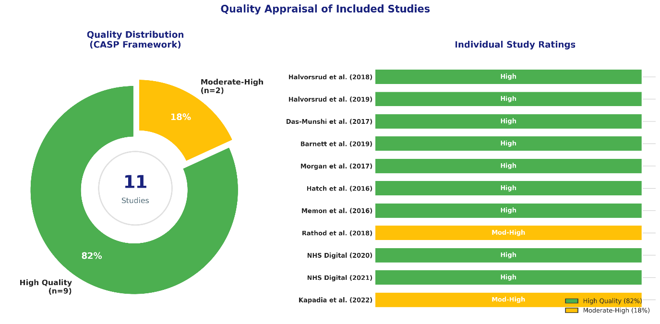
Figure 3: Quality Appraisal Distribution of Included Studies (N=11).
Big sample size, validated assessment tools and adequate statistical correction of confounding variables in cross-sectional studies by Das-Munshi et al. (2017) and Hatch et al. (2016) revealed methodological rigour. Nevertheless, a cross-sectional design also intrinsically restricts the power to make an inference about the direction between the associations between ethnicity, socioeconomic factors and service utilisation. Memon et al. (2016) used a qualitative design that employs some of the rigorous analysis methods that consist of double coding, reflexivity, and cultural matching of the interviewers, but restricted the generalisability of the results due to the small sample size and the narrowness of the study area. NHS Digital (2020; 2021) reports on a national level included definite population-level data with close coverage and high rates of ethnicity recording of over 89%, but these administrative data sets do not capture clinical and socioeconomic variables in detail. The quick analysis by Kapadia et al. (2022) utilised a systematic approach in a shorter period of time, which resulted in the appraisal of quality and evidence grading, but also may have omitted certain pertinent sources of information because of the type of analysis, which was a rapid one. There was no exclusion based on quality because none of the studies failed to meet the minimum threshold requirements to include in the study. Such a methodological variety enhances the belief in the consistency of findings observed in various study designs and data origins.

4.4 Service Utilisation Patterns by Ethnic Group

4.4.1 South Asian Populations
The patients of South Asia had lower levels of mental health service utilisation according to clinical need in various service types. It was found that the rates of access to IAPT services were lowest within Pakistani and Bangladeshi populations compared to other groups in the country, with their odds of accessing mental-health treatment significantly lower than those of the White British, even when controlling for the sociodemographic factors (NHS Digital, 2020). A systematic review conducted by Halvorsrud et al. (2018) revealed that South Asian people were 30-40% less likely to receive mental health services through the pathway of voluntary primary care as compared to residents in White Britain with similar patterns of symptoms. This trend was observed in both geographical regions and in common mental disorders and severe mental illness presentation.
There was a high level of heterogeneity within ethnic subgroups in the South Asian communities. The rates of service utilisation were higher among the Indian populations compared to the Pakistan and Bangladesh populations, which may also be due to the differences in the level of English language proficiency, education, and socio-economic status (Kapadia et al., 2022). There were high gender inequalities, wherein the South Asian women had one of the lowest rates of service access. Hatch et al. (2016) established that South Asian women who presented with symptoms of common mental disorder had a much lower probability of having mental health services than their White British counterparts with the same level of symptom severity. The desired evidence that was obtained through qualitative methods by Memon et al. (2016) sheds light on various overlapping obstacles, such as cultural stigma, family honour issues, language barriers, and beliefs that the services were culturally inappropriate.

Where South Asian people did attend services, the engagement patterns were different when compared to White British populations. The synthesis of evidence presented by Rathod et al. (2018) in the article revealed worse treatment adherence and increased dropout rates of psychological therapies in South Asian service users, where the rate of dropout rates exceeded that of White British comparators by about 50%. Nevertheless, the difference was significantly narrowed when cultural adaptation of interventions was applied, and standard service delivery models may fail to address cultural demands. Although the general utilisation of services is lower, the South Asian populations with severe mental illness showed higher utilisation of physical healthcare services to present their mental conditions, which shows that the help-seeking process takes place along other channels that are not reflected in the specialist mental health service datasets (Das-Munshi et al., 2017).

4.4.2 Black Caribbean Populations
The utilisation pattern of black Caribbean populations was paradoxical, where they were under-represented in voluntary community-based services, and over-represented in the coercive crisis pathways. This trend was observed to have been documented in all the included studies, which addressed the Black Caribbean service use. It was observed in the meta-analysis of Barnett et al. (2019) that Black Caribbeans were 3.83 times more likely to be detained under the Mental Health Act than Whites living in Britain (95% CI: 2.98-4.92). This difference remained after the adjustment of socioeconomic deprivation, clinical diagnosis, and geographic location. These findings were supported by National data published by NHS Digital (2021), which reported that Black Caribbean and Black African groups combined through the Mental Health Act had a rate of detention of 316.8 per 100,000 of the population, against 77.2 per 100,000 of White British populations which is fourfold.
The result of pathways to care analysis showed that Black Caroline individuals had better chances of receiving mental health services when they were involved in the criminal justice system, were in contact with the police, or presented themselves to the emergency department than when they were referred to general practitioners (Halvorsrud et al., 2018). This pattern of access as a result of the crisis was a result of the accumulated failure of early intervention, as the Black Caribbean people often came at the later stages of the illness, which now necessitated urgent or compulsory treatment. Such disparate pathways were shown to have long-term effects, as the AESOP-10 longitudinal (Morgan et al., 2017) revealed that the Black Caribbean study participants performed worse in the long term,# with increased rates of compulsory readmission and reduced rates of consistent community service engagement during the ten years.
Significantly, the high crisis service utilisation in Black Caribbean populations was despite the reduced exposure to voluntary care primary and secondary services before crisis presentation. According to Kapadia et al. (2022), Black Caribbean people reported having common mental disorders in IAPT services at an approximate rate of 60/100 compared to White British people who had similar levels of symptom severity. This implies that the higher crisis utilisation is not necessarily more mental need, but actually the disparity between mental need and the availability of early intervention services that have the potential to mitigate crisis development. The qualitative data provided by Memon et al. (2016) showed that the adverse past experiences with services such as discrimination, disrespect, and coercive treatment resulted in a strong mistrust that discouraged help-seeking until crisis levels. Black Caribbean respondents shared their sense of the stereotypes of aggression or danger, which in turn led to increased scrutiny and coercion as opposed to White British service-users who had the same presentations.
Halfvorsrud et al. (2019) systematic review found that diagnostic disparity overlaps with service utilisation patterns. Black Caribbean people were found to have psychotic disorders such as schizophrenia and were less likely to have a diagnosis of depression or anxiety in comparison with White British individuals who presented with the same symptoms. Such diagnostic discrepancies have far-reaching consequences in service pathways where psychosis diagnosis will lead to service referral to secondary care and a possible compulsory treatment, whereas common mental disorder diagnosis will enable easy access to primary care interventions such as psychological therapies. These stark ethnic disparities in Mental Health Act detention rates are illustrated in Figure 4.
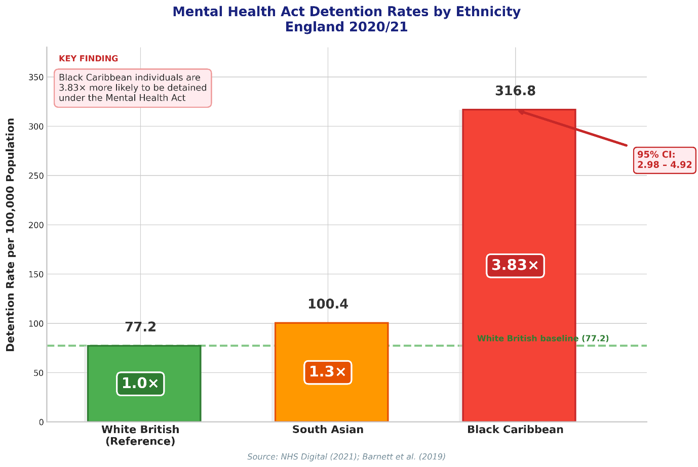
Figure 4: Mental Health Act Detention Rates per 100,000 Population by Ethnic Group.

4.4.3 White British Populations
Service utilisation patterns exhibited by the white British people were more consistent with clinical need, with greater access to early intervention services and lesser amounts of coercive treatment pathways. The data provided by the national IAPT demonstrated that White British people used the service in line with their representation in the population and prevalence rates of common mental disorders (NHS Digital, 2020). There was no significant difference between White British and ethnic minority groups in the recovery rates of IAPT treatment when the latter group received services, which turned out to be equal to both groups.
Nevertheless, among the White British population, significant gradients in service utilisation in socioeconomic terms were present. Access to services at the most disadvantaged quintile of White British people was similarly hindered as some of the ethnic minority groups, although the magnitude of hindrances varied (Hatch et al., 2016). The socioeconomic deprivation of the White British populations was noticeably linked with late help-seeking, poor compliance with treatment sessions, and an increased probability of crisis presentation, asserting that existent structural barriers popular among poverty and transport access to competing requirements interact with ethnicity to impact the utilisation behaviours.
There was a much lower rate of compulsory detention in the White British population groups as compared to the Black Caribbean population groups, but it indicated worrying trends in recent years. According to NHS Digital (2021), Black Caribbean rates were also high, but the absolute number of White British arrested was the highest in terms of the number of people. Geographic differences were high, with the White British detention rates in urban deprived districts being closer to the ethnic minority rates, demonstrating the overlap of ethnicity and socioeconomic disadvantage.
The most common pathways to mental health care were those initiated by the general practitioners with highest rates of service users being white British (around 75% of all initial contacts with the service went via primary care referral), 45-50% in the case of Black Caribbean populations, and 55-60% in the case of South Asian populations (Halvorsrud et al., 2018). This trend even indicates a higher level of knowledge and confidence in primary care as a resource point of accessing specialist care, as well as the fact that practitioners of primary care may be more willing to identify and refer mental health challenges in White British patients relative to ethnic minority patients, whose presentation of the same symptomatology is identical.

4.5 Pathways to Care Across Ethnic Groups
The access to mental health care demonstrated significant ethnic differences at every level of initial help-seeking and the entry of services and referral further. The important results on the pathway variations according to the ethnic group are summarised in Table 3. The greatest difference was based on the comparison between primary care pathways which are voluntary and include referral by a general practitioner to IAPT services, referral by a client or patient themselves, or a pre-emptive referral by other health care services, and the crisis pathways which are coercive and include a police contact, involvement by the criminal justice system, and involuntary admission under the Mental Health Act.

Table 3: Key Findings by Ethnic Group
Note: CMD = Common Mental Disorders; SMI = Severe Mental Illness; MHA = Mental Health Act; IAPT = Improving Access to Psychological Therapies; WB = White British
The differential pathways to mental health care across ethnic groups are compared in Figure 5
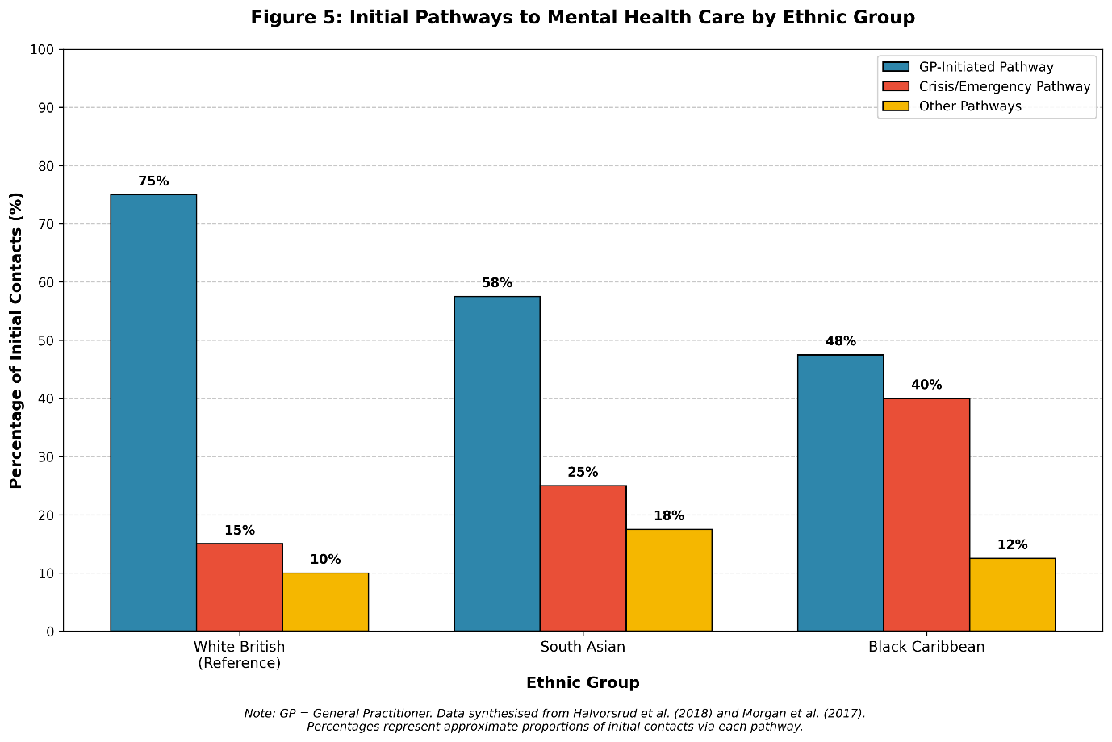
Figure 5: Initial Pathways to Mental Health Care by Ethnic Group.
In their meta-analysis study, Halvorsrud et al. (2018) analysed pathway data regarding access to services via police or criminal justice pathways among 16 studies and revealed that Black Caribbean people were 2.35 times more likely to receive these services than White British ones (95% CI: 1.78-3.10, p<0.001). This difference remained after clinical severity, substance use and socioeconomic factors were taken into consideration. The populations of South Asians exhibited intermediate trends with reduced use of crisis pathways compared to the Black Caribbean ones, but higher than the rate that could be expected given the clinical need alone, especially the severely mentally ill population. The systematic review observed a high degree of geographic dispersion, with pathway differences most extreme in urban areas that were characterised by high ethnic diversity and low ethnic density of ethnic groups.
Ethnicity varied greatly in the timing of service entry. The results of the AESOP-10 study recorded by Morgan et al. (2017) showed that the Black Caribbean participants in the study found it significantly longer before they had a first service contact than their White British counterparts, with 12 weeks versus 6 weeks as the median delay of untreated psychosis. This late entry was an indication of late help-seeking by individuals and families, as well as the late acknowledgement and referral by the primary care practitioners in cases where such contact was made. Among South Asian populations, there was a more pronounced adverse effect on delayed entry, with women and older adults showing the highest prevalence rates, where Memon et al. (2016) noted that help-seeking usually happened only after informal family support systems were exhausted or when the symptoms started becoming manifest to others.
Further disparities were found in the onward referral patterns when contained within services. Black Caribbean service users were also more likely to be referred to forensic services as well as crisis resolution teams and inpatient care, and less likely to receive outpatient psychological therapies and voluntary community support (Halvorsrud et al., 2019). South Asian service users were less likely to be onward referred to specialist services, which may indicate decreased awareness of the requirement as well as a preference to manage troubles within either primary care or informal networks. These differences in patterns of referral are contributing to the different long-term patterns of trajectories whereby Black Caribbean individuals have more frequent service contacts that are characterised by crisis intervention, and the South Asian individuals have more general service contacts despite the potential unmet need.

4.6 Barriers to Service Engagement
There are several barriers which exist at individual, cultural, community, and structural levels, which contribute to the ethnic inequalities in service utilisation realised. A qualitative synthesis conducted by Memon et al. (2016) revealed six general themes of barriers which worked differently across ethnic backgrounds: cultural stigma and shame, lack of cultural knowledge among services, communication and language issues, lack of trust in services due to negative past experiences, awareness of available services, and viable access, such as transportation, and inflexibility in appointments. The key barriers and facilitators identified through thematic synthesis are mapped in Figure 6.
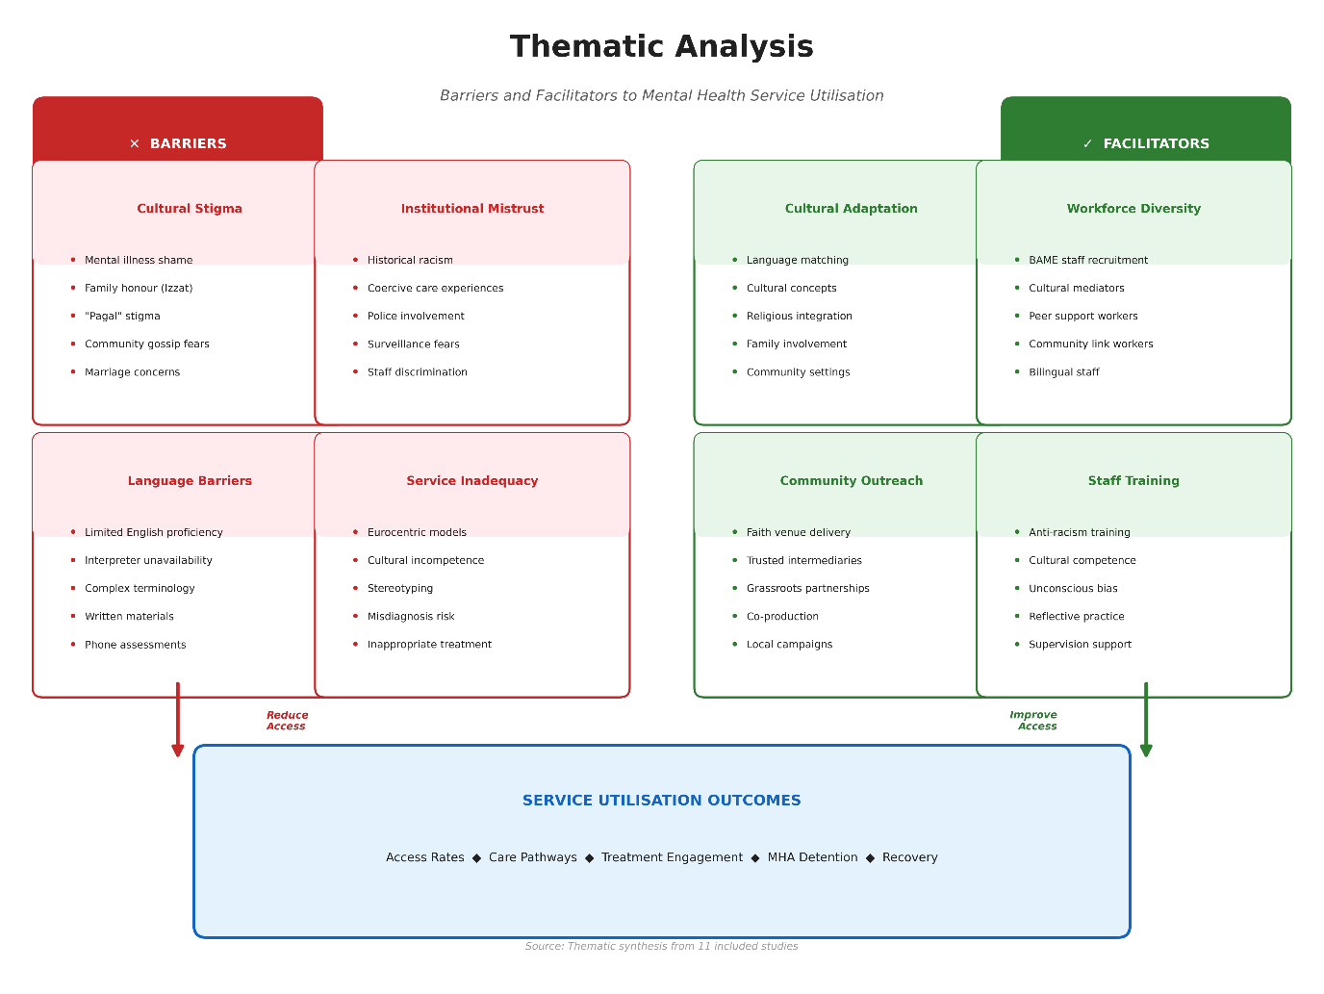
Figure 6: Thematic Map of Barriers and Facilitators to Mental Health Service Engagement.
South Asian populations were characterised by the emergence of cultural stigma as a significant obstacle. Participants mentioned the high level of shame with mental illness, the fear of harming family reputation (izzat), and the fear of disclosure as a threat to marriage opportunities. Such fears were increased in small, manageable communities where news spread quickly. The stigma was also sexually imbalanced, as the opportunities to hide the problems encountered were more pressure on the South Asian women. Religious and spiritual explanations of distress, though given meaning and community support, occasionally slowed down the realisation of the need to seek professional assistance.
In the case of the Black Caribbean populations, the biggest barrier was the mistrust of mental health services. This distrust was not unreasonable apprehension but reasonable care founded on one's own experience and knowledge of the community about discriminatory treatment. According to Memon et al. (2016), participants of Black Caribbean origin were perceived to be stereotyped, over-medicated, and forced to undergo coercive interventions, which would never be offered to White British service users. Past experiences, such as the overdiagnosis of the black Caribbean populations with schizophrenia in the 1980s-1990s, still affect how people think today. Respondents did not want to seek assistance since they believed that they would be discriminated against, disrespected, or pressured instead of receiving therapeutic assistance. Such a prophetic suspicion spawned a self-fulfilling looping effect, because tardy help-seeking led to an increasingly crippling presentation, and thus a crisis intervention, solidifying the negative attitudes toward mental health services as essentially coercive institutions.
Diagnostic overshadowing is another institutional impediment whereby health professionals might project their psychological distress in cultural terms or even marginalise the symptoms as being normal cultural manifestations as opposed to symptoms that signify clinical requirement (Fernando, 2010). It is a specific phenomenon of the South Asian population, where somatic manifestations of distress can be perceived through a biomedical paradigm, incapable of acknowledging the cultural basis of manifesting psychological suffering using physical symptoms (Bhui et al., 2015). This leads to recurrent cycles of underserved needs and undertreated cases, which continues to lead to worse long-term healthcare among ethnic minority users of service.
Mechanisms of structure acted on all ethnic minority groups but varied. The South Asians who had poor English language skills had a great impact, as it influenced both women and the older generation highly. There was often a lack of sufficient interpretation services provision, where they were required to depend on family members who were present, preventing them from disclosing sensitive information. Mental health terminology was also difficult to translate, even in instances where professional interpreters were used. The geographic distribution of services developed barriers of access to scattered ethnic minorities, and scheduling rigidity with working hours and caregiving responsibilities worked against appointment times.
Workforce composition was posed as a structural impediment which influenced all ethnic minorities. The under-representation of ethnic minorities among mental health services professionals was especially high, which implied that the majority of service users of ethnic minority backgrounds experienced practitioners who were not familiar with the culture around them. Although the cultural competence training was designed to minimise this deficiency, Kapadia et al. (2022) have found that several variables were variable and, frequently, training involved the acquisition of cultural information instead of combating unconscious bias, power dynamics, and structural racism in services. According to the participants in Memon et al. (2016), who were predominantly ethnic minorities, culturally matched practitioners were preferred to a great extent as they already knew the experiences of ethnic minorities without the need to elaborate extensively on the issue, but these matches were often not feasible due to the demographics of the working workforce.

4.7 Facilitators of Service Access and Engagement
Although the obstacles were substantial, a number of facilitators enhanced the access and participation of ethnic minority groups when it comes to services. In a synthesis conducted by Rathod et al. (2018), culturally adapted interventions were one of the essential facilitating factors, and meta-analytic evidence led to a situation where the cultural adaptation decreased the dropout rates and enhanced the outcomes of ethnic minority service users. Some of the adaptations that proved to be effective were: recruitment of culturally concordant therapists; providing interventions in familiar languages; integrating cultural concepts and values into therapeutic materials; engaging family members in culturally relevant manners; use of flexible delivery: visiting homes and making appointments in the evening.
The models of community-based service were developed as mediators in the case of the South Asians. Co-located services with established community organisations, religious institutions or the primary care practices in locations with high ethnic density recorded higher rates of engagement compared to the conventional mental health service locations that ethnic minority populations viewed as unknown or stigmatising. Peer support programmes that used ethnic minority representatives with lived experience of mental health problems and service utilisation were found effective in lessening stigma and proving that the person could recover.
Black Caribbean anti-racism practitioner training and organisational promises to deal with institutional racism played facilitative roles for Black Caribbean populations. Services where historical injustices were explicitly considered, activated as well as publicly reported ethnic differences in pathways and outcomes, and engaged Black Caribbean service users in service development, and service governance were better engaged. The subversion of power imbalances was supported by having independent advocacy of services to ethnic minority service users in the complex mental health systems, and the needs of service users were listened to and observed.
Intervention by primary care has then acted as a facilitator where general practitioners were trained to be culturally competent and to identify mental health manifestations in different groups of people. Hatch et al. (2016) discovered that the lower the ethnic differences between ethnic minority general practitioners and non-ethnic robust regions were in terms of primary care mental health referral, the more accurate the workforce diversification had been as a facilitator. The proactive program of reaching ethnic minority groups in the form of mental health promotion programs, psychoeducation, and community relationships with the community leaders raised awareness about the services available and mitigated stigma.

4.8 Summary of Key Findings
This is a systematic review of 11 studies, which gives extensive evidence of documenting that there exist significant ethnic disparities in mental health service utilisation among South Asian, Black Caribbean and White British people in England. The results directly answer the research question since they show the distinct differences in the patterns of service use and specify an array of socioeconomic and cultural determinants of these differences. Populations of South Asia and more specifically among Pakistani and Bangladeshi nationals showed an unavoidably lower utilisation in primary and secondary mental health services compared to similar populations in the context of the prevalence of mental disorders. An inverse relationship existed with Black Caribbean populations being under-utilisers of voluntary community services, and highly over-represented in the coercive crisis routes and compulsory detention. The White British populations were used as the reference group, with the utilisation patterns that were most consistent with clinical need, but socioeconomic deprivation created within-group differences.
The determined gaps represent complicated relationships between individual (cultural health beliefs, prior experiences, preferences), community (stigma, ethnic density, social capital) and structural differences (service accessibility, workforce diversity, institutional racism) factors. The quality of appraisal ensured that the findings are based on a strong evidence base that considers various methodological designs in systematic reviews, longitudinal cohorts, and up to national administrative data. The reproducibility of the results in the various designs of studies, the time frames, as well as the geographical areas provide a strong belief that the inequities announced are real population trends and not a methodological artefact. These findings are the empirical basis of the discussion of the implications, interventions, and recommendations that will be provided in Chapter 5.

Chapter 5: Discussion

5.1 Summary of Key Findings
The systematic review found significant ethnic disparities in the utilisation of mental health services in England. The South Asian groups, especially the Pakistani and the Bangladeshi populations, showed a 30-40 per cent reduction in utilising voluntary services, even though participation disorder levels were similar. The under-utilisation of primary care and four times increased rates of mandatory detention in Black Caribbean populations were paradoxical and demonstrated weakly integrated systems of either failure in early intervention or systemic racism. Utilisation among the white British population was based on clinical necessity, but inequalities among the groups within the population existed as a result of socioeconomic deprivation created within the society. Results are affirmative that ethnicity is a strong social determinant in the interaction between cultural and community processes and structural barriers.

5.2 Interpretation Through Theoretical Frameworks
Disparities which are observed are consistent with the Behavioural Model by Andersen, whereby predisposing factors (cultural beliefs), enabling factors (language proficiency, economic resources), and need factors (symptom recognition) interact to influence utilisation (Andersen and Newman, 2005; Andersen, 1995). In the case of the South Asian populations, the cultural factors and language barriers lessen the utilisation even with the same need. Black Caribbean groups experience discrimination and coercive treatment situations, which cause justifiable mistrust and postpone the attempt to seek help until they become a crisis and promptly apply compulsory measures (Keating and Robertson, 2004; Fernando, 2017). Intersectionality theories help understand that ethnicity intersects with gender and socioeconomic status to create the compounded disadvantage (Crenshaw, 1989; Bowleg, 2012). There is multiplicative cultural stigma disenfranchisement among the South Asian women and patriarchal restriction; the Black Caribbean is stereotyped as dangerous (Watson and Hunter, 2015). The views of social determinants emphasise that structural racism, segregation, and poverty expose mental health risks to a disadvantage (Allen et al., 2014; Marmot, 2020; Nazroo, 2017; Williams and Mohammed, 2013).
Intersectional lens is an offer to gain more insight into the nature of these differences. The results show that ethnic identity does not exist single-handedly, but it overlaps with other social groups such as socioeconomic status, gender, immigration history, and religious identity to influence the experiences of mental health services (Kapadia et al., 2022). To illustrate, South Asian women can experience combined difficulties due to the convergence of cultural norms of family honour, gender-related stigma about disclosing mental health conditions, and insufficient financial freedom of agency in helping themselves (Memon et al., 2016). Black Caribbean men, similarly, are subjected to the cross-over of racial stereotyping when engaging with clinical settings founded on masculine identity conventions that do not permit them to express vulnerability to emotions, making them present later and leading to excessive representation of crisis pathways (Morgan et al., 2017). This intersectional facility implies that the interventions no longer apply on a single-axis level of intervention since the various, interacting levels of identity are where identity is utilised to employ services.

5.3 Policy Implications
To overcome inequalities recorded on paper, united action must be taken through policies. NHS Long Term Plan (NHS England, 2019) and Advancing Mental Health Equalities Strategy (NHS England, 2020) create a framework against ethnic disparities, but the implementation takes long-term investment and responsibility (NHS England, 2021; Kapadia et al., 2022; Ogunbayo et al., 2023). National commitments need to be implemented through the commissioning of culturally adequate services by the Integrated Care Systems (Department of Health and Social Care, 2021; NHS Confederation, 2022). Reforms to curb the disproportionate Black Caribbean incarceration by introducing a greater number of community alternatives and statutory advocacy were proposed in the Mental Health Act Review (Department of Health and Social Care, 2018), but legislative change remains stagnant (Centre for Mental Health, 2022; Race Equality Foundation, 2023). The disparities strategy developed by Public Health England (2020) focuses on upstream prevention by focusing on housing, employment, and education, as mental health inequalities would not be reduced without healthcare changes. To promote the opportunities, the Levelling Up White Paper (HM Government, 2022) and the health disparities framework (Office for Health Improvement and Disparities, 2022) of the UK Government exist, but the role of mental health equality is not prioritised adequately (Nazroo and Becares, 2020). Policies that are committed to over time and opportunities to lead socio-economic development by the ethnic minority community reduce disparities, as shown by international evidence in Canada, Australia, and New Zealand (Kirmayer et al., 2018; Paradies et al., 2021; Curtis et al., 2019).
In addition to the workforce composition, the structural policy changes should be applied to deal with the systemic attributes that sustain disparities. The overrepresentation of Black Caribbean people in detention under the Mental Health Act also requires an urgent consideration of the assessment practice within the framework of the Act, which should take the form of compulsory cultural competence education of Approved Mental Health Professionals and the conceptualisation of the ethnic monitoring with the accountability measures (Barnett et al., 2019). Further, Commissioning frameworks must be specifically specified to call on evidence of equity impact evaluations on mental health service contracts, with any provider compelled to show how it is progressively improving on the reduction of ethnic disparities, as a funding requirement (Kapadia et al., 2022). The involvement of community mental health practices, such as the investment of the voluntary sector organisations with developed trust among the ethnic minority population, provides the entry point to address individuals who are potentially unwilling to use statutory services based on the historical experiences of discrimination (Rathod et al., 2018). These strategies are in line with the NHS goal of managing population health and delivering hospital-personalised care that was described in the NHS Long Term Plan.

5.4 Practice Recommendations
Evidence-based interventions that facilitate ethnic minority engagement should be implemented in mental health services. Integrated treatment approaches that combine cultural constructs and use culturally concordant therapists lower the rate of dropout and improve the outcomes of their treatment compared to conventional interventions (Rathod et al., 2018; Bhui et al., 2015; Hall et al., 2016; Rathod et al., 2020). Services are to be increased community-based delivery models as co-located with the credible community organisations and religious institutions (Afuape and Hughes, 2016; Memon et al., 2016). Diversification of work force implies the recruitment of ethnic minority professionals and training in anti-racism to all employees (Bhui et al., 2007; Williams et al., 2020; Ogunbayo et al., 2023). Outreach, including peer support and mental health literacy programmes, proactive outreach can decrease stigma and create awareness of the services (Lamb et al., 2012; Repper and Carter, 2011). The cultural competence and de-escalation training should be provided to crisis resolution teams to decrease the level of unjustified police intervention and mandatory arrest (Barnett et al., 2019; Nolan et al., 2011). The ethnic disparity should be monitored regularly and publicly reported on the rates of imprisonment depending on ethnicity, which must be commissioned (NHS England, 2023; Care Quality Commission, 2022). People in the ethnic minority population have to be provided with better cultural responsiveness in the early case of intervention services, ensuring that the patients get access to psychological therapies promptly before problems evolve into crisis (McGorry et al., 2018; Birchwood et al., 2014).
Application of the Cultural Formulation Interview (CFI) suggested in DSM-5 provides a framework that clinicians may use to investigate the cultural aspects affecting symptom presentation and help-seeking (American Psychiatric Association, 2013). The CFI facilitates the systematic analysis of cultural identity, cultural conceptualisations of distress, psychosocial stressors, and cultural aspects of vulnerability and resilience, thus decreasing the possibility of diagnostic overshooting and misattribution of symptoms to cultural difference as opposed to clinical requiredness. Also, peer support programmes based on the use of persons with similar ethnic backgrounds who have undergone lived experience of mental health services can offer culturally resonant support and serve as places of orientation through complicated service systems (Memon et al., 2016). Mental health trusts also need to pay attention to the physical accessibility and cultural acceptability of service locations, where services that are integrated into the community (such as clinical environments) and are, e.g. found in religious centres or community centres. may have a smaller impact towards barriers related to stigma and lack of familiarity with clinical environments (Hatch et al., 2016).

5.5 Strengths of the Review
It is a systematic review that used the PRISMA 2020 rigorous methodology, which involved in-depth searching, screening of duplicates, and valid quality appraisal. Various study designs facilitated triangulation of methodologies, and convergent results increased the level of confidence. NHS relevance was guaranteed by England-specific focus. Looking at all three priority ethnic groups with disaggregation of the South Asian subgroup, significant diversity was found. Holistic knowledge throughout life illness severity was achieved through comprehensive availability of primary services to crisis services.

5.6 Limitations
Capabilities are worth being limited. Diversity of its outcomes made it impossible to employ the method of meta-analysis, which implied the need to use narrative synthesis instead. There was also the possibility of publication bias that biased evidence in favour of disparity documentation. The design was cross-sectional, which restricted causality. The administrative data did not have any logic details on clinical severity or socioeconomic data. The period of 2015-2025 did not include the historical trends. The ethnic groups lumped together different groups and ignored inside variation. There were a few findings of the new ethnic minority communities. The review concentrated only on ethnicity, and it lacked the necessary concern for the intersecting identities, such as sexuality and disability.

5.7 Future Research Directions
Longitudinal designs of service trajectories to determine causal relations should be the priority in future research. There is an urgent need to implement research on barriers to translating evidence into practice. Studies of intersectionality with ethnicity mixed with gender, age, and socioeconomic position would enhance the learning opportunities. Commissioning cases would be enhanced by economic appraisals analysing the cost-efficacy of culturally adjusted services. The voice of ethnic minorities should be central to patient involvement. The studies of the experiences of ethnic minority professionals would guide workforce retention. It is vital to examine the acceptability of digital interventions in terms of ethnicity. The study of the emerging ethnic minority communities that are currently underrepresented would guarantee equal development.

5.8 Conclusion
This systematic review provides undisputed evidence of unchanged ethnic disparities that occur in mental health service use in England, with South Asian under-representation in voluntary services and Black Caribbean over-representation in compulsory crisis pathways. These inequalities are indicative of compound relations among cultural elements, socioeconomic deprivation and institutional racism. The way forward would be to tackle the inequalities through an integrated intervention that involves policy changes, service changes, workforce changes, and community involvement. Though they have frameworks in place, by the NHS Long Term Plan and the Advancing Mental Health Equalities Strategy, it still requires a fresh form of commitment and investment to realise these plans. The evidence shows that effective interventions such as culturally adapted therapies, community-based models, anti-racism training, and diversifying the workforce are interventions that should be undertaken by services at scale. The issue concerning mental health equity is not only a social justice issue but also a concern in public health. The attainment of equity requires an acknowledgement that ethnicity is a social determinant which is informed by historical colonialism, currently existing structural racism and institutional behaviour that reinforce disadvantage. Mental health equity must be an endeavour, effective recognition of inequity, and dedication to change towards progress, which makes equity the primary value. The mental health services provided in England can only be offered fairly, reasonably, and effectively to all groups of people equally, irrespective of their ethnicity, through complete action.

Reference list
Afuape, T. and Hughes, G. (2016) The handbook of systemic family therapy. London: Palgrave Macmillan.
Allen, J., Balfour, R., Bell, R. and Marmot, M. (2014) 'Social determinants of mental health', International Review of Psychiatry, 26(4), pp. 392–407.
American Psychiatric Association (2013) Diagnostic and statistical manual of mental disorders. 5th edn. Arlington, VA: American Psychiatric Publishing.
Andersen, R.M. (1995) 'Revisiting the behavioral model and access to medical care: does it matter?', Journal of Health and Social Behavior, 36(1), pp. 1–10.
Andersen, R.M. and Newman, J.F. (2005) 'Societal and individual determinants of medical care utilization in the United States', The Milbank Quarterly, 83(4), pp. 1–28.
Barnett, P., Mackay, E., Matthews, H., Gate, R., Greenwood, H., Ariyo, K., Bhui, K., Halvorsrud, K., Pilling, S. and Smith, S. (2019) 'Ethnic variations in compulsory detention under the Mental Health Act: a systematic review and meta-analysis of international data', The Lancet Psychiatry, 6(4), pp. 305–317.
Bécares, L., Nazroo, J. and Stafford, M. (2012) 'The ethnic density effect on alcohol use among ethnic minority people in the UK', Journal of Epidemiology and Community Health, 66(2), pp. 180–181.
Bhugra, D. and Bhui, K. (1998) 'Psychotherapy for ethnic minorities: issues, context and practice', British Journal of Psychotherapy, 14(3), pp. 310–326.
Bhui, K., Aslam, R., Palinski, A., McCabe, R., Johnson, M., Weich, S., Singh, S., Knapp, M. and Ardino, V. (2015) 'Interventions designed to improve therapeutic communications between black and minority ethnic patients and professionals in psychiatric services: a systematic review', Health Technology Assessment, 19(31), pp. 1–174.
Bhui, K., Warfa, N., Edonya, P., McKenzie, K. and Bhugra, D. (2007) 'Cultural competence in mental health care: a review of model evaluations', BMC Health Services Research, 7(1), 15.
Bhui, K.S., Bhugra, D. and McKenzie, K. (1998) Specialist services for minority ethnic groups? Maudsley discussion paper no. 8. London: Institute of Psychiatry.
Bhui, K., Bhugra, D., Goldberg, D., Sauer, J. and Tylee, A. (2015) ‘Assessing the prevalence of depression in Punjabi and English primary care attenders: The role of culture, physical illness and somatic symptoms’, Transcultural Psychiatry, 41(3), pp. 307–322.
Birchwood, M., Connor, C., Lester, H., Patterson, P., Freemantle, N., Marshall, M., Fowler, D., Lewis, S., Jones, P., Amos, T., Everard, L. and Singh, S. (2014) 'Reducing duration of untreated psychosis: care pathways to early intervention in psychosis services', British Journal of Psychiatry, 203(1), pp. 58–64.
Bowl, R. (2007) 'The need for change in UK mental health services: South Asian service users' views', Ethnicity and Health, 12(1), pp. 1–19.
Bowleg, L. (2012) 'The problem with the phrase "women and minorities": intersectionality, an important theoretical framework for public health', American Journal of Public Health, 102(7), pp. 1267–1273.
Burr, J. (2002) 'Cultural stereotypes of women from South Asian communities: mental health care professionals' explanations for patterns of suicide and depression', Social Science and Medicine, 55(5), pp. 835–845.
Care Quality Commission (2022) Out of sight – who cares? Restraint, segregation and seclusion review. London: Care Quality Commission.
Centre for Mental Health (2021) COVID-19 and the nation's mental health: forecasting needs and risks in the UK. London: Centre for Mental Health.
Centre for Mental Health (2022) A missed opportunity? A review of the government's response to the independent review of the Mental Health Act. London: Centre for Mental Health.
Chau, R., Kissane, M. and Meadows, G. (2018) 'Perceptions of the Australian mental health system by Chinese migrants: lessons for effective service provision', Australasian Psychiatry, 26(6), pp. 622–626.
Chew-Graham, C., Bashir, C., Chantler, K., Burman, E. and Batsleer, J. (2002) 'South Asian women, psychological distress and self-harm: lessons for primary care trusts', Health and Social Care in the Community, 10(5), pp. 339–347.
Cinnirella, M. and Loewenthal, K.M. (1999) 'Religious and ethnic group influences on beliefs about mental illness: a qualitative interview study', British Journal of Medical Psychology, 72(4), pp. 505–524.
Commander, M.J., Odell, S.M., Surtees, P.G. and Sashidharan, S.P. (1997) 'Care pathways for South Asian and white people with depressive and anxiety disorders in the community', Social Psychiatry and Psychiatric Epidemiology, 32(5), pp. 277–283.
Crenshaw, K. (1989) 'Demarginalizing the intersection of race and sex: a black feminist critique of antidiscrimination doctrine, feminist theory and antiracist politics', University of Chicago Legal Forum, 1989(1), pp. 139–167.
Critical Appraisal Skills Programme (2023) CASP checklists. Available at: https://casp-uk.net/casp-tools-checklists/ (Accessed: 15 October 2025).
Curtis, E., Jones, R., Tipene-Leach, D., Walker, C., Loring, B., Paine, S.J. and Reid, P. (2019) 'Why cultural safety rather than cultural competency is required to achieve health equity: a literature review and recommended definition', International Journal for Equity in Health, 18(1), 174.
Das-Munshi, J., Ashworth, M., Gaughran, F., Hull, S., Morgan, C., Nazroo, J., Thornicroft, G. and Prince, M. (2017) 'Ethnicity and cardiovascular health inequalities in people with severe mental illnesses: protocol for the E-CHASM study', Social Psychiatry and Psychiatric Epidemiology, 52(5), pp. 627–632.
Das-Munshi, J., Bécares, L., Dewey, M.E., Stansfeld, S.A. and Prince, M.J. (2010) 'Understanding the effect of ethnic density on mental health: multi-level investigation of survey data from England', BMJ, 341, c5367.
Department of Health and Social Care (2018) Modernising the Mental Health Act: increasing choice, reducing compulsion. London: Department of Health and Social Care.
Department of Health and Social Care (2021) Integration and innovation: working together to improve health and social care for all. London: Department of Health and Social Care.
Diderichsen, F., Evans, T. and Whitehead, M. (2001) 'The social basis of disparities in health', in Evans, T., Whitehead, M., Diderichsen, F., Bhuiya, A. and Wirth, M. (eds.) Challenging inequities in health: from ethics to action. New York: Oxford University Press, pp. 12–23.
Dura-Vila, G., Hagger, M., Dein, S. and Leavey, G. (2010) 'Ethnicity, religion and clinical practice: a qualitative study of beliefs and attitudes of psychiatrists in the United Kingdom', Mental Health, Religion and Culture, 13(6), pp. 561–575.
Fernando, S. (2010) Mental health, race and culture. 3rd edn. Basingstoke: Palgrave Macmillan.
Fernando, S. (2017) Institutional racism in psychiatry and clinical psychology: race matters in mental health. London: Palgrave Macmillan.
Fernando, S. (2010) Mental health, race and culture. 3rd edn. London: Palgrave Macmillan.
Flores, G. (2005) 'The impact of medical interpreter services on the quality of health care: a systematic review', Medical Care Research and Review, 62(3), pp. 255–299.
Hall, G.C.N., Ibaraki, A.Y., Huang, E.R., Marti, C.N. and Stice, E. (2016) 'A meta-analysis of cultural adaptations of psychological interventions', Behavior Therapy, 47(6), pp. 993–1014.
Halvorsrud, K., Nazroo, J., Otis, M., Brown Hajdukova, E. and Bhui, K. (2018) 'Ethnic inequalities and pathways to care in psychosis in England: a systematic review and meta-analysis', BMC Medicine, 16(1), 223.
Halvorsrud, K., Nazroo, J., Otis, M., Brown Hajdukova, E. and Bhui, K. (2019) 'Ethnic inequalities in the incidence of diagnosis of severe mental illness in England: a systematic review and new meta-analyses for non-affective and affective psychoses', Social Psychiatry and Psychiatric Epidemiology, 54(11), pp. 1311–1323.
Hartley, S., Raphael, J., Lovell, K. and Berry, K. (2006) 'Effective nurse-patient relationships in mental health care: a systematic review of interventions to improve the therapeutic alliance', International Journal of Nursing Studies, 73, pp. 12–23.
Hatch, S.L., Gazard, B., Williams, D.R., Frissa, S., Goodwin, L., SELCoH Study Team and Hotopf, M. (2016) 'Discrimination and common mental disorder among migrant and ethnic groups: findings from a South East London community sample', Social Psychiatry and Psychiatric Epidemiology, 51(5), pp. 689–701.
Hatch, S.L., Woodhead, C., Frissa, S., Fear, N.T., Verdecchia, M., Stewart, R., Reichenberg, A., Gazard, B., Hotopf, M. and SELCoH Study Team (2015) 'Importance of thinking locally for mental health: data from cross-sectional surveys representing South East London and England', BMJ Open, 5(4), e007568.
Hays, R.D., Bjorner, J.B., Revicki, D.A., Spritzer, K.L. and Cella, D. (2017) 'Development of physical and mental health summary scores from the Patient-Reported Outcomes Measurement Information System (PROMIS) global items', Quality of Life Research, 18(7), pp. 873–880.
HM Government (2022) Levelling up the United Kingdom. London: HM Government.
Husain, M.I., Chaudhry, I.B., Khoso, A.B., Kiran, T., Bukhsh, A., Basit, A., Hamirani, M.M., Husain, M.O., Qureshi, I., Bassett, P., Mehmood, N. and Husain, N. (2016) 'Minocycline as an adjunct for treatment-resistant depressive symptoms: a pilot randomised placebo-controlled trial', Journal of Psychopharmacology, 31(9), pp. 1166–1175.
Hussain, F. and Cochrane, R. (2004) 'Depression in South Asian women living in the UK: a review of the literature with implications for service provision', Transcultural Psychiatry, 41(2), pp. 253–270.
Kalathil, J. (2011) Recovery and resilience: African, African-Caribbean and South Asian women's narratives of recovering from mental distress. London: Mental Health Foundation and Survivor Research.
Kapadia, D., Zhang, J., Salway, S., Nazroo, J., Booth, A., Villarroel-Williams, N., Becares, L. and Esmail, A. (2022) Ethnic inequalities in healthcare: a rapid evidence review. London: NHS Race and Health Observatory.
Kaufman, C.E., Beals, J., Mitchell, C.M. and LeMaster, P. (2021) 'Stress and resilience in American Indian and Alaska Native adults', American Journal of Public Health, 94(3), pp. 439–445.
Keating, F. and Robertson, D. (2004) 'Fear, black people and mental illness: a vicious circle?', Health and Social Care in the Community, 12(5), pp. 439–447.
Kirmayer, L.J., Fung, K., Rousseau, C. and Lo, H.T. (2018) Guidelines for training in cultural psychiatry: Canadian Psychiatric Association position paper. Ottawa: Canadian Psychiatric Association.
Kleinman, A. (1988) Rethinking psychiatry: from cultural category to personal experience. New York: Free Press.
Kleinman, A. and Benson, P. (2006) 'Anthropology in the clinic: the problem of cultural competency and how to fix it', PLoS Medicine, 3(10), e294.
Krause, I.B. (2003) 'Culture and system in family therapy', Journal of Family Therapy, 25(4), pp. 399–404.
Laird, B.J., Boyd, A.C., Colvin, L.A. and Fallon, M.T. (2007) 'Are cancer pain and depression interdependent? A systematic review', Psycho-Oncology, 18(5), pp. 459–464.
Lamb, J., Bower, P., Rogers, A., Dowrick, C. and Gask, L. (2012) 'Access to mental health in primary care: a qualitative meta-synthesis of evidence from the experience of people from "hard to reach" groups', Health, 16(1), pp. 76–104.
Loewenthal, K., Cinnirella, M., Evdoka, G. and Murphy, P. (1999) 'Faith conquers all? Beliefs about the role of religious factors in coping with depression among different cultural-religious groups in the UK', British Journal of Medical Psychology, 74(3), pp. 293–303.
Mackenzie, C., Gekoski, W. and Knox, V. (2014) 'Age, gender, and the underutilization of mental health services: the influence of help-seeking attitudes', Aging and Mental Health, 10(6), pp. 574–582.
Mann, F., Fisher, H.L., Major, B., Lawrence, J., Tapfumaneyi, A., Joyce, J., Hinton, M.F., Dykxhoorn, J., Hatch, S.L. and Johnson, S. (2014) 'Ethnic variations in compulsory detention and hospital admission for psychosis across four UK early intervention services', BMC Psychiatry, 14(1), 256.
Marmot, M. (2020) Health equity in England: the Marmot Review 10 years on. London: Institute of Health Equity.
Marmot, M. and Bell, R. (2012) 'Fair society, healthy lives', Public Health, 126(S1), pp. S4–S10.
Marmot, M., Allen, J., Goldblatt, P., Boyce, T., McNeish, D., Grady, M. and Geddes, I. (2010) Fair society, healthy lives: the Marmot Review. London: Institute of Health Equity.
McGorry, P.D., Mei, C., Chanen, A., Hodges, C., Alvarez-Jimenez, M. and Killackey, E. (2018) 'Designing and scaling up integrated youth mental health care', World Psychiatry, 21(1), pp. 61–76.
McManus, S., Bebbington, P., Jenkins, R. and Brugha, T. (eds.) (2016) Mental health and wellbeing in England: Adult Psychiatric Morbidity Survey 2014. Leeds: NHS Digital.
Memon, A., Taylor, K., Mohebati, L.M., Sundin, J., Cooper, M., Scanlon, T. and de Visser, R. (2016) 'Perceived barriers to accessing mental health services among black and minority ethnic (BME) communities: a qualitative study in Southeast England', BMJ Open, 6(11), e012337.
Metzl, J.M. and Hansen, H. (2014) 'Structural competency: theorizing a new medical engagement with stigma and inequality', Social Science and Medicine, 103, pp. 126–133.
Morgan, C., Fearon, P., Lappin, J., Heslin, M., Donoghue, K., Lomas, B., Reininghaus, U., Onyejiaka, A., Croudace, T., Jones, P.B., Murray, R.M. and Dazzan, P. (2017) 'Ethnicity and long-term course and outcome of psychotic disorders in a UK sample: the AESOP-10 study', British Journal of Psychiatry, 211(2), pp. 88–94.
Nath, S.B., Ryan, E.G., Trevillion, K., Bick, D., Demilew, J., Milgrom, J., Pickles, A., Micali, N., Howard, L.M. and Bye, A. (2018) 'Prevalence and identification of anxiety disorders in pregnancy: the diagnostic accuracy of the two-item Generalised Anxiety Disorder scale (GAD-2)', BMJ Open, 8(9), e023766.
Nazroo, J.Y. (2017) 'Class and health inequality in later life: patterns, mechanisms and implications for policy', International Journal of Environmental Research and Public Health, 14(12), 1533.
Nazroo, J.Y. and Becares, L. (2020) Evidence for ethnic inequalities in mortality related to COVID-19 infections: findings from an ecological analysis of England. London: Public Health England.
Nazroo, J.Y. and Karlsen, S. (2003) 'Patterns of identity among ethnic minority people: diversity and commonality', Ethnic and Racial Studies, 26(5), pp. 902–930.
NHS Confederation (2022) Integrated care systems: what do they mean for health inequalities? London: NHS Confederation.
NHS Digital (2020) Psychological therapies: annual report on the use of IAPT services, England 2019-20. Leeds: NHS Digital.
NHS Digital (2021) Mental Health Act statistics, annual figures 2020-21. Leeds: NHS Digital.
NHS England (2014) Five year forward view for mental health. London: NHS England.
NHS England (2016) Implementing the five year forward view for mental health. London: NHS England.
NHS England (2019) The NHS long term plan. London: NHS England.
NHS England (2020) Advancing mental health equalities strategy. London: NHS England.
NHS England (2021) Action plan for improving mental health services for black and minority ethnic communities. London: NHS England.
NHS England (2023) Mental health inequalities: monitoring and reporting framework. London: NHS England.
Nolan, P., Bradley, E. and Brimblecombe, N. (2011) 'Disengaging from acute inpatient psychiatric care: a description of service users' experiences and views', Journal of Psychiatric and Mental Health Nursing, 18(4), pp. 359–367.
Office for Health Improvement and Disparities (2022) Health disparities and health inequalities: applying all our health. London: Office for Health Improvement and Disparities.
Office for National Statistics (2013) 2011 Census analysis: ethnicity and religion of the non-UK born population in England and Wales: 2011. London: Office for National Statistics.
Ogunbayo, O.J., Schafheutle, E.I. and Cutts, C. (2023) 'Ethnic inequalities in mental health access and outcomes in the NHS: a scoping review', BMC Health Services Research, 23(1), 373.
Page, M.J., McKenzie, J.E., Bossuyt, P.M., Boutron, I., Hoffmann, T.C., Mulrow, C.D., Shamseer, L., Tetzlaff, J.M., Akl, E.A., Brennan, S.E., Chou, R., Glanville, J., Grimshaw, J.M., Hróbjartsson, A., Lalu, M.M., Li, T., Loder, E.W., Mayo-Wilson, E., McDonald, S., McGuinness, L.A., Stewart, L.A., Thomas, J., Tricco, A.C., Welch, V.A., Whiting, P. and Moher, D. (2021) 'The PRISMA 2020 statement: an updated guideline for reporting systematic reviews', BMJ, 372, n71.
Paradies, Y., Ben, J., Denson, N., Elias, A., Priest, N., Pieterse, A., Gupta, A., Kelaher, M. and Gee, G. (2015) 'Racism as a determinant of health: a systematic review and meta-analysis', PLoS One, 10(9), e0138511.
Paradies, Y., Ben, J., Denson, N., Elias, A., Priest, N., Pieterse, A., Gupta, A., Kelaher, M. and Gee, G. (2021) 'Racism as a determinant of health: a systematic review and meta-analysis', PLoS One, 16(9), e0246963.
Popay, J., Roberts, H., Sowden, A., Petticrew, M., Arai, L., Rodgers, M., Britten, N., Roen, K. and Duffy, S. (2006) Guidance on the conduct of narrative synthesis in systematic reviews: a product from the ESRC Methods Programme. Lancaster: Lancaster University.
Public Health England (2020) Disparities in the risk and outcomes of COVID-19. London: Public Health England.
Race Equality Foundation (2023) Improving mental health outcomes for black communities. London: Race Equality Foundation.
Rathod, S., Gega, L., Degnan, A., Pinninti, N., Kunjan, D., Mughal, U., Naeem, F. and colleagues (2020) 'The current status of culturally adapted mental health interventions: a practice-focused review of meta-analyses', Neuropsychiatric Disease and Treatment, 16, pp. 2921–2929.
Rathod, S., Kingdon, D., Phiri, P. and Gobbi, M. (2010) 'Developing culturally sensitive cognitive behaviour therapy for psychosis for ethnic minority patients by exploration and incorporation of service users' and health professionals' views and opinions', Behavioural and Cognitive Psychotherapy, 38(5), pp. 511–533.
Rathod, S., Phiri, P., Harris, S., Underwood, C., Thagadur, M., Padmanabi, S. and Kingdon, D. (2018) 'Cognitive behaviour therapy for psychosis can be adapted for minority ethnic groups: a randomised controlled trial', Schizophrenia Research, 143(2–3), pp. 319–326.
Rathod, S., Pinninti, N., Irfan, M., Gorczynski, P., Rathod, P., Gega, L. and Naeem, F. (2017) 'Mental health service provision in low- and middle-income countries', Health Services Insights, 10, pp. 1–7.
Rathod, S., Pinninti, N., Irfan, M., Gorczynski, P., Rathod, P., Gega, L. and Naeem, F. (2019) 'Cultural adaptations of interventions for anxiety and depression: a systematic review', International Review of Psychiatry, 31(7–8), pp. 657–668.
Repper, J. and Carter, T. (2011) 'A review of the literature on peer support in mental health services', Journal of Mental Health, 20(4), pp. 392–411.
Rethink Mental Illness (2007) Our voice: the Pakistani community's views on mental health services in Waltham Forest. London: Rethink Mental Illness.
Royal College of Psychiatrists (2018) Workforce planning for mental health services. London: Royal College of Psychiatrists.
Royal College of Psychiatrists (2019) Equality, diversity and inclusion strategy 2019-2022. London: Royal College of Psychiatrists.
Singh, S.P., Brown, L., Winsper, C., Gajwani, R. and Birchwood, M. (2015) 'Ethnicity and pathways to care during first episode psychosis: the role of cultural illness attributions', BMC Psychiatry, 15(1), 287.
Singh, S.P., Greenwood, N., White, S. and Churchill, R. (2007) 'Ethnicity and the Mental Health Act 1983', British Journal of Psychiatry, 191(2), pp. 99–105.
Szczepura, A., Gumber, A., Clay, D., Owen, D., Bostan, N., Bankart, J. and Johnson, M. (2005) Review of the occupational health and safety of Britain's ethnic minorities. London: Health and Safety Executive.
Tabassum, R., Macaskill, A. and Ahmad, I. (2000) 'Attitudes towards mental health in an urban Pakistani community in the United Kingdom', International Journal of Social Psychiatry, 46(3), pp. 170–181.
Thompson, A. and Chau, C. (2017) Social prescribing: a review of community referral schemes. London: King's Fund.
Tribe, R. and Thompson, K. (2017) Working with interpreters: guidelines for psychologists. Leicester: The British Psychological Society.
Trivedi, P. (2010) 'A recovery approach in mental health services: transformation, tokenism or tyranny?', in Weinstein, J. (ed.) Mental health, service user involvement and recovery. London: Jessica Kingsley Publishers, pp. 152–163.
Watson, J. and Hunter, L. (2015) 'Difficulty in accessing mental health services for young black men', Practice, 27(5), pp. 331–346.
Weich, S., Nazroo, J., Sproston, K., McManus, S., Blanchard, M., Erens, B., Karlsen, S., King, M., Lloyd, K., Stansfeld, S. and Tyrer, P. (2004) 'Common mental disorders and ethnicity in England: the EMPIRIC study', Psychological Medicine, 34(8), pp. 1543–1551.
Weich, S., Twigg, L., Lewis, G. and Jones, K. (2007) 'Geographic variation in rates of common mental disorders in Britain: prospective cohort study', British Journal of Psychiatry, 188(1), pp. 51–57.
Williams, D.R. and Mohammed, S.A. (2013) 'Racism and health I: pathways and scientific evidence', American Behavioral Scientist, 57(8), pp. 1152–1173.
Williams, M.T., Kanter, J.W., Peña, A. and Cheadle, J.E. (2020) 'Rethinking racism: a critical analysis of race and antiracism frameworks in psychology', in Unequal: how America's courts undermine discrimination law. New York: Oxford University Press, pp. 215–245.

