

Financial Management for the Hotel Industry
Assignment Title: Business Report - Comparison of Two Hospitality Organisations

BMIH5007
Student Name: MD Belal Hussain
Student ID: 2225724
Module Code: BMIH5007
Lecturer Name: Tristan Hawkins
Word Count: 2135

Declaration
I declare that I have not used any artificial intelligence tools to complete my work. I confirm that I have not presented any AI generated materials as my own work. I confirm I have copies of my drafts, notes, and other resources I used, which I may be asked to provide in evidence

Table of Contents
Introduction 4
Overview of Shangri-La Hotels 4
Overview of Premier Inn Hotels 5
Comparison between Shangri-La Hotels and Premier Inn Hotels 5
1. Total Revenue 5
2. Market Position 8
3. Growth Potential 11
4. Financial commitment to CSR 12
Recommendation for Shangri-La Hotel and Premier Inn Hotels 13
Conclusion 14
Reference 15

Introduction
Financial management is an essential tool utilised by business organisations for planning, organising, controlling and reporting for financial sustainability. Financial management is imperative for financial managers to develop proper strategies for managing their revenues and costs so as to build strong financial platforms (Ren, 2022). Income generation, market segmentation, growth prospects, and financial investment in CSR programmes have been critically discussed in this report using the two business models of Shangri-La Hotels and Premier Inn Hotels.

Overview of Shangri-La Hotels
Shangri-La Hotels was established in 1971 and is a world’s famous luxury hotel. The resort chain operates in more than 22 countries and 76 destinations (Shangri-la.com, 2024). As a luxury hospitality and service provider, the company carries out its business in various strategic markets of the Asia-Pacific region, Europe, and the Middle East. This Malaysian-based company had a revenue of 213,384,000 Malaysian ringgit in 2019; however, due to the coronavirus outbreak starting late in 2019 and escalating into 2020, its revenues have begun to decline from 2020 onwards (Statista.com, 2024). The organisation has experienced steady financial growth until 2019 and is considered as third largest, most recognised hotel worldwide.
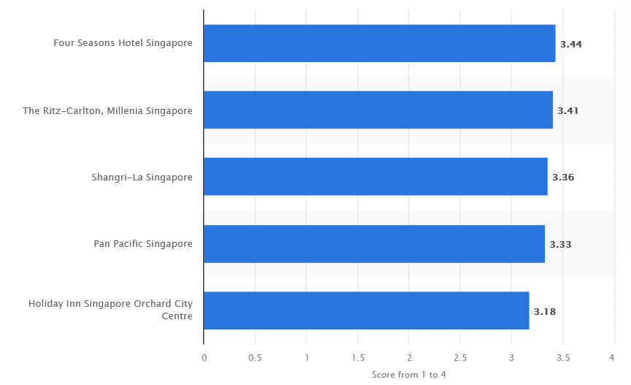
Figure 1: Rank of Shangri-la Hotel Singapore as per consumer choice
(Source: Statista.com, 2024)

Overview of Premier Inn Hotels
Premier Inn Hotel is one of the largest hotel chains, with 800 locations in the UK, Germany, and Ireland. Premier Inn Hotel has nearly 85443 hotel rooms across the UK and Ireland, indicating its steady growth (Statista.com, 2024). The consistent increase in Premier Inn’s number of rooms reflects its financial growth, driven by rising demand, strategic expansion, and constant investment in the UK and Ireland. This steady growth instils confidence in Premier Inn's future potential.
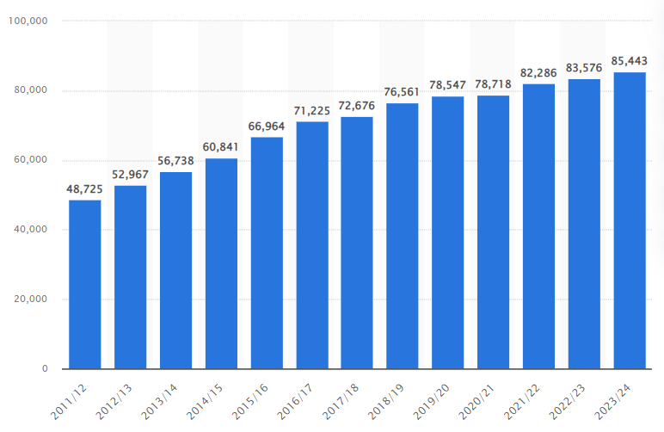

Figure 2: Number of Rooms of Premier Inn Hotels
(Source: Statista.com, 2024).

Comparison between Shangri-La Hotels and Premier Inn Hotels

Total Revenue
Total revenue is a key financial aspect that allows to identification of the growth trends, ability and future opportunities of an organisation. The economic data of an organisation allows one to identify the overall financial health of an organisation (Bhimani, 2006). In this report, we have used financial data from reliable sources such as the companies' financial statements and reputable financial databases. Shangri-la Group’s financial performance improved with a consolidated revenue of USD 2,141.8 million up by 46.5% from the previous year 2022 (Shangri-la Com, 2024). This growth shows how Shangri-La has been able to capture the market recovery as well as the renewed demand for luxury hospitality which is beneficial in its operations across the globe, such as the competitive luxury hotels market.
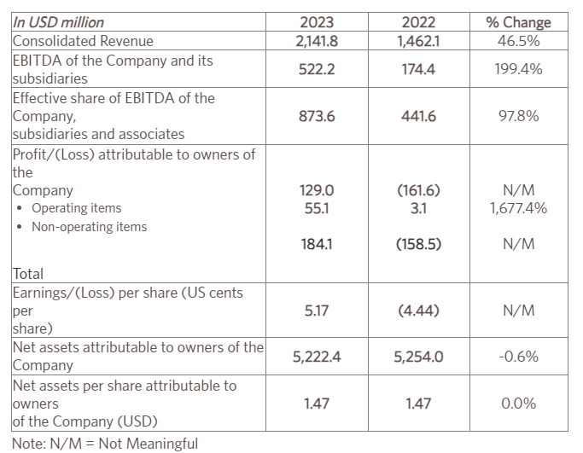
Figure 3: Financial highlights of Shangri-la hotel
(Source: Shangri-la Com, 2024).
The growth of Premier Inn Hotels appears to be in response to high demand as well as expansion strategies, leading to an adjusted profit before tax of £561 million. According to the data in 2023, the Whitbread Company, the parent company of Premier Inn, has disclosed significant progress in statutory revenues, rising to £2,960 million from £2,625 million in the year 2022/23 (Cdn.whitebread.co.uk, 2024).

Revenue Domain | Growth (in Million)
Statutory revenue | £2,960
Adjusted profit before tax | £561
Statutory profit before tax | £452m
Adjusted basic earnings | 206.9 (Per share)
Statutory basic earnings | 161.0 (Per Share)
Dividend Per Share | 97.0 (Per Share)
Adjust operating cash flow | £787m
Lease-adjusted net debt to adjusted EBITDAR | 2.9 X
Total Shareholder Returns | £756m
Table 1: Financial Report of Premium Inn Hotel (2023)
(Source: Self-made)
On the financial performance comparison between Shangri-La Hotels and Premier Inn, Premier Inn firms up as the outperformer. Although Shangri-La acquired a significant improvement in 2023 by earning 46.5% more in its revenue, Premier Inn demonstrates constant growth of revenues of £2,960 million in 2023 reflecting the steady market interest in the company. Another advantage of Premier Inn revealed by the authors is that it continuously grows in the UK and Ireland along with the enhancement in the overall profitability, which makes this entity a less risky business venture. However, while Shangri-La is now making a rebound, it restricts volatility more significantly, mainly owing to the pandemic effects implying that Premier Inn is better off both financially and in terms of growth.

Market Position
A strategic market position is an effective business strategy that allows the organisation to manage a business’s financial health in a competitive circle. A strategic marketing position is an effective method of gaining a competitive advantage through the effective management of accounting (Seal et al. 2008). Shangri-La Hotels has a strategic position in the global luxury sector providing extensive services and exceptional rooms and suites in Asia-Pacific, Europe, and the Middle East. The current values of $2.69 billion as of October 2024 reflect that Shangri La Hotel struggles for market share with other international hotel chains (Companiesmarketcap.com, 2024). The primary competitors of Shangri-la Hotel include Westin, Crowne Plaza, and Novotel, meaning it is in the business of serving high-end travellers in need of high-quality services (Hu and Trivedi, 2020).
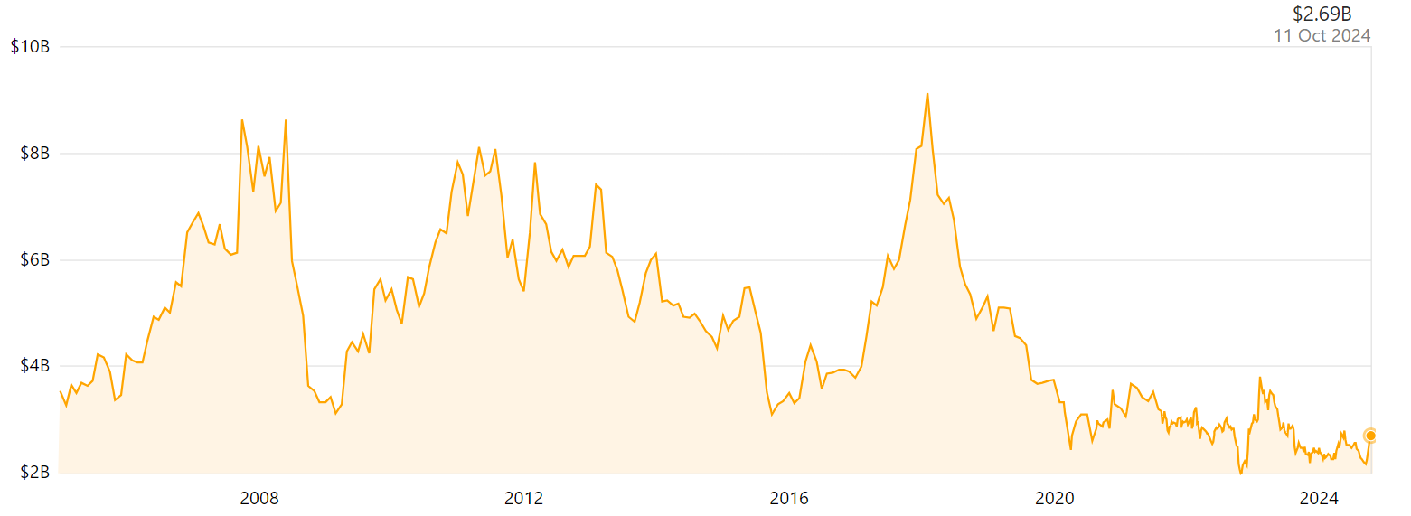
Figure 4: Market Cap of Shangri-La Hotel
(Source: Companiesmarketcap.com, 2024a).
Operating in a value-price chain niche market, Premier Inn competes with rivals like Ibis Styles and Wetherspoon Hotels. The UK-based Premier Inn, with a market capital of £ 1.85 Bn, is a robust player in the economy and midscale market in the UK and Ireland (Companiesmarketcap.com, 2024). It caters to the needs and wants of its clients, providing accommodation at a lower price while maintaining high standards of cleanliness and friendly staff, thereby ensuring its financial stability and market position.
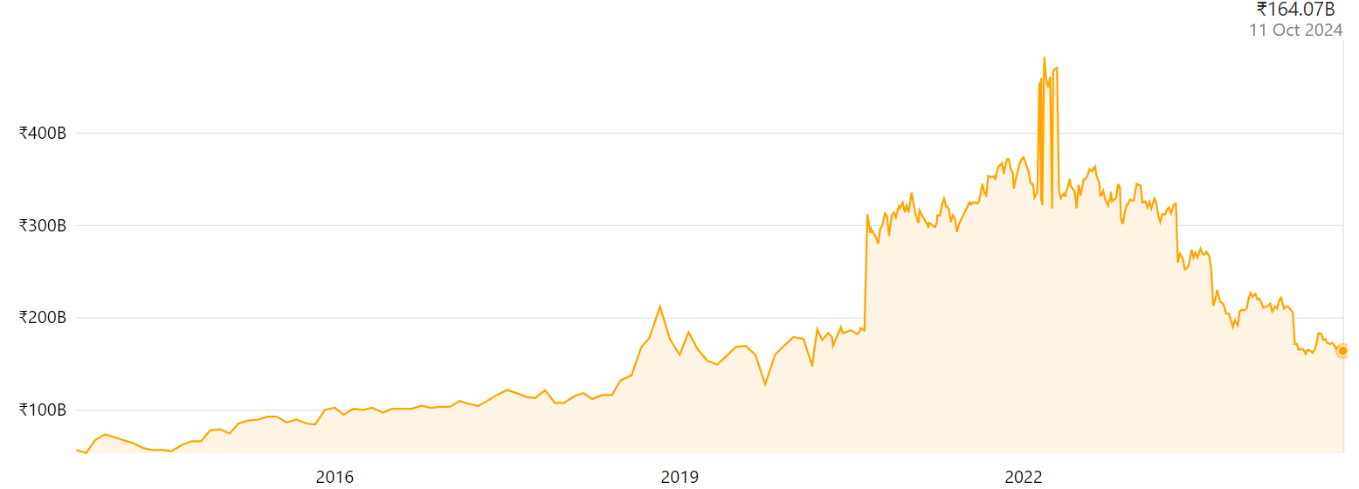
Figure 5: Market Cap of Premier Inn Hotel
(Source: Companiesmarketcap.com, 2024b).
Application of strategic positioning tool: Ansoff Model
Market Development: Shangri-La has established itself only in the luxury segment and cannot thus grow in the price-sensitive segment (Shangri-la.com, 2024). In contrast, Premier Inn has expanded well in the UK and Ireland, both in terms of increasing the number of rooms under control and broadening its market share.
Diversification: The current diversification in Shangri La’s operations in the UK, as well as other global locations, has been achieved through the strategic development of luxury resorts and high-end properties by prioritising culture (Shangri.la.com, 2024). On the other hand, there is relatively less diversification but more specialization by Premier Inn since its major concern is to offer quality and cheap accommodation.
Market Penetration: Premier Inn has a very extensive area coverage In the UK itself having over 850 hotels thus ensuring that customers are constantly loyal to the brand. However, Shangri-La is relatively less diversified with not as many hotels; therefore, it has not captured a competitive share in factions such as the low-end and mid-end segments.
Product Development: New concepts in luxurious services remain a strategic theme in Shangri-La over and above targeting customers at the upper end of the market. On the other hand, Premier Inn gives importance to customer satisfaction, and its service line consistency guarantees the company a strong status in the economic sector but distinguishes it from its competitors (Aroul et al. 2023). This particular approach differentiates Premier Inn by fewer innovations in service plans in contrast to Shangri-La, which offers premium services.
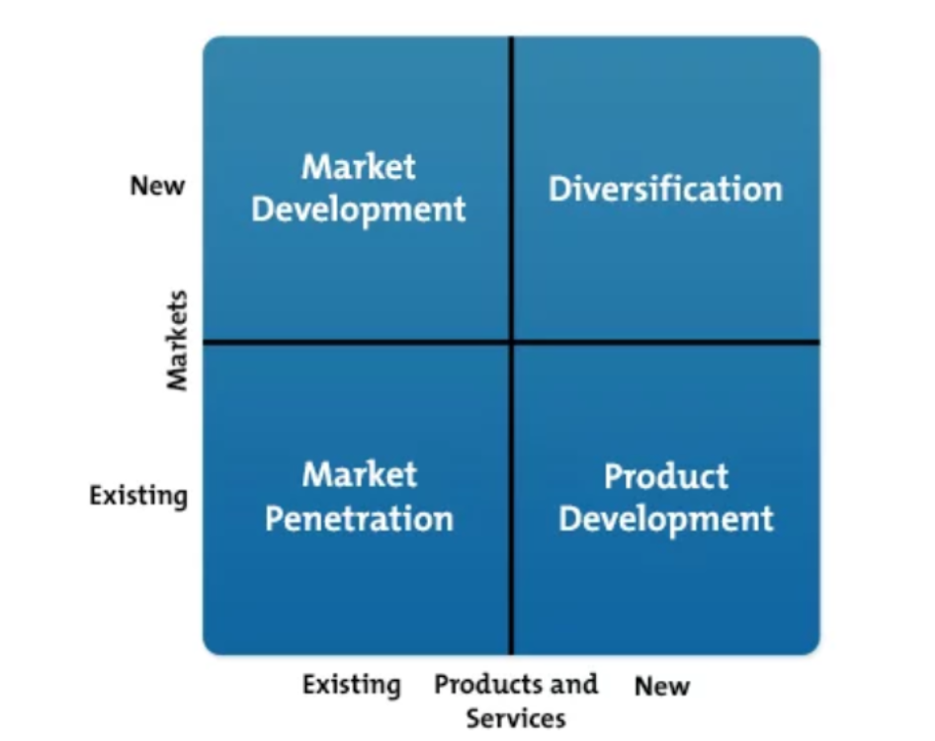
Figure 6: Ansoff Model for Market Positioning
(Source: Self-made)
The most obvious market positioning in contrast to budget and luxury distinguishes the chain of Shangri-La as a high-end, luxurious competitor to brands like Westin or Crowne Plaza. Thus, Premier Inn is focused on the price segment of budget and mid-price competing with the Ibis Styles and Wetherspoon Hotels (Which.co.uk, 2024). From the positioning map and looking at the overall market coverage it seems that Premier Inn is more market penetrative than Shangri-La and has incremental sustained revenue growth, especially within the United Kingdom and Ireland territories, where expansion seems to be more strategic and consistent. Shangri-La’s core business operates in the luxury market segment, it is less diverse than the market of Premier Inn which is more versatile and covers a wider customer base.

Growth Potential
A business growth potential is the ability of a firm to increase its market share revenue and profit in a competitive market. Growth is often accompanied by high inflation rate exchange rate loss and profitability (Seal et al. 2019). Half-yearly financial review of 2024 shows that Shangri-La Hotel’s rate of growth is limited by high capital intensity through property, plant, and equipment, which stood at $3.87 billion mid 2024 (Sitecore-cd.shangri-la.com, 2024). However, its market position, which targets the premium segment is a good opportunity for this company to expand through product differentiation and through expanding its geographic market.
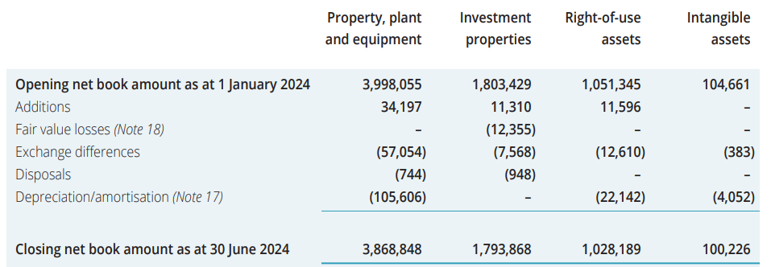
Figure 7: Growth report of Shangri-la
(Source: Sitecore-cd.shangri-la.com, 2024).
The current financial report of Premier Inn shows stability for developing the mid-range hotel chain. However Premier Inn Hotel currently face some economic issues in terms of net worth that is expected to be negative £851 million in 2024 (Companycheck.co.uk, 2024). Despite the limitation, it continues to undertake aggressive expansion in the UK.
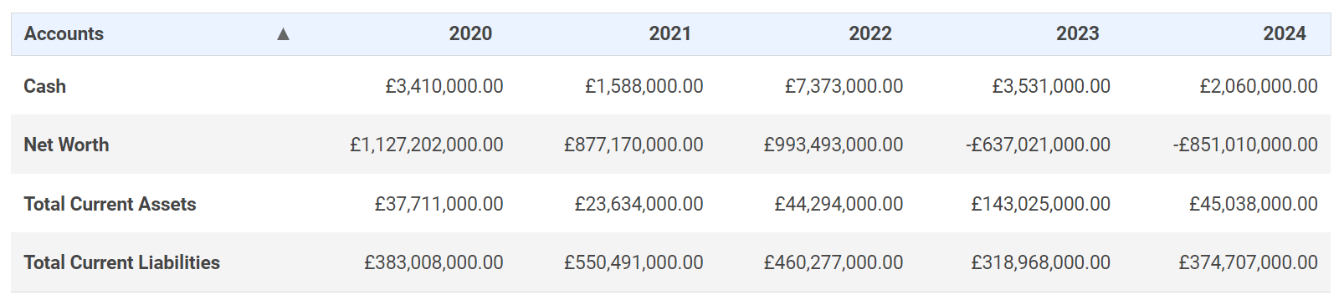
Figure 8: Financial Overview of Premier Inn
(Source: Companycheck.co.uk, 2024).
Shangri-La is positioned within narrowly defined segments of luxury travellers, while the broader reach of Premier Inn, and its lower-cost acquisition model imply higher growth rates. Thus, there are potential opportunities for Premier Inn to extend its mid-range hotels within the areas which do not have significant financial limitations. Shangri-La’s business model means that costs are more locked-in than in Premier Inn, which in turn makes Premier Inn better placed for future growth because Caines has direction and targets that are market-focused.

Financial commitment to CSR
The CSR plan of Shangri-La Hotel focuses on Environmental Management throughout its operation as part of the Triple Bottom Line. Their Sustainability P’s are “Planet”, including energy conservation and waste management “and People”, including community and employees, and responsible employment. Nonetheless, the extent of the company’s CSR spending is still questionable when it comes to its financial disclosure, particularly whether such spending is a real financial investment showing a clear sense of commitment to putting its money where its CSR mouth is when it comes to sharing its profits.
Under the “Force for Good” campaign, Premier Inn makes a larger tangible financial stake in CSR, especially when providing greener buildings and lower carbon intensity (Planet). Their strategic map, “People”, covers issues to do with hiring disadvantaged employees, increasing workplace diversity, and supporting local communities. It also seems that Premier Inn is more successful at balancing profit and sustainability, which means the company is probably more responsible for its CSR investments than Shangri-La.
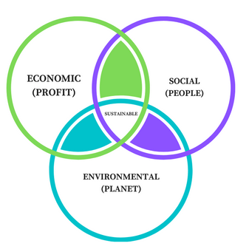
Figure 10: Triple Bottom line theory
(Source: Self-made)
The financial approach that Premier Inn manages its CRS commitments is comparatively more subordinate and explicit, which indicates a closer adherence to the Triple Bottom Line frame work. Therefore, in relation to TBL principles and arguments based thereon, Premier Inn has got clearer commitment of funds and is much more transparent with regard to CSR spending than Shangri-La.

Recommendation for Shangri-La Hotel and Premier Inn Hotels
- Recommendation for Shangri-La Hotel
The company should develop a new source of revenue through growing the mid-tier hospitality segment in the UK market for Shangri-La. For instance, IHG (Holiday Inn) have made its market base structural through the provision of several services segments to different guest categories (Ihgplc.com, 2024). Since Shangri-La is a luxury hotel, expanding in the mid-tier segment proves essential for customer reach and optimisation during difficult economic periods. This action will decrease dependence on high-end customers and provide a kind of hedge against fluctuations in the luxury market.
- Recommendation for Premier Inn Hotel
To develop further, Premier Inn should increase its international growth rate, especially for the Asia region because there is a need for a mid-price hotel. The hotel market in the United Kingdom is already saturated and this is why the growth opportunity of Premier Inn is to take its budget format international. Some insights into Whitbread’s latest Avant-garde strategies highlight how the concept of hotel chain differentiation in the international market- specifically Germany highlights how Premier Inn could successfully strike for the intercontinental international business venture (Whitbread.co.uk, 2024). One important opportunity is an increase in global travel as well as the emergence of a middle class in nations such as India and China.

Conclusion
Based on the strategic positioning, financial results, and GB commitments, both Shangri-La and Premier Inn Hotels reveal specific features of competitive advantage and opportunities for further expansion in the sphere of hospitality; although Shangri-La adopts a luxury image and has properties around the world to appeal to a high-end market, Premier Inn addresses the threat of low cost combined with uniformity in the UK’s submarket for budget hotels. Shangri-La has organic growth internationals and offers high-quality services, on the other hand, Premier Inn is focused on the United Kingdom region and hence has better domestic growth factors. Thus, the two chains can revolutionise their strategy processes and improve their competitive advantage considering market trends.

Reference
Aroul, R.R., Hodari, D., Bianchi, G. and Martignoni, G., (2023). The impact of brand affiliation on asset values: the case of UK hotels. Journal of property research, 40(2), pp.157-187.
Bhimani, A. ed., (2006). Contemporary issues in management accounting. Oxford University Press.
Cdn.whitebread.co.uk (2024). Building advantage. Available at: https://cdn.whitbread.co.uk/media/2024/05/Whitbread-PLC-Annual-Report-and-Accounts-2023_Single_pages-1.pdf[Accessed 11 September 2024]
Companiesmarketcap.com (2024a). The market capitalisation of Shangri-La (0069. HK). Available at: https://companiesmarketcap.com/shangri-la/marketcap/#:~:text=Market%20cap:%20$2.69%20Billion,much%20a%20company%20is%20worth.[Accessed 11 September 2024]
Companiesmarketcap.com (2024b). Market capitalization of Premier (PINC). Available at: https://companiesmarketcap.com/inr/premier/marketcap/[Accessed 11 September 2024]
Companycheck.co.uk (2024). Key Financials report. Available at: https://companycheck.co.uk/company/05137608/PREMIER-INN-HOTELS-LIMITED/companies-house-data [Accessed 11 September 2024]
Hu, F. and Trivedi, R.H., (2020). Mapping hotel brand positioning and competitive landscapes by text-mining user-generated content. International Journal of Hospitality Management, 84, p.102317.
Ihgplc.com (2024). How our business works. Available at: https://www.ihgplc.com/en/about-us/how-our-business-works[Accessed 11 September 2024]
Ren, S., (2022). Optimisation of Enterprise Financial Management and Decision‐Making Systems Based on Big Data. Journal of Mathematics, 2022(1), p.1708506.
Seal W (2019). (6th Ed) Management Accounting, London, McGraw Hill.
Seal W, Garrison RH, Noreen E (2008). Management Accounting, McGraw Hill
Shangri.la.com (2024). Corporate Profile. Available at: https://www.shangri-la.com/group/investors/corporate-profile[Accessed 11 September 2024]
Shangri-la Com (2024). Shangri-La Group Releases 2023 Full Year Results. Available at: https://www.shangri-la.com/group/media/media_post?post=Shangri-La%20Group%20Releases%202023%20Full%20Year%20Results[Accessed 11 September 2024]
Shangri-la.com (2024). Find Your Shangri-La. Available at: https://www.shangri-la.com/en/find-a-hotel/#:~:text=Luxury%20Hotels%20and%20Resorts%20%7C%20Official%20Site%20Shangri-La%20Hotels%20and%20Resorts&text=Discover%20from%20over%20100%20hotels,countries%2C%20regions%20and%2076%20destinations.[Accessed 11 September 2024]
Shangri-la.com (2024). Our Businesses. Available at: https://www.shangri-la.com/group/our-businesses/#:~:text=The%20Shangri-La%20brand%20is,both%20locals%20and%20global%20travellers.[Accessed 11 September 2024]
Sitecore-cd.shangri-la.com (2024). Interim Report 2024. Available at: https://sitecore-cd.shangri-la.com/-/media/Project/Shangri-La-Group/Investor/Files/Public-Disclosures/Latest-Top-Publications/e_IR2024_20240919.pdf[Accessed 11 September 2024]
Statista.com (2024). Leading hotels for business travellers based on customer evaluation in Singapore in 2022, by score. Available at: https://www.statista.com/statistics/1381827/singapore-leading-hotels-for-business-travelers/[Accessed 11 September 2024]
Statista.com (2024). Number of Premier Inn (Whitbread) hotel rooms in the United Kingdom and Ireland from 2011/12 to 2023/24. Available at: https://www.statista.com/statistics/629446/whitbread-premier-inn-hotel-rooms-united-kingdom-uk/#:~:text=In%20the%20financial%20year%202023,rose%2C%20reaching%20over%20850%20sites.[Accessed 11 September 2024]
Statista.com (2024). Revenue of Shangri-La Hotels (Malaysia) Berhad in 2019, by business segment. Available at: https://www.statista.com/statistics/1199674/shangri-la-malaysia-revenue-by-business-segment/ [Accessed 11 September 2024]
Which.co.uk (2024). Best UK hotel chains – and the ones to swerve. Available at: https://www.which.co.uk/reviews/uk-hotel-chains/article/best-and-worst-uk-hotel-chains-aaVVF4u1jZpe[Accessed 11 September 2024]
Whitbread.co.uk (2024). Our business model and strategy. Available at: https://www.whitbread.co.uk/about-us/our-business-model/ [Accessed 11 September 2024]

